A sample report
The author
Thu May 17 13:03:43 2012

The first part of my R script
Here I can generate my data
a <- matrix(rnorm(100), nrow = 10)

Results
An now the reults are plotted
image(a)
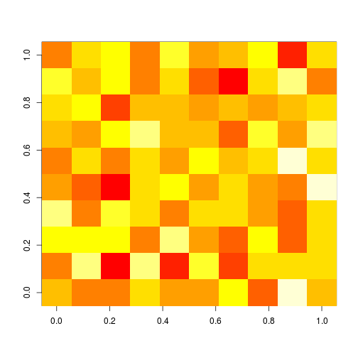

More
Of course I can use inline elemtnts: 3 + 3 = 6.

