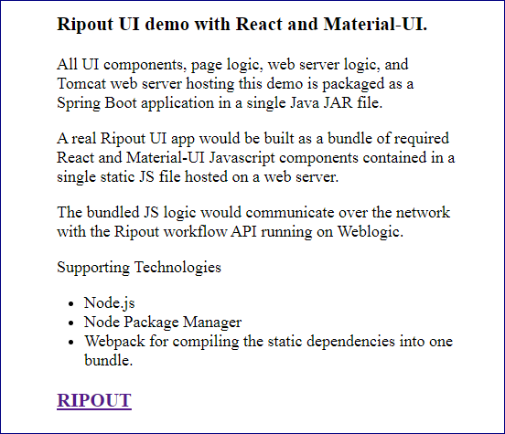
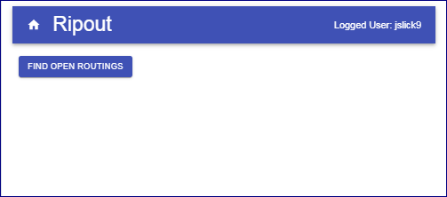
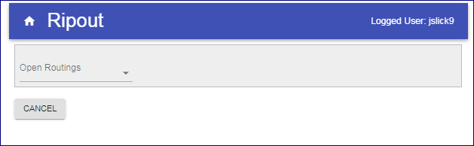
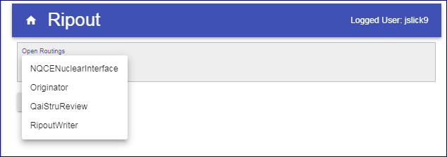
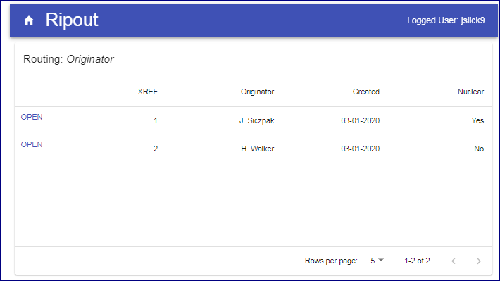
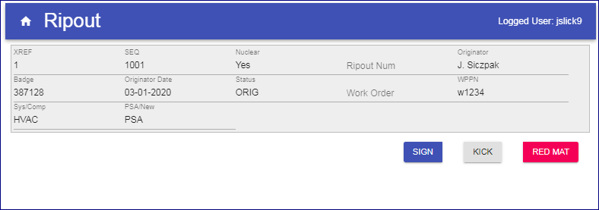
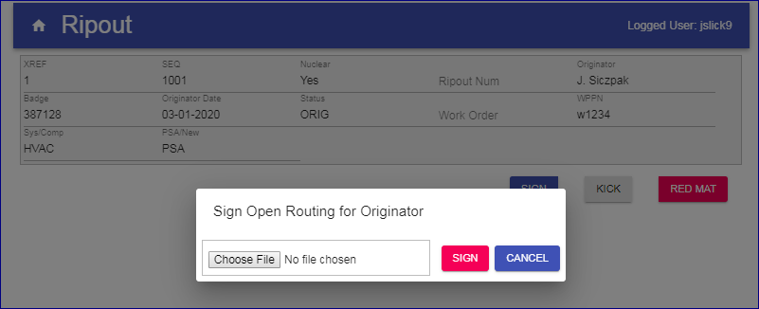
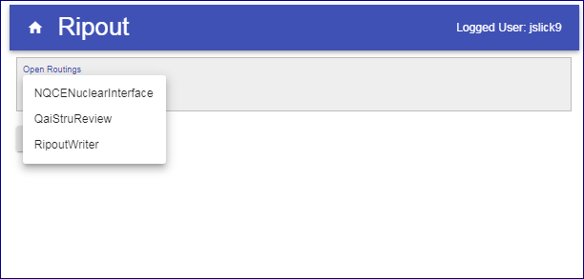
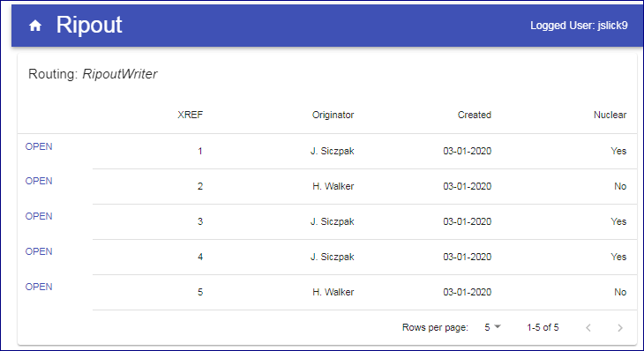
Ripout UI Simulation. John Slick, Dec 2019

Run it: java –jar ripout-0.0.1-SNAPSHOT.jar

- Landing page of the simulation app.

- The app demonstrates [React + MaterialUI + Java workflow simulation] running on a Tomcat web server.
The simulated workflow contains multiple Ripout records at different routing steps.
Demonstration landing page.

- Real app would display only records associated with the user’s AD role.
For demonstration, the simulation presents a list of open routings.

- The simulation is pre-loaded with several dummy Ripouts at various stages in the workflow.

- Selecting Originator reveals two open routings which Originator has not yet completed (signed off).

- Select first row of Originator’s open routings. The Ripout input form appears.
The sim implements only a small portion of the entire Ripout form.

- User fills in required fields, then clicks button “Sign”.
On the signing dialog, button “Choose File” presents a file navigation dialog for attaching files to the Ripout.
Attachment function is not implemented in the demonstration app.

- When user signs, the Ripout workflow is progressed to the next step.
When originator signs, the ripout record is progressed to RipoutWriter.
After both Originator open records have been signed, the Open Routings list has no Originator records.
Both records have been progressed to RipoutWriter.

8) Ripout Writer now has xref’s 1 & 2 to work on.

