1. Download SonarQube: <http://www.sonarqube.org/downloads/>

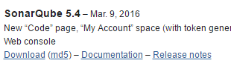

2. Download Sonar Scanner: <http://docs.sonarqube.org/display/SCAN/Analyzing+with+SonarQube+Scanner>

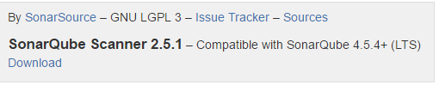

3. Extract both and place on desktop.

4. Run StartSonar.bat from your desktop’s folder.

Ex: C:\Users\Shalken\Desktop\sonarqube-5.4\bin\windows-x86-64

If successful should see something like this:

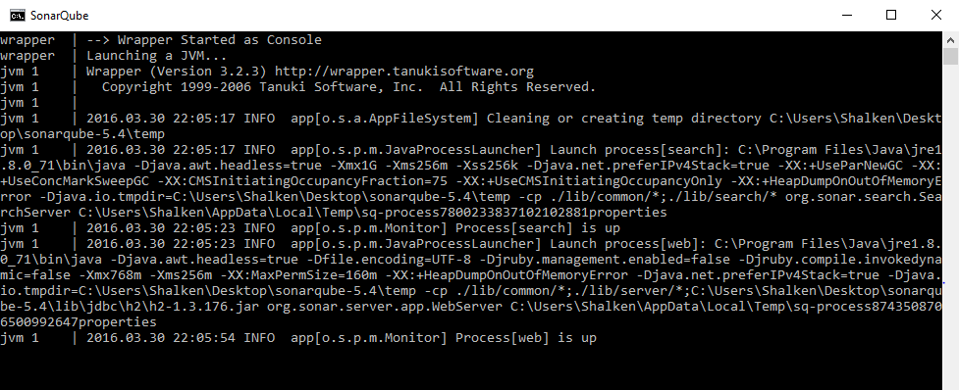

5. After this you should be able to navigate to the following page in a web browser: localhost:9000

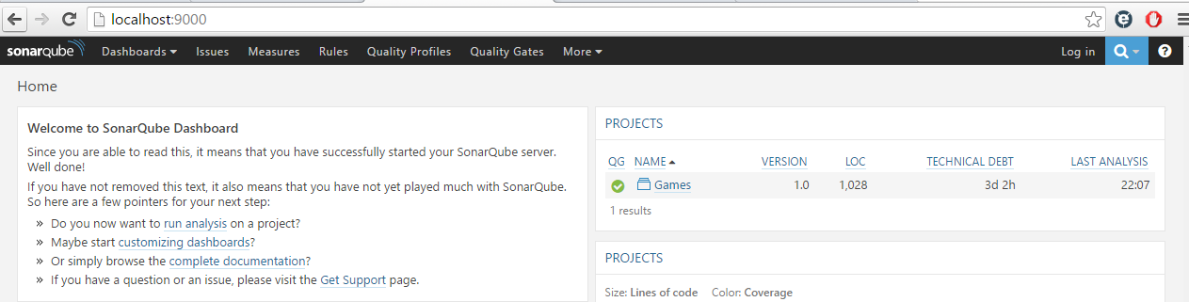

6. Open cmd and navigate to your project’s directory via the cd command. 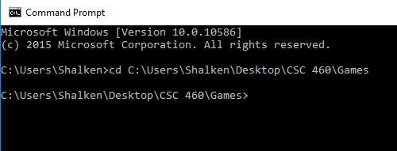

7. Run the sonar runner like such:



If it’s successful you should get something like this:

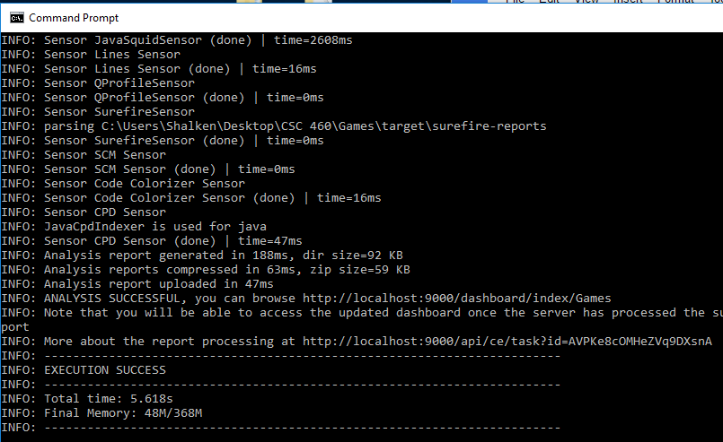

8. Now if you go back to localhost:9000 you should see the games project on the right.

