R Notebook

pag 12

install.packages("devtools")  
library(devtools)  
install_github("jmss70/dispocen")

pag 13

library(dispocen)

data <- read.dispocen("datos.txt")  
data %>%  
 head() %>%  
 flextable() %>% autofit() %>%  
 theme_booktabs()

| infos | users | centers | words |
| --- | --- | --- | --- |
| 21131 | 001 | 01 | mano, pi.... |
| 12131 | 002 | 01 | riñón, c.... |
| 12213 | 003 | 01 | brazo, m.... |
| 22214 | 004 | 01 | brazo, o.... |
| 12214 | 005 | 01 | cabeza, .... |
| 22213 | 006 | 01 | pie, man.... |

pag 14

disponibilidad <- build.lopezstrass.availability(data)

head(disponibilidad) %>%  
 flextable() %>%  
 set_header_labels(centers = "Centro de interés",  
 words = "Palabra",  
 order = "Orden",  
 availability = "Disponibilidad",  
 freq.abs = "Frecuencia absoluta",  
 freq.abs.cum = "Frecuencia absoluta acumulada",  
 freq.rel = "Frecuencia relativa",  
 freq.rel.cum = "Frecuencia relativa acumulada") %>%  
 colformat_double(j=c(4,6,8), digits=6) %>%  
 width(j=c(1,3,5,7), width=.65) %>%  
 width(j=c(2,4,6,8), width=.9) %>%  
 theme_booktabs()

| Centro de interés | Palabra | Orden | Disponibilidad | Frecuencia absoluta | Frecuencia relativa | Frecuencia absoluta acumulada | Frecuencia relativa acumulada |
| --- | --- | --- | --- | --- | --- | --- | --- |
| 01 | ojo | 1 | 0.632987 | 58 | 0.037395 | 58 | 0.037395 |
| 01 | brazo | 2 | 0.551808 | 50 | 0.032237 | 108 | 0.069632 |
| 01 | pierna | 3 | 0.507215 | 49 | 0.031593 | 157 | 0.101225 |
| 01 | mano | 4 | 0.489482 | 42 | 0.027079 | 199 | 0.128304 |
| 01 | cabeza | 5 | 0.478054 | 37 | 0.023856 | 236 | 0.152160 |
| 01 | pie | 6 | 0.450128 | 43 | 0.027724 | 279 | 0.179884 |

pag 15

disponibilidad %>%  
 filter(centers=="03") %>%  
 arrange(-availability) %>%  
 head(10) %>%  
 flextable() %>%  
 set_header_labels(centers = "Centro de interés",  
 words = "Palabra",  
 order = "Orden",  
 availability = "Disponibilidad",  
 freq.abs = "Frecuencia absoluta",  
 freq.abs.cum = "Frecuencia absoluta acumulada",  
 freq.rel = "Frecuencia relativa",  
 freq.rel.cum = "Frecuencia relativa acumulada") %>%  
 colformat_double(j=c(4,6,8), digits=6) %>%  
 width(j=c(1,3,5,7), width=.65) %>%  
 width(j=c(2,4,6,8), width=.9) %>%  
 theme_booktabs()

| Centro de interés | Palabra | Orden | Disponibilidad | Frecuencia absoluta | Frecuencia relativa | Frecuencia absoluta acumulada | Frecuencia relativa acumulada |
| --- | --- | --- | --- | --- | --- | --- | --- |
| 03 | cocina | 1 | 0.841569 | 69 | 0.066925 | 69 | 0.066925 |
| 03 | (cuarto de) baño | 2 | 0.746670 | 66 | 0.064016 | 135 | 0.130941 |
| 03 | salón | 3 | 0.715562 | 58 | 0.056256 | 193 | 0.187197 |
| 03 | dormitorio | 4 | 0.636728 | 55 | 0.053346 | 248 | 0.240543 |
| 03 | terraza | 5 | 0.608507 | 62 | 0.060136 | 310 | 0.300679 |
| 03 | comedor | 6 | 0.439152 | 39 | 0.037827 | 349 | 0.338506 |
| 03 | salita | 7 | 0.337618 | 31 | 0.030068 | 380 | 0.368574 |
| 03 | lavadero | 8 | 0.318056 | 33 | 0.032008 | 413 | 0.400582 |
| 03 | pasillo | 9 | 0.310978 | 34 | 0.032978 | 447 | 0.433560 |
| 03 | (cuarto de) aseo | 10 | 0.258557 | 24 | 0.023278 | 471 | 0.456838 |

pag 16

disponibilidad %>%  
 filter(centers == "03") %>%  
 arrange(-availability) %>%  
 ggplot(aes(x=order, y=availability)) + geom_line() +  
 xlab("Sucesión de palabras") + ylab("Disponibilidad")

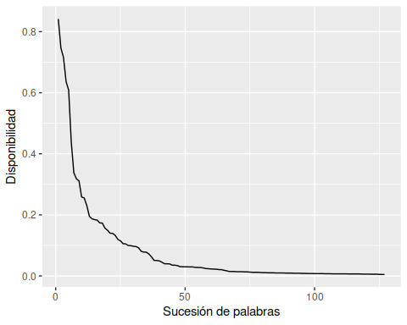

pag 17

disponibilidad <- build.avilasanchez.availability(data)

disponibilidad %>%  
 filter(centers=="03") %>%  
 arrange(-availability) %>%  
 head(10) %>%  
 flextable() %>%  
 set_header_labels(centers = "Centro de interés",  
 words = "Palabra",  
 order = "Orden",  
 availability = "Disponibilidad",  
 freq.abs = "Frecuencia absoluta",  
 freq.abs.cum = "Frecuencia absoluta acumulada",  
 freq.rel = "Frecuencia relativa",  
 freq.rel.cum = "Frecuencia relativa acumulada") %>%  
 colformat_double(j=c(4,6,8), digits=6) %>%  
 width(j=c(1,3,5,7), width=.65) %>%  
 width(j=c(2,4,6,8), width=.9) %>%  
 theme_booktabs()

| Centro de interés | Palabra | Orden | Disponibilidad | Frecuencia absoluta | Frecuencia relativa | Frecuencia absoluta acumulada | Frecuencia relativa acumulada |
| --- | --- | --- | --- | --- | --- | --- | --- |
| 03 | cocina | 1 | 1.000000 | 69 | 0.066925 | 69 | 0.066925 |
| 03 | salón | 2 | 1.000000 | 58 | 0.056256 | 127 | 0.123181 |
| 03 | (cuarto de) baño | 3 | 1.000000 | 66 | 0.064016 | 193 | 0.187197 |
| 03 | dormitorio | 4 | 1.000000 | 55 | 0.053346 | 248 | 0.240543 |
| 03 | comedor | 5 | 0.999928 | 39 | 0.037827 | 287 | 0.278371 |
| 03 | terraza | 6 | 0.999900 | 62 | 0.060136 | 349 | 0.338506 |
| 03 | salita | 7 | 0.997438 | 31 | 0.030068 | 380 | 0.368574 |
| 03 | entrada | 8 | 0.996197 | 23 | 0.022308 | 403 | 0.390883 |
| 03 | (cuarto de) aseo | 9 | 0.994715 | 24 | 0.023278 | 427 | 0.414161 |
| 03 | pasillo | 10 | 0.988474 | 34 | 0.032978 | 461 | 0.447139 |

pag 18

disponibilidad %>%  
 filter(centers=="03") %>%  
 arrange(-availability) %>%  
 ggplot(aes(x=order, y=availability)) + geom_line() +  
 xlab("Sucesión de palabras") + ylab("Disponibilidad")

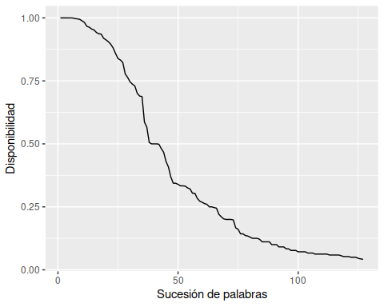

pag 19-20

disponibilidad <- build.avilasanchez.availability(data, k = 0.1)  
  
disponibilidad %>%  
 filter(centers == "03") %>%  
 arrange(-availability) %>%  
 ggplot(aes(x=order, y=availability)) + geom_line() +  
 xlab("Sucesión de palabras") + ylab("Disponibilidad")

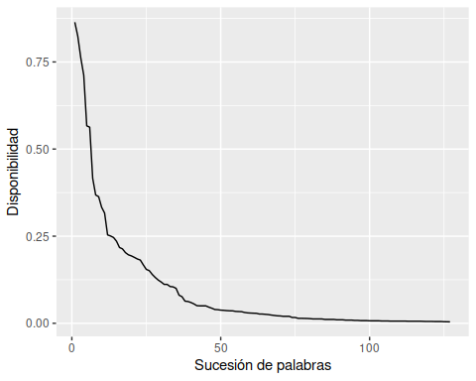

disponibilidad <- build.avilasanchez.availability(data, k = 2)  
  
disponibilidad %>%  
 filter(centers=="03") %>%  
 arrange(-availability) %>%  
 ggplot(aes(x=seq_along(availability), y=availability)) + geom_line() +  
 xlab("Sucesión de palabras") + ylab("Disponibilidad")

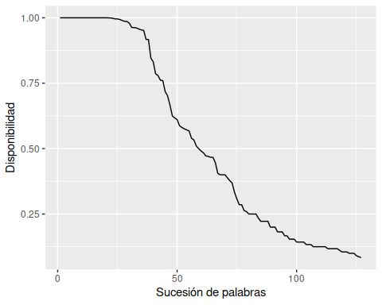

pag 21

disponibilidad <- build.avilasanchez.availability(data)  
levels <- classify.availability.levels(disponibilidad)  
levels %>%  
 head(20) %>%  
 arrange(-availability) %>%  
 select(-order) %>%  
 flextable() %>%  
 set_header_labels(centers = "Centro de interés",  
 words = "Palabra",  
 availability = "Disponibilidad",  
 level = "Nivel de disponibilidad",  
 cutlevel = "Nivel de corte",  
 freq.abs = "Frecuencia absoluta",  
 freq.abs.cum = "Frecuencia absoluta acumulada",  
 freq.rel = "Frecuencia relativa",  
 freq.rel.cum = "Frecuencia relativa acumulada") %>%  
 colformat_double(j=c(5,7,9), digits=5) %>%  
 width(j=c(1,4,6,8), width=.65) %>%  
 width(j=c(2,3,5,6,7,9), width=.75) %>%  
 theme_booktabs()

| Centro de interés | Palabra | Disponibilidad | Nivel de disponibilidad | Nivel de corte | Frecuencia absoluta | Frecuencia relativa | Frecuencia absoluta acumulada | Frecuencia relativa acumulada |
| --- | --- | --- | --- | --- | --- | --- | --- | --- |
| 14 | perro | 1 | 6 | 0.94971 | 67 | 0.04206 | 67 | 0.04206 |
| 12 | coche | 1 | 6 | 0.95891 | 65 | 0.05717 | 65 | 0.05717 |
| 19 | rojo | 1 | 6 | 0.96142 | 66 | 0.05255 | 66 | 0.05255 |
| 03 | cocina | 1 | 6 | 0.96381 | 69 | 0.06693 | 69 | 0.06693 |
| 19 | azul | 1 | 6 | 0.96142 | 68 | 0.05414 | 134 | 0.10669 |
| 14 | gato | 1 | 6 | 0.94971 | 64 | 0.04018 | 131 | 0.08223 |
| 04 | mesa | 1 | 6 | 0.95622 | 54 | 0.05182 | 54 | 0.05182 |
| 03 | salón | 1 | 6 | 0.96381 | 58 | 0.05626 | 127 | 0.12318 |
| 17 | euro | 1 | 6 | 0.94392 | 45 | 0.04014 | 45 | 0.04014 |
| 09 | aire acondicionado | 1 | 6 | 0.95832 | 58 | 0.07827 | 58 | 0.07827 |
| 06 | tenedor | 1 | 6 | 0.95511 | 59 | 0.05530 | 59 | 0.05530 |
| 11 | árbol | 1 | 6 | 0.93846 | 51 | 0.04048 | 51 | 0.04048 |
| 08 | pizarra | 1 | 6 | 0.95052 | 62 | 0.04769 | 62 | 0.04769 |
| 10 | calle | 1 | 6 | 0.95278 | 51 | 0.03783 | 51 | 0.03783 |
| 20 | ola | 1 | 6 | 0.94369 | 46 | 0.03430 | 46 | 0.03430 |
| 04 | silla | 1 | 6 | 0.95622 | 63 | 0.06046 | 117 | 0.11228 |
| 09 | ventilador | 1 | 6 | 0.95832 | 60 | 0.08097 | 118 | 0.15924 |
| 02 | pantalón | 1 | 6 | 0.95766 | 62 | 0.04829 | 62 | 0.04829 |
| 08 | mesa | 1 | 6 | 0.95052 | 46 | 0.03538 | 108 | 0.08308 |
| 01 | cabeza | 1 | 6 | 0.95760 | 37 | 0.02386 | 37 | 0.02386 |

pag 22

levels %>%  
 filter(centers=="01") %>%  
 arrange(-availability) %>%  
 filter(level > 0) %>%  
 select(-order) %>%  
 flextable() %>%  
 set_header_labels(centers = "Centro de interés",  
 words = "Palabra",  
 availability = "Disponibilidad",  
 level = "Nivel de disponibilidad",  
 cutlevel = "Nivel de corte",  
 freq.abs = "Frecuencia absoluta",  
 freq.abs.cum = "Frecuencia absoluta acumulada",  
 freq.rel = "Frecuencia relativa",  
 freq.rel.cum = "Frecuencia relativa acumulada") %>%  
 colformat_double(j=c(3,5,7,9), digits=5) %>%  
 width(j=c(1,4,6,8), width=.65) %>%  
 width(j=c(2,3,5,6,7,9), width=.75) %>%  
 theme_booktabs()

| Centro de interés | Palabra | Disponibilidad | Nivel de disponibilidad | Nivel de corte | Frecuencia absoluta | Frecuencia relativa | Frecuencia absoluta acumulada | Frecuencia relativa acumulada |
| --- | --- | --- | --- | --- | --- | --- | --- | --- |
| 01 | cabeza | 1.00000 | 6 | 0.95760 | 37 | 0.02386 | 37 | 0.02386 |
| 01 | brazo | 1.00000 | 6 | 0.95760 | 50 | 0.03224 | 87 | 0.05609 |
| 01 | ojo | 1.00000 | 6 | 0.95760 | 58 | 0.03740 | 145 | 0.09349 |
| 01 | mano | 1.00000 | 6 | 0.95760 | 42 | 0.02708 | 187 | 0.12057 |
| 01 | pierna | 0.99997 | 6 | 0.95760 | 49 | 0.03159 | 236 | 0.15216 |
| 01 | pie | 0.99992 | 6 | 0.95760 | 43 | 0.02772 | 279 | 0.17988 |
| 01 | corazón | 0.99937 | 6 | 0.95760 | 44 | 0.02837 | 323 | 0.20825 |
| 01 | dedo | 0.99810 | 6 | 0.95760 | 44 | 0.02837 | 367 | 0.23662 |
| 01 | nariz | 0.99786 | 6 | 0.95760 | 43 | 0.02772 | 410 | 0.26435 |
| 01 | boca | 0.99490 | 6 | 0.95760 | 33 | 0.02128 | 443 | 0.28562 |
| 01 | pelo | 0.99239 | 6 | 0.95760 | 27 | 0.01741 | 470 | 0.30303 |
| 01 | oreja | 0.98634 | 6 | 0.95760 | 29 | 0.01870 | 499 | 0.32173 |
| 01 | hueso | 0.97596 | 6 | 0.95760 | 21 | 0.01354 | 520 | 0.33527 |
| 01 | hígado | 0.97017 | 6 | 0.95760 | 29 | 0.01870 | 549 | 0.35397 |
| 01 | músculo | 0.96741 | 6 | 0.95760 | 19 | 0.01225 | 568 | 0.36622 |
| 01 | tronco | 0.96647 | 6 | 0.95760 | 10 | 0.00645 | 578 | 0.37266 |
| 01 | uña | 0.96456 | 6 | 0.95760 | 36 | 0.02321 | 614 | 0.39587 |
| 01 | pulmón | 0.92715 | 5 | 0.91971 | 31 | 0.01999 | 645 | 0.41586 |
| 01 | riñón | 0.91971 | 5 | 0.91971 | 23 | 0.01483 | 668 | 0.43069 |
| 01 | estómago | 0.91195 | 4 | 0.85694 | 25 | 0.01612 | 693 | 0.44681 |
| 01 | extremidad | 0.88274 | 4 | 0.85694 | 8 | 0.00516 | 701 | 0.45197 |
| 01 | ceja | 0.86702 | 4 | 0.85694 | 18 | 0.01161 | 719 | 0.46357 |
| 01 | oído | 0.85913 | 4 | 0.85694 | 13 | 0.00838 | 732 | 0.47195 |
| 01 | órgano | 0.85694 | 4 | 0.85694 | 7 | 0.00451 | 739 | 0.47647 |
| 01 | cara | 0.84609 | 3 | 0.76528 | 10 | 0.00645 | 749 | 0.48291 |
| 01 | cerebro | 0.84392 | 3 | 0.76528 | 12 | 0.00774 | 761 | 0.49065 |
| 01 | codo | 0.81224 | 3 | 0.76528 | 18 | 0.01161 | 779 | 0.50226 |
| 01 | páncreas | 0.78089 | 3 | 0.76528 | 18 | 0.01161 | 797 | 0.51386 |
| 01 | rodilla | 0.77772 | 3 | 0.76528 | 22 | 0.01418 | 819 | 0.52805 |
| 01 | diente | 0.77321 | 3 | 0.76528 | 18 | 0.01161 | 837 | 0.53965 |
| 01 | sangre | 0.76715 | 3 | 0.76528 | 16 | 0.01032 | 853 | 0.54997 |
| 01 | hombro | 0.76653 | 3 | 0.76528 | 14 | 0.00903 | 867 | 0.55899 |
| 01 | cuello | 0.73645 | 2 | 0.61961 | 16 | 0.01032 | 883 | 0.56931 |
| 01 | esqueleto | 0.70370 | 2 | 0.61961 | 4 | 0.00258 | 887 | 0.57189 |
| 01 | pestaña | 0.69882 | 2 | 0.61961 | 13 | 0.00838 | 900 | 0.58027 |
| 01 | cintura | 0.69805 | 2 | 0.61961 | 9 | 0.00580 | 909 | 0.58607 |
| 01 | tibia | 0.69390 | 2 | 0.61961 | 10 | 0.00645 | 919 | 0.59252 |
| 01 | antebrazo | 0.68921 | 2 | 0.61961 | 11 | 0.00709 | 930 | 0.59961 |
| 01 | lengua | 0.67137 | 2 | 0.61961 | 12 | 0.00774 | 942 | 0.60735 |
| 01 | tobillo | 0.66121 | 2 | 0.61961 | 15 | 0.00967 | 957 | 0.61702 |
| 01 | vello | 0.61961 | 2 | 0.61961 | 6 | 0.00387 | 963 | 0.62089 |
| 01 | vena | 0.61347 | 1 | 0.46263 | 11 | 0.00709 | 974 | 0.62798 |
| 01 | enfermedad | 0.60225 | 1 | 0.46263 | 5 | 0.00322 | 979 | 0.63121 |
| 01 | espalda | 0.59569 | 1 | 0.46263 | 12 | 0.00774 | 991 | 0.63894 |
| 01 | pecho | 0.59098 | 1 | 0.46263 | 12 | 0.00774 | 1,003 | 0.64668 |
| 01 | labio | 0.59024 | 1 | 0.46263 | 10 | 0.00645 | 1,013 | 0.65313 |
| 01 | garganta | 0.56908 | 1 | 0.46263 | 7 | 0.00451 | 1,020 | 0.65764 |
| 01 | peroné | 0.56348 | 1 | 0.46263 | 9 | 0.00580 | 1,029 | 0.66344 |
| 01 | muñeca | 0.56318 | 1 | 0.46263 | 11 | 0.00709 | 1,040 | 0.67054 |
| 01 | bazo | 0.54471 | 1 | 0.46263 | 11 | 0.00709 | 1,051 | 0.67763 |
| 01 | esófago | 0.54466 | 1 | 0.46263 | 11 | 0.00709 | 1,062 | 0.68472 |
| 01 | culo | 0.53444 | 1 | 0.46263 | 7 | 0.00451 | 1,069 | 0.68923 |
| 01 | fémur | 0.52785 | 1 | 0.46263 | 12 | 0.00774 | 1,081 | 0.69697 |
| 01 | torso | 0.51124 | 1 | 0.46263 | 4 | 0.00258 | 1,085 | 0.69955 |
| 01 | salud | 0.50403 | 1 | 0.46263 | 4 | 0.00258 | 1,089 | 0.70213 |
| 01 | barriga | 0.50263 | 1 | 0.46263 | 4 | 0.00258 | 1,093 | 0.70471 |
| 01 | cadera | 0.48391 | 1 | 0.46263 | 9 | 0.00580 | 1,102 | 0.71051 |
| 01 | falange | 0.46904 | 1 | 0.46263 | 10 | 0.00645 | 1,112 | 0.71696 |
| 01 | piel | 0.46263 | 1 | 0.46263 | 11 | 0.00709 | 1,123 | 0.72405 |

pag 23

levels %>%  
 filter(centers=="04") %>%  
 mutate(level=factor(level)) %>%  
 arrange(-availability) %>%  
 ggplot(aes(x=order, y=availability, color=level)) + geom_line() +  
 xlab("Posición del término en el centro de interés") +  
 ylab("Disponibilidad") +  
 theme_bw() + scale_colour_grey()

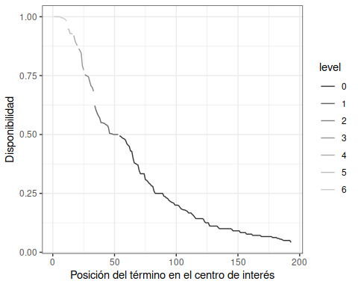

pag 24 (la columna de Recuento, no sé porqué, está entera en 1. Estos son los resultados correctos)

clasificacion <- build.availability.levels(levels)  
clasificacion %>%  
 filter(level> 0) %>% filter(centers %in% c("01","02","03","04")) %>%  
 flextable() %>%  
 set_header_labels(centers = "Centro de interés",  
 words = "Palabras",  
 level = "Nivel de disponibilidad",  
 count = "Recuento") %>%  
 width(j=c(1,2,3), width=.75) %>%  
 width(j=4, width=4) %>%  
 align(i=4, align="right") %>%  
 theme_booktabs()

| Centro de interés | Nivel de disponibilidad | Recuento | Palabras |
| --- | --- | --- | --- |
| 01 | 6 | 17 | cabeza, brazo, ojo, mano, pierna, pie, corazón, dedo, nariz, boca, pelo, oreja, hueso, hígado, músculo, tronco, uña |
| 01 | 5 | 2 | pulmón, riñón |
| 01 | 4 | 5 | estómago, extremidad, ceja, oído, órgano |
| 01 | 3 | 8 | cara, cerebro, codo, páncreas, rodilla, diente, sangre, hombro |
| 01 | 2 | 9 | cuello, esqueleto, pestaña, cintura, tibia, antebrazo, lengua, tobillo, vello |
| 01 | 1 | 18 | vena, enfermedad, espalda, pecho, labio, garganta, peroné, muñeca, bazo, esófago, culo, fémur, torso, salud, barriga, cadera, falange, piel |
| 02 | 6 | 16 | pantalón, camisa, falda, camiseta, calcetín, jersey, vestido, zapato, abrigo, chaqueta, blusa, braga, calzoncillo, sujetador, bufanda, corbata |
| 02 | 5 | 1 | (pantalón) vaquero |
| 02 | 4 | 5 | moda, tejido, media, sombrero, bañador |
| 02 | 3 | 7 | zapatilla, chándal, traje, camisón, anorak, bermudas, tanga |
| 02 | 2 | 10 | cinturón, biquini, rebeca, gorro, color, pijama, bolso, guante, necesario, chaleco |
| 02 | 1 | 18 | estilo, vestir, chaquetón, pañuelo, felpa, rebajas, diseño, comodidad, gabardina, botón, lana, (pantalón) pirata, falda vaquera, vestimenta, bota, sudadera, slip, algodón |
| 03 | 6 | 12 | cocina, salón, (cuarto de) baño, dormitorio, comedor, terraza, salita, entrada, (cuarto de) aseo, pasillo, lavadero, ventana |
| 03 | 5 | 4 | hall, recibidor, (cuarto) trastero, habitación |
| 03 | 4 | 6 | tejado, jardín, techo, escalera, sala de estar, vestidor |
| 03 | 3 | 5 | patio, garaje, pared, porche, balcón |
| 03 | 2 | 5 | despensa, buhardilla, sótano, suelo, vestíbulo |
| 03 | 1 | 5 | chimenea, puerta, despacho, azotea, estudio |
| 04 | 6 | 11 | mesa, silla, cama, sofá, sillón, armario, mesita de noche, aparador, cómoda, estantería, lámpara |
| 04 | 5 | 5 | ropero, mesa de comedor, espejo, vitrina, encimera |
| 04 | 4 | 4 | cuadro, lavadora, librería, frigorífico |
| 04 | 3 | 5 | tresillo, mueble de cocina, mueble-bar, lavavajillas, zapatero |
| 04 | 2 | 8 | butaca, tele(visión), mesilla de noche, escritorio, repisa, taquillón, tocador, cajonera |
| 04 | 1 | 20 | sinfonier, hornilla, lámpara de techo, mueble de salón, alacena, mesa camilla, cama de matrimonio, mesa de tele(visión), taburete, comodín, mecedora, televisor, mesa de salón, ordenador, cortina, armario de niños, barbacoa, cenefa, mueble de entrada, rinconero |

pag 25

levels %>%  
 mutate(level = factor(level)) %>%  
 filter(centers %in% c("01","02","03","04")) %>%  
 arrange(-availability) %>%  
 ggplot(aes(x=order, y=availability, color=level)) + geom_line() + facet_wrap(~centers) +  
 xlab("Secuencia de palabras (por grado descendente de compatibilidad)") +  
 ylab("Disponibilidad") +  
 theme_bw() + scale_colour_grey()

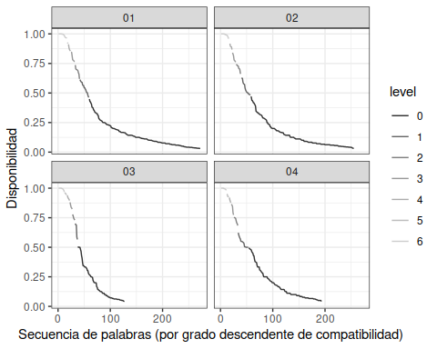

pag 26

library(dispocen)  
dispocen::runUtility()

pag 27

bs <- read.csv("BaseSociologica.csv", colClasses = "character")  
bs <- bs %>%  
 mutate(EDAD = strtoi(EDAD),  
 AÑOSDEESTUDIO = strtoi(AÑOSDEESTUDIO)) %>%  
 rename(GENERO = SEXO)  
bs %>%  
 head() %>%  
 select(SUJETO, GENERO, EDAD, AÑOSDEESTUDIO) %>%  
 flextable() %>%  
 autofit()

| SUJETO | GENERO | EDAD | AÑOSDEESTUDIO |
| --- | --- | --- | --- |
| 001 | 1 | 69 | 4 |
| 002 | 0 | 71 | 4 |
| 003 | 0 | 20 | 12 |
| 004 | 1 | 24 | 17 |
| 005 | 0 | 24 | 17 |
| 006 | 1 | 26 | 15 |

pag 28

idHombres <- bs %>%  
 filter(GENERO == "1") %>%  
 select(SUJETO) %>%  
 unlist()  
idHombres

## SUJETO1 SUJETO2 SUJETO3 SUJETO4 SUJETO5 SUJETO6 SUJETO7 SUJETO8   
## "001" "004" "006" "010" "012" "014" "015" "022"   
## SUJETO9 SUJETO10 SUJETO11 SUJETO12 SUJETO13 SUJETO14 SUJETO15 SUJETO16   
## "026" "029" "032" "035" "036" "039" "041" "043"   
## SUJETO17 SUJETO18 SUJETO19 SUJETO20 SUJETO21 SUJETO22 SUJETO23 SUJETO24   
## "046" "049" "050" "051" "052" "053" "055" "058"   
## SUJETO25 SUJETO26 SUJETO27 SUJETO28 SUJETO29 SUJETO30 SUJETO31 SUJETO32   
## "061" "064" "065" "070" "073" "075" "076" "097"   
## SUJETO33 SUJETO34   
## "098" "099"

idMujeres <- bs %>%  
 filter(GENERO == "0") %>%  
 select(SUJETO) %>%  
 unlist()  
idMujeres

## SUJETO1 SUJETO2 SUJETO3 SUJETO4 SUJETO5 SUJETO6 SUJETO7 SUJETO8   
## "002" "003" "005" "008" "009" "013" "019" "021"   
## SUJETO9 SUJETO10 SUJETO11 SUJETO12 SUJETO13 SUJETO14 SUJETO15 SUJETO16   
## "023" "024" "025" "027" "028" "030" "031" "033"   
## SUJETO17 SUJETO18 SUJETO19 SUJETO20 SUJETO21 SUJETO22 SUJETO23 SUJETO24   
## "034" "037" "038" "040" "042" "045" "047" "048"   
## SUJETO25 SUJETO26 SUJETO27 SUJETO28 SUJETO29 SUJETO30 SUJETO31 SUJETO32   
## "056" "059" "060" "062" "063" "066" "067" "068"   
## SUJETO33 SUJETO34 SUJETO35 SUJETO36 SUJETO37 SUJETO38   
## "069" "071" "072" "074" "077" "096"

data %>%  
 filter(users %in% idMujeres) %>%  
 head()

## infos users centers words  
## 1 12131 002 01 riñón, c....  
## 2 12213 003 01 brazo, m....  
## 3 12214 005 01 cabeza, ....  
## 4 11232 008 01 cabeza, ....  
## 5 11221 009 01 músculo,....  
## 6 12224 013 01 cabeza, ....

pag 29

data %>%  
 filter(users %in% idHombres) %>%  
 head()

## infos users centers words  
## 1 21131 001 01 mano, pi....  
## 2 22214 004 01 brazo, o....  
## 3 22213 006 01 pie, man....  
## 4 22224 010 01 esquelet....  
## 5 22224 012 01 cabeza, ....  
## 6 22212 014 01 mano, pi....

disponibilidadHombres <-   
 build.avilasanchez.availability(data %>%  
 filter(users %in% idHombres))  
  
head(disponibilidadHombres) %>%  
 select(centers, words, availability) %>%  
 flextable() %>%  
 autofit()

| centers | words | availability |
| --- | --- | --- |
| 01 | cabeza | 0.9999756 |
| 01 | mano | 0.9987419 |
| 01 | brazo | 0.9984684 |
| 01 | ojo | 0.9978411 |
| 01 | pierna | 0.9907053 |
| 01 | pie | 0.9894805 |

disponibilidadMujeres <-   
 build.avilasanchez.availability(data %>%  
 filter(users %in% idMujeres))  
  
head(disponibilidadMujeres) %>%  
 select(centers, words, availability) %>%  
 flextable() %>%  
 autofit()

| centers | words | availability |
| --- | --- | --- |
| 01 | brazo | 0.9999198 |
| 01 | ojo | 0.9998306 |
| 01 | cabeza | 0.9986111 |
| 01 | mano | 0.9970720 |
| 01 | pierna | 0.9963897 |
| 01 | pie | 0.9926613 |

pag 30

dispComp <-  
 inner_join(disponibilidadHombres %>%  
 select(centers, words, availability) %>%  
 rename(avHombres = availability),  
 disponibilidadMujeres %>%  
 select(centers, words, availability) %>%  
 rename(avMujeres = availability),  
 by = c("centers", "words"))  
dispComp %>%  
 head() %>%  
 flextable() %>%  
 autofit()

| centers | words | avHombres | avMujeres |
| --- | --- | --- | --- |
| 01 | cabeza | 0.9999756 | 0.9986111 |
| 01 | mano | 0.9987419 | 0.9970720 |
| 01 | brazo | 0.9984684 | 0.9999198 |
| 01 | ojo | 0.9978411 | 0.9998306 |
| 01 | pierna | 0.9907053 | 0.9963897 |
| 01 | pie | 0.9894805 | 0.9926613 |

pag 31

dispComp %>%  
 ggplot(aes(x=avHombres, y=avMujeres, color=centers)) + geom_point() +  
 theme_bw() + scale_colour_grey()

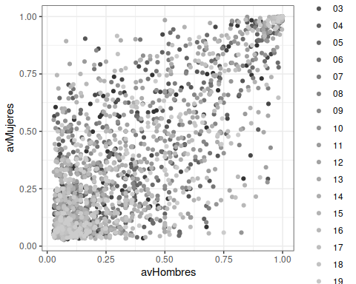

pag 31-32

levelsHombres <-   
 classify.availability.levels(disponibilidadHombres)  
clasificacionHombres <- build.availability.levels(levelsHombres)  
  
levelsMujeres <-   
 classify.availability.levels(disponibilidadMujeres)  
clasificacionMujeres <- build.availability.levels(levelsMujeres)  
  
clasificacionGenero <-  
 inner_join(clasificacionHombres %>%  
 select(centers, level, words) %>%  
 rename(wordsHombres = words),  
 clasificacionMujeres %>%   
 select(centers, level, words) %>%  
 rename(wordsMujeres = words),   
 by=c("centers","level"))   
   
clasificacionGenero %>%  
 filter(level> 0) %>%  
 filter(centers %in% c("01", "02", "03", "04")) %>%  
 flextable() %>%   
 set_header_labels(centers = "Centro de interés",   
 wordsHombres = "Palabras hombres",   
 wordsMujeres = "Palabras mujeres",   
 level = "Nivel de disponibilidad",  
 count = "Recuento") %>%  
 width(j=c(1,2), width=.75) %>%  
 width(j=c(3,4), width=2.5) %>%  
 align(j=c(3,4), align="right") %>%  
 theme_booktabs()

| Centro de interés | Nivel de disponibilidad | Palabras hombres | Palabras mujeres |
| --- | --- | --- | --- |
| 01 | 6 | cabeza, mano, brazo, ojo, pierna, pie, corazón | brazo, ojo, cabeza, mano, pierna, pie, nariz, dedo, corazón, pelo, boca |
| 01 | 5 | hueso |  |
| 01 | 4 | dedo, oreja, boca, tronco, nariz | uña, oreja, hígado |
| 01 | 3 | músculo, extremidad, pelo, hígado | músculo, pulmón, riñón, oído, tronco |
| 01 | 2 | estómago, pulmón, riñón, cerebro, esqueleto, uña, órgano | codo, hueso, ceja, estómago, hombro, rodilla, cara, cuello, antebrazo, vello |
| 01 | 1 | tibia, sangre, ceja, cara, vena, pestaña, peroné, páncreas, diente, oído, barriga | páncreas, diente, lengua, órgano, cintura, tobillo, enfermedad, cerebro, espalda, labio, sangre |
| 02 | 6 | pantalón, falda, camisa, vestido, camiseta, jersey, calcetín, blusa | camisa, pantalón, camiseta, calcetín, falda, zapato, jersey, chaqueta, calzoncillo |
| 02 | 5 | abrigo, sujetador, braga | vestido, abrigo, corbata |
| 02 | 4 | zapato, moda | sombrero |
| 02 | 3 | chaqueta, tejido, bufanda | bufanda, blusa, braga, bañador |
| 02 | 2 | (pantalón) vaquero, media, calzoncillo, estilo, bolso, bermudas | (pantalón) vaquero, traje, zapatilla, chándal, gorro, rebeca, vestir |
| 02 | 1 | pijama, biquini, camisón, zapatilla, comodidad, falda vaquera, vestimenta, corbata, chándal, diseño, (pantalón) pirata, chaleco, chaquetón | anorak, sujetador, media, tanga, cinturón, guante, felpa, tejido, color, camisón, rebajas, necesario |
| 03 | 6 | cocina, salón, (cuarto de) baño, dormitorio, terraza, comedor, salita | cocina, salón, dormitorio, (cuarto de) baño, comedor, terraza, entrada |
| 03 | 5 | recibidor | (cuarto de) aseo, salita |
| 03 | 4 | pasillo, (cuarto de) aseo | techo, pasillo, hall |
| 03 | 3 | lavadero, entrada, (cuarto) trastero, jardín | lavadero, ventana, tejado |
| 03 | 2 | ventana, sala de estar, habitación, porche, vestidor, despensa | pared, habitación, escalera, (cuarto) trastero, garaje, vestíbulo, patio |
| 03 | 1 | hall, escalera, patio, despacho, tejado | balcón, chimenea, suelo, vestidor, jardín, sala de estar, sótano |
| 04 | 6 | mesa, cama, silla, sofá, sillón, armario | silla, mesa, sofá, sillón, cama, aparador, armario, mesita de noche |
| 04 | 5 |  | cómoda |
| 04 | 4 | estantería, ropero, cómoda, lámpara, mesita de noche | estantería |
| 04 | 3 | aparador, lavadora, frigorífico | cuadro, lámpara, encimera, mesa de comedor, librería, espejo |
| 04 | 2 | vitrina, mesa de comedor, taquillón, zapatero, espejo, mueble de cocina, mesilla de noche | tresillo, vitrina, mueble-bar, cajonera, butaca |
| 04 | 1 | encimera, lámpara de techo, escritorio, tocador, mueble-bar, tele(visión), alacena, armario de niños, barbacoa, mueble de entrada, lavavajillas, cuadro, repisa | mueble de cocina, lavavajillas, lavadora, televisor, ropero, mecedora, cama de matrimonio, cenefa, comodín, rinconero, tele(visión) |

pag 34

levelsGenero <-  
 inner_join(levelsHombres %>%  
 select(centers, level, words, availability) %>%  
 rename(avHombre = availability, levelHombre=level),  
 levelsMujeres %>%   
 select(centers, level, words, availability) %>%  
 rename(avMujer = availability, levelMujer = level),   
 by=c("centers", "words"))   
levelsGenero %>%  
 filter(levelHombre != levelMujer) %>%  
 mutate(diffLevel = factor(abs(levelHombre - levelMujer))) %>%  
 ggplot(aes(x=avHombre, y=avMujer, color=diffLevel)) + geom_point() +  
 theme_bw() + scale_colour_grey()

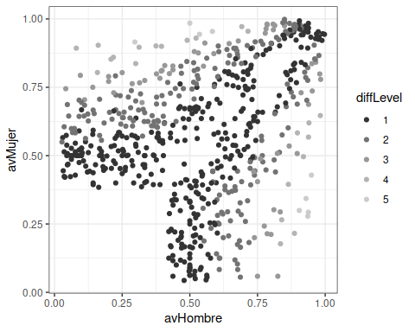

diffs <- tapply(levelsGenero$levelHombre == levelsGenero$levelMujer,  
 levelsGenero$centers, mean) * 100  
diffs

## 01 02 03 04 05 06 07 08   
## 71.66667 57.31707 60.00000 66.27907 66.20690 61.64384 71.42857 64.83516   
## 09 10 11 12 13 14 15 16   
## 66.66667 65.57377 71.42857 74.68354 65.15152 69.11765 64.95726 73.68421   
## 17 18 19 20   
## 71.30435 66.00000 73.77049 67.17557

pag 35

summary(diffs)

## Min. 1st Qu. Median Mean 3rd Qu. Max.   
## 57.32 65.10 66.47 67.44 71.43 74.68