The Final Project: Overview
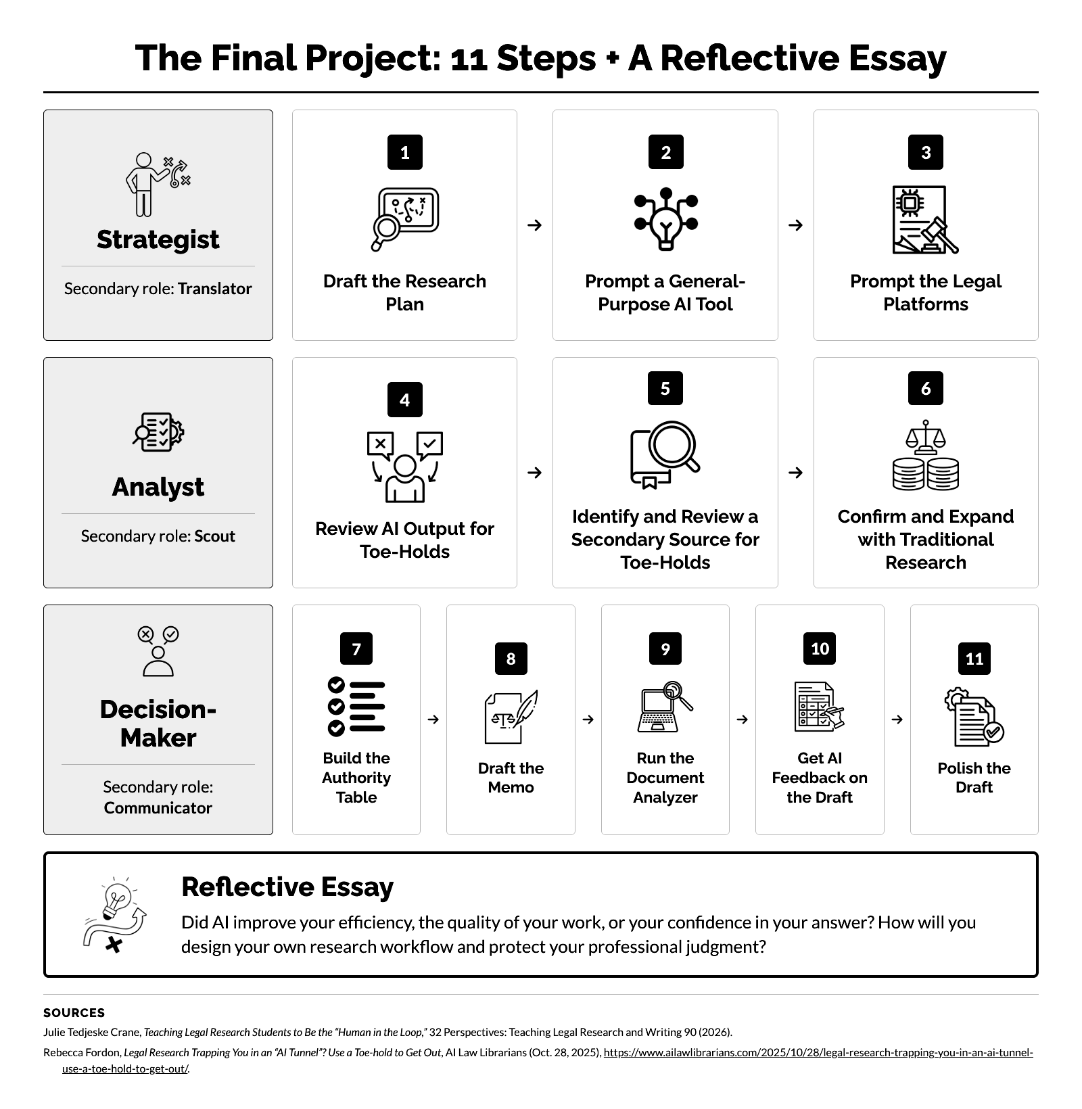
The Final Project: What to Submit, Grading, and Research Skills
What to Submit
Text box | File upload | Text box or file upload
- Steps 1 to 3: Research plan and record of prompts  - Steps 4 and 5: Toe-hold reviews, secondary source review, and comparison essay  - Steps 9 and 10: Feedback reflection  - Whole project: Reflective essay (Overall Reflection) | - Steps 2 and 3: Full AI outputs  - Step 7: Authority table  - Step 8: Objective memo (upload it after you finish Step 11)  - Steps 9 and 10: Analyzer report and AI feedback | - Step 6: Research log or essay

Grade  45% of your course grade. Grading is curved to align with the law school’s grading norms.  Due: [date], [time].  Bluebook and Citations  Bluebook form is graded only in your Step 8 memo. Elsewhere, Bluebook form is appropriate but not required.  Use Bluebook citations but don’t focus on details. I grade a citation only when its error affects the substance of your work, for example, when it names the wrong court, hides that a proposition comes from a dissent, or omits a pinpoint citation.  Every citation must lead the reader to the exact place that supports your proposition. Give a pinpoint citation (page or paragraph) for every case, and cite the exact subsection of every statute, court rule, or regulation.  Your Name  Do not put your name anywhere in your submissions or in any file name. Some platforms print your name on their AI reports, and that is fine. You may redact your name from a report, but do not change anything else in it. | What Is a Toe-Hold Review?  A toe-hold review is your first read of an AI output, or of a secondary source in Step 5, before you verify anything. The goal is to strip the output down to the most important leads for further research.  Each review has four parts  - Conclusion. The output’s conclusion, in one to three sentences.  - Statutes, Court Rules, Constitutional Provisions, and Regulations. Anything that looks relevant.  - Cases. No more than five.  - Secondary Sources. No more than three that you might review. | Traditional Research Skills (Step 6)  One good case method  - Citators. Run a key case through KeyCite, Shepard’s, or BCite to identify cases or other resources that cite to your authority.  - Key Numbers. Use the West Key Number on a relevant headnote to find cases on the same point.  - Topics. Use a headnote’s topic, such as a Lexis topic, to find cases on the same point.  - Headnotes. Follow a relevant headnote to later cases that cite the case for that point.  - Table of Authorities. Review the authorities that a key case cites, to find earlier cases.  Statutes, regulations, court rules, and constitutional provisions  - Statutory text. Read the statutory text, look at the surrounding provisions and structure, and check for definitions.  - Citators. Run the provision through KeyCite, Shepard’s, or BCite to find the cases that cite or apply it.  - Notes of Decisions. Review the annotated case summaries that follow the provision.  Additional secondary sources  - Treatises and practice guides. Read a second treatise or practice guide, and follow its footnotes to primary authority.  - Law review articles. Find a recent article, and use its footnotes to find authorities.  - Legal encyclopedias. Read Am. Jur. 2d or C.J.S. for an overview and the leading cases.  - ALR annotations. Find an annotation; it collects cases from many jurisdictions on one narrow question.  Cutting-edge search  - Parallel Search (Westlaw). Find cases that discuss the same concept in different words.  - Ravel View (Lexis). See which cases cite one another and which are cited most often.  Basic search  - Terms and connectors. Run a Boolean search with precise terms.  - Natural language. Run a plain-language search to catch terms you did not think of.  Verify with a citator  - Good law. Run every authority that you rely on through KeyCite, Shepard’s, or BCite to confirm that it is still good law.

