1. Data architecture

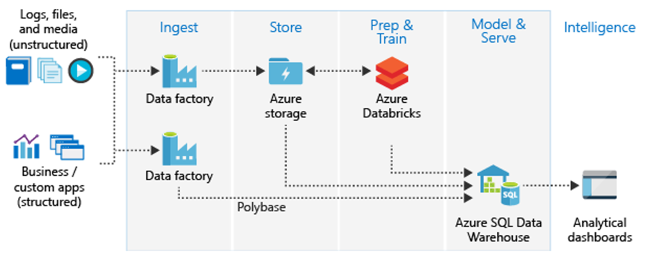

PBI

Overall architecture of that produces an excel file as one of the outputs for the Datawarehouse. The excel file is produced from the published PBI report.

2. Excel Template

Sample Monthly report template Diagram.

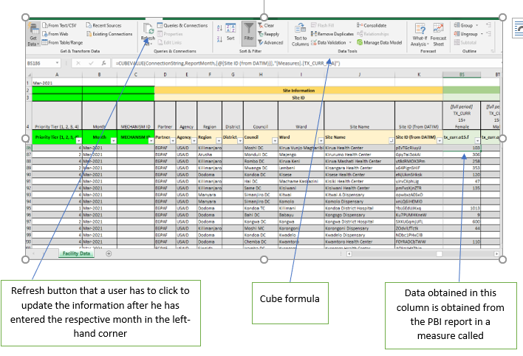

Data Model of the PBI Report that is used to generate the excel file above

