**GBV Brief Description**

**User Requirement(s):**

* Show GBV cases per each UBA region, council up to the facility level.
* Show GBV cases by Age group and sex

**STEPS TAKEN TO MAKE THE DASHBOARD**

**Step 1**: Load the UBA master site list. Found in SharePoint at: <https://pedaidsorg.sharepoint.com/sites/tanzania_sie> .

This file is used to link to the facility lists and brings in other sites characteristics to the data model i.e. site type etc.

**Step 2:** Load pivot from EGPAF data warehouse – this is data that is manually collected.

The Pivot name and link is as shown below; 

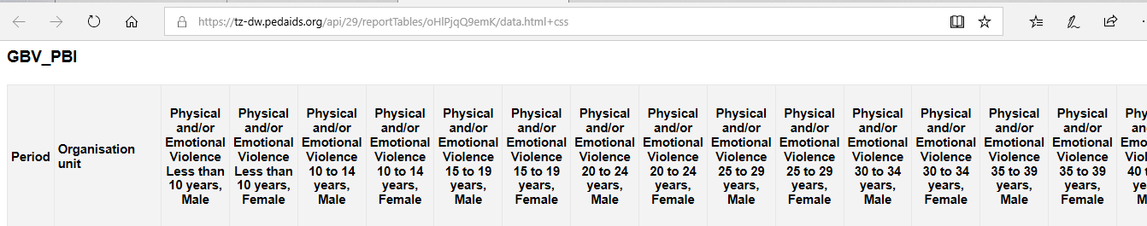

Note: This Pivot does not display the total number of clients receiving PEP as it is disaggregated by age and sex while the PEP dataset has no sex nor age.

**Step 3:** Load another separate pivot which only contains PEP data and no age nor sex disaggregates. The pivot name & link is shown below;

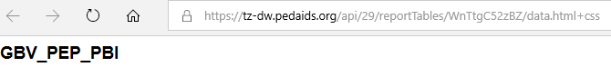

**Note:** This table will be joined later on after being loaded into PBI with the one with other GBV data to create needed visuals.

**Step 4***:* As per the dimensional modelling techniques Load other tables which will be used as lookup tables, which are table Period Lookup (for period information lookup) as well as table Indicator categories for setting up different categories.

***Note****: The new primary key had to be created by combining quarter and dhisID - called Unique ID since the UBA Master-site list has duplicates dhisID as it captures facility information/changes over time.*

**TABLE RELATIONSHIPS**

