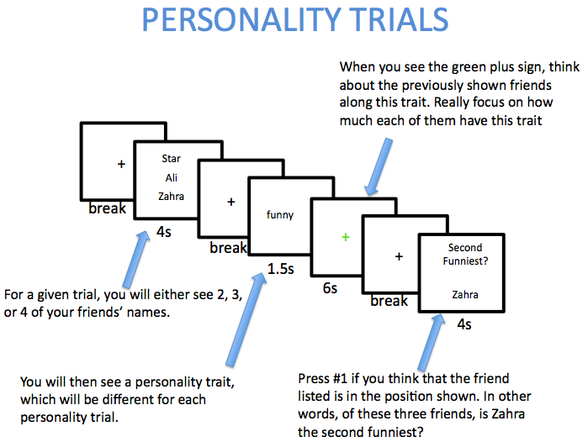

Above is a break-down of what a trial for the personality task looks like. There are a few important points to emphasize. First, you only have to think about the friends’ personality traits during the green plus sign. Other times, you will see black plus signs on the screen: those are just breaks. Second, we want you to think about the shown friends for each trial. Do not try to remember what rankings you put in your online questionnaire, just think about the friends shown on that trial in the moment, how much they demonstrate the given personality trait, and figure out whatever order you think they fall in along this trait dimension (i.e., from most funny to least funny). Third, you will complete several personality trials and then you will complete several alphabetize trials (we’ll cover those next). Before each chunk of personality or alphabetize trials, you’ll see an instruction cue that says ‘PERSONALITY’ or ‘ALPHABETIZE’, so you’ll know in advance what kind of trials you’ll be answering.

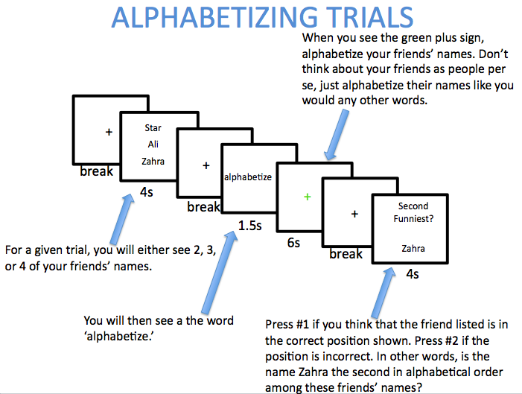

Above is a break-down of what a trial for the alphabetize task looks like. It is very similar to the personality trials. However, here you will alphabetize your friends’ names, rather than think about their personalities.