**Question: Has the removal of non-native fish created a trophic cascade in Bright Angel Creek?**

**Question:** Is there a difference in FFG densities/abundance for pre and post trout removal?

**Method/Figure:** *bar plot*. Use *ANOVA* to see if there is a significant difference or we could use a *paired t-test* to test for these differences.

**?:** Can we use ANOVA to see if there is a significant difference in densities…as the statistical analysis part? Would a paired t-test be better than ANOVA?

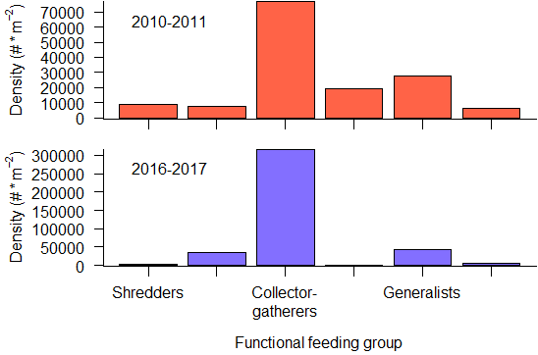

**NOTE:** Need to clean plot, make sure all FFG have labels and can be read clearly. Label Whiting’s graph (red) and our graph(blue).

**M/F:** Another way we could do this is by looking at FFG and looking at their general trends over the years. Combine our data with Whiting’s to see if the trends we see in pre and post are the same over all?

**Jeff’s thoughts**: We could definitely use ANOVA to test for FFG differences from one year to the next, and I think that’s probably a good strategy. However, an interesting point highlighted by these bar charts is also just how much ALL the densities have gone up in our study relative to Whiting’s. This could have something to do with us just being better at collecting bugs (and I definitely wouldn’t rule that out), or it could be another indicator of a trophic response. Something worth discussing in the paper definitely. But on the point about changes in FFGs, I think we’ll need to do ANOVA on relative densities, rather than the true densities. This will put the two datasets on the same scale. We might also think about a barplot showing the change in relative densities of each FFG, where a positive number indicates that the FFG increased in relative density in our study compared to Whiting, and a negative number indicates the opposite. In fact, a panel graph with the top panel showing that and the bottom panel showing the FFGs as just a change in average density could be really useful. We also need to add error bars and make sure your dataset is set up properly for ANOVA--I can help you through those parts.

**Q:** Does seasonality or any other environmental factors have an influence on this study?

**M/F:** *Ordination plot*- 2 plots one with our data and the season. Another with Whiting’s data and season.

**?:** Do you think 2 separate plots are best or do we combine them? Do we want to look at time of day as an environmental factor…predation rates might differ depending on time of day (some fish are more active during the day, others in the evening/same with invertebrates)?

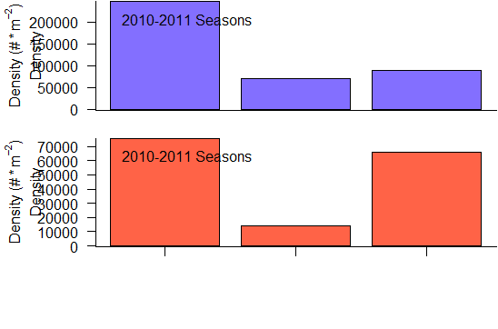

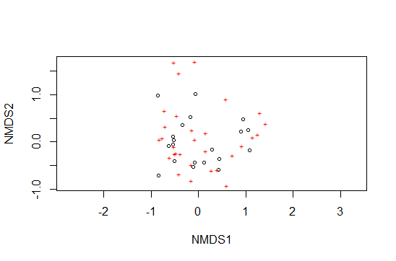

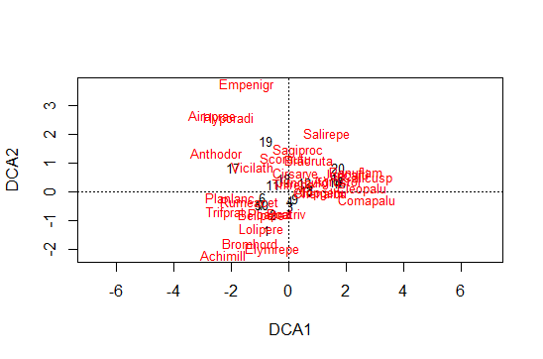

**Note:** The ordination plots were created after I ran the code for the seasonal barplot. I’m not sure if these ordination plots are accurate representations of how season has an affect on the species. The labels for the seasonal barplots are incorrect. One is Whiting and the other if GCMRC.

**Jeff’s thoughts**: Seasonality was something I suggested we look at just to see if there might be something interesting there. It doesn’t appear that there is, so I don’t think we’ll end up using that bar plot in the paper. Seasonality may also be important to include as a parameter in our model, which we haven’t built yet. I think the ordination may still end up being useful, although the current figure doesn’t look very promising. I’ll play around with that a bit in the near future and will share whatever I end up with.

**Q:** Do the species we label as predators and prey interact in the way we expect?

**M/F:** *Lotka-Volterra Model*. This would strengthen our trophic cascade argument. We could look at the interaction between trout and native fish as well as the interaction between native fish and their primary invertebrate prey.

**Q:** Is their a shift in each trophic class over the years?

*Other methods we may want to use:

* Shannon Diversity- Use this to show species diversity (evenness & abundance) with each trophic level.
* Generalized linear models- to see if some of the species densities have increased over the many years that they were implementing the removal.
* Jaccards Index of similarity- to look at how similar & different our sample sets are and also our sample sets compared to Whitting?

*Other methods I explored & don’t think we should use

* Predator-Prey body mass ratio (Emmerson & Raffaelli 2004). Wouldn’t work because we didn’t include measurements in our IDs.

**Jeff’s thoughts:** I’m not totally sure where you’re going with the Lotka-Volterra stuff. Convince me over the phone, I guess. Shannon’s is worth doing, as is a GLM. I’d do Simpson’s too. There are a suite of tools like Jaccards’, and one or more of them may be worth using, but we should talk through that a bit. A lot of times there’s overlap between those and ordination so it ends up being needlessly redundant to do both.

**Publications (ones we will for sure cite, refence pub notes for all others):**

[**Macroinvertebrate prey availability and food web dynamics of nonnative trout in a Colorado River tributary, Grand Canyon**](https://www.journals.uchicago.edu/doi/abs/10.1086/676915)

Daniel P. Whiting, Craig P. Paukert, Brian D. Healy, and Jonathan J. Spurgeon

Freshwater Science 2014 33:3, 872-884