**Report Generated by Test Manager**

|  |  |
| --- | --- |
| **Title:** | **Report** |
| **Author:** | **Juan** |
| **Date:** | **10-Jan-2021 21:34:37** |

|  |  |
| --- | --- |
| **Test Environment** | |
| Platform: | PCWIN64 |
| MATLAB: | (R2020b) |

|  |  |  |
| --- | --- | --- |
| **Summary** | | |
| **Name** | **Outcome** | **Duration (Seconds)** |
| Results: 2021-Jan-10 21:33:29 | 15 | 26.147 |
| Gatera_Test | 15 | 26.147 |
| estados_test | 15 | 26.147 |
| GatoEntraExteriorAutomatico |  | 1.653 |
| GatoEntraExteriorManual |  | 0 |
| GatoNoEntraNormal |  | 0 |
| GatoSaleNormalAutorizadoManual |  | 0 |
| CambioModoManualAutomatico |  | 0 |
| CambioModoAutomaticoManual |  | 0 |
| AlimentarGatoM |  | 0 |
| AlimentarGatoA |  | 0 |
| ParadaDeEmergencia |  | 0 |
| Ubicacion |  | 0 |
| NuevoGato |  | 0 |
| Observacion |  | 0 |
| AlertaExcesoTiempoFueraAutomatico |  | 0 |
| AlertaTiempoSinAlimentar |  | 0 |
| AlertaLluvia |  | 0 |

**Results: 2021-Jan-10 21:33:29**

|  |  |
| --- | --- |
| Result Type: | Result Set |
| Parent: | None |
| Start Time: | 10-Jan-2021 21:33:37 |
| End Time: | 10-Jan-2021 21:34:03 |
| Outcome: | Total: 15, Passed: 15 |

Back to Report Summary

|  |
| --- |
| **Gatera_Test** |

|  |  |
| --- | --- |
| **Test Result Information** | |
| Result Type: | Test File Result |
| Parent: | Results: 2021-Jan-10 21:33:29 |
| Start Time: | 10-Jan-2021 21:33:37 |
| End Time: | 10-Jan-2021 21:34:03 |
| Outcome: | Total: 15, Passed: 15 |

|  |  |
| --- | --- |
| **Test Suite Information** | |
| Name: | Gatera_Test |

Back to Report Summary

|  |
| --- |
| **estados_test** |

|  |  |
| --- | --- |
| **Test Result Information** | |
| Result Type: | Test Suite Result |
| Parent: | Gatera_Test |
| Start Time: | 10-Jan-2021 21:33:37 |
| End Time: | 10-Jan-2021 21:34:03 |
| Outcome: | Total: 15, Passed: 15 |

|  |  |
| --- | --- |
| **Test Suite Information** | |
| Name: | estados_test |

Back to Report Summary

|  |
| --- |
| **GatoEntraExteriorAutomatico** |

|  |  |
| --- | --- |
| **Test Result Information** | |
| Result Type: | Test Case Result |
| Parent: | estados_test |
| Start Time: | 10-Jan-2021 21:33:37 |
| End Time: | 10-Jan-2021 21:33:38 |
| Outcome: | Passed |
| Description: |  |

El sistema se sitúa en modo automático. Se testea la correcta entrada del gato desde el exterior, poniendo la ubicación a 1 cuando dicha entrada ha sido asegurada. AL ser el estado inicial del gato el interior del edificio, el test incluye la previa salida del gato, poniendo la ubicación a 0 (que no se comprueba explícitamente, pero si implícitamente porque sino el test nunca llegaría a comprobarse y se comprobaría en su estado).

|  |  |
| --- | --- |
| **Test Case Information** | |
| Name: | GatoEntraExteriorAutomatico |
| Type: | Baseline Test |
| **Test Case Requirements** | | |
| Description: | RF-G_02: EL gato quiere entrar en la vivienda (gatera#2) | |
| Document: | ../resources/requirements/gatera.slreqx | |

**Logical and Temporal Assessments**

|  |  |
| --- | --- |
| **Name** | **Assessment** |
| Assessment1 | At any point in time, if (presOUT == 1) becomes true then, with no delay, (actGatera == 1) must be true |
| Assessment2 | At any point in time, if (ubicacion == 1) becomes true then, with a delay of at most 5 seconds, (actGatera == 0) must be true |

**Simulation**

|  |  |
| --- | --- |
| **System Under Test Information** | |
| Model: | estados_test |
| Harness: | AAGatoEntraExteriorAuto |
| Harness Owner: | estados_test |
| Release: | Current |
| Simulation Mode: | normal |
| Override SIL or PIL Mode: | 0 |
| Configuration Set: | Configuration1 |
| Start Time: | 0 |
| Stop Time: | 150 |
| Checksum: | 417053457 3205289566 1045621337 2872732144 |
| Simulink Version: | 10.2 |
| Model Version: | 1.7 |
| Model Author: | Juan |
| Date: | Thu Jan 07 13:03:05 2021 |
| User ID: | Juan |
| Model Path: | C:\Users\Juan\Desktop\MODELO_FINAL_V6\CATSAFE\AAGatoEntraExteriorAuto.slx |
| Machine Name: | DESKTOP-UQ9MCEP |
| Solver Name: | VariableStepDiscrete |
| Solver Type: | Variable-Step |
| Max Step Size: | 3 |
| Simulation Start Time: | 2021-01-10 21:33:37 |
| Simulation Stop Time: | 2021-01-10 21:33:38 |
| Platform: | PCWIN64 |

**Simulation Output**

|  |  |  |  |  |  |  |
| --- | --- | --- | --- | --- | --- | --- |
| **Name** | **Data Type** | **Units** | **Sample Time** | **Interp** | **Sync** | **Link to Plot** |
| Input Conversion Subsystem:6 | double |  | Continuous | zoh | union | Link |
| actGatera | double |  | Continuous | zoh | union | Link |
| ubicacion | double |  | Continuous | zoh | union | Link |

|  |  |  |  |  |  |
| --- | --- | --- | --- | --- | --- |
| **Name** | **Data Type** | **Units** | **Sample Time** | **Interp** | **Sync** |
| Input Conversion Subsystem:6 | double |  | Continuous | zoh | union |
| actGatera | double |  | Continuous | zoh | union |

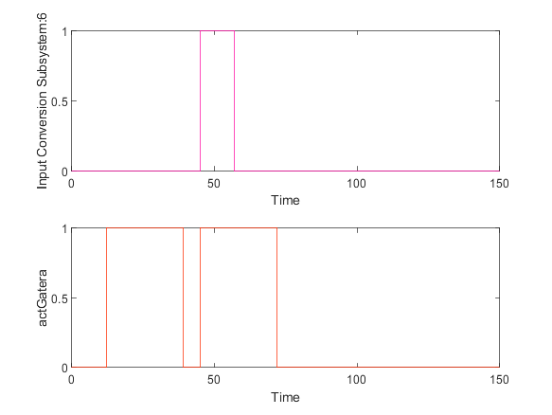

|  |  |
| --- | --- |
| Back to Report Summary | Back to Signal Summary |

|  |  |  |  |  |  |
| --- | --- | --- | --- | --- | --- |
| **Name** | **Data Type** | **Units** | **Sample Time** | **Interp** | **Sync** |
| ubicacion | double |  | Continuous | zoh | union |

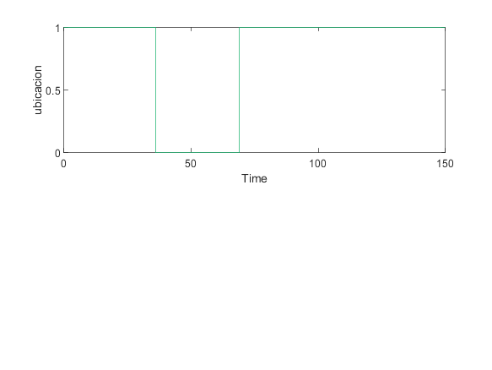

|  |  |
| --- | --- |
| Back to Report Summary | Back to Signal Summary |

Simulation Logs:

['dispensaComida'](matlab:sfprivate('sfOpenObjectBySId','estados_test:1:::232')) is defined, but is not used in the Stateflow chart. [Delete this object](matlab:%20internal.stateflow.dialogs.UnusedObjectDeleter.createDeleter('estados_test:1:::232')) or [configure the diagnostic](matlab:%20sfprivate('openConfigParamsSFDiagnostics',224)).

'[Output Port 18](matlab:slprivate('open_and_hilite_port_hyperlink',%20'hilite',%20['AAGatoEntraExteriorAuto/estados_test'%5d,%20'Outport',%2018);)' of '[AAGatoEntraExteriorAuto/estados_test](matlab:open_and_hilite_hyperlink%20('AAGatoEntraExteriorAuto/estados_test','error'))' is not connected.

Unconnected output line found on '[AAGatoEntraExteriorAuto/Input Conversion Subsystem](matlab:open_and_hilite_hyperlink%20('AAGatoEntraExteriorAuto/Input%20Conversion%20Subsystem','error'))' (output port: 18)

['actGatera'](matlab:sfprivate('sfOpenObjectBySId','AAGatoEntraExteriorAuto:58:::20')) is defined, but is never used in the Test Sequence block.  [Delete this object.](matlab:%20internal.stateflow.dialogs.UnusedObjectDeleter.createDeleter('AAGatoEntraExteriorAuto:58:::20'))

['actComedero'](matlab:sfprivate('sfOpenObjectBySId','AAGatoEntraExteriorAuto:58:::21')) is defined, but is never used in the Test Sequence block.  [Delete this object.](matlab:%20internal.stateflow.dialogs.UnusedObjectDeleter.createDeleter('AAGatoEntraExteriorAuto:58:::21'))

['peticionUsuario'](matlab:sfprivate('sfOpenObjectBySId','AAGatoEntraExteriorAuto:58:::22')) is defined, but is never used in the Test Sequence block.  [Delete this object.](matlab:%20internal.stateflow.dialogs.UnusedObjectDeleter.createDeleter('AAGatoEntraExteriorAuto:58:::22'))

['peticionIntHora'](matlab:sfprivate('sfOpenObjectBySId','AAGatoEntraExteriorAuto:58:::23')) is defined, but is never used in the Test Sequence block.  [Delete this object.](matlab:%20internal.stateflow.dialogs.UnusedObjectDeleter.createDeleter('AAGatoEntraExteriorAuto:58:::23'))

['modoReal'](matlab:sfprivate('sfOpenObjectBySId','AAGatoEntraExteriorAuto:58:::24')) is defined, but is never used in the Test Sequence block.  [Delete this object.](matlab:%20internal.stateflow.dialogs.UnusedObjectDeleter.createDeleter('AAGatoEntraExteriorAuto:58:::24'))

['ubicacion'](matlab:sfprivate('sfOpenObjectBySId','AAGatoEntraExteriorAuto:58:::25')) is defined, but is never used in the Test Sequence block.  [Delete this object.](matlab:%20internal.stateflow.dialogs.UnusedObjectDeleter.createDeleter('AAGatoEntraExteriorAuto:58:::25'))

['gatoIntroducido'](matlab:sfprivate('sfOpenObjectBySId','AAGatoEntraExteriorAuto:58:::26')) is defined, but is never used in the Test Sequence block.  [Delete this object.](matlab:%20internal.stateflow.dialogs.UnusedObjectDeleter.createDeleter('AAGatoEntraExteriorAuto:58:::26'))

['camarasOUT'](matlab:sfprivate('sfOpenObjectBySId','AAGatoEntraExteriorAuto:58:::27')) is defined, but is never used in the Test Sequence block.  [Delete this object.](matlab:%20internal.stateflow.dialogs.UnusedObjectDeleter.createDeleter('AAGatoEntraExteriorAuto:58:::27'))

['camarasIN'](matlab:sfprivate('sfOpenObjectBySId','AAGatoEntraExteriorAuto:58:::28')) is defined, but is never used in the Test Sequence block.  [Delete this object.](matlab:%20internal.stateflow.dialogs.UnusedObjectDeleter.createDeleter('AAGatoEntraExteriorAuto:58:::28'))

['tiempoSalida'](matlab:sfprivate('sfOpenObjectBySId','AAGatoEntraExteriorAuto:58:::29')) is defined, but is never used in the Test Sequence block.  [Delete this object.](matlab:%20internal.stateflow.dialogs.UnusedObjectDeleter.createDeleter('AAGatoEntraExteriorAuto:58:::29'))

['alertaTiempoFuera'](matlab:sfprivate('sfOpenObjectBySId','AAGatoEntraExteriorAuto:58:::30')) is defined, but is never used in the Test Sequence block.  [Delete this object.](matlab:%20internal.stateflow.dialogs.UnusedObjectDeleter.createDeleter('AAGatoEntraExteriorAuto:58:::30'))

['tiempoFuera'](matlab:sfprivate('sfOpenObjectBySId','AAGatoEntraExteriorAuto:58:::31')) is defined, but is never used in the Test Sequence block.  [Delete this object.](matlab:%20internal.stateflow.dialogs.UnusedObjectDeleter.createDeleter('AAGatoEntraExteriorAuto:58:::31'))

['tiempoDispensa'](matlab:sfprivate('sfOpenObjectBySId','AAGatoEntraExteriorAuto:58:::32')) is defined, but is never used in the Test Sequence block.  [Delete this object.](matlab:%20internal.stateflow.dialogs.UnusedObjectDeleter.createDeleter('AAGatoEntraExteriorAuto:58:::32'))

['alertaDispensar'](matlab:sfprivate('sfOpenObjectBySId','AAGatoEntraExteriorAuto:58:::33')) is defined, but is never used in the Test Sequence block.  [Delete this object.](matlab:%20internal.stateflow.dialogs.UnusedObjectDeleter.createDeleter('AAGatoEntraExteriorAuto:58:::33'))

['tiempoSinAlimentar'](matlab:sfprivate('sfOpenObjectBySId','AAGatoEntraExteriorAuto:58:::34')) is defined, but is never used in the Test Sequence block.  [Delete this object.](matlab:%20internal.stateflow.dialogs.UnusedObjectDeleter.createDeleter('AAGatoEntraExteriorAuto:58:::34'))

['alertaLluvia'](matlab:sfprivate('sfOpenObjectBySId','AAGatoEntraExteriorAuto:58:::35')) is defined, but is never used in the Test Sequence block.  [Delete this object.](matlab:%20internal.stateflow.dialogs.UnusedObjectDeleter.createDeleter('AAGatoEntraExteriorAuto:58:::35'))

['modoAnt'](matlab:sfprivate('sfOpenObjectBySId','AAGatoEntraExteriorAuto:58:::36')) is defined, but is never used in the Test Sequence block.  [Delete this object.](matlab:%20internal.stateflow.dialogs.UnusedObjectDeleter.createDeleter('AAGatoEntraExteriorAuto:58:::36'))

Back to Report Summary

Test Logs:

No baseline criteria evaluation performed as no baseline data is available for this test.

Back to Report Summary

|  |
| --- |
| **GatoEntraExteriorManual** |

|  |  |
| --- | --- |
| **Test Result Information** | |
| Result Type: | Test Case Result |
| Parent: | estados_test |
| Start Time: | 10-Jan-2021 21:33:40 |
| End Time: | 10-Jan-2021 21:33:40 |
| Outcome: | Passed |
| Description: |  |

El sistema se sitúa en  
modo manual (debiendo fijar una hora de comida). Se testea la correcta entrada  
del gato desde el exterior, poniendo la ubicación a 1 cuando dicha entrada ha  
sido asegurada. Al ser el estado inicial del gato el interior del edificio, el  
test incluye la previa salida del gato, poniendo la ubicación a 0 (que no se  
comprueba explícitamente, pero si implícitamente porque sino el test nunca llegaría  
a comprobarse y se comprobaría en su estado).

|  |  |
| --- | --- |
| **Test Case Information** | |
| Name: | GatoEntraExteriorManual |
| Type: | Baseline Test |
| **Test Case Requirements** | | |
| Description: | RF-G_02: EL gato quiere entrar en la vivienda (gatera#2) | |
| Document: | ../resources/requirements/gatera.slreqx | |

**Logical and Temporal Assessments**

|  |  |
| --- | --- |
| **Name** | **Assessment** |
| Assessment1 | At any point in time, if (presOUT == 1) becomes true then, with no delay, (actGatera == 1) must be true |
| Assessment2 | At any point in time, if (ubicacion == 1) becomes true then, with a delay of at most 5 seconds, (actGatera == 0) must be true |

**Simulation**

|  |  |
| --- | --- |
| **System Under Test Information** | |
| Model: | estados_test |
| Harness: | AABGatoEntraExteriorManual |
| Harness Owner: | estados_test |
| Release: | Current |
| Simulation Mode: | normal |
| Override SIL or PIL Mode: | 0 |
| Configuration Set: | Configuration1 |
| Start Time: | 0 |
| Stop Time: | 150 |
| Checksum: | 3766522820 1059779749 809757382 1796093770 |
| Simulink Version: | 10.2 |
| Model Version: | 1.8 |
| Model Author: | Juan |
| Date: | Thu Jan 07 13:09:03 2021 |
| User ID: | Juan |
| Model Path: | C:\Users\Juan\Desktop\MODELO_FINAL_V6\CATSAFE\AABGatoEntraExteriorManual.slx |
| Machine Name: | DESKTOP-UQ9MCEP |
| Solver Name: | VariableStepDiscrete |
| Solver Type: | Variable-Step |
| Max Step Size: | 3 |
| Simulation Start Time: | 2021-01-10 21:33:39 |
| Simulation Stop Time: | 2021-01-10 21:33:40 |
| Platform: | PCWIN64 |

**Simulation Output**

|  |  |  |  |  |  |  |
| --- | --- | --- | --- | --- | --- | --- |
| **Name** | **Data Type** | **Units** | **Sample Time** | **Interp** | **Sync** | **Link to Plot** |
| Input Conversion Subsystem:6 | double |  | Continuous | zoh | union | Link |
| actGatera | double |  | Continuous | zoh | union | Link |
| ubicacion | double |  | Continuous | zoh | union | Link |

|  |  |  |  |  |  |
| --- | --- | --- | --- | --- | --- |
| **Name** | **Data Type** | **Units** | **Sample Time** | **Interp** | **Sync** |
| Input Conversion Subsystem:6 | double |  | Continuous | zoh | union |
| actGatera | double |  | Continuous | zoh | union |

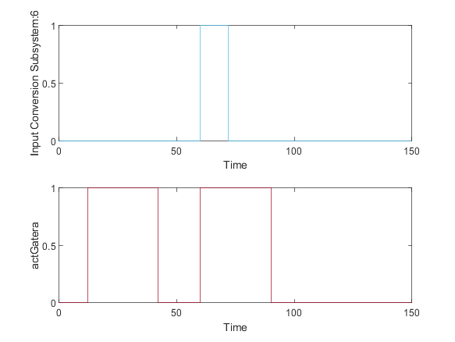

|  |  |
| --- | --- |
| Back to Report Summary | Back to Signal Summary |

|  |  |  |  |  |  |
| --- | --- | --- | --- | --- | --- |
| **Name** | **Data Type** | **Units** | **Sample Time** | **Interp** | **Sync** |
| ubicacion | double |  | Continuous | zoh | union |

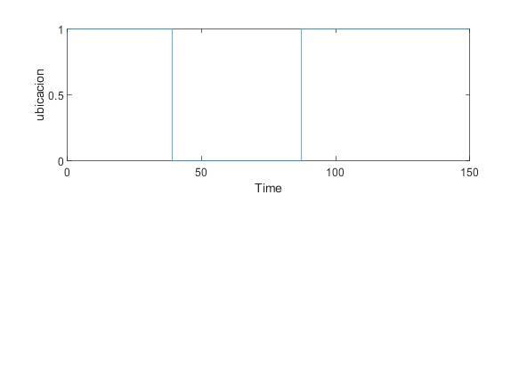

|  |  |
| --- | --- |
| Back to Report Summary | Back to Signal Summary |

Simulation Logs:

['dispensaComida'](matlab:sfprivate('sfOpenObjectBySId','estados_test:1:::232')) is defined, but is not used in the Stateflow chart. [Delete this object](matlab:%20internal.stateflow.dialogs.UnusedObjectDeleter.createDeleter('estados_test:1:::232')) or [configure the diagnostic](matlab:%20sfprivate('openConfigParamsSFDiagnostics',224)).

'[Output Port 18](matlab:slprivate('open_and_hilite_port_hyperlink',%20'hilite',%20['AABGatoEntraExteriorManual/estados_test'%5d,%20'Outport',%2018);)' of '[AABGatoEntraExteriorManual/estados_test](matlab:open_and_hilite_hyperlink%20('AABGatoEntraExteriorManual/estados_test','error'))' is not connected.

['actGatera'](matlab:sfprivate('sfOpenObjectBySId','AABGatoEntraExteriorManual:72:::20')) is defined, but is never used in the Test Sequence block.  [Delete this object.](matlab:%20internal.stateflow.dialogs.UnusedObjectDeleter.createDeleter('AABGatoEntraExteriorManual:72:::20'))

['actComedero'](matlab:sfprivate('sfOpenObjectBySId','AABGatoEntraExteriorManual:72:::21')) is defined, but is never used in the Test Sequence block.  [Delete this object.](matlab:%20internal.stateflow.dialogs.UnusedObjectDeleter.createDeleter('AABGatoEntraExteriorManual:72:::21'))

['peticionUsuario'](matlab:sfprivate('sfOpenObjectBySId','AABGatoEntraExteriorManual:72:::22')) is defined, but is never used in the Test Sequence block.  [Delete this object.](matlab:%20internal.stateflow.dialogs.UnusedObjectDeleter.createDeleter('AABGatoEntraExteriorManual:72:::22'))

['peticionIntHora'](matlab:sfprivate('sfOpenObjectBySId','AABGatoEntraExteriorManual:72:::23')) is defined, but is never used in the Test Sequence block.  [Delete this object.](matlab:%20internal.stateflow.dialogs.UnusedObjectDeleter.createDeleter('AABGatoEntraExteriorManual:72:::23'))

['modoReal'](matlab:sfprivate('sfOpenObjectBySId','AABGatoEntraExteriorManual:72:::24')) is defined, but is never used in the Test Sequence block.  [Delete this object.](matlab:%20internal.stateflow.dialogs.UnusedObjectDeleter.createDeleter('AABGatoEntraExteriorManual:72:::24'))

['ubicacion'](matlab:sfprivate('sfOpenObjectBySId','AABGatoEntraExteriorManual:72:::25')) is defined, but is never used in the Test Sequence block.  [Delete this object.](matlab:%20internal.stateflow.dialogs.UnusedObjectDeleter.createDeleter('AABGatoEntraExteriorManual:72:::25'))

['gatoIntroducido'](matlab:sfprivate('sfOpenObjectBySId','AABGatoEntraExteriorManual:72:::26')) is defined, but is never used in the Test Sequence block.  [Delete this object.](matlab:%20internal.stateflow.dialogs.UnusedObjectDeleter.createDeleter('AABGatoEntraExteriorManual:72:::26'))

['camarasOUT'](matlab:sfprivate('sfOpenObjectBySId','AABGatoEntraExteriorManual:72:::27')) is defined, but is never used in the Test Sequence block.  [Delete this object.](matlab:%20internal.stateflow.dialogs.UnusedObjectDeleter.createDeleter('AABGatoEntraExteriorManual:72:::27'))

['camarasIN'](matlab:sfprivate('sfOpenObjectBySId','AABGatoEntraExteriorManual:72:::28')) is defined, but is never used in the Test Sequence block.  [Delete this object.](matlab:%20internal.stateflow.dialogs.UnusedObjectDeleter.createDeleter('AABGatoEntraExteriorManual:72:::28'))

['tiempoSalida'](matlab:sfprivate('sfOpenObjectBySId','AABGatoEntraExteriorManual:72:::29')) is defined, but is never used in the Test Sequence block.  [Delete this object.](matlab:%20internal.stateflow.dialogs.UnusedObjectDeleter.createDeleter('AABGatoEntraExteriorManual:72:::29'))

['alertaTiempoFuera'](matlab:sfprivate('sfOpenObjectBySId','AABGatoEntraExteriorManual:72:::30')) is defined, but is never used in the Test Sequence block.  [Delete this object.](matlab:%20internal.stateflow.dialogs.UnusedObjectDeleter.createDeleter('AABGatoEntraExteriorManual:72:::30'))

['tiempoFuera'](matlab:sfprivate('sfOpenObjectBySId','AABGatoEntraExteriorManual:72:::31')) is defined, but is never used in the Test Sequence block.  [Delete this object.](matlab:%20internal.stateflow.dialogs.UnusedObjectDeleter.createDeleter('AABGatoEntraExteriorManual:72:::31'))

['tiempoDispensa'](matlab:sfprivate('sfOpenObjectBySId','AABGatoEntraExteriorManual:72:::32')) is defined, but is never used in the Test Sequence block.  [Delete this object.](matlab:%20internal.stateflow.dialogs.UnusedObjectDeleter.createDeleter('AABGatoEntraExteriorManual:72:::32'))

['alertaDispensar'](matlab:sfprivate('sfOpenObjectBySId','AABGatoEntraExteriorManual:72:::33')) is defined, but is never used in the Test Sequence block.  [Delete this object.](matlab:%20internal.stateflow.dialogs.UnusedObjectDeleter.createDeleter('AABGatoEntraExteriorManual:72:::33'))

['tiempoSinAlimentar'](matlab:sfprivate('sfOpenObjectBySId','AABGatoEntraExteriorManual:72:::34')) is defined, but is never used in the Test Sequence block.  [Delete this object.](matlab:%20internal.stateflow.dialogs.UnusedObjectDeleter.createDeleter('AABGatoEntraExteriorManual:72:::34'))

['alertaLluvia'](matlab:sfprivate('sfOpenObjectBySId','AABGatoEntraExteriorManual:72:::35')) is defined, but is never used in the Test Sequence block.  [Delete this object.](matlab:%20internal.stateflow.dialogs.UnusedObjectDeleter.createDeleter('AABGatoEntraExteriorManual:72:::35'))

['modoAnt'](matlab:sfprivate('sfOpenObjectBySId','AABGatoEntraExteriorManual:72:::36')) is defined, but is never used in the Test Sequence block.  [Delete this object.](matlab:%20internal.stateflow.dialogs.UnusedObjectDeleter.createDeleter('AABGatoEntraExteriorManual:72:::36'))

Back to Report Summary

Test Logs:

No baseline criteria evaluation performed as no baseline data is available for this test.

Back to Report Summary

|  |
| --- |
| **GatoNoEntraNormal** |

|  |  |
| --- | --- |
| **Test Result Information** | |
| Result Type: | Test Case Result |
| Parent: | estados_test |
| Start Time: | 10-Jan-2021 21:33:42 |
| End Time: | 10-Jan-2021 21:33:42 |
| Outcome: | Passed |
| Description: |  |

Testea lo que ocurre  
cuando el gato se acerca a la gatera pero sin intención de salir, por lo que  
chipGatera no se llega a detectar. En este caso, al no aportar nada la variable  
ubicación, no es necesario establecer la salida del gato previa al testeo de la  
entrada. Se debe comprobar que la gatera finalmente se cierra.

|  |  |
| --- | --- |
| **Test Case Information** | |
| Name: | GatoNoEntraNormal |
| Type: | Baseline Test |
| **Test Case Requirements** | | |
| Description: | RF-G_02: EL gato quiere entrar en la vivienda (gatera#2) | |
| Document: | ../resources/requirements/gatera.slreqx | |

**Logical and Temporal Assessments**

|  |  |
| --- | --- |
| **Name** | **Assessment** |
| Assessment1 | At any point in time, if (presOUT == 1) becomes true then, with no delay, (actGatera == 1) must be true |
| Assessment2 | At any point in time, whenever (presOUT == 0) is true then, with no delay, (actGatera == 0) must be true |
| Assessment3 | At any point in time, whenever ((presOUT == 1) & (actGatera == 1)) is true then, with a delay of at most 11 seconds, (actGatera == 0) must be true |

**Simulation**

|  |  |
| --- | --- |
| **System Under Test Information** | |
| Model: | estados_test |
| Harness: | ABGatoNoEntraExterior |
| Harness Owner: | estados_test |
| Release: | Current |
| Simulation Mode: | normal |
| Override SIL or PIL Mode: | 0 |
| Configuration Set: | Configuration1 |
| Start Time: | 0 |
| Stop Time: | 50 |
| Checksum: | 2177080025 2465221316 3406965640 3192108196 |
| Simulink Version: | 10.2 |
| Model Version: | 1.2 |
| Model Author: | Juan |
| Date: | Tue Jan 05 23:42:08 2021 |
| User ID: | Juan |
| Model Path: | C:\Users\Juan\Desktop\MODELO_FINAL_V6\CATSAFE\ABGatoNoEntraExterior.slx |
| Machine Name: | DESKTOP-UQ9MCEP |
| Solver Name: | VariableStepDiscrete |
| Solver Type: | Variable-Step |
| Max Step Size: | 1 |
| Simulation Start Time: | 2021-01-10 21:33:41 |
| Simulation Stop Time: | 2021-01-10 21:33:41 |
| Platform: | PCWIN64 |

**Simulation Output**

|  |  |  |  |  |  |  |
| --- | --- | --- | --- | --- | --- | --- |
| **Name** | **Data Type** | **Units** | **Sample Time** | **Interp** | **Sync** | **Link to Plot** |
| Input Conversion Subsystem:6 | double |  | Continuous | zoh | union | Link |
| actGatera | double |  | Continuous | zoh | union | Link |

|  |  |  |  |  |  |
| --- | --- | --- | --- | --- | --- |
| **Name** | **Data Type** | **Units** | **Sample Time** | **Interp** | **Sync** |
| Input Conversion Subsystem:6 | double |  | Continuous | zoh | union |
| actGatera | double |  | Continuous | zoh | union |

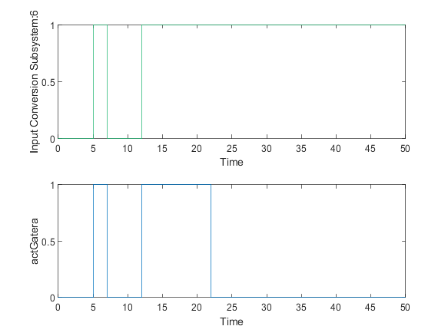

|  |  |
| --- | --- |
| Back to Report Summary | Back to Signal Summary |

Simulation Logs:

['dispensaComida'](matlab:sfprivate('sfOpenObjectBySId','estados_test:1:::232')) is defined, but is not used in the Stateflow chart. [Delete this object](matlab:%20internal.stateflow.dialogs.UnusedObjectDeleter.createDeleter('estados_test:1:::232')) or [configure the diagnostic](matlab:%20sfprivate('openConfigParamsSFDiagnostics',224)).

'[Output Port 18](matlab:slprivate('open_and_hilite_port_hyperlink',%20'hilite',%20['ABGatoNoEntraExterior/estados_test'%5d,%20'Outport',%2018);)' of '[ABGatoNoEntraExterior/estados_test](matlab:open_and_hilite_hyperlink%20('ABGatoNoEntraExterior/estados_test','error'))' is not connected.

Unconnected output line found on '[ABGatoNoEntraExterior/Input Conversion Subsystem](matlab:open_and_hilite_hyperlink%20('ABGatoNoEntraExterior/Input%20Conversion%20Subsystem','error'))' (output port: 18)

['actGatera'](matlab:sfprivate('sfOpenObjectBySId','ABGatoNoEntraExterior:58:::20')) is defined, but is never used in the Test Sequence block.  [Delete this object.](matlab:%20internal.stateflow.dialogs.UnusedObjectDeleter.createDeleter('ABGatoNoEntraExterior:58:::20'))

['actComedero'](matlab:sfprivate('sfOpenObjectBySId','ABGatoNoEntraExterior:58:::21')) is defined, but is never used in the Test Sequence block.  [Delete this object.](matlab:%20internal.stateflow.dialogs.UnusedObjectDeleter.createDeleter('ABGatoNoEntraExterior:58:::21'))

['peticionUsuario'](matlab:sfprivate('sfOpenObjectBySId','ABGatoNoEntraExterior:58:::22')) is defined, but is never used in the Test Sequence block.  [Delete this object.](matlab:%20internal.stateflow.dialogs.UnusedObjectDeleter.createDeleter('ABGatoNoEntraExterior:58:::22'))

['peticionIntHora'](matlab:sfprivate('sfOpenObjectBySId','ABGatoNoEntraExterior:58:::23')) is defined, but is never used in the Test Sequence block.  [Delete this object.](matlab:%20internal.stateflow.dialogs.UnusedObjectDeleter.createDeleter('ABGatoNoEntraExterior:58:::23'))

['modoReal'](matlab:sfprivate('sfOpenObjectBySId','ABGatoNoEntraExterior:58:::24')) is defined, but is never used in the Test Sequence block.  [Delete this object.](matlab:%20internal.stateflow.dialogs.UnusedObjectDeleter.createDeleter('ABGatoNoEntraExterior:58:::24'))

['ubicacion'](matlab:sfprivate('sfOpenObjectBySId','ABGatoNoEntraExterior:58:::25')) is defined, but is never used in the Test Sequence block.  [Delete this object.](matlab:%20internal.stateflow.dialogs.UnusedObjectDeleter.createDeleter('ABGatoNoEntraExterior:58:::25'))

['gatoIntroducido'](matlab:sfprivate('sfOpenObjectBySId','ABGatoNoEntraExterior:58:::26')) is defined, but is never used in the Test Sequence block.  [Delete this object.](matlab:%20internal.stateflow.dialogs.UnusedObjectDeleter.createDeleter('ABGatoNoEntraExterior:58:::26'))

['camarasOUT'](matlab:sfprivate('sfOpenObjectBySId','ABGatoNoEntraExterior:58:::27')) is defined, but is never used in the Test Sequence block.  [Delete this object.](matlab:%20internal.stateflow.dialogs.UnusedObjectDeleter.createDeleter('ABGatoNoEntraExterior:58:::27'))

['camarasIN'](matlab:sfprivate('sfOpenObjectBySId','ABGatoNoEntraExterior:58:::28')) is defined, but is never used in the Test Sequence block.  [Delete this object.](matlab:%20internal.stateflow.dialogs.UnusedObjectDeleter.createDeleter('ABGatoNoEntraExterior:58:::28'))

['tiempoSalida'](matlab:sfprivate('sfOpenObjectBySId','ABGatoNoEntraExterior:58:::29')) is defined, but is never used in the Test Sequence block.  [Delete this object.](matlab:%20internal.stateflow.dialogs.UnusedObjectDeleter.createDeleter('ABGatoNoEntraExterior:58:::29'))

['alertaTiempoFuera'](matlab:sfprivate('sfOpenObjectBySId','ABGatoNoEntraExterior:58:::30')) is defined, but is never used in the Test Sequence block.  [Delete this object.](matlab:%20internal.stateflow.dialogs.UnusedObjectDeleter.createDeleter('ABGatoNoEntraExterior:58:::30'))

['tiempoFuera'](matlab:sfprivate('sfOpenObjectBySId','ABGatoNoEntraExterior:58:::31')) is defined, but is never used in the Test Sequence block.  [Delete this object.](matlab:%20internal.stateflow.dialogs.UnusedObjectDeleter.createDeleter('ABGatoNoEntraExterior:58:::31'))

['tiempoDispensa'](matlab:sfprivate('sfOpenObjectBySId','ABGatoNoEntraExterior:58:::32')) is defined, but is never used in the Test Sequence block.  [Delete this object.](matlab:%20internal.stateflow.dialogs.UnusedObjectDeleter.createDeleter('ABGatoNoEntraExterior:58:::32'))

['alertaDispensar'](matlab:sfprivate('sfOpenObjectBySId','ABGatoNoEntraExterior:58:::33')) is defined, but is never used in the Test Sequence block.  [Delete this object.](matlab:%20internal.stateflow.dialogs.UnusedObjectDeleter.createDeleter('ABGatoNoEntraExterior:58:::33'))

['tiempoSinAlimentar'](matlab:sfprivate('sfOpenObjectBySId','ABGatoNoEntraExterior:58:::34')) is defined, but is never used in the Test Sequence block.  [Delete this object.](matlab:%20internal.stateflow.dialogs.UnusedObjectDeleter.createDeleter('ABGatoNoEntraExterior:58:::34'))

['alertaLluvia'](matlab:sfprivate('sfOpenObjectBySId','ABGatoNoEntraExterior:58:::35')) is defined, but is never used in the Test Sequence block.  [Delete this object.](matlab:%20internal.stateflow.dialogs.UnusedObjectDeleter.createDeleter('ABGatoNoEntraExterior:58:::35'))

['modoAnt'](matlab:sfprivate('sfOpenObjectBySId','ABGatoNoEntraExterior:58:::36')) is defined, but is never used in the Test Sequence block.  [Delete this object.](matlab:%20internal.stateflow.dialogs.UnusedObjectDeleter.createDeleter('ABGatoNoEntraExterior:58:::36'))

Back to Report Summary

Test Logs:

No baseline criteria evaluation performed as no baseline data is available for this test.

Back to Report Summary

|  |
| --- |
| **GatoSaleNormalAutorizadoManual** |

|  |  |
| --- | --- |
| **Test Result Information** | |
| Result Type: | Test Case Result |
| Parent: | estados_test |
| Start Time: | 10-Jan-2021 21:33:44 |
| End Time: | 10-Jan-2021 21:33:44 |
| Outcome: | Passed |
| Description: |  |

Testea la correcta salida del gato de la vivienda en modo manual, cuando el usuario autoriza su salida y el gato tiene intención de salir.

|  |  |
| --- | --- |
| **Test Case Information** | |
| Name: | GatoSaleNormalAutorizadoManual |
| Type: | Baseline Test |
| **Test Case Requirements** | | |
| Description: | RF-G_01: El gato quiere salir de la vivienda (gatera#1) | |
| Document: | ../resources/requirements/gatera.slreqx | |

**Logical and Temporal Assessments**

|  |  |
| --- | --- |
| **Name** | **Assessment** |
| Assessment1 | At any point in time, if (autorizUsuario == 1) becomes true then, with no delay, (actGatera == 1) must be true |
| Assessment2 | At any point in time, if (presIN == 1) becomes true then, with a delay of at most 5 seconds, (peticionUsuario == 1) must be true |
| Assessment3 | At any point in time, whenever (tiempoSalida ~= 0) is true then, with a delay of at most 15 seconds, (actGatera == 0) must be true |

**Simulation**

|  |  |
| --- | --- |
| **System Under Test Information** | |
| Model: | estados_test |
| Harness: | ACGatoSaleNormalAutorizadoManual |
| Harness Owner: | estados_test |
| Release: | Current |
| Simulation Mode: | normal |
| Override SIL or PIL Mode: | 0 |
| Configuration Set: | Configuration1 |
| Start Time: | 0 |
| Stop Time: | 100 |
| Checksum: | 2161344657 3815417821 70768359 2576888212 |
| Simulink Version: | 10.2 |
| Model Version: | 1.6 |
| Model Author: | Juan |
| Date: | Thu Jan 07 13:57:01 2021 |
| User ID: | Juan |
| Model Path: | C:\Users\Juan\Desktop\MODELO_FINAL_V6\CATSAFE\ACGatoSaleNormalAutorizadoManual.slx |
| Machine Name: | DESKTOP-UQ9MCEP |
| Solver Name: | VariableStepDiscrete |
| Solver Type: | Variable-Step |
| Max Step Size: | 2 |
| Simulation Start Time: | 2021-01-10 21:33:42 |
| Simulation Stop Time: | 2021-01-10 21:33:43 |
| Platform: | PCWIN64 |

**Simulation Output**

|  |  |  |  |  |  |  |
| --- | --- | --- | --- | --- | --- | --- |
| **Name** | **Data Type** | **Units** | **Sample Time** | **Interp** | **Sync** | **Link to Plot** |
| Input Conversion Subsystem:4 | double |  | Continuous | zoh | union | Link |
| Input Conversion Subsystem:5 | double |  | Continuous | zoh | union | Link |
| actGatera | double |  | Continuous | zoh | union | Link |
| peticionUsuario | double |  | Continuous | zoh | union | Link |
| tiempoSalida | double |  | Continuous | zoh | union | Link |

|  |  |  |  |  |  |
| --- | --- | --- | --- | --- | --- |
| **Name** | **Data Type** | **Units** | **Sample Time** | **Interp** | **Sync** |
| Input Conversion Subsystem:4 | double |  | Continuous | zoh | union |
| Input Conversion Subsystem:5 | double |  | Continuous | zoh | union |

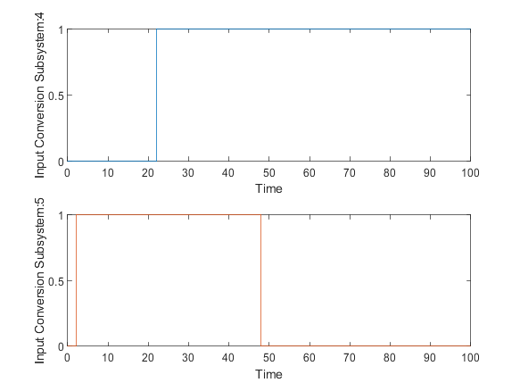

|  |  |
| --- | --- |
| Back to Report Summary | Back to Signal Summary |

|  |  |  |  |  |  |
| --- | --- | --- | --- | --- | --- |
| **Name** | **Data Type** | **Units** | **Sample Time** | **Interp** | **Sync** |
| actGatera | double |  | Continuous | zoh | union |
| peticionUsuario | double |  | Continuous | zoh | union |

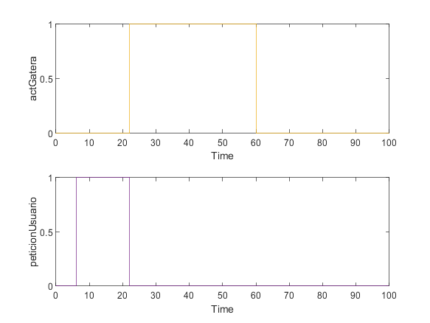

|  |  |
| --- | --- |
| Back to Report Summary | Back to Signal Summary |

|  |  |  |  |  |  |
| --- | --- | --- | --- | --- | --- |
| **Name** | **Data Type** | **Units** | **Sample Time** | **Interp** | **Sync** |
| tiempoSalida | double |  | Continuous | zoh | union |

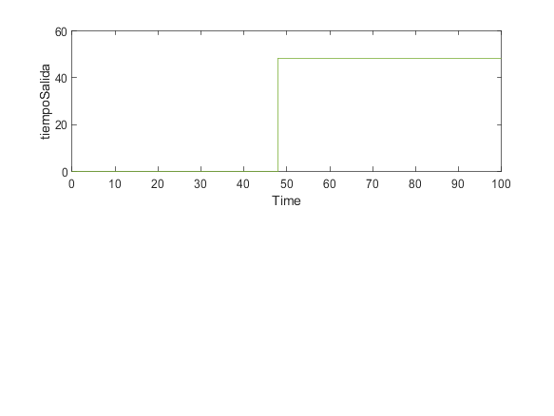

|  |  |
| --- | --- |
| Back to Report Summary | Back to Signal Summary |

Simulation Logs:

['dispensaComida'](matlab:sfprivate('sfOpenObjectBySId','estados_test:1:::232')) is defined, but is not used in the Stateflow chart. [Delete this object](matlab:%20internal.stateflow.dialogs.UnusedObjectDeleter.createDeleter('estados_test:1:::232')) or [configure the diagnostic](matlab:%20sfprivate('openConfigParamsSFDiagnostics',224)).

'[Output Port 18](matlab:slprivate('open_and_hilite_port_hyperlink',%20'hilite',%20['ACGatoSaleNormalAutorizadoManual/estados_test'%5d,%20'Outport',%2018);)' of '[ACGatoSaleNormalAutorizadoManual/estados_test](matlab:open_and_hilite_hyperlink%20('ACGatoSaleNormalAutorizadoManual/estados_test','error'))' is not connected.

Unconnected output line found on '[ACGatoSaleNormalAutorizadoManual/Input Conversion Subsystem](matlab:open_and_hilite_hyperlink%20('ACGatoSaleNormalAutorizadoManual/Input%20Conversion%20Subsystem','error'))' (output port: 18)

['actGatera'](matlab:sfprivate('sfOpenObjectBySId','ACGatoSaleNormalAutorizadoManual:58:::20')) is defined, but is never used in the Test Sequence block.  [Delete this object.](matlab:%20internal.stateflow.dialogs.UnusedObjectDeleter.createDeleter('ACGatoSaleNormalAutorizadoManual:58:::20'))

['actComedero'](matlab:sfprivate('sfOpenObjectBySId','ACGatoSaleNormalAutorizadoManual:58:::21')) is defined, but is never used in the Test Sequence block.  [Delete this object.](matlab:%20internal.stateflow.dialogs.UnusedObjectDeleter.createDeleter('ACGatoSaleNormalAutorizadoManual:58:::21'))

['peticionUsuario'](matlab:sfprivate('sfOpenObjectBySId','ACGatoSaleNormalAutorizadoManual:58:::22')) is defined, but is never used in the Test Sequence block.  [Delete this object.](matlab:%20internal.stateflow.dialogs.UnusedObjectDeleter.createDeleter('ACGatoSaleNormalAutorizadoManual:58:::22'))

['peticionIntHora'](matlab:sfprivate('sfOpenObjectBySId','ACGatoSaleNormalAutorizadoManual:58:::23')) is defined, but is never used in the Test Sequence block.  [Delete this object.](matlab:%20internal.stateflow.dialogs.UnusedObjectDeleter.createDeleter('ACGatoSaleNormalAutorizadoManual:58:::23'))

['modoReal'](matlab:sfprivate('sfOpenObjectBySId','ACGatoSaleNormalAutorizadoManual:58:::24')) is defined, but is never used in the Test Sequence block.  [Delete this object.](matlab:%20internal.stateflow.dialogs.UnusedObjectDeleter.createDeleter('ACGatoSaleNormalAutorizadoManual:58:::24'))

['ubicacion'](matlab:sfprivate('sfOpenObjectBySId','ACGatoSaleNormalAutorizadoManual:58:::25')) is defined, but is never used in the Test Sequence block.  [Delete this object.](matlab:%20internal.stateflow.dialogs.UnusedObjectDeleter.createDeleter('ACGatoSaleNormalAutorizadoManual:58:::25'))

['gatoIntroducido'](matlab:sfprivate('sfOpenObjectBySId','ACGatoSaleNormalAutorizadoManual:58:::26')) is defined, but is never used in the Test Sequence block.  [Delete this object.](matlab:%20internal.stateflow.dialogs.UnusedObjectDeleter.createDeleter('ACGatoSaleNormalAutorizadoManual:58:::26'))

['camarasOUT'](matlab:sfprivate('sfOpenObjectBySId','ACGatoSaleNormalAutorizadoManual:58:::27')) is defined, but is never used in the Test Sequence block.  [Delete this object.](matlab:%20internal.stateflow.dialogs.UnusedObjectDeleter.createDeleter('ACGatoSaleNormalAutorizadoManual:58:::27'))

['camarasIN'](matlab:sfprivate('sfOpenObjectBySId','ACGatoSaleNormalAutorizadoManual:58:::28')) is defined, but is never used in the Test Sequence block.  [Delete this object.](matlab:%20internal.stateflow.dialogs.UnusedObjectDeleter.createDeleter('ACGatoSaleNormalAutorizadoManual:58:::28'))

['tiempoSalida'](matlab:sfprivate('sfOpenObjectBySId','ACGatoSaleNormalAutorizadoManual:58:::29')) is defined, but is never used in the Test Sequence block.  [Delete this object.](matlab:%20internal.stateflow.dialogs.UnusedObjectDeleter.createDeleter('ACGatoSaleNormalAutorizadoManual:58:::29'))

['alertaTiempoFuera'](matlab:sfprivate('sfOpenObjectBySId','ACGatoSaleNormalAutorizadoManual:58:::30')) is defined, but is never used in the Test Sequence block.  [Delete this object.](matlab:%20internal.stateflow.dialogs.UnusedObjectDeleter.createDeleter('ACGatoSaleNormalAutorizadoManual:58:::30'))

['tiempoFuera'](matlab:sfprivate('sfOpenObjectBySId','ACGatoSaleNormalAutorizadoManual:58:::31')) is defined, but is never used in the Test Sequence block.  [Delete this object.](matlab:%20internal.stateflow.dialogs.UnusedObjectDeleter.createDeleter('ACGatoSaleNormalAutorizadoManual:58:::31'))

['tiempoDispensa'](matlab:sfprivate('sfOpenObjectBySId','ACGatoSaleNormalAutorizadoManual:58:::32')) is defined, but is never used in the Test Sequence block.  [Delete this object.](matlab:%20internal.stateflow.dialogs.UnusedObjectDeleter.createDeleter('ACGatoSaleNormalAutorizadoManual:58:::32'))

['alertaDispensar'](matlab:sfprivate('sfOpenObjectBySId','ACGatoSaleNormalAutorizadoManual:58:::33')) is defined, but is never used in the Test Sequence block.  [Delete this object.](matlab:%20internal.stateflow.dialogs.UnusedObjectDeleter.createDeleter('ACGatoSaleNormalAutorizadoManual:58:::33'))

['tiempoSinAlimentar'](matlab:sfprivate('sfOpenObjectBySId','ACGatoSaleNormalAutorizadoManual:58:::34')) is defined, but is never used in the Test Sequence block.  [Delete this object.](matlab:%20internal.stateflow.dialogs.UnusedObjectDeleter.createDeleter('ACGatoSaleNormalAutorizadoManual:58:::34'))

['alertaLluvia'](matlab:sfprivate('sfOpenObjectBySId','ACGatoSaleNormalAutorizadoManual:58:::35')) is defined, but is never used in the Test Sequence block.  [Delete this object.](matlab:%20internal.stateflow.dialogs.UnusedObjectDeleter.createDeleter('ACGatoSaleNormalAutorizadoManual:58:::35'))

['modoAnt'](matlab:sfprivate('sfOpenObjectBySId','ACGatoSaleNormalAutorizadoManual:58:::36')) is defined, but is never used in the Test Sequence block.  [Delete this object.](matlab:%20internal.stateflow.dialogs.UnusedObjectDeleter.createDeleter('ACGatoSaleNormalAutorizadoManual:58:::36'))

Back to Report Summary

Test Logs:

No baseline criteria evaluation performed as no baseline data is available for this test.

Back to Report Summary

|  |
| --- |
| **CambioModoManualAutomatico** |

|  |  |
| --- | --- |
| **Test Result Information** | |
| Result Type: | Test Case Result |
| Parent: | estados_test |
| Start Time: | 10-Jan-2021 21:33:45 |
| End Time: | 10-Jan-2021 21:33:45 |
| Outcome: | Passed |
| Description: |  |

Testea el correcto paso  
de modo manual a automático pidiendo al usuario que introduzca la hora a la que  
se alimentará a la mascota

|  |  |
| --- | --- |
| **Test Case Information** | |
| Name: | CambioModoManualAutomatico |
| Type: | Baseline Test |
| **Test Case Requirements** | | |
| Description: | RF-SY_01: Cambio de modo de uso de manual a automático (gatera#3) | |
| Document: | ../resources/requirements/gatera.slreqx | |

**Logical and Temporal Assessments**

|  |  |
| --- | --- |
| **Name** | **Assessment** |
| Assessment1 | At any point in time, if (modo == 0) becomes true then, with no delay, (peticionIntHora == 1) must be true |
| Assessment2 | At any point in time, whenever ((horaComida ~= 0) & (modo == 0)) is true then, with no delay, (modoReal == 0) must be true |

**Simulation**

|  |  |
| --- | --- |
| **System Under Test Information** | |
| Model: | estados_test |
| Harness: | ADCambioModManAut |
| Harness Owner: | estados_test |
| Release: | Current |
| Simulation Mode: | normal |
| Override SIL or PIL Mode: | 0 |
| Configuration Set: | Configuration1 |
| Start Time: | 0 |
| Stop Time: | 50 |
| Checksum: | 402585372 2370909754 1682869892 1125883270 |
| Simulink Version: | 10.2 |
| Model Version: | 1.3 |
| Model Author: | Juan |
| Date: | Wed Jan 06 00:21:23 2021 |
| User ID: | Juan |
| Model Path: | C:\Users\Juan\Desktop\MODELO_FINAL_V6\CATSAFE\ADCambioModManAut.slx |
| Machine Name: | DESKTOP-UQ9MCEP |
| Solver Name: | VariableStepDiscrete |
| Solver Type: | Variable-Step |
| Max Step Size: | 1 |
| Simulation Start Time: | 2021-01-10 21:33:44 |
| Simulation Stop Time: | 2021-01-10 21:33:45 |
| Platform: | PCWIN64 |

**Simulation Output**

|  |  |  |  |  |  |  |
| --- | --- | --- | --- | --- | --- | --- |
| **Name** | **Data Type** | **Units** | **Sample Time** | **Interp** | **Sync** | **Link to Plot** |
| Input Conversion Subsystem:1 | double |  | Continuous | zoh | union | Link |
| Input Conversion Subsystem:8 | double |  | Continuous | zoh | union | Link |
| peticionIntHora | double |  | Continuous | zoh | union | Link |
| modoReal | double |  | Continuous | zoh | union | Link |

|  |  |  |  |  |  |
| --- | --- | --- | --- | --- | --- |
| **Name** | **Data Type** | **Units** | **Sample Time** | **Interp** | **Sync** |
| Input Conversion Subsystem:1 | double |  | Continuous | zoh | union |
| Input Conversion Subsystem:8 | double |  | Continuous | zoh | union |

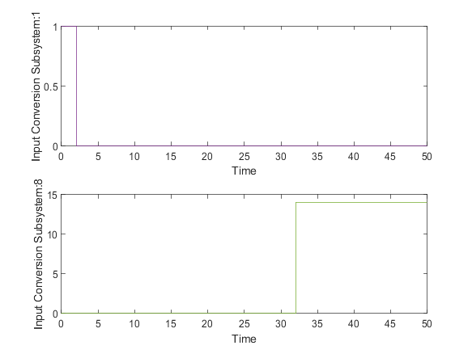

|  |  |
| --- | --- |
| Back to Report Summary | Back to Signal Summary |

|  |  |  |  |  |  |
| --- | --- | --- | --- | --- | --- |
| **Name** | **Data Type** | **Units** | **Sample Time** | **Interp** | **Sync** |
| peticionIntHora | double |  | Continuous | zoh | union |
| modoReal | double |  | Continuous | zoh | union |

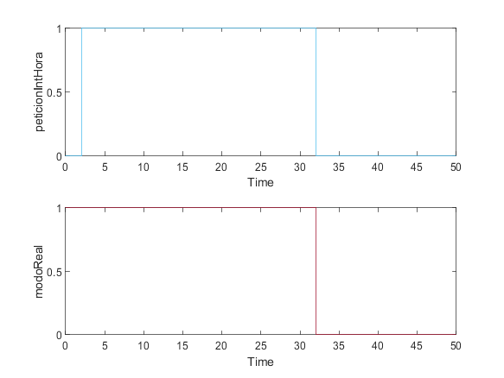

|  |  |
| --- | --- |
| Back to Report Summary | Back to Signal Summary |

Simulation Logs:

['dispensaComida'](matlab:sfprivate('sfOpenObjectBySId','estados_test:1:::232')) is defined, but is not used in the Stateflow chart. [Delete this object](matlab:%20internal.stateflow.dialogs.UnusedObjectDeleter.createDeleter('estados_test:1:::232')) or [configure the diagnostic](matlab:%20sfprivate('openConfigParamsSFDiagnostics',224)).

'[Output Port 18](matlab:slprivate('open_and_hilite_port_hyperlink',%20'hilite',%20['ADCambioModManAut/estados_test'%5d,%20'Outport',%2018);)' of '[ADCambioModManAut/estados_test](matlab:open_and_hilite_hyperlink%20('ADCambioModManAut/estados_test','error'))' is not connected.

Unconnected output line found on '[ADCambioModManAut/Input Conversion Subsystem](matlab:open_and_hilite_hyperlink%20('ADCambioModManAut/Input%20Conversion%20Subsystem','error'))' (output port: 18)

['actGatera'](matlab:sfprivate('sfOpenObjectBySId','ADCambioModManAut:58:::20')) is defined, but is never used in the Test Sequence block.  [Delete this object.](matlab:%20internal.stateflow.dialogs.UnusedObjectDeleter.createDeleter('ADCambioModManAut:58:::20'))

['actComedero'](matlab:sfprivate('sfOpenObjectBySId','ADCambioModManAut:58:::21')) is defined, but is never used in the Test Sequence block.  [Delete this object.](matlab:%20internal.stateflow.dialogs.UnusedObjectDeleter.createDeleter('ADCambioModManAut:58:::21'))

['peticionUsuario'](matlab:sfprivate('sfOpenObjectBySId','ADCambioModManAut:58:::22')) is defined, but is never used in the Test Sequence block.  [Delete this object.](matlab:%20internal.stateflow.dialogs.UnusedObjectDeleter.createDeleter('ADCambioModManAut:58:::22'))

['peticionIntHora'](matlab:sfprivate('sfOpenObjectBySId','ADCambioModManAut:58:::23')) is defined, but is never used in the Test Sequence block.  [Delete this object.](matlab:%20internal.stateflow.dialogs.UnusedObjectDeleter.createDeleter('ADCambioModManAut:58:::23'))

['modoReal'](matlab:sfprivate('sfOpenObjectBySId','ADCambioModManAut:58:::24')) is defined, but is never used in the Test Sequence block.  [Delete this object.](matlab:%20internal.stateflow.dialogs.UnusedObjectDeleter.createDeleter('ADCambioModManAut:58:::24'))

['ubicacion'](matlab:sfprivate('sfOpenObjectBySId','ADCambioModManAut:58:::25')) is defined, but is never used in the Test Sequence block.  [Delete this object.](matlab:%20internal.stateflow.dialogs.UnusedObjectDeleter.createDeleter('ADCambioModManAut:58:::25'))

['gatoIntroducido'](matlab:sfprivate('sfOpenObjectBySId','ADCambioModManAut:58:::26')) is defined, but is never used in the Test Sequence block.  [Delete this object.](matlab:%20internal.stateflow.dialogs.UnusedObjectDeleter.createDeleter('ADCambioModManAut:58:::26'))

['camarasOUT'](matlab:sfprivate('sfOpenObjectBySId','ADCambioModManAut:58:::27')) is defined, but is never used in the Test Sequence block.  [Delete this object.](matlab:%20internal.stateflow.dialogs.UnusedObjectDeleter.createDeleter('ADCambioModManAut:58:::27'))

['camarasIN'](matlab:sfprivate('sfOpenObjectBySId','ADCambioModManAut:58:::28')) is defined, but is never used in the Test Sequence block.  [Delete this object.](matlab:%20internal.stateflow.dialogs.UnusedObjectDeleter.createDeleter('ADCambioModManAut:58:::28'))

['tiempoSalida'](matlab:sfprivate('sfOpenObjectBySId','ADCambioModManAut:58:::29')) is defined, but is never used in the Test Sequence block.  [Delete this object.](matlab:%20internal.stateflow.dialogs.UnusedObjectDeleter.createDeleter('ADCambioModManAut:58:::29'))

['alertaTiempoFuera'](matlab:sfprivate('sfOpenObjectBySId','ADCambioModManAut:58:::30')) is defined, but is never used in the Test Sequence block.  [Delete this object.](matlab:%20internal.stateflow.dialogs.UnusedObjectDeleter.createDeleter('ADCambioModManAut:58:::30'))

['tiempoFuera'](matlab:sfprivate('sfOpenObjectBySId','ADCambioModManAut:58:::31')) is defined, but is never used in the Test Sequence block.  [Delete this object.](matlab:%20internal.stateflow.dialogs.UnusedObjectDeleter.createDeleter('ADCambioModManAut:58:::31'))

['tiempoDispensa'](matlab:sfprivate('sfOpenObjectBySId','ADCambioModManAut:58:::32')) is defined, but is never used in the Test Sequence block.  [Delete this object.](matlab:%20internal.stateflow.dialogs.UnusedObjectDeleter.createDeleter('ADCambioModManAut:58:::32'))

['alertaDispensar'](matlab:sfprivate('sfOpenObjectBySId','ADCambioModManAut:58:::33')) is defined, but is never used in the Test Sequence block.  [Delete this object.](matlab:%20internal.stateflow.dialogs.UnusedObjectDeleter.createDeleter('ADCambioModManAut:58:::33'))

['tiempoSinAlimentar'](matlab:sfprivate('sfOpenObjectBySId','ADCambioModManAut:58:::34')) is defined, but is never used in the Test Sequence block.  [Delete this object.](matlab:%20internal.stateflow.dialogs.UnusedObjectDeleter.createDeleter('ADCambioModManAut:58:::34'))

['alertaLluvia'](matlab:sfprivate('sfOpenObjectBySId','ADCambioModManAut:58:::35')) is defined, but is never used in the Test Sequence block.  [Delete this object.](matlab:%20internal.stateflow.dialogs.UnusedObjectDeleter.createDeleter('ADCambioModManAut:58:::35'))

['modoAnt'](matlab:sfprivate('sfOpenObjectBySId','ADCambioModManAut:58:::36')) is defined, but is never used in the Test Sequence block.  [Delete this object.](matlab:%20internal.stateflow.dialogs.UnusedObjectDeleter.createDeleter('ADCambioModManAut:58:::36'))

Back to Report Summary

Test Logs:

No baseline criteria evaluation performed as no baseline data is available for this test.

Back to Report Summary

|  |
| --- |
| **CambioModoAutomaticoManual** |

|  |  |
| --- | --- |
| **Test Result Information** | |
| Result Type: | Test Case Result |
| Parent: | estados_test |
| Start Time: | 10-Jan-2021 21:33:46 |
| End Time: | 10-Jan-2021 21:33:46 |
| Outcome: | Passed |
| Description: |  |

Testea que cuando el sistema esté en modo automático y se solicite el cambio a manual este se haga sin pedir nada al usuario.

|  |  |
| --- | --- |
| **Test Case Information** | |
| Name: | CambioModoAutomaticoManual |
| Type: | Baseline Test |
| **Test Case Requirements** | | |
| Description: | RF-SY_02: Cambio de modo de automático a manual (gatera#4) | |
| Document: | ../resources/requirements/gatera.slreqx | |

**Logical and Temporal Assessments**

|  |  |
| --- | --- |
| **Name** | **Assessment** |
| Assessment1 | At any point in time, whenever (modo == 1) is true then, with a delay of at most 5 seconds, (modoReal == 1) must be true |

**Simulation**

|  |  |
| --- | --- |
| **System Under Test Information** | |
| Model: | estados_test |
| Harness: | AECambioModoAutMan |
| Harness Owner: | estados_test |
| Release: | Current |
| Simulation Mode: | normal |
| Override SIL or PIL Mode: | 0 |
| Configuration Set: | Configuration1 |
| Start Time: | 0 |
| Stop Time: | 50 |
| Checksum: | 3843585467 1980101100 2788029645 2613230283 |
| Simulink Version: | 10.2 |
| Model Version: | 1.2 |
| Model Author: | Juan |
| Date: | Wed Jan 06 00:28:00 2021 |
| User ID: | Juan |
| Model Path: | C:\Users\Juan\Desktop\MODELO_FINAL_V6\CATSAFE\AECambioModoAutMan.slx |
| Machine Name: | DESKTOP-UQ9MCEP |
| Solver Name: | VariableStepDiscrete |
| Solver Type: | Variable-Step |
| Max Step Size: | 1 |
| Simulation Start Time: | 2021-01-10 21:33:45 |
| Simulation Stop Time: | 2021-01-10 21:33:46 |
| Platform: | PCWIN64 |

**Simulation Output**

|  |  |  |  |  |  |  |
| --- | --- | --- | --- | --- | --- | --- |
| **Name** | **Data Type** | **Units** | **Sample Time** | **Interp** | **Sync** | **Link to Plot** |
| Input Conversion Subsystem:1 | double |  | Continuous | zoh | union | Link |
| modoReal | double |  | Continuous | zoh | union | Link |

|  |  |  |  |  |  |
| --- | --- | --- | --- | --- | --- |
| **Name** | **Data Type** | **Units** | **Sample Time** | **Interp** | **Sync** |
| Input Conversion Subsystem:1 | double |  | Continuous | zoh | union |
| modoReal | double |  | Continuous | zoh | union |

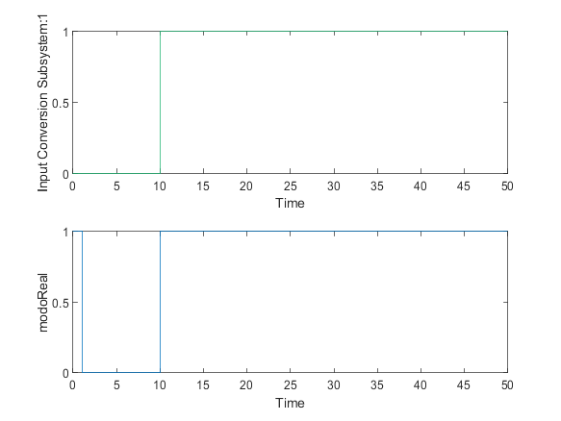

|  |  |
| --- | --- |
| Back to Report Summary | Back to Signal Summary |

Simulation Logs:

['dispensaComida'](matlab:sfprivate('sfOpenObjectBySId','estados_test:1:::232')) is defined, but is not used in the Stateflow chart. [Delete this object](matlab:%20internal.stateflow.dialogs.UnusedObjectDeleter.createDeleter('estados_test:1:::232')) or [configure the diagnostic](matlab:%20sfprivate('openConfigParamsSFDiagnostics',224)).

'[Output Port 18](matlab:slprivate('open_and_hilite_port_hyperlink',%20'hilite',%20['AECambioModoAutMan/estados_test'%5d,%20'Outport',%2018);)' of '[AECambioModoAutMan/estados_test](matlab:open_and_hilite_hyperlink%20('AECambioModoAutMan/estados_test','error'))' is not connected.

Unconnected output line found on '[AECambioModoAutMan/Input Conversion Subsystem](matlab:open_and_hilite_hyperlink%20('AECambioModoAutMan/Input%20Conversion%20Subsystem','error'))' (output port: 18)

['actGatera'](matlab:sfprivate('sfOpenObjectBySId','AECambioModoAutMan:58:::20')) is defined, but is never used in the Test Sequence block.  [Delete this object.](matlab:%20internal.stateflow.dialogs.UnusedObjectDeleter.createDeleter('AECambioModoAutMan:58:::20'))

['actComedero'](matlab:sfprivate('sfOpenObjectBySId','AECambioModoAutMan:58:::21')) is defined, but is never used in the Test Sequence block.  [Delete this object.](matlab:%20internal.stateflow.dialogs.UnusedObjectDeleter.createDeleter('AECambioModoAutMan:58:::21'))

['peticionUsuario'](matlab:sfprivate('sfOpenObjectBySId','AECambioModoAutMan:58:::22')) is defined, but is never used in the Test Sequence block.  [Delete this object.](matlab:%20internal.stateflow.dialogs.UnusedObjectDeleter.createDeleter('AECambioModoAutMan:58:::22'))

['peticionIntHora'](matlab:sfprivate('sfOpenObjectBySId','AECambioModoAutMan:58:::23')) is defined, but is never used in the Test Sequence block.  [Delete this object.](matlab:%20internal.stateflow.dialogs.UnusedObjectDeleter.createDeleter('AECambioModoAutMan:58:::23'))

['modoReal'](matlab:sfprivate('sfOpenObjectBySId','AECambioModoAutMan:58:::24')) is defined, but is never used in the Test Sequence block.  [Delete this object.](matlab:%20internal.stateflow.dialogs.UnusedObjectDeleter.createDeleter('AECambioModoAutMan:58:::24'))

['ubicacion'](matlab:sfprivate('sfOpenObjectBySId','AECambioModoAutMan:58:::25')) is defined, but is never used in the Test Sequence block.  [Delete this object.](matlab:%20internal.stateflow.dialogs.UnusedObjectDeleter.createDeleter('AECambioModoAutMan:58:::25'))

['gatoIntroducido'](matlab:sfprivate('sfOpenObjectBySId','AECambioModoAutMan:58:::26')) is defined, but is never used in the Test Sequence block.  [Delete this object.](matlab:%20internal.stateflow.dialogs.UnusedObjectDeleter.createDeleter('AECambioModoAutMan:58:::26'))

['camarasOUT'](matlab:sfprivate('sfOpenObjectBySId','AECambioModoAutMan:58:::27')) is defined, but is never used in the Test Sequence block.  [Delete this object.](matlab:%20internal.stateflow.dialogs.UnusedObjectDeleter.createDeleter('AECambioModoAutMan:58:::27'))

['camarasIN'](matlab:sfprivate('sfOpenObjectBySId','AECambioModoAutMan:58:::28')) is defined, but is never used in the Test Sequence block.  [Delete this object.](matlab:%20internal.stateflow.dialogs.UnusedObjectDeleter.createDeleter('AECambioModoAutMan:58:::28'))

['tiempoSalida'](matlab:sfprivate('sfOpenObjectBySId','AECambioModoAutMan:58:::29')) is defined, but is never used in the Test Sequence block.  [Delete this object.](matlab:%20internal.stateflow.dialogs.UnusedObjectDeleter.createDeleter('AECambioModoAutMan:58:::29'))

['alertaTiempoFuera'](matlab:sfprivate('sfOpenObjectBySId','AECambioModoAutMan:58:::30')) is defined, but is never used in the Test Sequence block.  [Delete this object.](matlab:%20internal.stateflow.dialogs.UnusedObjectDeleter.createDeleter('AECambioModoAutMan:58:::30'))

['tiempoFuera'](matlab:sfprivate('sfOpenObjectBySId','AECambioModoAutMan:58:::31')) is defined, but is never used in the Test Sequence block.  [Delete this object.](matlab:%20internal.stateflow.dialogs.UnusedObjectDeleter.createDeleter('AECambioModoAutMan:58:::31'))

['tiempoDispensa'](matlab:sfprivate('sfOpenObjectBySId','AECambioModoAutMan:58:::32')) is defined, but is never used in the Test Sequence block.  [Delete this object.](matlab:%20internal.stateflow.dialogs.UnusedObjectDeleter.createDeleter('AECambioModoAutMan:58:::32'))

['alertaDispensar'](matlab:sfprivate('sfOpenObjectBySId','AECambioModoAutMan:58:::33')) is defined, but is never used in the Test Sequence block.  [Delete this object.](matlab:%20internal.stateflow.dialogs.UnusedObjectDeleter.createDeleter('AECambioModoAutMan:58:::33'))

['tiempoSinAlimentar'](matlab:sfprivate('sfOpenObjectBySId','AECambioModoAutMan:58:::34')) is defined, but is never used in the Test Sequence block.  [Delete this object.](matlab:%20internal.stateflow.dialogs.UnusedObjectDeleter.createDeleter('AECambioModoAutMan:58:::34'))

['alertaLluvia'](matlab:sfprivate('sfOpenObjectBySId','AECambioModoAutMan:58:::35')) is defined, but is never used in the Test Sequence block.  [Delete this object.](matlab:%20internal.stateflow.dialogs.UnusedObjectDeleter.createDeleter('AECambioModoAutMan:58:::35'))

['modoAnt'](matlab:sfprivate('sfOpenObjectBySId','AECambioModoAutMan:58:::36')) is defined, but is never used in the Test Sequence block.  [Delete this object.](matlab:%20internal.stateflow.dialogs.UnusedObjectDeleter.createDeleter('AECambioModoAutMan:58:::36'))

Back to Report Summary

Test Logs:

No baseline criteria evaluation performed as no baseline data is available for this test.

Back to Report Summary

|  |
| --- |
| **AlimentarGatoM** |

|  |  |
| --- | --- |
| **Test Result Information** | |
| Result Type: | Test Case Result |
| Parent: | estados_test |
| Start Time: | 10-Jan-2021 21:33:48 |
| End Time: | 10-Jan-2021 21:33:48 |
| Outcome: | Passed |
| Description: |  |

Testea la correcta dispensa de comida en caso de que el usuario lo solicite.

|  |  |
| --- | --- |
| **Test Case Information** | |
| Name: | AlimentarGatoM |
| Type: | Baseline Test |
| **Test Case Requirements** | | |
| Description: | RF-CO_01: Alimentación del gato en modo manual (gatera#7) | |
| Document: | ../resources/requirements/gatera.slreqx | |

**Logical and Temporal Assessments**

|  |  |
| --- | --- |
| **Name** | **Assessment** |
| Assessment1 | At any point in time, whenever (autorizUsuarioCom == 1) is true then, with no delay, ((actComedero == 1) & (alertaDispensar == 0)) must be true |
| Assessment3 | At any point in time, whenever (actComedero == 1) is true then, with a delay of at most 11 seconds, (actComedero == 0) must be true |

**Simulation**

|  |  |
| --- | --- |
| **System Under Test Information** | |
| Model: | estados_test |
| Harness: | AFAlimentarGatoM |
| Harness Owner: | estados_test |
| Release: | Current |
| Simulation Mode: | normal |
| Override SIL or PIL Mode: | 0 |
| Configuration Set: | Configuration1 |
| Start Time: | 0 |
| Stop Time: | 40 |
| Checksum: | 1565055872 2246391528 3958501981 1084479578 |
| Simulink Version: | 10.2 |
| Model Version: | 1.19 |
| Model Author: | Iranzu |
| Date: | Sat Jan 09 20:43:10 2021 |
| User ID: | Juan |
| Model Path: | C:\Users\Juan\Desktop\MODELO_FINAL_V6\CATSAFE\AFAlimentarGatoM.slx |
| Machine Name: | DESKTOP-UQ9MCEP |
| Solver Name: | VariableStepDiscrete |
| Solver Type: | Variable-Step |
| Max Step Size: | 0.80000000000000004 |
| Simulation Start Time: | 2021-01-10 21:33:47 |
| Simulation Stop Time: | 2021-01-10 21:33:47 |
| Platform: | PCWIN64 |

**Simulation Output**

|  |  |  |  |  |  |  |
| --- | --- | --- | --- | --- | --- | --- |
| **Name** | **Data Type** | **Units** | **Sample Time** | **Interp** | **Sync** | **Link to Plot** |
| Input Conversion Subsystem:3 | double |  | Continuous | zoh | union | Link |
| actComedero | double |  | Continuous | zoh | union | Link |
| alertaDispensar | double |  | Continuous | zoh | union | Link |

|  |  |  |  |  |  |
| --- | --- | --- | --- | --- | --- |
| **Name** | **Data Type** | **Units** | **Sample Time** | **Interp** | **Sync** |
| Input Conversion Subsystem:3 | double |  | Continuous | zoh | union |
| actComedero | double |  | Continuous | zoh | union |

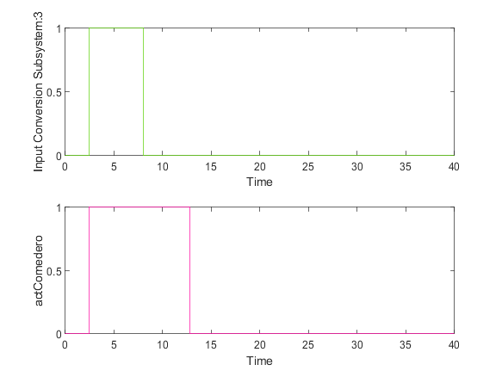

|  |  |
| --- | --- |
| Back to Report Summary | Back to Signal Summary |

|  |  |  |  |  |  |
| --- | --- | --- | --- | --- | --- |
| **Name** | **Data Type** | **Units** | **Sample Time** | **Interp** | **Sync** |
| alertaDispensar | double |  | Continuous | zoh | union |

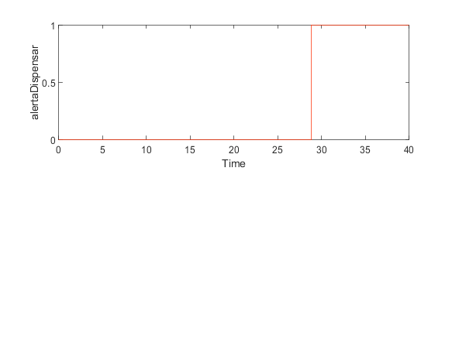

|  |  |
| --- | --- |
| Back to Report Summary | Back to Signal Summary |

Simulation Logs:

['dispensaComida'](matlab:sfprivate('sfOpenObjectBySId','estados_test:1:::232')) is defined, but is not used in the Stateflow chart. [Delete this object](matlab:%20internal.stateflow.dialogs.UnusedObjectDeleter.createDeleter('estados_test:1:::232')) or [configure the diagnostic](matlab:%20sfprivate('openConfigParamsSFDiagnostics',224)).

'[Output Port 18](matlab:slprivate('open_and_hilite_port_hyperlink',%20'hilite',%20['AFAlimentarGatoM/estados_test'%5d,%20'Outport',%2018);)' of '[AFAlimentarGatoM/estados_test](matlab:open_and_hilite_hyperlink%20('AFAlimentarGatoM/estados_test','error'))' is not connected.

['actGatera'](matlab:sfprivate('sfOpenObjectBySId','AFAlimentarGatoM:37:::20')) is defined, but is never used in the Test Sequence block.  [Delete this object.](matlab:%20internal.stateflow.dialogs.UnusedObjectDeleter.createDeleter('AFAlimentarGatoM:37:::20'))

['actComedero'](matlab:sfprivate('sfOpenObjectBySId','AFAlimentarGatoM:37:::21')) is defined, but is never used in the Test Sequence block.  [Delete this object.](matlab:%20internal.stateflow.dialogs.UnusedObjectDeleter.createDeleter('AFAlimentarGatoM:37:::21'))

['peticionUsuario'](matlab:sfprivate('sfOpenObjectBySId','AFAlimentarGatoM:37:::22')) is defined, but is never used in the Test Sequence block.  [Delete this object.](matlab:%20internal.stateflow.dialogs.UnusedObjectDeleter.createDeleter('AFAlimentarGatoM:37:::22'))

['peticionIntHora'](matlab:sfprivate('sfOpenObjectBySId','AFAlimentarGatoM:37:::24')) is defined, but is never used in the Test Sequence block.  [Delete this object.](matlab:%20internal.stateflow.dialogs.UnusedObjectDeleter.createDeleter('AFAlimentarGatoM:37:::24'))

['modoReal'](matlab:sfprivate('sfOpenObjectBySId','AFAlimentarGatoM:37:::25')) is defined, but is never used in the Test Sequence block.  [Delete this object.](matlab:%20internal.stateflow.dialogs.UnusedObjectDeleter.createDeleter('AFAlimentarGatoM:37:::25'))

['ubicacion'](matlab:sfprivate('sfOpenObjectBySId','AFAlimentarGatoM:37:::47')) is defined, but is never used in the Test Sequence block.  [Delete this object.](matlab:%20internal.stateflow.dialogs.UnusedObjectDeleter.createDeleter('AFAlimentarGatoM:37:::47'))

['gatoIntroducido'](matlab:sfprivate('sfOpenObjectBySId','AFAlimentarGatoM:37:::48')) is defined, but is never used in the Test Sequence block.  [Delete this object.](matlab:%20internal.stateflow.dialogs.UnusedObjectDeleter.createDeleter('AFAlimentarGatoM:37:::48'))

['camarasOUT'](matlab:sfprivate('sfOpenObjectBySId','AFAlimentarGatoM:37:::56')) is defined, but is never used in the Test Sequence block.  [Delete this object.](matlab:%20internal.stateflow.dialogs.UnusedObjectDeleter.createDeleter('AFAlimentarGatoM:37:::56'))

['camarasIN'](matlab:sfprivate('sfOpenObjectBySId','AFAlimentarGatoM:37:::57')) is defined, but is never used in the Test Sequence block.  [Delete this object.](matlab:%20internal.stateflow.dialogs.UnusedObjectDeleter.createDeleter('AFAlimentarGatoM:37:::57'))

['tiempoSalida'](matlab:sfprivate('sfOpenObjectBySId','AFAlimentarGatoM:37:::58')) is defined, but is never used in the Test Sequence block.  [Delete this object.](matlab:%20internal.stateflow.dialogs.UnusedObjectDeleter.createDeleter('AFAlimentarGatoM:37:::58'))

['alertaTiempoFuera'](matlab:sfprivate('sfOpenObjectBySId','AFAlimentarGatoM:37:::59')) is defined, but is never used in the Test Sequence block.  [Delete this object.](matlab:%20internal.stateflow.dialogs.UnusedObjectDeleter.createDeleter('AFAlimentarGatoM:37:::59'))

['tiempoFuera'](matlab:sfprivate('sfOpenObjectBySId','AFAlimentarGatoM:37:::60')) is defined, but is never used in the Test Sequence block.  [Delete this object.](matlab:%20internal.stateflow.dialogs.UnusedObjectDeleter.createDeleter('AFAlimentarGatoM:37:::60'))

['tiempoDispensa'](matlab:sfprivate('sfOpenObjectBySId','AFAlimentarGatoM:37:::61')) is defined, but is never used in the Test Sequence block.  [Delete this object.](matlab:%20internal.stateflow.dialogs.UnusedObjectDeleter.createDeleter('AFAlimentarGatoM:37:::61'))

['alertaDispensar'](matlab:sfprivate('sfOpenObjectBySId','AFAlimentarGatoM:37:::62')) is defined, but is never used in the Test Sequence block.  [Delete this object.](matlab:%20internal.stateflow.dialogs.UnusedObjectDeleter.createDeleter('AFAlimentarGatoM:37:::62'))

['tiempoSinAlimentar'](matlab:sfprivate('sfOpenObjectBySId','AFAlimentarGatoM:37:::63')) is defined, but is never used in the Test Sequence block.  [Delete this object.](matlab:%20internal.stateflow.dialogs.UnusedObjectDeleter.createDeleter('AFAlimentarGatoM:37:::63'))

['alertaLluvia'](matlab:sfprivate('sfOpenObjectBySId','AFAlimentarGatoM:37:::70')) is defined, but is never used in the Test Sequence block.  [Delete this object.](matlab:%20internal.stateflow.dialogs.UnusedObjectDeleter.createDeleter('AFAlimentarGatoM:37:::70'))

['modoAnt'](matlab:sfprivate('sfOpenObjectBySId','AFAlimentarGatoM:37:::71')) is defined, but is never used in the Test Sequence block.  [Delete this object.](matlab:%20internal.stateflow.dialogs.UnusedObjectDeleter.createDeleter('AFAlimentarGatoM:37:::71'))

Back to Report Summary

Test Logs:

No baseline criteria evaluation performed as no baseline data is available for this test.

Back to Report Summary

|  |
| --- |
| **AlimentarGatoA** |

|  |  |
| --- | --- |
| **Test Result Information** | |
| Result Type: | Test Case Result |
| Parent: | estados_test |
| Start Time: | 10-Jan-2021 21:33:49 |
| End Time: | 10-Jan-2021 21:33:49 |
| Outcome: | Passed |
| Description: |  |

Testea la correcta dispensa de comida en las horas programadas para ello por el usuario.

El funcionamiento del sistema está sincronizado con un reloj, de tal manera que cuando la hora coincide con la hora programada por el usuario para alimentar al gato, o se encuentra dentro de una región de confianza aceptable, dado que está seleccionado el modo automático, se realiza la secuencia de dispensa de comida.

En este test, se verifica que cuando la hora esté dentro de dicho pequeño intervalo alrededor de la hora definida del usuario, se dispense comida.

|  |  |
| --- | --- |
| **Test Case Information** | |
| Name: | AlimentarGatoA |
| Type: | Baseline Test |
| **Test Case Requirements** | | |
| Description: | RF-CO_02: Alimentación del gato en modo automático (gatera#14) | |
| Document: | ../resources/requirements/gatera.slreqx | |

**Logical and Temporal Assessments**

|  |  |
| --- | --- |
| **Name** | **Assessment** |
| Assessment1 | At any point in time, whenever ((t >= horaComida) & (t < (horaComida + 10))) is true then, with no delay, (actComedero == 1) must be true |
| Assessment2 | At any point in time, whenever (actComedero == 1) is true then, with a delay of at most 11 seconds, (actComedero ~= 1) must be true |

**Simulation**

|  |  |
| --- | --- |
| **System Under Test Information** | |
| Model: | estados_test |
| Harness: | AGAlimentarGatoA |
| Harness Owner: | estados_test |
| Release: | Current |
| Simulation Mode: | normal |
| Override SIL or PIL Mode: | 0 |
| Configuration Set: | Configuration1 |
| Start Time: | 0 |
| Stop Time: | 100 |
| Checksum: | 3715963600 737195090 2920889565 2752447550 |
| Simulink Version: | 10.2 |
| Model Version: | 1.21 |
| Model Author: | Juan |
| Date: | Thu Jan 07 13:47:53 2021 |
| User ID: | Juan |
| Model Path: | C:\Users\Juan\Desktop\MODELO_FINAL_V6\CATSAFE\AGAlimentarGatoA.slx |
| Machine Name: | DESKTOP-UQ9MCEP |
| Solver Name: | VariableStepDiscrete |
| Solver Type: | Variable-Step |
| Max Step Size: | 2 |
| Simulation Start Time: | 2021-01-10 21:33:48 |
| Simulation Stop Time: | 2021-01-10 21:33:49 |
| Platform: | PCWIN64 |

**Simulation Output**

|  |  |  |  |  |  |  |
| --- | --- | --- | --- | --- | --- | --- |
| **Name** | **Data Type** | **Units** | **Sample Time** | **Interp** | **Sync** | **Link to Plot** |
| Input Conversion Subsystem:8 | double |  | Continuous | zoh | union | Link |
| actComedero | double |  | Continuous | zoh | union | Link |
| modoReal | double |  | Continuous | zoh | union | Link |

|  |  |  |  |  |  |
| --- | --- | --- | --- | --- | --- |
| **Name** | **Data Type** | **Units** | **Sample Time** | **Interp** | **Sync** |
| Input Conversion Subsystem:8 | double |  | Continuous | zoh | union |
| actComedero | double |  | Continuous | zoh | union |

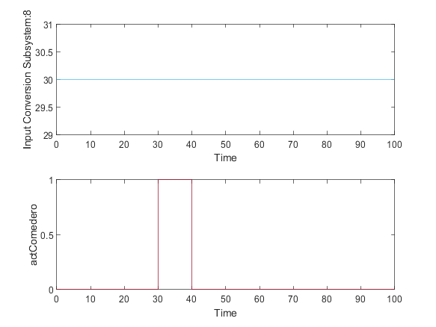

|  |  |
| --- | --- |
| Back to Report Summary | Back to Signal Summary |

|  |  |  |  |  |  |
| --- | --- | --- | --- | --- | --- |
| **Name** | **Data Type** | **Units** | **Sample Time** | **Interp** | **Sync** |
| modoReal | double |  | Continuous | zoh | union |

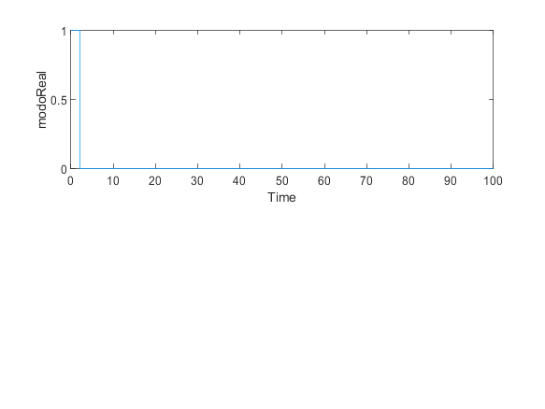

|  |  |
| --- | --- |
| Back to Report Summary | Back to Signal Summary |

Simulation Logs:

['dispensaComida'](matlab:sfprivate('sfOpenObjectBySId','estados_test:1:::232')) is defined, but is not used in the Stateflow chart. [Delete this object](matlab:%20internal.stateflow.dialogs.UnusedObjectDeleter.createDeleter('estados_test:1:::232')) or [configure the diagnostic](matlab:%20sfprivate('openConfigParamsSFDiagnostics',224)).

Matching "Goto" for "From" '[AGAlimentarGatoA/From_14](matlab:open_and_hilite_hyperlink%20('AGAlimentarGatoA/From_14','error'))' not found

Matching "From" for "Goto" '[AGAlimentarGatoA/Goto_14](matlab:open_and_hilite_hyperlink%20('AGAlimentarGatoA/Goto_14','error'))' not found

'[Output Port 18](matlab:slprivate('open_and_hilite_port_hyperlink',%20'hilite',%20['AGAlimentarGatoA/estados_test'%5d,%20'Outport',%2018);)' of '[AGAlimentarGatoA/estados_test](matlab:open_and_hilite_hyperlink%20('AGAlimentarGatoA/estados_test','error'))' is not connected.

['actGatera'](matlab:sfprivate('sfOpenObjectBySId','AGAlimentarGatoA:37:::20')) is defined, but is never used in the Test Sequence block.  [Delete this object.](matlab:%20internal.stateflow.dialogs.UnusedObjectDeleter.createDeleter('AGAlimentarGatoA:37:::20'))

['actComedero'](matlab:sfprivate('sfOpenObjectBySId','AGAlimentarGatoA:37:::21')) is defined, but is never used in the Test Sequence block.  [Delete this object.](matlab:%20internal.stateflow.dialogs.UnusedObjectDeleter.createDeleter('AGAlimentarGatoA:37:::21'))

['peticionUsuario'](matlab:sfprivate('sfOpenObjectBySId','AGAlimentarGatoA:37:::22')) is defined, but is never used in the Test Sequence block.  [Delete this object.](matlab:%20internal.stateflow.dialogs.UnusedObjectDeleter.createDeleter('AGAlimentarGatoA:37:::22'))

['peticionIntHora'](matlab:sfprivate('sfOpenObjectBySId','AGAlimentarGatoA:37:::24')) is defined, but is never used in the Test Sequence block.  [Delete this object.](matlab:%20internal.stateflow.dialogs.UnusedObjectDeleter.createDeleter('AGAlimentarGatoA:37:::24'))

['modoReal'](matlab:sfprivate('sfOpenObjectBySId','AGAlimentarGatoA:37:::25')) is defined, but is never used in the Test Sequence block.  [Delete this object.](matlab:%20internal.stateflow.dialogs.UnusedObjectDeleter.createDeleter('AGAlimentarGatoA:37:::25'))

['ubicacion'](matlab:sfprivate('sfOpenObjectBySId','AGAlimentarGatoA:37:::42')) is defined, but is never used in the Test Sequence block.  [Delete this object.](matlab:%20internal.stateflow.dialogs.UnusedObjectDeleter.createDeleter('AGAlimentarGatoA:37:::42'))

['gatoIntroducido'](matlab:sfprivate('sfOpenObjectBySId','AGAlimentarGatoA:37:::43')) is defined, but is never used in the Test Sequence block.  [Delete this object.](matlab:%20internal.stateflow.dialogs.UnusedObjectDeleter.createDeleter('AGAlimentarGatoA:37:::43'))

['camarasOUT'](matlab:sfprivate('sfOpenObjectBySId','AGAlimentarGatoA:37:::49')) is defined, but is never used in the Test Sequence block.  [Delete this object.](matlab:%20internal.stateflow.dialogs.UnusedObjectDeleter.createDeleter('AGAlimentarGatoA:37:::49'))

['camarasIN'](matlab:sfprivate('sfOpenObjectBySId','AGAlimentarGatoA:37:::50')) is defined, but is never used in the Test Sequence block.  [Delete this object.](matlab:%20internal.stateflow.dialogs.UnusedObjectDeleter.createDeleter('AGAlimentarGatoA:37:::50'))

['tiempoSalida'](matlab:sfprivate('sfOpenObjectBySId','AGAlimentarGatoA:37:::51')) is defined, but is never used in the Test Sequence block.  [Delete this object.](matlab:%20internal.stateflow.dialogs.UnusedObjectDeleter.createDeleter('AGAlimentarGatoA:37:::51'))

['alertaTiempoFuera'](matlab:sfprivate('sfOpenObjectBySId','AGAlimentarGatoA:37:::52')) is defined, but is never used in the Test Sequence block.  [Delete this object.](matlab:%20internal.stateflow.dialogs.UnusedObjectDeleter.createDeleter('AGAlimentarGatoA:37:::52'))

['tiempoFuera'](matlab:sfprivate('sfOpenObjectBySId','AGAlimentarGatoA:37:::53')) is defined, but is never used in the Test Sequence block.  [Delete this object.](matlab:%20internal.stateflow.dialogs.UnusedObjectDeleter.createDeleter('AGAlimentarGatoA:37:::53'))

['tiempoDispensa'](matlab:sfprivate('sfOpenObjectBySId','AGAlimentarGatoA:37:::54')) is defined, but is never used in the Test Sequence block.  [Delete this object.](matlab:%20internal.stateflow.dialogs.UnusedObjectDeleter.createDeleter('AGAlimentarGatoA:37:::54'))

['alertaDispensar'](matlab:sfprivate('sfOpenObjectBySId','AGAlimentarGatoA:37:::55')) is defined, but is never used in the Test Sequence block.  [Delete this object.](matlab:%20internal.stateflow.dialogs.UnusedObjectDeleter.createDeleter('AGAlimentarGatoA:37:::55'))

['tiempoSinAlimentar'](matlab:sfprivate('sfOpenObjectBySId','AGAlimentarGatoA:37:::56')) is defined, but is never used in the Test Sequence block.  [Delete this object.](matlab:%20internal.stateflow.dialogs.UnusedObjectDeleter.createDeleter('AGAlimentarGatoA:37:::56'))

['alertaLluvia'](matlab:sfprivate('sfOpenObjectBySId','AGAlimentarGatoA:37:::57')) is defined, but is never used in the Test Sequence block.  [Delete this object.](matlab:%20internal.stateflow.dialogs.UnusedObjectDeleter.createDeleter('AGAlimentarGatoA:37:::57'))

['modoAnt'](matlab:sfprivate('sfOpenObjectBySId','AGAlimentarGatoA:37:::58')) is defined, but is never used in the Test Sequence block.  [Delete this object.](matlab:%20internal.stateflow.dialogs.UnusedObjectDeleter.createDeleter('AGAlimentarGatoA:37:::58'))

Back to Report Summary

Test Logs:

No baseline criteria evaluation performed as no baseline data is available for this test.

Back to Report Summary

|  |
| --- |
| **ParadaDeEmergencia** |

|  |  |
| --- | --- |
| **Test Result Information** | |
| Result Type: | Test Case Result |
| Parent: | estados_test |
| Start Time: | 10-Jan-2021 21:33:51 |
| End Time: | 10-Jan-2021 21:33:51 |
| Outcome: | Passed |
| Description: |  |

Testea el paso a modo bloqueo en caso de producirse una parada de emergencia.

También se testea la correcta parada de emergencia, de tal forma que en el momento en el que se pasa a modo bloqueo, la gatera no se accione.

El test incluye la función de reestablecer el modo de tal forma que la gatera retorne al modo de uso en el que se encontraba antes de producirse la parada de emergencia.

|  |  |
| --- | --- |
| **Test Case Information** | |
| Name: | ParadaDeEmergencia |
| Type: | Baseline Test |
| **Test Case Requirements** | | |
| Description: | RNF-SE_01: Parada de Emergencia (gatera#15) | |
| Document: | ../resources/requirements/gatera.slreqx | |

**Logical and Temporal Assessments**

|  |  |
| --- | --- |
| **Name** | **Assessment** |
| Assessment1 | At any point in time, whenever (paradaEmergencia == 1) is true then, with a delay of at most 1 seconds, (modoReal == 2) must be true |
| Assessment2 | At any point in time, whenever (modoReal == 2) is true then, with no delay, (actGatera == 0) must be true |
| Assessment3 | At any point in time, whenever ((reestablecerModo == 1) & (modoAnt == 0)) is true then, with no delay, (modoReal == 0) must be true |
| Assessment4 | At any point in time, whenever ((reestablecerModo == 1) & (modoAnt == 1)) is true then, with no delay, (modoReal == 1) must be true |

**Simulation**

|  |  |
| --- | --- |
| **System Under Test Information** | |
| Model: | estados_test |
| Harness: | AHParadaDeEmergencia |
| Harness Owner: | estados_test |
| Release: | Current |
| Simulation Mode: | normal |
| Override SIL or PIL Mode: | 0 |
| Configuration Set: | Configuration1 |
| Start Time: | 0 |
| Stop Time: | 50 |
| Checksum: | 2945925574 3064231370 130570130 989987249 |
| Simulink Version: | 10.2 |
| Model Version: | 1.18 |
| Model Author: | Iranzu |
| Date: | Sat Jan 09 17:19:19 2021 |
| User ID: | Juan |
| Model Path: | C:\Users\Juan\Desktop\MODELO_FINAL_V6\CATSAFE\AHParadaDeEmergencia.slx |
| Machine Name: | DESKTOP-UQ9MCEP |
| Solver Name: | VariableStepDiscrete |
| Solver Type: | Variable-Step |
| Max Step Size: | 1 |
| Simulation Start Time: | 2021-01-10 21:33:50 |
| Simulation Stop Time: | 2021-01-10 21:33:51 |
| Platform: | PCWIN64 |

**Simulation Output**

|  |  |  |  |  |  |  |
| --- | --- | --- | --- | --- | --- | --- |
| **Name** | **Data Type** | **Units** | **Sample Time** | **Interp** | **Sync** | **Link to Plot** |
| Input Conversion Subsystem:12 | double |  | Continuous | zoh | union | Link |
| Input Conversion Subsystem:9 | double |  | Continuous | zoh | union | Link |
| Input Conversion Subsystem:10 | double |  | Continuous | zoh | union | Link |
| actGatera | double |  | Continuous | zoh | union | Link |
| modoAnt | double |  | Continuous | zoh | union | Link |
| modoReal | double |  | Continuous | zoh | union | Link |
| ubicacion | double |  | Continuous | zoh | union | Link |

|  |  |  |  |  |  |
| --- | --- | --- | --- | --- | --- |
| **Name** | **Data Type** | **Units** | **Sample Time** | **Interp** | **Sync** |
| Input Conversion Subsystem:12 | double |  | Continuous | zoh | union |
| Input Conversion Subsystem:9 | double |  | Continuous | zoh | union |

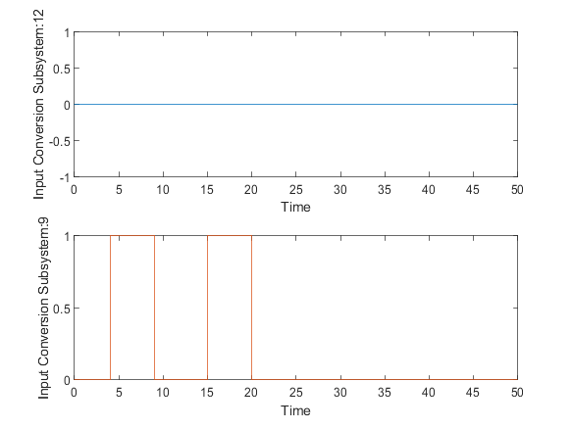

|  |  |
| --- | --- |
| Back to Report Summary | Back to Signal Summary |

|  |  |  |  |  |  |
| --- | --- | --- | --- | --- | --- |
| **Name** | **Data Type** | **Units** | **Sample Time** | **Interp** | **Sync** |
| Input Conversion Subsystem:10 | double |  | Continuous | zoh | union |
| actGatera | double |  | Continuous | zoh | union |

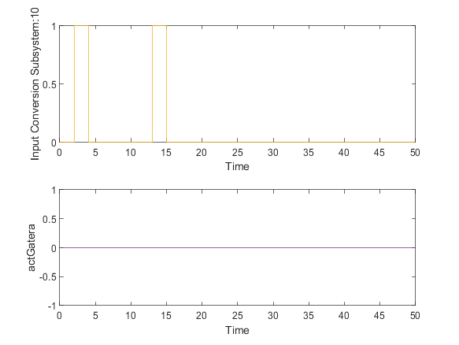

|  |  |
| --- | --- |
| Back to Report Summary | Back to Signal Summary |

|  |  |  |  |  |  |
| --- | --- | --- | --- | --- | --- |
| **Name** | **Data Type** | **Units** | **Sample Time** | **Interp** | **Sync** |
| modoAnt | double |  | Continuous | zoh | union |
| modoReal | double |  | Continuous | zoh | union |

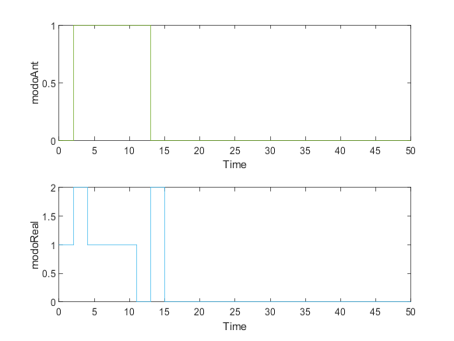

|  |  |
| --- | --- |
| Back to Report Summary | Back to Signal Summary |

|  |  |  |  |  |  |
| --- | --- | --- | --- | --- | --- |
| **Name** | **Data Type** | **Units** | **Sample Time** | **Interp** | **Sync** |
| ubicacion | double |  | Continuous | zoh | union |

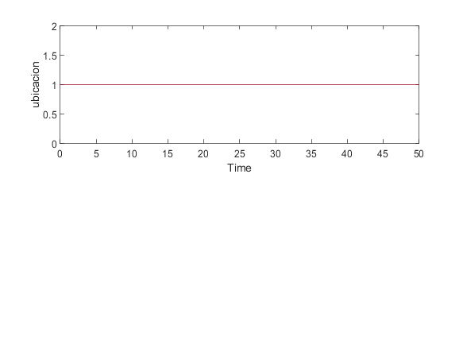

|  |  |
| --- | --- |
| Back to Report Summary | Back to Signal Summary |

Simulation Logs:

['dispensaComida'](matlab:sfprivate('sfOpenObjectBySId','estados_test:1:::232')) is defined, but is not used in the Stateflow chart. [Delete this object](matlab:%20internal.stateflow.dialogs.UnusedObjectDeleter.createDeleter('estados_test:1:::232')) or [configure the diagnostic](matlab:%20sfprivate('openConfigParamsSFDiagnostics',224)).

Matching "Goto" for "From" '[AHParadaDeEmergencia/From_15](matlab:open_and_hilite_hyperlink%20('AHParadaDeEmergencia/From_15','error'))' not found

Matching "From" for "Goto" '[AHParadaDeEmergencia/Goto_15](matlab:open_and_hilite_hyperlink%20('AHParadaDeEmergencia/Goto_15','error'))' not found

['actGatera'](matlab:sfprivate('sfOpenObjectBySId','AHParadaDeEmergencia:40:::20')) is defined, but is never used in the Test Sequence block.  [Delete this object.](matlab:%20internal.stateflow.dialogs.UnusedObjectDeleter.createDeleter('AHParadaDeEmergencia:40:::20'))

['actComedero'](matlab:sfprivate('sfOpenObjectBySId','AHParadaDeEmergencia:40:::21')) is defined, but is never used in the Test Sequence block.  [Delete this object.](matlab:%20internal.stateflow.dialogs.UnusedObjectDeleter.createDeleter('AHParadaDeEmergencia:40:::21'))

['peticionUsuario'](matlab:sfprivate('sfOpenObjectBySId','AHParadaDeEmergencia:40:::22')) is defined, but is never used in the Test Sequence block.  [Delete this object.](matlab:%20internal.stateflow.dialogs.UnusedObjectDeleter.createDeleter('AHParadaDeEmergencia:40:::22'))

['peticionIntHora'](matlab:sfprivate('sfOpenObjectBySId','AHParadaDeEmergencia:40:::24')) is defined, but is never used in the Test Sequence block.  [Delete this object.](matlab:%20internal.stateflow.dialogs.UnusedObjectDeleter.createDeleter('AHParadaDeEmergencia:40:::24'))

['modoReal'](matlab:sfprivate('sfOpenObjectBySId','AHParadaDeEmergencia:40:::25')) is defined, but is never used in the Test Sequence block.  [Delete this object.](matlab:%20internal.stateflow.dialogs.UnusedObjectDeleter.createDeleter('AHParadaDeEmergencia:40:::25'))

['ubicacion'](matlab:sfprivate('sfOpenObjectBySId','AHParadaDeEmergencia:40:::41')) is defined, but is never used in the Test Sequence block.  [Delete this object.](matlab:%20internal.stateflow.dialogs.UnusedObjectDeleter.createDeleter('AHParadaDeEmergencia:40:::41'))

['gatoIntroducido'](matlab:sfprivate('sfOpenObjectBySId','AHParadaDeEmergencia:40:::42')) is defined, but is never used in the Test Sequence block.  [Delete this object.](matlab:%20internal.stateflow.dialogs.UnusedObjectDeleter.createDeleter('AHParadaDeEmergencia:40:::42'))

['camarasOUT'](matlab:sfprivate('sfOpenObjectBySId','AHParadaDeEmergencia:40:::47')) is defined, but is never used in the Test Sequence block.  [Delete this object.](matlab:%20internal.stateflow.dialogs.UnusedObjectDeleter.createDeleter('AHParadaDeEmergencia:40:::47'))

['camarasIN'](matlab:sfprivate('sfOpenObjectBySId','AHParadaDeEmergencia:40:::48')) is defined, but is never used in the Test Sequence block.  [Delete this object.](matlab:%20internal.stateflow.dialogs.UnusedObjectDeleter.createDeleter('AHParadaDeEmergencia:40:::48'))

['tiempoSalida'](matlab:sfprivate('sfOpenObjectBySId','AHParadaDeEmergencia:40:::49')) is defined, but is never used in the Test Sequence block.  [Delete this object.](matlab:%20internal.stateflow.dialogs.UnusedObjectDeleter.createDeleter('AHParadaDeEmergencia:40:::49'))

['alertaTiempoFuera'](matlab:sfprivate('sfOpenObjectBySId','AHParadaDeEmergencia:40:::50')) is defined, but is never used in the Test Sequence block.  [Delete this object.](matlab:%20internal.stateflow.dialogs.UnusedObjectDeleter.createDeleter('AHParadaDeEmergencia:40:::50'))

['tiempoFuera'](matlab:sfprivate('sfOpenObjectBySId','AHParadaDeEmergencia:40:::51')) is defined, but is never used in the Test Sequence block.  [Delete this object.](matlab:%20internal.stateflow.dialogs.UnusedObjectDeleter.createDeleter('AHParadaDeEmergencia:40:::51'))

['tiempoDispensa'](matlab:sfprivate('sfOpenObjectBySId','AHParadaDeEmergencia:40:::52')) is defined, but is never used in the Test Sequence block.  [Delete this object.](matlab:%20internal.stateflow.dialogs.UnusedObjectDeleter.createDeleter('AHParadaDeEmergencia:40:::52'))

['alertaDispensar'](matlab:sfprivate('sfOpenObjectBySId','AHParadaDeEmergencia:40:::53')) is defined, but is never used in the Test Sequence block.  [Delete this object.](matlab:%20internal.stateflow.dialogs.UnusedObjectDeleter.createDeleter('AHParadaDeEmergencia:40:::53'))

['tiempoSinAlimentar'](matlab:sfprivate('sfOpenObjectBySId','AHParadaDeEmergencia:40:::54')) is defined, but is never used in the Test Sequence block.  [Delete this object.](matlab:%20internal.stateflow.dialogs.UnusedObjectDeleter.createDeleter('AHParadaDeEmergencia:40:::54'))

['alertaLluvia'](matlab:sfprivate('sfOpenObjectBySId','AHParadaDeEmergencia:40:::55')) is defined, but is never used in the Test Sequence block.  [Delete this object.](matlab:%20internal.stateflow.dialogs.UnusedObjectDeleter.createDeleter('AHParadaDeEmergencia:40:::55'))

['modoAnt'](matlab:sfprivate('sfOpenObjectBySId','AHParadaDeEmergencia:40:::56')) is defined, but is never used in the Test Sequence block.  [Delete this object.](matlab:%20internal.stateflow.dialogs.UnusedObjectDeleter.createDeleter('AHParadaDeEmergencia:40:::56'))

['peticionUbicacion'](matlab:sfprivate('sfOpenObjectBySId','AHParadaDeEmergencia:40:::69')) is defined, but is never used in the Test Sequence block.  [Delete this object.](matlab:%20internal.stateflow.dialogs.UnusedObjectDeleter.createDeleter('AHParadaDeEmergencia:40:::69'))

Back to Report Summary

Test Logs:

No baseline criteria evaluation performed as no baseline data is available for this test.

Back to Report Summary

|  |
| --- |
| **Ubicacion** |

|  |  |
| --- | --- |
| **Test Result Information** | |
| Result Type: | Test Case Result |
| Parent: | estados_test |
| Start Time: | 10-Jan-2021 21:33:53 |
| End Time: | 10-Jan-2021 21:33:53 |
| Outcome: | Passed |
| Description: |  |

Testea que la información proporcionada al usuario acerca de la ubicación del animal es correcta.

Dicha comprobación se ha realizado durante el proceso de salida del gato al exterior y su posterior entrada, comprobando su ubicación en el exterior cuando atraviesa la gatera una primera vez para salir, y comprobando posteriormente su ubicación en el interior tras volver a entrar.

|  |  |
| --- | --- |
| **Test Case Information** | |
| Name: | Ubicacion |
| Type: | Baseline Test |
| **Test Case Requirements** | | |
| Description: | RF-SY_04: El dueño quiere ver el registro de actividad del gato (gatera#16) | |
| Document: | ../resources/requirements/gatera.slreqx | |

**Logical and Temporal Assessments**

|  |  |
| --- | --- |
| **Name** | **Assessment** |
| Assessment1 | At any point in time, whenever (presOUT == 1) is true then, with no delay, (ubicacion == 0) must be true |
| Assessment2 | At any point in time, if (solUbicacion == 1) becomes true then, with a delay of at most 5 seconds, (peticionUbicacion == ubicacion) must be true |
| Assessment3 | At any point in time, if (presIN == 1) becomes true then, with no delay, (ubicacion == 1) must be true |

**Simulation**

|  |  |
| --- | --- |
| **System Under Test Information** | |
| Model: | estados_test |
| Harness: | AIRegUbicacion |
| Harness Owner: | estados_test |
| Release: | Current |
| Simulation Mode: | normal |
| Override SIL or PIL Mode: | 0 |
| Configuration Set: | Configuration1 |
| Start Time: | 0 |
| Stop Time: | 100 |
| Checksum: | 1516348361 3966353031 2234321433 3771721547 |
| Simulink Version: | 10.2 |
| Model Version: | 1.42 |
| Model Author: | Iranzu |
| Date: | Thu Jan 07 23:01:35 2021 |
| User ID: | Juan |
| Model Path: | C:\Users\Juan\Desktop\MODELO_FINAL_V6\CATSAFE\AIRegUbicacion.slx |
| Machine Name: | DESKTOP-UQ9MCEP |
| Solver Name: | VariableStepDiscrete |
| Solver Type: | Variable-Step |
| Max Step Size: | 2 |
| Simulation Start Time: | 2021-01-10 21:33:52 |
| Simulation Stop Time: | 2021-01-10 21:33:53 |
| Platform: | PCWIN64 |

**Simulation Output**

|  |  |  |  |  |  |  |
| --- | --- | --- | --- | --- | --- | --- |
| **Name** | **Data Type** | **Units** | **Sample Time** | **Interp** | **Sync** | **Link to Plot** |
| Input Conversion Subsystem:11 | double |  | Continuous | zoh | union | Link |
| Input Conversion Subsystem:5 | double |  | Continuous | zoh | union | Link |
| Input Conversion Subsystem:6 | double |  | Continuous | zoh | union | Link |
| peticionUbicacion | double |  | Continuous | zoh | union | Link |
| ubicacion | double |  | Continuous | zoh | union | Link |

|  |  |  |  |  |  |
| --- | --- | --- | --- | --- | --- |
| **Name** | **Data Type** | **Units** | **Sample Time** | **Interp** | **Sync** |
| Input Conversion Subsystem:11 | double |  | Continuous | zoh | union |
| Input Conversion Subsystem:5 | double |  | Continuous | zoh | union |

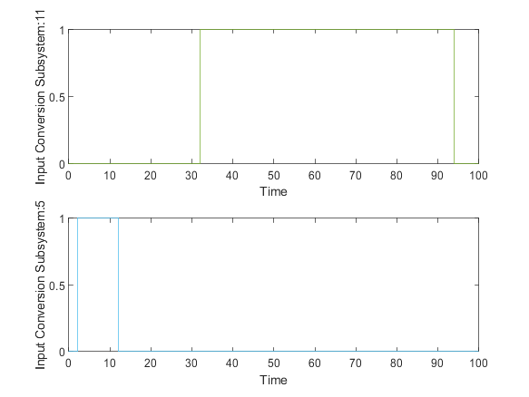

|  |  |
| --- | --- |
| Back to Report Summary | Back to Signal Summary |

|  |  |  |  |  |  |
| --- | --- | --- | --- | --- | --- |
| **Name** | **Data Type** | **Units** | **Sample Time** | **Interp** | **Sync** |
| Input Conversion Subsystem:6 | double |  | Continuous | zoh | union |
| peticionUbicacion | double |  | Continuous | zoh | union |

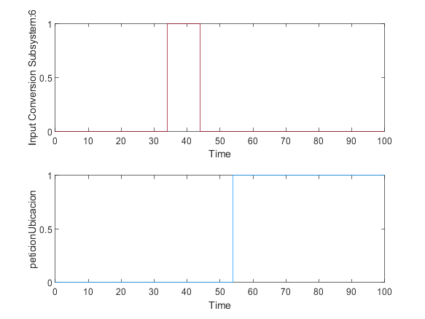

|  |  |
| --- | --- |
| Back to Report Summary | Back to Signal Summary |

|  |  |  |  |  |  |
| --- | --- | --- | --- | --- | --- |
| **Name** | **Data Type** | **Units** | **Sample Time** | **Interp** | **Sync** |
| ubicacion | double |  | Continuous | zoh | union |

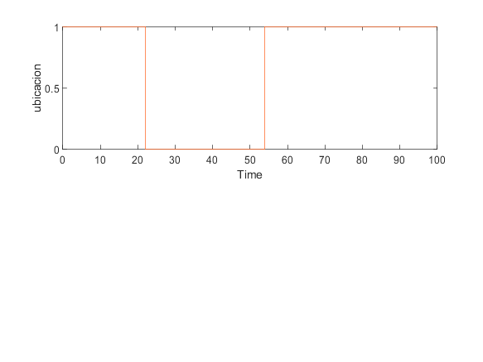

|  |  |
| --- | --- |
| Back to Report Summary | Back to Signal Summary |

Simulation Logs:

['dispensaComida'](matlab:sfprivate('sfOpenObjectBySId','estados_test:1:::232')) is defined, but is not used in the Stateflow chart. [Delete this object](matlab:%20internal.stateflow.dialogs.UnusedObjectDeleter.createDeleter('estados_test:1:::232')) or [configure the diagnostic](matlab:%20sfprivate('openConfigParamsSFDiagnostics',224)).

['actGatera'](matlab:sfprivate('sfOpenObjectBySId','AIRegUbicacion:52:::20')) is defined, but is never used in the Test Sequence block.  [Delete this object.](matlab:%20internal.stateflow.dialogs.UnusedObjectDeleter.createDeleter('AIRegUbicacion:52:::20'))

['actComedero'](matlab:sfprivate('sfOpenObjectBySId','AIRegUbicacion:52:::21')) is defined, but is never used in the Test Sequence block.  [Delete this object.](matlab:%20internal.stateflow.dialogs.UnusedObjectDeleter.createDeleter('AIRegUbicacion:52:::21'))

['peticionUsuario'](matlab:sfprivate('sfOpenObjectBySId','AIRegUbicacion:52:::22')) is defined, but is never used in the Test Sequence block.  [Delete this object.](matlab:%20internal.stateflow.dialogs.UnusedObjectDeleter.createDeleter('AIRegUbicacion:52:::22'))

['peticionIntHora'](matlab:sfprivate('sfOpenObjectBySId','AIRegUbicacion:52:::24')) is defined, but is never used in the Test Sequence block.  [Delete this object.](matlab:%20internal.stateflow.dialogs.UnusedObjectDeleter.createDeleter('AIRegUbicacion:52:::24'))

['modoReal'](matlab:sfprivate('sfOpenObjectBySId','AIRegUbicacion:52:::25')) is defined, but is never used in the Test Sequence block.  [Delete this object.](matlab:%20internal.stateflow.dialogs.UnusedObjectDeleter.createDeleter('AIRegUbicacion:52:::25'))

['ubicacion'](matlab:sfprivate('sfOpenObjectBySId','AIRegUbicacion:52:::26')) is defined, but is never used in the Test Sequence block.  [Delete this object.](matlab:%20internal.stateflow.dialogs.UnusedObjectDeleter.createDeleter('AIRegUbicacion:52:::26'))

['gatoIntroducido'](matlab:sfprivate('sfOpenObjectBySId','AIRegUbicacion:52:::27')) is defined, but is never used in the Test Sequence block.  [Delete this object.](matlab:%20internal.stateflow.dialogs.UnusedObjectDeleter.createDeleter('AIRegUbicacion:52:::27'))

['camarasIN'](matlab:sfprivate('sfOpenObjectBySId','AIRegUbicacion:52:::58')) is defined, but is never used in the Test Sequence block.  [Delete this object.](matlab:%20internal.stateflow.dialogs.UnusedObjectDeleter.createDeleter('AIRegUbicacion:52:::58'))

['camarasOUT'](matlab:sfprivate('sfOpenObjectBySId','AIRegUbicacion:52:::59')) is defined, but is never used in the Test Sequence block.  [Delete this object.](matlab:%20internal.stateflow.dialogs.UnusedObjectDeleter.createDeleter('AIRegUbicacion:52:::59'))

['tiempoSalida'](matlab:sfprivate('sfOpenObjectBySId','AIRegUbicacion:52:::61')) is defined, but is never used in the Test Sequence block.  [Delete this object.](matlab:%20internal.stateflow.dialogs.UnusedObjectDeleter.createDeleter('AIRegUbicacion:52:::61'))

['alertaTiempoFuera'](matlab:sfprivate('sfOpenObjectBySId','AIRegUbicacion:52:::62')) is defined, but is never used in the Test Sequence block.  [Delete this object.](matlab:%20internal.stateflow.dialogs.UnusedObjectDeleter.createDeleter('AIRegUbicacion:52:::62'))

['tiempoFuera'](matlab:sfprivate('sfOpenObjectBySId','AIRegUbicacion:52:::63')) is defined, but is never used in the Test Sequence block.  [Delete this object.](matlab:%20internal.stateflow.dialogs.UnusedObjectDeleter.createDeleter('AIRegUbicacion:52:::63'))

['tiempoDispensa'](matlab:sfprivate('sfOpenObjectBySId','AIRegUbicacion:52:::64')) is defined, but is never used in the Test Sequence block.  [Delete this object.](matlab:%20internal.stateflow.dialogs.UnusedObjectDeleter.createDeleter('AIRegUbicacion:52:::64'))

['alertaDispensar'](matlab:sfprivate('sfOpenObjectBySId','AIRegUbicacion:52:::65')) is defined, but is never used in the Test Sequence block.  [Delete this object.](matlab:%20internal.stateflow.dialogs.UnusedObjectDeleter.createDeleter('AIRegUbicacion:52:::65'))

['tiempoSinAlimentar'](matlab:sfprivate('sfOpenObjectBySId','AIRegUbicacion:52:::66')) is defined, but is never used in the Test Sequence block.  [Delete this object.](matlab:%20internal.stateflow.dialogs.UnusedObjectDeleter.createDeleter('AIRegUbicacion:52:::66'))

['alertaLluvia'](matlab:sfprivate('sfOpenObjectBySId','AIRegUbicacion:52:::67')) is defined, but is never used in the Test Sequence block.  [Delete this object.](matlab:%20internal.stateflow.dialogs.UnusedObjectDeleter.createDeleter('AIRegUbicacion:52:::67'))

['modoAnt'](matlab:sfprivate('sfOpenObjectBySId','AIRegUbicacion:52:::68')) is defined, but is never used in the Test Sequence block.  [Delete this object.](matlab:%20internal.stateflow.dialogs.UnusedObjectDeleter.createDeleter('AIRegUbicacion:52:::68'))

['peticionUbicacion'](matlab:sfprivate('sfOpenObjectBySId','AIRegUbicacion:52:::73')) is defined, but is never used in the Test Sequence block.  [Delete this object.](matlab:%20internal.stateflow.dialogs.UnusedObjectDeleter.createDeleter('AIRegUbicacion:52:::73'))

Back to Report Summary

Test Logs:

No baseline criteria evaluation performed as no baseline data is available for this test.

Back to Report Summary

|  |
| --- |
| **NuevoGato** |

|  |  |
| --- | --- |
| **Test Result Information** | |
| Result Type: | Test Case Result |
| Parent: | estados_test |
| Start Time: | 10-Jan-2021 21:33:55 |
| End Time: | 10-Jan-2021 21:33:55 |
| Outcome: | Passed |
| Description: |  |

Testea la correcta inclusión del nuevo gato en el sistema.

|  |  |
| --- | --- |
| **Test Case Information** | |
| Name: | NuevoGato |
| Type: | Baseline Test |
| **Test Case Requirements** | | |
| Description: | RF-SY_05: El dueño quiere introducir un nuevo gato en el sistema (gatera#17) | |
| Document: | ../resources/requirements/gatera.slreqx | |

**Logical and Temporal Assessments**

|  |  |
| --- | --- |
| **Name** | **Assessment** |
| Assessment1 | At any point in time, whenever (((nuevoGato == 1) & (gateraReconoce == 1)) & (sensorReconoce == 1)) is true then, with no delay, (gatoIntroducido == 1) must be true |

**Simulation**

|  |  |
| --- | --- |
| **System Under Test Information** | |
| Model: | estados_test |
| Harness: | AJNuevoGato |
| Harness Owner: | estados_test |
| Release: | Current |
| Simulation Mode: | normal |
| Override SIL or PIL Mode: | 0 |
| Configuration Set: | Configuration1 |
| Start Time: | 0 |
| Stop Time: | 50 |
| Checksum: | 636095551 4133153916 2336167551 4040280373 |
| Simulink Version: | 10.2 |
| Model Version: | 1.12 |
| Model Author: | Iranzu |
| Date: | Sat Jan 09 17:54:33 2021 |
| User ID: | Juan |
| Model Path: | C:\Users\Juan\Desktop\MODELO_FINAL_V6\CATSAFE\AJNuevoGato.slx |
| Machine Name: | DESKTOP-UQ9MCEP |
| Solver Name: | VariableStepDiscrete |
| Solver Type: | Variable-Step |
| Max Step Size: | 1 |
| Simulation Start Time: | 2021-01-10 21:33:54 |
| Simulation Stop Time: | 2021-01-10 21:33:54 |
| Platform: | PCWIN64 |

**Simulation Output**

|  |  |  |  |  |  |  |
| --- | --- | --- | --- | --- | --- | --- |
| **Name** | **Data Type** | **Units** | **Sample Time** | **Interp** | **Sync** | **Link to Plot** |
| Input Conversion Subsystem:12 | double |  | Continuous | zoh | union | Link |
| Input Conversion Subsystem:13 | double |  | Continuous | zoh | union | Link |
| Input Conversion Subsystem:14 | double |  | Continuous | zoh | union | Link |
| gatoIntroducido | double |  | Continuous | zoh | union | Link |

|  |  |  |  |  |  |
| --- | --- | --- | --- | --- | --- |
| **Name** | **Data Type** | **Units** | **Sample Time** | **Interp** | **Sync** |
| Input Conversion Subsystem:12 | double |  | Continuous | zoh | union |
| Input Conversion Subsystem:13 | double |  | Continuous | zoh | union |

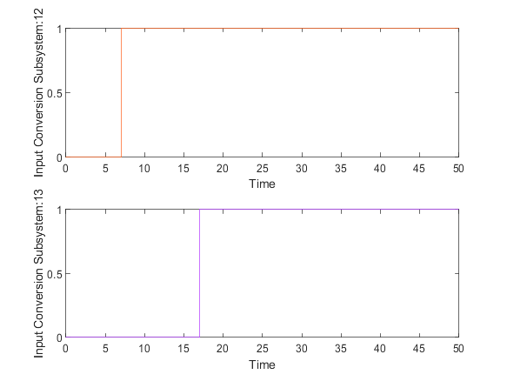

|  |  |
| --- | --- |
| Back to Report Summary | Back to Signal Summary |

|  |  |  |  |  |  |
| --- | --- | --- | --- | --- | --- |
| **Name** | **Data Type** | **Units** | **Sample Time** | **Interp** | **Sync** |
| Input Conversion Subsystem:14 | double |  | Continuous | zoh | union |
| gatoIntroducido | double |  | Continuous | zoh | union |

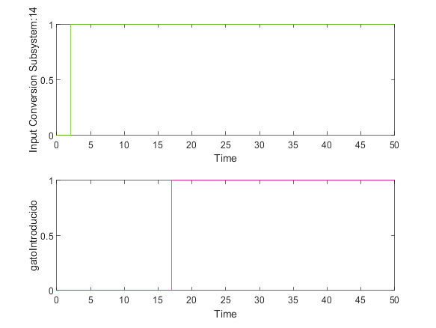

|  |  |
| --- | --- |
| Back to Report Summary | Back to Signal Summary |

Simulation Logs:

['dispensaComida'](matlab:sfprivate('sfOpenObjectBySId','estados_test:1:::232')) is defined, but is not used in the Stateflow chart. [Delete this object](matlab:%20internal.stateflow.dialogs.UnusedObjectDeleter.createDeleter('estados_test:1:::232')) or [configure the diagnostic](matlab:%20sfprivate('openConfigParamsSFDiagnostics',224)).

'[Input Port 1](matlab:slprivate('open_and_hilite_port_hyperlink',%20'hilite',%20['AJNuevoGato/Goto_4'%5d,%20'Inport',%201);)' of '[AJNuevoGato/Goto_4](matlab:open_and_hilite_hyperlink%20('AJNuevoGato/Goto_4','error'))' is not connected.

'[Input Port 15](matlab:slprivate('open_and_hilite_port_hyperlink',%20'hilite',%20['AJNuevoGato/Input%20Conversion%20Subsystem'%5d,%20'Inport',%2015);)' of '[AJNuevoGato/Input Conversion Subsystem](matlab:open_and_hilite_hyperlink%20('AJNuevoGato/Input%20Conversion%20Subsystem','error'))' is not connected.

'[Input Port 16](matlab:slprivate('open_and_hilite_port_hyperlink',%20'hilite',%20['AJNuevoGato/Input%20Conversion%20Subsystem'%5d,%20'Inport',%2016);)' of '[AJNuevoGato/Input Conversion Subsystem](matlab:open_and_hilite_hyperlink%20('AJNuevoGato/Input%20Conversion%20Subsystem','error'))' is not connected.

'[Input Port 17](matlab:slprivate('open_and_hilite_port_hyperlink',%20'hilite',%20['AJNuevoGato/Input%20Conversion%20Subsystem'%5d,%20'Inport',%2017);)' of '[AJNuevoGato/Input Conversion Subsystem](matlab:open_and_hilite_hyperlink%20('AJNuevoGato/Input%20Conversion%20Subsystem','error'))' is not connected.

'[Output Port 8](matlab:slprivate('open_and_hilite_port_hyperlink',%20'hilite',%20['AJNuevoGato/Output%20Conversion%20Subsystem'%5d,%20'Outport',%208);)' of '[AJNuevoGato/Output Conversion Subsystem](matlab:open_and_hilite_hyperlink%20('AJNuevoGato/Output%20Conversion%20Subsystem','error'))' is not connected.

'[Output Port 9](matlab:slprivate('open_and_hilite_port_hyperlink',%20'hilite',%20['AJNuevoGato/Output%20Conversion%20Subsystem'%5d,%20'Outport',%209);)' of '[AJNuevoGato/Output Conversion Subsystem](matlab:open_and_hilite_hyperlink%20('AJNuevoGato/Output%20Conversion%20Subsystem','error'))' is not connected.

'[Output Port 10](matlab:slprivate('open_and_hilite_port_hyperlink',%20'hilite',%20['AJNuevoGato/Output%20Conversion%20Subsystem'%5d,%20'Outport',%2010);)' of '[AJNuevoGato/Output Conversion Subsystem](matlab:open_and_hilite_hyperlink%20('AJNuevoGato/Output%20Conversion%20Subsystem','error'))' is not connected.

'[Output Port 11](matlab:slprivate('open_and_hilite_port_hyperlink',%20'hilite',%20['AJNuevoGato/Output%20Conversion%20Subsystem'%5d,%20'Outport',%2011);)' of '[AJNuevoGato/Output Conversion Subsystem](matlab:open_and_hilite_hyperlink%20('AJNuevoGato/Output%20Conversion%20Subsystem','error'))' is not connected.

'[Output Port 12](matlab:slprivate('open_and_hilite_port_hyperlink',%20'hilite',%20['AJNuevoGato/Output%20Conversion%20Subsystem'%5d,%20'Outport',%2012);)' of '[AJNuevoGato/Output Conversion Subsystem](matlab:open_and_hilite_hyperlink%20('AJNuevoGato/Output%20Conversion%20Subsystem','error'))' is not connected.

'[Output Port 13](matlab:slprivate('open_and_hilite_port_hyperlink',%20'hilite',%20['AJNuevoGato/Output%20Conversion%20Subsystem'%5d,%20'Outport',%2013);)' of '[AJNuevoGato/Output Conversion Subsystem](matlab:open_and_hilite_hyperlink%20('AJNuevoGato/Output%20Conversion%20Subsystem','error'))' is not connected.

'[Output Port 14](matlab:slprivate('open_and_hilite_port_hyperlink',%20'hilite',%20['AJNuevoGato/Output%20Conversion%20Subsystem'%5d,%20'Outport',%2014);)' of '[AJNuevoGato/Output Conversion Subsystem](matlab:open_and_hilite_hyperlink%20('AJNuevoGato/Output%20Conversion%20Subsystem','error'))' is not connected.

'[Output Port 15](matlab:slprivate('open_and_hilite_port_hyperlink',%20'hilite',%20['AJNuevoGato/Output%20Conversion%20Subsystem'%5d,%20'Outport',%2015);)' of '[AJNuevoGato/Output Conversion Subsystem](matlab:open_and_hilite_hyperlink%20('AJNuevoGato/Output%20Conversion%20Subsystem','error'))' is not connected.

'[Output Port 16](matlab:slprivate('open_and_hilite_port_hyperlink',%20'hilite',%20['AJNuevoGato/Output%20Conversion%20Subsystem'%5d,%20'Outport',%2016);)' of '[AJNuevoGato/Output Conversion Subsystem](matlab:open_and_hilite_hyperlink%20('AJNuevoGato/Output%20Conversion%20Subsystem','error'))' is not connected.

'[Output Port 17](matlab:slprivate('open_and_hilite_port_hyperlink',%20'hilite',%20['AJNuevoGato/Output%20Conversion%20Subsystem'%5d,%20'Outport',%2017);)' of '[AJNuevoGato/Output Conversion Subsystem](matlab:open_and_hilite_hyperlink%20('AJNuevoGato/Output%20Conversion%20Subsystem','error'))' is not connected.

'[Output Port 18](matlab:slprivate('open_and_hilite_port_hyperlink',%20'hilite',%20['AJNuevoGato/Output%20Conversion%20Subsystem'%5d,%20'Outport',%2018);)' of '[AJNuevoGato/Output Conversion Subsystem](matlab:open_and_hilite_hyperlink%20('AJNuevoGato/Output%20Conversion%20Subsystem','error'))' is not connected.

'[Output Port 8](matlab:slprivate('open_and_hilite_port_hyperlink',%20'hilite',%20['AJNuevoGato/Test%20Sequence'%5d,%20'Outport',%208);)' of '[AJNuevoGato/Test Sequence](matlab:open_and_hilite_hyperlink%20('AJNuevoGato/Test%20Sequence','error'))' is not connected.

'[Output Port 9](matlab:slprivate('open_and_hilite_port_hyperlink',%20'hilite',%20['AJNuevoGato/Test%20Sequence'%5d,%20'Outport',%209);)' of '[AJNuevoGato/Test Sequence](matlab:open_and_hilite_hyperlink%20('AJNuevoGato/Test%20Sequence','error'))' is not connected.

['actGatera'](matlab:sfprivate('sfOpenObjectBySId','AJNuevoGato:52:::20')) is defined, but is never used in the Test Sequence block.  [Delete this object.](matlab:%20internal.stateflow.dialogs.UnusedObjectDeleter.createDeleter('AJNuevoGato:52:::20'))

['actComedero'](matlab:sfprivate('sfOpenObjectBySId','AJNuevoGato:52:::21')) is defined, but is never used in the Test Sequence block.  [Delete this object.](matlab:%20internal.stateflow.dialogs.UnusedObjectDeleter.createDeleter('AJNuevoGato:52:::21'))

['peticionUsuario'](matlab:sfprivate('sfOpenObjectBySId','AJNuevoGato:52:::22')) is defined, but is never used in the Test Sequence block.  [Delete this object.](matlab:%20internal.stateflow.dialogs.UnusedObjectDeleter.createDeleter('AJNuevoGato:52:::22'))

['peticionUsuarioCom'](matlab:sfprivate('sfOpenObjectBySId','AJNuevoGato:52:::23')) is defined, but is never used in the Test Sequence block.  [Delete this object.](matlab:%20internal.stateflow.dialogs.UnusedObjectDeleter.createDeleter('AJNuevoGato:52:::23'))

['peticionIntHora'](matlab:sfprivate('sfOpenObjectBySId','AJNuevoGato:52:::24')) is defined, but is never used in the Test Sequence block.  [Delete this object.](matlab:%20internal.stateflow.dialogs.UnusedObjectDeleter.createDeleter('AJNuevoGato:52:::24'))

['modoReal'](matlab:sfprivate('sfOpenObjectBySId','AJNuevoGato:52:::25')) is defined, but is never used in the Test Sequence block.  [Delete this object.](matlab:%20internal.stateflow.dialogs.UnusedObjectDeleter.createDeleter('AJNuevoGato:52:::25'))

['ubicacion'](matlab:sfprivate('sfOpenObjectBySId','AJNuevoGato:52:::26')) is defined, but is never used in the Test Sequence block.  [Delete this object.](matlab:%20internal.stateflow.dialogs.UnusedObjectDeleter.createDeleter('AJNuevoGato:52:::26'))

['gatoIntroducido'](matlab:sfprivate('sfOpenObjectBySId','AJNuevoGato:52:::27')) is defined, but is never used in the Test Sequence block.  [Delete this object.](matlab:%20internal.stateflow.dialogs.UnusedObjectDeleter.createDeleter('AJNuevoGato:52:::27'))

Back to Report Summary

Test Logs:

No baseline criteria evaluation performed as no baseline data is available for this test.

Back to Report Summary

|  |
| --- |
| **Observacion** |

|  |  |
| --- | --- |
| **Test Result Information** | |
| Result Type: | Test Case Result |
| Parent: | estados_test |
| Start Time: | 10-Jan-2021 21:33:57 |
| End Time: | 10-Jan-2021 21:33:57 |
| Outcome: | Passed |
| Description: |  |

Testea el correcto funcionamiento de las cámaras alternativamente en función de la ubicación del animal.

La comprobación se ha realizado durante el proceso de salida del gato al exterior, comprobando su ubicación en el interior en un inicio, mostrando imágenes del interior de la vivienda, y pasando esta a señalar que se encuentra en el exterior cuando el gato atraviesa la gatera, mostrando entonces imágenes de las cámaras del exterior.

|  |  |
| --- | --- |
| **Test Case Information** | |
| Name: | Observacion |
| Type: | Baseline Test |
| **Test Case Requirements** | | |
| Description: | RF-CA_01: El dueño quiere ver las imágenes de las cámaras a tiempo real (gatera#18) | |
| Document: | ../resources/requirements/gatera.slreqx | |

**Logical and Temporal Assessments**

|  |  |
| --- | --- |
| **Name** | **Assessment** |
| Assessment1 | At any point in time, whenever ((solCamaras == 1) & (ubicacion == 1)) is true then, with a delay of at most 7 seconds, (camarasIN == ubicacion) must be true |
| Assessment2 | At any point in time, whenever ((solCamaras == 1) & (ubicacion == 0)) is true then, with no delay, (camarasOUT == ubicacion) must be true |

**Simulation**

|  |  |
| --- | --- |
| **System Under Test Information** | |
| Model: | estados_test |
| Harness: | AKObservacion |
| Harness Owner: | estados_test |
| Release: | Current |
| Simulation Mode: | normal |
| Override SIL or PIL Mode: | 0 |
| Configuration Set: | Configuration1 |
| Start Time: | 0 |
| Stop Time: | 100 |
| Checksum: | 3472453390 2222712609 1009025043 1973992697 |
| Simulink Version: | 10.2 |
| Model Version: | 1.20 |
| Model Author: | Iranzu |
| Date: | Sun Jan 10 13:20:24 2021 |
| User ID: | Juan |
| Model Path: | C:\Users\Juan\Desktop\MODELO_FINAL_V6\CATSAFE\AKObservacion.slx |
| Machine Name: | DESKTOP-UQ9MCEP |
| Solver Name: | VariableStepDiscrete |
| Solver Type: | Variable-Step |
| Max Step Size: | 2 |
| Simulation Start Time: | 2021-01-10 21:33:55 |
| Simulation Stop Time: | 2021-01-10 21:33:57 |
| Platform: | PCWIN64 |

**Simulation Output**

|  |  |  |  |  |  |  |
| --- | --- | --- | --- | --- | --- | --- |
| **Name** | **Data Type** | **Units** | **Sample Time** | **Interp** | **Sync** | **Link to Plot** |
| Input Conversion Subsystem:15 | double |  | Continuous | zoh | union | Link |
| ubicacion | double |  | Continuous | zoh | union | Link |
| camarasOUT | double |  | Continuous | zoh | union | Link |
| camarasIN | double |  | Continuous | zoh | union | Link |

|  |  |  |  |  |  |
| --- | --- | --- | --- | --- | --- |
| **Name** | **Data Type** | **Units** | **Sample Time** | **Interp** | **Sync** |
| Input Conversion Subsystem:15 | double |  | Continuous | zoh | union |
| ubicacion | double |  | Continuous | zoh | union |

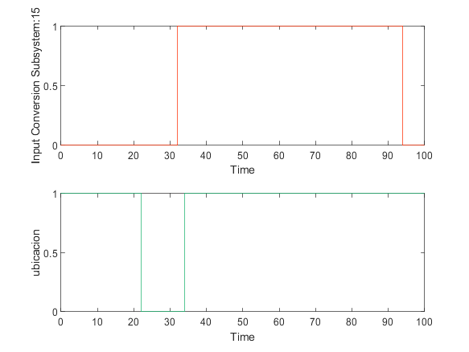

|  |  |
| --- | --- |
| Back to Report Summary | Back to Signal Summary |

|  |  |  |  |  |  |
| --- | --- | --- | --- | --- | --- |
| **Name** | **Data Type** | **Units** | **Sample Time** | **Interp** | **Sync** |
| camarasOUT | double |  | Continuous | zoh | union |
| camarasIN | double |  | Continuous | zoh | union |

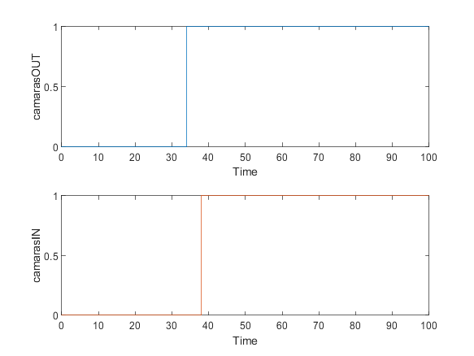

|  |  |
| --- | --- |
| Back to Report Summary | Back to Signal Summary |

Simulation Logs:

['dispensaComida'](matlab:sfprivate('sfOpenObjectBySId','estados_test:1:::232')) is defined, but is not used in the Stateflow chart. [Delete this object](matlab:%20internal.stateflow.dialogs.UnusedObjectDeleter.createDeleter('estados_test:1:::232')) or [configure the diagnostic](matlab:%20sfprivate('openConfigParamsSFDiagnostics',224)).

Matching "Goto" for "From" '[AKObservacion/From_4](matlab:open_and_hilite_hyperlink%20('AKObservacion/From_4','error'))' not found

'[Input Port 16](matlab:slprivate('open_and_hilite_port_hyperlink',%20'hilite',%20['AKObservacion/Input%20Conversion%20Subsystem'%5d,%20'Inport',%2016);)' of '[AKObservacion/Input Conversion Subsystem](matlab:open_and_hilite_hyperlink%20('AKObservacion/Input%20Conversion%20Subsystem','error'))' is not connected.

'[Input Port 17](matlab:slprivate('open_and_hilite_port_hyperlink',%20'hilite',%20['AKObservacion/Input%20Conversion%20Subsystem'%5d,%20'Inport',%2017);)' of '[AKObservacion/Input Conversion Subsystem](matlab:open_and_hilite_hyperlink%20('AKObservacion/Input%20Conversion%20Subsystem','error'))' is not connected.

'[Output Port 10](matlab:slprivate('open_and_hilite_port_hyperlink',%20'hilite',%20['AKObservacion/Output%20Conversion%20Subsystem'%5d,%20'Outport',%2010);)' of '[AKObservacion/Output Conversion Subsystem](matlab:open_and_hilite_hyperlink%20('AKObservacion/Output%20Conversion%20Subsystem','error'))' is not connected.

'[Output Port 11](matlab:slprivate('open_and_hilite_port_hyperlink',%20'hilite',%20['AKObservacion/Output%20Conversion%20Subsystem'%5d,%20'Outport',%2011);)' of '[AKObservacion/Output Conversion Subsystem](matlab:open_and_hilite_hyperlink%20('AKObservacion/Output%20Conversion%20Subsystem','error'))' is not connected.

'[Output Port 12](matlab:slprivate('open_and_hilite_port_hyperlink',%20'hilite',%20['AKObservacion/Output%20Conversion%20Subsystem'%5d,%20'Outport',%2012);)' of '[AKObservacion/Output Conversion Subsystem](matlab:open_and_hilite_hyperlink%20('AKObservacion/Output%20Conversion%20Subsystem','error'))' is not connected.

'[Output Port 13](matlab:slprivate('open_and_hilite_port_hyperlink',%20'hilite',%20['AKObservacion/Output%20Conversion%20Subsystem'%5d,%20'Outport',%2013);)' of '[AKObservacion/Output Conversion Subsystem](matlab:open_and_hilite_hyperlink%20('AKObservacion/Output%20Conversion%20Subsystem','error'))' is not connected.

'[Output Port 14](matlab:slprivate('open_and_hilite_port_hyperlink',%20'hilite',%20['AKObservacion/Output%20Conversion%20Subsystem'%5d,%20'Outport',%2014);)' of '[AKObservacion/Output Conversion Subsystem](matlab:open_and_hilite_hyperlink%20('AKObservacion/Output%20Conversion%20Subsystem','error'))' is not connected.

'[Output Port 15](matlab:slprivate('open_and_hilite_port_hyperlink',%20'hilite',%20['AKObservacion/Output%20Conversion%20Subsystem'%5d,%20'Outport',%2015);)' of '[AKObservacion/Output Conversion Subsystem](matlab:open_and_hilite_hyperlink%20('AKObservacion/Output%20Conversion%20Subsystem','error'))' is not connected.

'[Output Port 16](matlab:slprivate('open_and_hilite_port_hyperlink',%20'hilite',%20['AKObservacion/Output%20Conversion%20Subsystem'%5d,%20'Outport',%2016);)' of '[AKObservacion/Output Conversion Subsystem](matlab:open_and_hilite_hyperlink%20('AKObservacion/Output%20Conversion%20Subsystem','error'))' is not connected.

'[Output Port 17](matlab:slprivate('open_and_hilite_port_hyperlink',%20'hilite',%20['AKObservacion/Output%20Conversion%20Subsystem'%5d,%20'Outport',%2017);)' of '[AKObservacion/Output Conversion Subsystem](matlab:open_and_hilite_hyperlink%20('AKObservacion/Output%20Conversion%20Subsystem','error'))' is not connected.

'[Output Port 18](matlab:slprivate('open_and_hilite_port_hyperlink',%20'hilite',%20['AKObservacion/Output%20Conversion%20Subsystem'%5d,%20'Outport',%2018);)' of '[AKObservacion/Output Conversion Subsystem](matlab:open_and_hilite_hyperlink%20('AKObservacion/Output%20Conversion%20Subsystem','error'))' is not connected.

['actGatera'](matlab:sfprivate('sfOpenObjectBySId','AKObservacion:55:::20')) is defined, but is never used in the Test Sequence block.  [Delete this object.](matlab:%20internal.stateflow.dialogs.UnusedObjectDeleter.createDeleter('AKObservacion:55:::20'))

['actComedero'](matlab:sfprivate('sfOpenObjectBySId','AKObservacion:55:::21')) is defined, but is never used in the Test Sequence block.  [Delete this object.](matlab:%20internal.stateflow.dialogs.UnusedObjectDeleter.createDeleter('AKObservacion:55:::21'))

['peticionUsuario'](matlab:sfprivate('sfOpenObjectBySId','AKObservacion:55:::22')) is defined, but is never used in the Test Sequence block.  [Delete this object.](matlab:%20internal.stateflow.dialogs.UnusedObjectDeleter.createDeleter('AKObservacion:55:::22'))

['peticionUsuarioCom'](matlab:sfprivate('sfOpenObjectBySId','AKObservacion:55:::23')) is defined, but is never used in the Test Sequence block.  [Delete this object.](matlab:%20internal.stateflow.dialogs.UnusedObjectDeleter.createDeleter('AKObservacion:55:::23'))

['peticionIntHora'](matlab:sfprivate('sfOpenObjectBySId','AKObservacion:55:::24')) is defined, but is never used in the Test Sequence block.  [Delete this object.](matlab:%20internal.stateflow.dialogs.UnusedObjectDeleter.createDeleter('AKObservacion:55:::24'))

['modoReal'](matlab:sfprivate('sfOpenObjectBySId','AKObservacion:55:::25')) is defined, but is never used in the Test Sequence block.  [Delete this object.](matlab:%20internal.stateflow.dialogs.UnusedObjectDeleter.createDeleter('AKObservacion:55:::25'))

['ubicacion'](matlab:sfprivate('sfOpenObjectBySId','AKObservacion:55:::26')) is defined, but is never used in the Test Sequence block.  [Delete this object.](matlab:%20internal.stateflow.dialogs.UnusedObjectDeleter.createDeleter('AKObservacion:55:::26'))

['gatoIntroducido'](matlab:sfprivate('sfOpenObjectBySId','AKObservacion:55:::27')) is defined, but is never used in the Test Sequence block.  [Delete this object.](matlab:%20internal.stateflow.dialogs.UnusedObjectDeleter.createDeleter('AKObservacion:55:::27'))

['camarasOUT'](matlab:sfprivate('sfOpenObjectBySId','AKObservacion:55:::28')) is defined, but is never used in the Test Sequence block.  [Delete this object.](matlab:%20internal.stateflow.dialogs.UnusedObjectDeleter.createDeleter('AKObservacion:55:::28'))

['camarasIN'](matlab:sfprivate('sfOpenObjectBySId','AKObservacion:55:::29')) is defined, but is never used in the Test Sequence block.  [Delete this object.](matlab:%20internal.stateflow.dialogs.UnusedObjectDeleter.createDeleter('AKObservacion:55:::29'))

Back to Report Summary

Test Logs:

No baseline criteria evaluation performed as no baseline data is available for this test.

Back to Report Summary

|  |
| --- |
| **AlertaExcesoTiempoFueraAutomatico** |

|  |  |
| --- | --- |
| **Test Result Information** | |
| Result Type: | Test Case Result |
| Parent: | estados_test |
| Start Time: | 10-Jan-2021 21:33:59 |
| End Time: | 10-Jan-2021 21:33:59 |
| Outcome: | Passed |
| Description: |  |

Verifica que el Gato está fuera más de un tiempo determinado alta la alerta de exceso de tiempo fuera. Válido para modo automático. El tiempo establecido es de 20 segundos y sólo en el caso d eque sea superado se activará la alerta, debiendo desaparecer en caso contrario.

|  |  |
| --- | --- |
| **Test Case Information** | |
| Name: | AlertaExcesoTiempoFueraAutomatico |
| Type: | Baseline Test |
| **Test Case Requirements** | | |
| Description: | RF-SY_06: Aviso de emergencia. El gato lleva demasiado tiempo en el exterior (gatera#19) | |
| Document: | ../resources/requirements/gatera.slreqx | |

**Logical and Temporal Assessments**

|  |  |
| --- | --- |
| **Name** | **Assessment** |
| Assessment1 | At any point in time, whenever (tiempoFuera >= 20) is true then, with a delay of at most 5 seconds, (alertaTiempoFuera == 1) must be true |
| Assessment2 | At any point in time, whenever (tiempoFuera < 20) is true then, with no delay, (alertaTiempoFuera == 0) must be true |

**Simulation**

|  |  |
| --- | --- |
| **System Under Test Information** | |
| Model: | estados_test |
| Harness: | ALAlertaExcesoTiempoFueraAuto |
| Harness Owner: | estados_test |
| Release: | Current |
| Simulation Mode: | normal |
| Override SIL or PIL Mode: | 0 |
| Configuration Set: | Configuration1 |
| Start Time: | 0 |
| Stop Time: | 50 |
| Checksum: | 3788638115 303384496 2087179189 1227073628 |
| Simulink Version: | 10.2 |
| Model Version: | 1.7 |
| Model Author: | Juan |
| Date: | Wed Jan 06 00:47:18 2021 |
| User ID: | Juan |
| Model Path: | C:\Users\Juan\Desktop\MODELO_FINAL_V6\CATSAFE\ALAlertaExcesoTiempoFueraAuto.slx |
| Machine Name: | DESKTOP-UQ9MCEP |
| Solver Name: | VariableStepDiscrete |
| Solver Type: | Variable-Step |
| Max Step Size: | 1 |
| Simulation Start Time: | 2021-01-10 21:33:57 |
| Simulation Stop Time: | 2021-01-10 21:33:59 |
| Platform: | PCWIN64 |

**Simulation Output**

|  |  |  |  |  |  |  |
| --- | --- | --- | --- | --- | --- | --- |
| **Name** | **Data Type** | **Units** | **Sample Time** | **Interp** | **Sync** | **Link to Plot** |
| Input Conversion Subsystem:18 | double |  | Continuous | zoh | union | Link |
| actGatera | double |  | Continuous | zoh | union | Link |
| alertaTiempoFuera | double |  | Continuous | zoh | union | Link |
| tiempoFuera | double |  | Continuous | zoh | union | Link |
| tiempoSalida | double |  | Continuous | zoh | union | Link |

|  |  |  |  |  |  |
| --- | --- | --- | --- | --- | --- |
| **Name** | **Data Type** | **Units** | **Sample Time** | **Interp** | **Sync** |
| Input Conversion Subsystem:18 | double |  | Continuous | zoh | union |
| actGatera | double |  | Continuous | zoh | union |

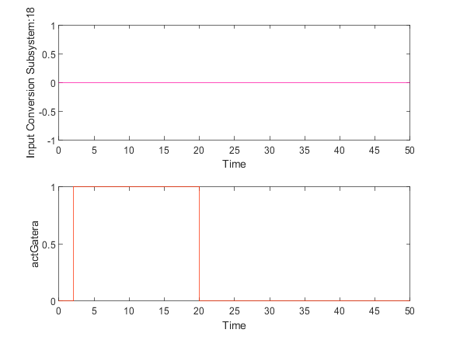

|  |  |
| --- | --- |
| Back to Report Summary | Back to Signal Summary |

|  |  |  |  |  |  |
| --- | --- | --- | --- | --- | --- |
| **Name** | **Data Type** | **Units** | **Sample Time** | **Interp** | **Sync** |
| alertaTiempoFuera | double |  | Continuous | zoh | union |
| tiempoFuera | double |  | Continuous | zoh | union |

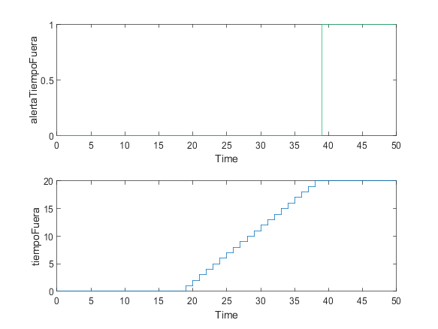

|  |  |
| --- | --- |
| Back to Report Summary | Back to Signal Summary |

|  |  |  |  |  |  |
| --- | --- | --- | --- | --- | --- |
| **Name** | **Data Type** | **Units** | **Sample Time** | **Interp** | **Sync** |
| tiempoSalida | double |  | Continuous | zoh | union |

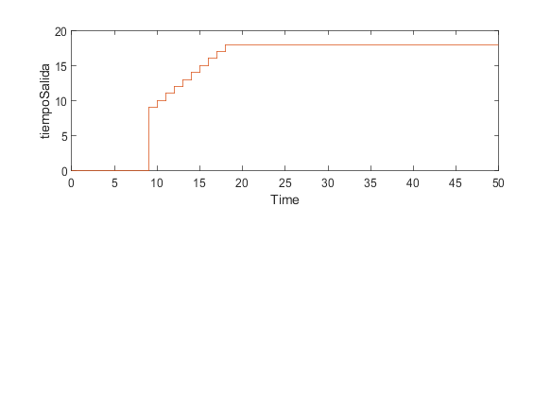

|  |  |
| --- | --- |
| Back to Report Summary | Back to Signal Summary |

Simulation Logs:

['dispensaComida'](matlab:sfprivate('sfOpenObjectBySId','estados_test:1:::232')) is defined, but is not used in the Stateflow chart. [Delete this object](matlab:%20internal.stateflow.dialogs.UnusedObjectDeleter.createDeleter('estados_test:1:::232')) or [configure the diagnostic](matlab:%20sfprivate('openConfigParamsSFDiagnostics',224)).

'[Output Port 18](matlab:slprivate('open_and_hilite_port_hyperlink',%20'hilite',%20['ALAlertaExcesoTiempoFueraAuto/estados_test'%5d,%20'Outport',%2018);)' of '[ALAlertaExcesoTiempoFueraAuto/estados_test](matlab:open_and_hilite_hyperlink%20('ALAlertaExcesoTiempoFueraAuto/estados_test','error'))' is not connected.

Unconnected output line found on '[ALAlertaExcesoTiempoFueraAuto/Input Conversion Subsystem](matlab:open_and_hilite_hyperlink%20('ALAlertaExcesoTiempoFueraAuto/Input%20Conversion%20Subsystem','error'))' (output port: 18)

['actGatera'](matlab:sfprivate('sfOpenObjectBySId','ALAlertaExcesoTiempoFueraAuto:58:::20')) is defined, but is never used in the Test Sequence block.  [Delete this object.](matlab:%20internal.stateflow.dialogs.UnusedObjectDeleter.createDeleter('ALAlertaExcesoTiempoFueraAuto:58:::20'))

['actComedero'](matlab:sfprivate('sfOpenObjectBySId','ALAlertaExcesoTiempoFueraAuto:58:::21')) is defined, but is never used in the Test Sequence block.  [Delete this object.](matlab:%20internal.stateflow.dialogs.UnusedObjectDeleter.createDeleter('ALAlertaExcesoTiempoFueraAuto:58:::21'))

['peticionUsuario'](matlab:sfprivate('sfOpenObjectBySId','ALAlertaExcesoTiempoFueraAuto:58:::22')) is defined, but is never used in the Test Sequence block.  [Delete this object.](matlab:%20internal.stateflow.dialogs.UnusedObjectDeleter.createDeleter('ALAlertaExcesoTiempoFueraAuto:58:::22'))

['peticionIntHora'](matlab:sfprivate('sfOpenObjectBySId','ALAlertaExcesoTiempoFueraAuto:58:::23')) is defined, but is never used in the Test Sequence block.  [Delete this object.](matlab:%20internal.stateflow.dialogs.UnusedObjectDeleter.createDeleter('ALAlertaExcesoTiempoFueraAuto:58:::23'))

['modoReal'](matlab:sfprivate('sfOpenObjectBySId','ALAlertaExcesoTiempoFueraAuto:58:::24')) is defined, but is never used in the Test Sequence block.  [Delete this object.](matlab:%20internal.stateflow.dialogs.UnusedObjectDeleter.createDeleter('ALAlertaExcesoTiempoFueraAuto:58:::24'))

['ubicacion'](matlab:sfprivate('sfOpenObjectBySId','ALAlertaExcesoTiempoFueraAuto:58:::25')) is defined, but is never used in the Test Sequence block.  [Delete this object.](matlab:%20internal.stateflow.dialogs.UnusedObjectDeleter.createDeleter('ALAlertaExcesoTiempoFueraAuto:58:::25'))

['gatoIntroducido'](matlab:sfprivate('sfOpenObjectBySId','ALAlertaExcesoTiempoFueraAuto:58:::26')) is defined, but is never used in the Test Sequence block.  [Delete this object.](matlab:%20internal.stateflow.dialogs.UnusedObjectDeleter.createDeleter('ALAlertaExcesoTiempoFueraAuto:58:::26'))

['camarasOUT'](matlab:sfprivate('sfOpenObjectBySId','ALAlertaExcesoTiempoFueraAuto:58:::27')) is defined, but is never used in the Test Sequence block.  [Delete this object.](matlab:%20internal.stateflow.dialogs.UnusedObjectDeleter.createDeleter('ALAlertaExcesoTiempoFueraAuto:58:::27'))

['camarasIN'](matlab:sfprivate('sfOpenObjectBySId','ALAlertaExcesoTiempoFueraAuto:58:::28')) is defined, but is never used in the Test Sequence block.  [Delete this object.](matlab:%20internal.stateflow.dialogs.UnusedObjectDeleter.createDeleter('ALAlertaExcesoTiempoFueraAuto:58:::28'))

['tiempoSalida'](matlab:sfprivate('sfOpenObjectBySId','ALAlertaExcesoTiempoFueraAuto:58:::29')) is defined, but is never used in the Test Sequence block.  [Delete this object.](matlab:%20internal.stateflow.dialogs.UnusedObjectDeleter.createDeleter('ALAlertaExcesoTiempoFueraAuto:58:::29'))

['alertaTiempoFuera'](matlab:sfprivate('sfOpenObjectBySId','ALAlertaExcesoTiempoFueraAuto:58:::30')) is defined, but is never used in the Test Sequence block.  [Delete this object.](matlab:%20internal.stateflow.dialogs.UnusedObjectDeleter.createDeleter('ALAlertaExcesoTiempoFueraAuto:58:::30'))

['tiempoFuera'](matlab:sfprivate('sfOpenObjectBySId','ALAlertaExcesoTiempoFueraAuto:58:::31')) is defined, but is never used in the Test Sequence block.  [Delete this object.](matlab:%20internal.stateflow.dialogs.UnusedObjectDeleter.createDeleter('ALAlertaExcesoTiempoFueraAuto:58:::31'))

['tiempoDispensa'](matlab:sfprivate('sfOpenObjectBySId','ALAlertaExcesoTiempoFueraAuto:58:::32')) is defined, but is never used in the Test Sequence block.  [Delete this object.](matlab:%20internal.stateflow.dialogs.UnusedObjectDeleter.createDeleter('ALAlertaExcesoTiempoFueraAuto:58:::32'))

['alertaDispensar'](matlab:sfprivate('sfOpenObjectBySId','ALAlertaExcesoTiempoFueraAuto:58:::33')) is defined, but is never used in the Test Sequence block.  [Delete this object.](matlab:%20internal.stateflow.dialogs.UnusedObjectDeleter.createDeleter('ALAlertaExcesoTiempoFueraAuto:58:::33'))

['tiempoSinAlimentar'](matlab:sfprivate('sfOpenObjectBySId','ALAlertaExcesoTiempoFueraAuto:58:::34')) is defined, but is never used in the Test Sequence block.  [Delete this object.](matlab:%20internal.stateflow.dialogs.UnusedObjectDeleter.createDeleter('ALAlertaExcesoTiempoFueraAuto:58:::34'))

['alertaLluvia'](matlab:sfprivate('sfOpenObjectBySId','ALAlertaExcesoTiempoFueraAuto:58:::35')) is defined, but is never used in the Test Sequence block.  [Delete this object.](matlab:%20internal.stateflow.dialogs.UnusedObjectDeleter.createDeleter('ALAlertaExcesoTiempoFueraAuto:58:::35'))

['modoAnt'](matlab:sfprivate('sfOpenObjectBySId','ALAlertaExcesoTiempoFueraAuto:58:::36')) is defined, but is never used in the Test Sequence block.  [Delete this object.](matlab:%20internal.stateflow.dialogs.UnusedObjectDeleter.createDeleter('ALAlertaExcesoTiempoFueraAuto:58:::36'))

Back to Report Summary

Test Logs:

No baseline criteria evaluation performed as no baseline data is available for this test.

Back to Report Summary

|  |
| --- |
| **AlertaTiempoSinAlimentar** |

|  |  |
| --- | --- |
| **Test Result Information** | |
| Result Type: | Test Case Result |
| Parent: | estados_test |
| Start Time: | 10-Jan-2021 21:34:02 |
| End Time: | 10-Jan-2021 21:34:02 |
| Outcome: | Passed |
| Description: |  |

Testea que se envíe correctamente una alerta cuando se ha superado un tiempo determinado desde la última vez que se dispensó comida. El tiempo establecido es de 25 segundos y sólo en ese caso deberá aparecer la alerta, debiendo desaparecer en caso contrario. Se deberá comprobar además que el sistema dispensa comida de forma automática si salta la alerta y el usuario está dormido, recibiendo dicha información de un sistema externo.

|  |  |
| --- | --- |
| **Test Case Information** | |
| Name: | AlertaTiempoSinAlimentar |
| Type: | Baseline Test |
| **Test Case Requirements** | | |
| Description: | RF-SY_07 (Requisito cruzado): Aviso de emergencia. El gato lleva demasiado tiempo sin alimentarse (gatera#21) | |
| Document: | ../resources/requirements/gatera.slreqx | |

**Logical and Temporal Assessments**

|  |  |
| --- | --- |
| **Name** | **Assessment** |
| Assessment1 | At any point in time, whenever (tiempoSinAlimentar >= 25) is true then, with a delay of at most 5 seconds, (alertaDispensar == 1) must be true |
| Assessment2 | At any point in time, if (autorizUsuarioCom == 1) becomes true then, with a delay of at most 30 seconds, ((alertaDispensar == 0) & (actComedero == 1)) must be true |
| Assessment3 | At any point in time, if (propietarioDormido == 1) becomes true then, with a delay of at most 30 seconds, ((alertaDispensar == 0) & (actComedero == 1)) must be true |
| Assessment4 | At any point in time, whenever ((alertaDispensar == 0) & (actComedero == 1)) is true then, with a delay of at most 17 seconds, (actComedero == 0) must be true |
| Assessment5 | At any point in time, whenever (tiempoSinAlimentar < 25) is true then, with a delay of at most 5 seconds, (alertaDispensar == 0) must be true |

**Simulation**

|  |  |
| --- | --- |
| **System Under Test Information** | |
| Model: | estados_test |
| Harness: | ALAlertaTiempoSinAlimentar |
| Harness Owner: | estados_test |
| Release: | Current |
| Simulation Mode: | normal |
| Override SIL or PIL Mode: | 0 |
| Configuration Set: | Configuration1 |
| Start Time: | 0 |
| Stop Time: | 150 |
| Checksum: | 2674434678 3059227133 3915565427 3384663654 |
| Simulink Version: | 10.2 |
| Model Version: | 1.18 |
| Model Author: | Iranzu |
| Date: | Wed Jan 06 13:28:22 2021 |
| User ID: | Juan |
| Model Path: | C:\Users\Juan\Desktop\MODELO_FINAL_V6\CATSAFE\ALAlertaTiempoSinAlimentar.slx |
| Machine Name: | DESKTOP-UQ9MCEP |
| Solver Name: | VariableStepDiscrete |
| Solver Type: | Variable-Step |
| Max Step Size: | 3 |
| Simulation Start Time: | 2021-01-10 21:33:59 |
| Simulation Stop Time: | 2021-01-10 21:34:01 |
| Platform: | PCWIN64 |

**Simulation Output**

|  |  |  |  |  |  |  |
| --- | --- | --- | --- | --- | --- | --- |
| **Name** | **Data Type** | **Units** | **Sample Time** | **Interp** | **Sync** | **Link to Plot** |
| Input Conversion Subsystem:16 | double |  | Continuous | zoh | union | Link |
| Input Conversion Subsystem:3 | double |  | Continuous | zoh | union | Link |
| actComedero | double |  | Continuous | zoh | union | Link |
| tiempoDispensa | double |  | Continuous | zoh | union | Link |
| alertaDispensar | double |  | Continuous | zoh | union | Link |
| tiempoSinAlimentar | double |  | Continuous | zoh | union | Link |

|  |  |  |  |  |  |
| --- | --- | --- | --- | --- | --- |
| **Name** | **Data Type** | **Units** | **Sample Time** | **Interp** | **Sync** |
| Input Conversion Subsystem:16 | double |  | Continuous | zoh | union |
| Input Conversion Subsystem:3 | double |  | Continuous | zoh | union |

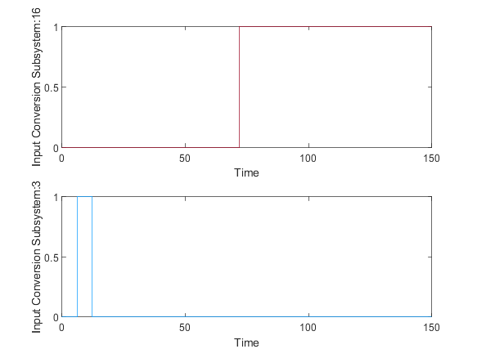

|  |  |
| --- | --- |
| Back to Report Summary | Back to Signal Summary |

|  |  |  |  |  |  |
| --- | --- | --- | --- | --- | --- |
| **Name** | **Data Type** | **Units** | **Sample Time** | **Interp** | **Sync** |
| actComedero | double |  | Continuous | zoh | union |
| tiempoDispensa | double |  | Continuous | zoh | union |

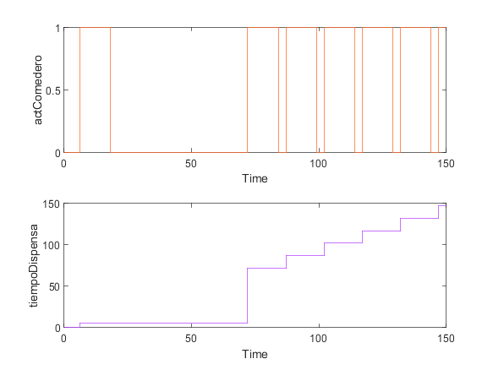

|  |  |
| --- | --- |
| Back to Report Summary | Back to Signal Summary |

|  |  |  |  |  |  |
| --- | --- | --- | --- | --- | --- |
| **Name** | **Data Type** | **Units** | **Sample Time** | **Interp** | **Sync** |
| alertaDispensar | double |  | Continuous | zoh | union |
| tiempoSinAlimentar | double |  | Continuous | zoh | union |

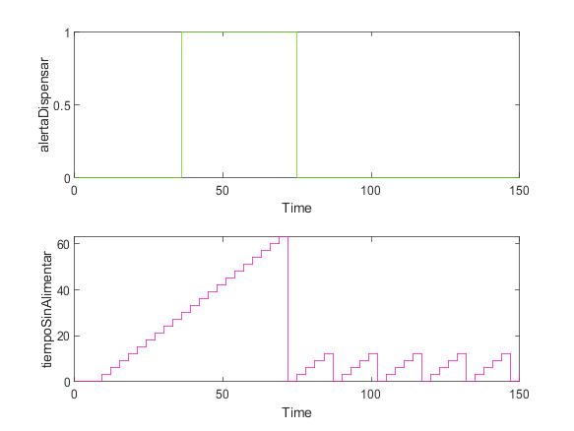

|  |  |
| --- | --- |
| Back to Report Summary | Back to Signal Summary |

Simulation Logs:

['dispensaComida'](matlab:sfprivate('sfOpenObjectBySId','estados_test:1:::232')) is defined, but is not used in the Stateflow chart. [Delete this object](matlab:%20internal.stateflow.dialogs.UnusedObjectDeleter.createDeleter('estados_test:1:::232')) or [configure the diagnostic](matlab:%20sfprivate('openConfigParamsSFDiagnostics',224)).

'[Output Port 18](matlab:slprivate('open_and_hilite_port_hyperlink',%20'hilite',%20['ALAlertaTiempoSinAlimentar/estados_test'%5d,%20'Outport',%2018);)' of '[ALAlertaTiempoSinAlimentar/estados_test](matlab:open_and_hilite_hyperlink%20('ALAlertaTiempoSinAlimentar/estados_test','error'))' is not connected.

['actGatera'](matlab:sfprivate('sfOpenObjectBySId','ALAlertaTiempoSinAlimentar:72:::20')) is defined, but is never used in the Test Sequence block.  [Delete this object.](matlab:%20internal.stateflow.dialogs.UnusedObjectDeleter.createDeleter('ALAlertaTiempoSinAlimentar:72:::20'))

['actComedero'](matlab:sfprivate('sfOpenObjectBySId','ALAlertaTiempoSinAlimentar:72:::21')) is defined, but is never used in the Test Sequence block.  [Delete this object.](matlab:%20internal.stateflow.dialogs.UnusedObjectDeleter.createDeleter('ALAlertaTiempoSinAlimentar:72:::21'))

['peticionUsuario'](matlab:sfprivate('sfOpenObjectBySId','ALAlertaTiempoSinAlimentar:72:::22')) is defined, but is never used in the Test Sequence block.  [Delete this object.](matlab:%20internal.stateflow.dialogs.UnusedObjectDeleter.createDeleter('ALAlertaTiempoSinAlimentar:72:::22'))

['peticionIntHora'](matlab:sfprivate('sfOpenObjectBySId','ALAlertaTiempoSinAlimentar:72:::23')) is defined, but is never used in the Test Sequence block.  [Delete this object.](matlab:%20internal.stateflow.dialogs.UnusedObjectDeleter.createDeleter('ALAlertaTiempoSinAlimentar:72:::23'))

['modoReal'](matlab:sfprivate('sfOpenObjectBySId','ALAlertaTiempoSinAlimentar:72:::24')) is defined, but is never used in the Test Sequence block.  [Delete this object.](matlab:%20internal.stateflow.dialogs.UnusedObjectDeleter.createDeleter('ALAlertaTiempoSinAlimentar:72:::24'))

['ubicacion'](matlab:sfprivate('sfOpenObjectBySId','ALAlertaTiempoSinAlimentar:72:::25')) is defined, but is never used in the Test Sequence block.  [Delete this object.](matlab:%20internal.stateflow.dialogs.UnusedObjectDeleter.createDeleter('ALAlertaTiempoSinAlimentar:72:::25'))

['gatoIntroducido'](matlab:sfprivate('sfOpenObjectBySId','ALAlertaTiempoSinAlimentar:72:::26')) is defined, but is never used in the Test Sequence block.  [Delete this object.](matlab:%20internal.stateflow.dialogs.UnusedObjectDeleter.createDeleter('ALAlertaTiempoSinAlimentar:72:::26'))

['camarasOUT'](matlab:sfprivate('sfOpenObjectBySId','ALAlertaTiempoSinAlimentar:72:::27')) is defined, but is never used in the Test Sequence block.  [Delete this object.](matlab:%20internal.stateflow.dialogs.UnusedObjectDeleter.createDeleter('ALAlertaTiempoSinAlimentar:72:::27'))

['camarasIN'](matlab:sfprivate('sfOpenObjectBySId','ALAlertaTiempoSinAlimentar:72:::28')) is defined, but is never used in the Test Sequence block.  [Delete this object.](matlab:%20internal.stateflow.dialogs.UnusedObjectDeleter.createDeleter('ALAlertaTiempoSinAlimentar:72:::28'))

['tiempoSalida'](matlab:sfprivate('sfOpenObjectBySId','ALAlertaTiempoSinAlimentar:72:::29')) is defined, but is never used in the Test Sequence block.  [Delete this object.](matlab:%20internal.stateflow.dialogs.UnusedObjectDeleter.createDeleter('ALAlertaTiempoSinAlimentar:72:::29'))

['alertaTiempoFuera'](matlab:sfprivate('sfOpenObjectBySId','ALAlertaTiempoSinAlimentar:72:::30')) is defined, but is never used in the Test Sequence block.  [Delete this object.](matlab:%20internal.stateflow.dialogs.UnusedObjectDeleter.createDeleter('ALAlertaTiempoSinAlimentar:72:::30'))

['tiempoFuera'](matlab:sfprivate('sfOpenObjectBySId','ALAlertaTiempoSinAlimentar:72:::31')) is defined, but is never used in the Test Sequence block.  [Delete this object.](matlab:%20internal.stateflow.dialogs.UnusedObjectDeleter.createDeleter('ALAlertaTiempoSinAlimentar:72:::31'))

['tiempoDispensa'](matlab:sfprivate('sfOpenObjectBySId','ALAlertaTiempoSinAlimentar:72:::32')) is defined, but is never used in the Test Sequence block.  [Delete this object.](matlab:%20internal.stateflow.dialogs.UnusedObjectDeleter.createDeleter('ALAlertaTiempoSinAlimentar:72:::32'))

['alertaDispensar'](matlab:sfprivate('sfOpenObjectBySId','ALAlertaTiempoSinAlimentar:72:::33')) is defined, but is never used in the Test Sequence block.  [Delete this object.](matlab:%20internal.stateflow.dialogs.UnusedObjectDeleter.createDeleter('ALAlertaTiempoSinAlimentar:72:::33'))

['tiempoSinAlimentar'](matlab:sfprivate('sfOpenObjectBySId','ALAlertaTiempoSinAlimentar:72:::34')) is defined, but is never used in the Test Sequence block.  [Delete this object.](matlab:%20internal.stateflow.dialogs.UnusedObjectDeleter.createDeleter('ALAlertaTiempoSinAlimentar:72:::34'))

['alertaLluvia'](matlab:sfprivate('sfOpenObjectBySId','ALAlertaTiempoSinAlimentar:72:::35')) is defined, but is never used in the Test Sequence block.  [Delete this object.](matlab:%20internal.stateflow.dialogs.UnusedObjectDeleter.createDeleter('ALAlertaTiempoSinAlimentar:72:::35'))

['modoAnt'](matlab:sfprivate('sfOpenObjectBySId','ALAlertaTiempoSinAlimentar:72:::36')) is defined, but is never used in the Test Sequence block.  [Delete this object.](matlab:%20internal.stateflow.dialogs.UnusedObjectDeleter.createDeleter('ALAlertaTiempoSinAlimentar:72:::36'))

Back to Report Summary

Test Logs:

No baseline criteria evaluation performed as no baseline data is available for this test.

Back to Report Summary

|  |
| --- |
| **AlertaLluvia** |

|  |  |
| --- | --- |
| **Test Result Information** | |
| Result Type: | Test Case Result |
| Parent: | estados_test |
| Start Time: | 10-Jan-2021 21:34:03 |
| End Time: | 10-Jan-2021 21:34:03 |
| Outcome: | Passed |
| Description: |  |

Si llega al sistema un aviso de lluvia, deberá aparecer la alerta de lluvia en la aplicación. Si dicho aviso desaparece, de igual forma la alerta deberá desaparecer.

|  |  |
| --- | --- |
| **Test Case Information** | |
| Name: | AlertaLluvia |
| Type: | Baseline Test |
| **Test Case Requirements** | | |
| Description: | RF-SY_08 (Requisito cruzado): Aviso de emergencia. Aviso de Lluvia (gatera#20) | |
| Document: | ../resources/requirements/gatera.slreqx | |

**Logical and Temporal Assessments**

|  |  |
| --- | --- |
| **Name** | **Assessment** |
| Assessment1 | At any point in time, whenever (avisoLluvia == 1) is true then, with no delay, (alertaLluvia == 1) must be true |
| Assessment2 | At any point in time, whenever (avisoLluvia == 0) is true then, with no delay, (alertaLluvia == 0) must be true |

**Simulation**

|  |  |
| --- | --- |
| **System Under Test Information** | |
| Model: | estados_test |
| Harness: | AMAlertaLluvia |
| Harness Owner: | estados_test |
| Release: | Current |
| Simulation Mode: | normal |
| Override SIL or PIL Mode: | 0 |
| Configuration Set: | Configuration1 |
| Start Time: | 0 |
| Stop Time: | 50 |
| Checksum: | 235224335 2320316335 3222278619 3194666554 |
| Simulink Version: | 10.2 |
| Model Version: | 1.2 |
| Model Author: | Juan |
| Date: | Wed Jan 06 01:15:36 2021 |
| User ID: | Juan |
| Model Path: | C:\Users\Juan\Desktop\MODELO_FINAL_V6\CATSAFE\AMAlertaLluvia.slx |
| Machine Name: | DESKTOP-UQ9MCEP |
| Solver Name: | VariableStepDiscrete |
| Solver Type: | Variable-Step |
| Max Step Size: | 1 |
| Simulation Start Time: | 2021-01-10 21:34:02 |
| Simulation Stop Time: | 2021-01-10 21:34:03 |
| Platform: | PCWIN64 |

**Simulation Output**

|  |  |  |  |  |  |  |
| --- | --- | --- | --- | --- | --- | --- |
| **Name** | **Data Type** | **Units** | **Sample Time** | **Interp** | **Sync** | **Link to Plot** |
| Input Conversion Subsystem:17 | double |  | Continuous | zoh | union | Link |
| alertaLluvia | double |  | Continuous | zoh | union | Link |

|  |  |  |  |  |  |
| --- | --- | --- | --- | --- | --- |
| **Name** | **Data Type** | **Units** | **Sample Time** | **Interp** | **Sync** |
| Input Conversion Subsystem:17 | double |  | Continuous | zoh | union |
| alertaLluvia | double |  | Continuous | zoh | union |

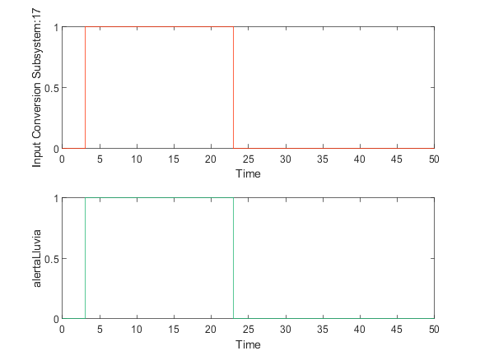

|  |  |
| --- | --- |
| Back to Report Summary | Back to Signal Summary |

Simulation Logs:

['dispensaComida'](matlab:sfprivate('sfOpenObjectBySId','estados_test:1:::232')) is defined, but is not used in the Stateflow chart. [Delete this object](matlab:%20internal.stateflow.dialogs.UnusedObjectDeleter.createDeleter('estados_test:1:::232')) or [configure the diagnostic](matlab:%20sfprivate('openConfigParamsSFDiagnostics',224)).

'[Output Port 18](matlab:slprivate('open_and_hilite_port_hyperlink',%20'hilite',%20['AMAlertaLluvia/estados_test'%5d,%20'Outport',%2018);)' of '[AMAlertaLluvia/estados_test](matlab:open_and_hilite_hyperlink%20('AMAlertaLluvia/estados_test','error'))' is not connected.

['actGatera'](matlab:sfprivate('sfOpenObjectBySId','AMAlertaLluvia:72:::20')) is defined, but is never used in the Test Sequence block.  [Delete this object.](matlab:%20internal.stateflow.dialogs.UnusedObjectDeleter.createDeleter('AMAlertaLluvia:72:::20'))

['actComedero'](matlab:sfprivate('sfOpenObjectBySId','AMAlertaLluvia:72:::21')) is defined, but is never used in the Test Sequence block.  [Delete this object.](matlab:%20internal.stateflow.dialogs.UnusedObjectDeleter.createDeleter('AMAlertaLluvia:72:::21'))

['peticionUsuario'](matlab:sfprivate('sfOpenObjectBySId','AMAlertaLluvia:72:::22')) is defined, but is never used in the Test Sequence block.  [Delete this object.](matlab:%20internal.stateflow.dialogs.UnusedObjectDeleter.createDeleter('AMAlertaLluvia:72:::22'))

['peticionIntHora'](matlab:sfprivate('sfOpenObjectBySId','AMAlertaLluvia:72:::23')) is defined, but is never used in the Test Sequence block.  [Delete this object.](matlab:%20internal.stateflow.dialogs.UnusedObjectDeleter.createDeleter('AMAlertaLluvia:72:::23'))

['modoReal'](matlab:sfprivate('sfOpenObjectBySId','AMAlertaLluvia:72:::24')) is defined, but is never used in the Test Sequence block.  [Delete this object.](matlab:%20internal.stateflow.dialogs.UnusedObjectDeleter.createDeleter('AMAlertaLluvia:72:::24'))

['ubicacion'](matlab:sfprivate('sfOpenObjectBySId','AMAlertaLluvia:72:::25')) is defined, but is never used in the Test Sequence block.  [Delete this object.](matlab:%20internal.stateflow.dialogs.UnusedObjectDeleter.createDeleter('AMAlertaLluvia:72:::25'))

['gatoIntroducido'](matlab:sfprivate('sfOpenObjectBySId','AMAlertaLluvia:72:::26')) is defined, but is never used in the Test Sequence block.  [Delete this object.](matlab:%20internal.stateflow.dialogs.UnusedObjectDeleter.createDeleter('AMAlertaLluvia:72:::26'))

['camarasOUT'](matlab:sfprivate('sfOpenObjectBySId','AMAlertaLluvia:72:::27')) is defined, but is never used in the Test Sequence block.  [Delete this object.](matlab:%20internal.stateflow.dialogs.UnusedObjectDeleter.createDeleter('AMAlertaLluvia:72:::27'))

['camarasIN'](matlab:sfprivate('sfOpenObjectBySId','AMAlertaLluvia:72:::28')) is defined, but is never used in the Test Sequence block.  [Delete this object.](matlab:%20internal.stateflow.dialogs.UnusedObjectDeleter.createDeleter('AMAlertaLluvia:72:::28'))

['tiempoSalida'](matlab:sfprivate('sfOpenObjectBySId','AMAlertaLluvia:72:::29')) is defined, but is never used in the Test Sequence block.  [Delete this object.](matlab:%20internal.stateflow.dialogs.UnusedObjectDeleter.createDeleter('AMAlertaLluvia:72:::29'))

['alertaTiempoFuera'](matlab:sfprivate('sfOpenObjectBySId','AMAlertaLluvia:72:::30')) is defined, but is never used in the Test Sequence block.  [Delete this object.](matlab:%20internal.stateflow.dialogs.UnusedObjectDeleter.createDeleter('AMAlertaLluvia:72:::30'))

['tiempoFuera'](matlab:sfprivate('sfOpenObjectBySId','AMAlertaLluvia:72:::31')) is defined, but is never used in the Test Sequence block.  [Delete this object.](matlab:%20internal.stateflow.dialogs.UnusedObjectDeleter.createDeleter('AMAlertaLluvia:72:::31'))

['tiempoDispensa'](matlab:sfprivate('sfOpenObjectBySId','AMAlertaLluvia:72:::32')) is defined, but is never used in the Test Sequence block.  [Delete this object.](matlab:%20internal.stateflow.dialogs.UnusedObjectDeleter.createDeleter('AMAlertaLluvia:72:::32'))

['alertaDispensar'](matlab:sfprivate('sfOpenObjectBySId','AMAlertaLluvia:72:::33')) is defined, but is never used in the Test Sequence block.  [Delete this object.](matlab:%20internal.stateflow.dialogs.UnusedObjectDeleter.createDeleter('AMAlertaLluvia:72:::33'))

['tiempoSinAlimentar'](matlab:sfprivate('sfOpenObjectBySId','AMAlertaLluvia:72:::34')) is defined, but is never used in the Test Sequence block.  [Delete this object.](matlab:%20internal.stateflow.dialogs.UnusedObjectDeleter.createDeleter('AMAlertaLluvia:72:::34'))

['alertaLluvia'](matlab:sfprivate('sfOpenObjectBySId','AMAlertaLluvia:72:::35')) is defined, but is never used in the Test Sequence block.  [Delete this object.](matlab:%20internal.stateflow.dialogs.UnusedObjectDeleter.createDeleter('AMAlertaLluvia:72:::35'))

['modoAnt'](matlab:sfprivate('sfOpenObjectBySId','AMAlertaLluvia:72:::36')) is defined, but is never used in the Test Sequence block.  [Delete this object.](matlab:%20internal.stateflow.dialogs.UnusedObjectDeleter.createDeleter('AMAlertaLluvia:72:::36'))

Back to Report Summary

Test Logs:

No baseline criteria evaluation performed as no baseline data is available for this test.

Back to Report Summary