**Report Generated by Test Manager**

|  |  |
| --- | --- |
| **Title:** | **Test** |
| **Author:** |  |
| **Date:** | **10-Jan-2021 22:04:53** |

|  |  |
| --- | --- |
| **Test Environment** | |
| Platform: | MACI64 |
| MATLAB: | (R2020b) |

|  |  |  |
| --- | --- | --- |
| **Summary** | | |
| **Name** | **Outcome** | **Duration (Seconds)** |
| Results: 2021-Jan-10 22:02:12 | 15 | 71.945 |
| Gatera_Test | 15 | 71.946 |
| estados_test | 15 | 71.944 |
| GatoEntraExteriorAutomatico |  | 19.168 |
| GatoEntraExteriorManual |  | 0 |
| GatoNoEntraNormal |  | 0 |
| GatoSaleNormalAutorizadoManual |  | 0 |
| CambioModoManualAutomatico |  | 0 |
| CambioModoAutomaticoManual |  | 0.00099993 |
| AlimentarGatoM |  | 0 |
| AlimentarGatoA |  | 0 |
| ParadaDeEmergencia |  | 0 |
| Ubicacion |  | 0 |
| NuevoGato |  | 0 |
| Observacion |  | 0 |
| AlertaExcesoTiempoFueraAutomatico |  | 0 |
| AlertaTiempoSinAlimentar |  | 0 |
| AlertaLluvia |  | 0 |

**Results: 2021-Jan-10 22:02:12**

|  |  |
| --- | --- |
| Result Type: | Result Set |
| Parent: | None |
| Start Time: | 10-Jan-2021 22:02:26 |
| End Time: | 10-Jan-2021 22:03:38 |
| Outcome: | Total: 15, Passed: 15 |

Back to Report Summary

|  |
| --- |
| **Gatera_Test** |

|  |  |
| --- | --- |
| **Test Result Information** | |
| Result Type: | Test File Result |
| Parent: | Results: 2021-Jan-10 22:02:12 |
| Start Time: | 10-Jan-2021 22:02:26 |
| End Time: | 10-Jan-2021 22:03:38 |
| Outcome: | Total: 15, Passed: 15 |

|  |  |
| --- | --- |
| **Test Suite Information** | |
| Name: | Gatera_Test |

Back to Report Summary

|  |
| --- |
| **estados_test** |

|  |  |
| --- | --- |
| **Test Result Information** | |
| Result Type: | Test Suite Result |
| Parent: | Gatera_Test |
| Start Time: | 10-Jan-2021 22:02:26 |
| End Time: | 10-Jan-2021 22:03:38 |
| Outcome: | Total: 15, Passed: 15 |

|  |  |
| --- | --- |
| **Test Suite Information** | |
| Name: | estados_test |

Back to Report Summary

|  |
| --- |
| **GatoEntraExteriorAutomatico** |

|  |  |
| --- | --- |
| **Test Result Information** | |
| Result Type: | Test Case Result |
| Parent: | estados_test |
| Start Time: | 10-Jan-2021 22:02:26 |
| End Time: | 10-Jan-2021 22:02:45 |
| Outcome: | Passed |
| Description: |  |

El sistema se sitúa en
modo automático. Se testea la correcta entrada del gato desde el exterior,
poniendo la ubicación a 1 cuando dicha entrada ha sido asegurada. AL ser el
estado inicial del gato el interior del edificio, el test incluye la previa
salida del gato, poniendo la ubicación a 0 (que no se comprueba explícitamente,
pero si implícitamente porque sino el test nunca llegaría a comprobarse y se comprobaría
en su estado).

|  |  |
| --- | --- |
| **Test Case Information** | |
| Name: | GatoEntraExteriorAutomatico |
| Type: | Baseline Test |

|  |  |
| --- | --- |
| **Test Case Requirements** | |
| Description: | RF-G_02: EL gato quiere entrar en la vivienda (gatera#2) |
| Document: | ../resources/requirements/gatera.slreqx |

**Logical and Temporal Assessments**

|  |  |
| --- | --- |
| **Name** | **Assessment** |
| Assessment1 | At any point in time, if (presOUT == 1) becomes true then, with no delay, (actGatera == 1) must be true |
| Assessment2 | At any point in time, if (ubicacion == 1) becomes true then, with a delay of at most 5 seconds, (actGatera == 0) must be true |

**Simulation**

|  |  |
| --- | --- |
| **System Under Test Information** | |
| Model: | estados_test |
| Harness: | AAGatoEntraExteriorAuto |
| Harness Owner: | estados_test |
| Release: | Current |
| Simulation Mode: | normal |
| Override SIL or PIL Mode: | 0 |
| Configuration Set: | Configuration1 |
| Start Time: | 0 |
| Stop Time: | 150 |
| Checksum: | 95089527 2721562314 875249743 3128363562 |
| Simulink Version: | 10.2 |
| Model Version: | 1.7 |
| Model Author: | Juan |
| Date: | Thu Jan 07 13:03:05 2021 |
| User ID: | jlanzas |
| Model Path: | /Users/jlanzas/Documents/MATLAB/CATSAFE/AAGatoEntraExteriorAuto.slx |
| Solver Name: | VariableStepDiscrete |
| Solver Type: | Variable-Step |
| Max Step Size: | 3 |
| Simulation Start Time: | 2021-01-10 22:02:26 |
| Simulation Stop Time: | 2021-01-10 22:02:42 |
| Platform: | MACI64 |

**Simulation Output**

|  |  |  |  |  |  |  |
| --- | --- | --- | --- | --- | --- | --- |
| **Name** | **Data Type** | **Units** | **Sample Time** | **Interp** | **Sync** | **Link to Plot** |
| Input Conversion Subsystem:6 | double |  | Continuous | zoh | union | Link |
| actGatera | double |  | Continuous | zoh | union | Link |
| ubicacion | double |  | Continuous | zoh | union | Link |

|  |  |  |  |  |  |
| --- | --- | --- | --- | --- | --- |
| **Name** | **Data Type** | **Units** | **Sample Time** | **Interp** | **Sync** |
| Input Conversion Subsystem:6 | double |  | Continuous | zoh | union |
| actGatera | double |  | Continuous | zoh | union |

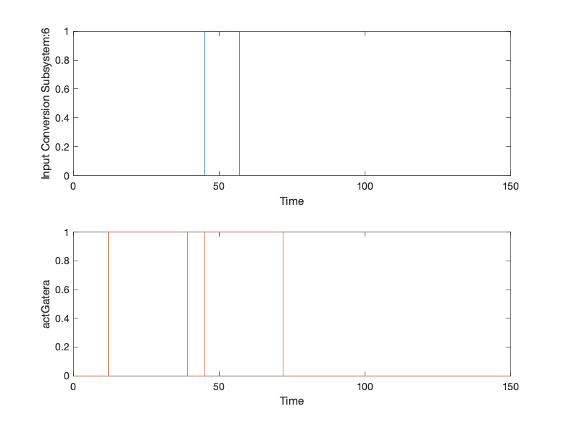

|  |  |
| --- | --- |
| Back to Report Summary | Back to Signal Summary |

|  |  |  |  |  |  |
| --- | --- | --- | --- | --- | --- |
| **Name** | **Data Type** | **Units** | **Sample Time** | **Interp** | **Sync** |
| ubicacion | double |  | Continuous | zoh | union |

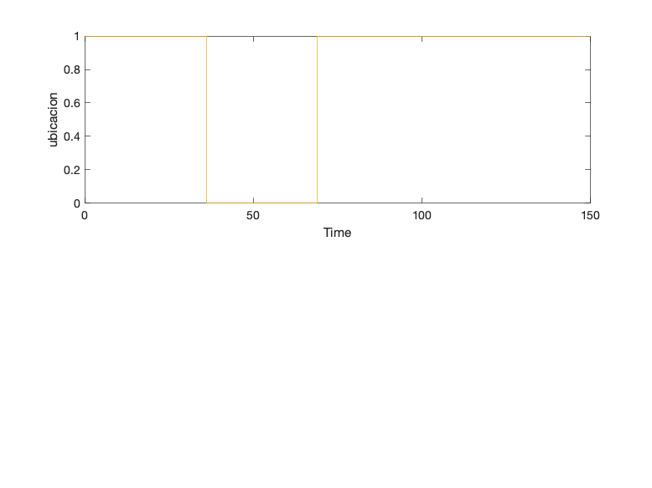

|  |  |
| --- | --- |
| Back to Report Summary | Back to Signal Summary |

|  |
| --- |
| **GatoEntraExteriorManual** |

|  |  |
| --- | --- |
| **Test Result Information** | |
| Result Type: | Test Case Result |
| Parent: | estados_test |
| Start Time: | 10-Jan-2021 22:02:50 |
| End Time: | 10-Jan-2021 22:02:50 |
| Outcome: | Passed |
| Description: |  |

El sistema se sitúa en  
modo manual (debiendo fijar una hora de comida). Se testea la correcta entrada  
del gato desde el exterior, poniendo la ubicación a 1 cuando dicha entrada ha  
sido asegurada. Al ser el estado inicial del gato el interior del edificio, el  
test incluye la previa salida del gato, poniendo la ubicación a 0 (que no se  
comprueba explícitamente, pero si implícitamente porque sino el test nunca llegaría  
a comprobarse y se comprobaría en su estado).

|  |  |
| --- | --- |
| **Test Case Information** | |
| Name: | GatoEntraExteriorManual |
| Type: | Baseline Test |

|  |  |
| --- | --- |
| **Test Case Requirements** | |
| Description: | RF-G_02: EL gato quiere entrar en la vivienda (gatera#2) |
| Document: | ../resources/requirements/gatera.slreqx |

**Logical and Temporal Assessments**

|  |  |
| --- | --- |
| **Name** | **Assessment** |
| Assessment1 | At any point in time, if (presOUT == 1) becomes true then, with no delay, (actGatera == 1) must be true |
| Assessment2 | At any point in time, if (ubicacion == 1) becomes true then, with a delay of at most 5 seconds, (actGatera == 0) must be true |

**Simulation**

|  |  |
| --- | --- |
| **System Under Test Information** | |
| Model: | estados_test |
| Harness: | AABGatoEntraExteriorManual |
| Harness Owner: | estados_test |
| Release: | Current |
| Simulation Mode: | normal |
| Override SIL or PIL Mode: | 0 |
| Configuration Set: | Configuration1 |
| Start Time: | 0 |
| Stop Time: | 150 |
| Checksum: | 315565539 3777750895 660004617 921679756 |
| Simulink Version: | 10.2 |
| Model Version: | 1.8 |
| Model Author: | Juan |
| Date: | Thu Jan 07 13:09:03 2021 |
| User ID: | jlanzas |
| Model Path: | /Users/jlanzas/Documents/MATLAB/CATSAFE/AABGatoEntraExteriorManual.slx |
| Solver Name: | VariableStepDiscrete |
| Solver Type: | Variable-Step |
| Max Step Size: | 3 |
| Simulation Start Time: | 2021-01-10 22:02:45 |
| Simulation Stop Time: | 2021-01-10 22:02:49 |
| Platform: | MACI64 |

**Simulation Output**

|  |  |  |  |  |  |  |
| --- | --- | --- | --- | --- | --- | --- |
| **Name** | **Data Type** | **Units** | **Sample Time** | **Interp** | **Sync** | **Link to Plot** |
| Input Conversion Subsystem:6 | double |  | Continuous | zoh | union | Link |
| actGatera | double |  | Continuous | zoh | union | Link |
| ubicacion | double |  | Continuous | zoh | union | Link |

|  |  |  |  |  |  |
| --- | --- | --- | --- | --- | --- |
| **Name** | **Data Type** | **Units** | **Sample Time** | **Interp** | **Sync** |
| Input Conversion Subsystem:6 | double |  | Continuous | zoh | union |
| actGatera | double |  | Continuous | zoh | union |

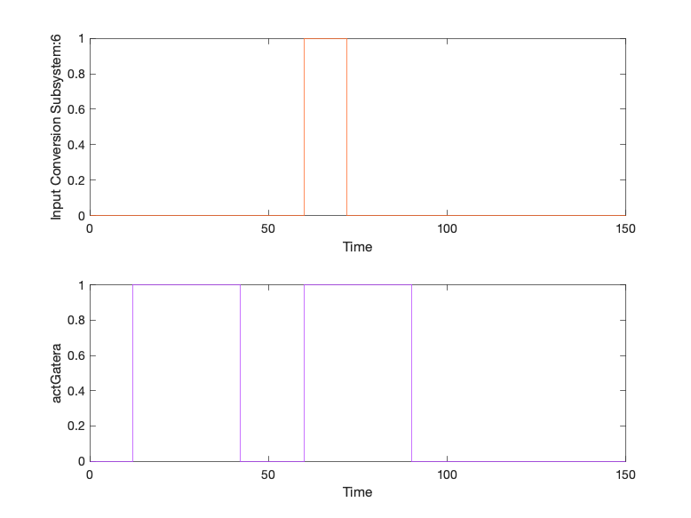

|  |  |
| --- | --- |
| Back to Report Summary | Back to Signal Summary |

|  |  |  |  |  |  |
| --- | --- | --- | --- | --- | --- |
| **Name** | **Data Type** | **Units** | **Sample Time** | **Interp** | **Sync** |
| ubicacion | double |  | Continuous | zoh | union |

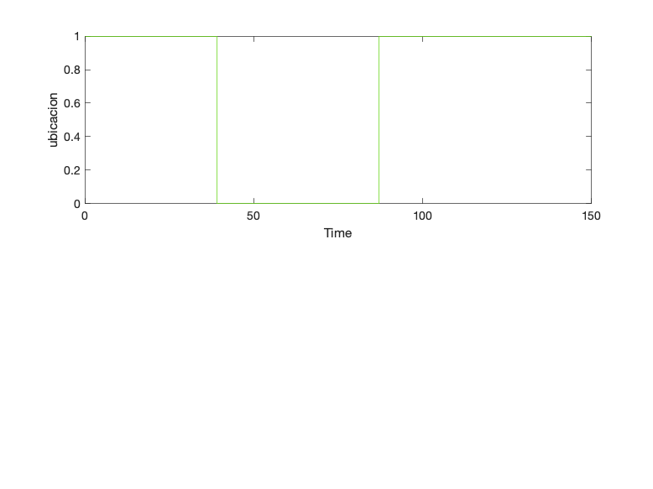

|  |  |
| --- | --- |
| Back to Report Summary | Back to Signal Summary |

|  |
| --- |
| **GatoNoEntraNormal** |

|  |  |
| --- | --- |
| **Test Result Information** | |
| Result Type: | Test Case Result |
| Parent: | estados_test |
| Start Time: | 10-Jan-2021 22:02:54 |
| End Time: | 10-Jan-2021 22:02:54 |
| Outcome: | Passed |
| Description: |  |

Testea lo que ocurre  
cuando el gato se acerca a la gatera pero sin intención de salir, por lo que  
chipGatera no se llega a detectar. En este caso, al no aportar nada la variable  
ubicación, no es necesario establecer la salida del gato previa al testeo de la  
entrada. Se debe comprobar que la gatera finalmente se cierra.

|  |  |
| --- | --- |
| **Test Case Information** | |
| Name: | GatoNoEntraNormal |
| Type: | Baseline Test |

|  |  |
| --- | --- |
| **Test Case Requirements** | |
| Description: | RF-G_02: EL gato quiere entrar en la vivienda (gatera#2) |
| Document: | ../resources/requirements/gatera.slreqx |

**Logical and Temporal Assessments**

|  |  |
| --- | --- |
| **Name** | **Assessment** |
| Assessment1 | At any point in time, if (presOUT == 1) becomes true then, with no delay, (actGatera == 1) must be true |
| Assessment2 | At any point in time, whenever (presOUT == 0) is true then, with no delay, (actGatera == 0) must be true |
| Assessment3 | At any point in time, whenever ((presOUT == 1) & (actGatera == 1)) is true then, with a delay of at most 11 seconds, (actGatera == 0) must be true |

**Simulation**

|  |  |
| --- | --- |
| **System Under Test Information** | |
| Model: | estados_test |
| Harness: | ABGatoNoEntraExterior |
| Harness Owner: | estados_test |
| Release: | Current |
| Simulation Mode: | normal |
| Override SIL or PIL Mode: | 0 |
| Configuration Set: | Configuration1 |
| Start Time: | 0 |
| Stop Time: | 50 |
| Checksum: | 4275001341 4161360323 45137838 4116700464 |
| Simulink Version: | 10.2 |
| Model Version: | 1.2 |
| Model Author: | Juan |
| Date: | Tue Jan 05 23:42:08 2021 |
| User ID: | jlanzas |
| Model Path: | /Users/jlanzas/Documents/MATLAB/CATSAFE/ABGatoNoEntraExterior.slx |
| Solver Name: | VariableStepDiscrete |
| Solver Type: | Variable-Step |
| Max Step Size: | 1 |
| Simulation Start Time: | 2021-01-10 22:02:50 |
| Simulation Stop Time: | 2021-01-10 22:02:52 |
| Platform: | MACI64 |

**Simulation Output**

|  |  |  |  |  |  |  |
| --- | --- | --- | --- | --- | --- | --- |
| **Name** | **Data Type** | **Units** | **Sample Time** | **Interp** | **Sync** | **Link to Plot** |
| Input Conversion Subsystem:6 | double |  | Continuous | zoh | union | Link |
| actGatera | double |  | Continuous | zoh | union | Link |

|  |  |  |  |  |  |
| --- | --- | --- | --- | --- | --- |
| **Name** | **Data Type** | **Units** | **Sample Time** | **Interp** | **Sync** |
| Input Conversion Subsystem:6 | double |  | Continuous | zoh | union |
| actGatera | double |  | Continuous | zoh | union |

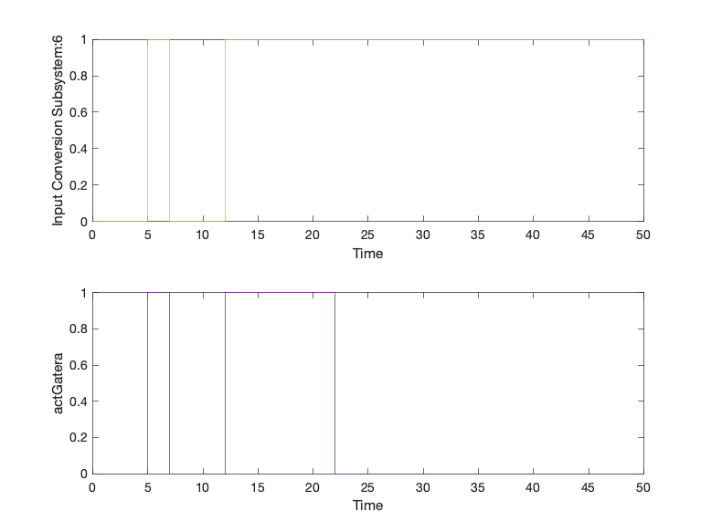

|  |  |
| --- | --- |
| Back to Report Summary | Back to Signal Summary |

|  |
| --- |
| **GatoSaleNormalAutorizadoManual** |

|  |  |
| --- | --- |
| **Test Result Information** | |
| Result Type: | Test Case Result |
| Parent: | estados_test |
| Start Time: | 10-Jan-2021 22:02:58 |
| End Time: | 10-Jan-2021 22:02:58 |
| Outcome: | Passed |
| Description: |  |

Testea la correcta salida del gato de la vivienda en modo manual, cuando el usuario autoriza su salida y el gato tiene intención de salir.

|  |  |
| --- | --- |
| **Test Case Information** | |
| Name: | GatoSaleNormalAutorizadoManual |
| Type: | Baseline Test |

|  |  |
| --- | --- |
| **Test Case Requirements** | |
| Description: | RF-G_01: El gato quiere salir de la vivienda (gatera#1) |
| Document: | ../resources/requirements/gatera.slreqx |

**Logical and Temporal Assessments**

|  |  |
| --- | --- |
| **Name** | **Assessment** |
| Assessment1 | At any point in time, if (autorizUsuario == 1) becomes true then, with no delay, (actGatera == 1) must be true |
| Assessment2 | At any point in time, if (presIN == 1) becomes true then, with a delay of at most 5 seconds, (peticionUsuario == 1) must be true |
| Assessment3 | At any point in time, whenever (tiempoSalida ~= 0) is true then, with a delay of at most 15 seconds, (actGatera == 0) must be true |

**Simulation**

|  |  |
| --- | --- |
| **System Under Test Information** | |
| Model: | estados_test |
| Harness: | ACGatoSaleNormalAutorizadoManual |
| Harness Owner: | estados_test |
| Release: | Current |
| Simulation Mode: | normal |
| Override SIL or PIL Mode: | 0 |
| Configuration Set: | Configuration1 |
| Start Time: | 0 |
| Stop Time: | 100 |
| Checksum: | 956761090 3310764108 4126336928 1501279655 |
| Simulink Version: | 10.2 |
| Model Version: | 1.6 |
| Model Author: | Juan |
| Date: | Thu Jan 07 13:57:01 2021 |
| User ID: | jlanzas |
| Model Path: | /Users/jlanzas/Documents/MATLAB/CATSAFE/ACGatoSaleNormalAutorizadoManual.slx |
| Solver Name: | VariableStepDiscrete |
| Solver Type: | Variable-Step |
| Max Step Size: | 2 |
| Simulation Start Time: | 2021-01-10 22:02:54 |
| Simulation Stop Time: | 2021-01-10 22:02:57 |
| Platform: | MACI64 |

**Simulation Output**

|  |  |  |  |  |  |  |
| --- | --- | --- | --- | --- | --- | --- |
| **Name** | **Data Type** | **Units** | **Sample Time** | **Interp** | **Sync** | **Link to Plot** |
| Input Conversion Subsystem:4 | double |  | Continuous | zoh | union | Link |
| Input Conversion Subsystem:5 | double |  | Continuous | zoh | union | Link |
| actGatera | double |  | Continuous | zoh | union | Link |
| peticionUsuario | double |  | Continuous | zoh | union | Link |
| tiempoSalida | double |  | Continuous | zoh | union | Link |

|  |  |  |  |  |  |
| --- | --- | --- | --- | --- | --- |
| **Name** | **Data Type** | **Units** | **Sample Time** | **Interp** | **Sync** |
| Input Conversion Subsystem:4 | double |  | Continuous | zoh | union |
| Input Conversion Subsystem:5 | double |  | Continuous | zoh | union |

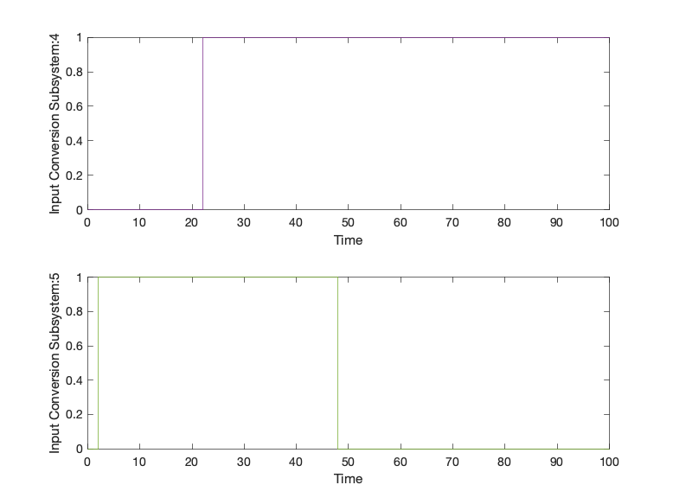

|  |  |
| --- | --- |
| Back to Report Summary | Back to Signal Summary |

|  |  |  |  |  |  |
| --- | --- | --- | --- | --- | --- |
| **Name** | **Data Type** | **Units** | **Sample Time** | **Interp** | **Sync** |
| actGatera | double |  | Continuous | zoh | union |
| peticionUsuario | double |  | Continuous | zoh | union |

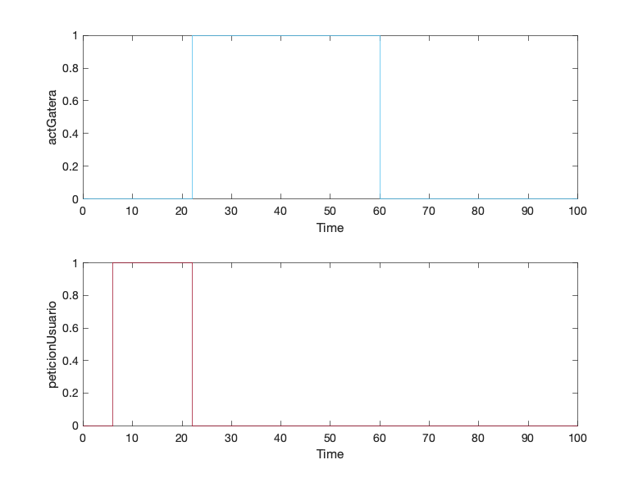

|  |  |
| --- | --- |
| Back to Report Summary | Back to Signal Summary |

|  |  |  |  |  |  |
| --- | --- | --- | --- | --- | --- |
| **Name** | **Data Type** | **Units** | **Sample Time** | **Interp** | **Sync** |
| tiempoSalida | double |  | Continuous | zoh | union |

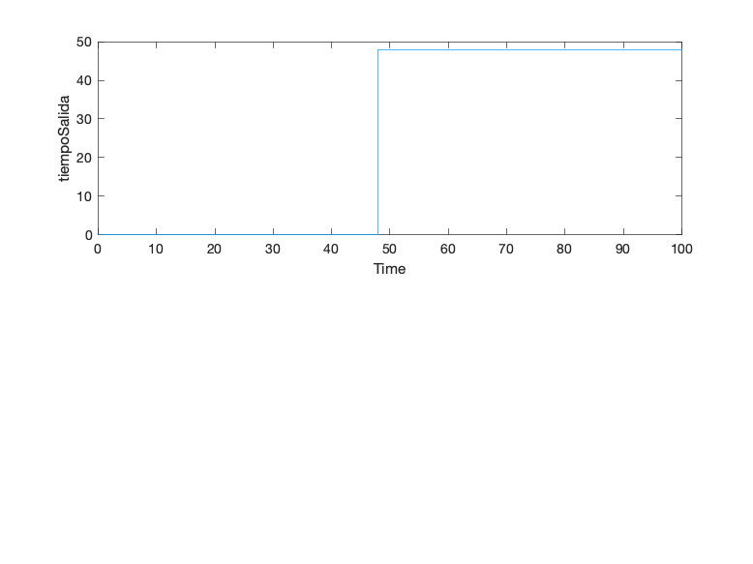

|  |  |
| --- | --- |
| Back to Report Summary | Back to Signal Summary |

|  |
| --- |
| **CambioModoManualAutomatico** |

|  |  |
| --- | --- |
| **Test Result Information** | |
| Result Type: | Test Case Result |
| Parent: | estados_test |
| Start Time: | 10-Jan-2021 22:03:02 |
| End Time: | 10-Jan-2021 22:03:02 |
| Outcome: | Passed |
| Description: |  |

Testea el correcto paso  
de modo manual a automático pidiendo al usuario que introduzca la hora a la que  
se alimentará a la mascota

|  |  |
| --- | --- |
| **Test Case Information** | |
| Name: | CambioModoManualAutomatico |
| Type: | Baseline Test |

|  |  |
| --- | --- |
| **Test Case Requirements** | |
| Description: | RF-SY_01: Cambio de modo de uso de manual a automático (gatera#3) |
| Document: | ../resources/requirements/gatera.slreqx |

**Logical and Temporal Assessments**

|  |  |
| --- | --- |
| **Name** | **Assessment** |
| Assessment1 | At any point in time, if (modo == 0) becomes true then, with no delay, (peticionIntHora == 1) must be true |
| Assessment2 | At any point in time, whenever ((horaComida ~= 0) & (modo == 0)) is true then, with no delay, (modoReal == 0) must be true |

**Simulation**

|  |  |
| --- | --- |
| **System Under Test Information** | |
| Model: | estados_test |
| Harness: | ADCambioModManAut |
| Harness Owner: | estados_test |
| Release: | Current |
| Simulation Mode: | normal |
| Override SIL or PIL Mode: | 0 |
| Configuration Set: | Configuration1 |
| Start Time: | 0 |
| Stop Time: | 50 |
| Checksum: | 3285433968 3698985744 1857421720 2446836491 |
| Simulink Version: | 10.2 |
| Model Version: | 1.3 |
| Model Author: | Juan |
| Date: | Wed Jan 06 00:21:23 2021 |
| User ID: | jlanzas |
| Model Path: | /Users/jlanzas/Documents/MATLAB/CATSAFE/ADCambioModManAut.slx |
| Solver Name: | VariableStepDiscrete |
| Solver Type: | Variable-Step |
| Max Step Size: | 1 |
| Simulation Start Time: | 2021-01-10 22:02:58 |
| Simulation Stop Time: | 2021-01-10 22:03:01 |
| Platform: | MACI64 |

**Simulation Output**

|  |  |  |  |  |  |  |
| --- | --- | --- | --- | --- | --- | --- |
| **Name** | **Data Type** | **Units** | **Sample Time** | **Interp** | **Sync** | **Link to Plot** |
| Input Conversion Subsystem:1 | double |  | Continuous | zoh | union | Link |
| Input Conversion Subsystem:8 | double |  | Continuous | zoh | union | Link |
| peticionIntHora | double |  | Continuous | zoh | union | Link |
| modoReal | double |  | Continuous | zoh | union | Link |

|  |  |  |  |  |  |
| --- | --- | --- | --- | --- | --- |
| **Name** | **Data Type** | **Units** | **Sample Time** | **Interp** | **Sync** |
| Input Conversion Subsystem:1 | double |  | Continuous | zoh | union |
| Input Conversion Subsystem:8 | double |  | Continuous | zoh | union |

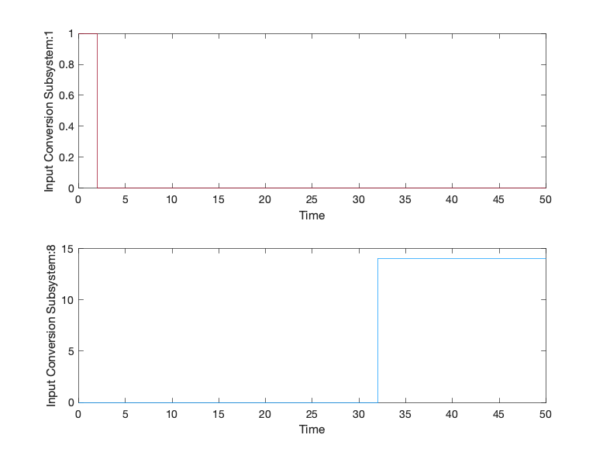

|  |  |
| --- | --- |
| Back to Report Summary | Back to Signal Summary |

|  |  |  |  |  |  |
| --- | --- | --- | --- | --- | --- |
| **Name** | **Data Type** | **Units** | **Sample Time** | **Interp** | **Sync** |
| peticionIntHora | double |  | Continuous | zoh | union |
| modoReal | double |  | Continuous | zoh | union |

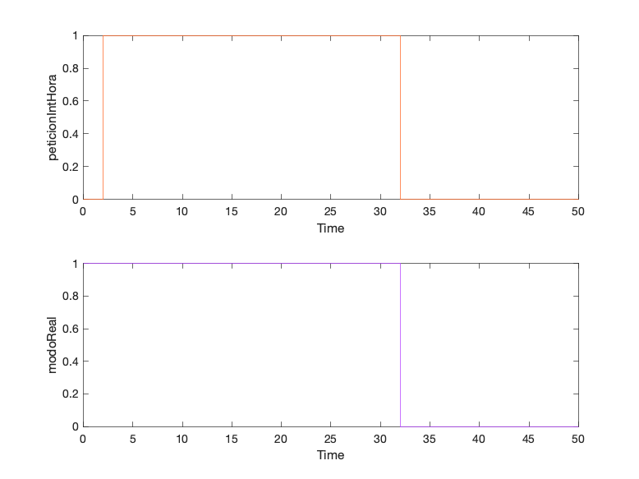

|  |  |
| --- | --- |
| Back to Report Summary | Back to Signal Summary |

|  |
| --- |
| **CambioModoAutomaticoManual** |

|  |  |
| --- | --- |
| **Test Result Information** | |
| Result Type: | Test Case Result |
| Parent: | estados_test |
| Start Time: | 10-Jan-2021 22:03:04 |
| End Time: | 10-Jan-2021 22:03:04 |
| Outcome: | Passed |
| Description: |  |

Testea que cuando el sistema esté en modo automático y se solicite el cambio a manual este se haga sin pedir nada al usuario.

|  |  |
| --- | --- |
| **Test Case Information** | |
| Name: | CambioModoAutomaticoManual |
| Type: | Baseline Test |

|  |  |
| --- | --- |
| **Test Case Requirements** | |
| Description: | RF-SY_02: Cambio de modo de automático a manual (gatera#4) |
| Document: | ../resources/requirements/gatera.slreqx |

**Logical and Temporal Assessments**

|  |  |
| --- | --- |
| **Name** | **Assessment** |
| Assessment1 | At any point in time, whenever (modo == 1) is true then, with a delay of at most 5 seconds, (modoReal == 1) must be true |

**Simulation**

|  |  |
| --- | --- |
| **System Under Test Information** | |
| Model: | estados_test |
| Harness: | AECambioModoAutMan |
| Harness Owner: | estados_test |
| Release: | Current |
| Simulation Mode: | normal |
| Override SIL or PIL Mode: | 0 |
| Configuration Set: | Configuration1 |
| Start Time: | 0 |
| Stop Time: | 50 |
| Checksum: | 724571269 990764586 3352645280 1200543636 |
| Simulink Version: | 10.2 |
| Model Version: | 1.2 |
| Model Author: | Juan |
| Date: | Wed Jan 06 00:28:00 2021 |
| User ID: | jlanzas |
| Model Path: | /Users/jlanzas/Documents/MATLAB/CATSAFE/AECambioModoAutMan.slx |
| Solver Name: | VariableStepDiscrete |
| Solver Type: | Variable-Step |
| Max Step Size: | 1 |
| Simulation Start Time: | 2021-01-10 22:03:02 |
| Simulation Stop Time: | 2021-01-10 22:03:04 |
| Platform: | MACI64 |

**Simulation Output**

|  |  |  |  |  |  |  |
| --- | --- | --- | --- | --- | --- | --- |
| **Name** | **Data Type** | **Units** | **Sample Time** | **Interp** | **Sync** | **Link to Plot** |
| Input Conversion Subsystem:1 | double |  | Continuous | zoh | union | Link |
| modoReal | double |  | Continuous | zoh | union | Link |

|  |  |  |  |  |  |
| --- | --- | --- | --- | --- | --- |
| **Name** | **Data Type** | **Units** | **Sample Time** | **Interp** | **Sync** |
| Input Conversion Subsystem:1 | double |  | Continuous | zoh | union |
| modoReal | double |  | Continuous | zoh | union |

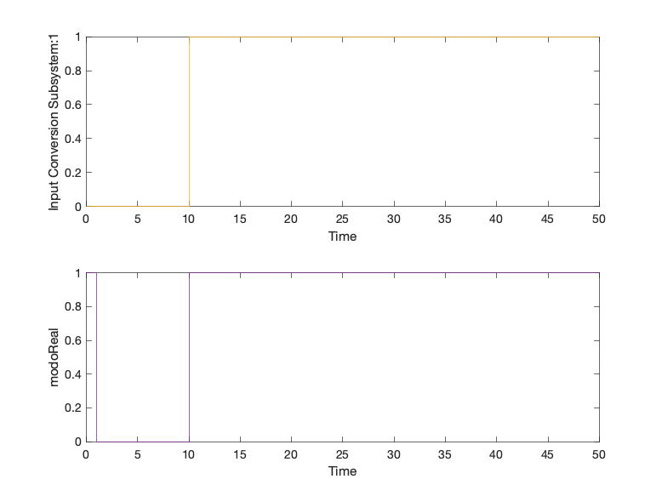

|  |  |
| --- | --- |
| Back to Report Summary | Back to Signal Summary |

|  |
| --- |
| **AlimentarGatoM** |

|  |  |
| --- | --- |
| **Test Result Information** | |
| Result Type: | Test Case Result |
| Parent: | estados_test |
| Start Time: | 10-Jan-2021 22:03:08 |
| End Time: | 10-Jan-2021 22:03:08 |
| Outcome: | Passed |
| Description: |  |

Suponiendo la selección  
del modo manual por parte del usuario, el presente test testea la correcta  
dispensa de comida en caso de que el usuario lo solicite, así como su parada  
una vez la comida ha sido dispensada.

|  |  |
| --- | --- |
| **Test Case Information** | |
| Name: | AlimentarGatoM |
| Type: | Baseline Test |

|  |  |
| --- | --- |
| **Test Case Requirements** | |
| Description: | RF-CO_01: Alimentación del gato en modo manual (gatera#7) |
| Document: | ../resources/requirements/gatera.slreqx |

**Logical and Temporal Assessments**

|  |  |
| --- | --- |
| **Name** | **Assessment** |
| Assessment1 | At any point in time, whenever (autorizUsuarioCom == 1) is true then, with no delay, ((actComedero == 1) & (alertaDispensar == 0)) must be true |
| Assessment3 | At any point in time, whenever (actComedero == 1) is true then, with a delay of at most 11 seconds, (actComedero == 0) must be true |

**Simulation**

|  |  |
| --- | --- |
| **System Under Test Information** | |
| Model: | estados_test |
| Harness: | AFAlimentarGatoM |
| Harness Owner: | estados_test |
| Release: | Current |
| Simulation Mode: | normal |
| Override SIL or PIL Mode: | 0 |
| Configuration Set: | Configuration1 |
| Start Time: | 0 |
| Stop Time: | 40 |
| Checksum: | 200793961 1296339477 1045993404 2570160091 |
| Simulink Version: | 10.2 |
| Model Version: | 1.19 |
| Model Author: | Iranzu |
| Date: | Sat Jan 09 20:43:10 2021 |
| User ID: | jlanzas |
| Model Path: | /Users/jlanzas/Documents/MATLAB/CATSAFE/AFAlimentarGatoM.slx |
| Solver Name: | VariableStepDiscrete |
| Solver Type: | Variable-Step |
| Max Step Size: | 0.80000000000000004 |
| Simulation Start Time: | 2021-01-10 22:03:05 |
| Simulation Stop Time: | 2021-01-10 22:03:07 |
| Platform: | MACI64 |

**Simulation Output**

|  |  |  |  |  |  |  |
| --- | --- | --- | --- | --- | --- | --- |
| **Name** | **Data Type** | **Units** | **Sample Time** | **Interp** | **Sync** | **Link to Plot** |
| Input Conversion Subsystem:3 | double |  | Continuous | zoh | union | Link |
| actComedero | double |  | Continuous | zoh | union | Link |
| alertaDispensar | double |  | Continuous | zoh | union | Link |

|  |  |  |  |  |  |
| --- | --- | --- | --- | --- | --- |
| **Name** | **Data Type** | **Units** | **Sample Time** | **Interp** | **Sync** |
| Input Conversion Subsystem:3 | double |  | Continuous | zoh | union |
| actComedero | double |  | Continuous | zoh | union |

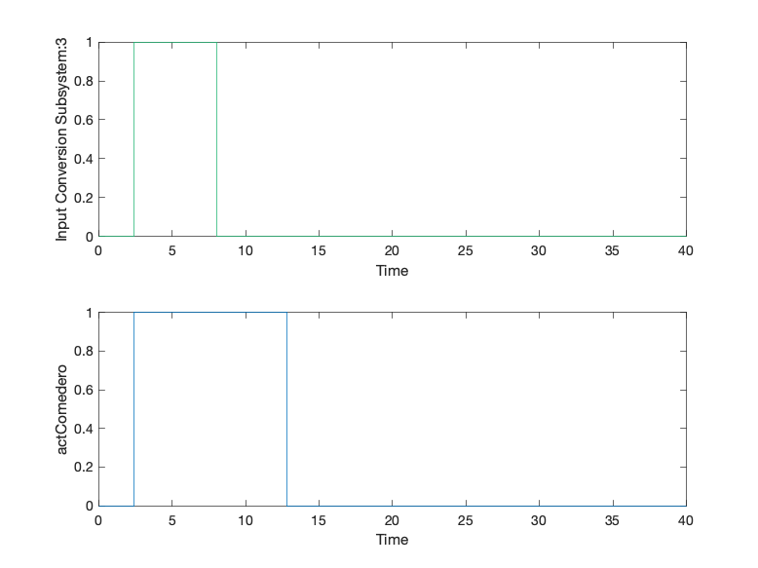

|  |  |
| --- | --- |
| Back to Report Summary | Back to Signal Summary |

|  |  |  |  |  |  |
| --- | --- | --- | --- | --- | --- |
| **Name** | **Data Type** | **Units** | **Sample Time** | **Interp** | **Sync** |
| alertaDispensar | double |  | Continuous | zoh | union |

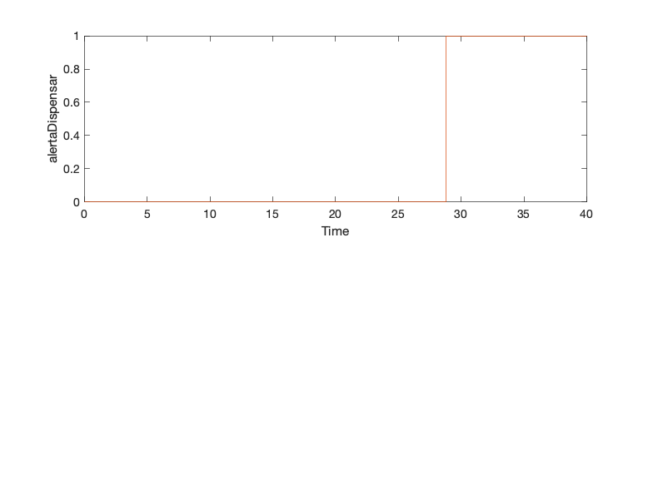

|  |  |
| --- | --- |
| Back to Report Summary | Back to Signal Summary |

|  |
| --- |
| **AlimentarGatoA** |

|  |  |
| --- | --- |
| **Test Result Information** | |
| Result Type: | Test Case Result |
| Parent: | estados_test |
| Start Time: | 10-Jan-2021 22:03:11 |
| End Time: | 10-Jan-2021 22:03:11 |
| Outcome: | Passed |
| Description: |  |

Suponiendo la selección  
del modo automático por parte del usuario, el presente test testea la correcta  
dispensa de comida en las horas programadas para ello por el usuario.

El funcionamiento del
sistema está sincronizado con un reloj, de tal manera que cuando la hora
coincide con la hora programada por el usuario para alimentar al gato, o se
encuentra dentro de una región de confianza aceptable, dado que está
seleccionado el modo automático, se realiza la secuencia de dispensa de comida.

También se verifica su
parada una vez la comida ha sido dispensada.

|  |  |
| --- | --- |
| **Test Case Information** | |
| Name: | AlimentarGatoA |
| Type: | Baseline Test |

|  |  |
| --- | --- |
| **Test Case Requirements** | |
| Description: | RF-CO_02: Alimentación del gato en modo automático (gatera#14) |
| Document: | ../resources/requirements/gatera.slreqx |

**Logical and Temporal Assessments**

|  |  |
| --- | --- |
| **Name** | **Assessment** |
| Assessment1 | At any point in time, whenever ((t >= horaComida) & (t < (horaComida + 10))) is true then, with no delay, (actComedero == 1) must be true |
| Assessment2 | At any point in time, whenever (actComedero == 1) is true then, with a delay of at most 11 seconds, (actComedero ~= 1) must be true |

**Simulation**

|  |  |
| --- | --- |
| **System Under Test Information** | |
| Model: | estados_test |
| Harness: | AGAlimentarGatoA |
| Harness Owner: | estados_test |
| Release: | Current |
| Simulation Mode: | normal |
| Override SIL or PIL Mode: | 0 |
| Configuration Set: | Configuration1 |
| Start Time: | 0 |
| Stop Time: | 100 |
| Checksum: | 2840792853 3614709184 3597129363 1098430605 |
| Simulink Version: | 10.2 |
| Model Version: | 1.21 |
| Model Author: | Juan |
| Date: | Thu Jan 07 13:47:53 2021 |
| User ID: | jlanzas |
| Model Path: | /Users/jlanzas/Documents/MATLAB/CATSAFE/AGAlimentarGatoA.slx |
| Solver Name: | VariableStepDiscrete |
| Solver Type: | Variable-Step |
| Max Step Size: | 2 |
| Simulation Start Time: | 2021-01-10 22:03:08 |
| Simulation Stop Time: | 2021-01-10 22:03:10 |
| Platform: | MACI64 |

**Simulation Output**

|  |  |  |  |  |  |  |
| --- | --- | --- | --- | --- | --- | --- |
| **Name** | **Data Type** | **Units** | **Sample Time** | **Interp** | **Sync** | **Link to Plot** |
| Input Conversion Subsystem:8 | double |  | Continuous | zoh | union | Link |
| actComedero | double |  | Continuous | zoh | union | Link |
| modoReal | double |  | Continuous | zoh | union | Link |

|  |  |  |  |  |  |
| --- | --- | --- | --- | --- | --- |
| **Name** | **Data Type** | **Units** | **Sample Time** | **Interp** | **Sync** |
| Input Conversion Subsystem:8 | double |  | Continuous | zoh | union |
| actComedero | double |  | Continuous | zoh | union |

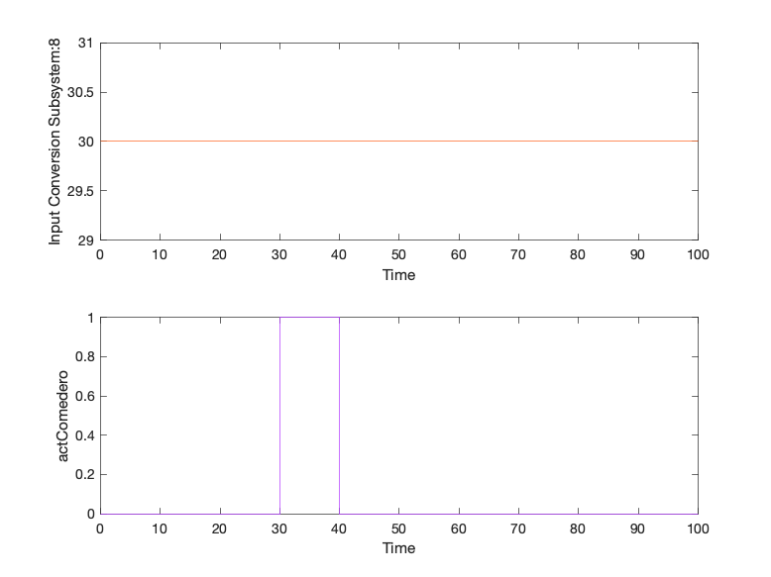

|  |  |
| --- | --- |
| Back to Report Summary | Back to Signal Summary |

|  |  |  |  |  |  |
| --- | --- | --- | --- | --- | --- |
| **Name** | **Data Type** | **Units** | **Sample Time** | **Interp** | **Sync** |
| modoReal | double |  | Continuous | zoh | union |

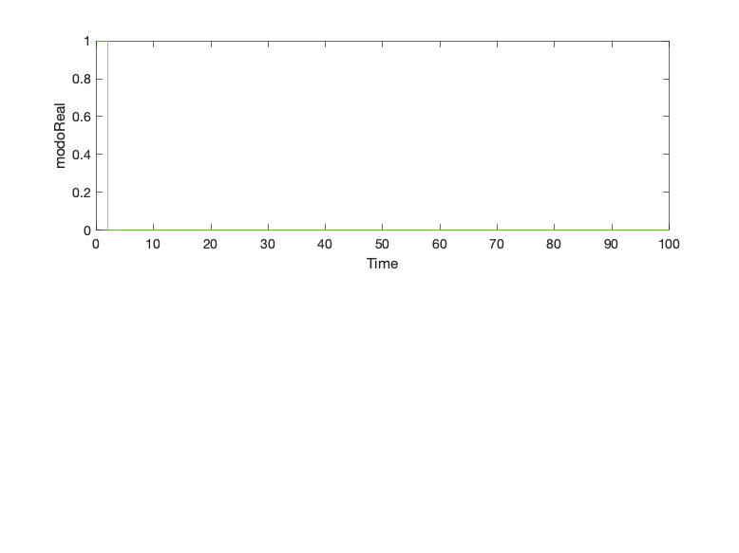

|  |  |
| --- | --- |
| Back to Report Summary | Back to Signal Summary |

|  |
| --- |
| **ParadaDeEmergencia** |

|  |  |
| --- | --- |
| **Test Result Information** | |
| Result Type: | Test Case Result |
| Parent: | estados_test |
| Start Time: | 10-Jan-2021 22:03:15 |
| End Time: | 10-Jan-2021 22:03:15 |
| Outcome: | Passed |
| Description: |  |

Testea el paso a modo  
bloqueo en caso de producirse una parada de emergencia.

También se testea la
correcta parada de emergencia, de tal forma que en el momento en el que se pasa
a modo bloqueo, la gatera no se accione.

El test incluye la
función de reestablecer el modo de tal forma que la gatera retorne al modo de
uso en el que se encontraba antes de producirse la parada de emergencia, sea
este el manual o el automático.

|  |  |
| --- | --- |
| **Test Case Information** | |
| Name: | ParadaDeEmergencia |
| Type: | Baseline Test |

|  |  |
| --- | --- |
| **Test Case Requirements** | |
| Description: | RNF-SE_01: Parada de Emergencia (gatera#15) |
| Document: | ../resources/requirements/gatera.slreqx |

**Logical and Temporal Assessments**

|  |  |
| --- | --- |
| **Name** | **Assessment** |
| Assessment1 | At any point in time, whenever (paradaEmergencia == 1) is true then, with a delay of at most 1 seconds, (modoReal == 2) must be true |
| Assessment2 | At any point in time, whenever (modoReal == 2) is true then, with no delay, (actGatera == 0) must be true |
| Assessment3 | At any point in time, whenever ((reestablecerModo == 1) & (modoAnt == 0)) is true then, with no delay, (modoReal == 0) must be true |
| Assessment4 | At any point in time, whenever ((reestablecerModo == 1) & (modoAnt == 1)) is true then, with no delay, (modoReal == 1) must be true |

**Simulation**

|  |  |
| --- | --- |
| **System Under Test Information** | |
| Model: | estados_test |
| Harness: | AHParadaDeEmergencia |
| Harness Owner: | estados_test |
| Release: | Current |
| Simulation Mode: | normal |
| Override SIL or PIL Mode: | 0 |
| Configuration Set: | Configuration1 |
| Start Time: | 0 |
| Stop Time: | 50 |
| Checksum: | 1602979798 2768271741 1260788232 2787128758 |
| Simulink Version: | 10.2 |
| Model Version: | 1.18 |
| Model Author: | Iranzu |
| Date: | Sat Jan 09 17:19:19 2021 |
| User ID: | jlanzas |
| Model Path: | /Users/jlanzas/Documents/MATLAB/CATSAFE/AHParadaDeEmergencia.slx |
| Solver Name: | VariableStepDiscrete |
| Solver Type: | Variable-Step |
| Max Step Size: | 1 |
| Simulation Start Time: | 2021-01-10 22:03:11 |
| Simulation Stop Time: | 2021-01-10 22:03:14 |
| Platform: | MACI64 |

**Simulation Output**

|  |  |  |  |  |  |  |
| --- | --- | --- | --- | --- | --- | --- |
| **Name** | **Data Type** | **Units** | **Sample Time** | **Interp** | **Sync** | **Link to Plot** |
| Input Conversion Subsystem:12 | double |  | Continuous | zoh | union | Link |
| Input Conversion Subsystem:9 | double |  | Continuous | zoh | union | Link |
| Input Conversion Subsystem:10 | double |  | Continuous | zoh | union | Link |
| actGatera | double |  | Continuous | zoh | union | Link |
| modoAnt | double |  | Continuous | zoh | union | Link |
| modoReal | double |  | Continuous | zoh | union | Link |
| ubicacion | double |  | Continuous | zoh | union | Link |

|  |  |  |  |  |  |
| --- | --- | --- | --- | --- | --- |
| **Name** | **Data Type** | **Units** | **Sample Time** | **Interp** | **Sync** |
| Input Conversion Subsystem:12 | double |  | Continuous | zoh | union |
| Input Conversion Subsystem:9 | double |  | Continuous | zoh | union |

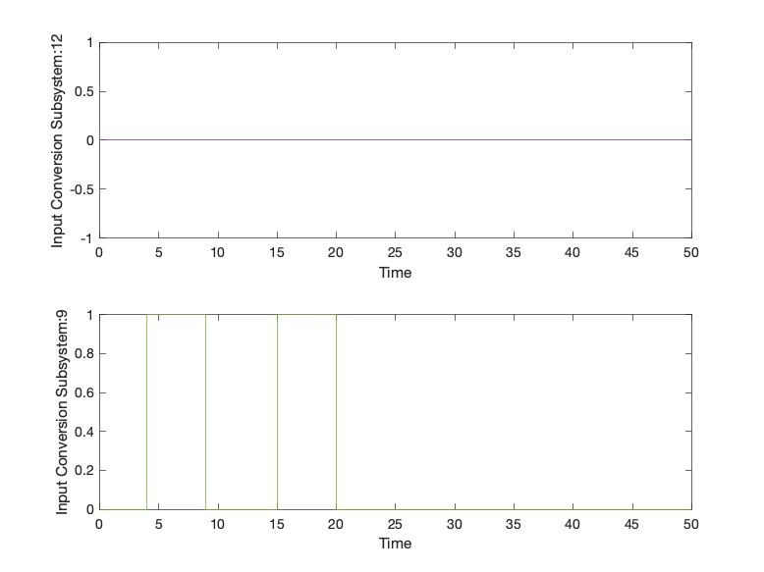

|  |  |
| --- | --- |
| Back to Report Summary | Back to Signal Summary |

|  |  |  |  |  |  |
| --- | --- | --- | --- | --- | --- |
| **Name** | **Data Type** | **Units** | **Sample Time** | **Interp** | **Sync** |
| Input Conversion Subsystem:10 | double |  | Continuous | zoh | union |
| actGatera | double |  | Continuous | zoh | union |

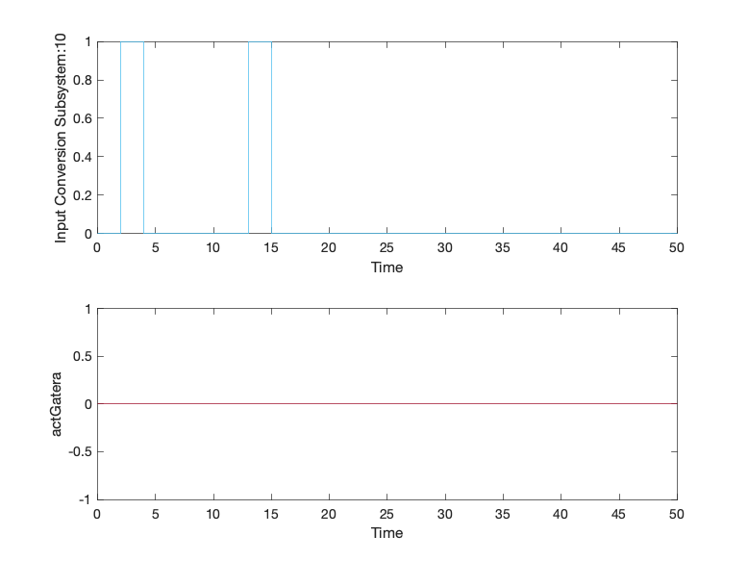

|  |  |
| --- | --- |
| Back to Report Summary | Back to Signal Summary |

|  |  |  |  |  |  |
| --- | --- | --- | --- | --- | --- |
| **Name** | **Data Type** | **Units** | **Sample Time** | **Interp** | **Sync** |
| modoAnt | double |  | Continuous | zoh | union |
| modoReal | double |  | Continuous | zoh | union |

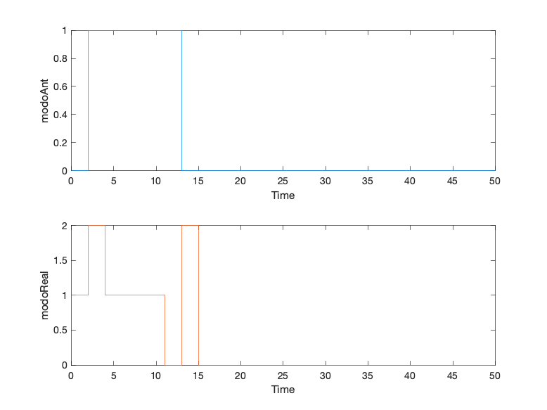

|  |  |
| --- | --- |
| Back to Report Summary | Back to Signal Summary |

|  |  |  |  |  |  |
| --- | --- | --- | --- | --- | --- |
| **Name** | **Data Type** | **Units** | **Sample Time** | **Interp** | **Sync** |
| ubicacion | double |  | Continuous | zoh | union |

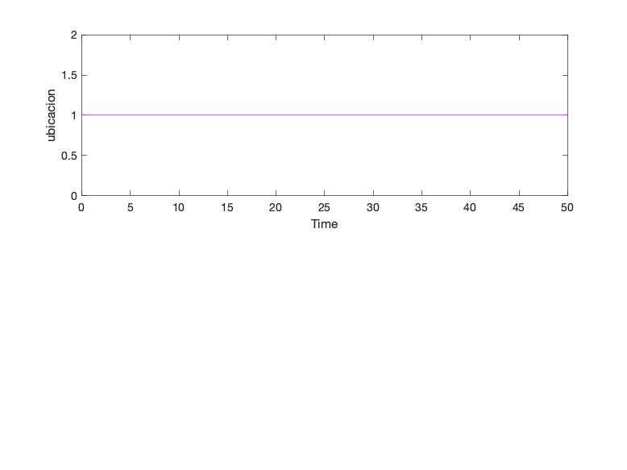

|  |  |
| --- | --- |
| Back to Report Summary | Back to Signal Summary |

|  |
| --- |
| **Ubicacion** |

|  |  |
| --- | --- |
| **Test Result Information** | |
| Result Type: | Test Case Result |
| Parent: | estados_test |
| Start Time: | 10-Jan-2021 22:03:19 |
| End Time: | 10-Jan-2021 22:03:19 |
| Outcome: | Passed |
| Description: |  |

Testea que la  
información proporcionada al usuario acerca de la ubicación del animal, cuando  
este la solicita, es correcta.

Dicha comprobación se ha
realizado durante el proceso de entrada del gato al interior y su posterior salida,
comprobando su ubicación en el exterior (0) cuando se detecta su presencia por
primera vez en el exterior, y comprobando posteriormente su ubicación en el
interior (1) tras haber entrado y solicitar su salida nuevamente.

|  |  |
| --- | --- |
| **Test Case Information** | |
| Name: | Ubicacion |
| Type: | Baseline Test |

|  |  |
| --- | --- |
| **Test Case Requirements** | |
| Description: | RF-SY_04: El dueño quiere ver el registro de actividad del gato (gatera#16) |
| Document: | ../resources/requirements/gatera.slreqx |

**Logical and Temporal Assessments**

|  |  |
| --- | --- |
| **Name** | **Assessment** |
| Assessment1 | At any point in time, whenever (presOUT == 1) is true then, with no delay, (ubicacion == 0) must be true |
| Assessment2 | At any point in time, if (solUbicacion == 1) becomes true then, with a delay of at most 5 seconds, (peticionUbicacion == ubicacion) must be true |
| Assessment3 | At any point in time, if (presIN == 1) becomes true then, with no delay, (ubicacion == 1) must be true |

**Simulation**

|  |  |
| --- | --- |
| **System Under Test Information** | |
| Model: | estados_test |
| Harness: | AIRegUbicacion |
| Harness Owner: | estados_test |
| Release: | Current |
| Simulation Mode: | normal |
| Override SIL or PIL Mode: | 0 |
| Configuration Set: | Configuration1 |
| Start Time: | 0 |
| Stop Time: | 100 |
| Checksum: | 1533826714 4114663693 3427449830 3778558618 |
| Simulink Version: | 10.2 |
| Model Version: | 1.42 |
| Model Author: | Iranzu |
| Date: | Thu Jan 07 23:01:35 2021 |
| User ID: | jlanzas |
| Model Path: | /Users/jlanzas/Documents/MATLAB/CATSAFE/AIRegUbicacion.slx |
| Solver Name: | VariableStepDiscrete |
| Solver Type: | Variable-Step |
| Max Step Size: | 2 |
| Simulation Start Time: | 2021-01-10 22:03:16 |
| Simulation Stop Time: | 2021-01-10 22:03:18 |
| Platform: | MACI64 |

**Simulation Output**

|  |  |  |  |  |  |  |
| --- | --- | --- | --- | --- | --- | --- |
| **Name** | **Data Type** | **Units** | **Sample Time** | **Interp** | **Sync** | **Link to Plot** |
| Input Conversion Subsystem:11 | double |  | Continuous | zoh | union | Link |
| Input Conversion Subsystem:5 | double |  | Continuous | zoh | union | Link |
| Input Conversion Subsystem:6 | double |  | Continuous | zoh | union | Link |
| peticionUbicacion | double |  | Continuous | zoh | union | Link |
| ubicacion | double |  | Continuous | zoh | union | Link |

|  |  |  |  |  |  |
| --- | --- | --- | --- | --- | --- |
| **Name** | **Data Type** | **Units** | **Sample Time** | **Interp** | **Sync** |
| Input Conversion Subsystem:11 | double |  | Continuous | zoh | union |
| Input Conversion Subsystem:5 | double |  | Continuous | zoh | union |

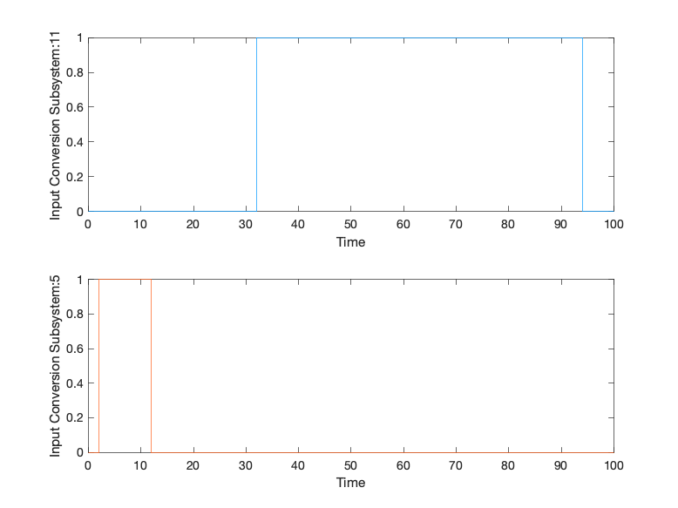

|  |  |
| --- | --- |
| Back to Report Summary | Back to Signal Summary |

|  |  |  |  |  |  |
| --- | --- | --- | --- | --- | --- |
| **Name** | **Data Type** | **Units** | **Sample Time** | **Interp** | **Sync** |
| Input Conversion Subsystem:6 | double |  | Continuous | zoh | union |
| peticionUbicacion | double |  | Continuous | zoh | union |

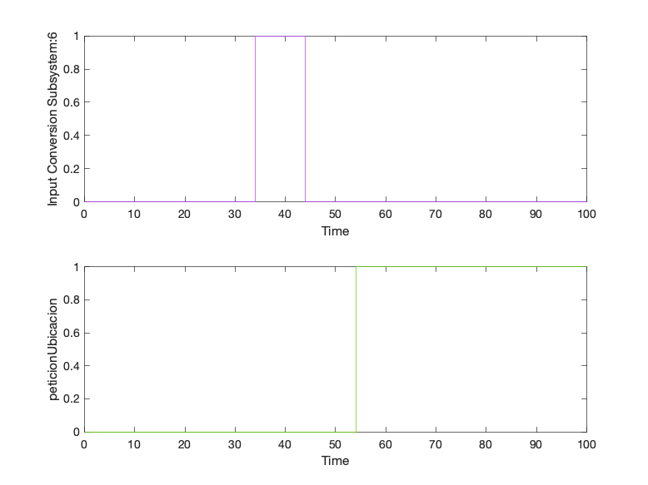

|  |  |
| --- | --- |
| Back to Report Summary | Back to Signal Summary |

|  |  |  |  |  |  |
| --- | --- | --- | --- | --- | --- |
| **Name** | **Data Type** | **Units** | **Sample Time** | **Interp** | **Sync** |
| ubicacion | double |  | Continuous | zoh | union |

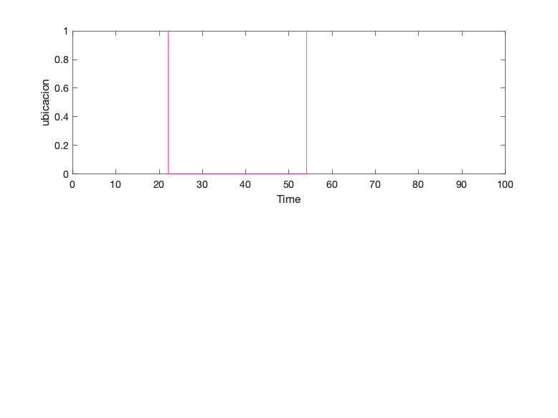

|  |  |
| --- | --- |
| Back to Report Summary | Back to Signal Summary |

|  |
| --- |
| **NuevoGato** |

|  |  |
| --- | --- |
| **Test Result Information** | |
| Result Type: | Test Case Result |
| Parent: | estados_test |
| Start Time: | 10-Jan-2021 22:03:22 |
| End Time: | 10-Jan-2021 22:03:22 |
| Outcome: | Passed |
| Description: |  |

Testea la correcta  
inclusión del nuevo gato en el sistema. Para ello, es necesario el  
reconocimiento del chip por parte de la gatera y del sensor.

|  |  |
| --- | --- |
| **Test Case Information** | |
| Name: | NuevoGato |
| Type: | Baseline Test |

|  |  |
| --- | --- |
| **Test Case Requirements** | |
| Description: | RF-SY_05: El dueño quiere introducir un nuevo gato en el sistema (gatera#17) |
| Document: | ../resources/requirements/gatera.slreqx |

**Logical and Temporal Assessments**

|  |  |
| --- | --- |
| **Name** | **Assessment** |
| Assessment1 | At any point in time, whenever (((nuevoGato == 1) & (gateraReconoce == 1)) & (sensorReconoce == 1)) is true then, with no delay, (gatoIntroducido == 1) must be true |

**Simulation**

|  |  |
| --- | --- |
| **System Under Test Information** | |
| Model: | estados_test |
| Harness: | AJNuevoGato |
| Harness Owner: | estados_test |
| Release: | Current |
| Simulation Mode: | normal |
| Override SIL or PIL Mode: | 0 |
| Configuration Set: | Configuration1 |
| Start Time: | 0 |
| Stop Time: | 50 |
| Checksum: | 312592730 564424305 3875006110 495813938 |
| Simulink Version: | 10.2 |
| Model Version: | 1.12 |
| Model Author: | Iranzu |
| Date: | Sat Jan 09 17:54:33 2021 |
| User ID: | jlanzas |
| Model Path: | /Users/jlanzas/Documents/MATLAB/CATSAFE/AJNuevoGato.slx |
| Solver Name: | VariableStepDiscrete |
| Solver Type: | Variable-Step |
| Max Step Size: | 1 |
| Simulation Start Time: | 2021-01-10 22:03:20 |
| Simulation Stop Time: | 2021-01-10 22:03:22 |
| Platform: | MACI64 |

**Simulation Output**

|  |  |  |  |  |  |  |
| --- | --- | --- | --- | --- | --- | --- |
| **Name** | **Data Type** | **Units** | **Sample Time** | **Interp** | **Sync** | **Link to Plot** |
| Input Conversion Subsystem:12 | double |  | Continuous | zoh | union | Link |
| Input Conversion Subsystem:13 | double |  | Continuous | zoh | union | Link |
| Input Conversion Subsystem:14 | double |  | Continuous | zoh | union | Link |
| gatoIntroducido | double |  | Continuous | zoh | union | Link |

|  |  |  |  |  |  |
| --- | --- | --- | --- | --- | --- |
| **Name** | **Data Type** | **Units** | **Sample Time** | **Interp** | **Sync** |
| Input Conversion Subsystem:12 | double |  | Continuous | zoh | union |
| Input Conversion Subsystem:13 | double |  | Continuous | zoh | union |

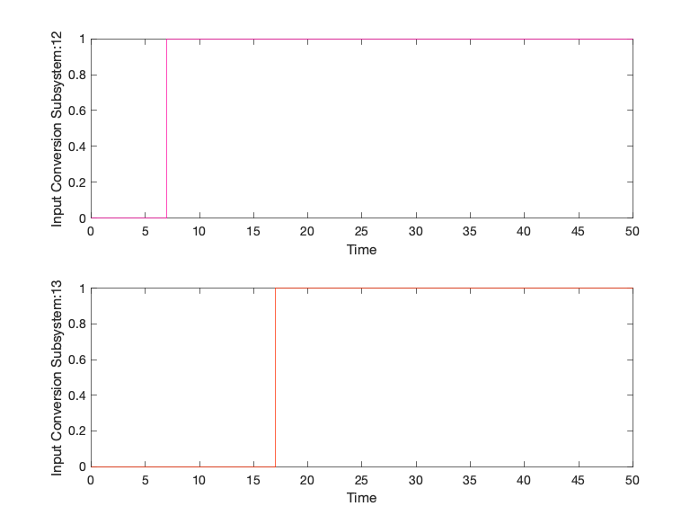

|  |  |
| --- | --- |
| Back to Report Summary | Back to Signal Summary |

|  |  |  |  |  |  |
| --- | --- | --- | --- | --- | --- |
| **Name** | **Data Type** | **Units** | **Sample Time** | **Interp** | **Sync** |
| Input Conversion Subsystem:14 | double |  | Continuous | zoh | union |
| gatoIntroducido | double |  | Continuous | zoh | union |

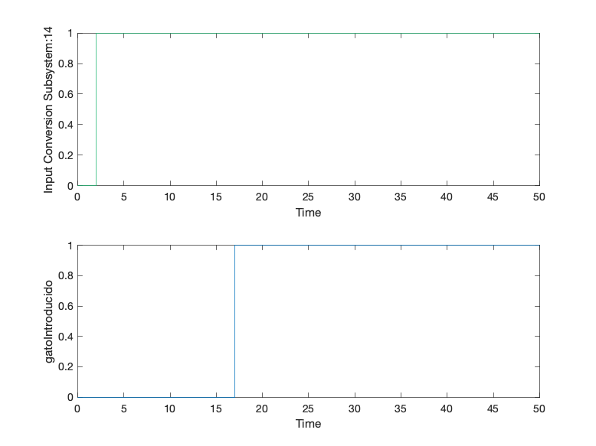

|  |  |
| --- | --- |
| Back to Report Summary | Back to Signal Summary |

|  |
| --- |
| **Observacion** |

|  |  |
| --- | --- |
| **Test Result Information** | |
| Result Type: | Test Case Result |
| Parent: | estados_test |
| Start Time: | 10-Jan-2021 22:03:28 |
| End Time: | 10-Jan-2021 22:03:28 |
| Outcome: | Passed |
| Description: |  |

Testea el correcto  
funcionamiento de las cámaras alternativamente en función de la ubicación del  
animal, estando ambos test altamente relacionados entre sí.

La comprobación se ha
realizado durante el proceso de salida del gato al exterior, comprobando su
ubicación en el interior en un inicio, mostrando imágenes del interior de la
vivienda, y pasando a señalar que se encuentra en el exterior cuando el gato
atraviesa la gatera, mostrando entonces imágenes de las cámaras del exterior.

|  |  |
| --- | --- |
| **Test Case Information** | |
| Name: | Observacion |
| Type: | Baseline Test |

|  |  |
| --- | --- |
| **Test Case Requirements** | |
| Description: | RF-CA_01: El dueño quiere ver las imágenes de las cámaras a tiempo real (gatera#18) |
| Document: | ../resources/requirements/gatera.slreqx |

**Logical and Temporal Assessments**

|  |  |
| --- | --- |
| **Name** | **Assessment** |
| Assessment1 | At any point in time, whenever ((solCamaras == 1) & (ubicacion == 1)) is true then, with a delay of at most 7 seconds, (camarasIN == ubicacion) must be true |
| Assessment2 | At any point in time, whenever ((solCamaras == 1) & (ubicacion == 0)) is true then, with no delay, (camarasOUT == ubicacion) must be true |

**Simulation**

|  |  |
| --- | --- |
| **System Under Test Information** | |
| Model: | estados_test |
| Harness: | AKObservacion |
| Harness Owner: | estados_test |
| Release: | Current |
| Simulation Mode: | normal |
| Override SIL or PIL Mode: | 0 |
| Configuration Set: | Configuration1 |
| Start Time: | 0 |
| Stop Time: | 100 |
| Checksum: | 1950000260 1132812729 836376055 923002449 |
| Simulink Version: | 10.2 |
| Model Version: | 1.20 |
| Model Author: | Iranzu |
| Date: | Sun Jan 10 13:20:24 2021 |
| User ID: | jlanzas |
| Model Path: | /Users/jlanzas/Documents/MATLAB/CATSAFE/AKObservacion.slx |
| Solver Name: | VariableStepDiscrete |
| Solver Type: | Variable-Step |
| Max Step Size: | 2 |
| Simulation Start Time: | 2021-01-10 22:03:22 |
| Simulation Stop Time: | 2021-01-10 22:03:27 |
| Platform: | MACI64 |

**Simulation Output**

|  |  |  |  |  |  |  |
| --- | --- | --- | --- | --- | --- | --- |
| **Name** | **Data Type** | **Units** | **Sample Time** | **Interp** | **Sync** | **Link to Plot** |
| Input Conversion Subsystem:15 | double |  | Continuous | zoh | union | Link |
| ubicacion | double |  | Continuous | zoh | union | Link |
| camarasOUT | double |  | Continuous | zoh | union | Link |
| camarasIN | double |  | Continuous | zoh | union | Link |

|  |  |  |  |  |  |
| --- | --- | --- | --- | --- | --- |
| **Name** | **Data Type** | **Units** | **Sample Time** | **Interp** | **Sync** |
| Input Conversion Subsystem:15 | double |  | Continuous | zoh | union |
| ubicacion | double |  | Continuous | zoh | union |

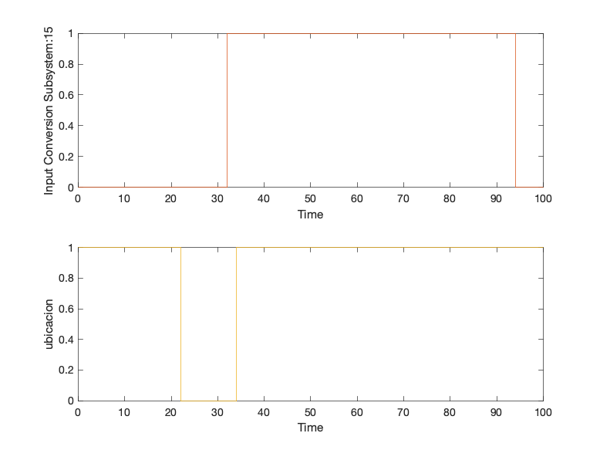

|  |  |
| --- | --- |
| Back to Report Summary | Back to Signal Summary |

|  |  |  |  |  |  |
| --- | --- | --- | --- | --- | --- |
| **Name** | **Data Type** | **Units** | **Sample Time** | **Interp** | **Sync** |
| camarasOUT | double |  | Continuous | zoh | union |
| camarasIN | double |  | Continuous | zoh | union |

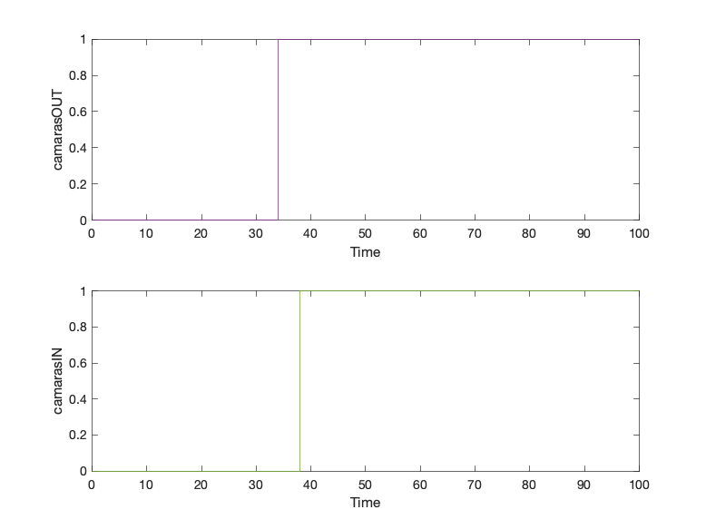

|  |  |
| --- | --- |
| Back to Report Summary | Back to Signal Summary |

|  |
| --- |
| **AlertaExcesoTiempoFueraAutomatico** |

|  |  |
| --- | --- |
| **Test Result Information** | |
| Result Type: | Test Case Result |
| Parent: | estados_test |
| Start Time: | 10-Jan-2021 22:03:31 |
| End Time: | 10-Jan-2021 22:03:31 |
| Outcome: | Passed |
| Description: |  |

Verifica que el Gato está fuera más de un tiempo determinado alta la alerta de exceso de tiempo fuera. Válido para modo automático. El tiempo establecido es de 20 segundos y sólo en el caso de que sea superado se activará la alerta, debiendo desaparecer en caso contrario.

|  |  |
| --- | --- |
| **Test Case Information** | |
| Name: | AlertaExcesoTiempoFueraAutomatico |
| Type: | Baseline Test |

|  |  |
| --- | --- |
| **Test Case Requirements** | |
| Description: | RF-SY_06: Aviso de emergencia. El gato lleva demasiado tiempo en el exterior (gatera#19) |
| Document: | ../resources/requirements/gatera.slreqx |

**Logical and Temporal Assessments**

|  |  |
| --- | --- |
| **Name** | **Assessment** |
| Assessment1 | At any point in time, whenever (tiempoFuera >= 20) is true then, with a delay of at most 5 seconds, (alertaTiempoFuera == 1) must be true |
| Assessment2 | At any point in time, whenever (tiempoFuera < 20) is true then, with no delay, (alertaTiempoFuera == 0) must be true |

**Simulation**

|  |  |
| --- | --- |
| **System Under Test Information** | |
| Model: | estados_test |
| Harness: | ALAlertaExcesoTiempoFueraAuto |
| Harness Owner: | estados_test |
| Release: | Current |
| Simulation Mode: | normal |
| Override SIL or PIL Mode: | 0 |
| Configuration Set: | Configuration1 |
| Start Time: | 0 |
| Stop Time: | 50 |
| Checksum: | 3706216924 4249672678 3647281383 2098960056 |
| Simulink Version: | 10.2 |
| Model Version: | 1.7 |
| Model Author: | Juan |
| Date: | Wed Jan 06 00:47:18 2021 |
| User ID: | jlanzas |
| Model Path: | /Users/jlanzas/Documents/MATLAB/CATSAFE/ALAlertaExcesoTiempoFueraAuto.slx |
| Solver Name: | VariableStepDiscrete |
| Solver Type: | Variable-Step |
| Max Step Size: | 1 |
| Simulation Start Time: | 2021-01-10 22:03:28 |
| Simulation Stop Time: | 2021-01-10 22:03:30 |
| Platform: | MACI64 |

**Simulation Output**

|  |  |  |  |  |  |  |
| --- | --- | --- | --- | --- | --- | --- |
| **Name** | **Data Type** | **Units** | **Sample Time** | **Interp** | **Sync** | **Link to Plot** |
| Input Conversion Subsystem:18 | double |  | Continuous | zoh | union | Link |
| actGatera | double |  | Continuous | zoh | union | Link |
| alertaTiempoFuera | double |  | Continuous | zoh | union | Link |
| tiempoFuera | double |  | Continuous | zoh | union | Link |
| tiempoSalida | double |  | Continuous | zoh | union | Link |

|  |  |  |  |  |  |
| --- | --- | --- | --- | --- | --- |
| **Name** | **Data Type** | **Units** | **Sample Time** | **Interp** | **Sync** |
| Input Conversion Subsystem:18 | double |  | Continuous | zoh | union |
| actGatera | double |  | Continuous | zoh | union |

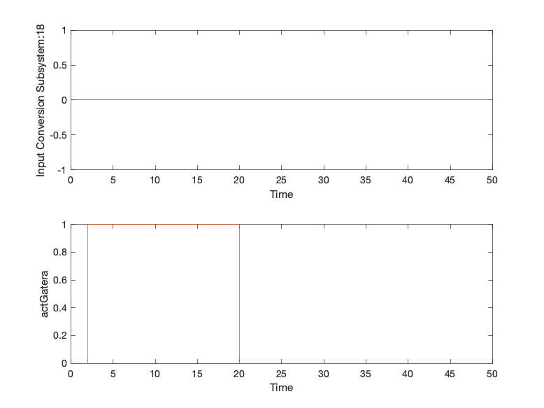

|  |  |
| --- | --- |
| Back to Report Summary | Back to Signal Summary |

|  |  |  |  |  |  |
| --- | --- | --- | --- | --- | --- |
| **Name** | **Data Type** | **Units** | **Sample Time** | **Interp** | **Sync** |
| alertaTiempoFuera | double |  | Continuous | zoh | union |
| tiempoFuera | double |  | Continuous | zoh | union |

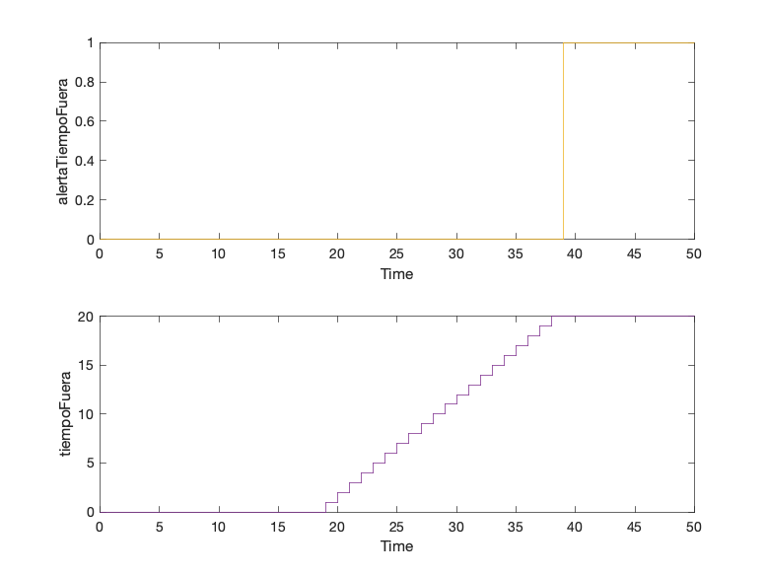

|  |  |
| --- | --- |
| Back to Report Summary | Back to Signal Summary |

|  |  |  |  |  |  |
| --- | --- | --- | --- | --- | --- |
| **Name** | **Data Type** | **Units** | **Sample Time** | **Interp** | **Sync** |
| tiempoSalida | double |  | Continuous | zoh | union |

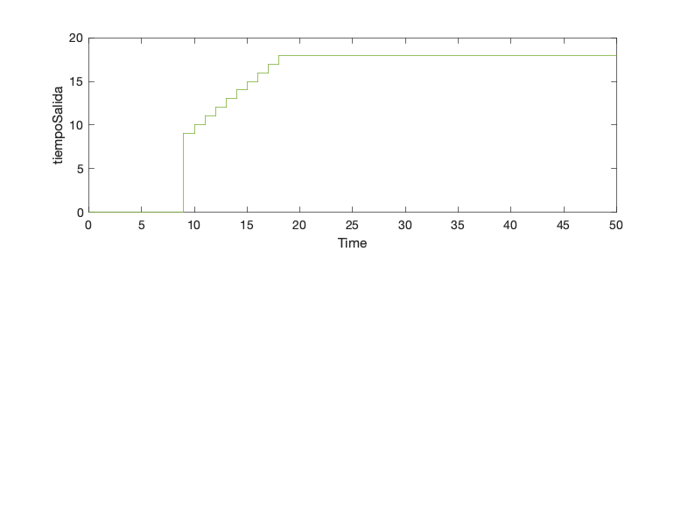

|  |  |
| --- | --- |
| Back to Report Summary | Back to Signal Summary |

|  |
| --- |
| **AlertaTiempoSinAlimentar** |

|  |  |
| --- | --- |
| **Test Result Information** | |
| Result Type: | Test Case Result |
| Parent: | estados_test |
| Start Time: | 10-Jan-2021 22:03:35 |
| End Time: | 10-Jan-2021 22:03:35 |
| Outcome: | Passed |
| Description: |  |

Testea que se envíe correctamente una alerta cuando se ha superado un tiempo determinado desde la última vez que se dispensó comida. El tiempo establecido es de 25 segundos y sólo en ese caso deberá aparecer la alerta, debiendo desaparecer en caso contrario. Se deberá comprobar además que el sistema dispensa comida de forma automática si salta la alerta y el usuario está dormido, recibiendo dicha información de un sistema externo.

|  |  |
| --- | --- |
| **Test Case Information** | |
| Name: | AlertaTiempoSinAlimentar |
| Type: | Baseline Test |

|  |  |
| --- | --- |
| **Test Case Requirements** | |
| Description: | RF-SY_07 (Requisito cruzado): Aviso de emergencia. El gato lleva demasiado tiempo sin alimentarse (gatera#21) |
| Document: | ../resources/requirements/gatera.slreqx |

**Logical and Temporal Assessments**

|  |  |
| --- | --- |
| **Name** | **Assessment** |
| Assessment1 | At any point in time, whenever (tiempoSinAlimentar >= 25) is true then, with a delay of at most 5 seconds, (alertaDispensar == 1) must be true |
| Assessment2 | At any point in time, if (autorizUsuarioCom == 1) becomes true then, with a delay of at most 30 seconds, ((alertaDispensar == 0) & (actComedero == 1)) must be true |
| Assessment3 | At any point in time, if (propietarioDormido == 1) becomes true then, with a delay of at most 30 seconds, ((alertaDispensar == 0) & (actComedero == 1)) must be true |
| Assessment4 | At any point in time, whenever ((alertaDispensar == 0) & (actComedero == 1)) is true then, with a delay of at most 17 seconds, (actComedero == 0) must be true |
| Assessment5 | At any point in time, whenever (tiempoSinAlimentar < 25) is true then, with a delay of at most 5 seconds, (alertaDispensar == 0) must be true |

**Simulation**

|  |  |
| --- | --- |
| **System Under Test Information** | |
| Model: | estados_test |
| Harness: | ALAlertaTiempoSinAlimentar |
| Harness Owner: | estados_test |
| Release: | Current |
| Simulation Mode: | normal |
| Override SIL or PIL Mode: | 0 |
| Configuration Set: | Configuration1 |
| Start Time: | 0 |
| Stop Time: | 150 |
| Checksum: | 3813345723 1996527020 2749796491 1256019540 |
| Simulink Version: | 10.2 |
| Model Version: | 1.18 |
| Model Author: | Iranzu |
| Date: | Wed Jan 06 13:28:22 2021 |
| User ID: | jlanzas |
| Model Path: | /Users/jlanzas/Documents/MATLAB/CATSAFE/ALAlertaTiempoSinAlimentar.slx |
| Solver Name: | VariableStepDiscrete |
| Solver Type: | Variable-Step |
| Max Step Size: | 3 |
| Simulation Start Time: | 2021-01-10 22:03:31 |
| Simulation Stop Time: | 2021-01-10 22:03:34 |
| Platform: | MACI64 |

**Simulation Output**

|  |  |  |  |  |  |  |
| --- | --- | --- | --- | --- | --- | --- |
| **Name** | **Data Type** | **Units** | **Sample Time** | **Interp** | **Sync** | **Link to Plot** |
| Input Conversion Subsystem:16 | double |  | Continuous | zoh | union | Link |
| Input Conversion Subsystem:3 | double |  | Continuous | zoh | union | Link |
| actComedero | double |  | Continuous | zoh | union | Link |
| tiempoDispensa | double |  | Continuous | zoh | union | Link |
| alertaDispensar | double |  | Continuous | zoh | union | Link |
| tiempoSinAlimentar | double |  | Continuous | zoh | union | Link |

|  |  |  |  |  |  |
| --- | --- | --- | --- | --- | --- |
| **Name** | **Data Type** | **Units** | **Sample Time** | **Interp** | **Sync** |
| Input Conversion Subsystem:16 | double |  | Continuous | zoh | union |
| Input Conversion Subsystem:3 | double |  | Continuous | zoh | union |

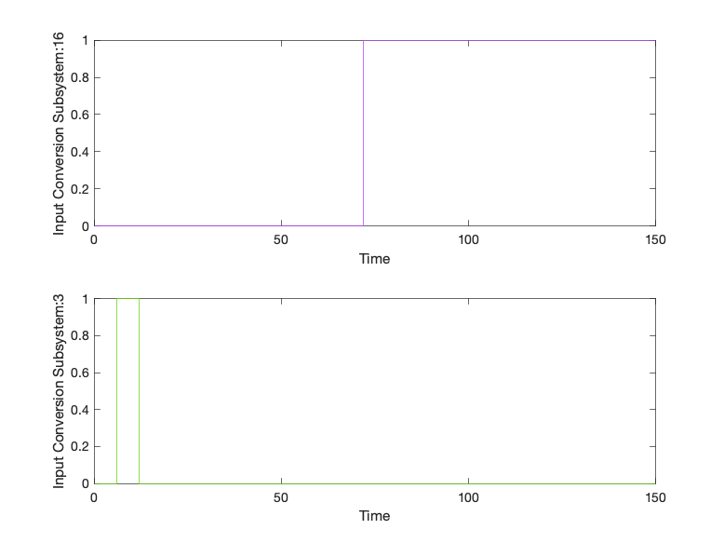

|  |  |
| --- | --- |
| Back to Report Summary | Back to Signal Summary |

|  |  |  |  |  |  |
| --- | --- | --- | --- | --- | --- |
| **Name** | **Data Type** | **Units** | **Sample Time** | **Interp** | **Sync** |
| actComedero | double |  | Continuous | zoh | union |
| tiempoDispensa | double |  | Continuous | zoh | union |

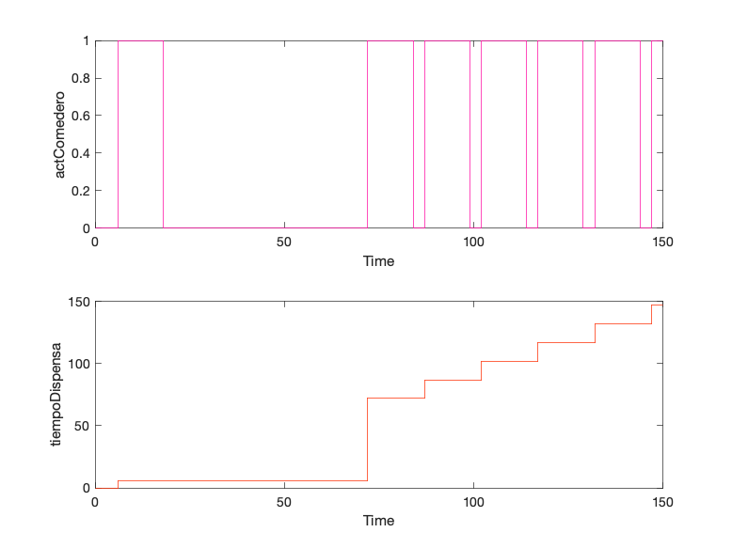

|  |  |
| --- | --- |
| Back to Report Summary | Back to Signal Summary |

|  |  |  |  |  |  |
| --- | --- | --- | --- | --- | --- |
| **Name** | **Data Type** | **Units** | **Sample Time** | **Interp** | **Sync** |
| alertaDispensar | double |  | Continuous | zoh | union |
| tiempoSinAlimentar | double |  | Continuous | zoh | union |

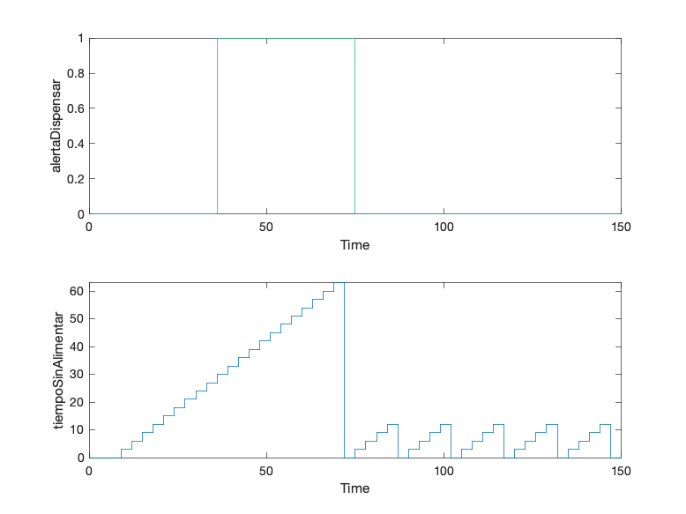

|  |  |
| --- | --- |
| Back to Report Summary | Back to Signal Summary |

|  |
| --- |
| **AlertaLluvia** |

|  |  |
| --- | --- |
| **Test Result Information** | |
| Result Type: | Test Case Result |
| Parent: | estados_test |
| Start Time: | 10-Jan-2021 22:03:38 |
| End Time: | 10-Jan-2021 22:03:38 |
| Outcome: | Passed |
| Description: |  |

Si llega al sistema un aviso de lluvia, deberá aparecer la alerta de lluvia en la aplicación. Si dicho aviso desaparece, de igual forma la alerta deberá desaparecer.

|  |  |
| --- | --- |
| **Test Case Information** | |
| Name: | AlertaLluvia |
| Type: | Baseline Test |

**Logical and Temporal Assessments**

|  |  |
| --- | --- |
| **Name** | **Assessment** |
| Assessment1 | At any point in time, whenever (avisoLluvia == 1) is true then, with no delay, (alertaLluvia == 1) must be true |
| Assessment2 | At any point in time, whenever (avisoLluvia == 0) is true then, with no delay, (alertaLluvia == 0) must be true |

**Simulation**

|  |  |
| --- | --- |
| **System Under Test Information** | |
| Model: | estados_test |
| Harness: | AMAlertaLluvia |
| Harness Owner: | estados_test |
| Release: | Current |
| Simulation Mode: | normal |
| Override SIL or PIL Mode: | 0 |
| Configuration Set: | Configuration1 |
| Start Time: | 0 |
| Stop Time: | 50 |
| Checksum: | 3230508997 3189601799 675231145 3054877009 |
| Simulink Version: | 10.2 |
| Model Version: | 1.2 |
| Model Author: | Juan |
| Date: | Wed Jan 06 01:15:36 2021 |
| User ID: | jlanzas |
| Model Path: | /Users/jlanzas/Documents/MATLAB/CATSAFE/AMAlertaLluvia.slx |
| Solver Name: | VariableStepDiscrete |
| Solver Type: | Variable-Step |
| Max Step Size: | 1 |
| Simulation Start Time: | 2021-01-10 22:03:35 |
| Simulation Stop Time: | 2021-01-10 22:03:37 |
| Platform: | MACI64 |

**Simulation Output**

|  |  |  |  |  |  |  |
| --- | --- | --- | --- | --- | --- | --- |
| **Name** | **Data Type** | **Units** | **Sample Time** | **Interp** | **Sync** | **Link to Plot** |
| Input Conversion Subsystem:17 | double |  | Continuous | zoh | union | Link |
| alertaLluvia | double |  | Continuous | zoh | union | Link |

|  |  |  |  |  |  |
| --- | --- | --- | --- | --- | --- |
| **Name** | **Data Type** | **Units** | **Sample Time** | **Interp** | **Sync** |
| Input Conversion Subsystem:17 | double |  | Continuous | zoh | union |
| alertaLluvia | double |  | Continuous | zoh | union |

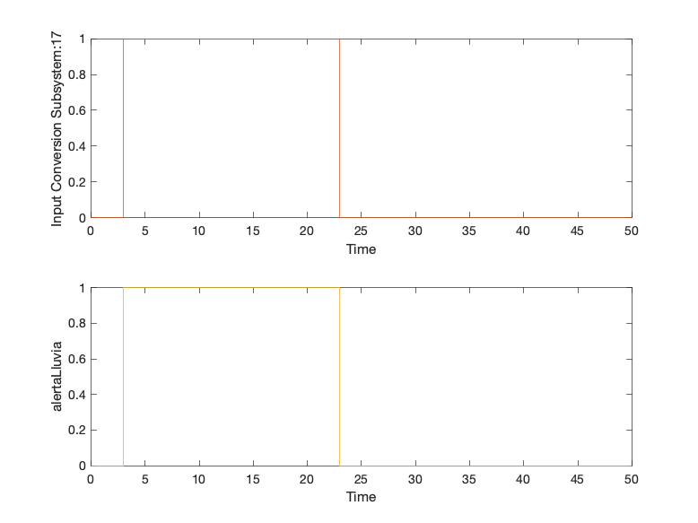

|  |  |
| --- | --- |
| Back to Report Summary | Back to Signal Summary |