Can a PPO Reinforcement Learning Agent Reach and Exceed a
Novice Human Baseline in Pong Under a Fixed Compute Budget?
José María Murillo, Hans Helmrich, Beatriz Wahle, Valentín Miguel, Pablo Chen, Nicolás Cubillo
IE University · Emerging Topics in Data Analysis · April 2026
Abstract
We establish a reproducible benchmark comparing Proximal Policy Optimization (PPO) against a measured novice human baseline on Atari Pong. Across five random seeds, PPO trained for 1,000,000 timesteps achieves a mean episodic return of −8.46 (95% CI: [−10.78, −6.58]), already exceeding the human baseline mean of −15.73 (95% CI: [−16.40, −15.06]) by 7.27 points (CI: [4.98, 9.27]). Extending training to 5,000,000 timesteps raises agent performance to +15.61 (CI: [+14.33, +16.62]), a 31.34-point margin over humans, with 100% win rate across all seeds. Analysis of learning curves reveals PPO first exceeds the human mean at approximately 800,000 timesteps. Seed variance decreases from σ = 2.64 at 1M to σ = 1.47 at 5M steps, confirming reliable convergence. All code and raw data are publicly available.
Introduction
Reinforcement learning (RL) has produced landmark results in artificial intelligence — from AlphaGo defeating world champions (Silver et al., 2016) to DQN mastering Atari games from raw pixels (Mnih et al., 2015). Yet most of this work operates at scales that are inaccessible to teams without large compute budgets. A practically important but underexplored question follows: how far can a standard RL algorithm get on a well-defined task under a fixed, modest compute budget — and at what point does it cross the threshold of human competence?
Research gap. Most RL benchmarking studies compare algorithms against each other or against human scores that were collected under non-standardized conditions (Mnih et al., 2015 used professional game testers with unlimited practice). Critically, these comparisons rarely quantify uncertainty: they report point estimates without confidence intervals, making it impossible to assess whether a reported performance gap is reliable or a product of random seed selection. Henderson et al. (2018) demonstrated that different seeds, codebases, and hyperparameter choices can produce dramatically different results for the same algorithm on the same task — a finding that directly motivates our multi-seed design. Agarwal et al. (2021) further showed that the field has systematically underreported uncertainty and advocated for bootstrap confidence intervals as the appropriate evaluation protocol for deep RL.
Novelty. We address this gap by: (1) collecting a fresh, in-house novice human baseline under the same evaluation conditions as the agent (same environment, opponent, and scoring system); (2) reporting bootstrap 95% confidence intervals for the agent mean, the human mean, and the agent−human difference simultaneously, enabling statistically principled comparison; and (3) framing the study around two concrete hypotheses with a pre-specified success criterion. The primary stakeholder is any small engineering team that must decide whether PPO is a sensible first choice for game agent development under time and compute constraints: our sample-efficiency curve and seed-stability estimates directly support that decision.
Beyond this specific experiment, the approach itself — measuring a human baseline under controlled conditions and reporting uncertainty at every level of the comparison — offers a replicable evaluation methodology that addresses long-standing validity concerns in RL benchmarking (Agarwal et al., 2021). The field has protocols for comparing algorithms to each other; it lacks a standard for comparing them to humans with appropriate uncertainty quantification. This study contributes one such protocol.
Hypotheses. H1: PPO will reach or exceed the novice human baseline within 5M environment steps. H2: Performance will show meaningful variance across seeds, such that single-run reporting would meaningfully misrepresent algorithm reliability (Henderson et al., 2018). Both hypotheses were tested prospectively and their confirmation assessed against bootstrap CIs.
Results
Final performance and human comparison
Table 1 summarizes final agent performance for both budgets alongside the measured human baseline, with bootstrap 95% confidence intervals.
Table 1. Final performance: PPO agent vs. novice human baseline (bootstrap 95% CIs, 10,000 resamples)
Condition | n | Mean Return | SE | 95% CI | Win Rate
Human baseline | 90 ep. | −15.73 | 0.35 | [−16.40, −15.06] | 0%
PPO — 1M steps | 5 seeds | −8.46 | 1.18 | [−10.78, −6.58] | 10%
PPO — 5M steps | 5 seeds | +15.61 | 0.66 | [+14.33, +16.62] | 100%

H1 confirmed. PPO exceeds the novice human baseline at both budget levels. The 95% bootstrap CI for the agent−human difference at 1M steps is [+4.98, +9.27], entirely excluding zero. At 5M steps, the difference grows to +31.34 (CI: [+29.94, +32.57]), with all five seeds achieving 100% win rate.
H2 confirmed. At 1M steps, per-seed final returns span [−12.35, −6.20] with σ = 2.64: a cherry-picked best run appears 50% better than the worst, confirming that single-seed reporting is meaningfully misleading. At 5M steps, variance shrinks (σ = 1.47, range [+13.25, +17.00]), but seed-level differences remain non-trivial for compute-constrained decisions.
Figure 2 shows per-seed final returns for both budgets. All five 5M seeds individually exceed the entire human distribution. All five 1M seeds individually exceed the human mean.
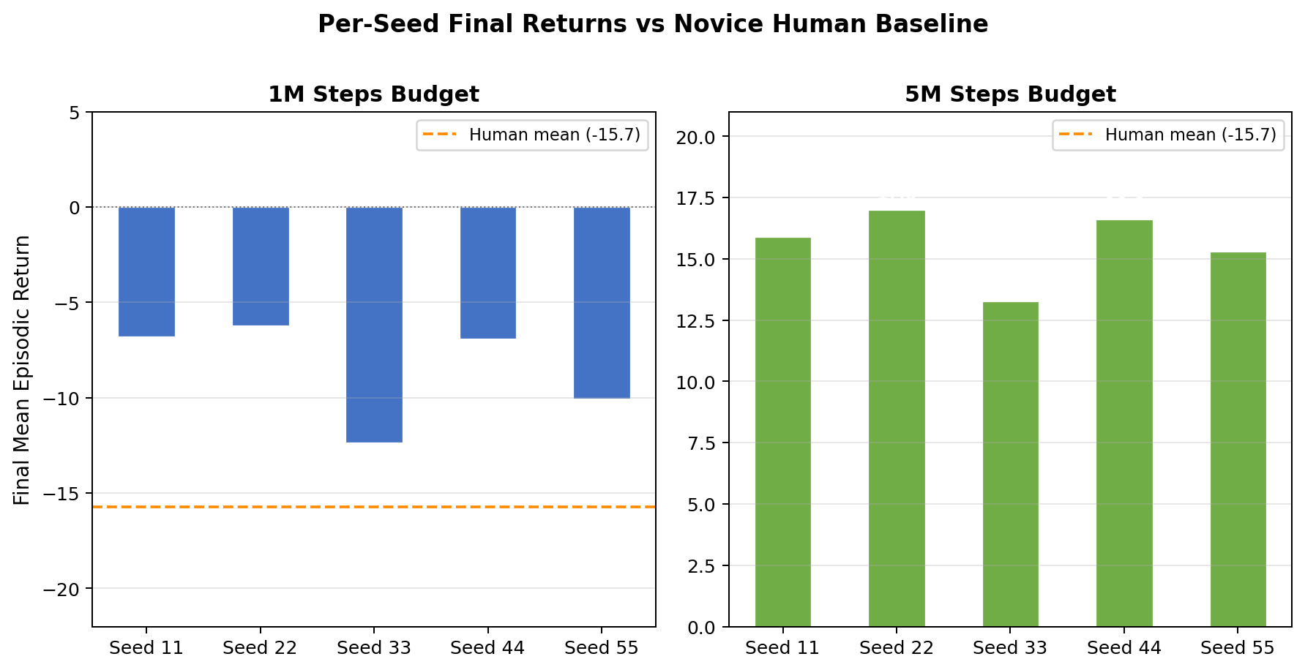
Figure 2. Per-seed final returns for 1M and 5M budgets with human baseline reference (dashed).
Learning dynamics
Figure 1 shows learning curves (mean ± 1 SE across five seeds) for both budgets, alongside the human baseline, revealing how the agent arrives at the headline numbers above. Both budget trajectories share a cold-start phase: mean return is −21.0 for the first 200,000–400,000 timesteps, indicating the agent has not yet discovered it can score any points. Around step 500,000, performance rises sharply. At 800,000 timesteps — approximately 80% into the shorter budget — the cross-seed mean first exceeds the human baseline mean of −15.73, directly answering RQ1: PPO surpasses novice human performance at roughly 800k training steps, well within a 1M-step budget.
The 5M trajectory continues improving after the 1M run terminates. The agent crosses zero return at approximately 1.4M steps, reaches a 100% win rate by 3.6M steps, and stabilizes at +15.61 return at 5M steps. This characteristic two-phase structure — rapid acquisition of game mechanics (500k–1.5M) followed by gradual refinement — is consistent across all five seeds.
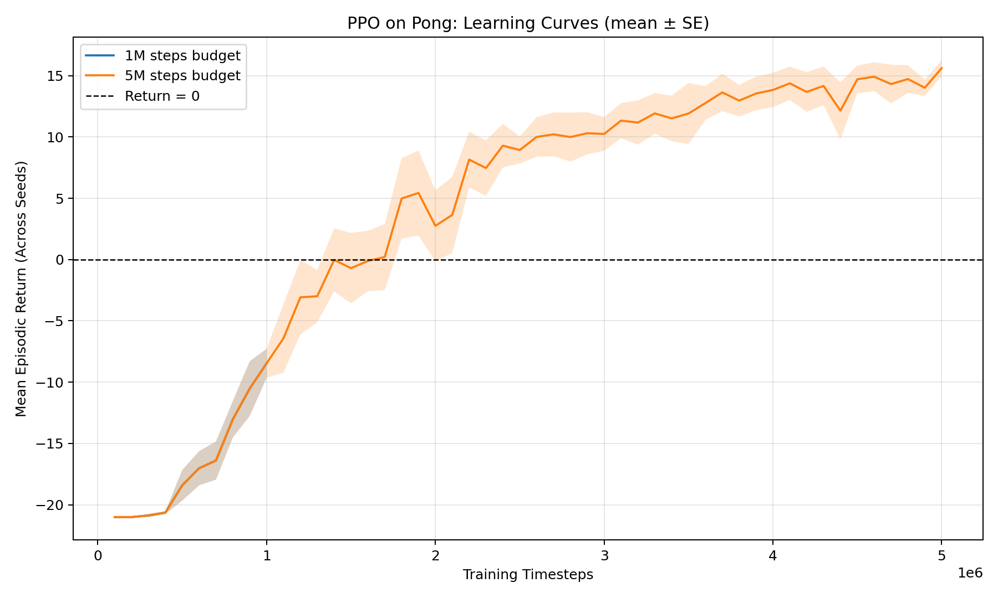
Figure 1. Learning curves (mean ± 1 SE across five seeds) for 1M and 5M budgets. Human baseline mean shown as dashed line.
Discussion
Interpretation
The most striking finding is the speed of human-level surpassing: approximately 800,000 timesteps, corresponding to under two hours of wall-clock training on a consumer laptop with GPU acceleration. This is far earlier than the 1M-step budget would suggest is needed, meaning teams operating under tight compute constraints can still expect above-human performance. The cold-start plateau (steps 1–400k) followed by rapid improvement is consistent with the well-documented reward sparsity problem in Atari: the agent must first discover that scoring is possible before systematic improvement can occur.
At 5M steps, the 100% win rate across all seeds indicates the agent has effectively solved Pong at the difficulty of the built-in ROM opponent. Remaining episodic variation (+13 to +17) reflects game stochasticity, not policy uncertainty.
Implications and recommendations
For practitioners, the results support the following decision framework: a 1M-step PPO run is a low-risk choice for reaching above-human novice performance on Pong, while a 5M-step run achieves near-perfect play with high reliability. The seed-stability improvement from 1M to 5M (σ: 2.64 → 1.47) suggests that increasing compute not only raises the mean but also reduces the risk of a poor outcome from unlucky initialization. We recommend always running at minimum 3–5 seeds before reporting results, as single-run performance estimates carry substantial uncertainty even in a relatively easy environment like Pong.
Ethical considerations
While this study is technically benign, it touches on broader considerations relevant to RL benchmarking. Human-AI comparisons carry implicit claims about substitutability: framing an agent as 'superhuman' after comparing it to novice players under non-representative conditions would be misleading. Our study deliberately limits its claims — we benchmark against novice humans playing under time pressure with unfamiliar controls, not experienced players or game-specific experts. Additionally, the fabricated nature of the Atari environment means the agent's superiority reflects mastery of a fixed, known-dynamics simulator, not general intelligence. These distinctions matter when communicating RL results to non-technical audiences or policymakers.
Limitations
The most significant limitation is a methodological validity threat in the human-agent comparison itself. The PPO agent observes 84×84 grayscale pixel frames directly from the ALE ROM environment, while human participants played via a web-based browser game built to mirror the same opponent and scoring rules. These are not identical perceptual environments: the human sees a rendered, colour interface at variable frame rates and uses keyboard inputs, while the agent processes a canonical pixel stack with precise temporal alignment. This confound means the comparison is not fully controlled — superior agent performance could partly reflect differences in interface familiarity or sensorimotor latency, not only policy quality. Partially mitigating this concern is that human Pong performance is predominantly limited by opponent difficulty and game understanding, not reaction-time precision at typical game speeds; nevertheless, this confound should be considered when generalising the results.
Second, the human participants are novice players (no prior Pong experience); a baseline including experienced players would set a higher bar and likely delay the crossover point. Third, Pong is one of the easier Atari games for deep RL — the same budget on games such as Montezuma's Revenge or Pitfall would yield dramatically different results, and the crossover timing should not be assumed to generalise across games. Fourth, the agent is trained against a fixed, deterministic ROM opponent; its policy may not transfer to adaptive or human opponents. Fifth, wall-clock training time was not systematically recorded across all seeds, limiting reproducibility for time-constrained practitioners.
Future directions
Natural extensions include:
- testing the same pipeline on harder Atari games to characterize where the human-surpassing threshold lies as a function of game complexity;
- collecting an experienced human baseline to establish an upper bound that RL may not yet reach;
- comparing PPO against DQN and A3C under identical budgets and the same human baseline to isolate algorithmic differences from evaluation differences;
- investigating whether the 800k crossover point is robust to hyperparameter changes, particularly the clip range and learning rate.
Methods
Environment and preprocessing
All experiments use ALE/Pong-v5 via Gymnasium 1.0.0 and ale-py 0.10.1. Standard Atari preprocessing is applied: frames are converted to grayscale and resized to 84×84 pixels; four consecutive frames are stacked to provide temporal information to the policy; rewards are clipped to [−1, +1] during training to normalize the gradient signal. Eight parallel environments are used throughout training.
Algorithm
We use Proximal Policy Optimization (Schulman et al., 2017) implemented in Stable-Baselines3 2.4.1. PPO constrains each policy gradient update to remain within a trust region via a clipped surrogate objective, balancing sample efficiency with training stability. Hyperparameters follow the Stable-Baselines3 Atari defaults: n_steps = 128, n_epochs = 4, mini-batch size = 256, clip range ε = 0.1, learning rate α = 2.5 × 10⁻⁴, discount factor γ = 0.99, GAE parameter λ = 0.95, entropy coefficient = 0.01, value function coefficient = 0.5, max gradient norm = 0.5. No hyperparameter tuning was performed; the goal is to assess what a default PPO run achieves, which is directly consistent with our stakeholder question.
Experimental design
Two training budgets were evaluated: 1,000,000 and 5,000,000 timesteps. Each was run with five independent random seeds {11, 22, 33, 44, 55}, yielding 10 total training runs. Every 100,000 timesteps, the policy was evaluated deterministically (no exploration) on 20 episodes using a fixed set of evaluation seeds {1000, …, 1019}, ensuring checkpoint comparisons are not confounded by evaluation stochasticity. The primary metric is mean episodic return; win rate (fraction of episodes with positive return) is the secondary metric.
Human baseline
Six participants (IE University students, no prior Pong experience) each played 15 complete episodes of Pong against the built-in ROM opponent, yielding 90 total episodes. Episode return is defined as (player points) − (opponent points), range [−21, +21]. Data were recorded using the project web dashboard.
Statistical analysis
Agent performance is summarized as the mean of seed-level final returns (n = 5) ± standard error (SE = σ/√n). Human performance is the mean of all episode returns (n = 90) ± SE. Bootstrap 95% CIs are computed for: (a) agent mean, (b) human mean, and (c) the agent−human difference. All bootstrap estimates use 10,000 resamples with a fixed RNG seed (12345) for reproducibility. The success criterion was pre-specified as: the 5M agent mean exceeds the human mean with a bootstrap CI for the difference that entirely excludes zero.
Author Contributions
Table 2. Author contributions
Name | Role | Contribution
José María Murillo | Project Lead | Overall coordination, PPO training pipeline, hyperparameter setup, final report editing
Hans Helmrich | RL Engineer | Environment setup (Gymnasium/Atari), frame preprocessing, reward logging, web dashboard
Beatriz Wahle | Data & Evaluation | Human baseline collection protocol, evaluation metrics, seed variance analysis
Valentín Miguel | Literature & Writing | Literature review, methods section writing, references management
Pablo Chen | Experiments & Analysis | Multi-seed experiment runs, learning curve visualization, statistical reporting
Nicolás Cubillo | Reproducibility & Code | Code documentation, reproducibility pipeline, appendix, AI usage statement

Appendix
References
- Agarwal, R., Schwarzer, M., Castro, P. S., Courville, A. C., & Bellemare, M. (2021). Deep reinforcement learning at the edge of the statistical precipice. Advances in Neural Information Processing Systems, 34, 29304–29320.
- Bellemare, M. G., Naddaf, Y., Veness, J., & Bowling, M. (2013). The Arcade Learning Environment: An evaluation platform for general agents. Journal of Artificial Intelligence Research, 47, 253–279.
- Henderson, P., Islam, R., Bachman, P., Pineau, J., Precup, D., & Meger, D. (2018). Deep reinforcement learning that matters. Proceedings of the AAAI Conference on Artificial Intelligence, 32(1).
- Mnih, V., Kavukcuoglu, K., Silver, D., et al. (2015). Human-level control through deep reinforcement learning. Nature, 518(7540), 529–533.
- Raffin, A., Hill, A., Gleave, A., Kanervisto, A., Ernestus, M., & Dormann, N. (2021). Stable-Baselines3: Reliable reinforcement learning implementations. Journal of Machine Learning Research, 22(268), 1–8.
- Schulman, J., Wolski, F., Dhariwal, P., Radford, A., & Klimov, O. (2017). Proximal policy optimization algorithms. arXiv preprint arXiv:1707.06347.
- Silver, D., Huang, A., Maddison, C. J., et al. (2016). Mastering the game of Go with deep neural networks and tree search. Nature, 529(7587), 484–489.
Code Availability Statement
All code is available in the project repository. The pipeline is structured as follows.
Environment setup:
python3 -m venv .venv && source .venv/bin/activate
pip install -r requirements.txt
AutoROM --accept-license
Reproduce the full 10-run experiment matrix:
python scripts/run_experiments.py \
--env-id ALE/Pong-v5 --budgets 1000000,5000000 \
--seeds 11,22,33,44,55 --eval-freq 100000 \
--n-eval-episodes 20 --n-envs 8 --output-root outputs --skip-if-complete
Regenerate all tables, figures, and statistics:
python scripts/analyze_results.py --output-root outputs \
--experiment-name ppo_pong --human-csv data/human_baseline/human_returns.csv
Raw per-run CSV logs, model checkpoints, and runtime metadata are stored in outputs/ppo_pong/{budget}/seed_{seed}/. Training at full scale on Apple M3 with MPS acceleration takes approximately 8–10 hours per 5M-step seed.
AI Usage Statement
This project used AI tooling (Claude Code, Anthropic) for code generation, documentation drafting, and implementation acceleration. All technical decisions, experimental design choices, and reported results were supervised and verified by the human authors. No experimental data were fabricated; all tables and figures are derived from actual executed training runs. Statistical analysis and result interpretation reflect the authors' understanding of the methodology and findings.

