

Jordan Murphy

Friday June 14th, 2019

**company profile**

Table of Contents

Introduction 4

Leadership Team 4

Corporate Structure Diagram 5

Auditing Firm 6

Significant Accounting Policies 6

Company Profile 7

Company History 7

Corporate Objectives 8

Mission Statement 8

Products Provided 9

Chairman’s Report 9

Summary of Chairman’s Report 9

Environmental Analysis 11

Direct and Indirect Competition 11

State of the Economy 12

Loblaws and the Law 13

Government Policies and Taxation Laws 13

Trends 14

Environment Analysis 15

SWOT Analysis 15

Financial Analysis 17

Comparative Analysis 17

**Horizontal Analysis** 17

Ratio Analysis 22

Loblaws Liquidity Ratios 22

Ratio 22

2018 22

2017 22

2016 22

Loblaws Profitability Ratios 22

Ratio 22

2018 22

2017 22

2016 22

Financial Position 24

Stock Market Analysis 25

Report to Management 26

Investment Decision 26

Short- and Long-Term Growth Projections 26

Short Term Credit Decision 27

Loan Decision 27

Appendix 28

Liquidity Ratios 28

Working Capital 28

Current Ratio 28

Inventory Turnover 29

Days Sales in Inventory 30

Receivables Turnover 31

Collection Period 32

Profitability Ratios 33

Gross Profit Margin 33

Profit Margin 34

Asset Turnover 35

Return on Assets 36

Return on Equity 37

Earnings Per Share 38

Price-Earnings Ratio 39

Payout Ratio 40

Bibliography 42

# 

**Introduction**

# **Introduction**

**Background Information**

The company Loblaws Companies Limited which will now be referred to Loblaws in the report from this point forward is a supermarket chain with over 2300 locations all across Canada; and is the country’s largest food distributor. Loblaws includes 22 subsidiary companies, major companies include Shoppers Drug Mart, Real Canadian Superstore, No Frills, Fortinos, and the President’s Choice brand. The head office is located in Brampton, Ontario and the company as a whole employs approximately 98,000 people.

## **Leadership Team**

The responsibility of Chief Operating Officer falls to Michael Motz. He was the Executive Vice President and Merchandising Officer of Shoppers Drug Mart until his promotion from Loblaws Galen George Weston serves as the executive Chairman, and Executive Chief Officer of Loblaws Companies CEO for George Weston Limited. Sarah R Davis was with Loblaws as the Executive Chief Officer for 7 years from 2010-2017, and now since 2018 served as the President of Loblaws. One of two directors of the Leadership group at Loblaws is Mark Wilson, who is the Executive Vice President, as well as Human Resources and Labour Relations Manager. Then there is Kevin Groh who portrays the responsibility of Senior Vice President, Corporate Affairs and communication.

# **Corporate Structure Diagram**

## **Auditing Firm**

The firm auditing Loblaws’ financial statements is KPMG. In the eyes of KPMG, they have looked over and assessed the financial statements of Loblaws and everything looks to be presented fairly and accurately. When looking at the comparison from 2017 to 2018 all numbers add up correctly and transfer over reliably. The performance consolidated cash flows the whole year then ended in accordance to the International Financial Reporting Statements. This task was taken on using the Canadian Generally Accepted Auditing Standards to provide the independent entity in accordance with ethical requirements that play a role in auditing financial statements in Canada, this then fulfills the ethical responsibilities of the auditing requirements.

## **Significant Accounting Policies**

Loblaws implements various significant accounting policies regarding the following areas; depreciation, inventory system, intangible assets, and fixed assets. Loblaws begins depreciating fixed assets when they are actually put into use. The fixed assets are depreciated through the straight-line method, estimated useful life is determined through estimation. The estimation varies based on the type of fixed asset, buildings estimated useful life ranges from 10-40 years while building improvements are estimated up to 10 years, while equipment and fixtures are averaged around 3-16 years. There is an option to renew and adjust the estimated useful life for up to an additional 25 years. As for leased capital equipment, the equipment depreciates with the term of the lease rather than the equipment itself.  As for Loblaws’ inventory system, they follow the weighted average cost system. Loblaws follows up this procedure with ensuring they estimate the net realizable value in order to have the most accurate and reliable financial numbers. Intangible assets do not get depreciated as they often do not have a definite life.

# 

**company profile**

# **Company Profile**

## **Company History**

Founded by Theodore Pringle Loblaw in the year 1919, the first ever Loblaws grocery store opened in Toronto, Ontario. Loblaws was a Canadian proud industry and it was the first ever time that self-serve, cash and carry concept was being applied in a grocery store. It was a massive hit for customers and became a big step for the company and industry of grocery stores all over the world. The other concept that Loblaws was driving to its customers was that they can get better quality for a cheaper price, ultimately it would pay off for the grocery store in the long run by attracting customers from all over. Within one decade the chain expanded to over 70 stores in Ontario and became one of the main providers of food in the province. Theodore and the rest of Loblaws leaders decided to expand their business down south, which included the state of New York and the headquarters were located in Buffalo, reasonably close to the border. The slogan of the company “We sell for less” then became heard around the entire country of the United States and they were intrigued, as stores opened up in Chicago, Illinois and the rest of Northern half of the United States. The company of Loblaws was ready to make bigger changes to the industry as they come up with “market stores” which have full-service meat and produce departments. You will now most likely see these at Fortinos or Real Canadian Superstore, both of which are under the Loblaws chain. This allows customers to not only get a better quality but its fresh and fast. Growing up in the town of Essa near simcoe county, a boy by the name of Theodore Loblaw arrived in the big city of Toronto with no more than just a few dollars in his pocket. He worked at a grocery store with dreams of one day running his own. Now his dream has come true and Loblaws has more than 150 stores in Ontario with parts of the United States included, Theodore then passed away at age 60 in 1933. By 1947, Loblaws has now partnered with George Weston Limited and Shoppers Drug Mart, two companies that would forever change the fate of the franchise. Shoppers Drug Mart expands to over hundreds of stores, and in the year 1985 President's Choice is born, this is a separate group of products that Loblaws stores would sell and could be sold in other grocery stores as well. In the year 2000, the Shoppers optimum program is launched and Loblaws gains nearly 6 million members in just one year. Now nearly 20 years later the Shopper’s Optimum program has now switched to PC optimum and 1 out of 3 Canadians is a member of the rewards program.

## **Corporate Objectives**

Loblaws approach is driven by the companies - Live Life Well brand image. By sourcing responsibly, respecting the environment and making a positive difference in the surrounding communities, Loblaws aim to earn the trust of our customers and be recognized as a leading contributor towards thriving Canadian society - today and for generations to come. Their goal is to continue to strive in the communities in which their franchises are in. Loblaws also wishes to leave its footprint in a positive way on the environment making contributions in many ways including reducing the carbon footprint by 20% by 2020 and 30% by 2030.

## 

## **Mission Statement**

Loblaw’s mission is to be Canada’s best food, health and home retailer by exceeding customer expectations through innovative products at great prices. Loblaw’s mission is to be Canada’s best food, health and home retailer by exceeding customer expectations through innovative products at great prices. This is an extremely effective mission statement, and if Loblaws sticks to their goals and company objectives then this will definitely help maximize profit. By exceeding customer expectations this will develop strong customer satisfaction and consumers will continue to stay loyal to the Loblaws brands and purchasing their everyday goods from their corporations. Not only will this build strong relationships but providing innovative products and great pricing is giving consumers something that they simply cannot say no to. When shopping for any kind of products consumers are looking for the best possible cost efficiency in products, so if they find that Loblaws provides just that, they will constantly bring in new customers. Loblaws also shows distinction between their company goals and other competitors. Mainly direct competitors of Loblaw stores (grocery stores) try to drive the aspect of either bring fresh foods and great quality or great pricing that is very affordable. Loblaws tries to provide the best of both worlds and make their customers feel as if they are getting and homemade feel for the best price. The main concern is always keeping the customers happy and ensuring that they are always being treated with the best possible scenario from Loblaws. In the end, it is the customers who keep franchises alive and thriving and that is why Loblaws is trying to pursue customer expectations.

## **Products Provided**

With many stores providing goods and services on Loblaws behalf they are a very diverse company. These sections include financial services, baby needs, baked goods, beauty care, dairy and eggs, dairy, ready meals, drinks, frozen, fruits and vegetables, household supplies, pantry, personal care, meat and seafood, pantry, and work supplies. This company has become well rounded in providing nearly all needs for families.

**chairman’s report**

**Chairman’s Report**

## **Summary of Chairman’s Report**

2018 was a year to prepare for the future of Loblaws. They made strategic decisions in order to maintain their financial position after lawsuits in previous years. They implemented strategies in order to rapidly accelerate growth for the future such as the increase in dividends. Over the past year Loblaws greatly improved their pick-up and delivery system, ensuring to expand to every part of Canada in order to achieve same day shipping no matter where the customer is located. PC optimum points also grew over the past year with 2/3 transactions at Loblaws owned stores including the new rewards program. Also, the PC financial Mastercard has been ranked #1 for customer satisfaction. Lastly, Loblaws focused on efficiency and insights to improve business decisions. In an analytical world Loblaws wants to continue to develop their analytical capabilities in order to make better business decisions. Looking forward, strong financials allow for the company to continue to face legal, business, and competition issues whenever they arise. Looking into 2019, Loblaws has confidence that they will continue to deliver on their brand purpose of ensuring Canadians *Live Life Well*.

# 

**environmental analysis**

# **Environmental Analysis**

## **Direct and Indirect Competition**

Loblaws is a widely expanded that provides many services for people of all needs. Therefore, Loblaws has a wider variety of competitors in all different kinds of markets. The grocery industry of Loblaws is dominated by Fortinos, Real Canadian Superstore, and Valu-Mart. These businesses go head to head with direct competitors such as Wal-Mart, a company that also dominates the grocery market and is one of the most profitable businesses in Canada. Loblaws is also represented in the pharmacy industry with Shoppers Drug Mart. Shoppers was the number one pharmacy voted by Canadians in the year 2018 and provides all kinds of necessities aside from just medications and prescriptions. Pharmasave is another drug store that is in direct competition the Loblaws company; Shoppers. Similar to Shopper Drug Mart, Pharmasave also has food, treats, toys, and household items on top of their consumers medication needs. Shoppers also provides consumers with the options of cosmetic products; this would directly compete with stores such as Sephora and Sally Beauty. Loblaws also has its own product line, President’s Choice, that is sold in grocery stores all over Canada that are not just Loblaws owned. This meets direct competition with Sobeys very own product line, Compliments, which is also sold across Canada. Loblaws also has reached into the liquor industry with their Real Canadian Liquor Store. Another direct competitor with Loblaws is LCBO through the liquor industry. Lastly, with Loblaws PC financial services, they are competing in the financial market by facing companies such as H & R Block financial services and Tangerine, these both mainly help with banking services but are still taking away customers that could be with PC financial services. Companies that share indirect competition with Loblaws are mainly active in the food industry. Instead of coming to Real Canadian Superstore or Valu-Mart to pick up food to cook a meal later on, families may go out to restaurants or even fast food places to eat instead. This is indirect competition because they are not directly selling the same product, but they are providing another option that results in consumers not going to a Loblaws franchise to purchase goods. This also affects stores like Fortinos who provide hot meals, and foods such as sandwiches that you can purchase to eat sit down and eat. Movie theatres can also be indirectly competing with Loblaws because instead of watching a movie or show at home where you can eat a home cooked meal provided with foods from Loblaws grocery stores, people will go to the movie theatres and the one thing that everyone does when they go to watch a movie is popcorn, candy, and drinks. Movie theatres also forbid people from bringing any other foods in to their theatres.

## **State of the Economy**

The state of the national economy is very strong with a score of 77.7 which makes Canada ranked 8th in freest economy and a great place for a business to be located. With a strong employment rate, consumers will have lots of money that can be spent and therefore will purchase more products from Loblaws. The money regulation will then be flowing at a good rate and will help maintain a strong economic system. Loblaws also cares about the community and environment in which they are surrounded so they know how important it is to maintain a strong economic system wherever their franchises are located. The government also contributes to helping business and domestic industries in thriving for success. The competitiveness of Canada’s economy has been able to stand stable due to an open market system and higher degree of regulatory efficiency.  When looking globally and down south to the U.S where a few Loblaws stores are located, it does not help that Donald Trump is running the country. If there is one thing that Trump strives for it is business within the United States being very successful so making sure unemployment is down and the GDP is solid. However, over the last few years there has been a decrease in GDP and inflation rates are continuing to rise. Also, Trump’s word on the unemployment rate has not reflected as he promised with thousands of jobs being lost due to engine plants being moved to Mexico because the cost for production is cheaper with a lower demand for labour. Also with the dollar in Canada being lower than the dollar in the states it will make it extremely beneficial to businesses that are started in Canada similar to how Loblaws was started in Canada, because the exchange will even out to having more Canadian money than one would have in American so it will attract more businesses to come North to Canada which also strengthens the economy.

## **Loblaws and the Law**

In December of 2017, Loblaws and its parent company George Weston Limited confessed to taking part in bread price-fixing scheme involving two bakeries and five major grocers. George Weston owns Weston bakeries and both George Weston and Loblaws agreed to bump up bread prices $1.50 and charge more for their bread because they knew people would continue to buy their bread. This then went on for 14 years until they admitted to it in December. There has now been a Bureau Investigation in the industry to see if there were any more businesses involved and to see how deep this scandal had gone. Loblaws is now in a lawsuit for this act and to make sure they do not lose their ties with their customers Loblaws has issued $25-dollar gift cards as a goodwill. This lawsuit will impact future financial positioning. Also, in 2015 Loblaws was served with a proposed class action, which was commenced in the Ontario Superior Court of Justice against the Company and certain subsidiaries. Weston Limited and other companies involved with the Rana Plaza collapse in Bangladesh in 2013. The claim is seeking 2 billion dollars; however, they have not made any liabilities because they are fighting this vigorously, but if this were to fall through and they had to pay 2 billion dollars this would be a massive financial shift for the company.

## **Government Policies and Taxation Laws**

Tax laws in Canada are much higher than the United states. With the income tax, the Canadian government receives more money from a business if they are more successful. With one of the biggest franchises in Canada this means that Loblaws most likely spends hundreds of thousands of dollars on income tax toward the Canadian government. The Canadian government supports the people of Canada more than in comparison to the states like for example health care or people dependent on healthcare. The United States however has a majority of its taxes go towards the Army and national defence. In Canada there are corporation tax rates that every business must abide by. Provincial taxes are split into lower rate and higher rate and based on Loblaws yearly revenue and net worth they would be a part of the higher rate. Then there is General Tax Reduction for Canadian controlled private corporations (CCPC), the corporation tax rate is 15% or may be higher. Whereas in the United States they also have federal income taxes, this rate was at 35%. However, the Tax Cuts and Jobs Act has since had the tax reduced by 14% down to 21% on taxes. This has now brought the United States into the average among the OECD (Organisation for Economic and Development) nations.

## **Trends**

A major technological trend that is going on in society right now is self-checkouts. These were made to make it more convenient for customers and cutbacks spending on cashiers. This causes lost jobs for employees which has sparked many disputes as to whether or not it's beneficial because despite them saving money they now have employees who are angry that their jobs are going to be lost. Also, many customers have complained that they are very difficult to use and can be frustrating. This takes away from a good shopping experience and will send customers home angered or not wanting to come back and use the self-checkouts. Another issue when using self-checkout is that it does not allow customers to build a relationship with the employees, cashiers are unable to talk and ask consumers how they are or get any kind of feedback from them. Another technological advancement that going on in society is online shopping, where customers can buy items online and go to the store and pick them up. Wal-Mart is also coming up with a new idea where you not only can purchase groceries online and then have dropped off at your house, or pick them up at Wal-Mart. This however will open jobs for people who need to deliver the purchased items to the customers house as well as picking the items out. Lastly, most companies are starting up social media pages on Instagram, Facebook, or Twitter so that they can notify their customers of any new sales or deals they have coming out. This allows them to connect better than sending multiple emails that will just go straight to junk. Companies can also start up contests and give out prized which increases the customer experience and allows them to connect better so they become more loyal to the company. The more engaged the customers get and the more they participate in activities then the more of a connection they will have to employees and this is how you build good relationships.

## **Environment Analysis**

These factors will both benefit the company and hurt Loblaws financially. With two Lawsuits in the last few years and one possibly pending out to 2 billion dollars will heavily impact the state of Loblaws not just financially but the actual state of the company in the eyes of the public. People can see the harm that Loblaws has done to their very own customers and this will cause them to lose loyalty. However, with many different ways to connect with customers through social media Loblaws can use Instagram and Facebook accounts to inform their consumers on different sales and contests. This also looks good in the eyes of the public due to how well they can connect with the target markets. The tax will continue to stay average in both the United States and Canadian stores which most businesses have to deal with. Since Canada and the U.S have such strong economies this will help Loblaws continue to thrive as a business.

## **SWOT Analysis**

Strengths: Loblaws is one of the largest grocery stores chains in Canada. They are one of the main grocery providers for Canadians while still having branches in the United States. Loblaws has a very strong name recognition and has customers all over the country. They also have many private labels such as no name, blue menu, and President’s Choice, this is another massive generator for the company that can be sold in stores all over North America and not Loblaw retail stores. Loblaws also offers a variety of different services and goods to their customers, with cosmetics, grocery stores, financial services, medicine and more they cover a majority of most Canadians needs. Lastly, there are stores in every province in Canada as well as most regions, this also helps increase the brand name and allowing Loblaws to be very well known, and they are currently operating under a number of different banners.

Weaknesses: All of Loblaws stores are very large and therefore very complicated to run. It is hard to keep track of everything that is taking place within the business and requires more and more people to focus specifically on everything and make sure that all stores are following the rules and no disobeying any guidelines. This is why they have gotten into a number of lawsuits over the last few years, because with such a large business that is spread out globally it is harder to keep track of everything going on. This then costs more money to have more people watch over and maintain the business. Lastly, there will be less fresh foods as opposed to smaller businesses who do not need to order as much because they sell less and when they order less products it will get to the location quicker and therefore can get on the shelves quicker.

Opportunities: They can constantly bring in new customers because of their wide variety of goods and services. Not to mention they have brought in a new rewards program which is the PC optimum system, this has much potential to grow and attract more members. Loblaws also has a very successful clothing line that is continuing to grow, this includes Joe Fresh. Loblaws is now aiming to be Canada’s “Low Price Leader”, they have embraced this motive for many years now that they want to sell for cheap and now they have the opportunity to have the best pricing in Canada. The economy in Canada is steady so the potential for the company to grow is promising.

Threats: With Loblaws being a grocery franchise they are going to have more competition due to there being more stronger competitors such as Sobeys, Co-op, and Safeway. Also, smaller businesses that produce fresh items and foods from other countries have the potential to steal customers because of the fresh produce and that Loblaws cannot advertise the homemade feel that a family owned meat shop or bakery can. More younger people are interested in natural goods from farmers markets and natural food stands, and since the people who are interested in the natural foods are younger it may be a bad sign that the future of consumers will turn away from grocery industries. Wal-Mart is also a massive company that is American who is now opening stores in Canada and expanding rapidly into other provinces in Canada other than just Ontario and Quebec. With Canada having regulations in place to help small businesses succeed more this will make it easier for food markets and local shops to open up and steal customers.

# 

**financial analysis**

# **Financial Analysis**

## **Comparative Analysis**

### **Horizontal Analysis**

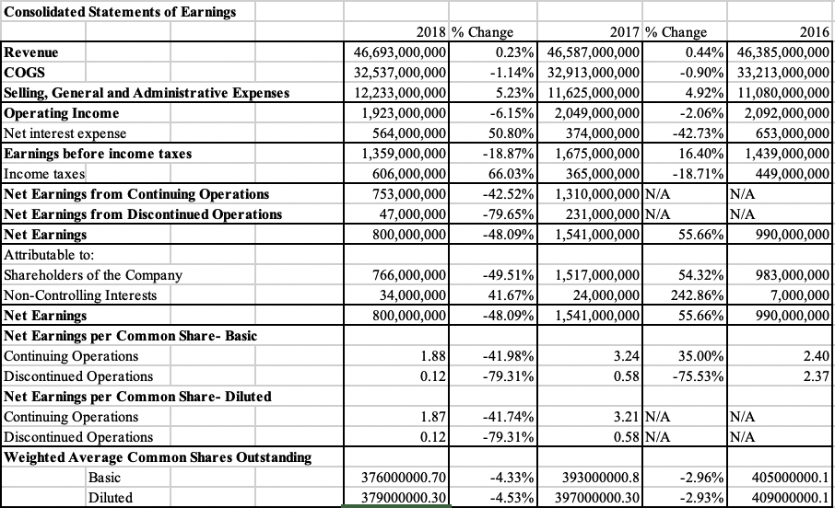 The first major change that was noted came up for the increase in income taxes from 2017 to 2018. It is often assumed that if a company earns more operating income, they pay more income tax and will generally pay more net interest. This was not the case for Loblaws, they actually saw a decrease of 6.15% for their operating income and a whopping 48.09% decrease in net income. So, the reason for the income tax and interest expense increase was related to Glenhuron Bank Limited. Glenhuron was a wholly-owned Barbadian subsidiary that folded in 2013. The problem was that the Tax Court determined that partial amounts of the income earned by the company should have been taxed and were not. After an unsuccessful appeal Loblaws ended up paying a 176,000,000 in the 2018 fiscal year which was the main cause for the spike in income tax from 2017 to 2018

This can also be classified as a reason for the 48.09% drop in net earnings from 2017 to 2018 as the increase to income tax increased expenses and therefore decreased net earnings for 2018.

The opposite ended up happening from 2016 to 2017, income tax decreased 18.71% during this time period this is a reason for the 55.56% increase in net earnings.

Discontinued contributions also had a major role in net income, seeing a 79.65% decrease in 2018 from 2017. Choice Properties closed down operations and transferred 61.6% interest to the parent company. Choice Properties discontinuation also extends to CREIT, Canadian Real Estate Investment Trust. This only adds to the income lost and is another reason for the drop-in net income from 2017 to 2018.

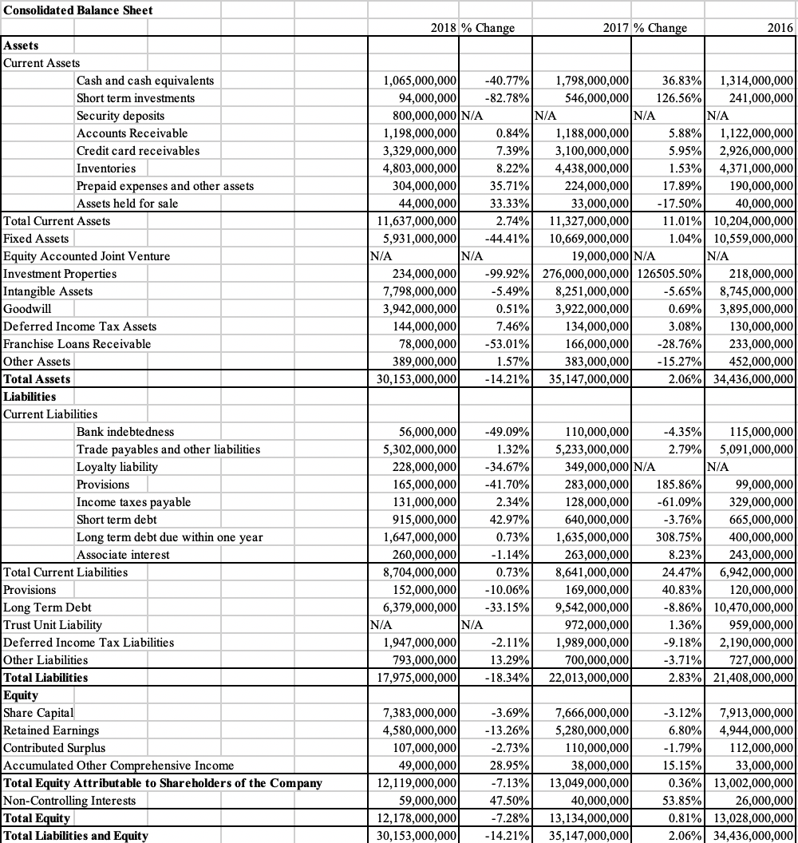

Cash and short-term investments have varied over the past 3 years. It dropped 40.77% in 2018 due to the lack of bankers’ acceptance in 2018. Another reason for this is because they spent $107,000,000 paying off debts from the bread scandal, they were involved in. Although their cash dropped, they were also able to get rid of bank indebtedness to put them in a better financial position for the future. From 2016 to 2017 long term debt increased 308.75%, 3 main debts were added in 2017. Shoppers Drug Mart notes, Independent Securitization, new mortgages, and paying off Choice Properties credit terms. In 2017 the pricing fix scandal occurred and led to $354,000,000 in provisions being added.

**Vertical Analysis**

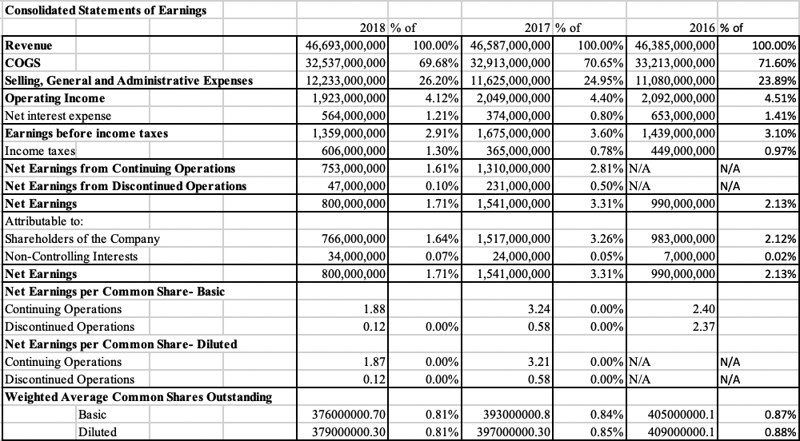

Based off of the last 3 years each section of the income statement has relatively the same percentage of revenue. This shows that even though all of the complicated and extensive transactions Loblaws is able to keep their income statement sections around the same percentage out of revenue. The largest discrepancy comes for net earnings, this has been explained in the horizontal analysis. Since Loblaws spent so much cash paying off debts they experienced a drop-in net earnings.

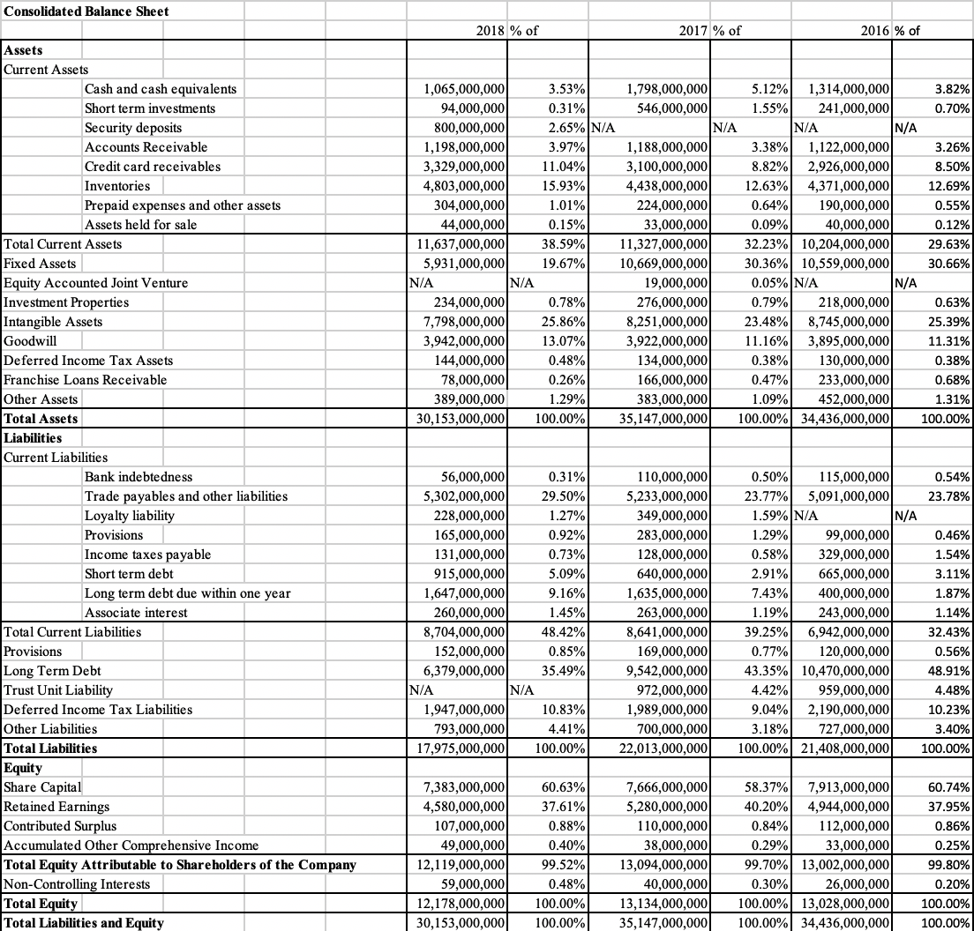

The same can be said when analyzing the vertical analysis of the balance sheet for Loblaws. Although the values change for certain sections as shown through the horizontal analysis, they remain relatively the same compared to total numbers, whether it is assets, liabilities, or shareholders equity.

## **Ratio Analysis**

|  |  |  |  |
| --- | --- | --- | --- |
| **Loblaws Liquidity Ratios** | | | |
| **Ratio** | **2018** | **2017** | **2016** |
| **Working Capital** | **$2,933,000,000** | **$2,686,000,000** | **$3,262,000,000** |
| **Current Ratio** | **1.34:1** | **1.31:1** | **1.47:1** |
| **Inventory Turnover** | **7.04 Times** | **7.47 Times** | **7.64 Times** |
| **Day Sales in Inventory** | **51.85 Days** | **48.86 Days** | **47.77 Days** |
| **Receivables Turnover** | **39.14 Times** | **40.34 Times** | **37.91 Times** |
| **Collection Period** | **9.33 Days** | **9.05 Days** | **9.63 Days** |

Working capital and current ratio measure the ability to pay short term debts, current assets and liabilities have increased over time but remained relatively close over the years, as working capital decreased from 2016 the short-term debts rose.

The inventory turnover and days sales in inventory ratio measures how long it takes to sell through inventory. The industry average sits somewhere between 12-16 times. This should not be concerning though, Loblaws is the largest grocer in Canada so they have much more inventory value than others so obviously it will take longer to sell through everything in inventory.

Receivables turnover measures liquidity of receivables, the industry average ranges from 28-32 times. Loblaws sits comfortably above this average, this means they effectively collect A/R and have policies that are neither too strict nor too lenient.

|  |  |  |  |
| --- | --- | --- | --- |
| **Loblaws Profitability Ratios** | | | |
| **Ratio** | **2018** | **2017** | **2016** |
| **Gross Profit Margin** | **30.32%** | **29.35%** | **28.40%** |
| **Profit Margin** | **1.71%** | **3.31%** | **2.13%** |
| **Asset Turnover** | **1.43 Times** | **1.34 Times** | **1.35 Times** |
| **Return on Assets** | **2.45%** | **4.43%** | **2.88%** |
| **Return on Equity** | **6.35%** | **11.81%** | **7.58%** |
| **Earnings per Share** | **$1.88** | **$3.24** | **$2.40** |
| **Price-Earnings Ratio** | **37.39 times** | **21.70 times** | **29.29 times** |
| **Payout Ratio** | **55.63%** | **21.22%** | **42.02%** |

Gross profit margin and profit margin measure the margin between selling price and COGS as well as net income generated by each dollar of sales. The industry average for gross profit margin is between 22-25%. This shows that Loblaws has good margins and selling points showing that they can sustain revenue for years to come.

Asset turnover shows how efficiently assets are used to generate sales. Loblaws sits right at the industry average. This proves that they adequately use their current and capital assets to help them earn revenue.

Return on assets measures the overall profitability of assets and the industry average is 3-5%. Loblaws is just below this and this may be because of the fixed assets that were removed from the company during the 2018 fiscal year.

Return on equity shows how profitable shareholders investments are. Industry average is around 10%. The only reason it is low in 2018 is due to the net income being lowered because Loblaws paid off debts. There should be positive outlook on this ratio as Loblaws is implementing strategies to increase dividends.

Again, earnings per share is low in 2018 because of net income and should bounce back in 2019.

Payout ratio for Loblaws spiked in 2018. This is due to net income being lowered in 2018 also, Loblaws changed their dividend price from $0.01 to $0.27 in order to try and gain shareholder loyalty back after the bread price fixing scandal. It should return to a more average rate in the near future as Loblaws cash and debts begin to balance back out.

# **Financial Position**

Although 2018 seemed as if it was a down year for Loblaws financially, major steps were made in order to prepare for success in the future. Net income was significantly lower in 2018 because of the expenses incurred with paying off long term debt. They have now lowered liabilities while keeping margins and assets near the same, this will allow them to grow and have more money to reinvest back into the business. Loblaws is constantly expanding into new and existing markets, this allows them to stay on top of competition. If they use the money wisely, they will be able to keep building on their net income and continue to pay off debts to remain in a strong financial position.

## **Stock Market Analysis**

## 

Loblaws is a publicly traded company on the Toronto Stock Exhange and is represented by the stock symbol: L. One year ago, on June 13th the Loblaws stock was worth $50.44 on the Toronto Stock Exchange. Numbers then remained constant for a few months and then there was a slight increase that continued for a few months and then finally reaching a high of $52.83. This was done due to the massive success that Loblaws received over the long weekend in August from the 5th to 6th. Then there was a decrease in the stock value in September due to the announcement that they filled disclosure materials containing information related to the proposed reorganization by plan of arrangement in which Loblaws will spin out of its 61.1% interest value in PC residents. People did not take this as a positive for the company’s future and the market value began to drop. After this the stock value increased slightly and then hit close to rock bottom from $50.03 to $41.74. This is strongly due to the outburst that came with the company’s price-fixing scheme in 2017, in December of 2018 it was for sure that the lawsuit would go through causing the stock value to drop this much. After December it took many months but the Loblaws stock was back to normal once they had issued $25 gift cards to every customer for the scandal on the fixed bread prices. This raised the price back up to $50.03, however the dollar value would fluctuate constantly in the company due to the trust they lost from investors with the scandal. Now in June 2019 the price has reached an all-time high of $53.21 this is because there was a large investment in the company towards the refrigerators for the next three years, this showed the faith that investors had in the company and forced the stock price to rise again. Over the last few years Loblaws has constantly been making money and has been on the incline for the last few years. This shows the success and experience in the company to continue to grow and become better.

# 

**report to management**

# **Report to Management**

## **Investment Decision**

Based on extensive research, comparison and professional judgement it has been decided that it would be in the best interest as a shareholder to invest in Loblaws. Although 2018 seemed as if it was a down year for Loblaws financially, major steps were made in order to prepare for success in the future. Net income was significantly lower in 2018 because of the expenses incurred with paying off long term debt. They have now lowered liabilities while keeping margins and assets near the same, this will allow them to grow and have more money to reinvest back into the business. Loblaws is constantly expanding into new and existing markets, this allows them to stay on top of competition. If they use the money wisely, they will be able to keep building on their net income and continue to pay off debts to remain in a strong financial position. With Loblaws’ new dividend growth plan investing in the company cannot come at a better time. Loblaws plans on increasing the price of common share dividend which should raise the stock price and provide shareholders with incentive to buy more shares.

## **Short- and Long-Term Growth Projections**

Based on extensive research, comparison and professional judgement it has been decided that

In the short term Loblaws may not see quick growth, as long-term debts are still high and need to be paid off and the next couple of years may be slow due to the less cash and other assets available caused by the large amounts of debts being paid off in the previous years. Loblaws is just beginning to rebound after the price fixing scandal, they are starting to pay off debts caused by the scandal and begin to regain shareholder loyalty with the rise of the dividend payouts.

Since Loblaws in getting back on track they have the ability to grow into a strong financial position. It has been proven that they can maintain financial numbers through many different cases and transactions. Hopefully, no more lawsuits will come their way and they will be able to stay trending in the positive direction.

## **Short Term Credit Decision**

Based on extensive research, comparison and professional judgement it has been decided that as a supplier short term credit would be extended for Loblaws.

Loblaws has done a great job keeping their working capital in a good position in order to always be able to pay short term debts. Since they have good margins it can be counted on that they will continue to see revenue somewhere around $46,000,000,000. It is also to be noted that Loblaws has been slowly reducing their COGS over the past 3 years and if that trend continues more cash will be available to further improve working capital and the ability to pay short term debt off.

## **Loan Decision**

Based on extensive research, comparison and professional judgement it has been decided that a substantial long-term note would be granted.

It has been stated that Loblaws has positioned itself nicely for the future so there is no reason a long-term note would not be granted. If problems do arise, Loblaws has shown their ability to adapt and overcome unfavourable situations they have been in before.

**appendix**

# **Appendix**

# **Liquidity Ratios**

## **Working Capital**

**Working Capital =**

**Working Capital 2018**

Current Assets = $11,637,000, 000

Current Liabilities = $8,704,000, 000

Working Capital =

**Working Capital = $2,933,000,** **000**

**Working Capital 2017**

Current Assets 2017 = $11,327,000, 000

Current Liabilities 2017 = $8,641,000, 000

Working Capital 2017 = (

**Working Capital 2017 = $2,686,000,000**

**Working Capital 2016**

Current Assets 2016 = $10,204,000, 000

Current Liabilities 2016 = $6,942,000, 000

Current Ratio 2016 = (

**Current Ratio 2016 = $3,262,000,** **000**

## **Current Ratio**

**Current Ratio =**

**Current Ratio 2018**

Current Assets 2017 = $11,637,000, 000

Current Liabilities 2017 = $8,704,000,000

Current Ratio 2018 =

**Current Ratio 2018 = 1.34:1**

**Current Ratio 2017**

Current Assets 2017 = $11,327,000,000

Current Liabilities 2017 = $8,641,000,000

Current Ratio 2017 =

**Current Ratio 2017 = 1.31:1**

**Current Ratio 2016**

Current Assets 2016 = $10,204,000,000

Current Liabilities 2016 = $6,942,000,000

Current Ratio 2016 =

**Current Ratio 2016 = 1.47:1**

## **Inventory Turnover**

**Inventory Turnover =**

**Inventory Turnover 2018**

COGS 2018 = $32,537,000,000

Inventory 2018 = $4,803,000,000

Inventory 2017 = $4,438,000,000

Inventory Turnover 2018 =

Inventory Turnover 2018 =

**Inventory Turnover 2018 = 7.04 times**

**Inventory Turnover 2017**

COGS 2017 = $32,913,000,000

Inventory 2017 = $4,438,000,000

Inventory 2016 = $4,371,000,000

Inventory Turnover 2017 =

Inventory Turnover 2017 =

**Inventory Turnover 2017 = 7.47 times**

**Inventory Turnover 2016**

COGS 2016 = $33,213,000,000

Inventory 2016 = $4,371,000,000

Inventory 2015 = $4,322,000,000

Inventory Turnover 2016 =

Inventory Turnover 2016 =

**Inventory Turnover 2016 = 7.64 times**

## **Days Sales in Inventory**

**Days Sales in Inventory =**

**Days Sales in Inventory 2018**

Days in a year = 365

Inventory Turnover 2018 = 7.04

Days Sales in Inventory 2018 =

**Days Sales in Inventory 2018 = 51.85 days**

**Days Sales in Inventory 2017**

Days in a year = 365

Inventory Turnover 2017 = 7.47

Days Sales in Inventory 2017 =

**Days Sales in Inventory 2017 = 48.86 days**

**Days Sales in Inventory 2016**

Days in a year = 365

Inventory Turnover 2016 = 7.64

Days Sales in Inventory 2016 =

**Days Sales in Inventory 2016 = 47.77 days**

## **Receivables Turnover**

**Receivables Turnover =**

**Receivables Turnover 2018**

Revenue 2018 = $46,693,000,000

Receivables 2018 = $1,198,000,000

Receivables 2017 = $1,188,000,000

Receivables Turnover 2018 =

Receivables Turnover 2018 =

**Receivables Turnover 2018 = 39.14 times**

**Receivables Turnover 2017**

Revenue 2017 = $46,587,000,000

Receivables 2017 = $1,188,000,000

Receivables 2016 = $1,122,000,000

Receivables Turnover 2017 =

Receivables Turnover 2017 =

**Receivables Turnover 2017 = 40.34 times**

**Receivables Turnover 2016**

Revenue 2016 = $46,385,000,000

Receivables 2016 = $1,122,000,000

Receivables 2015 = $1,325,000,000

Receivables Turnover 2016 =

Receivables Turnover 2016 =

**Receivables Turnover 2016 = 37.91 times**

## **Collection Period**

**Collection Period =**

**Collection Period 2018**

Days in a year = 365

Receivables Turnover 2018 = 39.14

Collection Period 2018 =

**Collection Period 2018 = 9.33 days**

**Collection Period 2017**

Days in a year = 365

Receivables Turnover 2017 = 40.34

Collection Period 2017 =

**Collection Period 2017 = 9.05 days**

**Collection Period 2016**

Days in a year = 365

Receivables Turnover 2018 = 37.91

Collection Period 2018 =

**Collection Period 2018 = 9.63 days**

# **Profitability Ratios**

## **Gross Profit Margin**

**Gross Profit Margin =**

**Gross Profit Margin 2018**

Revenue 2018 = $46,693,000,000

COGS 2018 = $32,537,000,000

Gross Profit Margin 2018=

Gross Profit Margin 2018 =

**Gross Profit Margin 2018 = 30.32%**

**Gross Profit Margin 2017**

Revenue 2017 = $46,587,000,000

COGS 2017 = $32,913,000,000

Gross Profit Margin 2017 =

Gross Profit Margin 2017 =

**Gross Profit Margin 2017 = 29.35%**

**Gross Profit Margin 2016**

Revenue 2016 = $46,385,000,000

COGS 2016 = $33,213,000,000

Gross Profit Margin 2016 =

Gross Profit Margin 2016 =

**Gross Profit Margin 2016 = 28.40 %**

## **Profit Margin**

**Profit Margin =**

**Profit Margin 2018**

Net Income 2018 = $800,000,000

Revenue 2018 = $46,693,000,000

Profit Margin 2018=

**Profit Margin 2018 = 1.71%**

**Profit Margin 2017**

Net Income 2017 = $1,541,000,000

Revenue 2017 = $46,587,000,000

Profit Margin 2017 =

**Profit Margin 2017 = 3.31%**

**Profit Margin 2016**

Net Income 2016 = $990,000,000

Revenue 2016 = $46,385,000,000

Profit Margin 2016 =

**Profit Margin 2016 = 2.13%**

## **Asset Turnover**

**Asset Turnover =**

**Asset Turnover 2018**

Revenue 2018 = $46,693,000,000

Total Assets 2018 = $30,153,000,000

Total Assets 2017 = $35,147,000,000

Asset Turnover 2018 =

Asset Turnover 2018 =

**Asset Turnover 2018 = 1.43 times**

**Asset Turnover 2017**

Revenue 2017 = $46,587,000,000

Total Assets 2017 = $35,147,000,000

Total Assets 2016 = $34,436,000,000

Asset Turnover 2017 =

Asset Turnover 2017 =

**Asset Turnover 2017 = 1.34 times**

**Asset Turnover 2016**

Revenue 2016 = $46,385,000,000

Total Assets 2016 = $34,436,000,000

Total Assets 2015 = $34,357,000,000

Asset Turnover 2016 =

Asset Turnover 2016 =

**Asset Turnover 2016 = 1.35 times**

## **Return on Assets**

**Return on Assets =**

**Return on Assets 2018**

Net Income 2018 = $800,000,000

Total Assets 2018 = $30,153,000,000

Total Assets 2017 = $35,147,000,000

Return on Assets 2018 =

Return on Assets 2018 =

**Return on Assets 2018 = 2.45%**

**Return on Assets 2017**

Net Income 2017 = $1,541,000,000

Total Assets 2017 = $35,147,000,000

Total Assets 2016 = $34,436,000,000

Return on Assets 2017 =

Return on Assets 2017 =

**Return on Assets 2017 = 4.43%**

**Return on Assets 2016**

Net Income 2016 = $990,000,000

Total Assets 2016 = $34,436,000,000

Total Assets 2015 = $34,357,000,000

Return on Assets 2016 =

Return on Assets 2016 =

**Return on Assets 2016 = 2.88%**

## **Return on Equity**

**Return on Equity =**

**Return on Assets 2018**

Net Income 2018 = $800,000,000

Total Shareholders Equity 2018 = $12,119,000,000

Total Shareholders Equity 2017 = $13,094,000,000

Return on Equity 2018 =

Return on Equity 2018 =

**Return on Equity 2018 = 6.35%**

**Return on Assets 2017**

Net Income 2017 = $1,541,000,000

Total Shareholders Equity 2017 = $13,094,000,000

Total Shareholders Equity 2016 = $13,002,000,000

Return on Assets 2017 =

Return on Assets 2017 =

**Return on Assets 2017 = 11.81%**

**Return on Equity 2016**

Net Income 2016 = $990,000,000

Total Shareholders Equity 2016 = $13,002,000,000

Total Shareholders Equity 2015 = $13,111,000,000

Return on Equity 2016 =

Return on Equity 2016 =

**Return on Equity 2016 = 7.58%**

## **Earnings Per Share**

**Earnings per Share =**

**Earnings per Share 2018**

Net Earnings attributable to Shareholders of the Company 2018 = $707,000,000

Weighted Average Number of Common Shares 2018 = 376,747,429

Earnings per Share 2018 =

**Earnings per Share 2018 = $1.88**

**Earnings per Share 2017**

Net Earnings attributable to Shareholders of the Company 2017 = $1,274,000,000

Weighted Average Number of Common Shares 2017 = 393,764,159

Earnings per Share 2017 =

**Earnings per Share 2017 = $3.24**

**Earnings per Share 2016**

Net Earnings attributable to Shareholders of the Company 2016 = $971,000,000

Weighted Average Number of Common Shares 2016 = 405,058,645

Earnings per Share 2016 =

Earnings per Share 2016 =

**Earnings per Share 2016 = $2.40**

## **Price-Earnings Ratio**

**Price-Earnings Ratio =**

**Price-Earnings Ratio 2018**

Price per Share as of June 12, 2019 = $70.30

Earnings per Share 2018 = $1.88

Price-Earnings Ratio 2018 =

**Price-Earning Ratio 2018 = 37.39 times**

**Price-Earnings Ratio 2017**

Price per Share as of June 12, 2019 = $70.30

Earnings per Share 2017 = $3.24

Price-Earnings Ratio 2017 =

**Price-Earnings Ratio 2017 = 21.70 times**

**Price-Earnings Ratio 2016**

Price per Share as of June 12, 2019 = $70.30

Earnings per Share 2016 = $2.40

Price-Earnings Ratio 2016 =

**Price-Earnings Ratio 2016 = 29.29 times**

## **Payout Ratio**

**Payout Ratio =**

**Payout Ratio 2018**

Cash Dividends 2018 = $440,000

Net Income 2018 = $800,000

Payout Ratio 2018 =

**Payout Ratio 2018 = 55.63%**

**Payout Ratio 2017**

Cash Dividends 2017 = $433,000,000

Net Income 2017 = $1,541,000,000

Payout Ratio 2017 =

**Payout Ratio 2017 = 21.22%**

**Payout Ratio 2016**

Cash Dividends 2016 = $416,000,000

Net Income 2016 = $990,000,000

Payout Ratio 2016 =

**Payout Ratio 2016 = 42.02%**

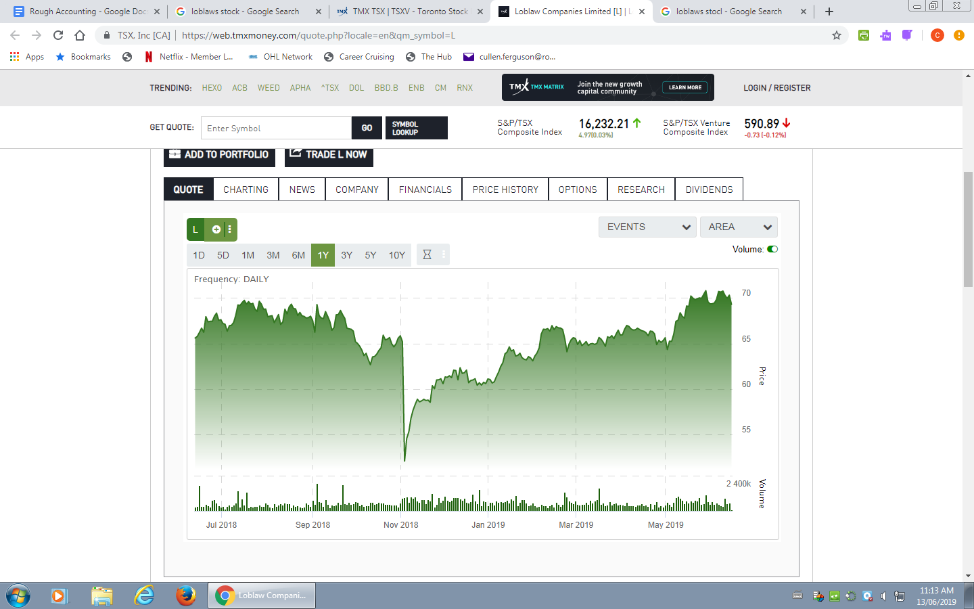

**Bibliography**

“Loblaws $25 Gift Card Offer to End as Class Action Lawsuits for Price-Fixing Gear up | CBC News.” *CBCnews*, CBC/Radio Canada, 6 May 2018, [www.cbc.ca/news/business/loblaws-25-gift-card-class-action-lawsuits-bread-price-fixing-1.4648642](http://www.cbc.ca/news/business/loblaws-25-gift-card-class-action-lawsuits-bread-price-fixing-1.4648642).

Murphy, Paige. “SWOT Analysis: Loblaw's.” *Management First*, 23 Mar. 2018, managementfirst.wordpress.com/2018/03/23/swot-analysis-loblaws/.

“History.” *Loblaw Companies Limited - History*, [www.loblaw.ca/en/about-us/history.html](http://www.loblaw.ca/en/about-us/history.html).

“2019 Economic Outlook: How Will Canada Perform?” *BDC*, [www.bdc.ca/en/blog/pages/2019-economic-outlook-canada-in-good-place.aspx](http://www.bdc.ca/en/blog/pages/2019-economic-outlook-canada-in-good-place.aspx).

“Why Some Stores Have Pulled Their Self-Checkout Machines | CBC News.” *CBCnews*, CBC/Radio Canada, 10 Feb. 2019, [www.cbc.ca/news/business/canadian-tire-self-checkout-cashiers-automation-1.5011981](http://www.cbc.ca/news/business/canadian-tire-self-checkout-cashiers-automation-1.5011981).

Canada Revenue Agency. “Acts and Regulations.” *Canada.ca*, 1 Oct. 2018, www.canada.ca/en/revenue-agency/programs/about-canada-revenue-agency-cra/acts-regulations.html.