Proof of Concept Joint Execution Plan (JEP)

AI Infrastructure on OCI

Customer name:

Table of Contents
Overview 3
High Level Scope and Approach 3
Future State Architecture 4
POC Plan 5
Proof of Concept Test Cases 5
Success Criteria 5
Bill of Materials 6
POC Participants 7
Deliverables 8
Logistics 8

Overview

Enterprise demand for high-performance computing resources has never been greater. Graphics Processing Units (GPUs) are at the forefront of this revolution, enabling breakthroughs in artificial intelligence (AI), machine learning (ML), data analytics, and other computationally intensive applications. However, deploying and managing GPU infrastructure presents significant challenges, particularly for organizations with operational capability constraints.

Modern enterprises face a dual challenge when it comes to GPU adoption. On one hand, there is an ever-increasing demand for GPU-powered computing to support workloads like AI training, real-time analytics, and advanced simulations. On the other hand, the complexity of building and maintaining large GPU clusters on-premises can be prohibitive. This complexity is driven by two primary factors:

High Power Density Requirements: Modern GPUs require substantial power and advanced cooling systems, often straining traditional data center infrastructure.

Operational Expertise: Successfully operating GPU clusters from lifecycle operations to capacity scaling is difficult and requires highly skilled personnel, detracting from core business priorities.

Oracle Cloud Infrastructure (OCI) addresses these challenges by leveraging Oracle’s expertise in managing GPU superclusters at scale in the public cloud.

High Level Scope and Approach

Example will test a cluster leveraging NVIDIA B300, focusing on evaluating both GPU compute performance and NVLink network performance/interconnectivity on OCI Bare Metal infrastructure. POC workloads will emulate production patterns, and tests will include usability, provisioning, and support model experience.
Key objectives include:
- Validating the ability to rapidly provision and expand next-generation GPU clusters with short lead times.
- Testing NVLink-based networking between nodes (same network fabric, up to 1024+ GPUs/cluster).
- Exploring bare metal and Kubernetes options, including running E custom OS/images.
- Assessing storage integrations with options including VAST, Weka, and Hammer Space, as well as customer-managed encryption keys.
Hardware Specs:
- GPU Type à BM.GPU.B300
- GPU Memory à 288gb/GPU
- CPUs à 128 OCPUs
- CPU Memory à 2 TBs DDR5
- Storage à 27.2 TBs local NVMe
Software Specs:
- Containers: Open source specs/containers. Oracle to provide the nccl test and pytorch k8s specs (which includes the respective images)
- Host OS: Any OS
- CUDA: CUDA 13.0 or 13.1 w/ driver version to match. We need the ability to run PyTorch within the pods
- Images: Use Docker images from public registries (i.e., pulled from the internet). Access to specific images you recommend we test with that have the required drivers and are recommended to use for the test, with the correct settings applied
- Kubernetes/OKE: kubectl v1.33.3, but we're not aware of any dependencies on the k8s client or server version as far as the PoC is concerned
- Workload: Run pytorch with torchrun
- File Storage: 100TBs of File Storage, recommending OCI Managed Lustre
- Additional Components: Allow list of JS external IPs, CPU nodes and storage access in the cluster ahead of time, OCI to perform NCCL test prior, Access to standard k8s events and container logs to troubleshoot during the PoC, Access to k8 audit logs

Future State Architecture
Compute scale (target)
- 50,000 “Blackwell-equivalent” GPUs across GB300 and VR200.
Storage at scale (target)
- 70–100 PB total storage, spanning:
- Cold storage on Object Storage
- Up to 20 PB hot in high-performance file storage, with Lustre as a primary option
- Example is also evaluating OCI partner options including WEKA, VAST, and Hammerspace for the hot tier.
Scheduling / orchestration (target)
- OKE-based scheduling as the standard operating model for cluster workloads.

POC Plan
- Days 1–2: Kickoff & access
- Confirm test owners and high-level success criteria; validate cluster, OKE scheduling, and Lustre mounts/access.
- Days 3–5: Baseline infrastructure checks
- Run basic ROCE v2 (CX8) network throughput checks and basic Lustre throughput checks to establish a baseline.
- Days 6–10: Workload test passes
- Perform NCCL test on cluster.
- Run pytorch with torchrun to test network performance and scalability
- Days 11–12: Re-runs / stabilization
- Re-run unstable tests, address obvious configuration issues, and confirm repeatability.
- Days 13–14: Summary & next steps
- Consolidate results, document gaps/risks, and align on what’s needed for production readiness and scale-out.

Proof of Concept Test Cases
First-person modeling (distributed run): Run representative first-person modeling job on 2 / 4 / 8 nodes; record time-to-result, GPU utilization, NCCL/collective stability, and Lustre read/write throughput during training + checkpointing.

Success Criteria
Network Criteria

- ROCE v2 (CX8) network throughput performance
- Measure and report: achieved throughput, latency, and error/retransmit indicators under sustained load.
- Validate performance consistency during multi-tenant-like contention scenarios within the PoC environment.
- Network scalability across nodes (2 / 4 / 8 nodes)
- Demonstrate linear or near-linear scaling behavior (as applicable to the workload/tooling) when increasing node counts from 2 to 4 to 8.
- Record and compare: aggregate bandwidth, per-node bandwidth, and tail latency at each node count.
- Confirm stability: no unexpected drops, flaps, or tuning changes required between runs beyond documented configuration adjustments.

Lustre Storage Criteria

- They will validate Lustre storage performance and capacity provisioning to ensure it meets quantitative research workload needs (dataset reads, intermediate writes, checkpoints/artifacts).
Performance Tier / Throughput Criteria
- File based Lustre storage is provisioned at the highest performance level: 1000 MB/s per TiB. Aggregate throughput expectation (derived) At 100 TB provisioned (97.7 TiB), the tier implies up to approximately 97,700 MB/s aggregate throughput (about ~97.7 GB/s, decimal GB/s).
Stability / Operability Criteria
- Stability during PoC window No unplanned Lustre outages during scheduled benchmark windows. Client mounts remain stable throughout tests; no data integrity issues observed.

Bill of Materials
This section defines the agreed upon bill of materials for a 14-day POC duration. Funding for the materials highlighted below is provided by Oracle.
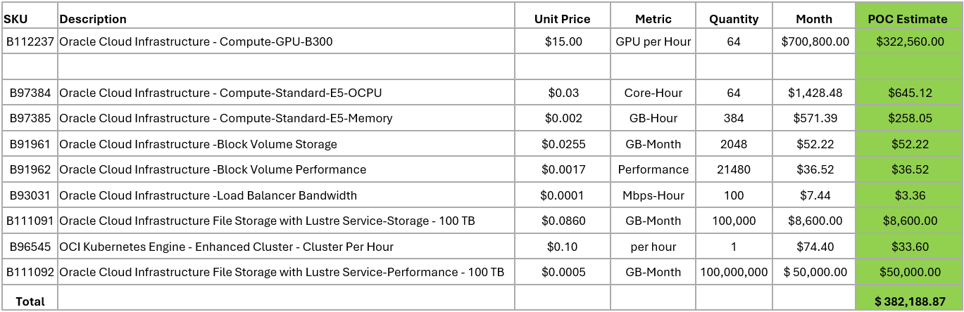

POC Participants
The following table lists the POC participants.

Oracle Team Members:

Name | Role
 | Principle Clou Solution Architect
 | Sale Representative
 | Sale Representative
 | Senior Cloud Engineer
 | VP Cloud Engineering

Example Team Members:

Name | Role
 | Research Engineering
 | Research Engineering
 | Research Engineering
 | Head of Research Engineering

Deliverables
- Documentation of POC test results

Logistics

Location
Oracle resources will be working on the POC remotely. NCCI team members will be working in NCCI offices or remotely. Co-location of resources is not expected, however, should co-location be required the logistics will be agreed to prior to travel being booked.

Data Transfer
Data will be transferred to Oracle Cloud into Object Storage.

Communication
The Oracle and NCCI teams will define a communication plan that may include daily meetings, shared workspace, chat group, or other methods of collaboration.

Data Cleansing
NCCI will remove and/or mask any required or sensitive data that will be used for the POC. Oracle has no data cleansing effort expected as part of the POC.

Cadence call
For the duration of the POC, the team will meet regularly via web conference to discuss progress.

Timing
Duration of the POC will be 2 weeks.

Oracle Corporation
Worldwide Headquarters
2300 Oracle Way, Austin, TX 78741
Worldwide Inquiries
Tele + 1.650.506.7000 + 1.800.ORACLE1
Fax + 1.650.506.7200
oracle.com
CONNECT WITH US
Call +1.800.ORACLE1 or visit oracle.com. Outside North America, find your local office at oracle.com/contact.
 | blogs.oracle.com/oracle |  | facebook.com/oracle |  | twitter.com/oracle
Copyright © 2026, Oracle and/or its affiliates. All rights reserved. This document is provided for information purposes only, and the contents hereof are subject to change without notice. This document is not warranted to be error-free, nor subject to any other warranties or conditions, whether expressed orally or implied in law, including implied warranties and conditions of merchantability or fitness for a particular purpose. We specifically disclaim any liability with respect to this document, and no contractual obligations are formed either directly or indirectly by this document. This document may not be reproduced or transmitted in any form or by any means, electronic or mechanical, for any purpose, without our prior written permission.
Oracle and Java are registered trademarks of Oracle and/or its affiliates. Other names may be trademarks of their respective owners.
Intel and Intel Xeon are trademarks or registered trademarks of Intel Corporation. All SPARC trademarks are used under license and are trademarks or registered trademarks of SPARC International, Inc. AMD, Opteron, the AMD logo, and the AMD Opteron logo are trademarks or registered trademarks of Advanced Micro Devices. UNIX is a registered trademark of The Open Group. 0626


