**SQL: Database Foundations: Sections 1, 2, 3, 4 : Intro, Modeling, Data Modeler**

**1-2**

1. **Personal information:** full name, date of birth, gender, student ID

**Contact information:** home address, phone number, email

**Family information:** parent/guardian names and relationship, parent/guardian contact information, emergency contact

**Academic information:** grade level, enrollment date, academic records, special needs, extracurricular activities

1. **Book information:** book ID, title, author, ISBN #, publisher, genre/category, language, status

**Customer information:** member ID, full name, date of birth, address, phone number, membership type

**Staff information:** staff ID, full name, position, contact information, work schedule

**Transaction information:** loan ID, book ID, member ID, loan date, return date

**Inventory information:** inventory ID, item name, quantity, condition

**1-3**

1. hierarchical
2. network
3. object
4. relational
5. flat file

**1-4**

1. **Business rule:** members pay membership fees, student is free but corporate and individual aren’t

**Constraint:** members only belong to one membership, membership type can’t be change

1. **Business rule:** doctors registered with the hospital have a unique ID, doctors must have seven years minimum of working experience, patients are required to register with hospital

**Constraint:** doctors’ ID must start with DC, experience requirement is for all doctors, patients’ ID must start with PT

**2-1**

* 1. **Books table:** book ID, title, ISBN, year, price, author ID, publisher ID

**Authors table:** author ID, author name

**Publishers table:** publisher ID, publisher name, publisher address

* 1. **Authors table:** author ID, author name, author address, author URL homepage
  2. **Publishers table:** publisher ID, publisher name, publisher address, publisher phone number, publisher URL website
  3. **Warehouse table:** warehouse ID, warehouse code, warehouse address, warehouse phone number, store ID
  4. **Books table:** book ID, title, ISBN, year, price, author ID, publisher ID

**Warehouse table:** warehouse ID, warehouse code, warehouse address, warehouse phone number, store ID

* 1. **Copies table:** copies ID, title, amount of books, book ID

**Warehouse table:** warehouse ID, warehouse code, warehouse address, warehouse phone number, store ID

* 1. **Customers table:** customer ID, customer name, customer address, customer email, customer phone number
  2. **Customer email table:** customer email ID
  3. **Shopping cart table:** shopping cart ID, customer ID, book ID
  4. **Shopping cart table:** shopping cart ID, customer ID, book ID, copies ID
  5. **Transaction table:** transaction ID, billing address, shipping address, shipping option, payment information, customer email ID
  6. **Customers table**: customer ID, customer name, email, phone number, billing address, shipping address

**Products table:** product ID, product name, description, category, price, quantity in stock, supplier ID,

**Suppliers table:** supplier ID, supplier name, contact person, contact number, address

**Orders table:** order ID, customer ID, order date, status

**Stock table:** stock ID, product ID, quantity in stock, reorder level

* 1. **Invoices items table:** invoice items ID, invoice ID, product ID, quantity, unit price

**Payments table:** payment ID, customer ID, payment date, total amount

**Backorder table:** backorder ID, order ID, product ID, quantity backordered, date backordered

**Reorder table:** reorder ID, backorder ID, supplier ID, ordered date, expected delivery date

* 1. **Invoices table:** invoice ID, order ID, invoice date, total amount

**Payment allocation table:** payment allocation ID, payment ID, invoice ID, allocated amount

**2-2**

1. Captures the needs of a business, may also reflect future needs, addresses what is conceptually ideal, identifies relationships between entities, identifies important entities
2. **Conceptual models:** flowchart, ERD diagrams

**Physical models:** 3D model of a building, solar system model

**2-3**

1. Departments, students, courses, faculty, registration, academic session, parent information, attendance information, exam information
2. **Course**: course nameo, course code*

**Department:** department nameo, department code*, course offered*, academic session*

**Student:** name*, age*, gradeo, email address*, addresso , course enrolled in*

**Faculty:** name*, course taught*, login*, logout*

**Academic session:** academic session period*

**Parent information:** name*, email, addresso, phone number*, relationship to student*  **Exam:** exam number, attendance status*, eligibility*, results*

**2-4**

* 1. A unique identifier for SONG could be song ID. A song title or artist cannot be a unique identifier because they may be used more than once.
  2. A unique attribute could be student ID or email address
  3. Student ID, none? , locker number
  4. **Unique identifiers:** course code, department code, student name, faculty name, academic session, parent name, exam number

**Candidate unique identifiers:** department code, student email address, faculty login, parent email address

**2-5**

* 1. Each EMPLOYEE must be assigned to one and only one DEPARTMENT. Each DEPARTMENT must be responsible for one or more EMPLOYEEs.
  2. Each PERSON must be born in one and only one TOWN. Each TOWN may be the birthplace of one or more PERSONs.

Each PERSON must be living in one and only one TOWN. Each TOWN may be the hometown of one or more PERSONs.

Each PERSON may be visitor of one or more TOWNs. Each TOWN must be visited by one or more PERSONs.

Each PERSON may be mayor of one and only one TOWN. Each TOWN may be governed by one and only one PERSON.

**2-6**

1. **Entities:** departments supervisor, employee, project

**Attributes:** department name, supervisor number, employee number, unique project number

1. A black and white diagram of a phone

   Description automatically generated

**3-1**

* 1. Enrollment 🡪 student id, course id
  2. Faculty course 🡪 course id, faculty id
  3. Enrollment 🡪 student id, course id

Course exam 🡪 course id, exam id

Exam registration 🡪 student id, exam id

2.1

4.1

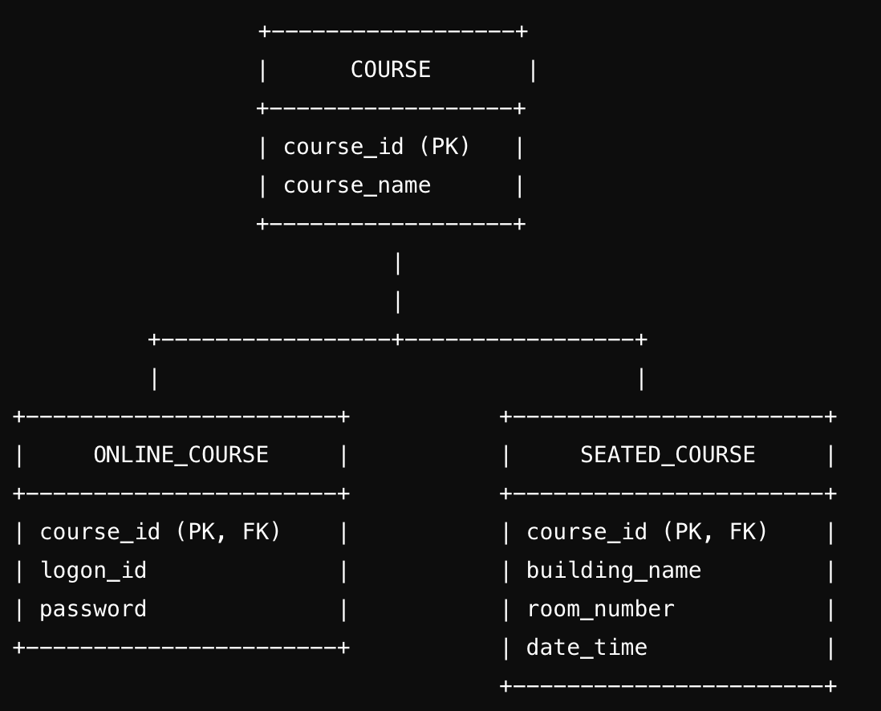

5.1

6.1

7.1

**3-2**

2a. It will be unique across instances

2b. End Time Must Be Later Than Start Time, Deadline for Submissions Must Be After Assignment Creation Date, Course Enrollment Start Date Must Be Before the Course End Date. All are conditional non-transferable.

**3-3**

1.1 Remove the repeating colors because each cell should have a single value. Create an additional row for repeating groups.

1.2 Create a new table for store information by extracting the store ID and location to another table. This is because location only depends on store ID. Adjust the original table by removing the Location column from the original table and keep only attributes that depend on both Supplier ID and Store ID.

1.3 Create a table for category information by extracting category ID and category description to a new table. Fix the original table by removing category description from the original table and retain only attributes directly dependent on book ID.

2. The student attendance information repeats in STUDENT, violating 1NF. Each ACADEMIC SESSION in attendance information will repeat, so it should be a separate entity.

Faculty logon is another repeating group, violating 1NF. In FACULTY, every time a faculty logs in, the information is repeated and should be a separate entity.

EXAM violates 3NF because the exam type determines exam name and exam description. No non-key attribute can determine another attribute, so they should have their own entity under EXAM TYPE for example. Exam type, name, and description would go under it.

3.1

3.2

4.1 A CUSTOMER can have zero, one, or many ORDERS

A CUSTOMER_ADDERSS can only be associated with one ADDRESS

A CUSTOMER must have an EMAIL ADDRESS

A DELIVERY is associated with one ORDER

An ORDER can be associated with one of many PRODUCTS

A PAYMENT must be associated with a PRODUCT

4.2

**3-4**

* 1. attribute 🡪 column

entity 🡪 table

ER model 🡪 physical design

Instance 🡪 row

Primary UID 🡪 primary key

Relationship 🡪 foreign key

Secondary UID 🡪 unique key

* 1. pk 🡪 primary key

fk 🡪 foreign key

uk 🡪 unique key

* 🡪 mandatory

o 🡪 optional

* 1. authors 🡪 AUTH

publishers 🡪 PUBL

customers 🡪 CUST

1.4

2.

Parent information

|  |  |  |
| --- | --- | --- |
| Key type | Optionality | Column name |
| pk | * | id |
|  | * | Parent 1 fn |
|  | * | Parent 1 ln |
|  | * | Parent 2 fn |
|  | * | Parent 2 ln |

Student

|  |  |  |
| --- | --- | --- |
| Key type | Optionality | Column name |
| pk | * | id |
|  | * | fn |
|  | * | Ls |
|  | * | Registration yr |
|  | * | email |

Academic session

|  |  |  |
| --- | --- | --- |
| Key type | Optionality | Column name |
| pk | * | id |
|  | * | name |

Course

|  |  |  |
| --- | --- | --- |
| Key type | Optionality | Column name |
| pk | * | id |
|  | * | name |

Department

|  |  |  |
| --- | --- | --- |
| Key type | Optionality | Column name |
| pk | * | id |
|  | * | name |
|  | * | Head |

Faculty

|  |  |  |
| --- | --- | --- |
| Key type | Optionality | Column name |
| pk | * | id |
|  | * | fn |
|  | * | Ls |
|  | * | email |

Exam

|  |  |  |
| --- | --- | --- |
| Key type | Optionality | Column name |
| pk | * | id |
|  | o | Start date |