**SQL: Database Foundations: Sections 5, 6: Mapping to Physical Model, SQL syntax intro**

**5-1**

**5-2**

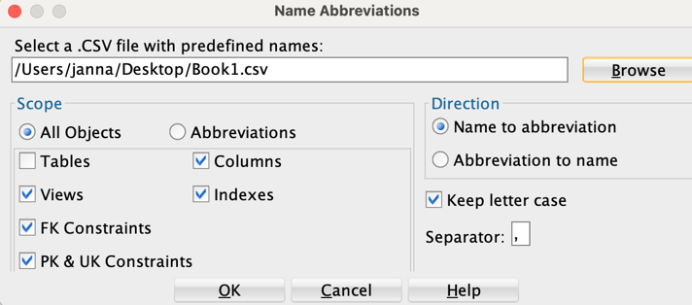

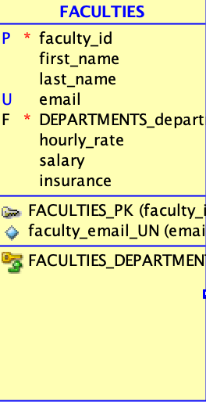

**6-1**

Oracle Application Express (APEX) is a web application that has an SQL workshop, application builder, and object browser.

**6-2**

Object browser allows us to create new objects, view and modify objects, and browse our data. There is also SQL commands where we can exeute SQL statements, look at our statement results, and download our query results to a CSV file. Lastly, SQL Scripts can help maintain scripts, view results, and create applications.

**6-3**

**6-4**

**6-5**

1. Yes, the email field would still be there because the SAVEPOINT was created after ALTER was done.
2. The original INSERTS that were executed would still be there, except that one of those records would be UPDATED where the id is = 940. There would be no deletion since ROLLBACK since before the DELETE was executed.

**6-6**

**6-7**

**6-8**

**6-9**

