Julie Muzina
2713300
jumuzina
CIS 545 Project 1

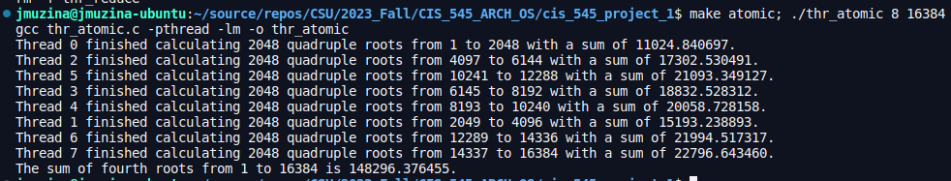Figure 1: Output of thr_atomic.c for 8 threads up to 16384.
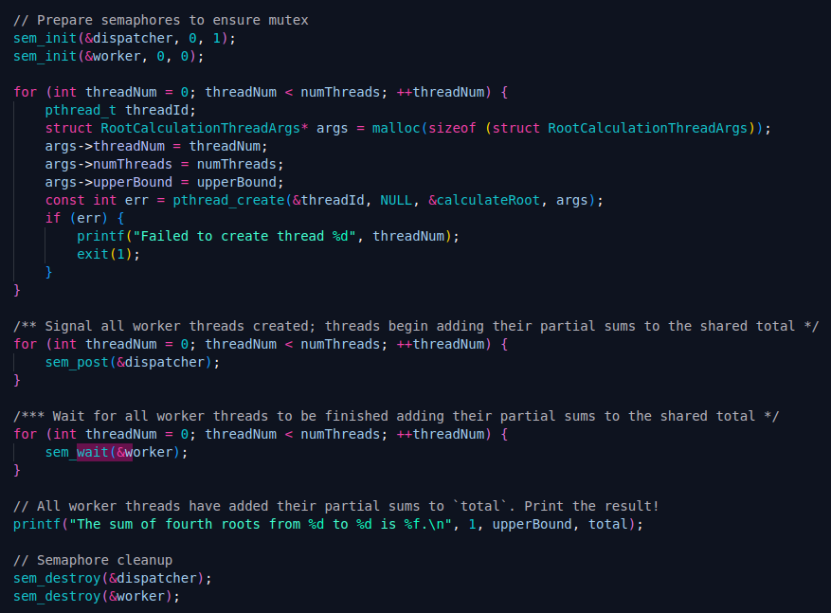Figure 2: thr_atomic.c: Main thread's thread creation logic, and semaphore management

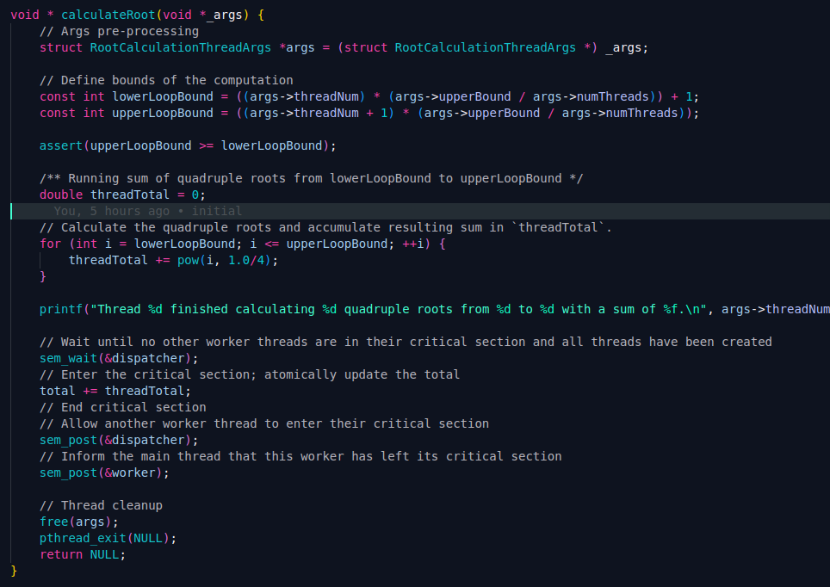Figure 3: thr_atomic.c: Thread function

Figure 4: Output of thr_reduce.c for 8 threads up to 16384.
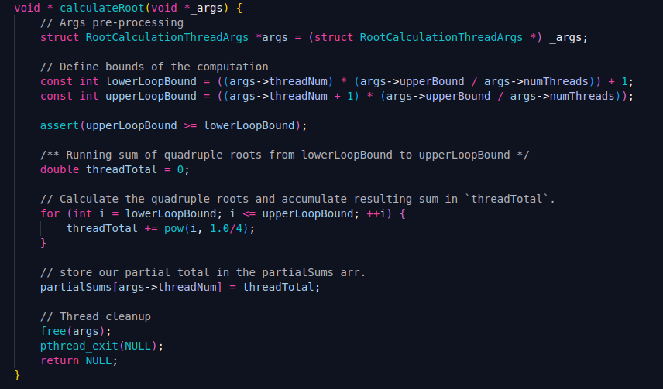Figure 5: thr_reduce.c: Thread function. Identical to the function for thr_atomic, but without semaphores, and the partial sum is stored in a global array.
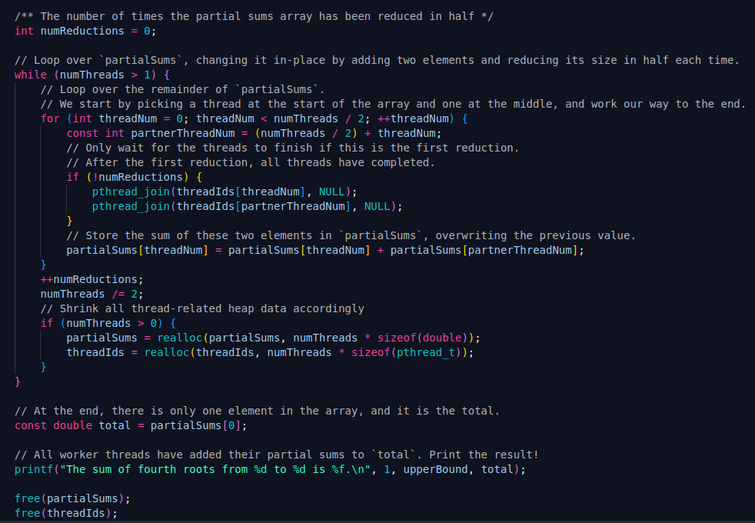Figure 6: thr_reduce: Partial sum reduction logic

Code Description

Input validation
For both programs, I begin with some input validation. The following conditions are all enforced on the command-line arguments:
- Correct number of arguments
- At least one thread
- Number of threads and upper bound are powers of 2
- Number of threads is less than or equal to the upper bound
  - If this is not true, then each thread will not have at least 1 integer to compute the 4th root of.

Thread creation
I create m threads where m is the second command-line argument after the program name. Each one of these threads is supplied the following information in the thread function arguments:
- Thread number
- Total number of threads
- Calculation upper bound
The thread identifiers created by pthreads are then stored for later usage.

Atomic

Semaphores
The C library semaphore.h s used to provide mutual exclusion to thread critical sections. For the most part, the threads can run completely asynchronously. They can compute their partial root sums without waiting for their turn. However, when it comes time to atomically add to the global total, mutual exclusion is needed. Two semaphores are used:
- Dispatcher (initial value: 1):
  - Ensures:
    - Atomic reads and writes for the global total.
    - No worker threads enter their critical sections before all worker threads have been created.
  - wait() calls
    - Once by each worker thread, before reading and modifying the global total.
  - post() calls
    - By the main thread: once per each worker thread, after creating all worker threads.
    - By each worker thread: once, after updating the global total.
- Worker (initial value: 0)
  - Ensures:
    - Main thread waits for all worker threads to complete before printing final output.
  - wait() calls
    - By the main thread: once per each worker thread, after signaling all worker threads to start.
  - post() calls
    - By each worker thread: once, after updating the global total.
After all worker threads have signaled their completion, the main thread reads and displays the value of the global total.

Reduce
The reduce program is very similar to the atomic program, but each thread stores its partial sum in a globally shared array. Thus, there is no critical section in the thread functions (no volatile memory is being overwritten or used in a calculation), and semaphores are not needed. Threads store their partial sum in the global array using their thread identifier as an index.
The partial sums array is then systematically reduced in half until it contains just one element, the final sum. In each reduction, pairs of partial sums are selected, added, and re-stored in the partial sums array. On the first reduction, pthread_join() is used to wait for the two threads to complete their partial sum calculation. When the array has been reduced to just one element, the final answer is in the first element.

Debugging/Testing experience
This was my first notable hands-on C experience in quite some time so I spent some time first getting familiar with the basics of input validation, setting up a Makefile, and memory management. I then set about creating threads and passing values into them. I found that if I wanted to pass anything more than a single value into a thread, I needed to create a dynamically allocated structure to pass in.
The most time-consuming part of debugging was figuring out exactly where to place the wait() and post() calls for the atomic program’s semaphores, as well as what to set their initial values to. I found the semaphore.h library to be very intuitive and useful, I just needed a bit more experience with implementing mutex with semaphores which this project gave me!

Code
Full source code is included with this submission in a .zip file, as well as a README file.

