BCB Report
  - CMRI Biostatistics and Computational Biology Core
Analyst
October 29, 2026
Report Contents

Load Libraries
#install cmribio from github
#library(pak)
#pak::pkg_install("jmvarberg/cmribio")
library(cmribio)
library(tidyverse)
library(cowplot)
library(ggsci)
library(ggpubr)
library(rstatix)
library(data.table)
library(DT)
#download logo to use for example
logo <- "https://raw.githubusercontent.com/jmvarberg/cmribio/main/man/figures/logo.png"
dest <- "logo.png"
download.file(logo, dest)

Background and Objectives
Information on project background and analysis goals.
Bold any important information, and italicize any key terms. Use bullet points to list items.
Embed a locally-saved image like this: 
Include call-outs (notes, warnings, info etc) to users like this:
 Note
Note that there are five types of callouts, including: note, warning, important, tip, and caution.

 Tip with Title
This is an example of a callout with a title.

 Expand To Learn About Collapse
This is an example of a ‘folded’ caution callout that can be expanded by the user. You can use collapse="true" to collapse it by default or collapse="false" to make a collapsible callout that is expanded by default.

Methods

Data Collection
Included information about where the data is located/stored, the source and how it was collected.

Data Cleanup
Capture any code used for cleaning up, importing, and formatting the raw data to prepare it for analysis.

Methods Used
Provide information and references/citations to any relevant tools or methods used for the statistical analysis, bioinformatics analysis, PK modeling etc.

Results

Table 1: Summary of Study Design and Cohort
Example of how to use gtsummary() to create Table 1 and save it out as Excel file.
table1 <- mtcars |>
gtsummary::tbl_summary(
by = cyl) |>
gtsummary::add_p()
#print table 1
if (knitr::is_html_output()) {
table1
}
#export to Excel file
gtsummary::as_hux_xlsx(table1, file = "./output_table1.xlsx")

Tables and Graphs
Include separate sections and chunks used to generate results tables and plots during the analysis.

Static and Interactive Tables
Here are simple examples of how to make static or interactive tables. See source code for examples for how to optionally have Quarto only execute the chunks with interactive tables/plots if being rendered to HTML. This will prevent errors with interactive outputs when rendering to Word/.docx files.
#static table output
mtcars |>
knitr::kable()
 | mpg | cyl | disp | hp | drat | wt | qsec | vs | am | gear | carb
Mazda RX4 | 21.0 | 6 | 160.0 | 110 | 3.90 | 2.620 | 16.46 | 0 | 1 | 4 | 4
Mazda RX4 Wag | 21.0 | 6 | 160.0 | 110 | 3.90 | 2.875 | 17.02 | 0 | 1 | 4 | 4
Datsun 710 | 22.8 | 4 | 108.0 | 93 | 3.85 | 2.320 | 18.61 | 1 | 1 | 4 | 1
Hornet 4 Drive | 21.4 | 6 | 258.0 | 110 | 3.08 | 3.215 | 19.44 | 1 | 0 | 3 | 1
Hornet Sportabout | 18.7 | 8 | 360.0 | 175 | 3.15 | 3.440 | 17.02 | 0 | 0 | 3 | 2
Valiant | 18.1 | 6 | 225.0 | 105 | 2.76 | 3.460 | 20.22 | 1 | 0 | 3 | 1
Duster 360 | 14.3 | 8 | 360.0 | 245 | 3.21 | 3.570 | 15.84 | 0 | 0 | 3 | 4
Merc 240D | 24.4 | 4 | 146.7 | 62 | 3.69 | 3.190 | 20.00 | 1 | 0 | 4 | 2
Merc 230 | 22.8 | 4 | 140.8 | 95 | 3.92 | 3.150 | 22.90 | 1 | 0 | 4 | 2
Merc 280 | 19.2 | 6 | 167.6 | 123 | 3.92 | 3.440 | 18.30 | 1 | 0 | 4 | 4
Merc 280C | 17.8 | 6 | 167.6 | 123 | 3.92 | 3.440 | 18.90 | 1 | 0 | 4 | 4
Merc 450SE | 16.4 | 8 | 275.8 | 180 | 3.07 | 4.070 | 17.40 | 0 | 0 | 3 | 3
Merc 450SL | 17.3 | 8 | 275.8 | 180 | 3.07 | 3.730 | 17.60 | 0 | 0 | 3 | 3
Merc 450SLC | 15.2 | 8 | 275.8 | 180 | 3.07 | 3.780 | 18.00 | 0 | 0 | 3 | 3
Cadillac Fleetwood | 10.4 | 8 | 472.0 | 205 | 2.93 | 5.250 | 17.98 | 0 | 0 | 3 | 4
Lincoln Continental | 10.4 | 8 | 460.0 | 215 | 3.00 | 5.424 | 17.82 | 0 | 0 | 3 | 4
Chrysler Imperial | 14.7 | 8 | 440.0 | 230 | 3.23 | 5.345 | 17.42 | 0 | 0 | 3 | 4
Fiat 128 | 32.4 | 4 | 78.7 | 66 | 4.08 | 2.200 | 19.47 | 1 | 1 | 4 | 1
Honda Civic | 30.4 | 4 | 75.7 | 52 | 4.93 | 1.615 | 18.52 | 1 | 1 | 4 | 2
Toyota Corolla | 33.9 | 4 | 71.1 | 65 | 4.22 | 1.835 | 19.90 | 1 | 1 | 4 | 1
Toyota Corona | 21.5 | 4 | 120.1 | 97 | 3.70 | 2.465 | 20.01 | 1 | 0 | 3 | 1
Dodge Challenger | 15.5 | 8 | 318.0 | 150 | 2.76 | 3.520 | 16.87 | 0 | 0 | 3 | 2
AMC Javelin | 15.2 | 8 | 304.0 | 150 | 3.15 | 3.435 | 17.30 | 0 | 0 | 3 | 2
Camaro Z28 | 13.3 | 8 | 350.0 | 245 | 3.73 | 3.840 | 15.41 | 0 | 0 | 3 | 4
Pontiac Firebird | 19.2 | 8 | 400.0 | 175 | 3.08 | 3.845 | 17.05 | 0 | 0 | 3 | 2
Fiat X1-9 | 27.3 | 4 | 79.0 | 66 | 4.08 | 1.935 | 18.90 | 1 | 1 | 4 | 1
Porsche 914-2 | 26.0 | 4 | 120.3 | 91 | 4.43 | 2.140 | 16.70 | 0 | 1 | 5 | 2
Lotus Europa | 30.4 | 4 | 95.1 | 113 | 3.77 | 1.513 | 16.90 | 1 | 1 | 5 | 2
Ford Pantera L | 15.8 | 8 | 351.0 | 264 | 4.22 | 3.170 | 14.50 | 0 | 1 | 5 | 4
Ferrari Dino | 19.7 | 6 | 145.0 | 175 | 3.62 | 2.770 | 15.50 | 0 | 1 | 5 | 6
Maserati Bora | 15.0 | 8 | 301.0 | 335 | 3.54 | 3.570 | 14.60 | 0 | 1 | 5 | 8
Volvo 142E | 21.4 | 4 | 121.0 | 109 | 4.11 | 2.780 | 18.60 | 1 | 1 | 4 | 2

Static and Interactive Plots
Here are basic examples of using static and interactive plots.
p <- ggplot(mtcars, aes(x = mpg, y = wt, color = factor(cyl), text1 = disp, text2=drat, text3 = qsec, text4 = gear, text5 = carb)) +
geom_point() +
scale_color_bcb() +
theme_bcb(base_theme = "bw")
#static plot
p + ggtitle("Static Plot Output")
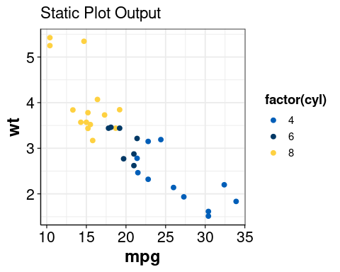
Figure 1: Static penguin plot
You can also modify the size of the plot generated by each chunk like this:
#default size
p
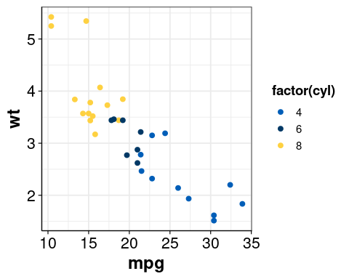
p
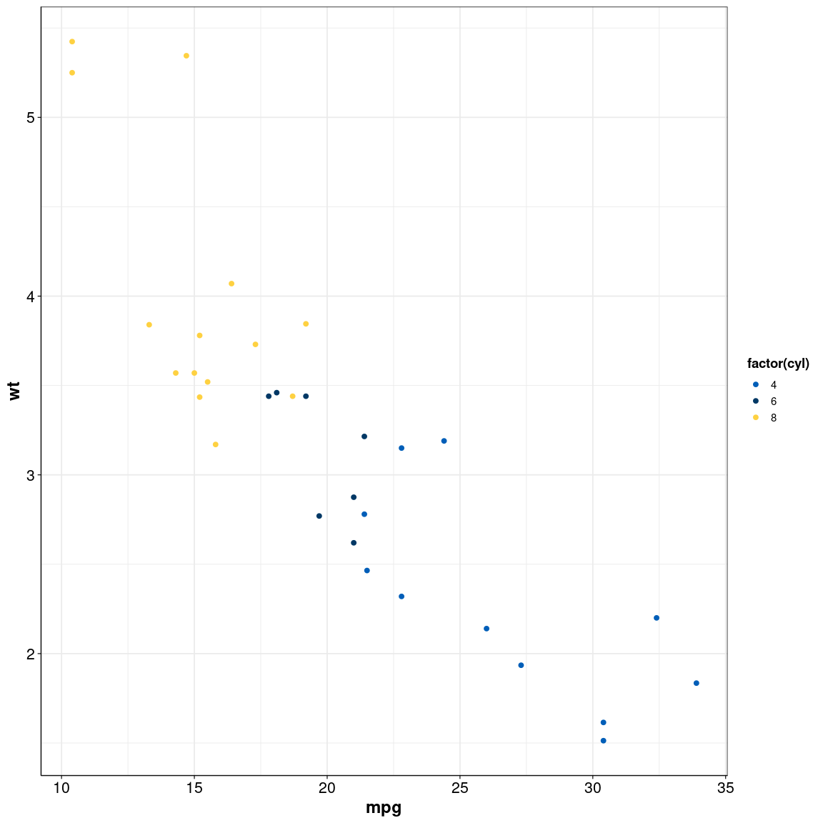

Using Tabs
It can be helpful to use tabs to organize reports with multiple outputs/plots/tables. Here we show an example of how to use this feature.

Embedded files
The function xfun::embed_file() and related functions can be used to directly embed results files, like CSVs or Excel files, into the document. It will then be self-contained, so anyone with the report can download the embedded file.
#showing simple example
#create results data frame
results <- mtcars
#save results to the project results directory
write.csv(mtcars, "./results/mtcars.csv", row.names = F)
#also embed a copy of the results in the HTML report for quick access and sharing with collaborators
xfun::embed_file("./results/mtcars.csv", "./results/mtcars.csv", "Results - mtcars.csv")

Conclusions
Summarize key findings and conclusions. Can refer back to sections with Section 1.3.2.1 or to specific outputs (plots, tables) using the #| label: <label> formating: see Figure 1 or ?@fig-interactive-plot.
Link out to any relevant external websites using link.

References
Include any references here. If you want to use Quarto’s citation formatting, see this page for the required files and formatting to use in this report.

Session Info
Three options for including session info using different tools:
devtools::session_info()
─ Session info ───────────────────────────────────────────────────────────────
setting value
version R version 4.4.0 (2024-04-24)
os Red Hat Enterprise Linux 8.10 (Ootpa)
system x86_64, linux-gnu
ui X11
language (EN)
collate en_US.UTF-8
ctype en_US.UTF-8
tz America/Chicago
date 2026-10-29
pandoc 3.8.3 @ /usr/lib/rstudio-server/bin/quarto/bin/tools/x86_64/ (via rmarkdown)
quarto 1.9.37 @ /usr/lib/rstudio-server/bin/quarto/bin/quarto
─ Packages ───────────────────────────────────────────────────────────────────
package * version date (UTC) lib source
abind 1.4-8 2024-09-12 [1] CRAN (R 4.4.0)
assertthat 0.2.1 2019-03-21 [1] CRAN (R 4.4.0)
babelgene 22.9 2022-09-29 [1] CRAN (R 4.4.0)
backports 1.5.0 2024-05-23 [1] CRAN (R 4.4.0)
broom 1.0.13 2026-05-14 [1] CRAN (R 4.4.0)
cachem 1.1.0 2024-05-16 [1] CRAN (R 4.4.0)
car 3.1-5 2026-02-03 [1] CRAN (R 4.4.0)
carData 3.0-5 2022-01-06 [1] CRAN (R 4.4.0)
cards 0.7.1 2025-12-02 [1] CRAN (R 4.4.0)
cardx 0.3.2 2026-02-05 [1] CRAN (R 4.4.0)
cli 3.6.5 2025-04-23 [1] CRAN (R 4.4.0)
cmribio * 0.1.0 2026-09-16 [1] Github (jmvarberg/cmribio@ead7190)
cowplot * 1.2.0 2025-07-07 [1] CRAN (R 4.4.0)
curl 7.0.0 2025-08-19 [1] CRAN (R 4.4.0)
data.table * 1.17.8 2025-07-10 [1] CRAN (R 4.4.0)
devtools 2.4.6 2025-10-03 [1] CRAN (R 4.4.0)
digest 0.6.39 2025-11-19 [1] CRAN (R 4.4.0)
dplyr * 1.2.0 2026-02-03 [1] CRAN (R 4.4.0)
DT * 0.34.0 2025-09-02 [1] CRAN (R 4.4.0)
ellipsis 0.3.2 2021-04-29 [1] CRAN (R 4.4.0)
evaluate 1.0.5 2025-08-27 [1] CRAN (R 4.4.0)
farver 2.1.2 2024-05-13 [1] CRAN (R 4.4.0)
fastmap 1.2.0 2024-05-15 [1] CRAN (R 4.4.0)
forcats * 1.0.1 2025-09-25 [1] CRAN (R 4.4.0)
Formula 1.2-5 2023-02-24 [1] CRAN (R 4.4.0)
fs 1.6.6 2025-04-12 [1] CRAN (R 4.4.0)
generics 0.1.4 2025-05-09 [1] CRAN (R 4.4.0)
ggplot2 * 4.0.3 2026-04-22 [1] RSPM
ggpubr * 1.0.0 2026-07-06 [1] CRAN (R 4.4.0)
ggsci * 4.1.0 2025-10-25 [1] CRAN (R 4.4.0)
ggsignif 0.6.4 2022-10-13 [1] CRAN (R 4.4.0)
glue 1.8.0 2024-09-30 [1] CRAN (R 4.4.0)
gtable 0.3.6 2024-10-25 [1] CRAN (R 4.4.0)
gtsummary 2.5.0 2025-12-05 [1] CRAN (R 4.4.0)
hms 1.1.4 2025-10-17 [1] CRAN (R 4.4.0)
htmltools 0.5.9 2025-12-04 [1] CRAN (R 4.4.0)
htmlwidgets 1.6.4 2023-12-06 [1] CRAN (R 4.4.0)
httr 1.4.7 2023-08-15 [1] CRAN (R 4.4.0)
jmvtools 0.0.0.9000 2025-11-24 [1] Github (jmvarberg/jmvtools@c34dc9c)
jsonlite 2.0.0 2025-03-27 [1] CRAN (R 4.4.0)
knitr 1.50 2025-03-16 [1] CRAN (R 4.4.0)
labeling 0.4.3 2023-08-29 [1] CRAN (R 4.4.0)
lifecycle 1.0.5 2026-01-08 [1] CRAN (R 4.4.0)
limma 3.62.2 2025-01-09 [1] Bioconductor 3.20 (R 4.4.0)
lubridate * 1.9.4 2024-12-08 [1] CRAN (R 4.4.0)
magrittr 2.0.4 2025-09-12 [1] CRAN (R 4.4.0)
memoise 2.0.1 2021-11-26 [1] CRAN (R 4.4.0)
msigdbr 25.1.1 2025-07-21 [1] CRAN (R 4.4.0)
pheatmap 1.0.13 2025-06-05 [1] CRAN (R 4.4.0)
pillar 1.11.1 2025-09-17 [1] CRAN (R 4.4.0)
pkgbuild 1.4.8 2025-05-26 [1] CRAN (R 4.4.0)
pkgconfig 2.0.3 2019-09-22 [1] CRAN (R 4.4.0)
pkgload 1.4.1 2025-09-23 [1] CRAN (R 4.4.0)
plotly * 4.12.1 2026-07-22 [1] CRAN (R 4.4.0)
purrr * 1.2.0 2025-11-04 [1] CRAN (R 4.4.0)
R6 2.6.1 2025-02-15 [1] CRAN (R 4.4.0)
RColorBrewer 1.1-3 2022-04-03 [1] CRAN (R 4.4.0)
readr * 2.1.6 2025-11-14 [1] CRAN (R 4.4.0)
remotes 2.5.0 2024-03-17 [1] CRAN (R 4.4.0)
rlang 1.1.7 2026-01-09 [1] CRAN (R 4.4.0)
rmarkdown 2.30 2025-09-28 [1] CRAN (R 4.4.0)
rstatix * 1.1.0 2026-07-23 [1] CRAN (R 4.4.0)
rstudioapi 0.17.1 2024-10-22 [1] CRAN (R 4.4.0)
S7 0.2.1 2025-11-14 [1] CRAN (R 4.4.0)
scales 1.4.0 2025-04-24 [1] CRAN (R 4.4.0)
sessioninfo 1.2.3 2025-02-05 [1] CRAN (R 4.4.0)
statmod 1.5.1 2025-10-09 [1] CRAN (R 4.4.0)
stringi 1.8.7 2025-03-27 [1] CRAN (R 4.4.0)
stringr * 1.6.0 2025-11-04 [1] CRAN (R 4.4.0)
tibble * 3.3.0 2025-06-08 [1] CRAN (R 4.4.0)
tidyr * 1.3.2 2025-12-19 [1] CRAN (R 4.4.0)
tidyselect 1.2.1 2024-03-11 [1] CRAN (R 4.4.0)
tidyverse * 2.0.0 2023-02-22 [1] CRAN (R 4.4.0)
timechange 0.3.0 2024-01-18 [1] CRAN (R 4.4.0)
tzdb 0.5.0 2025-03-15 [1] CRAN (R 4.4.0)
usethis 3.2.1 2025-09-06 [1] RSPM (R 4.4.0)
vctrs 0.7.2 2026-03-21 [1] CRAN (R 4.4.0)
viridisLite 0.4.2 2023-05-02 [1] CRAN (R 4.4.0)
withr 3.0.2 2024-10-28 [1] CRAN (R 4.4.0)
xfun 0.54 2025-10-30 [1] CRAN (R 4.4.0)
yaml 2.3.12 2025-12-10 [1] CRAN (R 4.4.0)
[1] /mnt/home/jmvarberg/R/x86_64-pc-linux-gnu-library/4.4
[2] /mnt/software/R/4.4.0-tcl/lib64/R/library
* ── Packages attached to the search path.
──────────────────────────────────────────────────────────────────────────────

