

Game Design Document



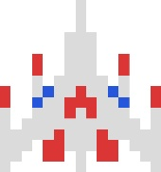

Developer: Namco

Publishers: Namco (Japan), Midway (North America)

Intended for the Namco Galaga arcade cabinet

Rated E for Everyone

Release by September 1981

Copyright © 1981 by Namco

**Table of Contents**

Game Overview 3

Gameplay 4

* Stage Indicators

Game Experience 5

* Main Screen
* Sound

Characters 6

* Protagonist
* Enemies

HUD Overview 7

Core Mechanics 8

* Scoring System
* Lives
* Second Ship

Monetization 9

**Game Overview**

Galaga is a simple endless shoot-’em-up game, where the player takes control of a Gyaraga and can shoot bullets. The main objective of the game is to score the most of points on the leaderboards before reaching Game Over, by shooting down the hostile swarm of Galaga (insectoid alien species from the titular planet). The player can move the Gyaraga (positioned at the bottom of the playfield) left and right, and fire by repeatedly pressing the shoot button.

From off the screen, the swarm of Galaga - varying in type, color, and look - fly down the screen and create an array formation, and once positioned they move back and forth horizontally within the playfield. Soon, one-by-one, they’ll start homing towards the Gyaraga (and start shooting as well), making the player maneuver through their attacks. If the enemies fly past through the bottom of the play field, they’ll reappear at the top, return to formation and start homing again.

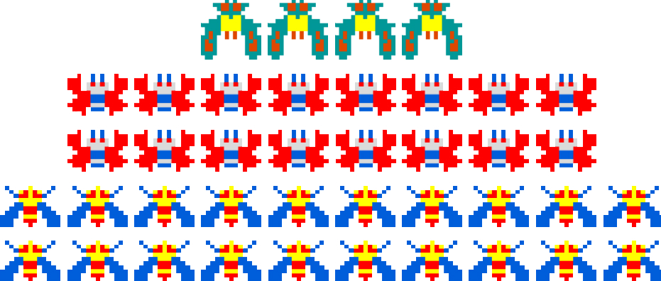 Once the player reaches Game Over (by losing their last ship), the game will ask them for their initials (3 characters only). Their score will be recorded and be shown on the leaderboards with all the other top scores and their initials.

Figure 1 - Formation of the Galaga Army

**Gameplay**

Galaga can be played in either single or 2 players. Single is just a regular playthrough, but in 2 players, each player will take turns playing the game. If the Player 1 loses a life, then Player 2 will start playing. Both players have separate lives and scores.

The game is divided into stages, and there are two types: regular and challenge stages. Regular stages are just numbered stages, where the enemies come into of the playfield and start their assault. The objective in these stages are to shoot down all the enemies on the play field. Once the player clears the stage (when all the enemies are down), the stage is complete and advances to the next stage, repeating the gameplay loop.

Challenge stages are special; here the enemies don’t shoot, instead move in tricky patterns. The player can shoot them down score more points, and if they manage to get all of the enemies, the game will reward them bonus points. Otherwise, it would continue to the next regular stage. Challenge stages start on Stage 3 and occurs every 4 stages after it (Stage 7, 11, 15, etc.). As each stage number increases, the difficulty increases; enemies spawn in greater numbers, move more quickly and shoots more frequently when they start homing.

**Stage Indicator**

During gameplay, how Galaga shows what stage the player is currently on are badges (located on the bottom right of the playfield). The badges are the sum of the current stage, and will be represented by the images shown below. For example:

 Stage 47 = = 30 + 10 + 5 + 1 + 1

|  |  |  |  |  |  |  |
| --- | --- | --- | --- | --- | --- | --- |
| Stage Number | 1 | 5 | 10 | 20 | 30 | 50 |
| Badge Indicator |  |  |  |  |  |  |

*Table 1 - Each Badge correlates to a stage value*

**Game Experience**

**Main Screen**

As players walk up to the arcade cabinet, the first thing they’ll see before playing is the title screen. A black screen with flickering of colored pixels sprinkled all over the playfield, emulating vast space. Then, the title “Galaga” scrolls up from the bottom of the screen. The music in this game short but sweet tune, which invokes you’re the sole protector of Earth against the Galaga Army. If the player continues to watch and not pay to play, the will show a demo of an A.I. playing the game, but it always ends up dying at the end. There are also general rules to how to earn extra lives and the score system (further explained in Core Mechanics).

**Sound**

Sound design is simple, indicating various cues throughout the game:

* when the player shoots a bullet
* the bullet hits an enemy
* an enemy start homing on the Gyaraga
* the player gets a 1-up
* the Boss uses the capturing beam
* if Gyaraga gets caught by the capturing beam
* when that Gyaraga is rescued from the Boss
* if ship is destroyed; and
* 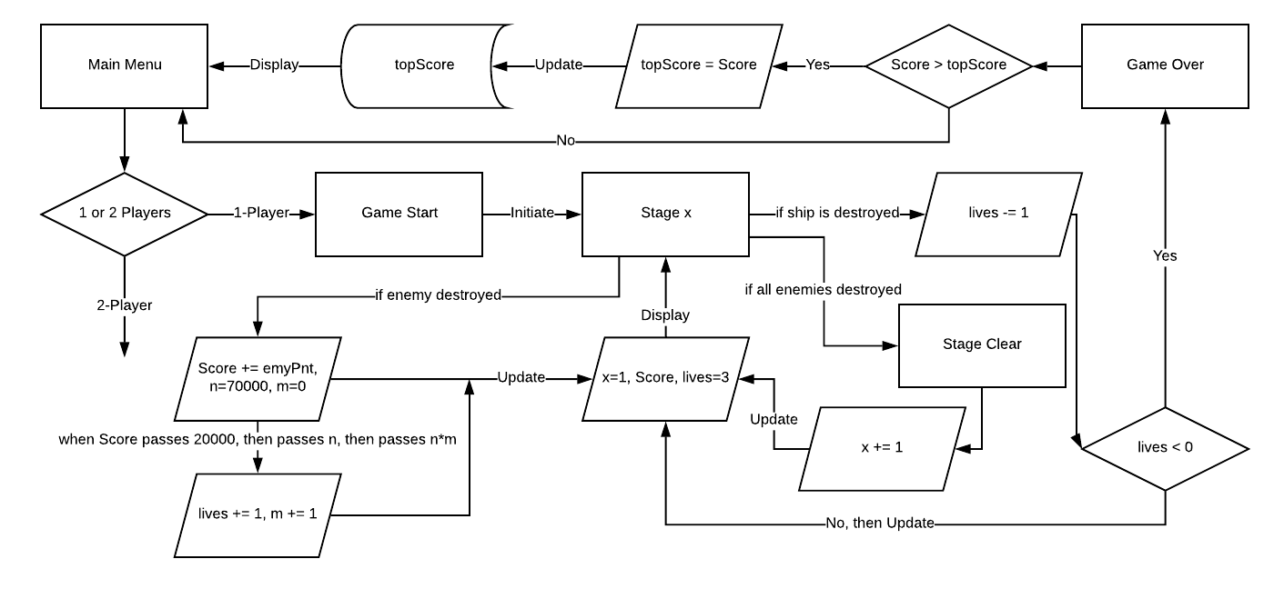when the player clears a level

Figure 6 - A simple flowchart of a playthrough in Galaga (single player)

**Characters**

**Protagonist**

The Gyaraga is the Starfighter that the player controls throughout the game. This white bomber is what will destroy the Galaga Army and becomes the mechanical guardian of Earth.

The player can move the Gyaraga left or right with the arcade stick and can shoot with the fire button.

Figure 2 - Gyaraga



**Enemies**

The Red Minions follow their Boss and they resemble large moths/butterflies. Not being the smartest enemy, they will break off their formation to attack Gyaraga.



Figure 3 - Red Minion Bug

The Yellow Minions also follow the Boss and resembles as giant bees with blue wings and red-tan stripes. When this enemy starts homing on the Gyaraga, it will loop around from the bottom of the playfield and attack again, before returning to formation

Figure 4 - Yellow Minion Bug

The Boss are the leading enemies of each regular stage. When homing on the Gyaraga, they follow behind 1 or 2 Red Minion. They are few in numbers compared to the Red and Yellow minions, but they contain a special weapon that is different from them.

They have a capturing beam that takes away one Gyaraga. The ship is not destroyed and can be retrieved. It takes two shots to destroy it.

Figure 5 - Galagan Boss using the Capturing Beam

**HUD Overview**

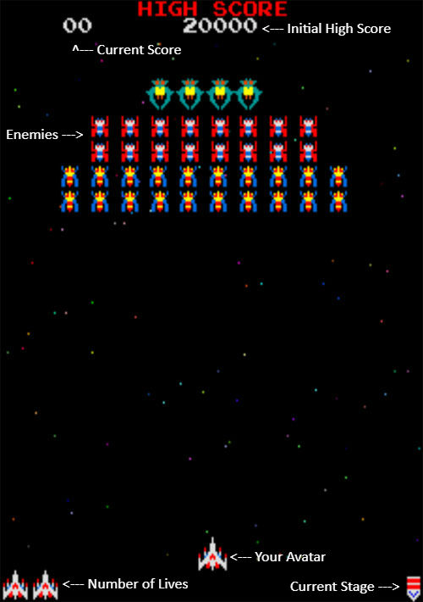

Figure 6 - The playfield of Galaga

**Core Mechanics**

**Scoring System**

Scoring is the central part of playing this game. Competition arises when different players attempt to score the most points than the others. Without it, the game becomes repetitive with no end-goal. In Galaga, the system gives the player a lot of opportunities to score a lot of points and is what determines the novices and the veterans. Each enemy have different score values:

* Yellow: 50 points in formation, 100 while homing
* Red: 80 points in formation, 160 while homing
* Boss: 150 in formation, 400 while homing, 800 while homing with 1 Red, 1600 while homing with 2 Reds

There are other opportunities to score big in this game. Each challenge stage, if the player is able to shoot down all enemies, that player will be rewarded 10000 points.

**Lives**

 Lives in Galaga work in like any other arcade game. The player is given 3 lives in each playthrough, and they lose one if they get hit. It is possible to earn extra lives, and it is by scoring. In one playthrough, if their current score passes 20000 points, they’ll be rewarded an extra life. Then, if their current score passes 70000 points, they get another life. Finally, every extra life will be rewarded when they pass every 70000 points (140000, 210000, etc.).

**Second** **Ship**

When a Boss captures a Gyaraga with its beam, the player is forces to use a second life. If the player destroys that Boss, they get that ship back. But instead of that ship being stored as an extra life, it is positioned adjacent to the active Gyaraga, used as a pseudo power-up allowing the player to double shoot.

If they lose one ship, the other is still operational and gameplay continues.

Figure 7 - Two ships shooting bullets

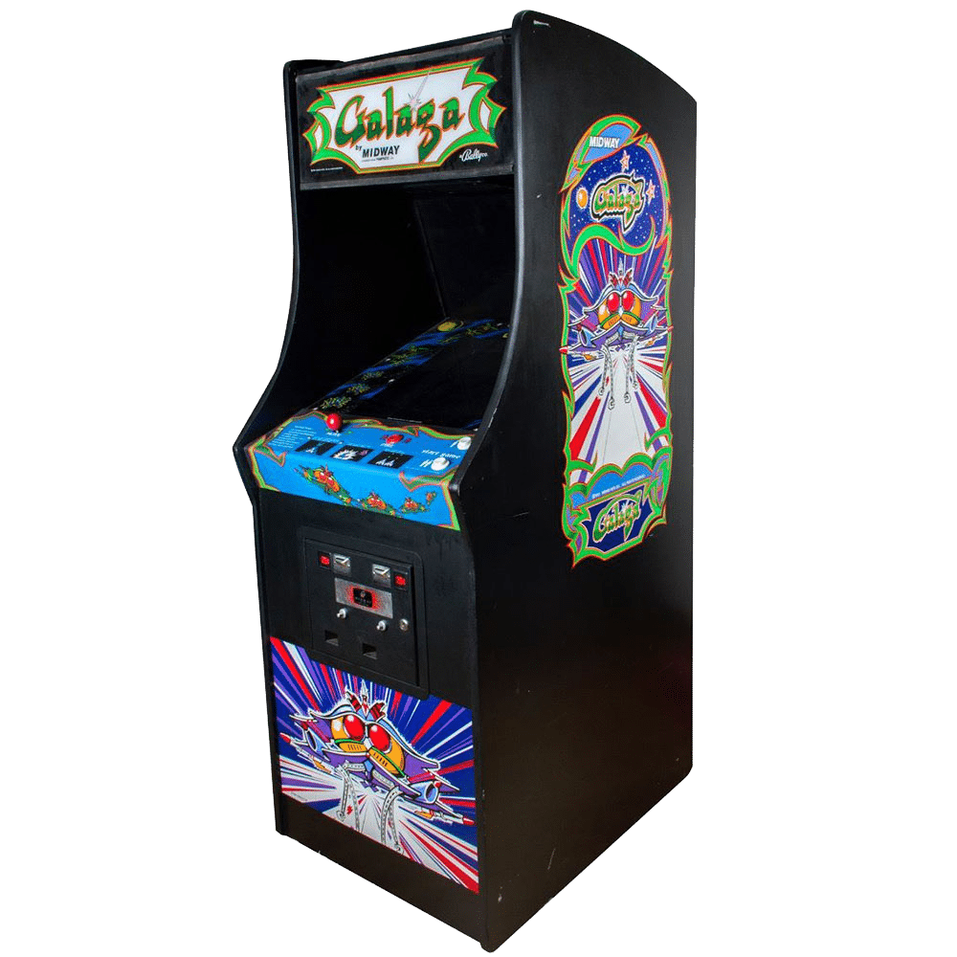**Monetization**

The Namco Galaga cabinet will be produced by Namco, and is what players will be able to play Galaga. This will be shipped to arcade locations in Japan and North America, provided by Namco and Midway respectively. Players will need to pay 2 quarters for 1-player (starting with 3 lives), and 3 quarters for 2-players (with 3 lives each).

Figure 8 - The Namco Galaga arcade cabinet