**PadBall**

Game Design Document

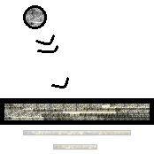

Developer: Jaimeson Mario Villaescusa

Contact: Jaimeson.Villaescusa@triosstudent.com

Intended for PC, N. Switch, Android, and iOS

Rated E for Everyone

Documented on 12/03/2018

**Table of Contents**

Game Overview 3

HUD Overview 4

Game Mechanics 5

Bumping

Scoring in Endless Bricks

Matchmaking in Ranked

Gamemodes 6

Solo

Campaign

Endless Bricks

Versus 7

Localplay

Online

Quickplay

Ranked

Menu Shell 8

Profile Accounts 9

Friends List

Leaderboards

Monetization 10

Disclaimer – The images in this document are not going to be what the game looks like on release. These are only concept art for this documentation.

**Game Overview**

PadBall is a simple sport game that simulates table tennis in 2-D space. Like the arcade classics, *Pong* (1972) and *Breakout* (1976), where the objective is to prevent the ball from passing your side. What makes this different from it is the ‘bump’ mechanic (further explained in the ‘Game Mechanics’ section.), which allows the ball to move faster than its initial speed and manipulate its trajectory. There are modes for single and multiplayer, like a campaign and a competitive mode for online. The games simple, but addictive concept will cater to both competitive and casuals alike.

In versus mode, the match starts with a coin flip; this is to determine which side the ball will move. Both players decide on either heads or tails (there will be a popup prompt of the two choices). Then the game will randomly generate either head or tail, and the winner will be able to hit the ball first. The ball will bounce off the wall first before the paddle.

There are only 3 control configurations for this game: left button, right button and the bump button. Left and right buttons move the paddle at a set speed, and the bump button pushes the paddle upward then move back to its initial horizontal position.

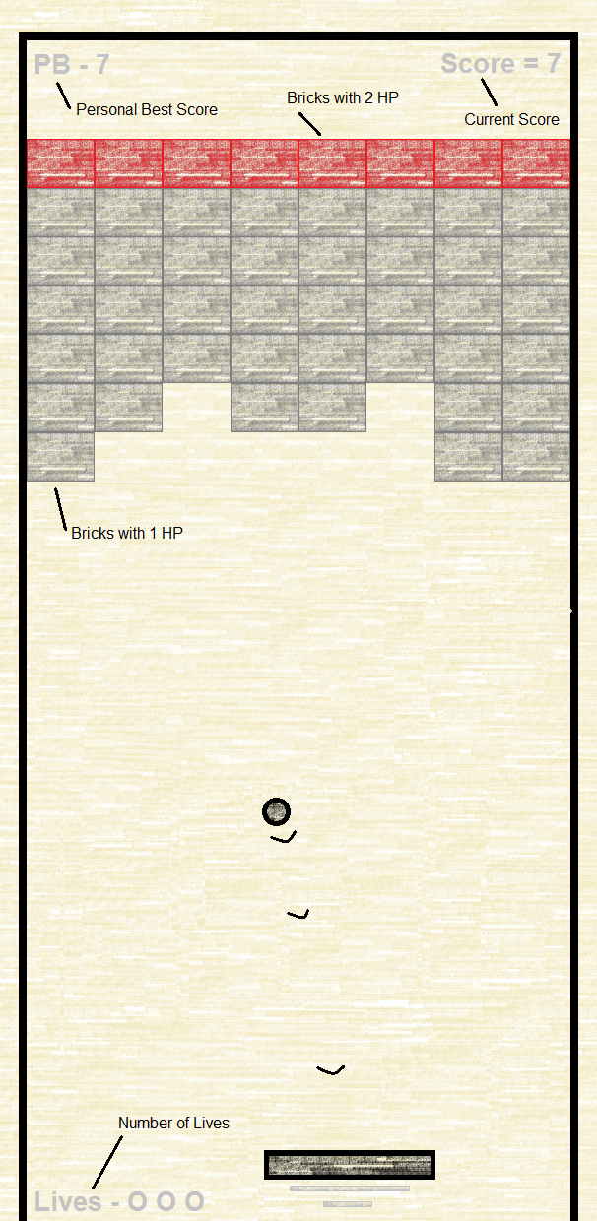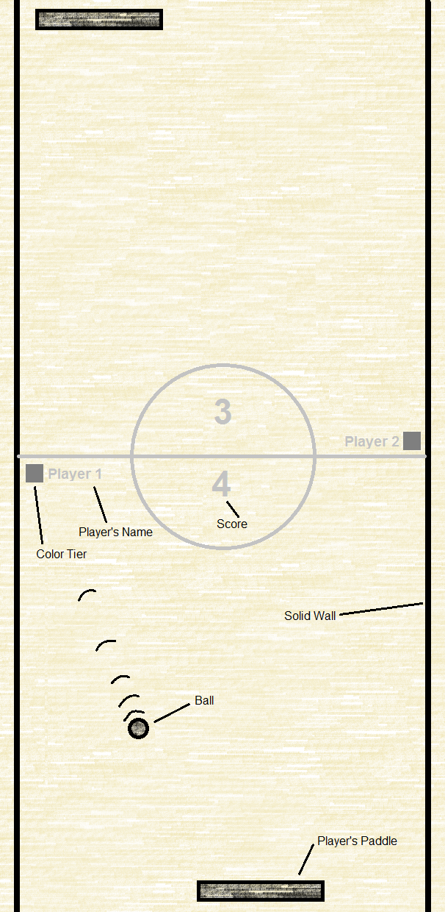**HUD Overview**

Figure 1 - Playfield of Solo, Endless Bricks mode

Figure 2 - Playfield of Versus, Ranked mode

**Game Mechanics**

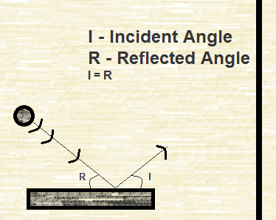Bumping

When the ball bounces off the side-wall, if the paddle does not bump the ball, that ball will bounce off it at the same reflection angle as its incident angle. But if the paddle bumps the ball coming off the wall, the ball will bounce off the paddle but with the reflection angle being greater than the incident angle.

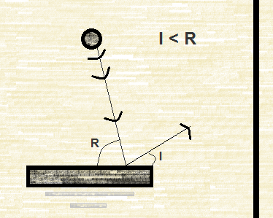Bumping also will increase the ball’s speed; there are speed values – from 1 to 5 – with each value showing the ball’s speed (with 1 being the initial speed and 5 is the maximum speed). When a paddle bumps the ball at value 1, that value will change to 2, causing the ball to increase in speed. Consecutive bumps will increase the speed value, which in turn will increase the ball speed. After reaching speed value 5, the ball’s speed will cap, and any further bumps will not have any effect. The speed value reverts to 1 when the ball passes the paddle.

Figure 3 - No Bump Bounce

In Versus, the speed value will increase when both paddles bump the ball. When one paddle bumps but the other doesn’t, the speed value will stay at 1 until the other paddle bumps.

Figure 4 - Bump Bounce

Scoring in Endless Bricks

Scoring is determined by how many bricks were hit (1 hit = 1 point). Bricks have hit points (HP for short); at the start each brick has one HP, and as time goes on their HP increases. When all 3 lives are lost (by missing the ball), the score will be recorded and uploaded to a leaderboard dedicated to this mode.

Matchmaking in Ranked

Determining matches in ranked are considered by two things: color tier and rank points. Colors are for matchmaking players with the same color, regardless of rank points. Each tier can be unlocked by earning rank points. The higher the color tier, the better the players will be matched. Points determine placings in the ranked leaderboards and can be earned by winning ranked matches. There is a bonus multiplier (starting on 1.0x after 3 wins, then adds 0.1 per match won) when the player on a winning streak, causing them to earn more rank points. If the player loses while on a winning streak, the bonus multiplier will be removed; the player must win 3 consecutive wins to get the bonus multiplier back. Consecutive losses after the initial lost will lose points. If the player leaves mid-match, it is considered a loss. Should the player leave ranked matches with a winning streak, the bonus multiplier will be maintained.

**Gamemodes**

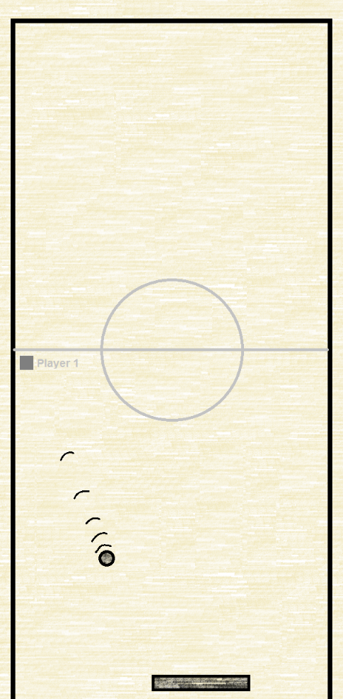Solo

Campaign

This is just a series of 15 level of breaking bricks, with each level getting more difficult by making complex patterns and more HP per brick. There is a leaderboard for this, but instead of keeping score, there will be an in-game timer, and it records the shortest times (for each individual level, and all 15 levels).

Endless Bricks

This mode is an endless mode, where the objective is to break the most bricks until losing all 3 lives. There is no way to increase the life count, only 3 lives per playthrough. Once the player clears all the bricks, the will be a new batch of bricks to break and will continuously repeat. There is a leaderboard, showing all the high scores (between friends, national, and worldwide) of this mode.

Training

This mode allows the player to train in a closed ended playfield.

Figure 5 - Playfield of Training Mode

Versus

In this mode, games are determined by first to 7 points. Each point is scored when the ball passes the paddle.

Localplay

Play with another player offline. For mobile users, connect by wireless connection. Otherwise, play against the computer with adjustable difficulty settings.

Online

Cross-play between ALL PLATFORMS!!!!

Quickplay

In Quickplay, the player can play with anyone around the world, regardless of rank. They can replay them after a game is finished or re-queue to a different player. They can choose to play either with someone in the friends list, or with anyone within their country (national) or around the world (worldwide).

Ranked

Rise through the ranks against fierce players around the world. Rank placings are determined by a special points system and matchmaking is determined by color. Matches are in best of 3 games, with each game first to 7 points. When queuing, the player has access to training stage as they wait for their matches

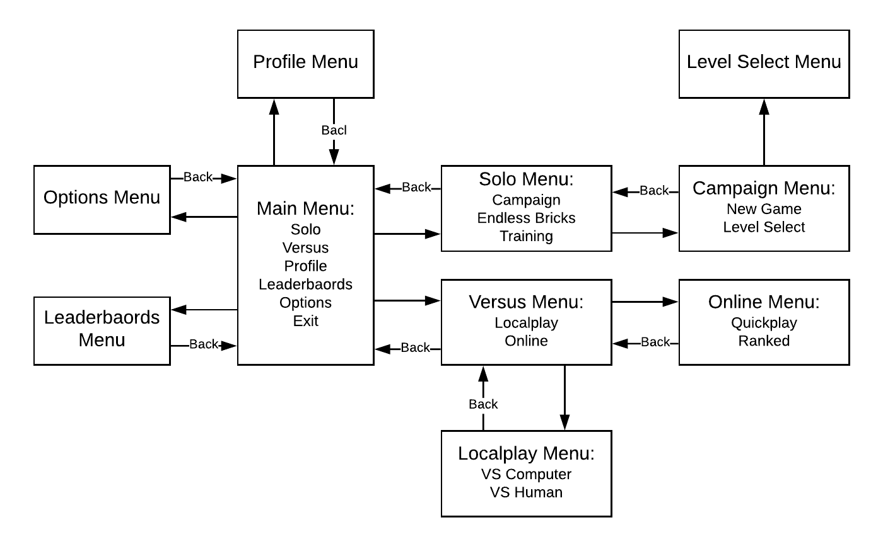**Menu Shell**

Figure 6 - Flowchart of the Menu Shell navigation

**Profile Account**

Upon first opening the game, it will ask you to create an account (making a username, password, country of residence, and email for verification). This account will record your Campaign times, Endless Bricks high score, and color tier and rank points for ranked mode. Accounts are transferable across all intended platforms.

Friends List

This list used to play with friends on quickplay mode. In order to make friends in this game, the player must search for the username of their friends and send a friend invite. Then that person accepts the invitation, both will be able to each other in the friends list. Another method of making friends is by searching through the history of other players they have played, and the same process is applied. With this, the player can view their profile accounts, and compare each other's score and times on the leaderboards.

Leaderboards

This list compiles all the records the player can make and what criteria is used [shown in this]:

* Campaign Mode [shortest time]
  + Individual Levels
  + Full Run
* Endless Bricks [most bricks break]
* Ranked [most rank points]

All of these can be compared between friends, within the player’s country and worldwide.

**Monetization**

There will be no micro transactions, but it will cost $4.99 USD across all platforms (digital only). Purchasing this gives access to all gamemodes.