**The Entity-Relationship Model**

last updated 2-sep-11

Top of Form

Bottom of Form

**Database Design**

Goal of design is to generate a formal specification of the database schema

Methodology:

1. Use E-R model to get a high-level graphical view of essential components of enterprise and how they are related
2. Then convert E-R diagram to SQL DDL, or whatever database model you are using

E-R Model is not SQL based. It's not limited to any particular DBMS. It is a conceptual and semantic model – captures meanings rather than an actual implementation

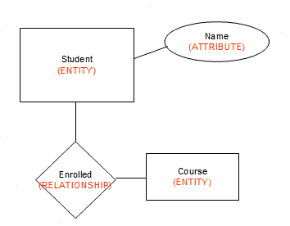The E-R Model: The enterprise is viewed as set of

* Entities
* Relationships among entities

Symbols used in E-R Diagram

* Entity – rectangle
* Attribute – oval
* Relationship – diamond
* Link - line

**Entities and Attributes**

**Entity**: an object that is involved in the enterprise and that be distinguished from other objects. (not shown in the ER diagram--is an instance)

* Can be person, place, event, object, concept in the real world
* Can be physical object or abstraction
* Ex: "John", "CSE305"

**Entity Type**: set of similar objects or a category of entities; they are well defined

* A rectangle represents an entity set
* Ex: ***students***, ***courses***
* We often just say "entity" and mean "entity type"

**Attribute**: describes one aspect of an entity type; usually [and best when] single valued and indivisible (atomic)

* Represented by oval on E-R diagram
* Ex: *name, maximum enrollment*
* May be **multi-valued** – use double oval on E-R diagram
* May be **composite** – attribute has further structure; also use oval for composite attribute, with ovals for components connected to it by lines
* May be **derived** – a virtual attribute, one that is computable from existing data in the database, use dashed oval. This helps reduce redundancy

**Entity Types**

An entity type is **named** and is described by **set of attributes**

* Student: Id, Name, Address, Hobbies

**Domain**: possible values of an attribute.

* Note that the value for an attribute can be a set or list of values, sometimes called "multi-valued" attributes
* This is in contrast to the pure relational model which requires atomic values
* E.g., (111111, John, 123 Main St, (stamps, coins))

**Key**: subset of attributes that uniquely identifies an entity (candidate key)

**Entity Schema**: The meta-information of entity type name, attributes (and associated domain), key constraints

*Entity Types* tend to correspond to **nouns**; *attributes* are also nouns albeit descriptions of the parts of entities

May have **null** values for some entity attribute instances – no mapping to domain for those instances

**Keys**

**Superkey**: an attribute or set of attributes that uniquely identifies an entity--there can be many of these

**Composite key**: a key requiring more than one attribute

**Candidate key**: a superkey such that no proper subset of its attributes is also a superkey (minimal superkey – has no unnecessary attributes)

**Primary key**: the candidate key chosen to be used for identifying entities and accessing records.  Unless otherwise noted "key" means "primary key"

**Alternate key**: a candidate key not used for primary key

**Secondary key**: attribute or set of attributes commonly used for accessing records, but not necessarily unique

**Foreign key:** term used in relational databases **(but not in the E-R model)** for an attribute that is the primary key of another table and is used to establish a relationship with that table where it appears as an attribute also.

So a foreign key value occurs in the table and again in the other table. This conflicts with the idea that a **value** is stored only once; the idea that a **fact** is stored once is not undermined.

**Graphical Representation in E-R diagram**

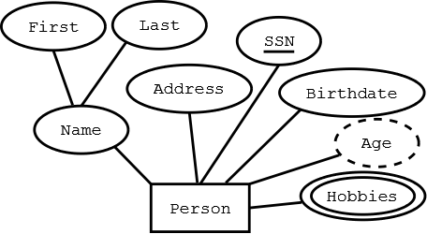

**Rectangle** -- Entity

**Ellipses** -- Attribute (underlined attributes are [part of] the primary key)

**Double ellipses** -- multi-valued attribute

**Dashed ellipses**-- derived attribute, e.g. age is derivable from birthdate and current date.

[Drawing notes: keep all attributes above the entity. Lines have no arrows. Use straight lines only]

**Relationships**

**Relationship**: connects two or more entities into an association/relationship

* "John" majors in "Computer Science"

**Relationship Type**: set of similar relationships

* ***Student*** (entity type) is related to ***Department*** (entity type) by ***MajorsIn*** (relationship type).

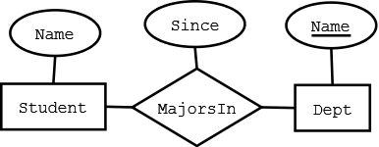

Relationship Types may also have attributes in the E-R model.  When they are mapped to the relational model, the attributes become part of the relation. Represented by a diamond on E-R diagram.

Relationship types can have descriptive attributes like entity sets

Relationships tend to be **verbs or verb phrases;** attributes of relationships are again nouns

[Drawing tips: relationship diamonds should connect off the left and right points; Dia can label those points with cardinality; use Manhattan connecting line (horizontal/vertical zigzag)]

**Attributes and Roles**

An **attribute** of a relationship type describes the relationship

* e.g., "John" majors in "CS" *since* 2000
* John and CS are related
* 2000 describes the relationship - it's the value of the ***since*** attribute of ***MajorsIn*** relationship type

The **role** of a relationship type names one of the related entities

e.g., "John" is value of ***Student*** role, "CS" value of ***Department*** role of ***MajorsIn*** relationship type

(John, CS, 2000) describes a relationship

**Relationship Type**

Relationship types are described by set of roles and [optional] attributes

* e.g., **MajorsIn**: Student, Department, Since

Think that entities are nouns; relationship types are often verbs

* students and departments are the entities (nouns) and roles in relationship types
* majors is the relationship type (verb)
* i.e., "student" "majors in " "department"

Here we have used as the role name (Student) the name of the entity type (Student) of the participant in the relationship.

**Degree of relationship**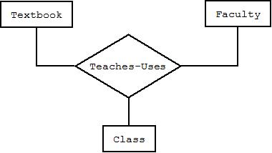

**Binary** – links two entity sets; set of ordered pairs (most common)

**Ternary** – links three entity sets; ordered triples (rare)

**N-ary** – links n entity sets; ordered n-tuples (very rare)

Note: ternary relationships may sometimes be replaced by two binary relationships (see book Figures 3.5 and 3.13). Semantic equivalence between ternary relationships and two binary ones are not necessarily true.

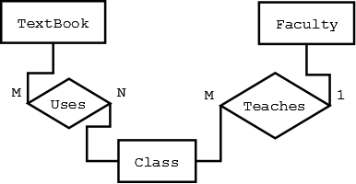

**Cardinality of Relationships**

Number of entity instances to which another entity set can map under the relationship

**One-to-one**: X-Y is 1:1 when each entity in X is associated with at most one entity in Y, and each entity in Y is associated with at most one entity in X.

**One-to-many**: X-Y is 1:M when each entity in X can be associated with many entities in Y, but each entity in Y is associated with at most one entity in X.

**Many-to-many**: X:Y is M:M if each entity in X can be associated with many entities in Y, and each entity in Y is associated with many entities in X ("many" =>one or more and sometimes zero)

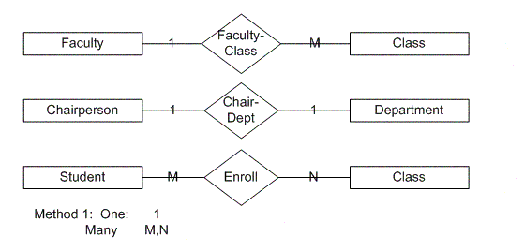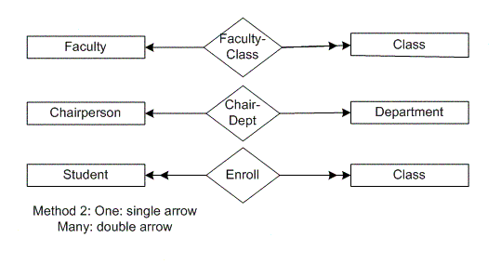

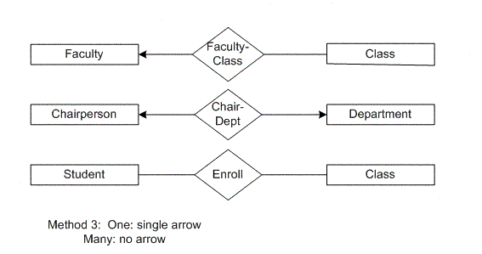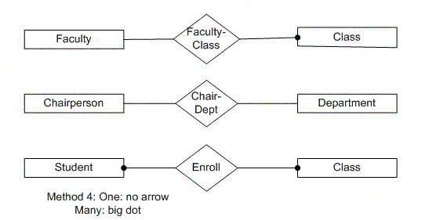

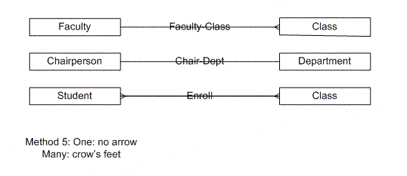

**Relationship Participation Constraints**

Total participation

* Every member of entity set must participate in the relationship
* Represented by double line from entity rectangle to relationship diamond
* E.g., A ***Class*** entity cannot exist unless related to a ***Faculty*** member entity

Partial participation

* Not every entity instance must participate
* Represented by single line from entity rectangle to relationship diamond
* E.g., A ***Textbook*** entity can exist without being related to a C***lass*** or vice versa.

**Roles**

**Problem**: relationships can relate elements of same entity type

e.g., ReportsTo relationship type relates two elements of Employee entity type:

* Bob reports to Mary since 2000

We do not have distinct names for the roles

It is not clear who reports to whom

**Solution**: the role name of relationship type need not be same as name of entity type from which participants are drawn

* ReportsTo has roles Subordinate and Supervisor and attribute Since
* Values of Subordinate and Supervisor both drawn from entity type Employee

Optional to name role of each entity, but helpful in cases of

* Recursive relationship – entity set relates to itself
* Multiple relationships between same entity sets

**Schema of a Relationship Type**

Contains the following features:

*Role names*, Ri, and their corresponding entity sets. Roles must be single valued (the number of roles is called its **degree**)

*Attribute names*, Aj, and their corresponding domains. Attributes in the E-R model may be set or multi-valued.

*Key*: Minimum set of roles and attributes that uniquely identify a relationship

*Relationship*: <e1, …en; a1, …ak>

* ei is an entity, a value from Ri’s entity set
* aj is a set of attribute values with elements from domain of Aj

**Graphical Representation**

Roles are edges labeled with role names (omitted if role name = name of entity set). Most attributes have been omitted.

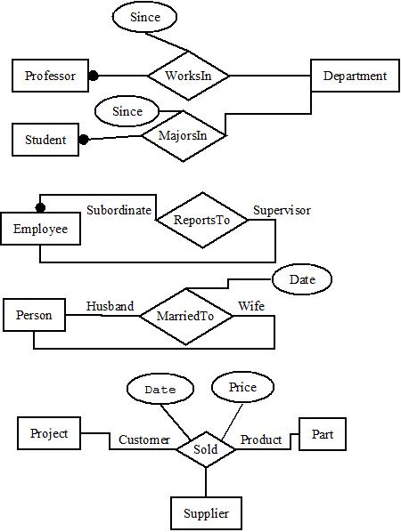

**Key Constraint (special case)**

If, for a particular participant entity type, each entity participates in *at most* one relationship, its corresponding role is a foreign key relationship type.

* E.g., *Professor* role is unique in **WorksIn**

The representation in an E-R diagram is an arrow.

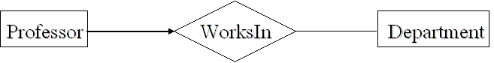

**Existence Dependency and Weak Entities**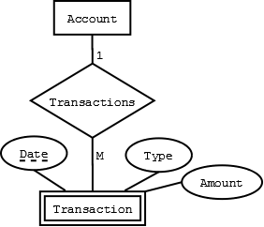

**Existence dependency**: Entity Y is existence dependent on entity X is each instance of Y must have a corresponding instance of X

In that case, Y must have total participation in its relationship with X

If Y does not have its own candidate key, Y is called a **weak entity**, and X is **strong entity**

Weak entity may have a partial key, called a discriminator, that distinguishes instances of the weak entity that are related to the same strong entity

Use double rectangle for weak entity, with double diamond for relationship connecting it to its associated strong entity

Note: not all existence dependent entities are weak – the lack of a key is essential to definition

**ER Diagram Example**

