Practical:2 Case study of linux architecture.

Architecture of Linux Operating System
In my previous articles I have given you an Overview about the Linux Operating system ,we have discussed various point regarding what is linux, Reasons of Linux popularity, Linux Features, Various Linux distribution and Linux soft wares. In this article we will go little bit deeper inside linux and will discuss the Basic architecture of linux Operating System on which the whole linux operating system structure is based.
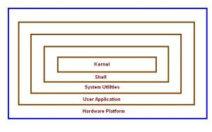
linux architecture
Learning about the linux architecture in important if you want to build an application for android or for linux that can directly communicate with the system libraries.
- Components of Linux System

Linux Operating System has primarily three components
- Kernel - Kernel is the core part of Linux. It is responsible for all major activities of this operating system. It is consists of various modules and it interacts directly with the underlying hardware. Kernel provides the required abstraction to hide low level hardware details to system or application programs.
- System Library - System libraries are special functions or programs using which application programs or system utilities accesses Kernel's features. These libraries implements most of the functionalities of the operating system and do not requires kernel module's code access rights.
- System Utility - System Utility programs are responsible to do specialized, individual level tasks.
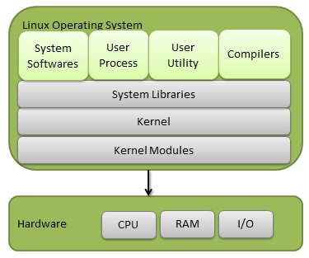

Linux Operating System Architecture
The operating system architecture is generally organized into two parts
- Kernel Mode
- User Mode

Kernel Mode

It executes the operating system processes

User Mode
It execute application program of the user like MS word, MS paint etc .* A system can enter from user o Kernel mode using a System Call.This is important as kernel mode generate a process to support a User Mode

The Architecture Of Operating system consist of 5 parts:-
- Kernel
- Shell
- System Utilities
- User Applications
- Hardware Platform
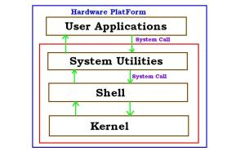

What is a Kernel
It act as an interface between operating system and other hardware resources.It is the main part of the operating system that loads firsts and remains in the main memory.It is the bridge between the application and the actual data processing to support the application. It is responsible for task management, memory management and disk management .Its primary function is to manage the computer resources and support other program who want to use these resources.

What is a Shell
It act as an interface between user and the operating system. It is software that provide an interface for user of an operation system which need services of a kernel. An operating system shell is divided into two parts:-
- Command line
- GUI

Command line Shell
It is the part of the operating system which receives and executes the operating system command by the user. The commands are then send to the kernel for execution. If the command is valid the kernal starts the execution else error will be produced.
GUI (Graphical User Interface)
This provides a user friendly environment. User cannot remember the syntax of all the command thus it help to simply point toward the object by the mean or mouse or some other pointing device which a user required for its execution.

Interconnection Between kernel and shell
When user give command for performing any operation the request goes to the SHELL. The Shell then translates these human program to machine language and then transfer the request to the kernel. The kernel receives the request from shell, processes the request and then displays the result on the screen. All these functions are performed by the kernel in a transparent ma

What is System Utilities

The System Utilities consist of various system interrupts and system calls which is to transfer the control for the user mode to the kernel mode containing the kernel and shell for further execution of the commands. The control can be transfer using System calls.

System Call

System call is an interface between a process and the operating system. In simple words the system call is the request for running any program and for performing any operation on the system that the user has requested
eg. A user has requested to MS paint. This request will be sent to the operating system, and then the operating system will generate some activity to support MS paint and run on the system.
System calls are of different types
- File Management System call – For performing open, close, read, write etc operations.
- Process Control System Call – For performing Load,execute,create etc operations.
- Device Management System Call – For performing request device,write device,release device etc operations.
- Communication System call – For performing Send message,transfer status etc operations etc.

User Applications

These the application which a user require to perform its task. Linux and other operating system come up which various different application in it like g++, gcc, office suits etc .Kernel is used to generate processes to support these these applications.

Hardware Platform

All of you are familiar with this, the resource of the system such as keyboard, monitor, printer etc with which user can input/output the request.

Architecture
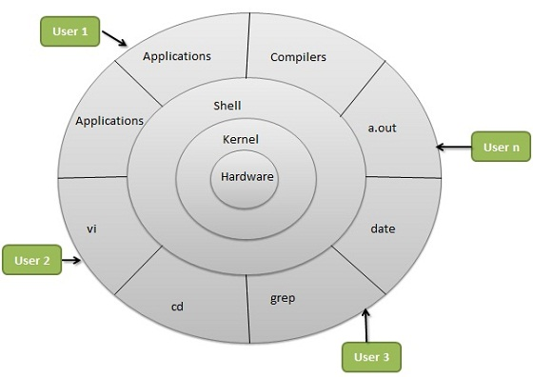
Linux System Architecture is consists of following layers
- Hardware layer - Hardware consists of all peripheral devices (RAM/ HDD/ CPU etc).
- Kernel - Core component of Operating System, interacts directly with hardware, provides low level services to upper layer components.
- Shell - An interface to kernel, hiding complexity of kernel's functions from users. Takes commands from user and executes kernel's functions.
- Utilities - Utility programs giving user most of the functionalities of an operating systems.

Basic Features
Following are some of the important features of Linux Operating System.
- Portable - Portability means softwares can works on different types of hardwares in same way.Linux kernel and application programs supports their installation on any kind of hardware platform.
- Open Source - Linux source code is freely available and it is community based development project. Multiple teams works in collaboration to enhance the capability of Linux operating system and it is continuously evolving.
- Multi-User - Linux is a multiuser system means multiple users can access system resources like memory/ ram/ application programs at same time.
- Multiprogramming - Linux is a multiprogramming system means multiple applications can run at same time.
- Hierarchical File System - Linux provides a standard file structure in which system files/ user files are arranged.
- Shell - Linux provides a special interpreter program which can be used to execute commands of the operating system. It can be used to do various types of operations, call application programs etc.
- Security - Linux provides user security using authentication features like password protection/ controlled access to specific files/ encryption of data.

- Comparision of linux and windows.

Parameters | Linux | Windows
What is it? | Linux is an example of Open Source software development and Free Operating System (OS). | Windows is the family of operating system (OS) from Microsoft, which is the most famous OS in the world.
Cost | Linux can be freely distributed, downloaded freely, distributed through magazines, Books etc. There are priced versions for Linux also, but they are normally cheaper than Windows. | Windows can be expensive.
Manufacturer | Linux kernel is developed by the community. Linus Torvalds oversees things. | Microsoft created the Windows operating system, but allows other computer manufactures to distribute their own computers with Windows pre-installed.
File system support | Ext2, Ext3, Ext4, Jfs, ReiserFS, Xfs, Btrfs, FAT, FAT32, NTFS | FAT, FAT32, NTFS, exFAT
Processors | Dozens of different kinds. | Limited
Company / developer | Linus Torvalds | Microsoft
License | GNU/Free | Proprietary
Default user interface | Gnome or KDE (Depends on distro) | Graphical (Windows Aero)
Preceded by | Basic Terminal (CLI) | MS-DOS
Source model | Open Source | Closed / Shared source
Update method | Many | Windows Update

