**Voting System Software Plan**

1. Scope
   1. Functions
      1. Receive votes via text message

When the application is launched on a mobile phone, it will be able to accept properly formatted text messages.

* + 1. Process vote

After a vote is received the application will be able to decode it and determine if it is a valid vote by checking if the sending phone has previously voted or not. If it has voted previously the vote will be discarded.

* + 1. Store valid vote

Once a vote had been determined to be valid, the application will add its vote to the total and save the voting phone’s number to check for future double voting.

* + 1. Close voting session

The administrator will be able to close the voting session from the application. Once this happens no new votes will be counted.

* + 1. Generate report

Once the vote has been closed the administrator can generate a report through the application. The report will display the results of the vote.

* + 1. Dispose of Data

Once the application was closed by the administrator all data will be disposed of.

* 1. Performance
  2. Limitations
     1. Cannot store data long term
     2. Data is only accessible from host phone

The administrator should be the only one with access to the vote data, and they can only access it through the mobile application.

1. Tasks
   1. User interface

This is the front end the administrator will interact with in the mobile application. It will interface to a back end that will perform the functions outlined above.

* 1. Data storage

This task will involve keeping track of the vote data while the vote is occurring.

* 1. Data processing

This is a multi-faceted task that will involve processing incoming votes, interfacing with the short-term storage of the vote data and generating the final report.

* 1. Cleanup

This task involves deleting all vote data.

1. Resources
   1. Hardware

All software will run on an Android smartphone.

* 1. Software
     1. Android Studio

Android studio will be used as the development environment.

* + 1. SIS Server

This will be used to translate the voting metadata for processing.

* 1. People
     1. Jake Winkler

Application Front End Development

* + 1. Zach Blouse

Application Back End Development

**Voting System Diagrams**

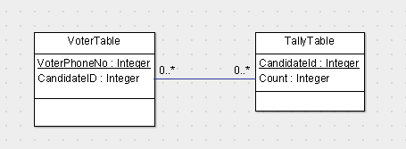

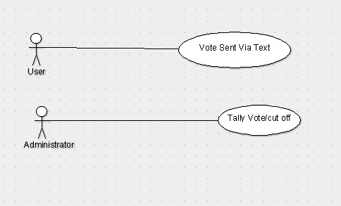

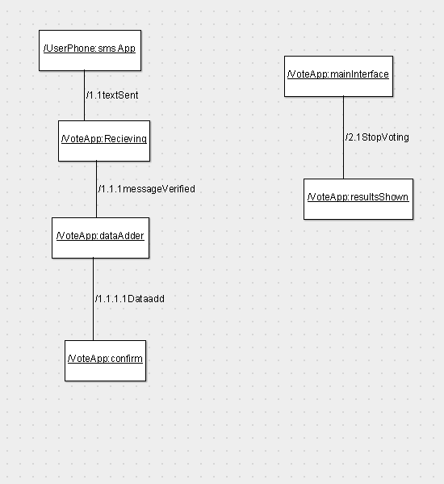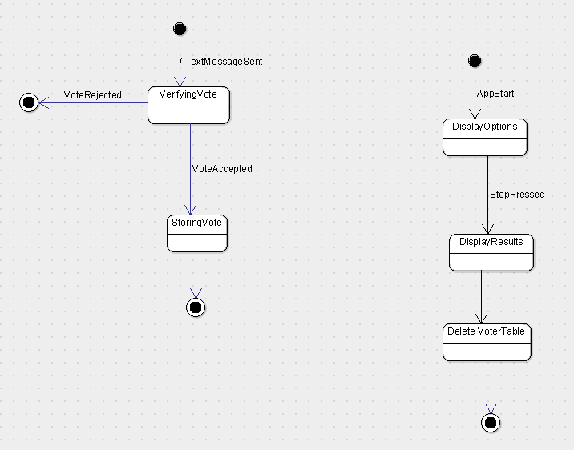

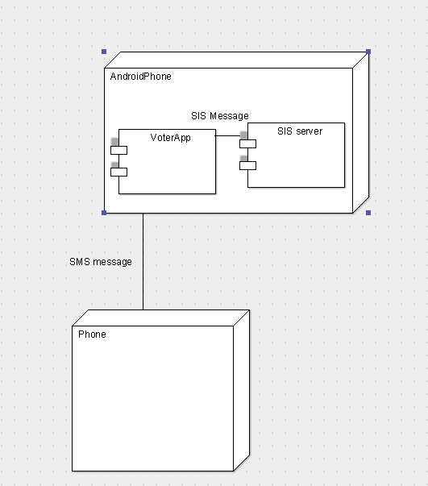

**SPG Tool Results**

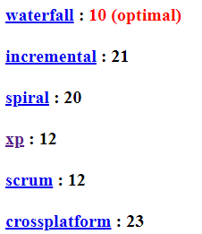These results were about in line with our expectations – we both prefer

an iterative approach to programming, but also do not think that much

user feedback will be needed. The project is not big enough to

warrant a scrum or spiral process, as the work should not require that

much iteration.