**Data Science Practicum Report**

**Mar 8 th 2017**

**Preprocessing**

As agreed in the meeting on Thursday 23rd, in addition to remove columns with >80% missing values, we kept columns suggested by Joel in the excel file sent on Monday Feb 27th. Our final list of 79 features was as follows:

|  |  |  |
| --- | --- | --- |
| Sport | ECCNote | Eparent_welcome |
| EventsAttended | ECCNote_camp | Epost_event_email |
| Hprofileview | Ecoach_list_known_updated | Esms_update |
| Hcoachimport | ECoachEmailOpen | CollegeProspects |
| Hmessage | ECoachEval | MessagesReceived |
| Hsearchhit | ECoachImport | MessagesSent |
| Hcoacheval | ECoachSearchHit | CaptainU_CHURN |
| Hemailopen | ECoachVisit | NumYear |
| EAthlete newsletter | Ecolleges_going_to_the_event | NumMonth |
| Eathlete_new | Efailed_subscription | monthly_price |
| Eathlete_new_info_request | EEmailsDigest | Eparent_new |
| Gender | Hprofileview_Freq | Hcoachimport_Freq |
| Hmessage_Freq | Hsearchhit_Freq | Hcoacheval_Freq |
| Ecolleges_going_to_the_event_Freq | Efailed_subscription_Freq | Esms_update_Freq |
| Hits_Frequency | College_Prospects_Frequency |  |
| Hemailopen_Freq | Ecoach_list_known_updated_Freq | ECoachVisit_Freq |

We then took columns with continuous values and normalized the values by the mean and the standard deviation:

$$z=\frac{x-μ}{σ}$$

Hence each feature had a mean of 0 and a standard deviation of 1. Below is a snapshot of the data:

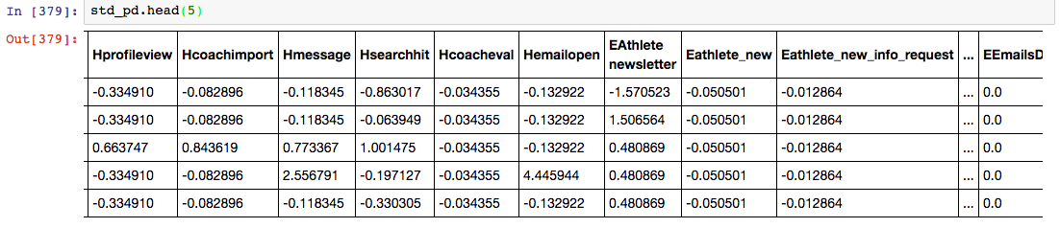

We then created dummy variables from features with categorical features: gender and sport .

Final table shape: **16117 rows 79 columns**

**Predicting Lifetime Churn**

This week, we focused on predicting lifetime churn. We implemented three models machine-learning models recorded and visualized Precision and Recall Values.

Below are the three models we chose:

* Decision Trees
* Logistic Regression
* Support Vector Machines (SVM)

When it came to building models, we used 80% of the data (12893 rows) for training and the remaining 20% for testing.

Training data: **12893 rows 79 columns**

Test data: **: 3224 rows 79 columns**

**Class distribution of Churners and Non-Churners**

**Training set**

|  |  |
| --- | --- |
| **Non-Churners** | **8083** |
| **Churners** | **4810** |

**Testing Set**

|  |  |
| --- | --- |
| **Non-Churners** | **1991** |
| **Churners** | **1233** |

**Summary of Precision Recall Values of Churning**

|  |  |  |  |
| --- | --- | --- | --- |
| **Model** | **Precision** | **Recall** | **F1 Score** |
| Decision Trees | 0.73 | 0.72 | 0.73 |
| Logistic Regression | 0.76 | 0.71 | 0.73 |
| SVM | 0.77 | 0.68 | 0.72 |

**Summary of Precision Recall Values of Retention**

|  |  |  |  |
| --- | --- | --- | --- |
| **Model** | **Precision** | **Recall** | **F1 Score** |
| Decision Trees | 0.83 | 0.83 | 0.83 |
| Logistic Regression | 0.83 | 0.86 | 0.84 |
| SVM | 0.82 | 0.82 | 0.82 |

**Logistic Regression Visualization**

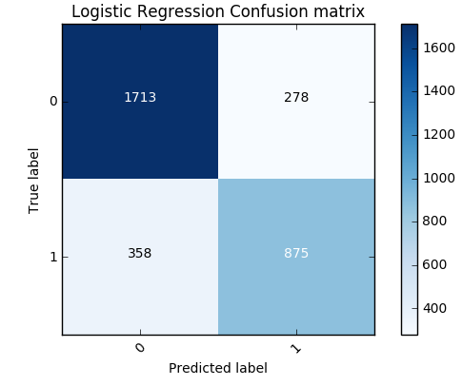

**Important Features According to Logistic Regression**

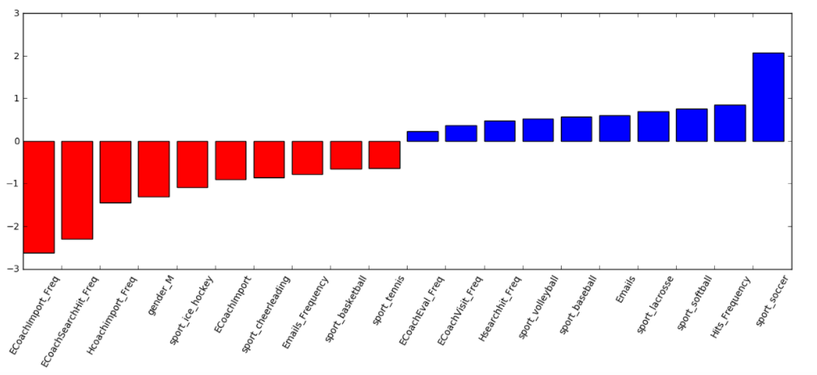

**Support Vector Machine Visualization**

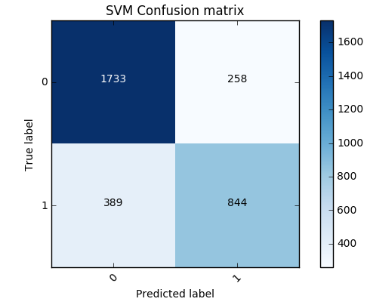

**Important Features According to SVM**

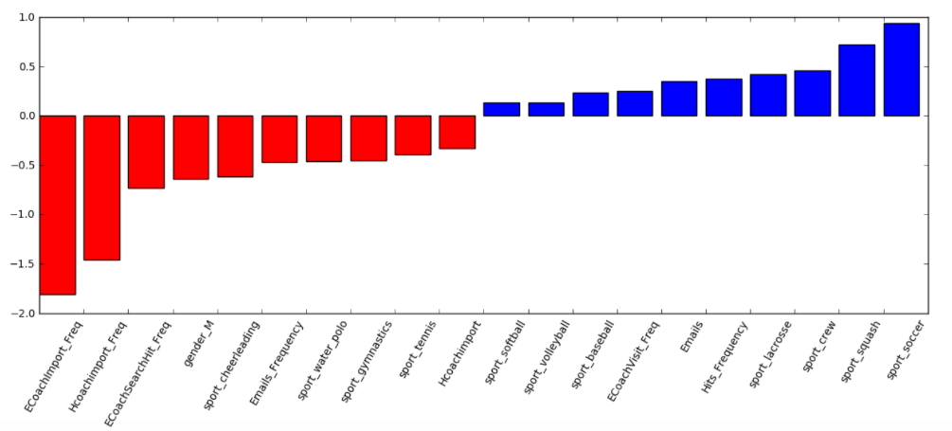

**Decision Trees**



**Tree Visualization**

