|  |  |
| --- | --- |
| Team Number : | IMMCHEXXXXX |
| Problem Chosen : | A or B |

Use this template to begin typing the first page (summary page) of your electronic report. This template uses a 12-point Times New Roman font. Submit your paper as an Adobe PDF electronic file (e.g. 11111.pdf), typed in English, with a readable font of at least 12-point type.

Do not include the name of your school, advisor, or team members on this or any page.

Papers must be within the 25 page limit.

Be sure to change the control number and problem choice above.  
You may delete these instructions as you begin to type your report here.

Directory

Question1:

Algorithm 1: The process of drawing a word cloud based on the comments in Appendices (I II).

Input: Excel spreadsheet for Appendices I and II.

1. Use DataFram for column indexing and reviewText extraction
2. Using the technique, divide each word in the reviewText
3. Remove meaningless terms from reviewText, such as subject, preposition, pronoun, number word, conjunction, measure word, and so on
4. Plot the cloud based on the frequency of word occurrences in the remaining reviewText

Final Product

Output: Word cloud for Appendices (I II)

The word cloud is a graphic representation of words that appear more frequently in comments, filtering out a vast amount of low-frequency information to help us better comprehend purchasing users' opinions about products

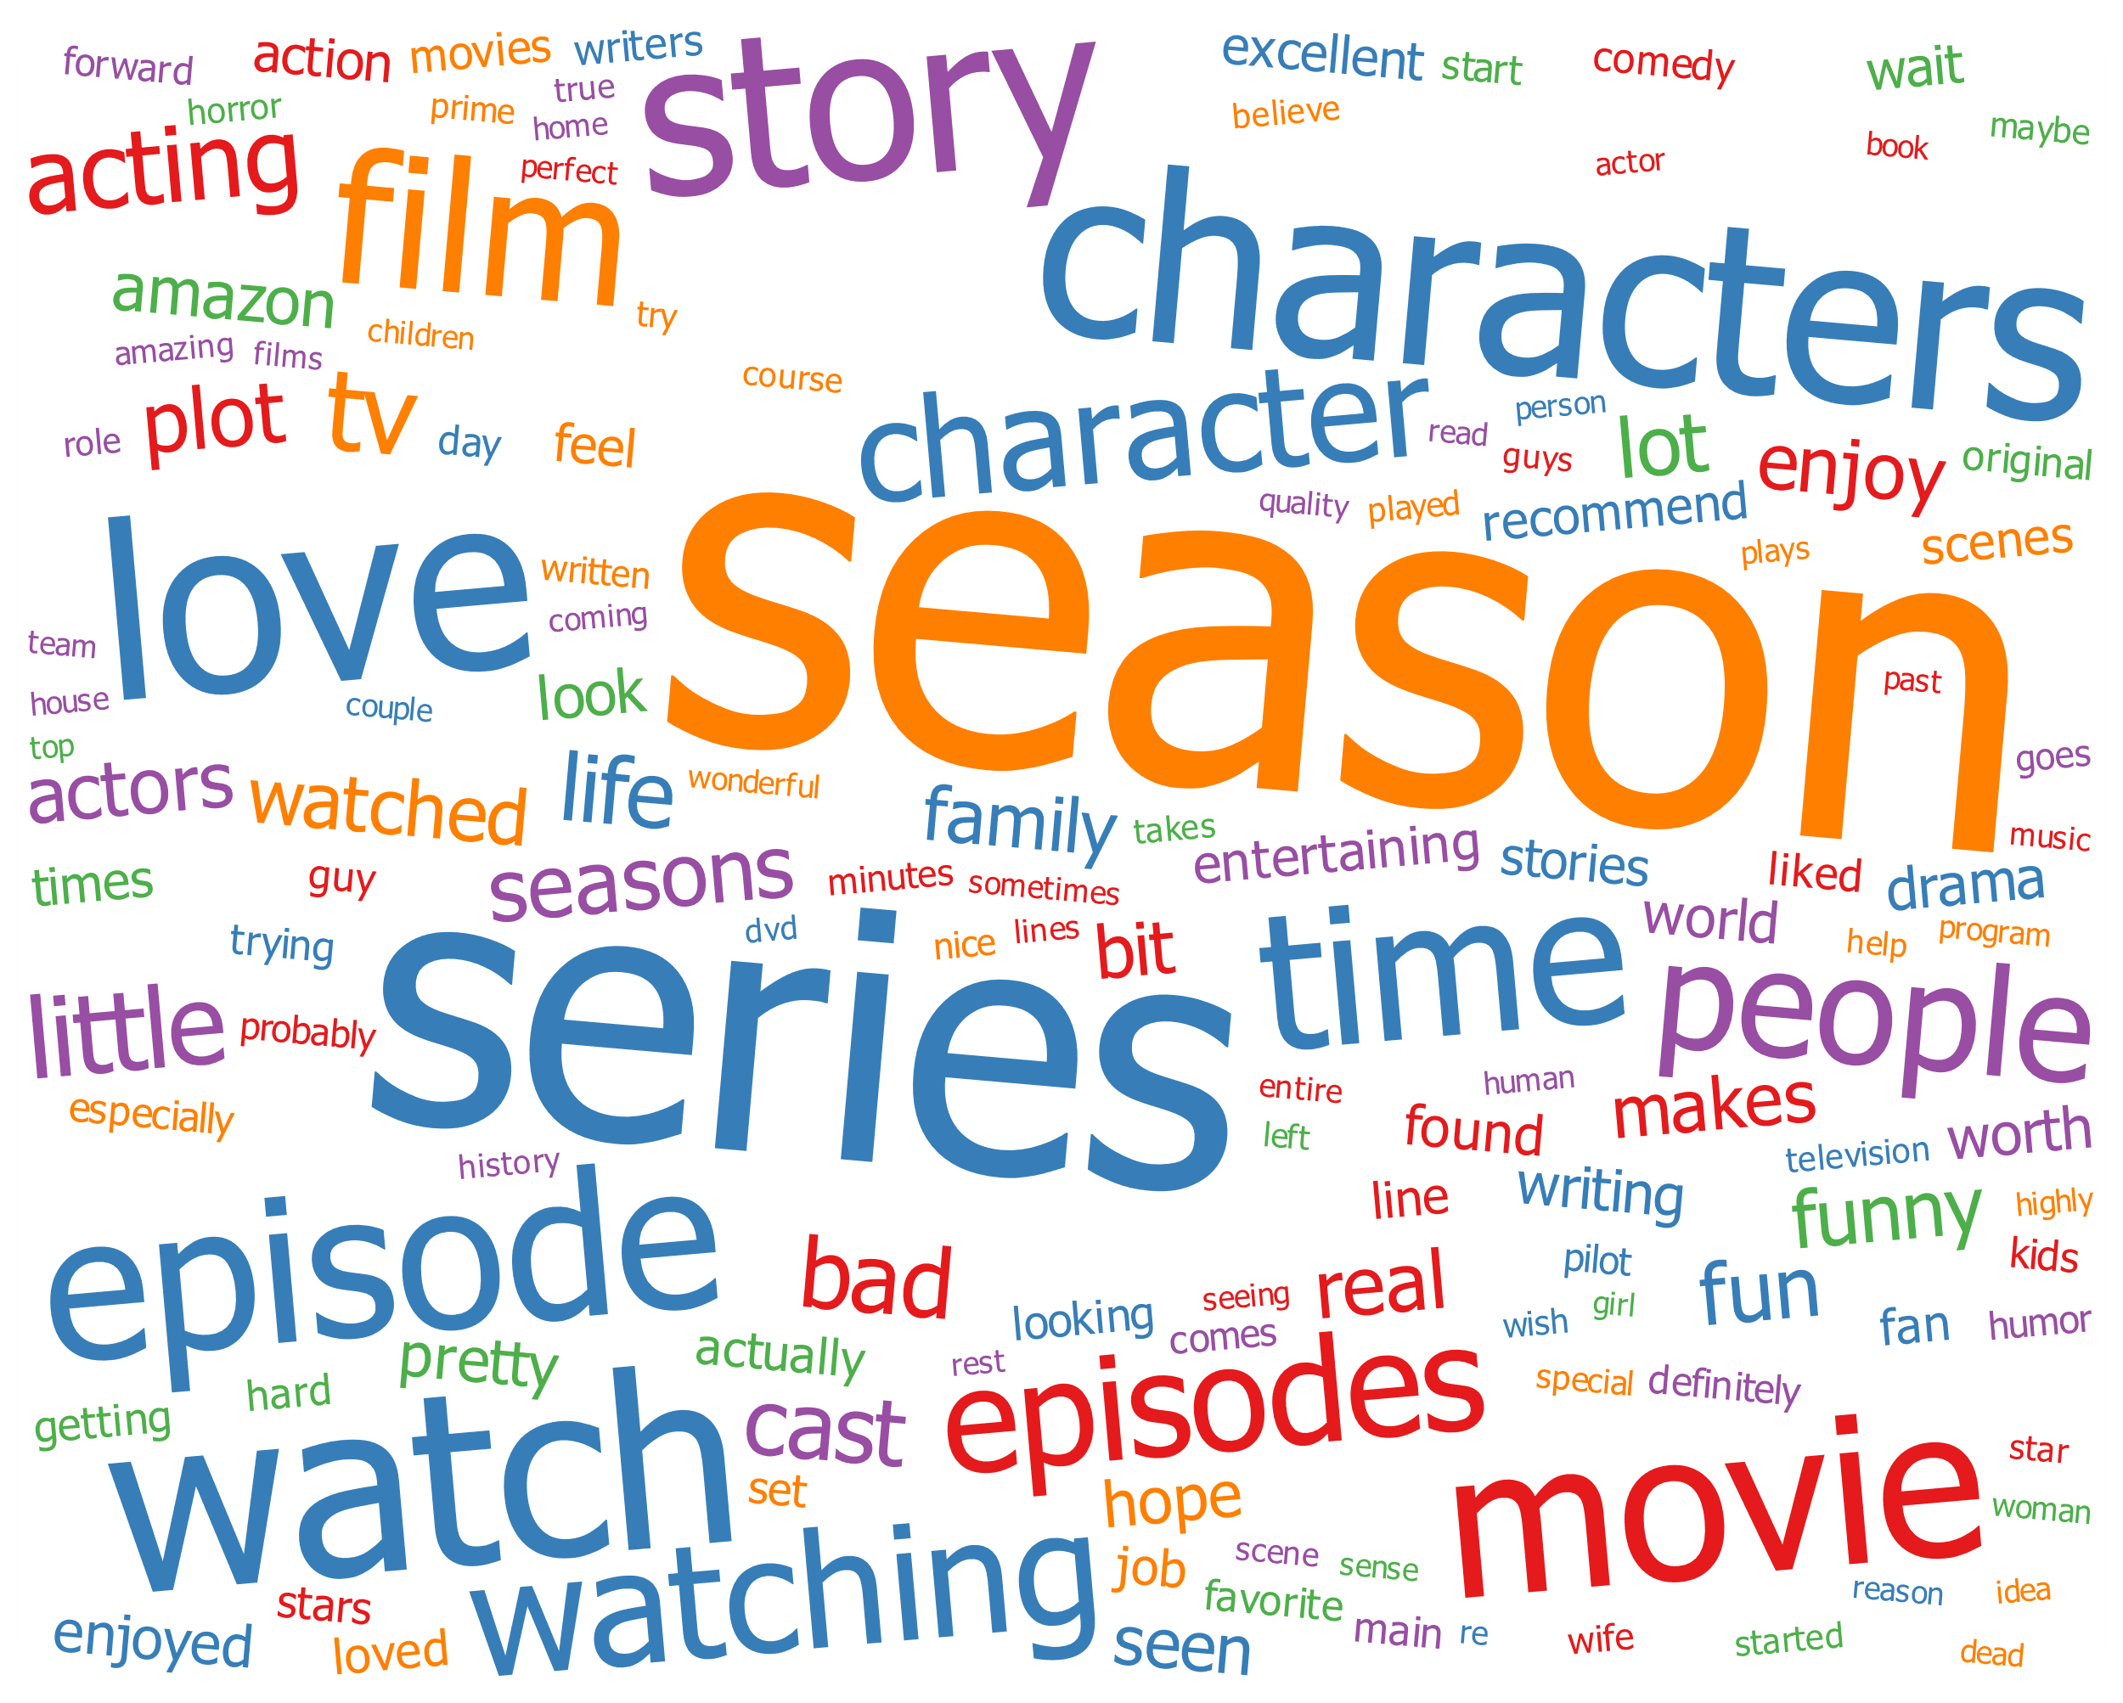

Figure 1: A word cloud of the comments in Appendix I

Figure 1 shows a word cloud plotted for the comments in Appendix I. The words with the highest frequency are season, series, watch, love, movie, episode, and characters. The remarks in Appendix I are for the viewing notion of a certain series of seasons on Amazon, and the user's evaluation of the series of the season is story-based, highly characteristic, and likes the plot when watching, thinking that this season is outstanding, according to the word cloud analysis.

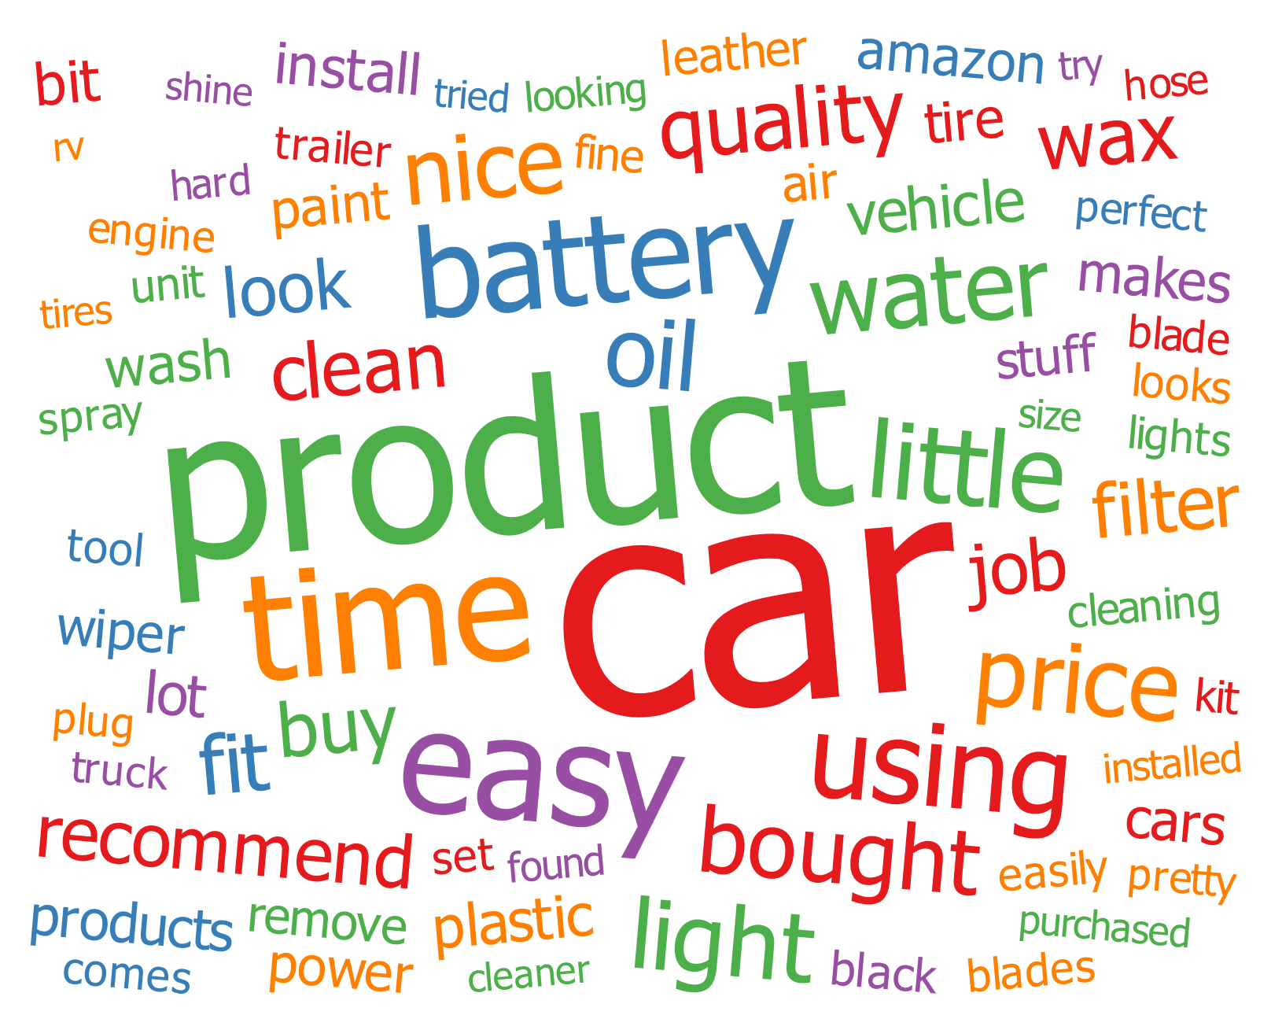

Figure 2: A word cloud plotted for the comments in Appendix Ⅱ

Figure 2 is a word cloud plotted for the comments in Appendix II, revealing that the words with the highest frequency are automobile, product, time, easy, battery, and using. The comments in Appendix II, according to the word cloud analysis, are aimed at the use experience of car products purchased on the Amazon platform, and the store's related car products are convenient and effective in solving problems with the car's battery, fuel, and other aspects, and are considered nice for car cleaning.