**Introduction**

A principal tenet of motor learning is that skillful action requires practice, and a key component of practice is repetition. However, even after a skill is acquired, practice and thus repetition still plays an important role. For example, repetition decreases preparation time and overall reaction time (Mawase et al., 2018; Wong et al., 2017), increases movement speed (Hammerbeck et al., 2014) and biases future movements in the direction of the repeated movements (Classen et al., 1998; Diedrichsen et al., 2010). This helps explain why a professional basketball player continues to practice catching and shooting a jump shot even after taking thousands of practice shots throughout a career. However, since no two movements can ever be identical, how consistent must the basketball players movements be during practice to engage a repetition-based learning process?

Most motor learning studies probing the use-dependent process (UDP) have examined the phenomenon during upper-extremity movements. The relatively sparse literature on UDP in locomotion is surprising, given the repetitive nature of walking. Locomotion is, by definition, the repetition of a cyclical movement pattern until arriving at the destination. On the other hand, reaching for an object, such as a glass of water, is discrete and is usually accomplished in one movement. The cyclical, repetitive nature of walking creates an excellent opportunity to study the use-dependent learning process. A recent study used visual targets to guide participants into walking with an asymmetry (i.e. a limp). Practicing this asymmetric walking pattern caused a use-dependent bias when all visual feedback was removed and participants were instructed to “walk normally”. This study provides an indication that use-dependent biases can occur in walking, but since walking is more variable than reaching, it is unclear how consistent the practice must be to activate the use-dependent process.

Here, through computational modeling, simulations, and a series of behavioral experiments, we directly tackle the question of how the consistency of movement patterns impacts use-dependent learning. We first provide two distinct computational accounts of how UDP arises. In our Adaptive Bayesian model, adopted from a study of reaching (Verstynen and Sabes, 2011), UDP is framed as a process which combines quickly adapting prior probabilities of target (step) locations with current sensory estimates of where to step. Thus, the magnitude of use-dependent biases is directly related to the consistency of the environment, or target locations. Our second model involves two processes acting in parallel: a strategic learning process that is active when the goal is to match step lengths to visual targets (process 1), and in parallel, a slowly updating UDP process that biases movements in the direction of immediately preceding movements (Diedrichsen et al., 2010). Critically, our two-process model is much less sensitive to the consistency of the environment than the Bayesian model. Thus, we have designed a set of walking experiments that vary the amount of environmental consistency and assess the state of use-dependent biases during no-feedback trials in order to discriminate between these two competing theories on the underlying constraints of the use-dependent learning process.

**Materials and Methods**

**Behavioral Methods:**

*Participants****:***

Young, healthy individuals between the ages of 18-40 years will be recruited to participate in this study. Potential participants will be included if they are naive to locomotor learning tasks. Potential participants will be excluded if they have a history of any neurologic, psychiatric or cognitive conditions; or have any cardiovascular or musculoskeletal problems that limit their walking. This study has been approved by the (university name redacted until approved for publication) institutional review board. We expect to recruit 12-18 individuals for this study. The sample size was chosen to ensure appropriate counterbalancing of practice schedules across participants while also being well-above the threshold for good statistical power relative to documented effect sizes in comparable motor learning studies (Diedrichsen et al., 2010; French et al., 2018; Long et al., 2016; Verstynen and Sabes, 2011).

*Data replacement:*

Data will only be replaced under the following conditions:

1) If a participant does not complete the entire learning task for all 3 conditions due to technical error or equipment failure in the middle of data collection or if the participant chooses to stop or drop out of the experiment or does not return for one of the testing sessions. 2) if the experimenter deems the participant unsafe to continue the study which may occur if there is an injury or illness after the participant has been enrolled. 3) if a participant does not meet a threshold of performance on the task, which will be defined as falling outside of 3 standard deviations s from the mean performance of all other participants in terms of either step asymmetry index or target accuracy.

*Paradigm:*

Participants will perform three sessions of walking spaced 5-10 days apart. During each session they will walk on a dual belt treadmill (with the belts tied throughout the experiment) at a speed between 1.0 and 1.2 meters per second selected by the participants. This range is to ensure that each participant walks at a speed that is comfortable for their own anthropometrics. Participants will trial each speed and choose which is the most comfortable (See supplemental materials). Participants will wear a ceiling mounted harness which does not provide any body weight support and hold onto a handrail for safety during all walking phases. A computer monitor placed 60 cm in front of the treadmill will provide real-time visual feedback of the participant’s step length (Figure 1A; The Motion Monitor Toolbox, Innovative Sports Training Inc., Chicago, IL, USA). A step length is defined as the sagittal distance between the leading limb’s heel marker and the trailing limb’s heel marker at the moment of the leading limb heel strike.

Each of the three sessions of walking will involve the same learning schedule. Participants will first be told to “look forward and walk normally” on the treadmill during the Baseline phase for 250 strides. One stride is defined as one left heel strike to the subsequent left heel strike. No visual feedback will be presented on the monitor during the Baseline phase. In order for participants to understand how changing each step length changes the height of the bars on the screen, they will undergo a short (25 strides) Orientation phase following Baseline during day one only. During Orientation, the participant will practice changing their step lengths while watching the feedback on the screen guided by the examiner. Participants will be asked to confirm they understand the relationship between their step length and the visual feedback after this phase. During the Learning phase, participants will be asked to hit the pink horizontal target lines exactly with each leg for 500 strides. Both target lines will be changed leading the participants to take a longer step with the left leg and a shorter step with the right leg. These changes in step length will be quantified with a step asymmetry index (SAI), our primary outcome measure:

(1)

Thus, SAI represents the difference between the two step lengths normalized by the stride length. We express this measure as a percentage where 0% is perfect symmetry and SAIs further away from 0% are greater asymmetry. During the Washout phase, the feedback will be removed from the screen and participants will be asked to “look forward and walk normally” for 750 strides (see Supplemental Material for the full instruction script).

The visual feedback will be in the form of a bar graph with a blue bar representing the left leg’s step length and a green bar representing the right leg’s step length (Figure 1B). The bars will be time synchronized with each respective limb’s swing phase, increasing in height until the limb reaches heel strike at which point the bar will hold on the screen until the next swing phase begins. There will also be a pink horizontal target line for each leg which will be derived from each participant’s baseline step length for each session and serve as the target during that session’s Learning phase. Baseline step length will be calculated as the mean of the last 50 strides of the Baseline phase.

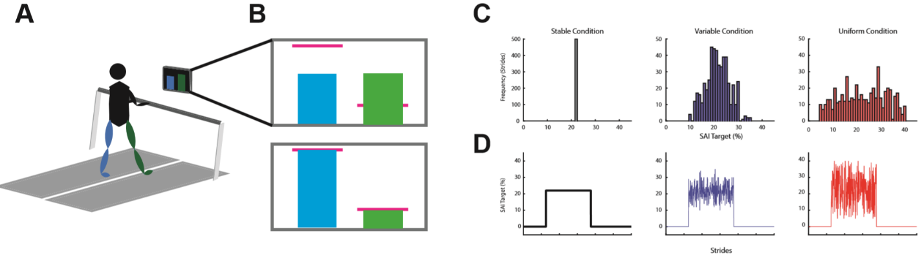**Figure 1**

*Conditions:*

Participants will perform three different conditions on separate days. Each condition will be separated by 5-10 days. To prevent order effects, we will counterbalance the order of conditions. The primary manipulation will be the consistency of targets during the Learning phase. Going from most to least consistent condition: 1) In the Stable condition, the target positions will be set to 22% SAI throughout the Learning phase; 2) In the Variable condition, target SAI will be drawn from a normal distribution with a mean of 22% and standard deviation of 5%; and 3) In the Uniform condition, the targets will be drawn from a uniform distribution with a range of 5%-39% SAI (Figure 1C & D). Based on our pilot testing, changing the target on a stride-by-stride basis made the task impractically difficult, thus, for both the Variable and Uniform conditions, targets will change every 1-5 strides, with equal probability.

*Data collection:*

Kinetic data will be collected at a frequency of 1000 Hz from the dual belt treadmill instrumented with two force plates, one under each belt (Bertec, Columbus, OH, USA). Kinematic data will be collected at a frequency of 100 Hz using a Vicon MX40 motion capture system with 8 cameras and Nexus software (Vicon Motion Systems, Inc., London, UK). We will use a custom marker set with 7 retroreflective markers, one for each heel, each lateral malleolus, and each 5th metatarsal head. The seventh marker will be placed on the left 1st metatarsal head to ensure the tracking system can differentiate between the right and left feet. Kinematic data will be time-synchronized with kinetic data in Nexus.

*Proposed analysis pipeline:*

First, any gaps in the kinematic data will be filled using a Woltering filter for small gaps (1-4 frames) and Pattern Fill for larger gaps (>4 frames) in Nexus. The remainder of the data analysis will be performed with custom-written MATLAB scripts (Mathworks, Natick, MA, USA). The code/software described in the paper is freely available online at [URL redacted for double-blind review]. The code is available as Extended Data. Kinematic and kinetic data will be low pass filtered at 10 Hz using a 4th order Butterworth filter. Kinetic data will be used to detect heel strike events when the force plate reads greater that 20 N and toe off events when the force plate reads less than 20 N. Erroneous force plate events will be removed and replaced with kinematic events. For heel strikes this is the most anterior position of the heel marker in the sagittal plane, for toe offs this is the most posterior position of the 5th metatarsal head in the sagittal plane. Step lengths will be calculated as the sagittal difference between the leading and trailing heel markers at the moment of leading heel strike. Step lengths will be used to calculate our primary outcome, step asymmetry index (SAI; equation 1). We will remove any SAI baseline bias for each participant for each respective training session: the mean of the last 50 strides of Baseline will be subtracted from all strides for that respective session. The baseline corrected measure will be used for the remainder of our analysis.

To assess how well participants performed on the learning task, we will calculate SAI accuracy as the absolute difference between the target SAI and the actual SAI during the Learning phase. Mean differences between the target step lengths and empirical step lengths for the learning phase will be used as a general measure of accuracy to test how well participants were able to perform the task. If a participant’s accuracy falls outside 3 standard deviations of all behavior this participant will be replaced. In pilot testing we found that individuals are able to follow the feedback reasonably well averaging a distance of 2.6 cm from the targets during the stable condition and 4.2 cm from the targets during the uniform condition (Figure X).

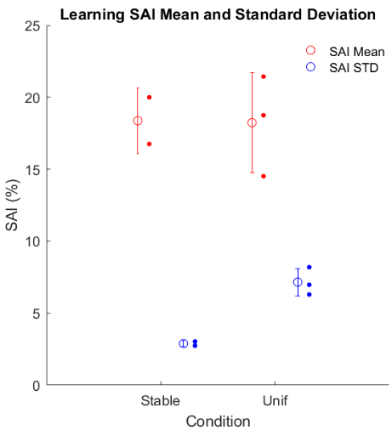

**Figure 2**

To determine how well the overall distribution of SAI targets during learning matched the distribution of SAI behavior during learning we will determine the mean and standard deviation of the entire Learning phase for both for these measures. We expect that mean SAI behavior during the entire learning phase will not be different between the conditions. However, we expect that the standard deviation of SAI behavior during the entire learning phase will be different between conditions. We will test these differences with a repeated measures analysis of variance and post-hoc pairwise comparisons if the analysis of variance test is significant. Our pilot data appear to support this assumption (Figure 2) that the mean SAI during learning is similar between stable and uniform conditions but the standard deviation is different.

Our primary dependent variable of use-dependent bias will be calculated as the mean SAI during the first 10 strides of the Washout phase (Initial Washout). As the primary behavioral comparison, we will analyze the measure of use-dependent bias across conditions using a repeated measures analysis of variance and post-hoc pairwise comparisons if the analysis of variance is significant. To draw out differences between the computational models we will also compare the change in use-dependent bias from the variable conditions to the stable condition. If the consistency of practice is not important to the use-dependent process these differences will be small, but if consistency of practice is important these differences will be large. We will also analyze the rate of washout using a regression analysis (Kitago et al., 2013) and compare these rates with a repeated measures analysis of variance with post-hoc pairwise comparisons if the analysis of variance is significant.

To further analyze any SAI differences across the Washout phases for each condition, we will use a cluster permutation analysis (Nichols and Holmes, 2002). In this analysis, we will compare differences between two conditions at a time with paired t-tests at each stride, or bins of strides. The largest cluster of significant paired t-tests (p < 0.05) in a row will be determined and the t-statistics for this cluster are summed. The summed t-statistics are then compared to a null distribution of summed t-statistics. The null distribution is built from resampling each group without replacement 1000 times and computing the largest cluster’s t-statistic for each sample. This null distribution serves as the null hypothesis which states that each group is sampled from the same distribution. The cluster size from the empirical data is then compared to the null distribution of 1000 samples. This comparison provides a probability that the empirical cluster is different from the null distribution. This analysis will be performed three times to compare each condition.

We will report exact p-values for all statistical tests. We will report for each test: t-statistic values for t-tests and F-statistic values for repeated measures analysis of variances. Standardized effect sizes will be reported as ƞp2 for repeated measures analysis of variance, and as Cohen’s d for t-tests. To express uncertainty in our data we plan on reporting means and 95% confidence intervals using a bootstrap approach for all data. When plotting participant data at specific timepoints, we will plot means, 95% confidence intervals and individual data. We will check assumptions of normality of residuals for linear models and of the actual SAI data for t-tests with the Shapiro-Wilks test of normality. We assume that the data we collect will be normally distributed, but if we are wrong, we plan on using non-parametric testing.

**Modeling**

We have adapted two computational models of use-dependent learning which make dissociable predictions regarding the effect practice consistency has on use-dependent bias. One is an Adaptive Bayesian model (Verstynen and Sabes, 2011) the other is the Strategy plus UDP model (Diedrichsen et al., 2010).

*Adaptive Bayesian Model:*

We first consider a Bayesian model which predicts the appropriate step length through the weighted combination of expected target locations based on prior history with current sensory estimates of target location.

In the context of the current study, this model combines the prior expectation of the step asymmetry target with the current sensory estimate of target position to equal the posterior probability distribution. The model assumes that the motor output is a direct readout of the maximum a posteriori (MAP) estimate (), as in Verstynen and Sabes (2011):

(2)

Where . We assume that the likelihood is centered around the actual target on each stride, . The likelihood’s standard deviation ( is a free parameter representing the amount of sensory uncertainty regarding target location. The adaptive nature of the model is encapsulated by the stride-by-stride updating of the prior probability’s parameters (, σ2 prior) are:

(3)

(4)

Where is a free parameter representing the learning rate and constrained to be between 0 and 1. is constrained between 0 and 25.

*Strategy Plus UDP model:*

, The Strategy plus UDP model conceptualizes overall motor outputs as the sum of two parallel processes: Strategy and UDP. Prior work shows that participants are able to explicitly control SAI in response to visual feedback (French et al., 2018; Long et al., 2016). Despite this explicit control an implicit mechanism causes aftereffects that can be attributed to UDP. Here, UDP is a stride by stride biasing of motor output based on recent actions (Diedrichsen et al., 2010). In the context of the current study, the motor output is SAI () which is the sum of the strategic process () and the use-dependent process () on each stride, :

(5)

The strategic process corrects errors () between the motor output () and the target ():

(6)

During the learning phase when the participants are aiming for a target , a proportion of this error is corrected on each stride and is added to a proportion of the current strategy (). When the visual feedback (VF) is turned off there is no target and the participants are instructed to walk normally, effectively setting the strategy to 0.:

(7)

Where is the error correction rate and is the strategic retention rate constrained between 0 and 1. During the Washout phase, when there is no strategy, motor output is driven only by the use-dependent. The use-dependent process () learns a proportion of the current motor output () and retains a proportion of the current use-dependent process:

(8)

Where is the use dependent retention rate and is the use-dependent learning rate. We constrained between 0 and 1. Because we assume the use-dependent process learns significantly more slowly than a strategic process we set to be 5x less than .

Therefore, the Adaptive Bayesian model has two free parameters and the Strategy plus UDP model has four free parameters. We performed parameter recovery (Supplemental Figure 1) and model recovery (Figure 3) for both of models

*Model Comparison:*

To determine if the models are distinguishable and to determine an adequate method of comparison, we performed model recovery analysis. We simulated each model 100 times per condition using randomized parameters and compared model fits. The model which generated the simulation should consistently demonstrate better fits than the model which did not generate the simulation. We fit the simulated data from each model using MATLAB’s fmincon function and compared fits using Akaike Information Criterion (AIC). This procedure revealed that the models are distinguishable and that AIC is an adequate method to distinguish between the two models (Figure 2).

**Figure 3**

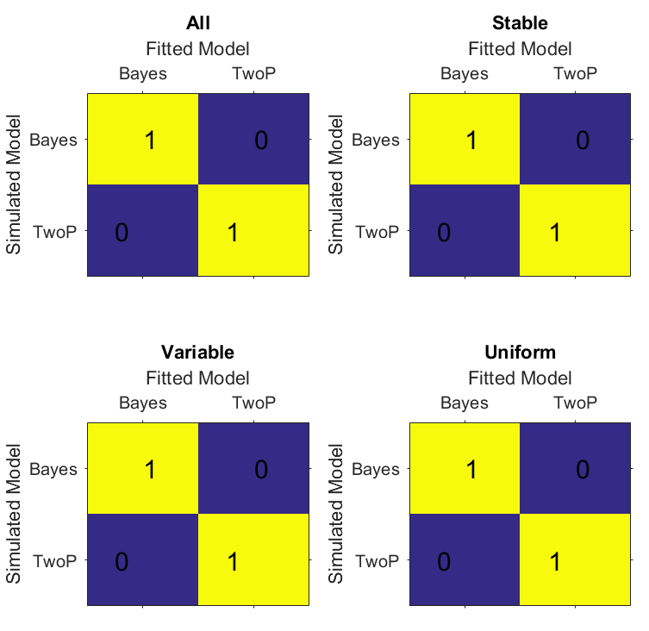

After data are collected, we will fit both models to individual participant data for each condition to obtain parameter values using the same fitting procedure as above. We will assess the face validity of each model’s range of parameter values for the fitted models. We will further simulate each model with the fitted parameters as a posterior predictive check then analyze these simulations in the same way we will analyze the empirical data. We will use AIC to objectively compare the model fits. We will compare mean AIC values for the fits of each model as well as the number of subjects best fit by each model.

*Simulations:*

We simulated both models to demonstrate how each model is affected by more variable conditions. For the Adaptive Bayesian model, the sensory estimate may become biased based on prior experience. The more consistent (i.e. less variable) the prior experience, the more certain it becomes as more weight is given to prior experience. Therefore, subsequent world state estimates become more biased toward a more consistent prior. If the prior experiences are inconsistent (i.e. more variable), there is a reduced weight on prior experiences. Thus, subsequent world states are less biased toward the inconsistent prior. The Bayesian estimation framework predicts a dependence on consistency of practice in the use-dependent process. In the Strategic plus UDP model framework the use-dependent process is a low-level bias which only changes based on only the direction, not the consistency, of the motor output. Therefore, two-process model predicts that the use-dependent aftereffect does not depend on the consistency of prior movements.

**Figure 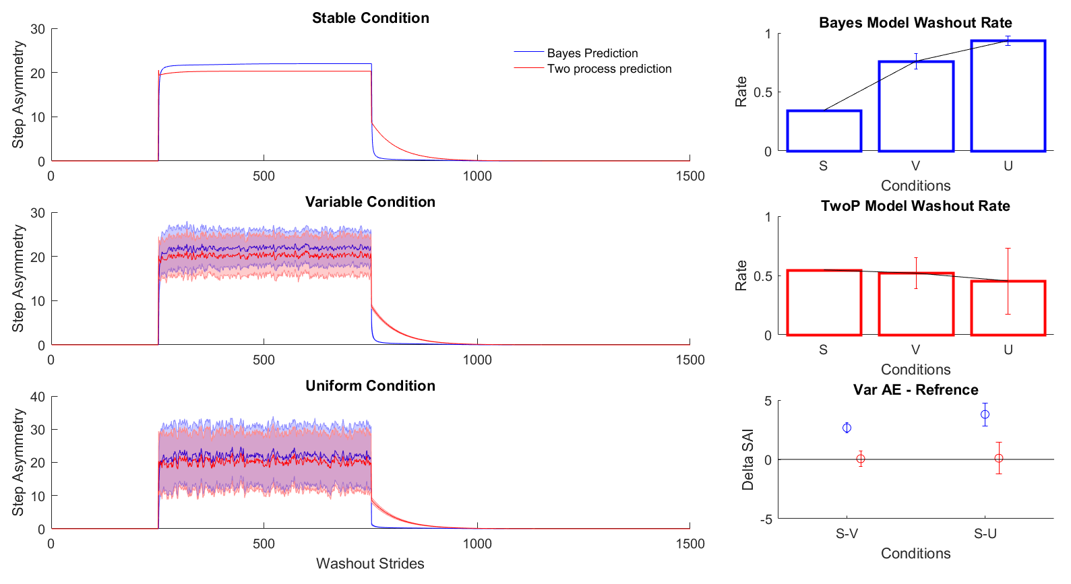4**

To obtain parameters for model simulation, we fit the models to previously collected walking data. We used 10,000 bootstrapped samples and fit each sample to the models using MATLAB’s fmincon function (Supplemental Figure 2). Figure 4 details the simulated data from these parameters for each condition. The panels in Figure 4A show each model simulation for the entire experiment. The models perform similarly during the Learning Phase, but the primary difference is in the Washout phase. Figure 4 B and C depict the washout rates across the conditions for each model for the first 50 strides of Washout. The model predicts different washout rates across the three conditions. The Adaptative Bayesian model predicts an increase in the washout rate as the conditions are less stable while the Strategy plus UDP model predicts steady Washout rate across conditions. To test how the consistency of practice modifies aftereffects, we used the stable condition as a reference and subtracted the bias after the variable and uniform practice conditions from this reference (Figure 4C). The Strategy plus UDP model predicts little change in aftereffects across conditions. However, the Adaptive Bayesian model predicts aftereffects which stray further from the reference condition indicating a decline in aftereffects compared to the Stable condition.

**Timeline for completion:**

We have received IRB approval from our university for this project. However, all labs have been shut down due to the COVID-19 pandemic. Data collections are ready to be initiated as soon as human research resumes at the university. Given uncertainty around when labs will be reopened we offer a proposed resubmission window from November 15th to May 15th, 2021.

**Figures:**

* Figure 1: Experimental paradigm
  + Figure 1A: experiment set up (include step length)
  + Figure 1B: visual feedback
  + Figure 1C: Target distributions (histogram)
  + Figure 1D: Stride by stride learning targets
* Figure 2: Pilot Data (proof of concept)
* Figure 3: Confusion Matrices
  + Figure 3A: All conditions confusion matrix
  + Figure 3B: Stable condition confusion matrix
  + Figure 3C: Variable condition confusion matrix
  + Figure 3D: Uniform condition confusion matrix
* Figure 4: Model simulations
  + Figure 4A: Aftereffects
  + Figure 4B: Washout simulations

**Supplemental material:**

* Instruction script
* Figures:
  + Supplemental Figure 1: Parameter recovery
  + Supplemental Figure 2: Correlations between recovered parameters
  + Supplemental Figure 3: Fits and parameter values from prior data

**References:**

Classen J, Liepert J, Wise SP, Hallett M, Cohen LG (1998) Rapid plasticity of human cortical movement representation induced by practice. J Neurophysiol 79:1117–1123.

Diedrichsen J, White O, Newman D, Lally N (2010) Use-dependent and error-based learning of motor behaviors. J Neurosci 30:5159–5166.

French MA, Morton SM, Charalambous CC, Reisman DS (2018) A locomotor learning paradigm using distorted visual feedback elicits strategic learning. J Neurophysiol 120:1923–1931.

Hammerbeck U, Yousif N, Greenwood R, Rothwell JC, Diedrichsen J (2014) Movement speed is biased by prior experience. Journal of Neurophysiology 111:128–134.

Kitago T, Ryan SL, Mazzoni P, Krakauer JW, Haith AM (2013) Unlearning versus savings in visuomotor adaptation: comparing effects of washout, passage of time, and removal of errors on motor memory. Front Hum Neurosci 7.

Long AW, Roemmich RT, Bastian AJ (2016) Blocking trial-by-trial error correction does not interfere with motor learning in human walking. J Neurophysiol 115:2341–2348.

Mawase F, Lopez D, Celnik PA, Haith AM (2018) Movement Repetition Facilitates Response Preparation. Cell Reports 24:801–808.

Nichols TE, Holmes AP (2002) Nonparametric permutation tests for functional neuroimaging: A primer with examples. Hum Brain Mapp 15:1–25.

Verstynen T, Sabes PN (2011) How each movement changes the next: an experimental and theoretical study of fast adaptive priors in reaching. J Neurosci 31:10050–10059.

Wong AL, Goldsmith J, Forrence AD, Haith AM, Krakauer JW (2017) Reaction times can reflect habits rather than computations. Elife 6.