**Title: The role of movement consistency in locomotor use-dependent learning**

**Introduction**

Practice, in the form of movement repetition, is widely recognized as an indispensable component of motor skill acquisition (Schmidt and Lee, 2005). Yet, even after acquiring a skill, repetition continues to play an important role. For example, repetition hastens the time required to prepare a movement (Mawase et al., 2018; Wong et al., 2017), increases movement speed (Hammerbeck et al., 2014) and biases future movements in the direction of the repeated movements (Classen et al., 1998; Diedrichsen et al., 2010). These features of use-dependent learning may explain why a sprinter continues to practice her stride timing years after she initially learned how to sprint. However, since no two movements can ever be identical, how consistent must the sprinters’ strides be during practice to engage the repetition-based learning process?

Most motor learning studies ofuse-dependent plasticity (UDP) have examined the phenomenon during upper-extremity movements (Classen et al., 1998; Diedrichsen et al., 2010; Orban de Xivry et al., 2011; Verstynen and Sabes, 2011). The relatively sparse literature on UDP in locomotion is surprising, given the highly repetitive nature of walking. Locomotion is, by definition, the repetition of a cyclical movement pattern until arriving at the destination. On the other hand, reaching for an object, such as a glass of water, is discrete and is usually accomplished as one movement. Indeed, fast reaching is planned and fully specified prior to movement initiation (Shadmehr and Wise, 2005). The cyclical, repetitive nature of walking creates an excellent opportunity to study use-dependent learning.

A recent study demonstrated that use-dependent biases play a role in walking. Visual targets were used to guide participants into walking with an asymmetry (i.e. a limp). Practicing this asymmetric walking pattern caused a use-dependent bias: when all visual feedback was removed and participants were instructed to “walk normally”, participants demonstrated a small, but persistent aftereffect resembling the practiced limp (Wood et al., 2020). However, since normal movement is variable, it is unclear how consistent the practice must be to activate the use-dependent process. Furthermore, there has been no computational account of use-dependent learning in locomotion.

Here, through computational modeling, simulations, and a series of behavioral experiments, we directly tackle the question of how the consistency of movement patterns impacts use-dependent learning. We first provide two distinct computational accounts of how UDP may arise. In the Adaptive Bayesian model, adopted from a study of reaching (Verstynen and Sabes, 2011), UDP is framed as a process which combines quickly adapting prior probabilities of target (step) locations with current sensory estimates of where to step. Thus, the magnitude of use-dependent bias is directly related to the consistency of the environment, or target locations. Our second model involves two processes acting in parallel: a strategic learning process that is active when the goal is to match step lengths to visual targets, and in parallel, a slowly updating UDP process that biases movements in the direction of immediately preceding movements ( Diedrichsen et al., 2010). Critically, our two-process model is much less sensitive to the consistency of the environment than the Bayesian model. Thus, we have designed a set of walking experiments that systematically vary environmental consistency and assess the state of use-dependent biases during no-feedback trials in order to discriminate between these two competing theories on the underlying constraints of use-dependent learning.

**Materials and Methods**

**Behavioral Methods:**

*Participants****:***

Young, healthy individuals between the ages of 18-40 years will be recruited to participate in this study. Potential participants will be included if they are naive to locomotor learning tasks. Potential participants will be excluded if they have a history of any neurologic, psychiatric or cognitive conditions; or have any cardiovascular or musculoskeletal problems that limit their walking. This study has been approved by the (university name redacted until approved for publication) institutional review board. We expect to recruit 12-18 individuals for this study. The sample size was chosen to ensure appropriate counterbalancing of practice schedules across participants while also being well-above the threshold for good statistical power relative to documented effect sizes in comparable motor learning studies (Diedrichsen et al., 2010; French et al., 2018; Long et al., 2016; Verstynen and Sabes, 2011; Wood et al., 2020).

*Data replacement:*

Data will only be replaced under the following conditions:

1) If a participant does not complete the entire learning task for all 3 conditions due to a technical error or equipment failure in the middle of data collection or if the participant chooses to drop out of the experiment; 2) if the experimenter deems the participant unsafe to continue the study, which may occur if there is an injury or illness after the participant has been enrolled; or 3) if a participant does not meet a threshold of performance on the task, which will be defined as falling outside of 3 standard deviations from the mean performance of all other participants in terms of either step asymmetry index or target accuracy. If any data are replaced, we will perform our analyses both with and without the removed participant(s), reporting any major differences in our findings.

*Paradigm:*

Participants will perform three sessions of walking spaced 5-10 days apart. During each session they will walk on a dual belt treadmill (with the belts tied throughout the experiment) at a speed between 1.0 and 1.2 meters per second, to be selected based on comfort by the participants (See supplemental materials). This range is to ensure that each participant walks at a speed that is comfortable based on their anthropometrics. Participants will wear a ceiling mounted harness, which does not provide any body weight support, and hold onto a handrail for safety during all walking phases. A computer monitor placed 60 cm in front of the treadmill will provide real-time visual feedback of the participant’s step length (Figure 1A; The Motion Monitor Toolbox, Innovative Sports Training Inc., Chicago, IL, USA). A step length is defined as the sagittal distance between the leading limb’s heel marker and the trailing limb’s heel marker at the moment of the leading limb heel strike.

Each of the three sessions of walking will involve the same block schedule. Participants will first be told to “look forward and walk normally” on the treadmill during the Baseline phase for 250 strides. One stride is defined as one left heel strike to the subsequent left heel strike. No visual feedback will be presented on the monitor during the Baseline phase. In order for participants to understand how changing each step length changes the height of the bars on the screen, they will undergo a short (25 strides) Orientation phase following Baseline during day one only. During Orientation, the participant will perform guided practice in changing their step lengths relative to their baseline – depicted on screen as a pink horizontal line. Participants will be asked to confirm they understand the relationship between their step length and the visual feedback after this phase. During the Learning phase, participants will be asked to hit the pink horizontal target lines exactly with each leg for 500 strides. Both target lines will be changed, leading the participants to take a longer step with the left leg and a shorter step with the right leg. These changes in step length will be quantified with a step asymmetry index (SAI), our primary outcome measure:

(1)

Thus, SAI represents the difference between the two step lengths normalized by the stride length. We express this measure as a percentage where 0% is perfect symmetry and SAIs further away from 0% indicate greater asymmetry. During the Washout phase, the feedback will be removed from the screen and participants will be asked to “look forward and walk normally” for 750 strides (see Supplemental Material for the full instruction script).

The visual feedback will be in the form of a bar graph with a blue bar representing the left leg’s step length and a green bar representing the right leg’s step length (Figure 1B). The bars will be time synchronized with each respective limb’s swing phase, increasing in height until the limb reaches heel strike at which point the bar will hold on the screen until the next swing phase begins. There will also be a pink horizontal target line for each leg which will be derived from each participant’s baseline step length for each session and serve as the target during that session’s Learning phase. Baseline step length will be calculated as the mean of the last 50 strides of the Baseline phase.

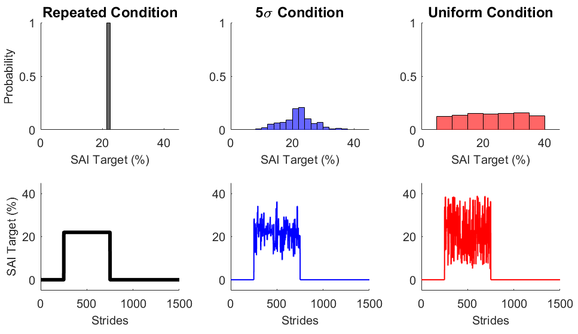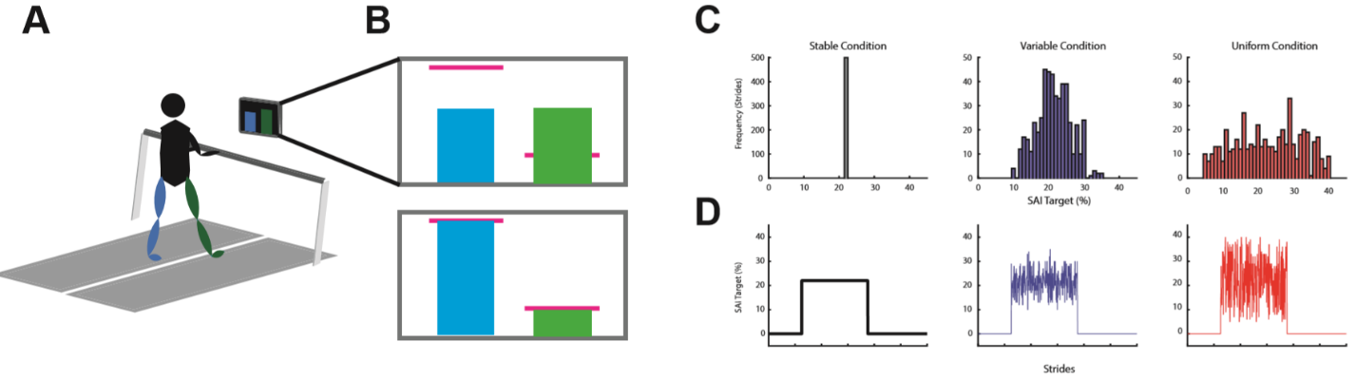**Figure 1**

*Conditions:*

Participants will perform three different conditions separated by 5-10 days. To prevent order effects, we will counterbalance the order of conditions. The primary manipulation will be the consistency of targets during the Learning phase. Going from the most to least consistent condition: 1) In the Repeated condition, the target positions will be set to 22% SAI throughout the Learning phase; 2) In the 5σ condition, target SAI will be drawn from a normal distribution with a mean of 22% and standard deviation of 5%; and 3) In the Uniform condition, the targets will be drawn from a uniform distribution with a range of 5%-39% SAI (Figure 1C & D). Based on our pilot testing, changing the target on a stride-by-stride basis made the task too difficult for participants; thus, for both the 5σ and Uniform conditions, targets will change, with equal probability, every 1-5 strides.

*Data collection:*

Kinetic data will be collected at a frequency of 1000 Hz from the dual belt treadmill instrumented with two force plates, one under each belt (Bertec, Columbus, OH, USA). Kinematic data will be collected at a frequency of 100 Hz using a Vicon MX40 motion capture system with 8 cameras and Nexus software (Vicon Motion Systems, Inc., London, UK). We will use a custom marker set with 7 retroreflective markers, one for each heel, each lateral malleolus, and each 5th metatarsal head. The seventh marker will be placed on the left 1st metatarsal head to ensure the tracking system can differentiate between the right and left feet. Kinematic data will be time-synchronized with kinetic data in Nexus.

*Proposed analysis pipeline:*

First, any gaps in the kinematic data will be filled using a Woltering filter for small gaps (1-4 frames) and Pattern Fill for larger gaps (>4 frames) in Nexus. The remainder of the data analysis will be performed with custom-written MATLAB scripts (Mathworks, Natick, MA, USA). The code/software described in the paper is freely available online at [URL redacted for double-blind review]. The code is available as Extended Data. Kinematic and kinetic data will be low pass filtered at 10 Hz using a 4th order Butterworth filter. Kinetic data will be used to detect heel strike events when the force plate reads greater that 20 N and toe off events when the force plate reads less than 20 N. Erroneous force plate events will be removed and replaced with kinematic events. For heel strikes this is the most anterior position of the heel marker in the sagittal plane, and for toe offs this is the most posterior position of the 5th metatarsal head in the sagittal plane. Step lengths will be calculated as the sagittal difference between the leading and trailing heel markers at the moment of leading heel strike. Step lengths will be used to calculate our primary outcome, step asymmetry index (SAI; equation 1). We will remove any SAI baseline bias for each participant for each respective training session: the mean of the last 50 strides of Baseline will be subtracted from all strides for that respective session. The baseline corrected measure will be used for the remainder of our analysis.

To assess how well participants performed on the learning task, we will calculate SAI accuracy as the absolute difference between the target SAI and the actual SAI during the Learning phase. Mean absolute differences between the target step lengths and actualstep lengths for the learning phase will be used as a general measure of accuracy to test how well participants were able to perform the task. Our pilot results from two individuals show that they were able to follow the feedback during the Uniform condition,with a mean distance of 4.2 cm from the targets. Furthermore, the right and left step lengths were significantly correlated with the right and left targets (r = 0.61, r = 0.83), respectively. We will also test our assumption that, during the learning phase, while the SAI will be similar across conditions, the SAI standard deviation will be different across conditions. Our pilot data appear consistent with these predictions (Figure 2), as the mean SAI during learning is similar between repeated and Uniform conditions but the standard deviation appears different.

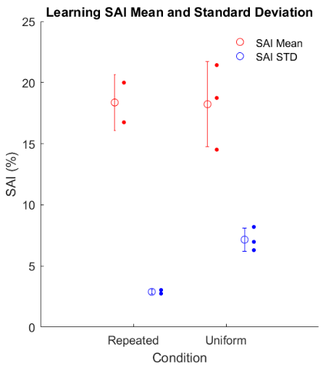

**Figure 2**

Use-dependent bias will be calculated as the mean SAI during the first 10 strides of the Washout phase. We will also compare the change in use-dependent biases across conditions, as our computational models make distinct predictions regarding the sensitivity of UDP to environmental consistency (see Modeling). We will also analyze the rate of washout by regressing subsequent strides onto current strides for each stride of washout. The slope of this regression predicts the amount of SAI retained from one stride to the next. (Kitago et al., 2013; Wood et al., 2020).

*Statistical analysis:*

We will test for within-subjects differences across conditions for the mean and standard deviation SAI during Learning, SAI aftereffects and SAI washout rate using repeated measures analysis of variance and post-hoc pairwise comparisons if the analysis of variance test is significant. We will report t- and F- statistic, exact p-values, means, 95% confidence intervals and standardized effect sizes (Cohen’s d for t-tests and ƞp2 for analysis of variance). Assumptions of normality and homoscedasticity will be tested with the Shapiro-Wilks test and Levene’s test, respectively.

In addition to our parametric analyses, we will also employ a cluster permutation analysis to assess potential SAI differences across the Washout phases for each condition (Holmes et al., 1996; Maris and Oostenveld, 2007). In this analysis, we will compare differences between two conditions at a time with paired t-tests at each stride. The largest cluster of significant paired t-tests (p < 0.05) in a row will be determined and the t-statistics for this cluster are summed. The summed t-statistics are then compared to a null distribution of summed t-statistics. The null distribution is built from resampling each group without replacement 1000 times and computing the largest cluster’s t-statistic for each sample. This null distribution serves as the null hypothesis which states that each group is sampled from the same distribution. The cluster size from the empirical data is then compared to the null distribution of 1000 samples. This comparison provides a probability that the empirical cluster is different from the null distribution while controlling for type I error (Nichols and Holmes, 2002). This analysis will be performed three times to compare differences between each condition.

**Modeling**

We have adapted two computational models of use-dependent learning which make dissociable predictions regarding the effect practice consistency has on use-dependent bias. One is an Adaptive Bayesian model (Verstynen and Sabes, 2011) the other is the Strategy plus UDP model (Diedrichsen et al., 2010).

*Strategy Plus UDP model:*

The Strategy plus UDP model conceptualizes overall motor output as the sum of two parallel processes: cognitive strategy and UDP. Prior work shows that participants are able to explicitly control SAI in response to visual feedback (French et al., 2018; Long et al., 2016; Wood et al., 2020), yet still demonstrate aftereffects. Our model proposes that UDP is insensitive to any explicit task goal, and is an obligatory stride by stride biasing of motor output based on recent actions (Diedrichsen et al., 2010). In the context of the current study, the motor output is SAI () which is the sum of the strategic process () and the use-dependent process () on each stride, :

(5)

The strategic process corrects errors () between the motor output () and the target ():

(6)

During the learning phase, is a memory term representing how much of the strategy () is retained from one trial to the next, and is the proportion of the error that is corrected for on each stride. As this is a strategic, or voluntary, process, we assume that is equal to zero when the visual feedback (VF) is turned off and the participants are instructed to walk normally:

(7)

Where is the error correction rate and is the strategic retention rate. During the Washout phase, when there is no strategy, motor output is driven only by the use-dependent process. The use-dependent process () becomes biased towards the current motor output (), while retaining a proportion of the current use-dependent process:

(8)

Where is the use dependent retention rate and is the use-dependent learning rate. We assume the use-dependent process learns much slower than a strategic process and thus constrain to be at least 5x’s less than .

*Adaptive Bayesian Model:*

The Adaptive Bayesian model predicts the appropriate step length through the weighted combination of expected target locations based on prior history with current sensory estimates of target location.

In the context of the current study, this model combines the prior expectation of the SAI target with the current sensory estimate of target position to compute the posterior probability distribution. The model assumes that the motor output is a direct readout of the maximum a posteriori (MAP) estimate () of target location, as in Verstynen and Sabes (2011):

(2)

Where . We assume that the likelihood is centered around the actual target on each stride, . The likelihood’s standard deviation ( is a free parameter representing the amount of sensory uncertainty regarding target location. The adaptive nature of the model is encapsulated by the stride-by-stride updating of the prior probability’s parameters *N*(, σ2 prior):

(3)

(4)

Where is a free parameter representing the learning rate. Therefore, the Adaptive Bayesian model has two free parameters and the Strategy plus UDP model has four free parameters.

These two models provide distinct interpretations of how use-dependent biases evolve and the specific constraints acting on them. The Strategy plus UDP model assumes separate, yet parallel, implicit (UDP) and explicit (Strategy) learning mechanisms. In this model, use-dependent learning is persistently active, but evolves slowly in response to the direction of the walking asymmetry. In contrast, the Adaptive Bayesian model does not invoke separate implicit and explicit learning processes, but frames the problem of changing an agent’s behavior in response to visual targets as one of Bayesian estimation (citations – Kording review(s), others). The MAP estimate may certainly result from contributions of implicit and explicit mechanisms, but the model does not distinguish between the two.

*Model Comparison:*

To determine whether the models are distinguishable and the best method of objective comparison, we performed model recovery analysis (Hardwick et al., 2019; Wilson and Collins, 2019). By sequentially simulating data from each model and then comparing model fits of the simulated data, we show in Fig. 3 that the models are distinguishable under these ideal circumstances (Figure 3). We fit the simulated data from each model using MATLAB’s fmincon function and found that comparison using Akaike Information Criterion (AIC) distinguishes between the models better than Bayesian Information Criterion (BIC).

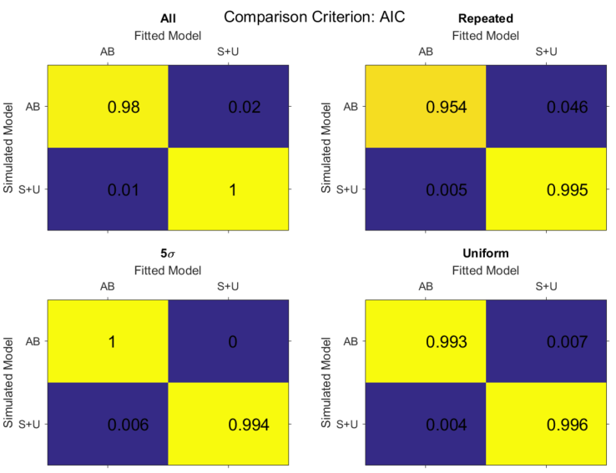

**Figure 3**

After data are collected, we will fit both models to individual participant data for each condition to obtain parameter values using the same fitting procedure as above. We will further simulate each model with the fitted parameters as a posterior predictive check then analyze these simulations in the same way we will analyze the empirical data. We will use AIC to objectively compare the model fits and compare mean AIC values as well as the number of subjects best fit by each model.

*Simulations:*

We simulated both models to demonstrate how each accounts for the variability of practiced target step lengths. For the Adaptive Bayesian model, the MAP estimate is sensitive to environmental consistency: The more consistent (i.e. less variable) the schedule of target step lengths, the more biased towards the prior (i.e., away from the likelihood) the MAP becomes; conversely, the more variable the schedule, the less weight is given to the prior and the more the MAP is pulled towards the likelihood (i.e., the actual target location). In direct contrast to this framework, the Strategy plus UDP model is much more robust to environmental consistency in cases, as here, where there is a large asymmetry in one direction. The model assumes use-dependent learning is slow to learn and washout; therefore, as long as the practiced asymmetry is much larger than the current state of use-dependent learning, the consistency of target step lengths has minimal impact on its output.

After performing model recovery (Supplemental Figure 1), we obtained parameters for model simulation by fitting the models to each individual from a previously collected dataset (Supplemental Figure 2). We then simulated our proposed experiment 1000 x’s using bootstrapped samples of the individual parameter fits. Figure 4 details the simulated data from these parameters for each condition. The panels in Figure 4A show each model simulation for the entire experiment. The models perform similarly during the Baseline and Learning phases, but the primary difference between the models is during the Washout phase. Figure 4B and C depict the simulated retention rates across the conditions for each model for the first 50 strides of Washout. The Adaptative Bayesian model predicts a faster washout as the conditions are less stable. The Strategy plus UDP model predicts a consistent washout rate across conditions.

We also compared use-dependent biases by calculating difference scores between the 5σ and Uniform practice conditions relative to the Repeated condition (Figure 4D). The Strategy plus UDP model predicts little change in aftereffects across conditions. However, the Adaptive Bayesian model predicts aftereffects which stray further from the reference condition indicating a decline in aftereffects compared to the Repeated condition.

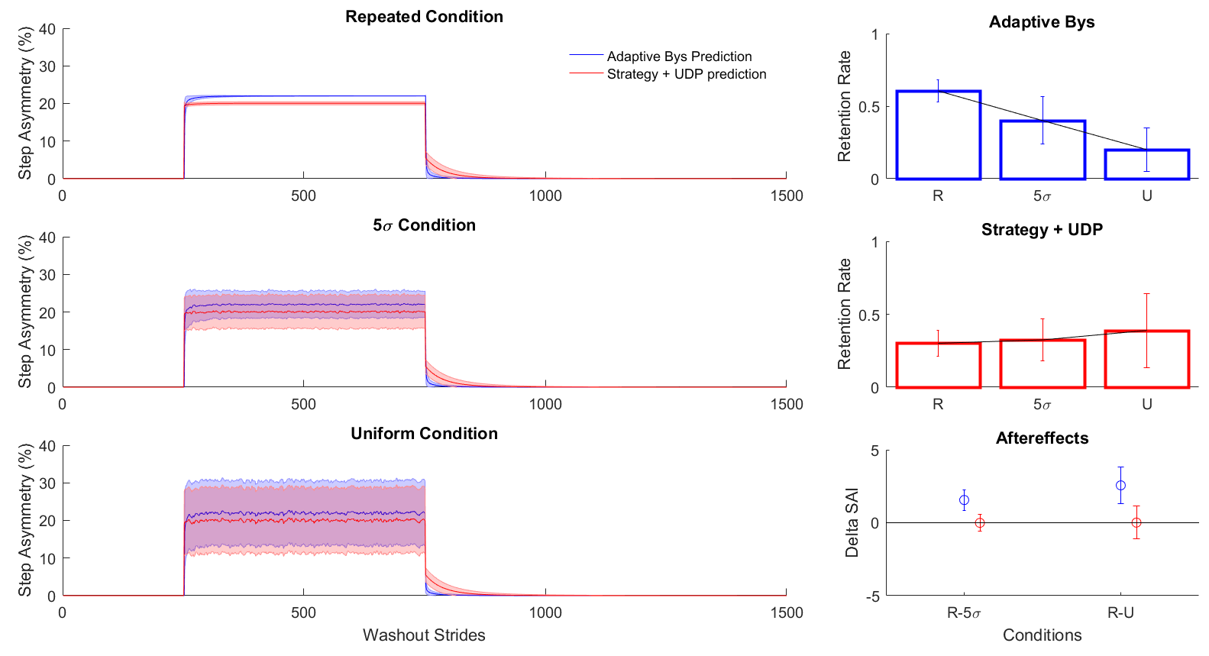

Figure 4

**Timeline for completion:**

We have received IRB approval from our university for this project. However, all labs have been shut down due to the COVID-19 pandemic. Data collections are ready to be initiated as soon as human research resumes at the university. Given uncertainty around when labs will be reopened we offer a proposed resubmission window from November 15th to May 15th, 2021.

**Figures:**

* Figure 1: Experimental paradigm
  + Figure 1A: experiment set up (include step length)
  + Figure 1B: visual feedback
  + Figure 1C: Target distributions (histogram)
  + Figure 1D: Stride by stride learning targets
* Figure 2: Pilot Data (proof of concept)
* Figure 3: Confusion Matrices
  + Figure 3A: All conditions confusion matrix
  + Figure 3B: Repeated condition confusion matrix
  + Figure 3C: 5σ condition confusion matrix
  + Figure 3D: Uniform condition confusion matrix
* Figure 4: Model simulations
  + Figure 4A: Aftereffects
  + Figure 4B: Washout simulations

**Supplemental material:**

* Instruction script
* Figures:
  + Supplemental Figure 1: Parameter recovery
  + Supplemental Figure 2: Correlations between recovered parameters
  + Supplemental Figure 3: Fits and parameter values from prior data

**References:**

Classen J, Liepert J, Wise SP, Hallett M, Cohen LG (1998) Rapid plasticity of human cortical movement representation induced by practice. J Neurophysiol 79:1117–1123.

Diedrichsen J, White O, Newman D, Lally N (2010) Use-dependent and error-based learning of motor behaviors. J Neurosci 30:5159–5166.

French MA, Morton SM, Charalambous CC, Reisman DS (2018) A locomotor learning paradigm using distorted visual feedback elicits strategic learning. J Neurophysiol 120:1923–1931.

Hammerbeck U, Yousif N, Greenwood R, Rothwell JC, Diedrichsen J (2014) Movement speed is biased by prior experience. Journal of Neurophysiology 111:128–134.

Hardwick RM, Forrence AD, Krakauer JW, Haith AM (2019) Time-dependent competition between goal-directed and habitual response preparation. Nat Hum Behav 3:1252–1262.

Holmes AP, Blair RC, Watson JD, Ford I (1996) Nonparametric analysis of statistic images from functional mapping experiments. J Cereb Blood Flow Metab 16:7–22.

Kitago T, Ryan SL, Mazzoni P, Krakauer JW, Haith AM (2013) Unlearning versus savings in visuomotor adaptation: comparing effects of washout, passage of time, and removal of errors on motor memory. Front Hum Neurosci 7.

Long AW, Roemmich RT, Bastian AJ (2016) Blocking trial-by-trial error correction does not interfere with motor learning in human walking. J Neurophysiol 115:2341–2348.

Maris E, Oostenveld R (2007) Nonparametric statistical testing of EEG- and MEG-data. Journal of Neuroscience Methods 164:177–190.

Mawase F, Lopez D, Celnik PA, Haith AM (2018) Movement Repetition Facilitates Response Preparation. Cell Reports 24:801–808.

Nichols TE, Holmes AP (2002) Nonparametric permutation tests for functional neuroimaging: A primer with examples. Hum Brain Mapp 15:1–25.

Orban de Xivry J-J, Criscimagna-Hemminger SE, Shadmehr R (2011) Contributions of the motor cortex to adaptive control of reaching depend on the perturbation schedule. Cereb Cortex 21:1475–1484.

Schmidt RA, Lee TD (2005) Motor control and learning: A behavioral emphasis, 4th ed, Motor control and learning: A behavioral emphasis, 4th ed. Champaign, IL, US: Human Kinetics.

Shadmehr R, Wise SP (2005) The computational neurobiology of reaching and pointing a foundation for motor learning. Cambridge, Mass: The MIT Press.

Verstynen T, Sabes PN (2011) How each movement changes the next: an experimental and theoretical study of fast adaptive priors in reaching. J Neurosci 31:10050–10059.

Wilson RC, Collins AG (2019) Ten simple rules for the computational modeling of behavioral data. eLife 8:e49547.

Wong AL, Goldsmith J, Forrence AD, Haith AM, Krakauer JW (2017) Reaction times can reflect habits rather than computations. Elife 6.