LABORATORY EXERCISE 1

INITIALIZING A PROJECT USING CODEIGNITER WITH BOOTSTRAP INTEGRATION AND GITHUB VERSION CONTROL

Learning Objectives
By the end of this laboratory exercise, students should be able to:
- Learn how to install and configure CodeIgniter as a PHP framework for web application development.
- Understand the integration of Bootstrap for creating responsive and user-friendly web interfaces.
- Develop skills in setting up a project folder structure and linking CodeIgniter with Bootstrap templates.
- Gain practical experience in using GitHub for version control and project collaboration.
- Apply best practices for project initialization and version tracking in a development environment.

Prerequisite student experiences and knowledge
Before starting this exercise, students should have:
- Basic understanding of HTML, CSS, and PHP.
- Familiarity with databases and MySQL basics.
- Experience using a local web server (XAMPP/WAMP/LAMP).
- Knowledge of basic Git commands and GitHub usage.
- Ability to use a text editor/IDE such as Visual Studio Code.

Background
This exercise introduces students to initializing a web project using the CodeIgniter framework, a lightweight PHP MVC framework known for speed and simplicity. The integration of Bootstrap ensures that the project interface is responsive and visually appealing. Furthermore, using GitHub provides students with a professional approach to version control, ensuring project tracking, collaboration, and code management.

Materials/Resources
- Personal Computer with Internet Access
- XAMPP/WAMP/LAMP server installed
- CodeIgniter Framework (latest version)
- Bootstrap (via CDN or downloaded files)
- Visual Studio Code or any code editor
- Git and GitHub Account
- Web Browser (Chrome, Firefox, etc.)

Laboratory Activity
Step 1: Environment Setup
- Install and configure XAMPP/WAMP on your machine.
- Download and extract the latest version of CodeIgniter from your `htdocs` (XAMPP) or `www` (WAMP) directory.
- Rename the folder as ` ITE311-LASTNAME`.
- Run your local server and test the CodeIgniter installation by accessing:
http://localhost/ ITE311-LASTNAME

Step 2: Initialize Git Repository
- Open the project folder in your terminal or Git Bash.
- Run the following commands:
git init
git add .
git commit -m "Initial commit - CodeIgniter setup"
- Create a new repository on GitHub named WebSystem-ITE311.
- Link your local project to GitHub:
git remote add origin https://github.com/yourusername/ WebSystem-ITE311.git
git push -u origin main

Step 3: Integrate Bootstrap
- Download Bootstrap from [https://getbootstrap.com](https://getbootstrap.com) or use the CDN links.
- Navigate to `application/views` and create a new file `template.php`.
- Add Bootstrap CDN inside your template's `<head>` section.
- Test by creating a simple navigation bar using Bootstrap classes.

Step 4: Create a Home Controller and View
- Navigate to `application/controllers` and create a file named `Home.php`.
- Insert the following code:
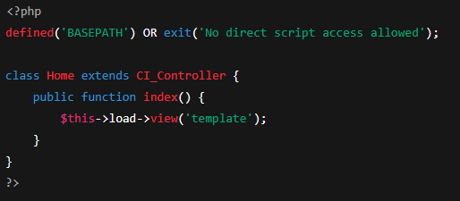
- In your browser, visit: http://localhost/ITE311-LASTNAME /index.php/home
- Open your web browser and navigate to http://127.0.0.1:8000 to see your basic homepage.

Step 5: Push Update Project to GitHub
- After Bootstrap integration and controller creation, push changes:
git add .
git commit -m "Added Bootstrap template and Home controller"
git push
Step 6: Push Update Project to GitHub
- Take screenshots of your running home page and GitHub repository.
- Insert them in your lab report under “Output/Results.”

Output / Results
- Screenshot of successful CodeIgniter setup.
- Screenshot of integrated Bootstrap layout.
- Screenshot of GitHub repository with pushed commits.
- The instructional manual should be printed, and the softcopy uploaded at the time of checking.

QUESTIONS:
- Why is it important to integrate Bootstrap when developing a web project in CodeIgniter?
It makes the website look cleaner, more modern, and mobile-friendly without writing a lot of CSS from scratch.

- How does using GitHub improve the development and management of web applications?
GitHub helps save versions of your code, track changes, and share your work easily with others or back it up.

- What steps did you perform to successfully set up and test the CodeIgniter framework on your local server?
I placed the CodeIgniter folder in htdocs, opened it in the browser, added a controller and view, linked Bootstrap, and tested it to see the homepage working.

Output / Results
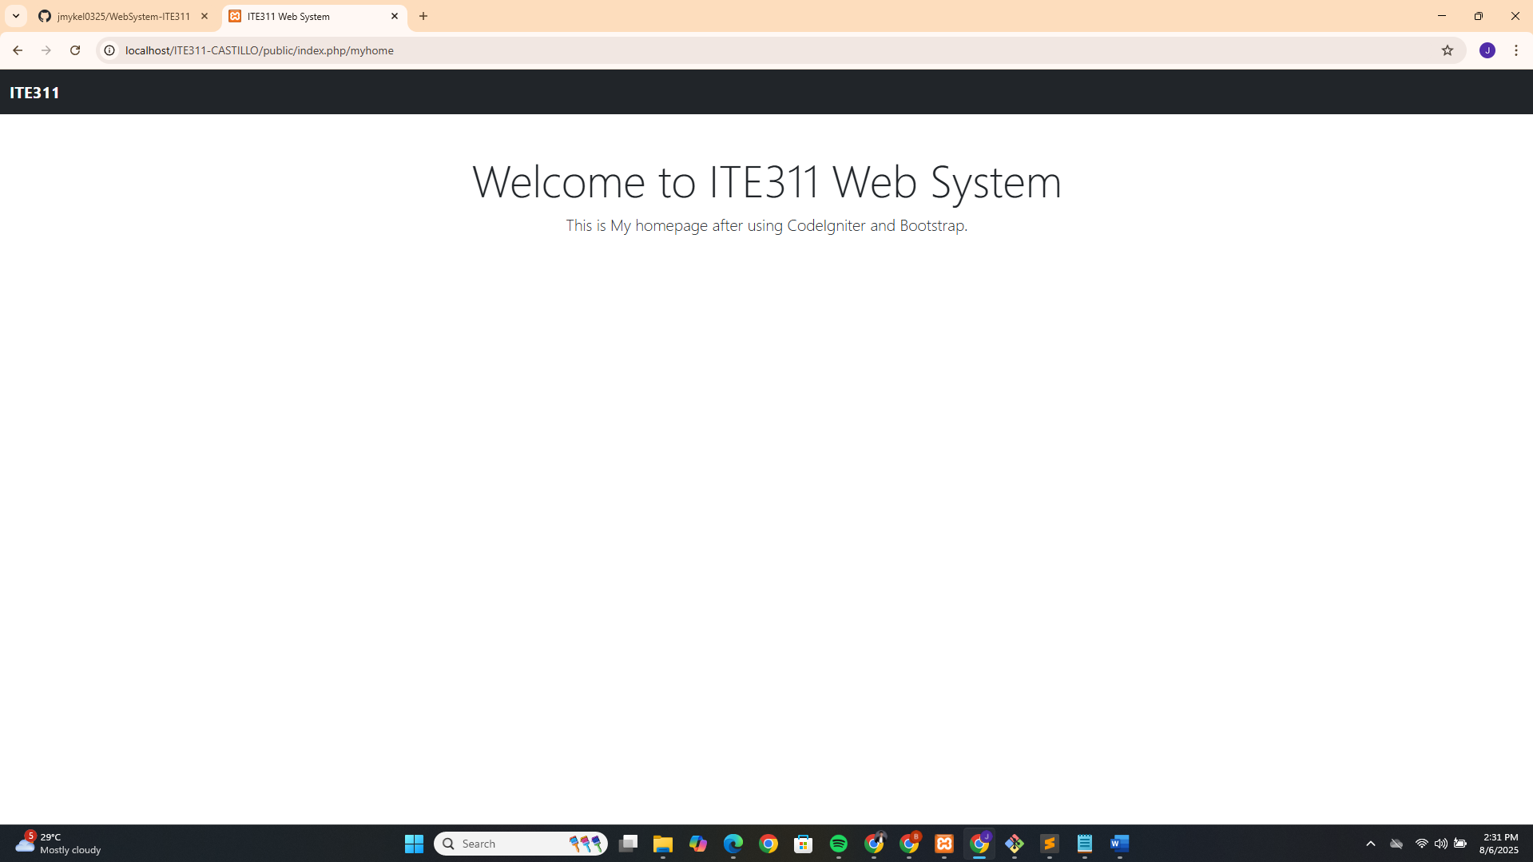
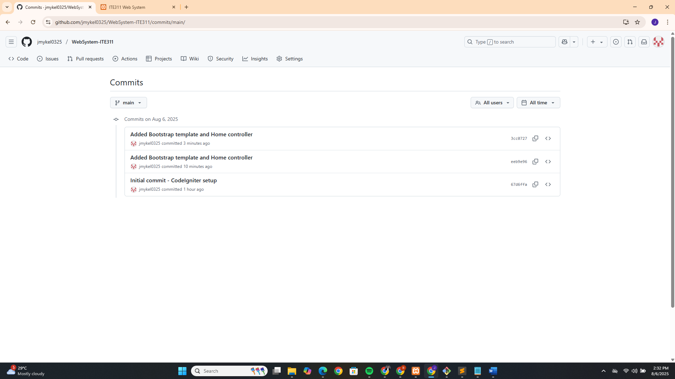

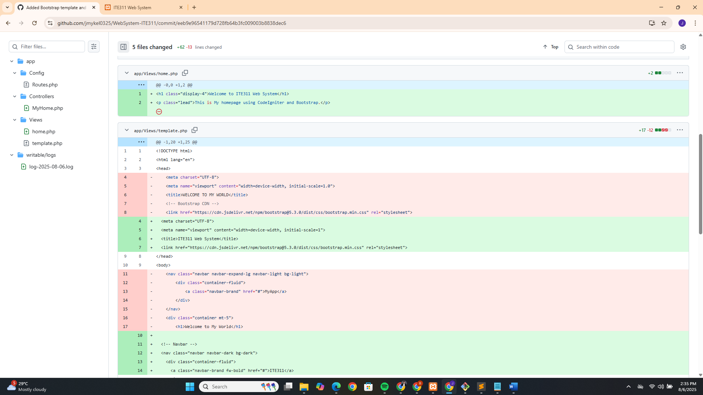
Conclusion
This activity helped me learn how to set up a web project using CodeIgniter and improve its design with Bootstrap. By creating a controller, a view, and a template, I understood how CodeIgniter organizes web content. Adding Bootstrap made the layout look more professional and user-friendly without taking too much time on custom styling.
I also learned to use GitHub to manage and track my project. It was helpful for saving my work and keeping a backup online. This activity gave me practical experience with tools that are important for real-world web development, like frameworks, design libraries, and version control.

