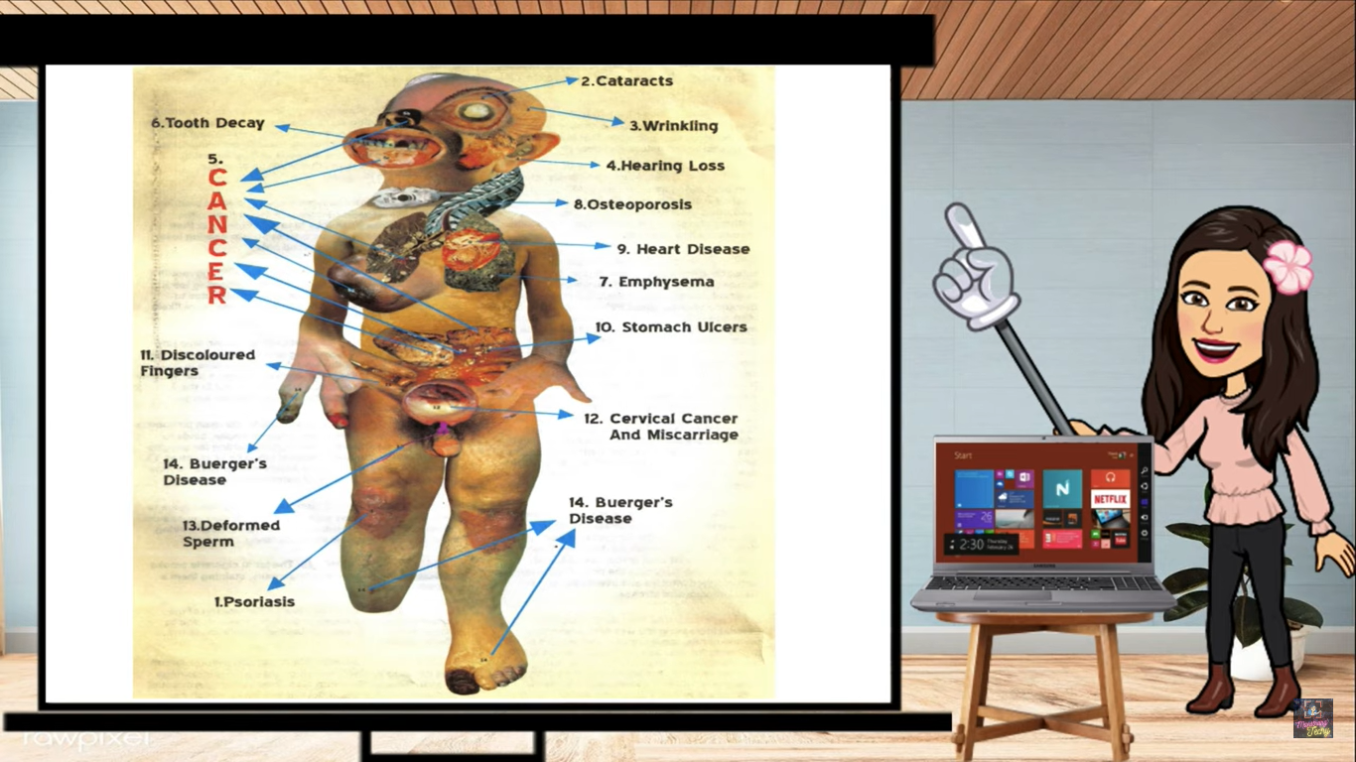
REVIEWER IN HEALTHY LIFESTYLE
COMMON DISEASE IN RESPIRATORY AND CIRCULARTORY
1. ASTHMA – It is an condition in wich airways narrow and swell
2. COLDS- Most common respiratory trat infection
3. HYPERTENSION – Also known as high blood pressure
4.ANEMIA- Having anemia can you feel tired, loss of appetite and weak.
5. HEART DISEASE- Refer to any conditio affecting the heart.
RESPIRATORY DISEASE
Emphysema is a lung condition that causes shortness of breath. It is part of chronic obstructive pulmonary disease (COPD), along with chronic bronchitis. The main cause of COPD is cigarette smoking, but it can also be caused by marijuana smoke, air pollution, and chemical fumes or dust.
Bronchitis is when the tubes that carry air to your lungs get swollen and filled with thick mucus. This can make you cough, feel tired, and have a heavy chest. It can happen because of germs (like viruses or bacteria) or dirty air (like smoke or dust).
Pneumonia is an infection in the lungs that makes the air sacs swollen and sometimes filled with fluid. It can be caused by germs like bacteria, viruses, or fungi. It can make it hard to breathe and may cause fever or cough.
Asthma is a long-term lung problem where the air tubes in the lungs become swollen and narrow, making it hard to breathe. It can cause coughing, wheezing, and shortness of breath, especially when running or playing.
Tuberculosis (TB) is a disease caused by bacteria that usually attacks the lungs, but it can also affect other parts of the body. It spreads through the air when a sick person coughs or sneezes.

