A Survey-Based Machine Learning Depression Screener Developed in Korea and Externally Validated in the United States Across the COVID-19 Period: Algorithm Development and Validation Study
Authors: [to be completed]
Corresponding author: [to be completed]

Abstract
Background: Depression is a leading cause of disability, and scalable, low-cost screening is needed. Most machine learning (ML) depression models from national surveys report internal validation only; whether such models transport to another country and remain stable across the COVID-19 shift is rarely tested.
Objective: To develop an ML model for current depression (Patient Health Questionnaire-9 [PHQ-9] ≥10) in the Korea Community Health Survey (KCHS), externally validate it in the US National Health and Nutrition Examination Survey (NHANES) across the pre- and post-COVID-19 periods as the engine for a digital triage tool, and determine whether any external shortfall is closable by modeling.
Methods: Elastic net, random forest and gradient boosting were developed in KCHS (2017-2025; pooled n=2,048,510; cluster-level split into a 500,000-record training set and a 100,001-record hold-out sharing no cluster) using a harmonized 17-predictor set shared with NHANES, one item of which is unavailable in the pre-pandemic NHANES file. Primary-model fitting, tuning and selection used KCHS-internal cross-validation only; the trained model was applied to NHANES without refitting. Evaluation was complex-survey-weighted with rescaled cluster-bootstrap CIs, plus Shapley additive explanations (SHAP) and subgroup fairness. Performance was contrasted between the National Center for Health Statistics (NCHS)-defined pre-pandemic (n=7,888) and post-pandemic (n=5,210) cycles. A leakage-controlled run registry and an in-domain oracle fitted on NHANES labels characterized attainable external discrimination.
Results: Gradient boosting (LightGBM) was primary. Internal area under the receiver operating characteristic curve (AUROC) in clusters never used for training was 0.836 (95% confidence interval [CI] 0.827-0.846), meeting the ≥0.80 target (H1). External discrimination was lower yet clinically useful, and the two pandemic periods were indistinguishable (pre 0.765, 95% CI 0.724-0.804; post 0.771, 0.739-0.801; difference +0.006, 95% CI -0.045 to +0.056, computed post hoc); calibration deteriorated (slope 0.65-0.68; calibration-in-the-large [CITL] +0.51 and +1.13, under-prediction) and was restored by intercept/slope recalibration to slope 1.00 (95% CI 0.95-1.00) and 1.00 (0.97-1.00) with CITL 0.00 (H2, H3 supported). The analysis plan's parsimony margin, applied entirely inside the development data, selected a 6-item model (0.822 internal, 0.748 pre, 0.757 post; H4 supported). No leakage-controlled configuration among 2,199 catalogued runs exceeded ~0.77 externally, and the in-domain oracle reached only 0.764-0.776, whereas the same predictors reached 0.81-0.82 in equally sized Korean samples.
Conclusions: A Korea-developed depression screener transported to the US and across both pandemic periods with clinically useful discrimination and calibration recoverable by intercept/slope updating. The ~0.77 cross-national ceiling survived sample size, algorithm choice and covariate-shift correction, and is most consistent with a property of the transportable predictor set rather than a modeling failure. A low-burden six-item version with local recalibration is a plausible scalable digital triage aid.
Keywords: depression; mass screening; machine learning; external validation; transportability; COVID-19; mobile health; Republic of Korea.

Introduction
Depression is among the leading causes of years lived with disability worldwide [1], and its detection at the community and primary-care level remains incomplete. Brief self-report instruments such as the PHQ-9 enable population-scale screening [2,3], yet a fixed cut-off applied uniformly across heterogeneous populations does not prioritize those at highest risk, even where universal screening of adults is recommended [4]. Risk stratification from routinely available sociodemographic and behavioral information could support more efficient triage, and a tool restricted to self-reportable items can be delivered as a web or mobile form at low marginal cost. National health-examination and community-health surveys already collect these items and the relevant clinical ones, and community-health surveillance in particular reaches hundreds of thousands of respondents a year, an attractive development base.
ML models for depression have been developed repeatedly from large national surveys, including the KCHS and the Korea National Health and Nutrition Examination Survey (KNHANES) [5,6], typically reporting strong internal discrimination. Most published prediction models are assessed through internal validation alone, in depression modeling and in other clinical domains alike [7,8]. Internal performance is an optimistic indicator of real-world behavior: it does not establish that a model transports to a different sampling frame, health system, or population [9], and it does not test stability under temporal distribution shift.
The COVID-19 pandemic constitutes a natural distribution shift for mental-health prediction [10,11]: the distributions of depressive symptoms and of the associated behavioral characteristics changed, and Korean national surveillance recorded a rise in depressive symptoms and suicide attempts over the pandemic years [12]. A screening model carried into a shifted target population may show degraded calibration even where discrimination is preserved. Whether recalibration, ie, updating the intercept and slope alone [13,14], restores clinical usefulness is a practically important, under-studied question for deployed screening tools.
This study addresses these gaps by validating a KCHS-developed model in the US National Health and Nutrition Examination Survey (NHANES). Depression is operationalized identically in both surveys, minimizing outcome-harmonization error, while country, health system, racial/ethnic composition, and survey mode differ, which makes NHANES a substantively external validation set. NHANES additionally provides NCHS-defined pre- and post-pandemic data, allowing the transported model to be evaluated in two periods of the same external population; since KCHS development pools 2017-2025 and spans both, this contrasts target periods rather than validating a model frozen before the later cycle.
Two questions follow, neither settled by the models and reviews cited above [5-8]. The first is empirical: how much discrimination is lost when a model developed in one national survey is applied without refitting to another country's survey, and does that loss change across a population-wide shock such as the pandemic? The second is interpretive: when external performance falls, is the shortfall a modeling failure that better algorithms or larger training sets could recover, or a property of the transportable predictor set that no modeling effort can close? Separating the two requires more than a single external estimate. It requires an estimate of what the same predictors can achieve when a model is fitted directly inside the external population, together with a modeling search in which no external label is used for selection.
This study pursued five aims: (1) develop an ML depression-screening model in KCHS; (2) externally validate it in US NHANES (geographic transportability); (3) evaluate it separately in the pre- and post-COVID-19 cycles and quantify recalibration (transportability across target periods); (4) derive a parsimonious model for a low-burden digital tool; and (5) determine whether any residual external shortfall is closable by modeling, using a catalogued leakage-controlled optimization registry and an in-domain oracle fitted inside the external population. The pre-specified hypotheses attach to aims 1 to 4: H1 the full model achieves internal AUROC ≥0.80; H2 external discrimination remains clinically useful while calibration may deteriorate; H3 recalibration substantially improves calibration; H4 the parsimonious model incurs only a small performance loss. Aim 5 carried no numeric hypothesis and is reported as a diagnostic analysis.

Methods
Study Design and Data Sources
This retrospective secondary-data study developed a clinical prediction model in one national survey and validated it, without refitting, in another. Reporting follows Transparent Reporting of a multivariable prediction model for Individual Prognosis Or Diagnosis extended to artificial intelligence (TRIPOD+AI, 2024) [15]. Self-assessed risk of bias (Prediction model Risk Of Bias Assessment Tool, PROBAST) [16] was low-to-unclear overall, driven by complete-case handling of substantial and differential depression-module non-response in the external cohorts (Multimedia Appendix 1). The protocol and statistical analysis plan, including the four hypotheses, were dated before any analysis; the study was not registered.
Development used the Korea Community Health Survey, a nationwide Korea Disease Control and Prevention Agency (KDCA) survey [17] of community-dwelling adults, with annual in-person household interviews (~230,000/year) under a stratified, clustered, weighted complex-sample design. The development sample pooled KCHS 2017-2025 records with the PHQ-9 administered (n=2,048,510), split at cluster level (survey year crossed with design stratum crossed with primary sampling unit): the 100,001-record hold-out and the 500,000-record training set share 0 clusters. Training-set size was fixed for tractability before any external evaluation.
External validation used NHANES, an NCHS survey combining household interview and mobile examination center assessment, with depression measured by the Depression Screener (DPQ; PHQ-9) module; NCHS documents the 2015-2018 sample design and estimation procedures [18]. Two periods served as separate validation sets: pre-pandemic (2017-March 2020, "P_" files; n=7,888) and post-pandemic (August 2021-August 2023, "_L" files; n=5,210); cycle-specific documentation and weight variables are named in Multimedia Appendix 1.
Participants and Outcome
Eligible respondents in both surveys were adults aged 20 years or older with all nine PHQ-9 items answered; pregnant respondents were retained. Pooling KCHS 2017-2025 gave 2,048,510 eligible records, and among examined NHANES adults 7,888 pre-pandemic and 5,210 post-pandemic answered all nine items. Frame counts and item-level non-response are tabulated in Table S1 in Multimedia Appendix 1. Predictors and outcome were recorded in the same survey contact, and blinding does not apply to already-collected responses.
The outcome is current depression, a PHQ-9 total of at least 10, computed identically in both surveys (nine items scored 0 to 3, KCHS items recoded 1-4→0-3 to match NHANES). The ≥10 cut-off is the conventional screening threshold, evaluated against semi-structured diagnostic interviews in individual-participant-data meta-analyses [3,19] and validated in a Korean population [20].
Predictors and Harmonization
Only variables reducible to a common definition in both surveys entered the harmonized model of 17 predictors (Table 1). All 616 KCHS concepts were crosswalked against the NHANES codebook for both cycles; a concept was retained if available in NHANES, collected in more than one KCHS survey year, and not circular with the PHQ-9 outcome. Those criteria rest on documentation and availability alone, no NHANES outcome association having been estimated before the amendment below was locked. Retained domains carry established associations with depression: socioeconomic position [21], sleep duration [22], physical activity [23], body mass index (BMI) [24], smoking [25], living alone [26] and partnership status [27].
Table 1. Harmonized 17-predictor set shared by the Korea Community Health Survey (KCHS) and the National Health and Nutrition Examination Survey (NHANES).
#ª | Concept | KCHS (example var) | NHANES (var) | Harmonized definition
1 | Age | age | RIDAGEYR | Continuous, top-coded at 80 years in both surveys
2 | Sex | sex | RIAGENDR | Male/female
3 | Education | sob_01z1 | DMDEDUC2 | 4 levels
4 | Household income | fma_14z1 | INDFMPIR | Within-survey quintiles
5 | Self-rated health | qoa_01z1 | HUQ010 | 5-level ordinal (1 best-5 worst)
6 | Partnered | sod_02z3 | DMDMARTZ | Partnered vs not
7 | Living alone | mbhld_co | DMDHHSIZ | Yes/no (absent in NHANES pre)
8 | Smoking | sma_03z2 | SMQ020/040 | Never/former/current
9 | Alcohol | dra_01z1 | ALQ111/121 | Current drinker
10 | Physical activity | pha_07z1 | PAQ650/665; PAD790/810 | Meets the aerobic recommendation (≥150 min/week moderate or ≥75 min/week vigorous); single binary indicator
11 | Sleep duration | mtc_17z1 | SLD012 | Hours (continuous)
12 | BMI^{b} | oba_bmi | BMXBMI | Continuous (self-report vs measured)
13 | Hypertension | hya_04z1 | BPQ020 | Diagnosed y/n
14 | Diabetes | dia_04z1 | DIQ010 | Diagnosed y/n
15 | Employment | soa_01z1 | OCD150 | Currently working/with job vs not
16 | Self-rated oral health | ora_01z1 | OHQ845 | 5-level ordinal (1 best-5 worst)
17 | Food insecurity | nue_01z1 | FSDAD | Insecure vs secure (single-item vs 10-item module; see cautions)
 | Outcome: depression | mtb_07a1-i1 | DPQ010-090 | PHQ-9 sum ≥10^{c}
 | Race/ethnicity (fairness only) |  | RIDRETH3 | NHANES subgroup analysis only
ªOne representative variable name is shown per concept; several concepts, physical activity in particular, derive from more codes than are shown, and the full year- and cycle-specific crosswalk is in Multimedia Appendix 1. Predictors 15 to 17 entered the set through the documented protocol amendment, and race and ethnicity is not a predictor.
^{b}BMI: body mass index.
^{c}PHQ-9: Patient Health Questionnaire-9.
The 17-predictor set was not pre-specified: the protocol specified 14, and employment, self-rated oral health and household food insecurity were added by an amendment written and dated before any model using those items was fitted, though after the external result for the 14-predictor set was known. Each has an established depression association: food insecurity (pooled odds ratio ≈1.4) [28], unemployment (≈1.9-2.1) [29] and poor oral health (bidirectional) [30]. The seventeen are every eligible concept in the extract available at that point; five further items from a later exhaustive extraction were screened post hoc, none added (Multimedia Appendix 1).
Living alone, the one retained item absent from the pre-pandemic NHANES file, has no missing values anywhere in the KCHS training data; the tree learner therefore never learns a missing direction for it, and that cohort is scored as if no respondent lived alone. The pandemic-period contrast is repeated without it.
Three harmonization cautions attach to the set: BMI is self-reported in KCHS and measured in NHANES; alcohol, physical activity and income were reduced to conservatively comparable definitions across different instruments; and food insecurity rests on a single KCHS item against the 10-item NHANES module, the weakest link in the set [31].
The preprocessing pipeline handling missing data was fitted in the development training set and applied unchanged to the internal hold-out and to each external set, with no leakage; the one exception is the income quintile, recomputed as a rank-based score within each dataset and each KCHS survey year (Multimedia Appendix 1).
Model Development and Evaluation
No a priori sample-size calculation was performed; each external cohort is every eligible respondent in that cycle. Available power is reported instead: approximately 18,000 events in the training set, about 1,000 per candidate predictor, and approximately 3,600 in the hold-out. The external cohorts (728 events pre, 661 post; weighted prevalence 8.4% and 12.2%) are the binding constraint on precision; discrimination therefore carries confidence intervals, and subgroup estimates are read as exploratory.
Three algorithms were considered in two selection steps confined to the KCHS training set: penalized logistic regression (elastic net), random forest and gradient boosting (LightGBM). A randomized search over 24 LightGBM configurations crossed with two feature representations (main effects with and without four candidate interaction terms) fixed the gradient-boosting hyperparameters and selected main effects. All three were then tuned over comparable grids under one cross-validation protocol and compared at best configuration, following evidence that machine learning shows no systematic advantage over regression once validation bias is controlled [32].
The analysis plan fixed the primary-model rule in advance: highest cross-validated AUROC, differences below 0.005 treated as ties and broken by proximity of the calibration slope to 1, then by parsimony. The pipeline as executed omitted the tie band, though the plan's rule checked retrospectively reproduces the selected model. No imbalance correction was applied, the learner being fitted on the natural 3.6% event rate; that departure, and the use of single-pass 4-fold cross-validation for the hyperparameter and feature-representation search and single-pass 5-fold cross-validation for the algorithm comparison in place of 5-fold cross-validation repeated five times, are recorded in Table S2 in Multimedia Appendix 1.
No NHANES data were used in fitting, tuning or selecting the primary model; the predictor set is the one exception (Predictors and Harmonization). The in-domain oracle reported under Testing Whether External Discrimination Can Be Raised Above ~0.77 is fitted on NHANES labels by design, as a diagnostic upper bound rather than a candidate model. Complex-survey weights were handled by unweighted training with weighted evaluation.
Performance was summarized, all complex-survey weighted, by discrimination (AUROC and area under the precision-recall curve [AUPRC]), operating characteristics, and calibration, assessed at the moderate level of the calibration hierarchy [33] through the calibration slope, calibration-in-the-large (CITL), the Brier score and expected calibration error (ECE). Ninety-five percent CIs came from a rescaled stratified cluster bootstrap with 1000 replicates [34], for cohort-level and subgroup estimates alike; ECE, operating characteristics and net benefit are point estimates, ECE for the reason given with Table S3 in Multimedia Appendix 1, and two-sided bootstrap P values reach P<.001 at the smallest attainable value.
A single operating threshold, the predicted probability giving 85% sensitivity (0.02051), was fixed once in the development data and applied unchanged to the hold-out and both external cohorts; the Youden and prevalence-matched reference points are given for comparison in Table S4 in Multimedia Appendix 1, hence the external operating characteristics are transported rather than locally selected. Clinical utility was assessed by weighted decision-curve analysis [35] over threshold probabilities of 0.02 to 0.30, with net benefit at 0.10 and 0.15 tabulated in Table S5 in Multimedia Appendix 1.
External Validation and Sensitivity Analyses
Geographic transportability was assessed by applying the KCHS-trained model to NHANES without refitting, and period transportability by evaluating the same transported model separately in the pre- and post-pandemic cycles; since development pools KCHS 2017-2025 across both periods, the second comparison contrasts target periods rather than validating a model frozen before the later cycle. Calibration recovery was quantified by out-of-sample intercept and slope updating, which corrects calibration without re-estimating predictor effects [13,14] and is the conventional first step for a transported model [36]. Following the plan, three updates, cross-fitted over five folds grouped by primary sampling unit, were applied: intercept only, intercept plus slope (recommended, Table 2), and one-parameter temperature scaling with the intercept fixed at zero; the other two appear in the Results.
Three further analyses were undertaken: interpretability, through global tree-based Shapley additive explanations (SHAP) importance [37] and cross-survey rank concordance of predictor importance (Spearman correlation between KCHS and each NHANES cycle); fairness, through weighted subgroup AUROC and calibration slope across sex, age, education, household income quintile and, in NHANES, race and ethnicity, undertaken since algorithmic performance can differ systematically across groups even where overall accuracy is high [38], any subgroup differing from the cohort value by more than 0.05 AUROC being flagged; and a parsimonious model for a low-burden self-administered form, with predictor order and item count fixed inside the development training set and evaluation reserved to the hold-out and both NHANES cohorts (Multimedia Appendix 1).
Sensitivity analyses, pre-specified with further analyses added afterwards, varied the outcome cut-off (≥5 as well as ≥10), the predictor set (→14 without the three added predictors, →16 without food insecurity), weighting, imputation, three alternative alcohol definitions and an age lower bound of 30 years applied to training and evaluation, and included a protocol-specified continuous-score analysis of the untransformed PHQ-9 total; weighted AUROC is tabulated in Table S6 in Multimedia Appendix 1 apart from the continuous-score and alcohol analyses, reported in the Results text. Analyses used Python 3.14 with package versions in the model card; net benefit is reported without intervals, since inference on a decision-analytic quantity answers a different question from the decision itself [39].
An adversarial data-integrity audit corrected three silent data-processing defects before final analysis: a fabricated living-alone constant in NHANES pre-pandemic, a post-pandemic physical-activity parsing error, and an income refusal code (77777) not treated as missing. Peer review identified four further defects (post-pandemic income quintile, 2017 income refusal codes, post-2020 drinking classification, 2018 physical-activity indicator), all corrected in the primary analysis rather than carried as limitations; defects, remedies and six singly quantified corrections are in Multimedia Appendix 1 and Table S7.
Ethical Considerations
NHANES data collection was approved by the NCHS Research Ethics Review Board, and KCHS is conducted under the authority of the KDCA; both sources as analyzed are de-identified secondary survey data (see Data Availability). The Institutional Review Board of Daejeon University granted an exemption from review (approval number [to be inserted]) on the grounds that the study analyzes de-identified secondary survey data obtained under the data-collecting agencies' release conditions, records no personal identifiers, and poses no more than minimal risk (Multimedia Appendix 1). Patients and members of the public were not involved in the design, conduct, reporting or dissemination plans of this secondary analysis of existing survey data. Written informed consent was obtained from every participant by the data-collecting agencies at the time of the original surveys; the present analysis required no additional consent, and none was sought.

Results
Participant Characteristics
The pooled KCHS development sample comprised 2,048,510 adults and the external cohorts 7,888 pre-pandemic and 5,210 post-pandemic NHANES adults, similar in mean age (49.4, 48.4 and 48.8 years) and in proportion female (50.5%, 51.5% and 50.8%) but not in outcome frequency. Weighted depression prevalence (PHQ-9 ≥10) was 3.6% in KCHS against 8.4% and 12.2% in the two NHANES cycles (Figure 1). Measured covariates differed as sharply: mean BMI 23.7 against 29.8 and 29.7, and weighted food-insecurity prevalence 3.7% in KCHS vs 16.4% and 17.2% in the NHANES cycles among respondents with the item recorded (missing 22.1%, 6.0% and 6.3%; Table S8 in Multimedia Appendix 1 uses available-case denominators throughout).
Figure 1. Weighted sample characteristics across the three cohorts. Estimates are complex-survey weighted and computed on available cases, that is, respondents with the item recorded; the accompanying missing shares are unweighted record proportions, and both are tabulated in Table S8 in Multimedia Appendix 1. Self-rated health and self-rated oral health are scored 1 (best) to 5 (worst).
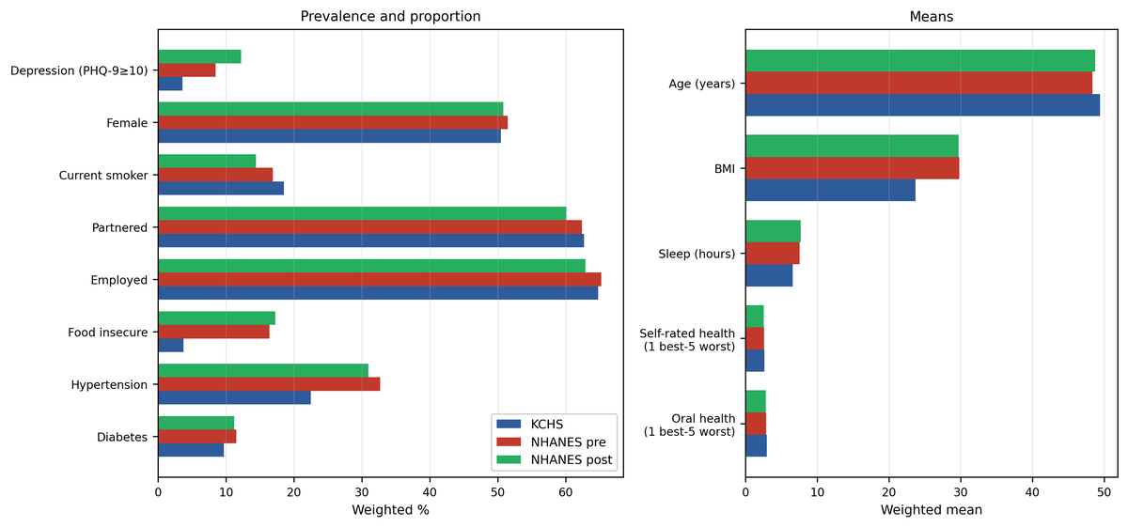

On the mobile examination center (MEC) frame, which supplies the depression module and the weights used throughout, 7.7% of 8,544 pre-pandemic and 14.1% of 6,064 post-pandemic examined adults aged ≥20 years were lost to PHQ-9 item non-response, yielding the complete-case analytic samples of 7,888 and 5,210. Non-response was differential: on the same examination-center frame, three or more items were unanswered by 12.9% of respondents with less than high-school education pre-pandemic and 26.6% post-pandemic, against 7.4% and 13.3% overall on that definition, and rates were also higher among Asian and Black respondents; hence the external cohorts, and particularly the post-pandemic fairness estimates, should be read as complete-case results (Table S1 in Multimedia Appendix 1).
Model Development and Internal Performance
Under the identical tuning protocol, unweighted cross-validated AUROC in the training set was 0.840 for LightGBM, 0.835 for random forest and 0.822 for elastic net. The two leading algorithms differ by 0.0046 before rounding and therefore fall inside the analysis plan's 0.005 tie band, which the calibration-slope tie-break resolves in favor of LightGBM (cross-validated slope 1.00 against 1.20), while elastic net lay outside it (Table S2 in Multimedia Appendix 1). Internal hold-out AUROC was 0.836 (95% CI 0.827-0.846), AUPRC 0.246, Brier 0.030, calibration slope 1.03, CITL +0.10; H1 met. The split being at cluster level, this is an estimate for clusters the model never saw.
External Validation Across Country and Pandemic Period
External discrimination fell by about 0.07 AUROC from the internal estimate and differed little between the two cycles: pre 0.765 (95% CI 0.724-0.804), post 0.771 (0.739-0.801) (Table 2; Figures 2 and 3); the difference is +0.006 (95% CI -0.045 to +0.056; bootstrap P=.86), computed after the fact, no between-cycle test having been pre-specified. AUPRC moved in the opposite direction (Table 2), which follows from the higher external event rate: each value should be read against its own no-skill baseline of 3.6%, 8.4% and 12.2%. Calibration degraded in both cycles, the slope falling to 0.65 (pre) and 0.68 (post) and CITL rising to +0.51 and +1.13, indicating that the Korea-trained model systematically under-predicted absolute risk in the US (KCHS 3.6% vs 8.4% and 12.2%). Of the three pre-specified recalibration steps applied out-of-sample, intercept-plus-slope updating restored both slope and CITL (Table 2), intercept-only updating removed the mean bias but left the slope unchanged (0.65 pre, 0.68 post), and temperature scaling was intermediate (Multimedia Appendix 1); intercept-plus-slope is the recommended deployment update; H2 and H3 supported.
Figure 2. Calibration of the primary model in the internal KCHS hold-out and the two NHANES cycles, shown as transported and after intercept-and-slope recalibration applied out-of-sample by 5-fold cross-fitting; the recalibration is applied to all three cohorts so that the panels are comparable. Points are deciles of predicted risk, plotted as weighted mean predicted probability against weighted observed proportion; the dashed line is perfect calibration, and points above it indicate under-prediction of absolute risk. The deployed internal model is the one shown as transported.
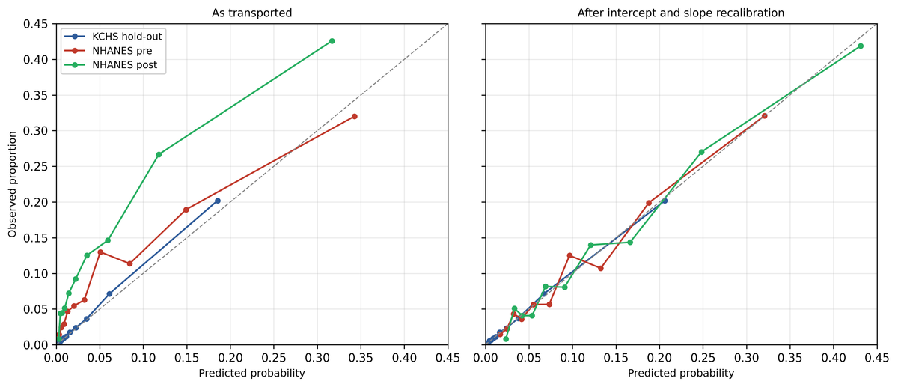

Figure 3. Weighted receiver operating characteristic curves for the internal KCHS hold-out and the two NHANES cycles, using the transported model without refitting or recalibration. The area under each curve is given in the legend; the diagonal is chance performance.
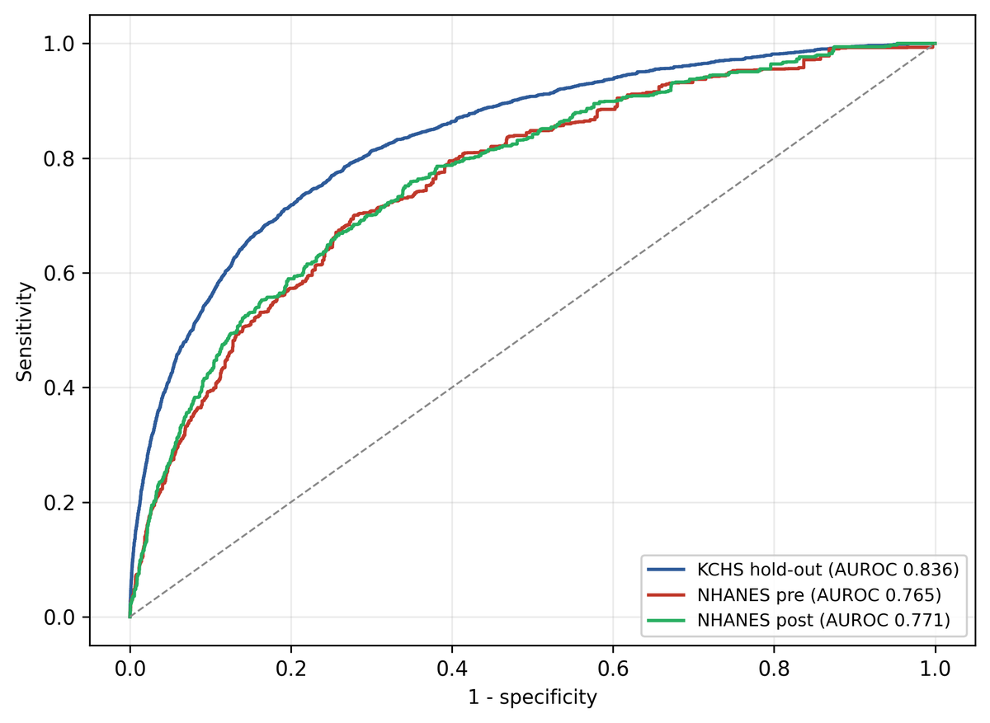

Table 2. Discrimination and calibration of the primary model (light gradient-boosting machine, 17 predictors) in the internal KCHS hold-out and the two NHANES cycles, before and after recalibration.
Metricª | Internal hold-out | NHANES pre-pandemic | pre-pandemic, recalibrated | NHANES post-pandemic | post-pandemic, recalibrated
AUROC (95% CI)^{b} | 0.836  (0.827-0.846) | 0.765  (0.724-0.804) | 0.764 | 0.771  (0.739-0.801) | 0.769
AUPRC (95% CI)^{c} | 0.246  (0.227-0.266) | 0.262  (0.208-0.329) | 0.261 | 0.345  (0.308-0.387) | 0.341
Brier score^{d} | 0.030 | 0.071 | 0.070 | 0.099 | 0.094
ECE^{e} | 0.003 | 0.030 | 0.010 | 0.068 | 0.014
Calibration slope (95% CI) | 1.03 | 0.65  (0.53-0.77) | 1.00  (0.95-1.00) | 0.68  (0.60-0.76) | 1.00  (0.97-1.00)
CITL (95% CI)^{f} | +0.10 | +0.51  (+0.37 to +0.64) | 0.00  (-0.01 to +0.02) | +1.13  (+0.98 to +1.26) | 0.00  (-0.02 to +0.01)
ªCIs are from a rescaled stratified cluster bootstrap with 1000 replicates; a cell shown without an interval was not resampled. Recalibration is the cross-fitted intercept-and-slope update described in the Methods; each fold carries its own calibration map, hence the recalibrated AUROC may shift by up to 0.002 and is not what the update targets.
^{b}AUROC: area under the receiver operating characteristic curve.
^{c}AUPRC: area under the precision-recall curve.
^{d}Brier score: mean squared difference between predicted probability and observed outcome, smaller being better.
^{e}ECE: expected calibration error.
^{f}CITL: calibration-in-the-large; positive values denote under-prediction of observed risk.
Testing Whether External Discrimination Can Be Raised Above ~0.77
Leakage-controlled optimization, whose pre-specified method search was additionally re-run independently (Table S9 in Multimedia Appendix 1), covered 2,199 recorded runs across 117 experiment files spanning feature engineering, hyperparameter search, ensembling, transfer-robust internal selection, domain adaptation, alternative losses and structural variants, and did not exceed external AUROC ~0.77 when model selection was restricted to KCHS-internal criteria; apparent gains from externally tuned variants did not survive leakage control (Tables S9 and S11 in Multimedia Appendix 1).
The ceiling was localized with an in-domain oracle, a diagnostic upper bound rather than a candidate model: NHANES was fitted on its own labels, cross-validated with folds split by primary sampling unit within each cycle. Across logistic, penalized-logistic, histogram-gradient-boosting and LightGBM learners the oracle reached only 0.764-0.776 (best learner 0.776, 95% CI 0.753-0.799; widening to 0.745-0.794 when the oracle is refitted inside each bootstrap replicate; Table S10 in Multimedia Appendix 1). The KCHS-transferred model (pre 0.765, post 0.771) therefore sits inside the confidence interval of the best in-domain performance any of these learners reached on NHANES itself, an empirical benchmark over the learners evaluated rather than a proof of a maximum, and one estimated on the pooled pre-plus-post sample against cycle-specific transported figures; the comparison is therefore approximate and cannot exclude a modest true gap.
Matching sample size did not close the gap: reduced to the NHANES sample size and cross-validated within Korea, the same 17 predictors still yielded 0.823 at n=7,888 and 0.810 at n=13,098 (the pooled oracle size), ie, 0.81-0.82 against an NHANES ceiling of ~0.77, and 0.830 only at n=200,000 (best of three learners, 5-fold weighted AUROC, in a separate KCHS-internal sample-size experiment). Three further checks agreed: density-ratio reweighting of the KCHS training sample toward the NHANES covariate distribution (labels unused) reduced external AUROC, to 0.766 and 0.758 against the in-run baseline of 0.772 pre and 0.769 post (Table S11 in Multimedia Appendix 1); increasing the KCHS training set from 0.5 million to 2 million records did not raise external discrimination; and adding the remaining harmonized-but-unused survey items (public-assistance receipt, weekend sleep duration, alcohol frequency, alcohol quantity in two codings and binge drinking) changed external AUROC by at most 0.003 in either direction, a check evaluated on external data and therefore reported as a diagnostic rather than as leakage-controlled evidence (Table S11 in Multimedia Appendix 1). Deep tabular learners (two multilayer perceptrons, TabNet and an FT-Transformer) all fell below gradient boosting internally, and none exceeded it on both external cohorts (Table S12 in Multimedia Appendix 1). None of these closed the gap, which recalibration cannot close either, correcting calibration rather than rank ordering.
Parsimonious Deployment Model
Predictor order and item count were both fixed inside the training set, the full item-count trajectory being given in Table S13 in Multimedia Appendix 1, and the analysis plan's margin (the smallest set within 0.02 AUROC of the full model) selected six items: self-rated health, age, sex, sleep duration, self-rated oral health, partnership. Evaluated afterwards on data that played no part in selection, this six-item form achieved hold-out AUROC 0.822, NHANES pre 0.748 and NHANES post 0.757, against 0.837/0.766/0.769 for the full 17-predictor model fitted on the same data (a loss of 0.015 internally, 0.018 pre-pandemic and 0.012 post-pandemic, each within the plan's 0.02 tolerance); H4 supported. On the selection set, discrimination rose steeply and then flattened (1 item 0.741; 3 items 0.781; 5 items 0.813; 6 items 0.818; 8 items 0.825; 12 items 0.832; 17 items 0.833), the margin being applied over every count below 17 without imposing the plan's preferred 5-10 item range. The five-item set falls 0.0002 below the threshold and the six-item set clears it by 0.0044; the five-versus-six boundary is therefore decided at the fourth decimal and should not be read as robust, the five-item model reaching 0.737 pre-pandemic and 0.751 post-pandemic externally. A variant selected under a stricter 0.01 margin adds smoking as a seventh item and is exploratory only, that margin being post hoc while the plan fixed 0.02; on external data the seventh item does not help consistently, raising pre-pandemic AUROC to 0.757 while lowering post-pandemic AUROC to 0.752. No external information entered the item-count decision (Tables S5, S13 and S15 in Multimedia Appendix 1).
Sensitivity Analyses
Discrimination was stable across specifications that alter modeling choices rather than the target condition (Figure 4): weighted training (0.836/0.764/0.768 internal/pre/post), missing-indicator imputation (0.837/0.764/0.772) and single chained-equations imputation of the continuous predictors (0.837/0.763/0.770) all lay close to the primary model. Restricting both training and evaluation to respondents aged ≥30 years improved discrimination (0.838/0.781/0.787); restricting training alone gave 0.836/0.770/0.769, placing most of that improvement in the evaluation case mix rather than in what the model learned. Changing the outcome definition to PHQ-9 ≥5 lowered discrimination throughout (0.761/0.735/0.740) at a much higher weighted prevalence (15.6%/25.0%/32.1%); notably, the Korea-US gap narrows from about 0.07 AUROC at the ≥10 threshold to about 0.02 at ≥5 (0.761 vs 0.735-0.740). Alternative alcohol definitions changed weighted AUROC by at most 0.003 externally, and each harmonization correction applied singly against the uncorrected baseline changed it by at most 0.003 in any cohort (Tables S6 and S7 in Multimedia Appendix 1).
Figure 4. Weighted area under the receiver operating characteristic curve (AUROC) for the internal hold-out and both NHANES cycles across specifications that alter modeling choices, the predictor set, the analytic population, or the outcome definition. The dotted vertical line marks the 0.80 internal target set in the protocol; exact values are given in Table S6 in Multimedia Appendix 1.
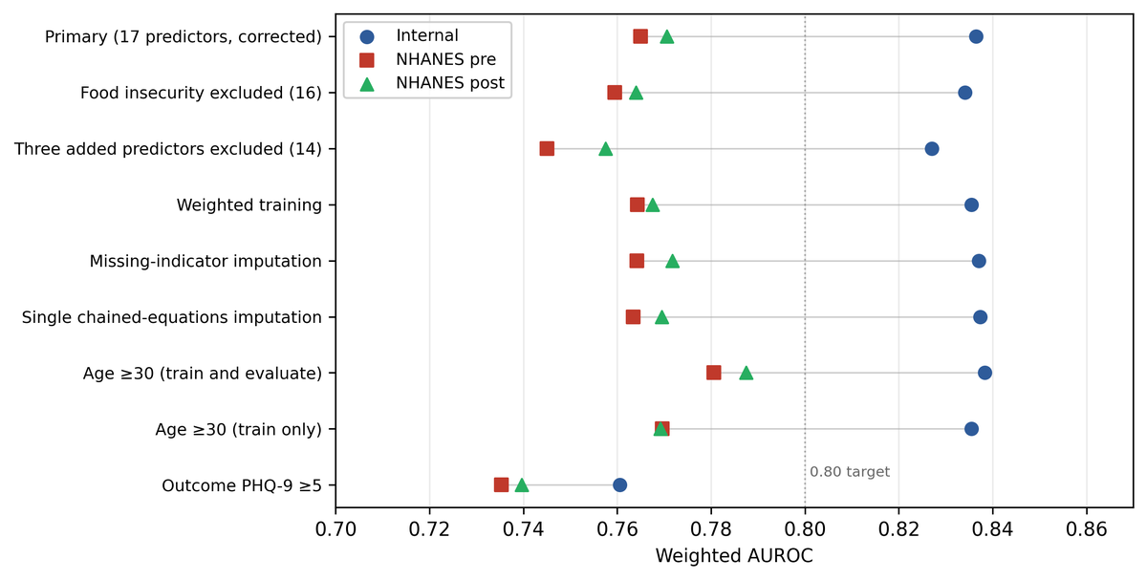

The harmonized set is also robust to its least-established members: refitting without employment, self-rated oral health and food insecurity, each model given its own hyperparameter search, lowers external discrimination to 0.745 (pre) and 0.757 (post), a difference of Δ+0.020, 95% CI +0.010 to +0.030 and Δ+0.014, 95% CI +0.006 to +0.020 (P<.001 for both; paired rescaled cluster bootstrap). In the pre-specified continuous-score analysis, run in the same pre-correction generation as the alcohol analysis and on a record-level rather than cluster-level split, a classifier of the deployed specification ranked the untransformed PHQ-9 total with weighted Spearman ρ=0.378 internally, 0.403 pre-pandemic and 0.439 post-pandemic, and a model trained on the continuous score performed similarly (ρ=0.402/0.403/0.424; weighted R² 0.216/0.166/0.102); the pattern is not an artifact of dichotomizing the outcome.
Living alone is absent from the pre-pandemic NHANES file, hence that cohort is scored as if no respondent lived alone, and the pandemic-period contrast mixes a period difference with a predictor-availability difference. Refitting on the 16 predictors observed in both cycles leaves the contrast unchanged: external AUROC 0.765 pre-pandemic and 0.771 post-pandemic, a difference of +0.006 (95% CI -0.044 to +0.056) against +0.006 (-0.045 to +0.056) for the 17-predictor model, with internal discrimination 0.836 against 0.836. Response-propensity weighting by the inverse of each cohort's education-specific module response rate moved external AUROC by at most 0.002 (0.765 vs 0.765 pre-pandemic, 0.769 vs 0.771 post-pandemic). Data-integrity fixes did not alter substantive conclusions. Under the common configuration of Table S6 in Multimedia Appendix 1, where the 17-, 16- and 14-predictor models share one setting and the 14-predictor value is 0.758 post-pandemic, removing food insecurity alone accounts for 28% of the 17-versus-14 gap pre-pandemic and 50% post-pandemic.
Interpretability, Fairness, and Clinical Utility
Global SHAP importance, computed in the development fitting partition, ranked the predictors: self-rated health (0.59); age (0.37); sex (0.28); sleep duration (0.26); self-rated oral health (0.23); partnership (0.19); smoking (0.17). Food insecurity contributed modestly (0.06, ranked 10th). The predictors carrying most of the signal are therefore the general-health, demographic and sleep items that both surveys measure identically (Figure 5).
Figure 5. Global predictor importance of the 17-predictor model, measured as mean absolute Shapley additive explanations (SHAP) value and computed on a random subsample of the development fitting partition. Larger values indicate a greater average contribution to the predicted risk; the measure is unsigned and does not indicate direction of effect.
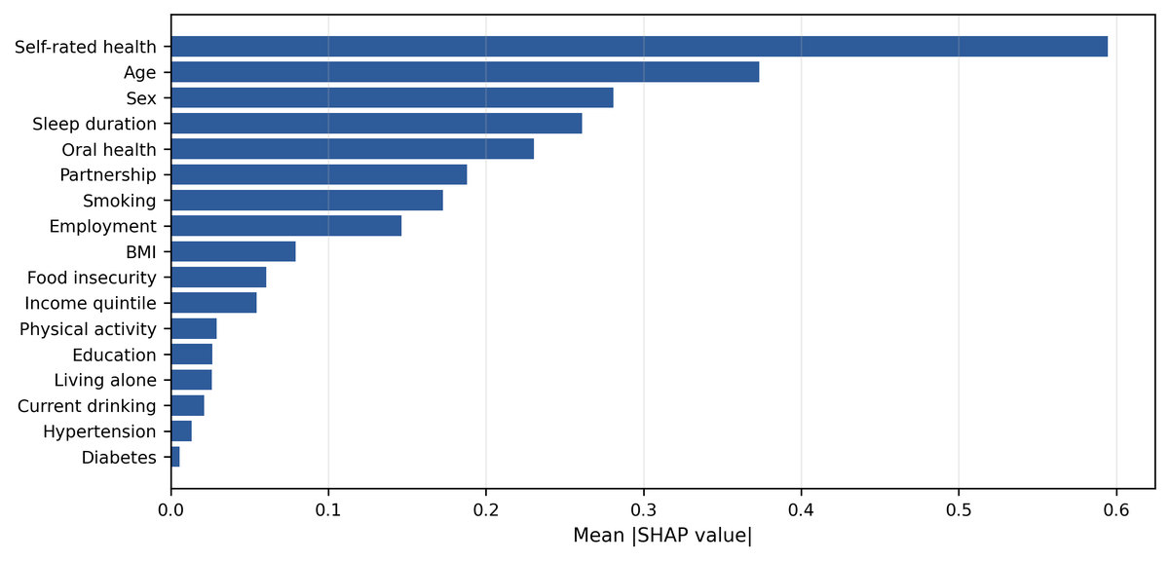

Rank ordering was highly concordant between KCHS and both NHANES cycles (Spearman ρ=0.97 pre, 0.99 post), an attribution that observes no external outcome. The clearest exception was food insecurity, on which the transported model leaned substantially harder externally (mean absolute SHAP 0.06 in KCHS against 0.18 and 0.15 in the NHANES cycles), consistent with its different measurement and much higher US prevalence.
Subgroup discrimination in KCHS spanned 0.781-0.882 (weighted AUROC): sex (female 0.826, 95% CI 0.814-0.837; male 0.838, 0.822-0.854), education (0.811-0.882), age (20-39 years 0.808, 0.790-0.827 < 40-59 years 0.822, 0.801-0.842 < ≥60 years 0.860, 0.850-0.870), and household income quintile (0.781-0.835, lowest in the highest-income quintile). In NHANES, discrimination was lower and far less precisely estimated. Pre-pandemic: Mexican American 0.693 (0.633-0.763; n=914), non-Hispanic Black 0.762 (0.727-0.805; n=2,096), other/multiracial 0.764 (0.665-0.865; n=381), non-Hispanic White 0.769 (0.715-0.818; n=2,798), other Hispanic 0.773 (0.725-0.820; n=813), non-Hispanic Asian 0.807 (0.716-0.874; n=886). Post-pandemic: Mexican American 0.692 (0.533-0.802; n=330), non-Hispanic Black 0.726 (0.642-0.791; n=598), non-Hispanic White 0.773 (0.726-0.815; n=3,215), other/multiracial 0.782 (0.701-0.853; n=340), other Hispanic 0.789 (0.751-0.845; n=499), non-Hispanic Asian 0.845 (0.656-0.987; n=228). Applying the fairness flag set in the analysis plan (a subgroup AUROC differing from the cohort value by more than 0.05) flags the highest income quintile in KCHS (-0.056); Mexican American in NHANES pre-pandemic (-0.072); Mexican American in NHANES post-pandemic (-0.078); non-Hispanic Asian in NHANES post-pandemic (+0.074). Within KCHS a few intervals sit clear of the cohort interval: higher in adults aged ≥60 years (0.850-0.870), middle-school-educated respondents (0.861-0.902); lower in income quintile 4 (0.772-0.822), the highest income quintile (0.744-0.818). Subgroup discrimination is therefore not uniform in the development population. In NHANES, by contrast, the intervals are wide and mutually overlapping, and every one overlaps the cohort-level interval; hence the race/ethnicity ordering should not be read as established differential performance; that the lowest point estimate falls in Mexican American respondents in both cycles nonetheless warrants monitoring as an equity caveat (Figure 6). Internal subgroup calibration was good (slope 0.96-1.13 across sex, age, education and income strata; subgroup CITL -0.03 to +0.20). In NHANES the subgroup calibration slopes were below 1 in all but one subgroup (0.57-0.79; non-Hispanic Asian post-pandemic 1.19), and subgroup CITL was positive in every group except Mexican American pre-pandemic (up to +1.32), confirming that the external miscalibration is under-prediction of absolute risk and not only over-extreme ranking. Exact subgroup values with CIs are tabulated in Table S14 in Multimedia Appendix 1.
Figure 6. Weighted AUROC and 95% CI by sex, age band, education and household income quintile in the KCHS hold-out, and by race and ethnicity in the two NHANES cycles. Intervals are domain estimates computed from replicate weights generated on the full cohort design; dotted vertical lines mark the corresponding cohort-level AUROC.
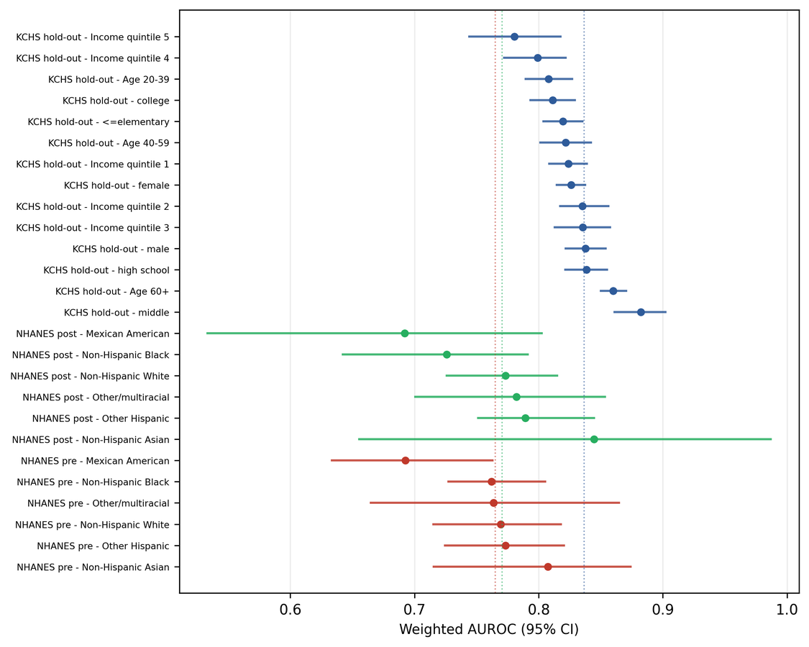

On decision-curve analysis the model gave positive net benefit exceeding both defaults across a clinically relevant threshold-probability range in all three datasets (Figure 7). At a threshold probability of 0.10, net benefit was +0.028 pre-pandemic and +0.058 post-pandemic after intercept/slope updating, against +0.010 internally, in each case above screen-all (-0.017, +0.024 and -0.072). The operating threshold was fixed once in the development data at 85% sensitivity and applied unchanged thereafter, hence the external operating characteristics are transported rather than guaranteed by construction. At that single threshold, sensitivity/specificity were 0.833/0.665 internally, 0.810/0.566 in NHANES pre and 0.791/0.596 in NHANES post, with positive predictive value 0.147 and 0.214 externally (number needed to screen 6.8 and 4.7) and negative predictive value 0.970 and 0.953; the model flagged 47% of the pre-pandemic and 45% of the post-pandemic population; operating points tuned to fixed sensitivity targets of 0.85 and 0.90 are tabulated in Table S15 in Multimedia Appendix 1. The flagged share follows from where the threshold is set: at 0.10 and 0.15 it falls to 27% and 16% pre-pandemic and to 40% and 26% post-pandemic (Tables S4, S5 and S15 in Multimedia Appendix 1). Clinical utility remains provisional pending prospective evaluation.
Figure 7. Weighted net benefit plotted against threshold probability over the range 0.02 to 0.30, with each dataset carrying its own screen-all and screen-none default strategies. The internal KCHS hold-out is scored with the original probabilities, and the two external cohorts with probabilities recalibrated out-of-sample by 5-fold cross-fitting grouped by primary sampling unit. The model is clinically useful over the range in which its curve lies above both defaults.
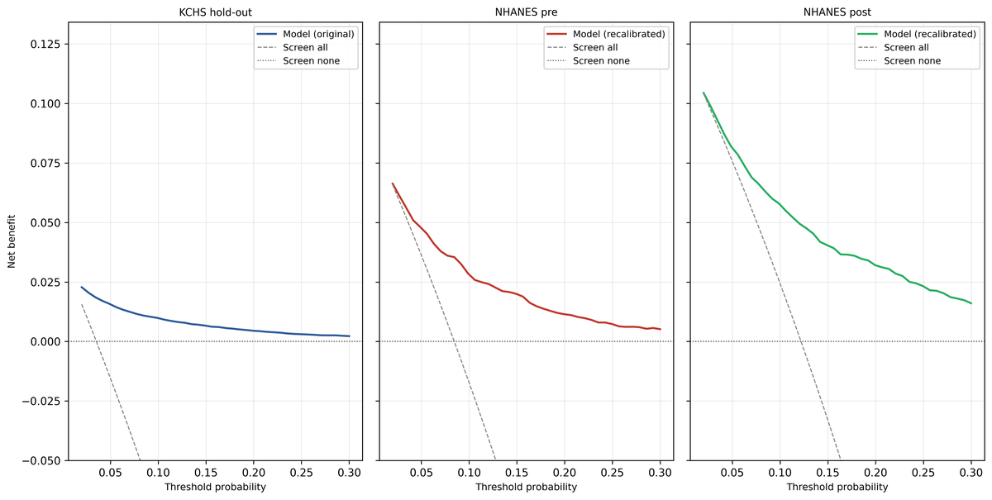

Discussion
Principal Findings
A depression-screening ML model developed in Korea met its internal target (AUROC 0.836) and retained clinically useful discrimination near 0.77 on genuinely external US data and across the COVID-19 shift, with calibration recoverable by lightweight recalibration. Further modeling did not raise external discrimination.
External discrimination was 0.765 (95% CI 0.724-0.804) before the pandemic and 0.771 (0.739-0.801) after it; the difference is +0.006 (95% CI -0.045 to +0.056; bootstrap P=.86), an interval computed after the fact, and the two cycles are not distinguishable at this sample size. Calibration behaved as transportability theory predicts: the slope fell to 0.65 and 0.68 and calibration-in-the-large rose to +0.51 and +1.13, ie, systematic under-prediction of absolute risk in a higher-prevalence population. Intercept-plus-slope updating restored both without re-estimating any predictor effect, to slope 1.00 (0.95-1.00) and 1.00 (0.97-1.00), with the update refitted inside every replicate so that its own uncertainty is carried. A six-item form selected entirely inside the development data lost only 0.015 internally and 0.018 and 0.012 externally; whether triage delivered this way improves depression outcomes was not evaluated here, the available mobile-delivery trial evidence concerning intervention delivery to defined patient groups [40] rather than the delivery of screening. With the threshold fixed once in the development data at 85% sensitivity and applied unchanged, external sensitivity was 0.810 and 0.791, the number needed to screen 6.8 and 4.7, and decision-curve net benefit exceeded both screen-all and screen-none defaults in every dataset, with the external cohorts taken after local recalibration.
Comparison With Prior Work
Prior ML depression models built on Korean national surveys report strong internal performance but no external validation. Using KNHANES 2014-2018 restricted to non-smokers at risk of secondhand smoke exposure (n=11,463), Kim et al [6] classified PHQ-9 ≥10 with internal AUROC up to 0.90; using the 2023 KCHS restricted to culturally diverse families (n=2,568), Kim et al [5] predicted the continuous PHQ-9 score with a test R² of 33%. Two deliberate design choices plausibly account for the lower internal discrimination (0.836): outcome-proximal predictors such as perceived stress and single-item depressed-mood questions were excluded, and the predictor set was restricted to variables transportable to a second country; no ablation was run to attribute the difference quantitatively across studies that differ in population and outcome scale. The wider field supplies the same contrast: a systematic review of electronic-health-record depression models found discrimination clustered near 0.80, almost always internal [7], and among hundreds of prediction models published during the pandemic almost none were validated outside the development source [8]. An internal 0.836 is therefore unremarkable against that literature; an externally validated 0.77 in a second country has few published counterparts. That the same predictors carry more signal within Korea (0.836 internally, 0.81-0.82 at matched sample size) than in the US (near 0.77) instantiates the dataset-shift problem described for deployed clinical artificial intelligence [11,41].
Plausible Mechanisms for the External Ceiling
Several lines of evidence converge on concept shift as the leading explanation for the plateau near 0.77. Modeling effort is ruled out first: across 2,199 catalogued runs spanning feature engineering, hyperparameter search, ensembling, domain adaptation and deep tabular learners, no configuration selected on development-internal criteria exceeded that level, and apparent gains from externally tuned variants did not survive leakage control [42]. Estimation error is ruled out next: matching sample size did not close the gap, and increasing the training set from 0.5 to 2 million records slightly lowered external discrimination.
The most direct test was an in-domain oracle, a diagnostic upper bound rather than a candidate model. Fitting NHANES on its own labels under cluster-separated cross-validation reached just 0.764-0.776, whereas the same predictors reached 0.81-0.82 in equally sized Korean samples. The transported model sits inside the oracle's confidence interval, and therefore already performs at the level of the best model fitted on those predictors inside the external population, among the learners evaluated.
Two specification analyses locate the shortfall at the moderate-or-worse end of the symptom distribution and among the youngest adults: at a PHQ-9 ≥5 threshold the Korea-US gap narrows from about 0.07 to about 0.02 (0.761 internally against 0.735 and 0.740 externally), and restricting training and evaluation to adults aged ≥30 years narrows it from 0.071 and 0.066 to 0.058 and 0.051; both patterns are suggestive rather than confirmatory. Predictor-importance rank order was almost unchanged between surveys (Spearman ρ=0.97 pre-pandemic and 0.99 post-pandemic). Near-identical ordering alongside external discrimination about 0.07 lower is more consistent with predictors that are the right ones but weaker externally than with a model attending to the wrong ones, a pattern at least consistent with the shift-stability framing of deployment failure in health artificial intelligence [43]. Measurement differences and complete-case selection cannot be separated from concept shift with these data.
Clinical and Policy Implications
The intended use is triage, not diagnosis; a positive score prompts confirmatory assessment rather than an action in itself. At the single development-fixed operating point, positive predictive value was 0.147 pre-pandemic and 0.214 post-pandemic, ie, 6.8 and 4.7 respondents screened per case identified, and 47% and 45% of the population were flagged for confirmatory assessment. The flag rate, not the positive predictive value, sizes the confirmatory capacity a screening program needs.
All six items of the deployment form are answerable on a single screen and need no examination, no laboratory value and no clinician; none is a symptom item, keeping the triage step distinct from the full PHQ-9. The 17-predictor version additionally needs body mass index and two physician-diagnosed conditions, which a self-completed form can only take on trust.
Any implementation outside the development population must apply local recalibration, since discrimination transported but absolute risk did not; published minimum-sample-size derivations for external validation are driven by the calibration slope rather than the AUROC [44], a constraint that binds first at a small deployment site.
Subgroup discrimination was lowest in Mexican American respondents in both NHANES cycles and, within the development population, in the highest income quintile, the one development subgroup that trips the analysis plan's 0.05 flag; the NHANES race and ethnicity intervals are wide and overlapping, leaving those differences unestablished. A deployed screener should report subgroup performance continuously [45]: the subgroup AUROC, the subgroup calibration slope, and the false-negative rate at the operating threshold, which spans 0.03 to 0.31 here (Table S14 in Multimedia Appendix 1).
Strengths and Limitations
The principal strength is that the outcome is identical in both surveys: a nine-item PHQ-9 sum of at least 10 in KCHS and in NHANES alike, which removes the outcome-harmonization error that usually confounds cross-national validation and leaves country, health system, population composition and survey mode as the differences under test. Evaluation was complex-survey weighted throughout; a data-integrity audit and peer review corrected seven data-processing and harmonization defects before the primary analysis. No NHANES data were used in fitting, tuning or selecting the primary model, and the optimization search was leakage-controlled, which removes external-label selection as a source of optimism in the ceiling claim.
Depression-module non-response is substantial and differential, costing 7.7% of the pre-pandemic and 14.1% of the post-pandemic sample on the MEC frame, counting any unanswered item (14.6% and 33.3% on the wider interview frame; Table S1 in Multimedia Appendix 1), and varying by education and by race and ethnicity; the external cohorts are therefore complete-case results, and the external estimates, particularly post-pandemic subgroup results, may be biased in an unknown direction. Alcohol, physical activity, income, body mass index and food insecurity are measured differently in the two surveys and were harmonized conservatively. Every predictor value was collected by interviewer administration or in an examination center; a web or mobile form changes the mode of administration for all 17 items, an untested change. The design is cross-sectional; the model screens current symptoms rather than predicting onset. The reference standard is a PHQ-9 sum of at least 10 rather than a diagnostic interview, hence every estimate reported here is agreement with a questionnaire-defined screening result and carries the imperfect sensitivity and specificity of that instrument against a semi-structured diagnosis [3,19]. Living alone is absent from the pre-pandemic NHANES file, hence that cohort is scored as if no respondent lived alone; food insecurity is a single item in KCHS, unmeasured there in 2020 and 2021; and prior depression diagnosis is unrecorded in KCHS, precluding a diagnosis-exclusion sensitivity analysis.
Internal estimates are hold-out rather than fully cross-validated (Multimedia Appendix 1). The external cohorts carry 728 and 661 events, modest for a validation study and most limiting for calibration [44]; conditioning on a single fitted update rather than refitting it gives visibly wider slope intervals (0.82-1.19 pre and 0.88-1.13 post, Table S3 in Multimedia Appendix 1), and a deployment that fits its update once on a modest local sample is in that wider regime. The predictor-set amendment was written while the study was under way, after an earlier external result was known but before any model using the amended set was fitted, and contributes a robustness analysis rather than a primary result (Multimedia Appendix 1). Two of the four hypotheses, H2 and H3, were stated qualitatively, without numeric decision margins; judging those two "supported" therefore involves interpretation.
A competing contributor is partly quantified, and it is not concept shift: the transportable predictor set is bounded by the development survey's content. Adding multimorbidity and healthcare utilization domains available in NHANES but not harmonizable to KCHS raised the in-domain oracle from 0.765 to 0.778, a 0.013 gain that is not itself evidence of signal transportable from Korea (Table S16 in Multimedia Appendix 1).
Conclusions
A survey-derived depression screener transports across country and pandemic period with clinically useful discrimination and recoverable calibration. The cross-national ceiling near 0.77 held against every leakage-controlled attempt to exceed it and against an in-domain oracle fitted on the external labels. It is therefore best read as a property of the transportable predictor set rather than as a proven maximum, most consistent with shift in the predictor-outcome relationship and with residual contributions from differing measurement, development-survey coverage and complete-case selection. Remaining gains are more likely to come from predictor domains a development survey does not yet collect than from further algorithm search. A low-burden six-item version, paired with local recalibration and continuing subgroup monitoring, is a plausible scalable digital triage aid.
Acknowledgments
The authors thank the Korea Disease Control and Prevention Agency (KDCA) and the US National Center for Health Statistics (NCHS) for making the KCHS and NHANES data available.
Funding
This research received no specific grant from any funding agency in the public, commercial, or not-for-profit sectors.
Data Availability
NHANES data are openly available from the NCHS (https://wwwn.cdc.gov/nchs/nhanes/). KCHS microdata are access-controlled and were obtained through the KDCA raw-data request-and-review process (https://chs.kdca.go.kr); under the data-use agreement the microdata cannot be redistributed. Analysis code sufficient to refit the reported model exactly from the source data (fixed seed, fixed hyperparameters), the full preprocessing specification (including the household income quintile, which is derived within the target cohort before the fitted pipeline is applied and is therefore not reproducible from a single individual's record alone), the variable-harmonization dictionary, the model card, and the protocol, statistical analysis plan and amendment documents are available from the corresponding author upon reasonable request, subject to applicable survey data-use restrictions; derived result tables are provided as Multimedia Appendices.
Authors' Contributions
[Author contributions, described per the CRediT taxonomy.]
Conflicts of Interest
The authors declare no conflicts of interest.
Use of Generative AI Tools
Generative artificial intelligence tools were used to assist with analysis code and manuscript drafting; all data processing, analyses, results, and interpretations were verified by the authors, who take full responsibility for the content.
Multimedia Appendix 1
Supplementary methods and results: the year-specific KCHS↔NHANES harmonization crosswalk, the predictor-set amendment, and the study-design, participant, harmonization, model-development, external-validation and ethics detail supporting the Methods, followed by Tables S1 to S16 giving the clinical-utility, sample-characteristic, sensitivity, transportability-ceiling and calibration-interval results.
Multimedia Appendix 2
TRIPOD+AI (2024) reporting checklist.
References
1. GBD 2019 Diseases and Injuries Collaborators. Global burden of 369 diseases and injuries in 204 countries and territories, 1990-2019: a systematic analysis for the Global Burden of Disease Study 2019. Lancet. Oct 17, 2020;396(10258):1204-1222. [doi: 10.1016/S0140-6736(20)30925-9] [Medline: 33069326]
2. Kroenke K, Spitzer RL, Williams JB. The PHQ-9: validity of a brief depression severity measure. J Gen Intern Med. Sep 2001;16(9):606-13. [doi: 10.1046/j.1525-1497.2001.016009606.x] [Medline: 11556941]
3. Levis B, Benedetti A, Thombs BD. Accuracy of Patient Health Questionnaire-9 (PHQ-9) for screening to detect major depression: individual participant data meta-analysis. BMJ. Apr 09, 2019;365:l1476. [doi: 10.1136/bmj.l1476] [Medline: 30967483]
4. Barry MJ, Nicholson WK, Silverstein M, Chelmow D, Coker TR, Davidson KW, et al. Screening for Depression and Suicide Risk in Adults: US Preventive Services Task Force Recommendation Statement. JAMA. Jun 20, 2023;329(23):2057-2067. [doi: 10.1001/jama.2023.9297] [Medline: 37338872]
5. Kim GM, Cha S, Jung M, Kim S. Machine learning prediction of depression in culturally diverse families: Findings from the Korea Community Health Survey. Front Public Health. Sep 18, 2025;13:1666084. [doi: 10.3389/fpubh.2025.1666084] [Medline: 41048299]
6. Kim NH, Kim M, Han JS, Sohn H, Oh B, Lee JW, et al. Machine-learning model for predicting depression in second-hand smokers in cross-sectional data using the Korea National Health and Nutrition Examination Survey. Digit Health. May 23, 2024;10:20552076241257046. [doi: 10.1177/20552076241257046] [Medline: 38784054]
7. Nickson D, Meyer C, Walasek L, Toro C. Prediction and diagnosis of depression using machine learning with electronic health records data: a systematic review. BMC Med Inform Decis Mak. Nov 27, 2023;23(1):271. [doi: 10.1186/s12911-023-02341-x] [Medline: 38012655]
8. Wynants L, Van Calster B, Collins GS, Riley RD, Heinze G, Schuit E, et al. Prediction models for diagnosis and prognosis of covid-19: systematic review and critical appraisal. BMJ. Apr 07, 2020;369:m1328. [doi: 10.1136/bmj.m1328] [Medline: 32265220]
9. Ramspek CL, Jager KJ, Dekker FW, Zoccali C, van Diepen M. External validation of prognostic models: what, why, how, when and where? Clin Kidney J. Nov 24, 2020;14(1):49-58. [doi: 10.1093/ckj/sfaa188] [Medline: 33564405]
10. COVID-19 Mental Disorders Collaborators. Global prevalence and burden of depressive and anxiety disorders in 204 countries and territories in 2020 due to the COVID-19 pandemic. Lancet. Oct 08, 2021;398(10312):1700-1712. [doi: 10.1016/S0140-6736(21)02143-7] [Medline: 34634250]
11. Finlayson SG, Subbaswamy A, Singh K, Bowers J, Kupke A, Zittrain J, et al. The Clinician and Dataset Shift in Artificial Intelligence. N Engl J Med. Jul 15, 2021;385(3):283-286. [doi: 10.1056/NEJMc2104626] [Medline: 34260843]
12. Kang J, Park J, Lee H, Lee M, Kim S, Koyanagi A, et al. National trends in depression and suicide attempts and COVID-19 pandemic-related factors, 1998-2021: A nationwide study in South Korea. Asian J Psychiatr. Aug 06, 2023;88:103727. [doi: 10.1016/j.ajp.2023.103727] [Medline: 37633158]
13. Steyerberg EW, Vergouwe Y. Towards better clinical prediction models: seven steps for development and an ABCD for validation. Eur Heart J. Jun 04, 2014;35(29):1925-31. [doi: 10.1093/eurheartj/ehu207] [Medline: 24898551]
14. Van Calster B, McLernon DJ, van Smeden M, Wynants L, Steyerberg EW. Calibration: the Achilles heel of predictive analytics. BMC Med. Dec 16, 2019;17(1):230. [doi: 10.1186/s12916-019-1466-7] [Medline: 31842878]
15. Collins GS, Moons KGM, Dhiman P, Riley RD, Beam AL, Van Calster B, et al. TRIPOD+AI statement: updated guidance for reporting clinical prediction models that use regression or machine learning methods. BMJ. Apr 16, 2024;385:e078378. [doi: 10.1136/bmj-2023-078378] [Medline: 38626948]
16. Moons KGM, Wolff RF, Riley RD, Whiting PF, Westwood M, Collins GS, et al. PROBAST: A Tool to Assess Risk of Bias and Applicability of Prediction Model Studies: Explanation and Elaboration. Ann Intern Med. Jan 01, 2019;170(1):W1-W33. [doi: 10.7326/M18-1377] [Medline: 30596876]
17. Kang YW, Ko YS, Kim YJ, Sung KM, Kim HJ, Choi HY, et al. Korea Community Health Survey Data Profiles. Osong Public Health Res Perspect. Jun 10, 2015;6(3):211-7. [doi: 10.1016/j.phrp.2015.05.003] [Medline: 26430619]
18. Chen TC, Clark J, Riddles MK, Mohadjer LK, Fakhouri THI. National Health and Nutrition Examination Survey, 2015-2018: Sample Design and Estimation Procedures. Vital Health Stat 2. Apr 2020;(184):1-35. [Medline: 33663649]
19. He C, Levis B, Riehm KE, Saadat N, Levis AW, Azar M, et al. The Accuracy of the Patient Health Questionnaire-9 Algorithm for Screening to Detect Major Depression: An Individual Participant Data Meta-Analysis. Psychother Psychosom. Oct 08, 2019;89(1):25-37. [doi: 10.1159/000502294] [Medline: 31593971]
20. Han C, Jo SA, Kwak JH, Pae CU, Steffens D, Jo I, et al. Validation of the Patient Health Questionnaire-9 Korean version in the elderly population: the Ansan Geriatric study. Compr Psychiatry. Oct 24, 2007;49(2):218-23. [doi: 10.1016/j.comppsych.2007.08.006] [Medline: 18243897]
21. Lorant V, Deliège D, Eaton W, Robert A, Philippot P, Ansseau M. Socioeconomic inequalities in depression: a meta-analysis. Am J Epidemiol. Jan 15, 2003;157(2):98-112. [doi: 10.1093/aje/kwf182] [Medline: 12522017]
22. Zhai L, Zhang H, Zhang D. SLEEP DURATION AND DEPRESSION AMONG ADULTS: A META-ANALYSIS OF PROSPECTIVE STUDIES. Depress Anxiety. Jun 05, 2015;32(9):664-70. [doi: 10.1002/da.22386] [Medline: 26047492]
23. Schuch FB, Vancampfort D, Firth J, Rosenbaum S, Ward PB, Silva ES, et al. Physical Activity and Incident Depression: A Meta-Analysis of Prospective Cohort Studies. Am J Psychiatry. Apr 25, 2018;175(7):631-648. [doi: 10.1176/appi.ajp.2018.17111194] [Medline: 29690792]
24. Luppino FS, de Wit LM, Bouvy PF, Stijnen T, Cuijpers P, Penninx BW, et al. Overweight, obesity, and depression: a systematic review and meta-analysis of longitudinal studies. Arch Gen Psychiatry. Mar 2010;67(3):220-9. [doi: 10.1001/archgenpsychiatry.2010.2] [Medline: 20194822]
25. Fluharty M, Taylor AE, Grabski M, Munafò MR. The Association of Cigarette Smoking With Depression and Anxiety: A Systematic Review. Nicotine Tob Res. May 19, 2016;19(1):3-13. [doi: 10.1093/ntr/ntw140] [Medline: 27199385]
26. Wu D, Liu F, Huang S. Assessment of the relationship between living alone and the risk of depression based on longitudinal studies: A systematic review and meta-analysis. Front Psychiatry. Aug 30, 2022;13:954857. [doi: 10.3389/fpsyt.2022.954857] [Medline: 36111305]
27. Buckman JEJ, Saunders R, Stott J, Arundell LL, O'Driscoll C, Davies MR, et al. Role of age, gender and marital status in prognosis for adults with depression: An individual patient data meta-analysis. Epidemiol Psychiatr Sci. Jun 04, 2021;30:e42. [doi: 10.1017/S2045796021000342] [Medline: 34085616]
28. Pourmotabbed A, Moradi S, Babaei A, Ghavami A, Mohammadi H, Jalili C, et al. Food insecurity and mental health: a systematic review and meta-analysis. Public Health Nutr. Mar 16, 2020;23(10):1778-1790. [doi: 10.1017/S136898001900435X] [Medline: 32174292]
29. Amiri S. Unemployment associated with major depression disorder and depressive symptoms: a systematic review and meta-analysis. Int J Occup Saf Ergon. Aug 05, 2021;28(4):2080-2092. [doi: 10.1080/10803548.2021.1954793] [Medline: 34259616]
30. Karimi P, Zojaji S, Abolghasemi Fard A, Nateghi MN, Mansouri Z, Zojaji R. The impact of oral health on depression: A systematic review. Spec Care Dentist. Nov 06, 2024;45(1):e13079. [doi: 10.1111/scd.13079] [Medline: 39501933]
31. Lee SJ, Lee KW, Cho MS. Association of Food Insecurity with Nutrient Intake and Depression among Korean and US Adults: Data from the 2014 Korea and the 2013-2014 US National Health and Nutrition Examination Surveys. Int J Environ Res Public Health. Jan 09, 2021;18(2):506. [doi: 10.3390/ijerph18020506] [Medline: 33435492]
32. Christodoulou E, Ma J, Collins GS, Steyerberg EW, Verbakel JY, Van Calster B. A systematic review shows no performance benefit of machine learning over logistic regression for clinical prediction models. J Clin Epidemiol. Feb 11, 2019;110:12-22. [doi: 10.1016/j.jclinepi.2019.02.004] [Medline: 30763612]
33. Van Calster B, Nieboer D, Vergouwe Y, De Cock B, Pencina MJ, Steyerberg EW. A calibration hierarchy for risk models was defined: from utopia to empirical data. J Clin Epidemiol. Jan 06, 2016;74:167-76. [doi: 10.1016/j.jclinepi.2015.12.005] [Medline: 26772608]
34. Rust KF, Rao JN. Variance estimation for complex surveys using replication techniques. Stat Methods Med Res. Sep 1996;5(3):283-310. [doi: 10.1177/096228029600500305] [Medline: 8931197]
35. Vickers AJ, Elkin EB. Decision curve analysis: a novel method for evaluating prediction models. Med Decis Making. 2006;26(6):565-74. [doi: 10.1177/0272989X06295361] [Medline: 17099194]
36. Vergouwe Y, Nieboer D, Oostenbrink R, Debray TPA, Murray GD, Kattan MW, et al. A closed testing procedure to select an appropriate method for updating prediction models. Stat Med. 2017;36(28):4529-4539. [doi: 10.1002/sim.7179] [Medline: 27891652]
37. Lundberg SM, Erion G, Chen H, DeGrave A, Prutkin JM, Nair B, et al. From local explanations to global understanding with explainable AI for trees. Nat Mach Intell. Jan 17, 2020;2(1):56-67. [doi: 10.1038/s42256-019-0138-9] [Medline: 32607472]
38. Obermeyer Z, Powers B, Vogeli C, Mullainathan S. Dissecting racial bias in an algorithm used to manage the health of populations. Science. 2019;366(6464):447-453. [doi: 10.1126/science.aax2342] [Medline: 31649194]
39. Vickers AJ, Van Calster B, Wynants L, Steyerberg EW. Decision curve analysis: confidence intervals and hypothesis testing for net benefit. Diagn Progn Res. Jun 06, 2023;7(1):11. [doi: 10.1186/s41512-023-00148-y] [Medline: 37277840]
40. Sun X, Jiang Y, Wang J, Fan S, Fu X, An Z, et al. Effects of a mobile health intervention based on a multitheoretical model of health behavior change on anxiety and depression, fear of cancer progression, and quality of life in patients with differentiated thyroid cancer: A randomized controlled trial. BMC Med. Oct 15, 2024;22(1):466. [doi: 10.1186/s12916-024-03652-0] [Medline: 39407174]
41. Futoma J, Simons M, Panch T, Doshi-Velez F, Celi LA. The myth of generalisability in clinical research and machine learning in health care. Lancet Digit Health. Aug 24, 2020;2(9):e489-e492. [doi: 10.1016/S2589-7500(20)30186-2] [Medline: 32864600]
42. Kapoor S, Narayanan A. Leakage and the reproducibility crisis in machine-learning-based science. Patterns (N Y). Aug 04, 2023;4(9):100804. [doi: 10.1016/j.patter.2023.100804] [Medline: 37720327]
43. Subbaswamy A, Saria S. From development to deployment: dataset shift, causality, and shift-stable models in health AI. Biostatistics. Apr 01, 2020;21(2):345-352. [doi: 10.1093/biostatistics/kxz041] [Medline: 31742354]
44. Riley RD, Debray TPA, Collins GS, Archer L, Ensor J, van Smeden M, et al. Minimum sample size for external validation of a clinical prediction model with a binary outcome. Stat Med. May 24, 2021;40(19):4230-4251. [doi: 10.1002/sim.9025] [Medline: 34031906]
45. Rajkomar A, Hardt M, Howell MD, Corrado G, Chin MH. Ensuring Fairness in Machine Learning to Advance Health Equity. Ann Intern Med. Dec 04, 2018;169(12):866-872. [doi: 10.7326/M18-1990] [Medline: 30508424]
Abbreviations
AUPRC: area under the precision-recall curve
AUROC: area under the receiver operating characteristic curve
BMI: body mass index
CI: confidence interval
CITL: calibration-in-the-large
DPQ: depression screener module (NHANES)
ECE: expected calibration error
KCHS: Korea Community Health Survey
KDCA: Korea Disease Control and Prevention Agency
KNHANES: Korea National Health and Nutrition Examination Survey
LightGBM: light gradient-boosting machine
MEC: mobile examination center
ML: machine learning
NCHS: National Center for Health Statistics
NHANES: National Health and Nutrition Examination Survey
PHQ-9: Patient Health Questionnaire-9
PROBAST: Prediction model Risk Of Bias Assessment Tool
SHAP: Shapley additive explanations
TRIPOD+AI: Transparent Reporting of a multivariable prediction model for Individual Prognosis Or Diagnosis, artificial intelligence extension

