Response Sheet for Modeling Soil Fluxes with NEON Data
Instructions: Read carefully and in your groups working together answer the numbered questions on your response paper. If you get stuck, please ask!

Introduction
- Read more about NEON: LINK. After reviewing the information on this page, what did you wonder or notice? What would you like to know more about? Please answer the question on the response sheet.
- One site in NEON is the San Joaquin Experimental Range website and record three facts you find interesting or important. What scientific or ecological questions do you think could be studied here? Please answer the question on the response sheet.

Fick’s law

Dependence of Fick’s Law on soil water and temperature

Understanding $g\left(W\right)$
- Based on this information, when soils are completely dry, we would expect more / less diffusion compared to when soils are completely wet. Please circle the correct answer on the response sheet.
- Let’s assume the function $g\left(W\right)$ is linear. Sketch a linear equation between the two points in Figure 1 for $0≤W≤1$. Sketch the function on the grid in the response sheet. Then determine the formula for the linear function $g\left(W\right)$ on your response sheet, showing your work appropriately. Please answer the question on the response sheet.
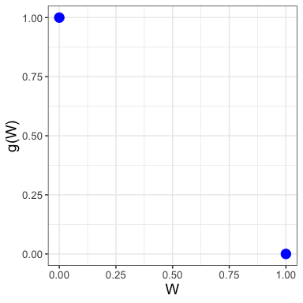
Figure 1: Grid for drawing $g\left(W\right)$ for different models.
- Evaluate $g\left(W\right)$ for different values of $W$, filling in Table 1 below on your response sheet:
Table 1: Comparison of different response functions to increasing soil water content $W$.
$W$ | $0$ | $0.2$ | $0.4$ | $0.6$ | $0.8$ | $1$
$g\left(W\right)$ (linear)
$g\left(W\right)$ (Equation )

- Use the information in Table 1 to add the Moyano model for $g\left(W\right)$ in Figure 1. Sketch the function on the grid in the response sheet. What do you notice about the Moyano model in comparison to your linear model? Please answer the question on the response sheet.
- Using the information in Table 1 and Figure 1, as $W$ increases, compared to the linear model the Moyano model is more / less sensitive to changes in soil water content because the linear model for $g\left(W\right)$ is greater than / less than the Moyano model at the same value of $W$. Please circle the correct answers on the response sheet.
- Since $g\left(W\right)$ ultimately affects $D_{s}$, which in turn is directly proportional to $F_{s}$, interpret your previous graph to determine for what values of $W$ would cause soil flux, $F_{s}$, to increase? to decrease? Please answer the question on the response sheet.

Understanding $f\left(T\right)$
- Evaluate $f\left(T\right)$ for different values of $T$, filling in entries in Table 2 below on your response sheet:
Table 2: Evaluation of $f\left(T\right)$ for different soil temperatures $T$
$T$ | $10$ | $15$ | $20$ | $25$ | $30$ | $35$ | $40$ | $45$ | $50$
$f\left(T\right)$ ($​^{∘}$C)

- Next use the information in Table 2, along with other additional points, to make a plot of $f\left(T\right)$ in Figure 2. Graph the function on your response sheet.
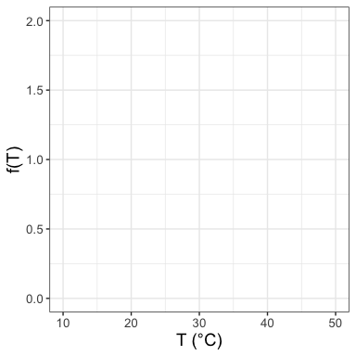
Figure 2: Grid for drawing $f\left(T\right)$.
- Based on the information in Table 2 and Figure Figure 2, $f\left(T\right)$ is increasing / decreasing as temperature $T$ increases. Circle the correct answer on the response sheet.
- Complete Table 3 for different values of $h$, first by evaluating $T\left(h\right)$ and then by evaluating $f\left(T\right)$. Fill in the table on the response sheet.
Table 3: Evaluation of $f\left(T\right)$ for different soil temperatures $T$
$h$ | $0$ | $4$ | $8$ | $12$ | $16$ | $20$ | $24$ | $50$
$T\left(h\right)$ ($​^{∘}$C)
$f\left(T\right)$

- Finally use the information Table 3 along with other values to sketch $f\left(T\right)$ over the course of the day in Figure 3. Sketch your graph on the grid in the response sheet.
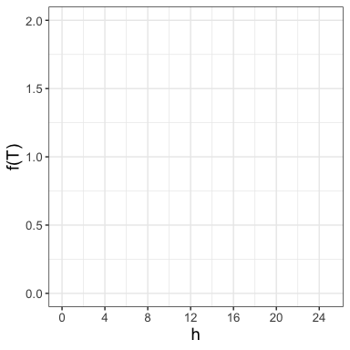
Figure 3: Grid for drawing $f\left(T\right)$.
- Using your graph, explain how the plot of $T\left(h\right)$ in Figure 3 could be representative of soil temperature over the course of a warm day. Please answer the question on the response sheet.
- Since $f\left(T\right)$ ultimately affects $D_{s}$, which in turn is directly proportional to $F_{s}$, interpret your previous graph to determine at what hours of the day would you expect the flux $F_{s}$ to be the largest. At what hours of the day is $F_{s}$ the smallest? Increasing or decreasing the quickest? Please answer the question on the response sheet.

Summarizing up
- In Table 4 indicate if the following factor increases or decreases soil CO$​_{2}$ by making a check ($✓$) for yes or $X$ for noin the appropriate column. Complete the table on the response sheet.
Table 4: Evaluation of different factors that influence soil CO$​_{2}$.
Factor | Increase soil CO$​_{2}$ | Decrease soil CO$​_{2}$
Temperature
Soil moisture
Plant roots
Soil microbes

Understanding and estimating concentration gradients
- The two depths closest to the soil surface occur at 3 and 9 cm. Using the values in Table 5, Compute the rate of change in CO$​_{2}$ for each unit change in depth using the two depths closest to the soil surface (this occurs at 3 and 9 cm). Please answer the question on the response sheet.
Remember to include units with your answer.
Table 5: Data for a CO$​_{2}$ profile at different soil depths.
Depth (cm) | CO$​_{2}$ (ppm)
3 | 735
9 | 1345
21 | 2879

- Table 6 provides data for another CO$​_{2}$ profile. Using the information in the table, estimate $\frac{dC}{dz}$. Please answer the question on the response sheet.
Table 6: Another CO$​_{2}$ profile at different depths.
Depth (cm) | CO$​_{2}$ (ppm)
3 | 735
9 | 1345
21 | 2879

- Which CO$​_{2}$ profile (Table 5 or Table 6) would predict a larger value of $F_{s}$? Provide a quick explanation why. Please answer the question on the response sheet.

Evaluating patterns in soil fluxes and environmental measurements
- Study the above interactive figure. Working with your group, identify:
- time intervals where $F_{s}$ increases rapidly.
- time intervals where $F_{s}$ steadily increases.
- time intervals where $F_{s}$ has several fluctuations.
Please answer the question on the response sheet.
- Next co-locate these intervals with measurements of $T$ (?@fig-soil-t) and $W$ (?@fig-soil-water). Explain how the measurements of $T$ and $W$ during these intervals would lead to larger or smaller values of $F_{s}$. Please answer the question on the response sheet.
- Choose two particular half-hours that correspond to where $F_{s}$ is low and another where $F_{s}$ is high and record your values of $F_{s}$, $T$, and $W$ in Table 7. Compute $f\left(T\right)$ and $g\left(W\right)$ at each of these times. Explain how these computations provide evidence / support for the calculated value of $F_{s}$. Please fill in the table on the response sheet.
Table 7: Summary table comparing two fluxes
h | $T$ | $W$ | $f\left(T\right)$ | $g\left(W\right)$ | $F_{s}$
$F_{s}$ low:
$F_{s}$ high:

- Here is a link to nearby weather station located by the San Joaquin Experimental Range: LINK. Look at the historical weather during the dates and intervals you selected to see if you can infer any additional evidence and support for what observed in $T$, $W$, $D_{s}$, or $F_{s}$. Please answer the question on the response sheet.

Additional questions for exploration
- Which CO$​_{2}$ profile (Table 5 or Table 6) might produce a higher uncertainty for $\frac{dC}{dz}$? Explain your reasoning. Please answer the question on the response sheet.

- Draw a conceptual picture of a soil CO$​_{2}$ profile following a heavy rainstorm that re-charged the soil, but the day following the top soil layers dried out. Explain why the soil profile should look that way. Please answer the question on the response sheet.

