

**The Patrol Portal**

Made by-

Aman Jain (16103335)

Deepak Parashar(16103099)

Hrishav Kumar(16103088)

Ujjwal Alreja(16103225)

The Patrol Portal is a website made for the goodwill of our city. It is a place where people can report the crimes in their vicinities and be assured that the issue will be dealt with, by the concerned authorities. But The Patrol Portal is not restricted to just reporting the crime. You can actually volunteer and be a part of the team- the brigade of citizens that are ready to dedicate some amounts of their schedules for the city.

**Features**

1. A person can sign up to volunteer and be a part of the patrolling team. (HTML Forms, Database updation and entry)
2. The registered volunteers can search the database for fellow volunteers. (Traversal of a database with more than 500 entries)
3. The members of functional teams divided according to their line of work can be viewed. (Queries red through the website)
4. View the number of currently operating volunteers in and around a locality.
5. Report a crime.

**Specifications**

The project encompasses concepts of Databases and Web Development. The database is managed with the help of MySQL. The website has been developed in HTML5, CSS3, RubyOnRails and JavaScript.

**Now a little detour of our website:**

**­­­­**

**­Simple way to find help around you**

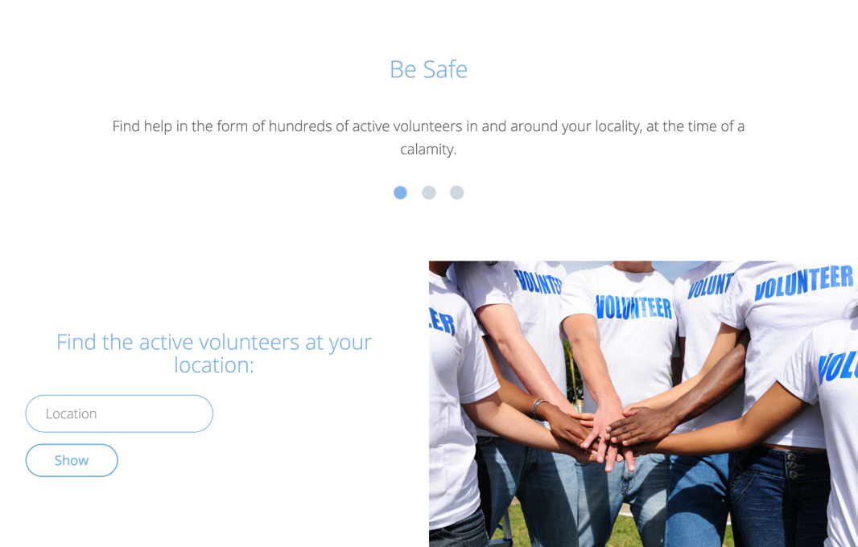

**­­­­It suggests your location**

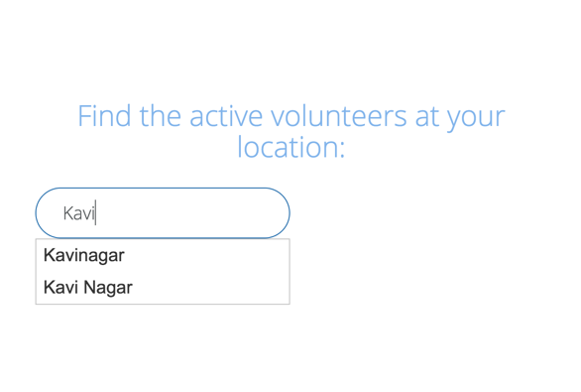

**And gives results accordingly**

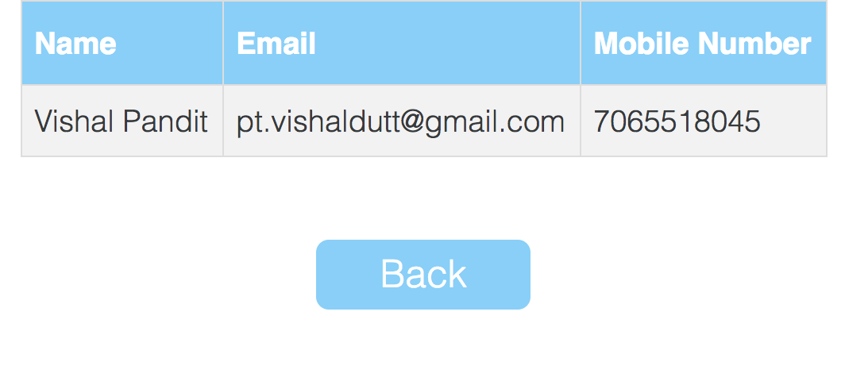

**You can report a crime**

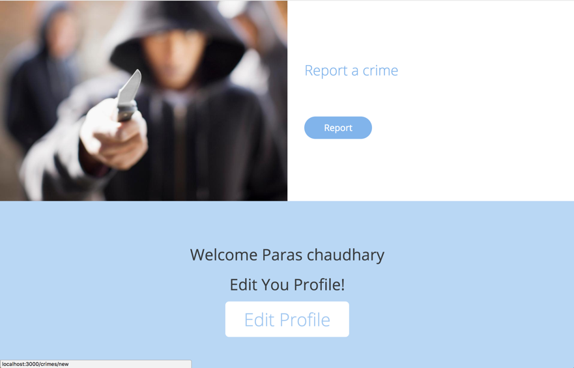

**Describe it**

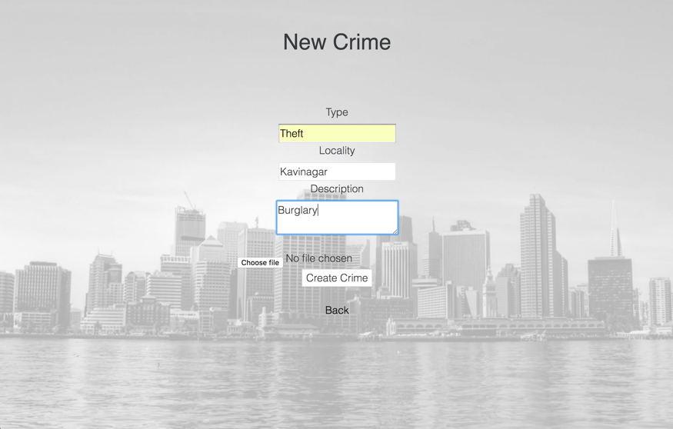

**Attach a photo of what you witnessed**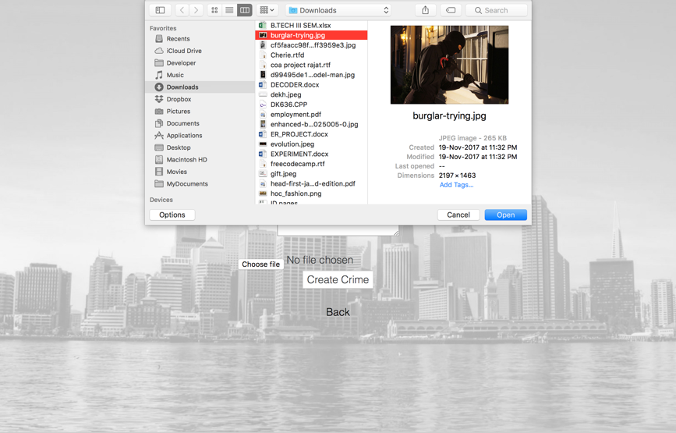

**You can Sign Up and you’ll get a confirmation mail too**

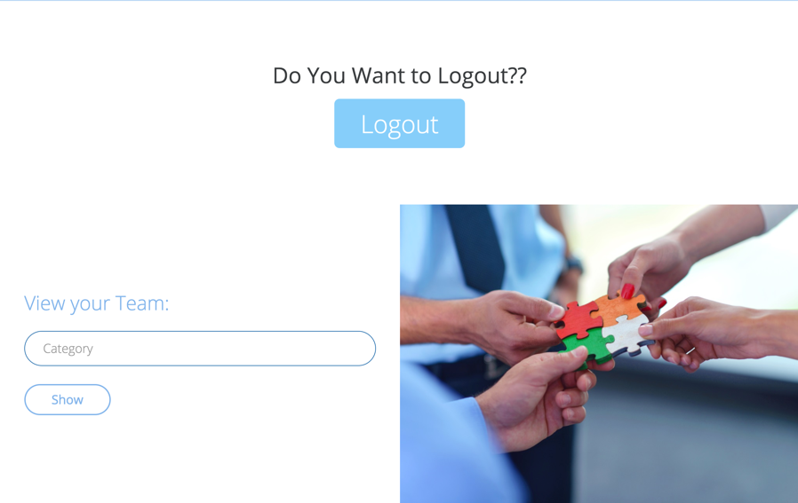

**You can view teams according to the categories**

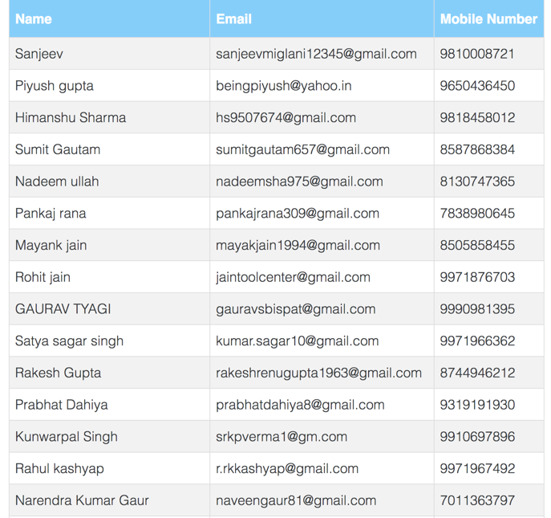

**Find volunteers with their names**

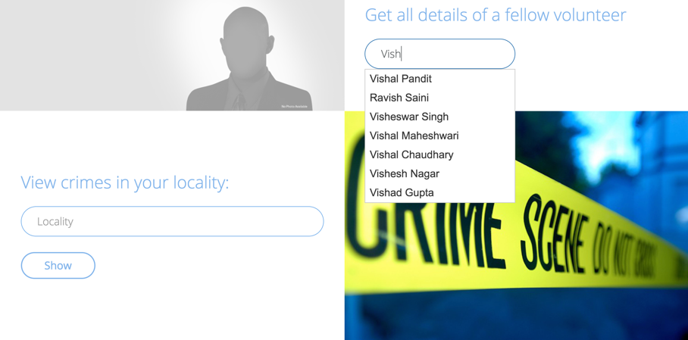

**View crimes in your locality, or all of them at once**

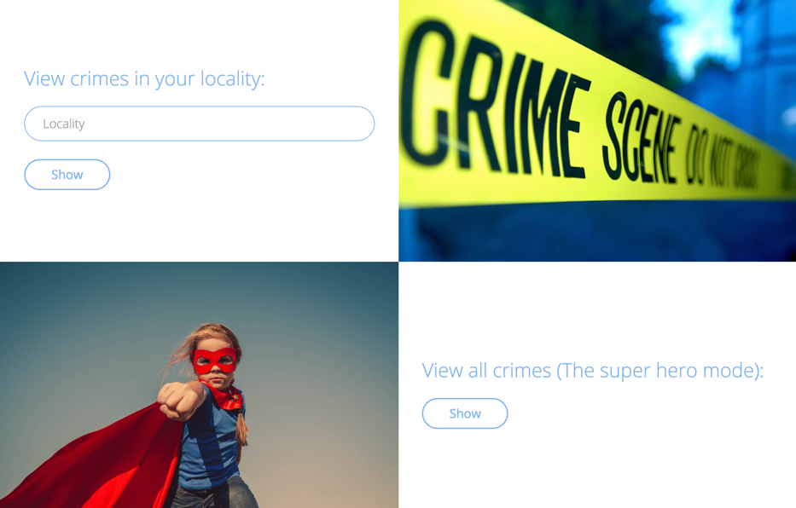

**View them as a list**

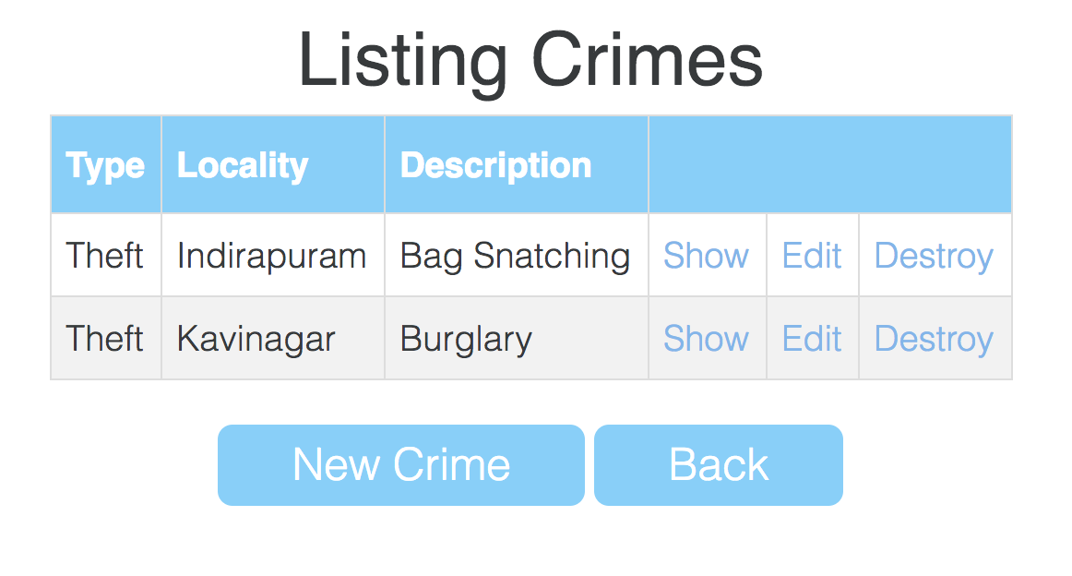

**Or see all the details and the image attached**

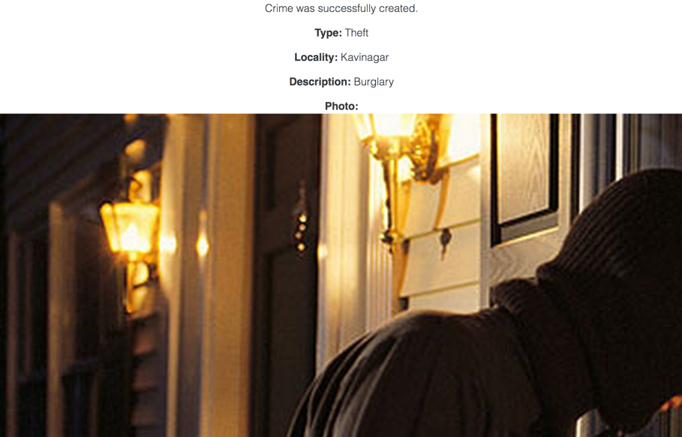

**HTML Code:**

<!DOCTYPE html>

<html>

<head>

<title>PatrolPortal</title>

<link rel="stylesheet" media="all" href="/assets/font-awesome.self-2a86d2017f4b74f22943750b3b50b9cb753581bab96cbdaaf2df53f4c04c995b.css?body=1" data-turbolinks-track="true" />

<link rel="stylesheet" media="all" href="/assets/animate.self-641be07219b40b6c5f730205ed8953f183ad973406d4bf0b0fbc2f682ebb6878.css?body=1" data-turbolinks-track="true" />

<link rel="stylesheet" media="all" href="/assets/bootstrap.min.self-69873844cda05bd5b5353d69d9e58ca6d0e8daf060cc39f76624152347f63ff6.css?body=1" data-turbolinks-track="true" />

<link rel="stylesheet" media="all" href="/assets/crimes.self-e3b0c44298fc1c149afbf4c8996fb92427ae41e4649b934ca495991b7852b855.css?body=1" data-turbolinks-track="true" />

<link rel="stylesheet" media="all" href="/assets/dev.self-38caf3195bf80bfe49dd7e015a33a4da6a5bd885fb5efdf08fec416548fd353d.css?body=1" data-turbolinks-track="true" />

<link rel="stylesheet" media="all" href="/assets/templatemo-style.self-0b3c10c824478800a60286a503c5e3565c43d5e9a28a324b0ae31e0d4f990bc6.css?body=1" data-turbolinks-track="true" />

<link rel="stylesheet" media="all" href="/assets/volunteers.self-e3b0c44298fc1c149afbf4c8996fb92427ae41e4649b934ca495991b7852b855.css?body=1" data-turbolinks-track="true" />

<link rel="stylesheet" media="all" href="/assets/welcome.self-e3b0c44298fc1c149afbf4c8996fb92427ae41e4649b934ca495991b7852b855.css?body=1" data-turbolinks-track="true" />

<link rel="stylesheet" media="all" href="/assets/application.self-4f22ee513bff51c07ddbacea6716b3bb025259c40c0c44f68b3b024ed0ff7a2c.css?body=1" data-turbolinks-track="true" />

<link rel="stylesheet" media="all" href="/assets/tether.self-5e572476d5a0a68e31995a09474060b5ab5b57f5292d388e13e5017d1185bad8.css?body=1" data-turbolinks-track="true" />

<script src="/assets/jquery.self-bd7ddd393353a8d2480a622e80342adf488fb6006d667e8b42e4c0073393abee.js?body=1" data-turbolinks-track="true"></script>

<script src="/assets/jquery_ujs.self-784a997f6726036b1993eb2217c9cb558e1cbb801c6da88105588c56f13b466a.js?body=1" data-turbolinks-track="true"></script>

<script src="/assets/turbolinks.self-1d1fddf91adc38ac2045c51f0a3e05ca97d07d24d15a4dcbf705009106489e69.js?body=1" data-turbolinks-track="true"></script>

<script src="/assets/autocomplete-rails.self-5d8d93a5f6e19ab6e682b9dd9999592b61ff3c3d69ea242a830a8556158001fa.js?body=1" data-turbolinks-track="true"></script>

<script src="/assets/bootstrap.min.self-7ef466d9e4a1de35084ed6cffed4e7f2d8a1931f9ccab3291d123244a9797a8c.js?body=1" data-turbolinks-track="true"></script>

<script src="/assets/crimes.self-877aef30ae1b040ab8a3aba4e3e309a11d7f2612f44dde450b5c157aa5f95c05.js?body=1" data-turbolinks-track="true"></script>

<script src="/assets/jquery-1.11.3.min.self-d62a9d41fef2c7d31d7005b6de57b0875ffa9be7ae812438d06d154dc4a197ff.js?body=1" data-turbolinks-track="true"></script>

<script src="/assets/jquery.touchSwipe.min.self-4c7c382c1cbe302cc09a77894c078f917509ecb255ecdef9bc8916b69afa9094.js?body=1" data-turbolinks-track="true"></script>

<script src="/assets/volunteers.self-877aef30ae1b040ab8a3aba4e3e309a11d7f2612f44dde450b5c157aa5f95c05.js?body=1" data-turbolinks-track="true"></script>

<script src="/assets/welcome.self-877aef30ae1b040ab8a3aba4e3e309a11d7f2612f44dde450b5c157aa5f95c05.js?body=1" data-turbolinks-track="true"></script>

<script src="/assets/tether.self-0e1103bd72084f20bc17863434595ea99e999bcf530d80110698608f35ff5620.js?body=1" data-turbolinks-track="true"></script>

<script src="/assets/wow.self-e243f7ab870fad3715097b85b0b0cfa6304e558637818d3f7f66dcf9195e474a.js?body=1" data-turbolinks-track="true"></script>

<script src="/assets/application.self-7862a8a8b42407b4741a1adeeea35f0d13ddc4f702ec532adb0674491d296495.js?body=1" data-turbolinks-track="true"></script>

<script type="text/javascript" src="https://cdnjs.cloudflare.com/ajax/libs/jquery-noty/2.4.1/packaged/jquery.noty.packaged.min.js"></script>

<script type="text/javascript" src="https://code.jquery.com/ui/1.12.0/jquery-ui.min.js"></script>

<link rel="stylesheet" media="screen" href="/assets/bootstrap.min.self-69873844cda05bd5b5353d69d9e58ca6d0e8daf060cc39f76624152347f63ff6.css?body=1" />

<link rel="stylesheet" media="screen" href="/assets/templatemo-style.self-0b3c10c824478800a60286a503c5e3565c43d5e9a28a324b0ae31e0d4f990bc6.css?body=1" />

<link rel="stylesheet" media="screen" href="/stylesheets/font-awesome-4.5.0/css/font-awesome.min.css" />

<link rel="stylesheet" type="text/css" href="https://code.jquery.com/ui/1.12.0/themes/smoothness/jquery-ui.css">

<meta name="viewport" content="initial-scale=7.0, width=device-width">

<link rel="stylesheet" type="text/css" href="https://cdnjs.cloudflare.com/ajax/libs/animate.css/3.5.2/animate.min.css">

<script type="text/javascript" src="https://cdnjs.cloudflare.com/ajax/libs/socket.io/2.0.4/socket.io.js"></script>

<script src="https://www.atlasestateagents.co.uk/javascript/tether.min.js"></script>

<meta name="csrf-param" content="authenticity_token" />

<meta name="csrf-token" content="eFt1DeLXCj6YE6lyRxgu+DzMFRotLW2p26TiU9cBoARQOpAcvev9lDvtk2lxCFKZhZBZZNeUXn2D1Eflz2KJ1w==" />

</head>

<body>

<!DOCTYPE html>

<html>

<head>

<meta charset="utf-8">

<meta http-equiv="X-UA-Compatible" content="IE=edge">

<meta name="viewport" content="width=device-width, initial-scale=1">

<title>The Patrol Portal </title>

<link rel="stylesheet" href="https://fonts.googleapis.com/css?family=Open+Sans:300,400">

<!-- <link rel="stylesheet" href="font-awesome-4.5.0/css/font-awesome.min.css">

<link rel="stylesheet" href="css/bootstrap.min.css">

<link rel="stylesheet" href="css/templatemo-style.css"> -->

</head>

<body>

<link rel="stylesheet" href="https://code.jquery.com/ui/1.12.1/themes/base/jquery-ui.css">

<script src="https://code.jquery.com/jquery-1.12.4.js"></script>

<script src="https://code.jquery.com/ui/1.12.1/jquery-ui.js"></script>

<script>

new WOW().init();

$(function() {

var availableTags = ["Kavinagar","Kotwali","Sihani Gate","Sahibabad","Kavi Nagar","Khoda","Vijay Nagar","Link Road","Indirapuram","Noida"];

$( "#contact_name" ).autocomplete({

source: availableTags

});

} );

</script>

<script>

$(function() {

var availableTags = ["Vishal Pandit","Kapil Mehra","Rajiv Garg","Dharmendra Kumar Jain ","Anurag Bansal","Yashpal Gupta","Ravi Kumar Kashyap","Mohit Chaudhary","Pawan Saini ","Sanjeev ","Pooja Chadha","Vipul Sharma","Sanjeev Kumar Mittal","Siddharth","Rishi Bhardwaj","Munish Gupta","Vijendra Singh","Sachin Bhatnagar","Tarun","Mohit Chauhan","Amit ","Vikas Kumar","R D Pal Garg","Rakshit Josain ","Rishi Raman","Deepak Darora","Anju Singh","Piyush Gupta","Babita","Sandeep Kumar","Kamal","Himanshu Sharma ","Ravi Kiran.Panwar@Gmail.Com","Vineet Prasad","Kapil Tyagi ","Brijesh Rana ","Sumit Gautam","Mayank Kaushik ","Akash","Ashu Gautam","Rohit Sharma","Anshu Bhati ","Manish Kumar","Gaurav Arora","Mayank Sharma","Nadeem Ullah","Vaseem Alam","Harsh Verma","Rajmala Mishra","Ravish Saini","Chiranjeev Sharma ","Kapil Kumar","Chetan Sharma","Puneet","Bhairav Kumar Jha","Vikash Kumar Dwivedi","Pradeep Kumar ","Sandeep Tyagi","Pankaj Rana","Shivender ","Chandranshu Tyagi","Vivek Sharma","Deepak ","Nitin Kaushik","Samir","Prabhat Gupta","Rahul Kumar","Dheeraj Kumar","Pritam Kumar","Mayank Jain","Rohit Jain","Gaurav Tyagi","Satya Sagar Singh","Sunil Vaid","Sonu Chaudhary ","Rakesh Gupta","Rohit Shrivastava","Adv Monu Tyagi","Prabhat Dahiya","Anil Kumar Sharma","Ajay Kumar Gupta","Kunwarpal Singh","Noor Raja","Harish Kaushik","Ankit Sharma","Ani Choudhay","Adheesh Vats ","Shamir Khan","Abhishek Garg ","Sanjeev Satija","Vinod Kumar ","Rahul Kashyap ","Sandeep Pal","Ashok Kumar","Rajeev Kumar Sharma","Shubham","Rishu Kumar ","Ankur","Rahul Singh ","Avneet Kumar","Nitesh Kumar","Ashutosh","Sachin Shrivastava","Narendra Kumar Gaur","Alok Upadhyay","Navinder Kumar","Munesh Kumar Gaur","Ravinder Singh","Adv. Chandrapal","Rajiv Malhotra","Sunny Choudhary","Ashit Tyagi ","Yogesh Kumar","Hemant Tyagi ","Azad Khalid","Sanjay Chauhan","Amit Pradhan","Saket Agarwal","Vikas Kumar ","Saurabh Singhal","Krishan Pratap Singh","Gaurav","B S Manral","Ankur Garg","Nitin Sharma","Gagan Deep Singh ","Inderjeet Singh Rao","Tanveer Ahmed","Gajendra Singh Teotia","Anmol Khanna","Gaurav Garg","Satish Gupta","Sanjay Tripathi","Rohit Gupta","Praveen Kumar","Ashish Bhargava ","Mohan Sharma","Kapil Bhati","Gajendra Yadav","Anil Sarin","Vivek Chaturvedi","Naveen Rana ","Kapil","Meenu Jain","Gajendra Chauhan","Dr Sompal Singh","Sanjay Sharma ","Tanuj Gambhir","Sukhveer","Ravi Aggarwal","Maheswaran Nair","Vikas Goel","Ravi Kathuria","Deepak Tyagi ","Dev Sharma","Shivam Gautam","Sanjay Chaudhary ","Ashish Mudgal","Deepak Agrawal","Sachin Kumar Kadiyan","Sonu Malhotra","Nitin Tyagi","Rajiv Walia","Vivek Kumar","Sudhir Rai","Atul Tyagi","Vivek Jain","Sandeep Chaudhary","Ranjeet Kushwaha ","Shiva Tiwari","Bhupendra Singh Chaudhary","Amit Singh Chauhan","Manoj Kumar Gaur","Amritesh Kumar ","Visheswar Singh","Ashish Kumar Mishra","Ashutosh Chauhan","Afsar Ali","Kamlendra Gautam(Monu)","Saurabh Kumar Panwar","Rajkumar Tiwari","Shubham Garg","Peeyush Rohilla","Deepanshu Sharma","Arun Kumar","Aman Jain","Tauseef Siddiqui","Sumit Sharma","Jitendra Sharma","Mursalin Khan","Sahil Pervez","Kamalaksh K M ","Azeem Khan","Shakir Khan","Ved Prakash Gupta","Anit Kumar","Gaurav Gupta","Rajat Bansal","Sanjay Garg","Punit Kansal","Mohit","Saurabh Vats","Ajay Gautam","Bharat Kumar Upadhayay","Inder Pal Chauhan","Mayank Gupta","Shivendra Singh","Sachin Arya","Amitkumar Sharma","Deepak","Sanjay Awasthi","Yogesh Kumar Gola","Naresh Kumar Sharma","Yugal Kishor","Tulika Gupta","Sachin Kumar","Debashis Chatterjee","Arvind Kumar Singh","Jaikumar Sharma","Shishir Vats","Nand Kishore Negi","Navtej Singh","Deepak Dagar","Sajid Saifi","Shailav Bhushan","Pankaj Kumar","Sunil Kumar","Anand Aggarwal","Gaurav Mittal","Rajender Singh Chauhan ","Vineet Agrawal","Prakash Chand Srivastava ","Saurabh Mishra","Ankit Kumar ","Shubham Sharma","Ravindra Kumar","Jatin Kumar","Kishan Kashyap ","Deepankar Mishra ","Sharad Goel","Rohit Yadav","Ashok Kumar Sethi ","Bhanu Pratap Singh","Abhishek Chaudhary","Bharat Panwar ","Anurag Sharma ","Dalip Singh ","Vinay Gupta","Pawan","Parmod Bisht","Manish Bhatnagar","Abhinav Choudhary","Nikunj Tyagi ","Rahul Pal","Anil Pandit","Akhilesh","Manoj Kumar","Harsh Gureja","Vikash Kumar","Rahul","Adit Chandra Pokhriyal","Nikhil Mishra ","Dinesh Sharma","Iklakh Khan","Tarun Kumar","Rajeev Pasi","Dr .C.B.Jha","Anshumaan Choudhary","Abhijit Mukherjee","Sachin Singhal","Ashwani Tyagi","Sunil Sharma","Pankaj Dutt Sharma","Rovin Rajput","Mohd Sabir","Preeti Agarwal","Shobhit. Ansal","Rohit Chauhan","Rajendera Kumar","Vijay Sharma","Sahil Khatri","Mohd Danish","Jayant Abhishek","Mohd Usama","Viresh Nagar","Arindam Roy","Kishor Kumar","Deepak Jha","Vikrant Tyagi","Kapil Tyagi","Shiva Kant Singh","Ashu Sengar","Mitesh Kumar","Prabhakar Bhatt","Gourav Agarwal","Navin Kumar","Neeraj Tyagi","Jeet Jha","Vikas Yadav","Mohit Kumar Bansal","Animesh Kunar","Piyush Garg","Ravi Tripathi","Sakir Saifi ","Shailendra Tamoli","Nishant Tyagi","Kuldeep Sharma","Narayan Dutt Joshi","Sanjaykumar","Abhay Singh","Vijay Kumar Mittal","Kohinoor ","Arun Madaan","Deepak Sharma","Vipin Kumar","Kush","Mohammad Salam","Yogesh Solanki","Mannu Tyagi","Lalit Sharma","Shivkumar","Nitin Singh","Ansar Saifi","Vinay Kumar ","Sagar Chaudhary","Pintu Kumar","Deepanshu Sakhuja ","Vicky Gautam","Rakesh Kumar ","Rajesh Kumar Jain ","Bittu","Ashok Sharma","Aakash Singh","Pulkit Agrawal","Mohit Kumar","Pawan Kumar","Vijay Pal Singh","Suraj Jha","Vikas Vashisht ","Amit Giri","Sunil Singh Yadav","Amit Kumar","Puneet Yadav","Aleem Alvi Advocate","R K Sharma","Rajinder Sharma","Vaishali Bhardwaj","Akash Verma","Anil Sharma","Varun Goyal","Puneet Bhardwaj","Neerajkumarkashyap","Rishabh Jain","Vivek Tomar","Monitor Kumar","Virendra Singh","Nk Pandey","Niranjan","Sunil Rawat","Sunil Kumar ","Sachin Rathore","Praveen Sharma","Vishal Maheshwari","Pradeep Tyagi","Manish Kumar ","Irfan Ali","Pankaj Bhardwaj ","Ashish Kumar Mittal","Dr B P Sharma","Aditya Singh","Satyendra Kumar Singh","Vipul Singhal ","Akshay Bhati","B K Khanna","Arun Sharma","V. K. Saxena","Ashish Agnihotri ","Deepak Gupta ","Virendra Grover","Nandini Singh ","Mohit Tomar","Shobhit Garg","Suman Pal","Nishant Madan","Sankalp Jain","Asis Kumar Das","Sanjay Gupta","Sanjeev Dixit","Neeraj Mishra ","K.Ashish","Ajay Pal Singh","Mahendra Pal Sharma","Vipin Kumar Tomar","Raaj Kamal Khare","Brijesh Misra ","Vinay Agarwal","Azwar Ali","Ravi Kumar","Saumya Ahuja","Meeta Bose","Dharamvir Singh","Vivek Tyagi","Sanjay Tyagi","Snehlata Singh ","Akash Kumar Chaurasiya","Manoj Kumar Yadav","Ankit Singhal","Gaurav Bhardwaj","Vijay Arora","J K Sarna","Rashmi Chakravarti","Umesh Kumar Saraswat","Sunil Kumar Shukla","Sunil Jain","Mubarak Hussain Siddique","Nitin Jain","Mukesh Choudhary","Surendra Pratap Singh","Chandra Mohan Tyagi","Atul Kumar Gupta","Aman Goel","Santanu Das","Sheetal Tyagi","Ashish Singhal","Arun Kumar Singh","Shivam","Harish Pandit","Phool Singh Sharma","Athar Kamal Alias Sameer Shahi","Ashwini Kumar Singh","Nirmal Jatav","Rahul Tomer","Sandeep Kumar ","Vikrant Singh","Ashish Arora ","Vishal Chaudhary","Rishab Chaudhary","Chiradeep","Sanjay Tomar","Sandeep Singh","Satender Singh","Js Rajpoot ","Rakesh Kumar Chakraworty ","Akanksha Singh Kushwaha","Seema ","Ved Pal ","Sandhya Tyagi","Anshu Tyagi","Neha Verma","Akshay","Sanjay Kumar","Abhinav Yadav","Amit Kumar Sharma","Mohit Mittal ","Alok Kumar","Anurag Goyal","Sailesh Kumar","Rupesh Varshney","Ankit Varshney","Rahul Kumar Verma","Pramod Kumar ","Neeraj Kumar Vats","Vishesh Nagar","Deepak Singh","Ajay Gupta ","Sachin Goel","Ankur Agarwal ","Varun Gulati","Hansa Tewari","Narendarkumar ","Sachin Sharma","Tarun Kumar ","Anubhav Agarwal","Megga","Prabhat Rai","Shamshad Khan","Sachin Bhati ","Arun Kumar ( Rinku)","Abhishek Rana","Suni Mantoo","Pankaj Bhardwaj","Vishad Gupta","Sanjeev Awal ","Preeti Chandra ","A K Sharma","Akash Pachauri ","Syed Abid Ali","Hari","Gajender Paswan ","Kamlesh Pandey","Mayank Deo","Saurabh Sirohi","H.C.Pant","Vikas","Yogesh ","Vikas Singh","Rohit Kumar","Naresh Pal Singh ","Jay Kumar","Gargi Tyagi","Mukesh Gairola","Arpit Arora","Vijay Shanker Tiwari","Varun Kumar","Vipin","Madhur Jain","Rakesh K Garg","Charanjeet Singh","Raj Sharma","Karan Bhullar","Ashutosh Savarni","Vikas Deep","Ashish Kumar","Dharmendra Kumar ","Rahul Chopra","Priyanka Gautam","Shikha Chetan","Pawan Gautam","Dushyant Gautam","Krishna","Vineet Kumar","Ashish Meena","Ram Bal Sharma","Durgesh Kumar Gupta","Namita Bhalla","Kunal Gautam","Lalit Gautam","Shivam Saxena","Kuldeep Dubey","Gaurav Goel","Shipra","Kapil Kasana ","Jitendra Singh","Vijay Kumar Srivastava ","Phiroz Shah","Anil Kumar Singh","Lalit Pande","C. Ashok Vardhan","Sandeep Sharma","Malay Majumder","Brijesh Sharma ","Khajan Pant","Maneesh Jain","Yudhveer Singh ","Rahul Agarwal","Anurag Agarwal","Ghanshyam Kumar Jha","Deepak Sharma ","Aditya Jain","Manish Sen Gupta","Harish Chandra Singh","Sahil Sen Gupta","Vipul Agarwal","Atul Kumar Jagota ","Rajender Kumar Verma","Shameem Alvi","Lalit Shrma","M.S. Rajpal","Gaurav Agarwal","Navneet Sirohi","Praveen Kumar Gupta","Kapil Singhal","Sunil Dutt","Arun Gangwar","Paras Chaudhary"];

$( "#contact_namess" ).autocomplete({

source: availableTags

});

} );

$(function() {

var availableTags = ["General Public","Spo","Civil Defence","Rwa Member","Rwa Members"];

$( "#contact_namesss" ).autocomplete({

source: availableTags

});

} );

$(function() {

var availableTags = ["Indirapuram"];

$( "#contact_namessss" ).autocomplete({

source: availableTags

});

} );

</script>

<div class="container-fluid">

<div class="row wow zoomInUp">

<section class="tm-section-intro">

<div class="col-xs-12 col-sm-12 col-md-12 col-lg-12 col-xl-12">

<div class="tm-wrapper-center">

<h1 class="tm-section-intro-title">The Patrol Portal</h1>

<p class="tm-section-intro-text">Your go to place for all your security concerns.<br>

We provide safety which is for the civilians, by the civilians and from the civilians.

</p>

<a href="#tm-section-2" class="tm-btn-white-big">Explore</a>

</div>

</div>

</section>

</div>

<div class="row wow shake" id="tm-section-2">

<div class="col-xs-12 col-sm-12 col-md-12 col-lg-12 col-xl-12">

<section class="wow tada">

<div id="tmCarousel" class="carousel slide tm-carousel" data-ride="carousel" data-interval="false">

<ol class="carousel-indicators">

<li data-target="#tmCarousel" data-slide-to="0" class="active"></li>

<li data-target="#tmCarousel" data-slide-to="1" class=""></li>

<li data-target="#tmCarousel" data-slide-to="2" class=""></li>

</ol>

<div class="carousel-inner" role="listbox">

<div class="carousel-item active">

<div class="carousel-content">

<div>

<h2 class="tm-carousel-item-title">Be Safe</h2>

<p class="tm-carousel-item-text">Find help in the form of hundreds of active volunteers in and around your locality, at the time of a calamity.

</p>

</div>

</div>

</div>

<div class="carousel-item">

<div class="carousel-content">

<div>

<h2 class="tm-carousel-item-title">Make Safe</h2>

<p class="tm-carousel-item-text">Report a crime as soon as you witness one, the tip would be kept totally anonymous and the closest volunteer team would be deployed to the crime scene, as soon as possible.

</div>

</div>

</div>

<div class="carousel-item">

<div class="carousel-content">

<div>

<h2 class="tm-carousel-item-title">Keep Safe</h2>

<p class="tm-carousel-item-text">Become a permanent volunteer yourself and find the satisfaction of making the world a better place by helping your fellow locality inhabitants, and making the streets safer for everyone.

</div>

</div>

</div>

</div>

</div>

</section>

</div>

</div>

<div class="row wow bounceInLeft">

<section class="tm-2-col-img-text tm-2-col-img-lg-right">

<div class="col-xs-12 col-sm-12 col-md-12 col-lg-6 col-xl-6 tm-2-col-img">

<!-- <img src="/images/sun-cloud.jpg" alt="Image" class="img-fluid"> -->

<img alt="Image" class="img-fluid" src="/assets/sun-cloud-0b22aaa9777439ca84d1d55095af42d002537af30355513f244de197b52387b0.jpg" />

</div>

<div class="col-xs-12 col-sm-12 col-md-12 col-lg-6 col-xl-6 tm-2-col-text wow slideInLeft">

<h2 class="tm-2-col-text-title">Find the active volunteers at your location:</h2>

<form action="index.html" method="post" class="tm-contact-form">

<div class="form-group">

<input type="text" id="contact_name" name="contact_name" class="form-control" placeholder="Location" required/>

</div>

</form>

<a href="#" class="tm-bordered-btn" onclick="window.location.href = '/volunteers/'+$( '#contact_name' ).val()">Show</a>

</div>

</section>

</div>

<div class="row row wow bounceInRight">

<section class="tm-2-col-img-text tm-2-col-img-lg-left">

<div class="col-xs-12 col-sm-12 col-md-12 col-lg-6 col-xl-6 tm-2-col-img">

<!-- <img src="crime.jpg" alt="Image" class="img-fluid"> -->

<img alt="Image" class="img-fluid" src="/assets/crime-ba6244df437c360bb77e3515f9a2a84eecd42a58fd653b0421fccb27d4147adb.jpg" />

</div>

<div class="col-xs-12 col-sm-12 col-md-12 col-lg-6 col-xl-6 tm-2-col-text">

<h2 class="tm-2-col-text-title">Report a crime</h2>

<br>

<br>

<a class="tm-bordered-btn" href="/crimes/new">Report</a>

</div>

</section>

</div>

<div class="row tm-section tm-blue-bg-row wow zoomInLeft">

<section class="tm-section-contact">

<div class="col-xs-12 col-sm-12 col-md-12 col-lg-12 col-xl-12 text-xs-center">

<h2 class="tm-section-title">Become a Volunteer</h2>

<p class="tm-section-subtitle">Sign up and start contributing to the society.</p>

<a class="tm-btn-white-big" href="/volunteers/sign_up">Register</a>

</div>

</section>

</div>

<div class="row tm-section wow zoomInRight">

<section class="tm-section-contact">

<div class="col-xs-12 col-sm-12 col-md-12 col-lg-12 col-xl-12 text-xs-center">

<h2 class="tm-section-title">Already a member?</h2>

<p class="tm-section-subtitle">Sign in and start using your powers.</p>

<a class="tm-btn-white-big1" href="/volunteers/sign_in">Login</a>

</div>

</section>

</div>

<div class="row wow bounceInLeft">

<section class="tm-2-col-img-text tm-2-col-img-lg-right">

<div class="col-xs-12 col-sm-12 col-md-12 col-lg-6 col-xl-6 tm-2-col-img">

<!-- <img src="img/1.jpg" alt="Image" class="img-fluid"> -->

<img alt="Image" class="img-fluid" src="/assets/1-03f2557733aef5608cf2bd32819af4ae9b85cc6e3dc957f76e38deb0c88ab24c.jpg" />

</div>

<div class="col-xs-12 col-sm-12 col-md-12 col-lg-6 col-xl-6 tm-2-col-text">

<h2 class="tm-2-col-text-title">View your Team:</h2>

<input type="text" id="contact_namesss" name="contact_namesss" class="form-control" placeholder="Category" required/><br>

<a href="#" class="tm-bordered-btn" onclick="window.location.href = '/voluni/'+$( '#contact_namesss' ).val()">Show</a>

</div>

</section>

</div>

<div class="row wow bounceInRight">

<section class="tm-2-col-img-text tm-2-col-img-lg-left">

<div class="col-xs-12 col-sm-12 col-md-12 col-lg-6 col-xl-6 tm-2-col-img">

<img alt="Image" class="img-fluid" src="/assets/2-bfb0882856e50535e9d88c7f56aff2ae938768fc62e23b910fe6ad9a953ac8a8.jpg" />

</div>

<div class="col-xs-12 col-sm-12 col-md-12 col-lg-6 col-xl-6 tm-2-col-text">

<h2 class="tm-2-col-text-title">Get all details of a fellow volunteer</h2>

<form action="index.html" method="post" class="tm-contact-form">

<div class="form-group">

<input type="text" id="contact_namess" name="contact_namess" class="form-control" placeholder="First and Last Name" required/>

</div>

</form>

<a href="#" class="tm-bordered-btn" onclick="window.location.href = '/volun/'+$( '#contact_namess' ).val()">Show</a>

</div>

</section>

</div>

<div class="row wow bounceInLeft">

<section class="tm-2-col-img-text tm-2-col-img-lg-right">

<div class="col-xs-12 col-sm-12 col-md-12 col-lg-6 col-xl-6 tm-2-col-img">

<!-- <img src="img/3.jpg" alt="Image" class="img-fluid"> -->

<img alt="Image" class="img-fluid" src="/assets/3-4e0b886d5c6664fbecb2bdb9642c916ab1fec02f70d1b14618b9e52bb53e4074.jpg" />

</div>

<div class="col-xs-12 col-sm-12 col-md-12 col-lg-6 col-xl-6 tm-2-col-text">

<h2 class="tm-2-col-text-title">View crimes in your locality:</h2>

<input type="text" id="contact_namessss" name="contact_namessss" class="form-control" placeholder="Locality" required/><br>

<a href="#" class="tm-bordered-btn" onclick="window.location.href = '/crim/'+$( '#contact_namessss' ).val()">Show</a>

</div>

</section>

</div>

<div class="row wow bounceInRight">

<section class="tm-2-col-img-text tm-2-col-img-lg-left">

<div class="col-xs-12 col-sm-12 col-md-12 col-lg-6 col-xl-6 tm-2-col-img">

<!-- <img src="img/4.jpg" alt="Image" class="img-fluid"> -->

<img alt="Image" class="img-fluid" src="/assets/4-26e7d51dee4fa2a9125311acae157e4513ff23aeb09ed647331f72c4ee3b99bc.jpg" />

</div>

<div class="col-xs-12 col-sm-12 col-md-12 col-lg-6 col-xl-6 tm-2-col-text">

<h2 class="tm-2-col-text-title">View all crimes (The super hero mode):</h2>

<a class="tm-bordered-btn" href="/crimes">Show</a>

</div>

</section>

</div> <!-- row -->

<div class="row wow bounceInRight">

<div class="col-xs-12 col-sm-12 col-md-12 col-lg-12 col-xl-12">

<hr>

</div>

</div>

<div class="row wow bounceInRight">

<div class="col-xs-12 col-sm-12 col-md-12 col-lg-12 col-xl-12">

<p class="text-xs-center tm-copyright-text">VAPR Copyright &copy; 2017 </p>

</div>

</div>

</div>

<script>

$(document).ready(function(){

/* Smooth Scrolling*/

$('a[href*="#"]:not([href="#"])').click(function() {

if (location.pathname.replace(/^\//,'') == this.pathname.replace(/^\//,'')

&& location.hostname == this.hostname) {

var target = $(this.hash);

target = target.length ? target : $('[name=' + this.hash.slice(1) +']');

if (target.length) {

$('html, body').animate({

scrollTop: target.offset().top

}, 1000);

return false;

}

}

});

/* Enable swiping for tablets and mobile*/

if($(window).width() <= 991) {

$(".carousel-inner").swipe( {

swipeLeft:function(event, direction, distance, duration, fingerCount) {

$(this).parent().carousel('next');

},

swipeRight: function() {

$(this).parent().carousel('prev');

},

threshold:0

});

}

/* Handle window resize */

$(window).resize(function(){

if($(window).width() <= 991) {

$(".carousel-inner").swipe( {

swipeLeft:function(event, direction, distance, duration, fingerCount) {

$(this).parent().carousel('next');

},

swipeRight: function() {

$(this).parent().carousel('prev');

},

threshold:0

});

}

});

});

</script>

</body>

</html>

</body>

</html>