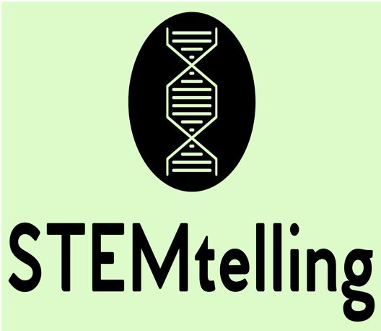

*STEMtelling: Narrative science practices for students to connect their own lived experiences, identities, and relationships to STEM.*

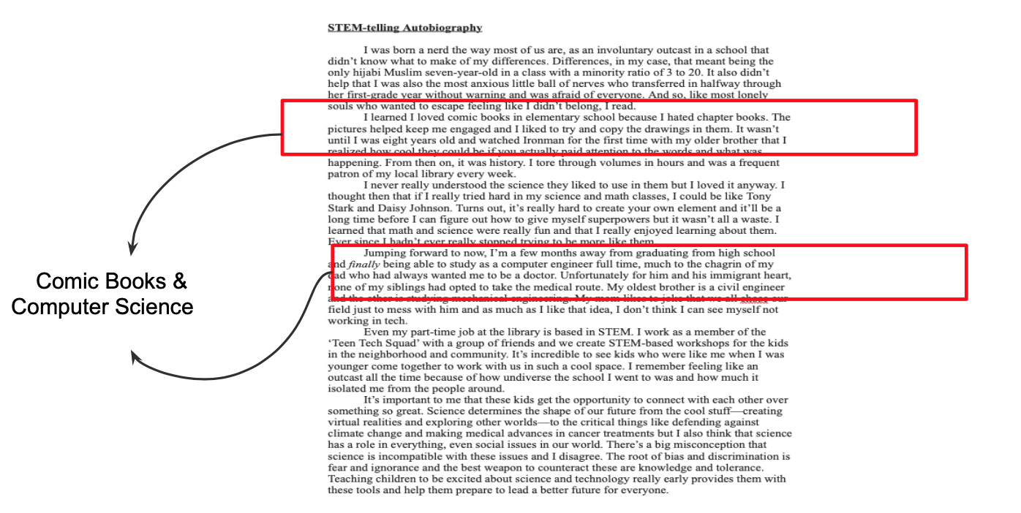

*Segment of Hanan Barre’s STEMtell that she wrote in 2017 when she was in 11th grade. Hanan is now a freshman at the University of Minnesota pursuing a degree in Computer Science.*

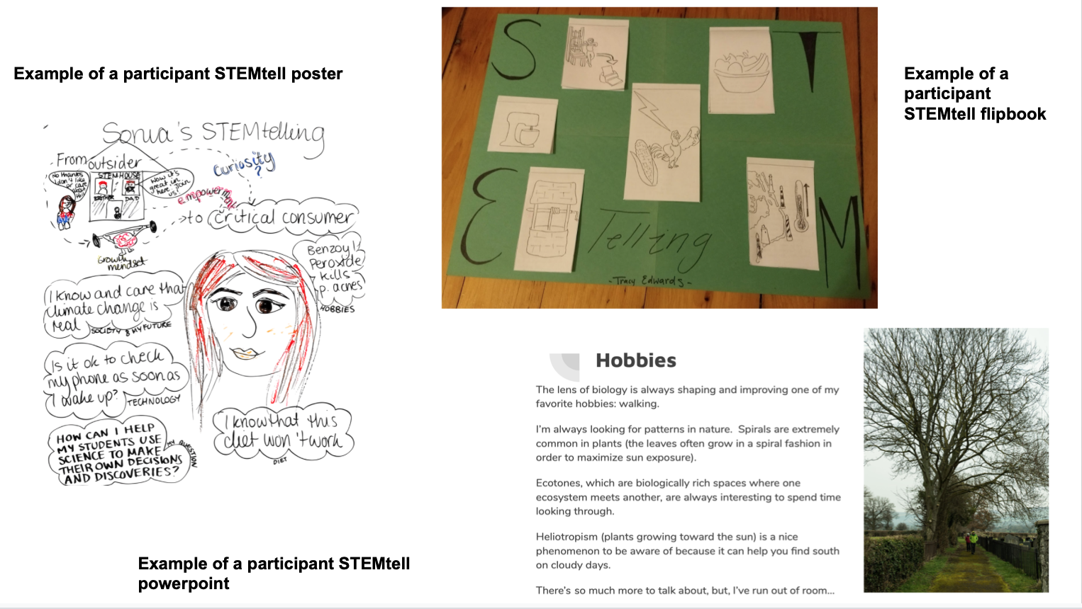*Examples of pre-service teachers’ STEMtells created during their science methods class at Harvard Graduate School of Education, 2018.*

*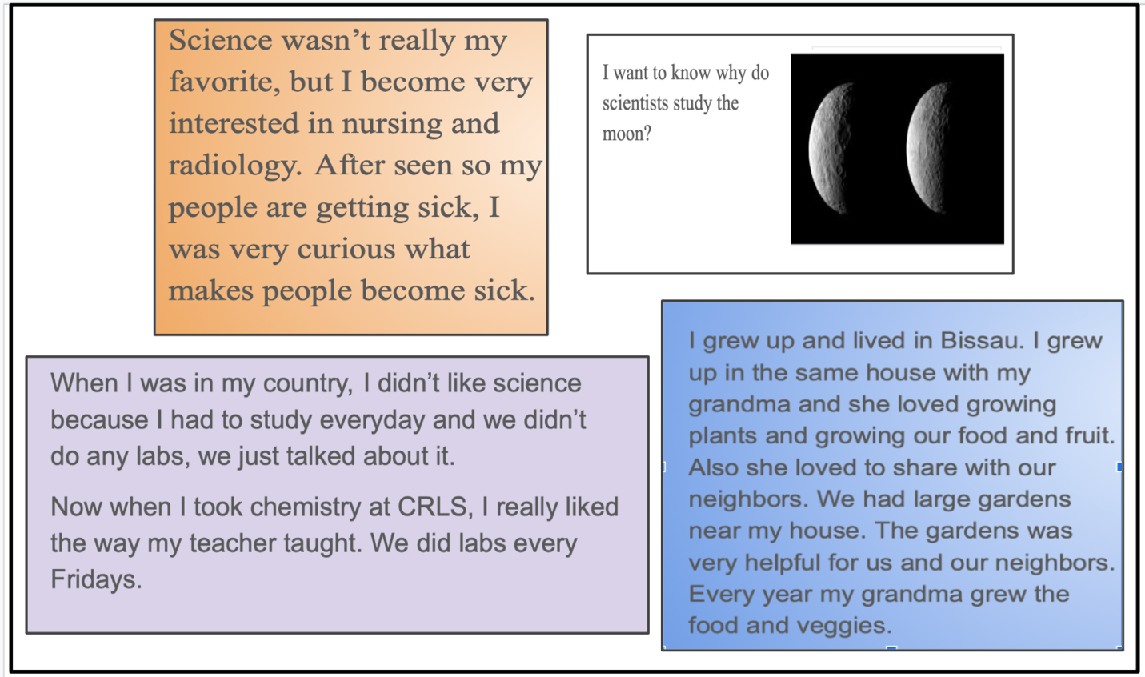*

*STEMtells from students at Cambridge Rindge & Latin High School who are learning English while taking Biology, 2019.*

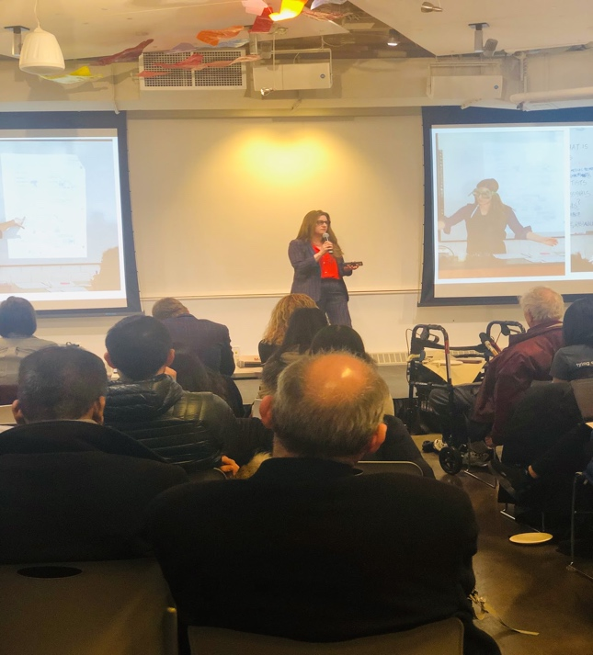

*STEMtelling at the Harvard Innovation and Ventures in Education (HIVE)*

*pitch competition at the Harvard innovation labs, 2019.*