|  |
| --- |
| TOTAL REWARD IN 2022: Astrid Berthelette |

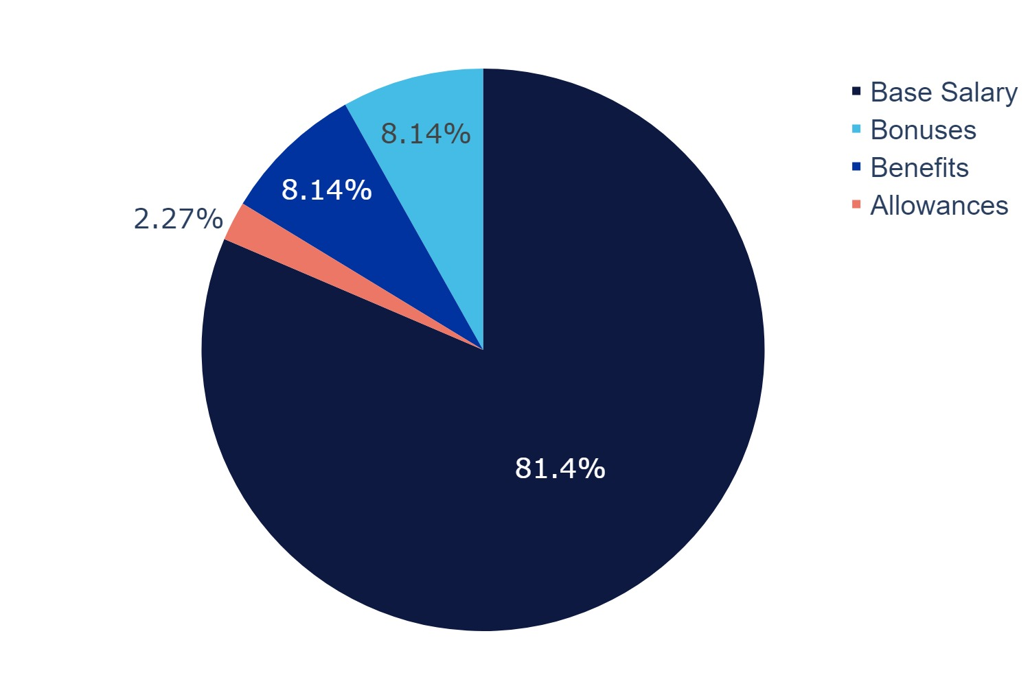

TOTAL REWARD VALUE IN 2022

£147,338

|  |  |  |  |  |  |  |
| --- | --- | --- | --- | --- | --- | --- |
| **SALARY** | **+** | **BENEFITS** | **+** | **BONUSES** | **+** | **ALLOWANCES** |
| £120,000 |  | £12,000 |  | £12,000 |  | £3,338 |

|  |  |
| --- | --- |
| Name: Astrid Berthelette | |
| Job Title: HR Manager | |
|  |  |
| Salary | Your salary will increase to **£204,000** per year, which represents an increase of 70.0%. This will take effect from 5 February 2023. |
| Bonus | Based on your achievements in 2022, you will receive a discretionary one-off bonus payment of **£12,000**. This will be paid in 5 February 2023. |

|  |  |
| --- | --- |
|  |  |
| Pension | Your percentage pension contribution provided by the Company will continue to be 10.0% of your salary. This is paid monthly via salary sacrifice (to be tax efficient) provided you match contributions with a minimum of 10.0% of your salary. |
| Private Medical Insurance | You are entitled to single Private Medical Insurance, currently with Axe. |
| Life Assurance | You are entitled to Life Assurance to the value of 4x your annual salary. |
| Fitness Allowance | You are entitled to a fitness allowance of £100 per month. This is automatically added to your pay each month. |
| Wellness Allowance | You are entitled to a wellness allowance of £18 per month. You can use this to expense items that contribute to your wellness. To access this benefit, you should submit receipts with a brief description through Concur. |
| Learning & Development Fund | You have access to a £20 fund for your personal development. Talk to your manager about suitable training courses and materials that you can use this fund to access. |
| Mobile phone | You can expense your mobile costs if you use your device as part of your work. We prefer that those in the UK take out a contract with our partner, 3UK, for the device that they use for work purposes and also subscribe to our monthly 3 UK insurance product. You can then expense the cost of the monthly contract and the insurance product. For more details, please see our mobile phone policy. |
| Shelter in Place | Contribution of up to £750 per employee for home office set up (e.g. desk, chair, computer monitor etc), expensed through Concur. This expense is a one-off contribution per employee, not an annual allowance. |
| Volunteering policy | You have up to 9 paid days per year to spend volunteering or supporting charity work. When you use those days, Square Trade will also contribute the equivalent of your salary for those days to the charity. Square Trade will also match charity fundraising efforts up to £900 per employee. |
| Community | You can expense for meals/drinks/activities with other colleagues to encourage (covid safe) connection in this remote time. You have an allowance of £800 per event. You can claim multiple times but can’t claim for a meet up with the same person more than once in a month. |