

**Monitor**





**Pair**





**Alert Dashboard**



**Alerts**





**Monitor Threshold**



**iMOM**

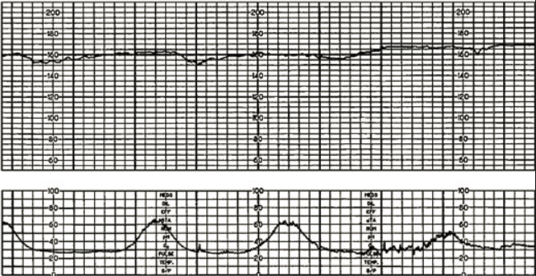





Capture



Scheduler







**Health Resources**

 



Welcome Gina!

|  |
| --- |
| **Name Ph # Address** |
| Dr Ross (8am-5pm (M-F)) (965)-774-8190 999 W Orchard Rd  (Off hours) (965)-112-3456 Suite #112, Chandler  AZ 99999 |
| Sonoran Lab (965)-111-3333 W Eden Ln  Suite #333, Chandler  AZ 99998 |
| Walgreens (888)-587-1234 2593 S Roca Rd  Pharmacy Chandler, AZ 99998 |

**Quick Contacts View:**

**Contacts**:

**Dr Ross** Office hours: (8 am - 5pm Mon - Fri)

Regular hours Ph : (965)-774-8190

Off hours Ph : (965)-112-3456

Address: : 999 W Orchard Rd, Suite #112, Chandler, AZ 99999

**Sonoran Lab** Office hours: (8 am - 5pm Mon - Fri)

Regular hours Ph : (965)-111-3333

Address : W Eden Ln, Suite #333, Chandler, AZ 99998

**Walgreens Pharmacy** Office hours: (8 am - 8pm Mon - Sun)

Ph : (888)-587-1234

Address : 2593 S Roca Rd, Chandler, AZ 99998

Contacts Quick View:

Dr Ross

Office hours : 8 am - 5pm (Mon - Fri)

Regular hours Ph : (965)-774-8190

Off hours Ph : (965)-112-3456

Address : 999 W Orchard Rd, Suite #112, Chandler, AZ 99999

Sonoran Lab

Office hours : 8 am - 5pm (Mon - Fri)

Regular hours Ph : (965)-111-3333

Address : W Eden Ln, Suite #333, Chandler, AZ 99998

Walgreens Pharmacy

Office hours : 8 am - 8pm (Mon - Sun)

Ph : (888)-587-1234

Address : 2593 S Roca Rd, Chandler, AZ 99998

 



Welcome Dr Ross

**Patient List:**

|  |
| --- |
| **Id:** W12345 |
| **Name:** Gina Gardoni |
| **Date Of Birth:** 3/11/1987  **Insurance:** Aetna Corp – W123456789 |
| **Allergy:** Penicillin |
| **Condition:** Twin-Twin Transfusion |
| **Pharmacy:**  Walgreens Pharmacy  (888)-587-1234  2593 S Roca Rd, Chandler, AZ 99998 |