Software Requirements Specification
for
DETERMINING THE VEHICAL COUNT
USING Rasberry Pi

Version 1.0 approved
Prepared by Nachiketh J(17BCB0056)
Allan Abraham(17BCB0041)
SCOPE ( CSE- BIO)
21-March-19
Table of Contents

Contents
1. Introduction 1
1.1 Purpose and Intended Audience 1
1.2 Aim 1
2. Overall Description 2
2.1 Product Scope 2
2.2 Operating Environment 2
2.4 Literature survey 3
3. External Interface Requirements 3
3.1 Proposed system design architecture 3
3.2 Architecture explanation 3
3.3 Algorithms & Pseudocode 4
4. Result and Discussions 5
5. Other Nonfunctional Requirements 5
5.1 Performance Requirements 5

5.7 Safety Requirements 5

Introduction

Purpose and Intended Audience

Traveling is part of our daily lives. Everyone has to be on the road, may it be on going to work, going to school, or going to the grocery store to buy any material. Every time we travel, we have to spend important time and energy on the road. India has one of the largest road networks in the world (around 4 million km at present).National Highways (NHs) are the main arterial roads connecting ports, state capitals, industrial and tourist centers, and neighboring countries. NHs constitute less than 10 percent of the total road network, but carry nearly 60 percent of the total road. traffic A measurement system is needed to gauge the impact of travel-related problems on "quality of life" since it is insubstantial. An approximate measurement system for transportation is also recommended for the problem of overcrowding in trains and traffic congestion on roads. This system calculates the overall impact of congestion and transportation on quality of life. Number of steps have been taken by the Ministry to spread road safety culture in the country. These include road safety training, education and driving instructions, traffic regulations, measures to deal with traffic offences and improvement of both active and passive vehicle safety.

Aim

The focus problem statement comes under highway management system .Highway management system includes

• Efficient management on parking

• Traffic congestion control

• Toll management

Overall Description

Product Scope

Camera Based Systems- Camera based systems are able to detect, count and classify vehicles. These systems use video image processors to identify vehicles and their traffic flow parameters by analysing imagery supplied by video cameras. Images supplied by cameras are digitized and then series of image processing algorithms are applied on them. Information about vehicle passage, presence, speed can be extracted by using various image processing techniques

Though camera based systems are more accurate than loop based systems and do not require lane discipline they have several disadvantages. Their performance is unsatisfactory in foggy conditions of poor visibility. Other environmental conditions such as light reflected from wet pavements and shadows affect the performance of Video image processors. Large vehicles can obscure smaller vehicles. Camera based systems are expensive to install and maintain as they require quite a lot of dedicated hardware and software. Chances of theft are also higher for such systems

Operating Environment
Raspbian is the Foundation’s official supported operating system. You can install it with NOOBS or download the image below and follow our installation guide.Raspbian comes pre-installed with plenty of software for education, programming and general use. It has Python, Scratch, Sonic Pi, Java and more.The Raspbian with Desktop image contained in the ZIP archive is over 4GB in size, which means that these archives use features which are not supported by older unzip tools on some platforms. If you find that the download appears to be corrupt or the file is not unzipping correctly, please try using 7Zip (Windows) or The Unarchiver (Macintosh). Both are free of charge and have been tested to unzip the image correctly.

Literature survey

https://www.raspberrypi.org/forums/viewtopic.php?t=90728

https://blog.devcolor.org/heating-up-with-firebase-tutorial-on-how-to-integrate-firebase-into-your-app-6ce97440175d

http://ai2.appinventor.mit.edu/?locale=en#5874546821955584

https://pinout.xyz/

https://www.raspberrypi.org/documentation/usage/gpio/python/README.md

External Interface Requirements

Proposed system design architecture

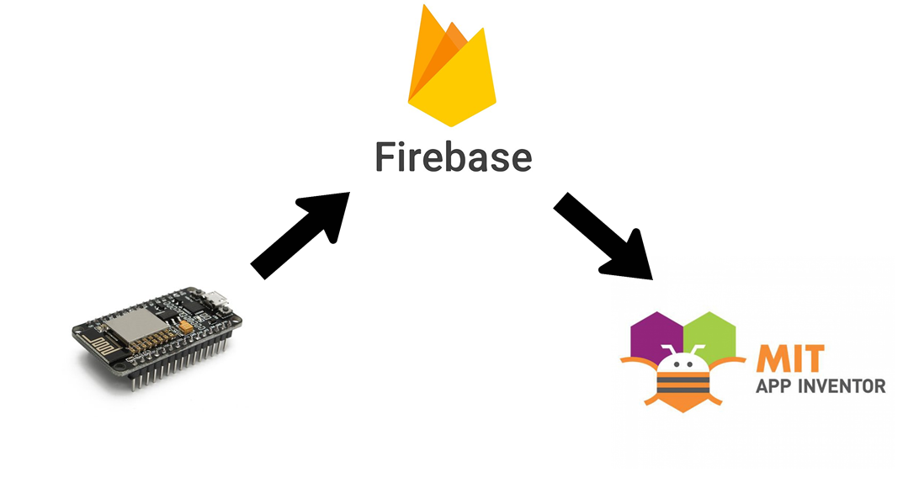

Architecture explanation
The architecture constitutes of three phases which also includes the final interface.
- The pi
It’s the core which ensures the proper working of the IR sensors. It runs on Raspbian and the basic functionality is to generate the number of vehicles entering and exiting the lot. This is done using two IR sensors, the first one is the primary and the other one is used to counter verify the direction of the moment thereby reducing the chances of errors.
- Firebase
The intermediate between the backend and the final front end. It acts as a platform between receiving the signals generated from the IR sensors and further transmitting them in a presentable manner to the app based platform.
- MIT App
This is all the user needs to know. Once the user logs into the app, he knows the exact situation of the parking lot. The total number of vehicles in the lot will be displayed along with the capacity so the person knows where there is space available.

Algorithms & Pseudocode
import RPi.GPIO as IO
from time import sleep

from firebase import firebase
firebase = firebase.FirebaseApplication('https://micro-2bc28.firebaseio.com/', None)

IO.setmode (IO.BOARD)

IO.setup(11,IO.IN)
IO.setup(13,IO.IN)

count = 0
inIR = IO.input(11);
outIR = IO.input(13);

def callback1(channel):
global count
if IO.input(11):
count=count+1
data = {'number':count}
result = firebase.post('/', count)

def callback2(channel):
global count
if IO.input(13):
count=count-1
data = {'number':count}
result = firebase.post('/', count)

IO.add_event_detect(11, IO.BOTH, callback=callback1)
IO.add_event_detect(13, IO.BOTH, callback=callback2)

try:
print("Program started")
sleep(100)
finally:
IO.cleanup()

Result and Discussions
Since the success of the project depend on providing a proper line of site for the sensor range, placing the sensor on an overhead bridge directly over the flow of traffic route was necessary to minimize the vehicle occlusion. Due to security situation in the country, tests were carried out (to debug the developed algorithms and to evaluate the performance) with freely available video clips on internet, one with vehicles moving away from the sensor range and another with vehicles moving towards the sensor range.

Other Nonfunctional Requirements

Performance Requirements

1. Connect a Reliable Power Supply

2. Employ a Lightweight Operating System

3. Ditch the Bloatware

4. Disable JavaScript

5. Overclock (But Keep It Cool)

Safety Requirements

- A very stable power-supply is the most important thing.
Don't use rpi-update if you don't know what you're doing.
- Don't overclock over 900 MHz.
- Don't unplug the power at the Pi side , but on the other side of
the cable.
- If you are working with the GPIO , be careful and check what
you're doing.

