Exercise1
Program: Finding the Longest increasing sub-sequence of values.
Overview:
The “Exercise1.Java” file placed under “test/src/main/java” directory, contain a function “findLargestIncreasingSubsequence(Float[] arrA)” that accept an array of floating point integers as parameter and print the length and longest increasing sub-sequence.

On executing the “main(String argrs[])” function of “Exercise1.Java” then it read the floating point values from “EDA.txt” file and store them in the array of floating point number. This array of floating point numbers is passed to “findLargestIncreasingSubsequence(Float[] arrA)” function and it print the longest increasing sub-sequence.

Setup:

- JDK should be installed on user's computer. It can be downloaded from http://www.oracle.com/technetwork/java/javase/downloads/index.html
- Intellij Community edition should be installed on user's computer. It can be downloaded through “https://www.jetbrains.com/idea/download/#section=windows”

Execution through IntelliJ IDE:

- Save the program at your local disk.
- Open the the “pom.xml” file and the project should be loaded successfully in Intellij
- Navigate to “test/src/main/java” and open the “exercise1.java” file.
- Right click and click “Run exercise1.main()”.
- The program will execute and will print the longest increasing sub-sequence from the “ED.txt” file which is located at “test/src/main/resources/exercise1” folder.

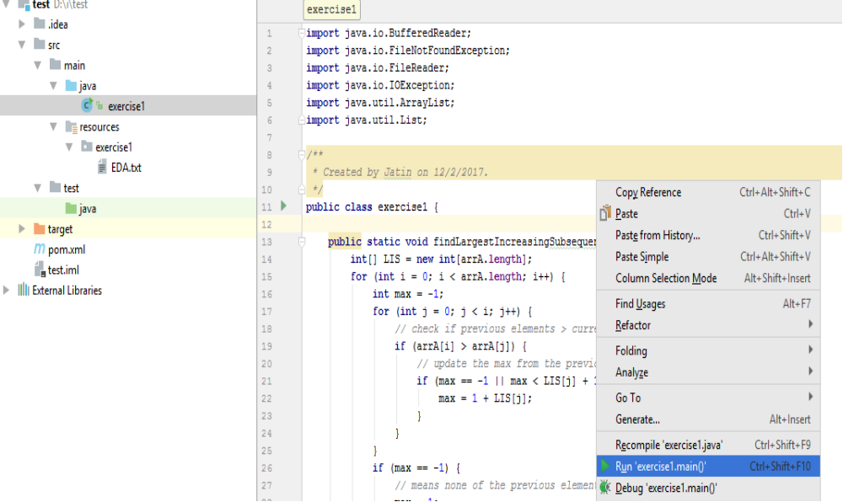

Execution through command Prompt:

- On Windows 7 machine, press window + r and it will open the Run window. Type “cmd” and hit enter.
- Navigate to the folder containing “exercise1.java” file using CD “path of directory containing exercise1.java”
- Type Javac exercise1.java and hit enter.
- Type java exercise1 and it will execute the program.

Output:

Longest Increasing Subsequence Length: 405
Longest Increasing Subsequence: -0.12655 -0.069171 -0.066609 -0.033305 -0.020495 -0.012809 -0.010248 -0.0089666 -0.0064047 -0.0038428 -0.0025619 -0.0012809 0.0 0.0012809 0.0025619 0.0064047 0.011529 0.015371 0.020495 0.04099 0.0538 0.065328 0.06789 0.074295 0.076857 0.097352 0.11272 0.12041 0.1345 0.13706 0.13834 0.13962 0.1409 0.15371 0.15499 0.15884 0.16012 0.1614 0.16268 0.16396 0.16524 0.16652 0.1678 0.16908 0.17037 0.17165 0.17293 0.17421 0.17549 0.17677 0.17805 0.17933 0.18061 0.18189 0.18318 0.18446 0.19086 0.19214 0.1947 0.19598 0.19727 0.19855 0.19983 0.20111 0.20239 0.20367 0.20495 0.20623 0.20751 0.20879 0.21392 0.2152 0.21648 0.21776 0.21904 0.22032 0.2216 0.22288 0.22545 0.22673 0.22801 0.22929 0.23057 0.23185 0.23313 0.23441 0.23569 0.23697 0.23826 0.23954 0.24082 0.2421 0.24338 0.24466 0.25107 0.25619 0.25747 0.25875 0.26131 0.26387 0.26516 0.26644 0.26772 0.269 0.27028 0.27284 0.27412 0.27668 0.27925 0.28053 0.28181 0.28309 0.28437 0.29077 0.29334 0.2959 0.29718 0.29846 0.29974 0.30102 0.30487 0.30743 0.31127 0.31255 0.31383 0.32024 0.32152 0.3228 0.32536 0.32664 0.3292 0.33176 0.33305 0.33433 0.33945 0.34073 0.34329 0.34457 0.34586 0.34714 0.34842 0.3497 0.35098 0.35226 0.35354 0.35482 0.35738 0.35866 0.36251 0.36379 0.36635 0.36891 0.37276 0.37404 0.37532 0.37788 0.37916 0.38172 0.38556 0.40478 0.42527 0.42655 0.42912 0.44449 0.44705 0.45089 0.45217 0.46626 0.48548 0.52903 0.55337 0.55465 0.56004 0.56644 0.57413 0.58054 0.5831 0.58438 0.59078 0.59463 0.60743 0.61256 0.61768 0.62537 0.63562 0.6369 0.64843 0.65355 0.65611 0.65739 0.65995 0.66508 0.67276 0.67917 0.68045 0.68173 0.68942 0.69326 0.69582 0.6971 0.69838 0.71632 0.72144 0.73297 0.73553 0.74193 0.74706 0.76243 0.7778 0.78549 0.82648 0.85081 0.85722 0.85978 0.86619 0.89052 0.92767 0.96866 0.97257 0.98538 0.98666 0.98794 0.99179 0.99691 1.0059 1.0123 1.0212 1.0264 1.0289 1.0328 1.0341 1.0353 1.0366 1.0405 1.0622 1.1109 1.1762 1.2249 1.2698 1.2788 1.298 1.3032 1.3083 1.316 1.3301 1.3429 1.3506 1.357 1.3646 1.3954 1.4607 1.4902 1.4915 1.503 1.5107 1.5171 1.526 1.6183 1.6272 1.6413 1.671 1.6723 1.6774 1.6825 1.6838 1.6902 1.6979 1.7043 1.7184 1.7453 1.7504 1.7542 1.7594 1.7901 1.794 1.8016 1.8029 1.8106 1.8119 1.8145 1.817 1.8209 1.8234 1.8337 1.8414 1.858 1.8721 1.8772 1.8887 1.89 1.8952 1.9003 1.9054 1.908 1.9092 1.9105 1.9118 1.9195 1.9208 1.9297 1.931 1.9336 1.9349 1.94 1.9438 1.9566 1.9771 1.9784 1.9797 1.981 1.9823 1.9912 1.9951 1.9963 1.9976 1.9989 2.0002 2.0437 2.1155 2.127 2.1501 2.1898 2.2205 2.2269 2.2447 2.246 2.2472 2.2782 2.3127 2.3371 2.3382 2.3638 2.4471 2.5316 2.6059 2.661 2.6687 2.6721 2.6785 2.6956 2.702 2.7161 2.7289 2.7914 2.7951 3.0103 3.0143 3.0271 3.0822 3.0976 3.0989 3.1014 3.1091 3.1168 3.1219 3.1245 3.1309 3.1386 3.1514 3.1642 3.1732 3.1796 3.1872 3.1962 3.2039 3.2116 3.2167 3.218 3.2205 3.2282 3.2718 3.3192 3.3307 3.3512 3.3615 3.3653 3.3781 3.3909 3.396 3.4012 3.4114 3.4217 3.4281 3.437 3.446 3.4537 3.4844 3.5062 3.5152 3.5241 3.5472 3.5523 3.5677 3.5792 3.5818 3.5831 3.5856 3.5895 3.5907 3.592 3.6497 3.6766 3.7099 3.7227 3.7368

