Exercise 2: End To End Testing of Login Page

Solution Overview:

To End to end testing of the login page I have used following technologies:
- Selenium WebDriver
- TestNG Frmawork
- Maven as build tool

Code is written in the Java programming language. I have created very basic test automation framework using following design patterns:

- Page Object Model
- Singleton
- Fluent interface for script writing

This is a very basic framework which can be enhanced to meet the need of complete web application.

Tests Execution:

Setup:

- JDK should be installed on user's computer. It can be downloaded from http://www.oracle.com/technetwork/java/javase/downloads/index.html
- Intellij Community edition should be installed on user's computer. It can be downloaded through “https://www.jetbrains.com/idea/download/#section=windows”
Steps:

- Unzip the project and open the “Pom.xml” in the Intellij IDE.
- Navigate to “src/test/java” and open the “LoginPageTest.java” file
- Right click on “loginAdminTest()” and click “Run loginAdminTest()”
- This will open the chrome browser and execute the test.
- Repeat the step 3 for executing “loginTestResearcher()” and “loginTestSimpleUser”
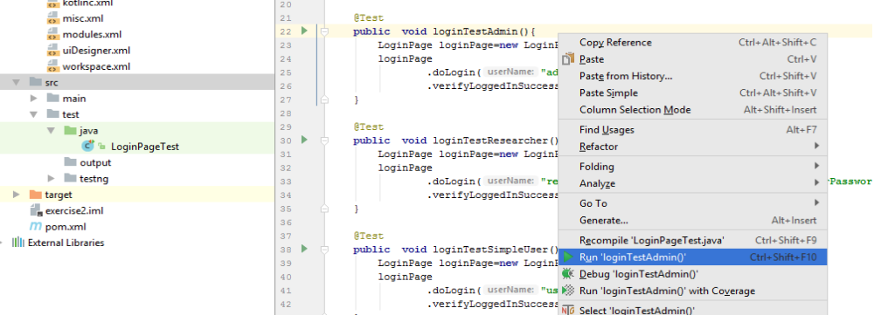

Note : Currently, these tests will enter the username, password and then click submit button and then will fail. This is because I was not able to automate these test case completely as I the “” command was hanged at “Attaching to ex2_api_1” and the web-service didn't run:

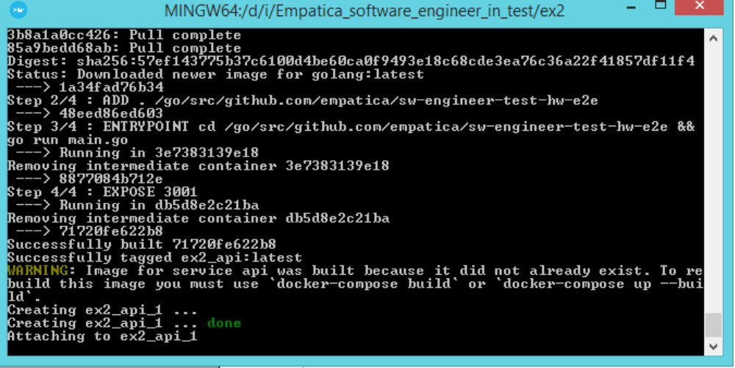
So I was not able to see the page that appears after login page and was not able to locate it's elements. However, for creating the login page locators, I have used the “index.html”file which was available under “Empatica_software_engineer_in_test\ex2\public” folder.

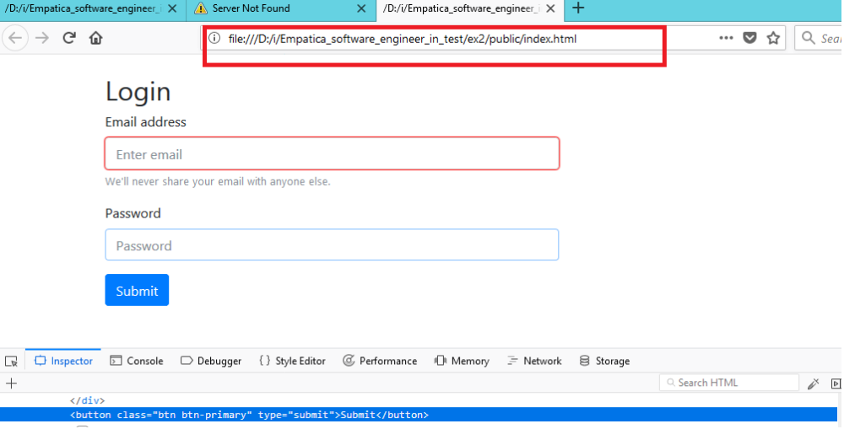

Framework Structure:

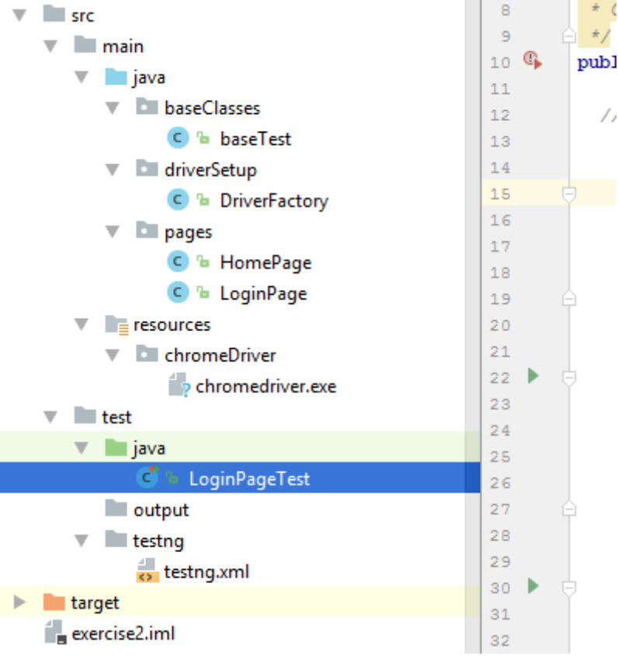

Folders overview:

DriverSetup: It contains the DriverSetup class which is Singleton class. This class contains static “getDriver” method which return only single instance of the driver which is used by all the test-cases.

Pages: It contains all the pages of application. Each page contain the functions specific to particular page.

Baseclasses: This folder contain “baseTest” class which is inherited by the test classes which are under “src/test/java” folder. The “BaseTest” class contain that should be perform before and after executing the test. It launch the driver before executing the test and then close the drive after completed the execution.

Test/Java: This folder contain all the automation scripts. For example, the LoginTest.java contains all the tests specific to login page.

Resources: This folder contains the chrome driver executable for executing the test on chrome driver.

