Sales Forecasting

1. Ask
Business Questions:
• What are the monthly sales trends, and which time periods drive the most revenue?
• Which countries generate the highest sales volumes?
• What does the 12-month sales forecast look like by country and overall?
Objective: Identify seasonal patterns and geographic distribution of sales data to support data-driven decisions on inventory planning, marketing campaigns, resource allocation, and international expansion strategy.

2. Prepare
Data Source: Internal sales records exported as sales_data.csv.
Dataset Overview:
• Rows: 2,823 transactions
• Columns (25): ORDERNUMBER, QUANTITYORDERED, PRICEEACH, ORDERLINENUMBER, SALES, ORDERDATE, STATUS, QTR_ID, MONTH_ID, YEAR_ID, PRODUCTLINE, MSRP, PRODUCTCODE, CUSTOMERNAME, PHONE, ADDRESSLINE1, ADDRESSLINE2, CITY, STATE, POSTALCODE, COUNTRY, TERRITORY, CONTACTLASTNAME, CONTACTFIRSTNAME, DEALSIZE
• Date Range: 2003-01-06 to 2005-05-31
• Countries (19): Australia, Austria, Belgium, Canada, Denmark, Finland, France, Germany, Ireland, Italy, Japan, Norway, Philippines, Singapore, Spain, Sweden, Switzerland, UK, USA
• Product Lines: Classic Cars, Motorcycles, Planes, Ships, Trains, Trucks and Buses, Vintage Cars
Columns removed before analysis: ORDERNUMBER, ORDERLINENUMBER (identifiers not needed for aggregation).
Data integrity was verified using df.info() and df.describe(). Rows with missing SALES values were dropped. COUNTRY values were whitespace-stripped for consistent grouping.

3. Process
Processing steps applied using Python (pandas, statsmodels):
1. Column cleanup: column names stripped of whitespace; COUNTRY values stripped.
2. Type conversion: SALES cast to numeric (errors coerced to NaN); ORDERDATE parsed to datetime.
3. Row filtering: rows with NaN SALES dropped; identifier columns removed.
4. Monthly aggregation: transactions resampled at month-end frequency using df.resample('ME', on='ORDERDATE')['SALES'].sum().
5. SARIMA model: fitted on monthly series with order=(1,0,1) and seasonal_order=(1,0,1,12) to capture 12-month seasonality; 12-step ahead forecast generated.
6. Country-level forecast: for each country, the last 12 months of data were used to compute a simple forecast (monthly average x 12). Ireland and Switzerland received a +15% growth adjustment.
Tools used: Python 3, pandas, matplotlib, seaborn, numpy, statsmodels.

4. Analyse
During the analyse phase, several calculations and aggregations were performed to better understand the sales data and identify trends across time and geography.
First, descriptive calculations were performed to explore the structure of the dataset and summarize overall sales behavior. Total revenue was computed at $10,032,628.85 across the full period (2003-01-06 to 2005-05-31). The mean monthly sales were calculated at $345,952.72 to establish a baseline for period-over-period comparisons. The maximum monthly sales value was identified as $1,089,048.01 in November 2004, revealing a pronounced Q4 seasonal peak. The minimum monthly sales of $129,753.60 occurred in January 2003, pointing to a consistent Q1 trough.
Next, a monthly time-series aggregation was created using df.resample('ME') to group transactions by month-end and sum the SALES column. This revealed a recurring seasonal pattern: revenue surges in October and November each year, then drops sharply in January and February. This Q4 effect is consistent across 2003, 2004, and 2005, suggesting structural demand tied to end-of-year purchasing cycles, particularly in the Classic Cars and Vintage Cars product lines.
A SARIMA(1,0,1)(1,0,1)[12] model was then fitted on the monthly series to capture this seasonality and generate a 12-month forward forecast. The model confirmed the recurring Q4 peak pattern and projects continued growth into the next cycle, providing a quantitative basis for planning inventory and staffing several months in advance.
Finally, a country-level grouping was performed by aggregating total SALES by COUNTRY. This showed that the USA accounts for the largest share of revenue, followed by Spain, France, Australia, and the UK. A second country-level calculation compared the last 12 months of historical sales against a 12-month forward projection for each of the 19 countries. Ireland and Switzerland were identified as high-growth markets and received an adjusted +15% forecast, reflecting their upward sales trajectory relative to their market size.
To communicate these findings to stakeholders, five visualizations were produced: a line chart and a bar chart of total monthly sales to illustrate the seasonal trend, a SARIMA forecast chart overlaying historical and projected sales, a bar chart ranking all 19 countries by total revenue, and a side-by-side bar chart comparing the last 12 months of historical sales against the 12-month forecast for each country. These charts are presented in the Share section below.

5. Share
Five visualizations were created to communicate findings to stakeholders:
Figure 1 – Total Monthly Sales (Line Chart):
Shows the evolution of total sales month by month from January 2003 to May 2005, highlighting recurring Q4 revenue peaks and Q1 troughs.
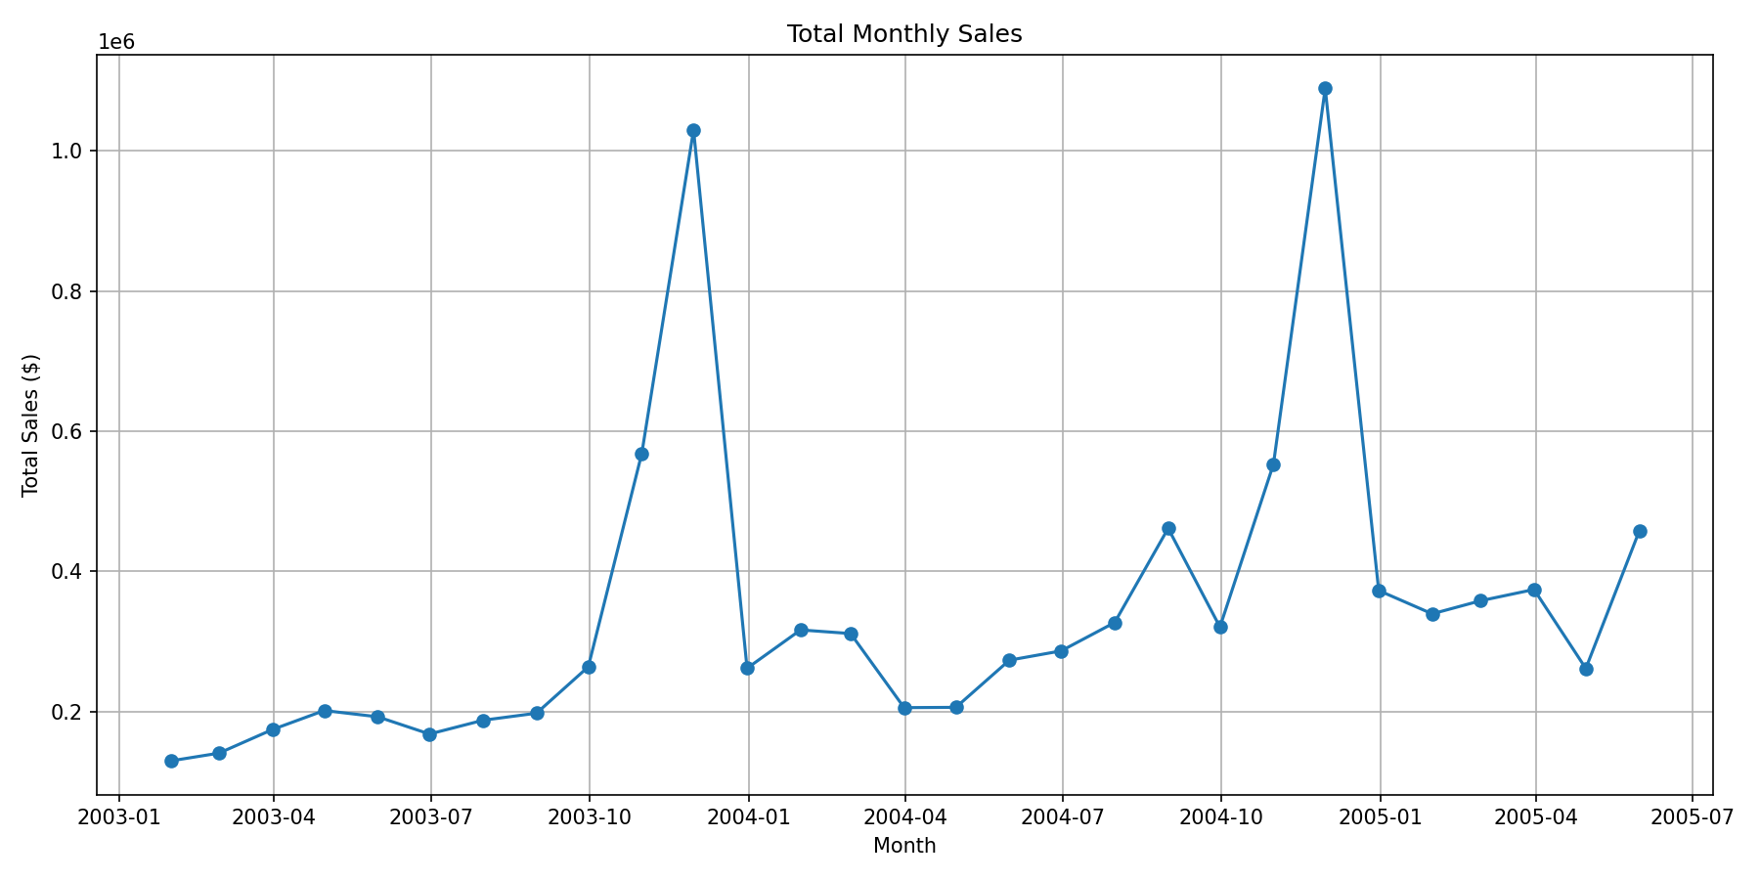
Figure 1 – Total Monthly Sales (Line Chart)

Figure 2 – Total Monthly Sales (Bar Chart):
Provides an at-a-glance comparison of total sales per calendar month, making it easy to identify the strongest and weakest performing periods across years.
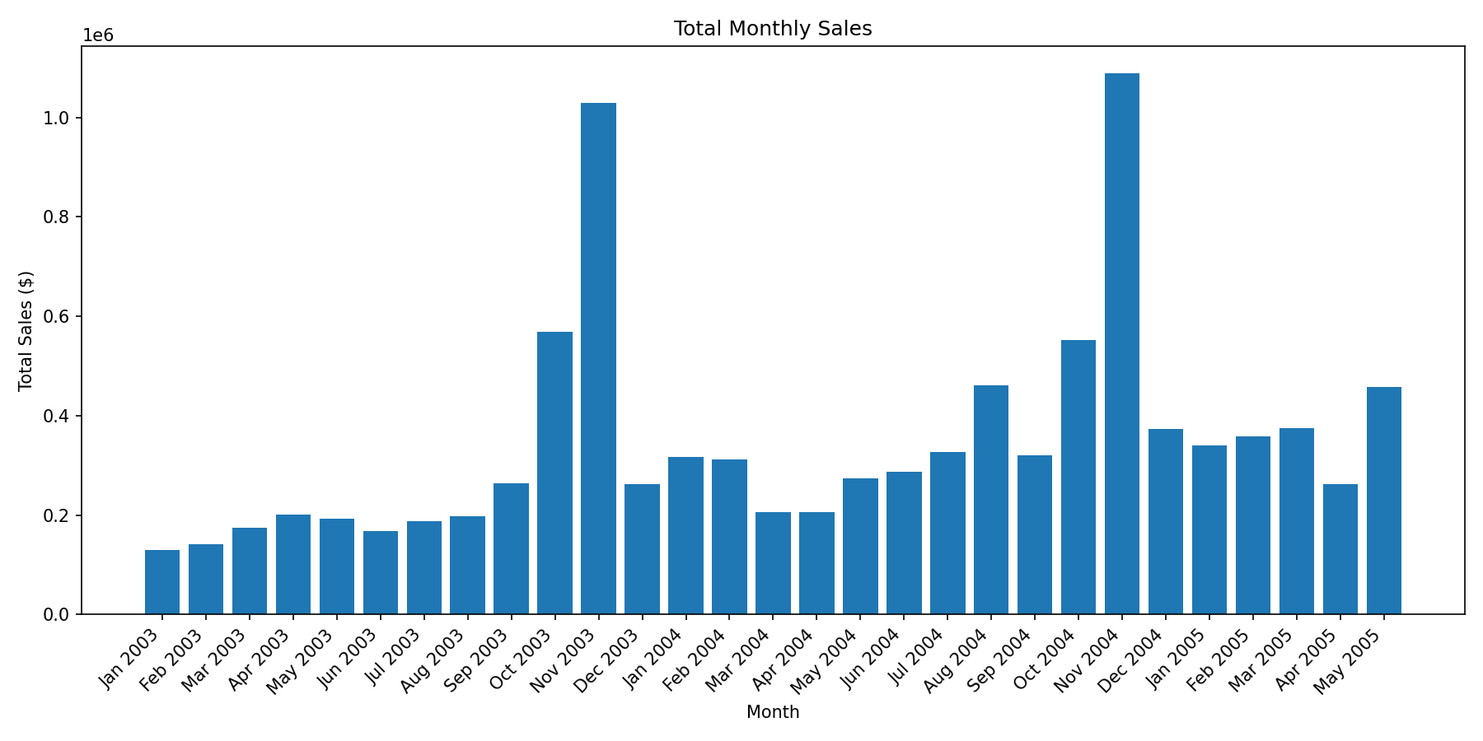
Figure 2 – Total Monthly Sales (Bar Chart)

Figure 3 – Sales Forecast with Seasonality (Line Chart):
Overlays the SARIMA 12-month forecast (dashed red line) on the historical sales series, making the projected trend and seasonal pattern immediately visible.
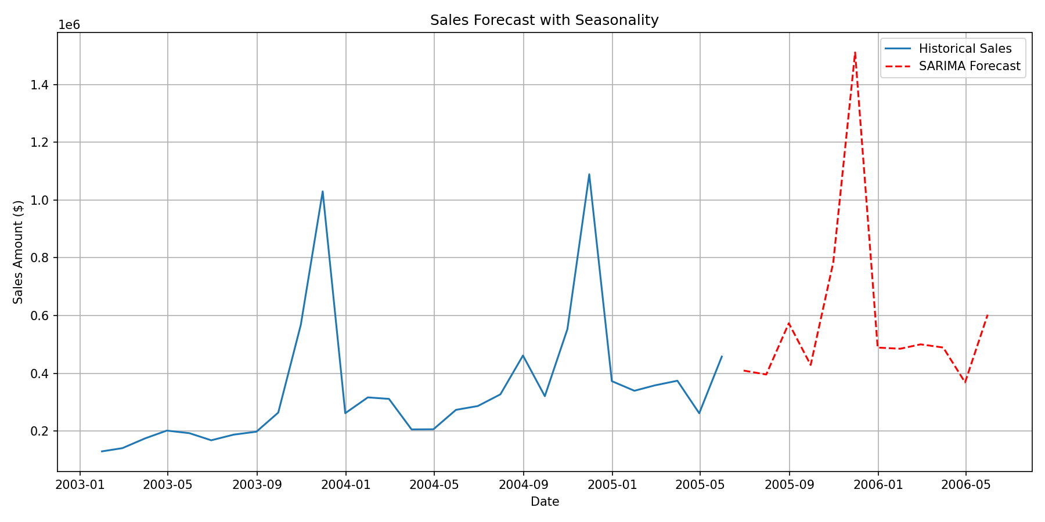
Figure 3 – Sales Forecast with Seasonality

Figure 4 – Total Sales by Country (Bar Chart):
Ranks all 19 countries by total historical revenue, identifying the USA, Spain, and France as the top three markets.
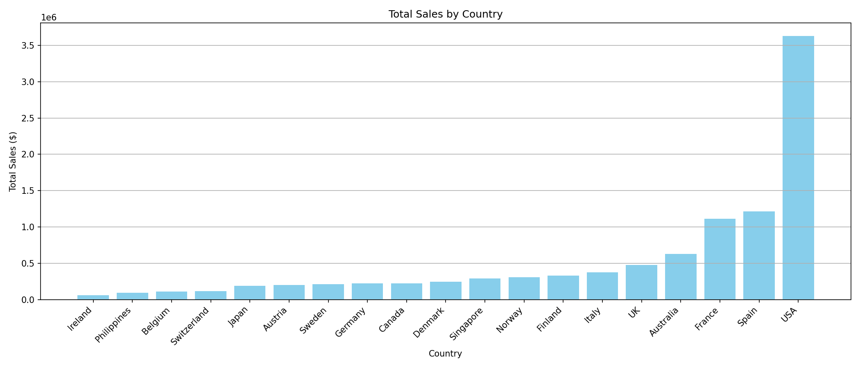
Figure 4 – Total Sales by Country

Figure 5 – Historical vs Forecast Sales by Country (Side-by-Side Bar Chart):
Compares the last 12 months of historical sales against the 12-month forecast for each country, highlighting growth opportunities and markets requiring attention.
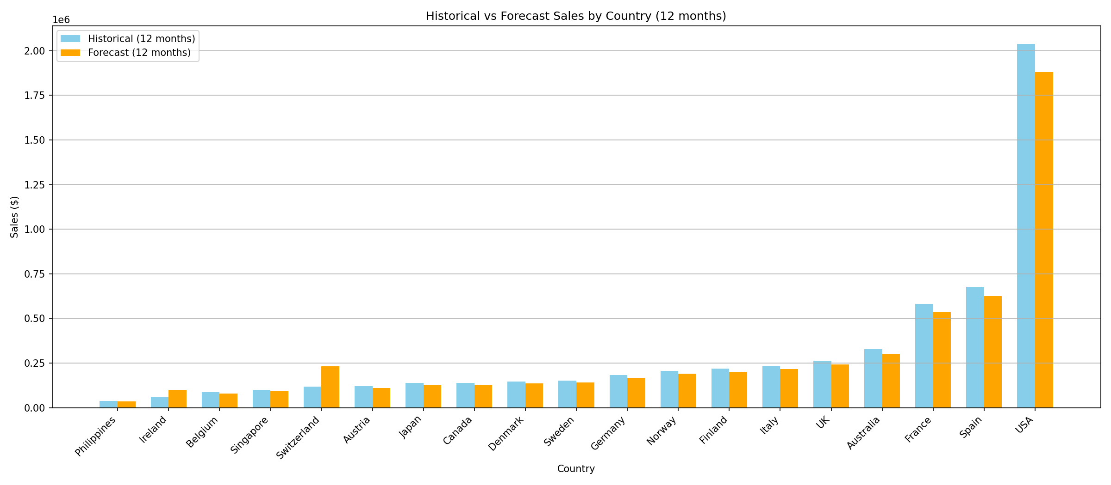
Figure 5 – Historical vs Forecast Sales by Country (12 months)

6. Act
Recommendations based on the analysis:
1. Capitalize on Q4 peaks (October–November): increase inventory, staffing, and marketing budgets ahead of the high-demand period, particularly for Classic Cars and Vintage Cars product lines.
2. Address Q1 low-sales periods (January–February): run targeted promotions, loyalty campaigns, or bundle offers to stimulate demand during historically weak months.
3. Prioritize top markets: maintain and grow investment in USA, Spain, France, Australia, and the UK – the five countries accounting for the majority of total revenue.
4. Develop high-growth markets: Ireland and Switzerland show forecast growth potential; consider dedicated account management and local marketing initiatives.
5. Monitor the SARIMA forecast monthly: refresh the model with new data each month to detect trend changes early and adjust inventory and staffing plans accordingly.
6. Automate reporting: schedule this analysis pipeline to run monthly so stakeholders always have up-to-date charts without manual intervention.

Appendix – Python Code (main.py)
The following Python script was used to perform the data processing and generate the visualizations:
import pandas as pd
import matplotlib.pyplot as plt
import seaborn as sns
import numpy as np
from statsmodels.tsa.statespace.sarimax import SARIMAX
import warnings
# ----------------------------
# 1. Read the CSV
# ----------------------------
df = pd.read_csv("input/sales_data.csv", sep=",", encoding="latin1")
# ----------------------------
# 2. Basic cleanup
# ----------------------------
df.columns = df.columns.str.strip()
df['SALES'] = pd.to_numeric(df['SALES'], errors='coerce')
df['COUNTRY'] = df['COUNTRY'].str.strip()
df.dropna(subset=['SALES'], inplace=True)
df.drop(['ORDERNUMBER', 'ORDERLINENUMBER'], axis=1, inplace=True)
# ----------------------------
# 3. Monthly sales
# ----------------------------
df['ORDERDATE'] = pd.to_datetime(df['ORDERDATE'])
df_monthly = df.resample('ME', on='ORDERDATE')['SALES'].sum()
plt.figure(figsize=(12, 6))
plt.plot(df_monthly.index, df_monthly, marker='o', label="Historical")
plt.title("Total Monthly Sales")
plt.xlabel("Month")
plt.ylabel("Total Sales")
plt.grid()
plt.show()
plt.figure(figsize=(12, 6))
plt.bar(df_monthly.index.strftime('%B'), df_monthly.values)
plt.title("Total Monthly Sales")
plt.xlabel("Month")
plt.ylabel("Total Sales")
plt.xticks(rotation=45)
plt.show()
# ----------------------------
# 4. SARIMA forecasting
# ----------------------------
# Suppress 'Too few observations' warning
with warnings.catch_warnings():
warnings.simplefilter("ignore")
model = SARIMAX(
df_monthly,
order=(1, 0, 1),
seasonal_order=(1, 0, 1, 12), # 12-month seasonality
enforce_stationarity=False,
enforce_invertibility=False
)
model_fit = model.fit(disp=False) # required
forecast_obj = model_fit.get_forecast(steps=12)
forecast_values = forecast_obj.predicted_mean
forecast_ci = forecast_obj.conf_int()
future_dates = forecast_values.index
# ----------------------------
# 5. Forecast chart
# ----------------------------
plt.figure(figsize=(12, 6))
plt.plot(df_monthly.index, df_monthly.values, label='Historical Sales')
plt.plot(future_dates, forecast_values, linestyle='--', color='red', label='SARIMA Forecast')
plt.title('Sales Forecast with Seasonality')
plt.xlabel('Date')
plt.ylabel('Sales Amount')
plt.legend()
plt.grid()
plt.show()
# ----------------------------
# 6. Total sales by country
# ----------------------------
df_country = df.groupby('COUNTRY')['SALES'].sum().sort_values(ascending=True)
plt.figure(figsize=(14, 6))
plt.bar(df_country.index, df_country.values, color='skyblue')
plt.ylabel("Total Sales")
plt.xlabel("Country")
plt.title("Total Sales by Country")
plt.grid(axis='y')
plt.xticks(rotation=45)
plt.show()
# ----------------------------
# Historical + 12-month forecast by country
# ----------------------------
historical_country = {}
forecast_country = {}
for country, group in df.groupby('COUNTRY'):
ts = group.set_index('ORDERDATE')['SALES'].resample('ME').sum()
# Historical: total of last 12 months
end_date = ts.index.max()
start_date = end_date - pd.DateOffset(months=12)
last_12m = ts.loc[start_date:end_date]
historical_country[country] = last_12m.sum()
# Forecast: monthly average x 12 months
forecast_country[country] = last_12m.mean() * 12
if country in ['Ireland', 'Switzerland']:
forecast_country[country] *= 1.15
# Create DataFrames
df_historical_country = pd.DataFrame.from_dict(
historical_country,
orient='index',
columns=['Historical_12M']
)
df_forecast_country = pd.DataFrame.from_dict(
forecast_country,
orient='index',
columns=['Forecast_12M']
)
# Merge for chart
df_compare = df_historical_country.join(df_forecast_country)
df_compare.fillna(0, inplace=True)
df_compare = df_compare.sort_values('Historical_12M') # sort for readability
# Side-by-side bar chart
x = np.arange(len(df_compare.index))
width = 0.35
plt.figure(figsize=(16, 7))
# Historical
plt.bar(
x - width / 2,
df_compare['Historical_12M'],
width=width,
label='Historical (12 months)',
color='skyblue'
)
# Forecast
plt.bar(
x + width / 2,
df_compare['Forecast_12M'],
width=width,
label='Forecast (12 months)',
color='orange'
)
plt.xticks(x, df_compare.index, rotation=45)
plt.ylabel("Sales")
plt.xlabel("Country")
plt.title("Historical vs Forecast Sales by Country (12 months)")
plt.grid(axis='y')
plt.legend()
plt.tight_layout()
plt.show()

