Sales Data Analysis

1. Ask
Business Question: What are the monthly sales trends, and which time periods drive the most revenue?
Objective: Identify seasonal patterns in sales data to support data-driven decisions on inventory planning, marketing campaigns, and resource allocation.

2. Prepare
Data Source: Internal sales records exported as sales.csv.
Dataset Overview:
• Rows: 1000 transactions
• Columns (9): Transaction ID, Date, Customer ID, Gender, Age, Product Category, Quantity, Price per Unit, Total Amount
• Date Range: 2023-01-01 to 2024-01-01
• Product Categories: Beauty, Clothing, Electronics
Data integrity was verified using df.info() and df.describe(). No missing values were found in critical columns.

3. Process
Processing steps applied using Python (pandas):
1. Date conversion: df['Date'] parsed to datetime using pd.to_datetime().
2. Monthly aggregation: transactions resampled at month-end frequency using df.resample('M', on='Date').sum(), summing Total Amount per month.
3. Month label: a 'Month' column (abbreviated name) derived for chart readability.
4. Null check: df.info() confirmed no missing values in critical columns.
Tools used: Python 3, pandas, matplotlib, seaborn.

4. Analyse
Key Findings:
• Average Monthly Sales: $456.00
• Highest Sales Month: May 2023
• Lowest Sales Month: January 2024
Monthly aggregation reveals seasonal variation in sales volume. The peak month (May 2023) shows significantly higher revenue, suggesting seasonal demand. The lowest month (January 2024) represents an opportunity for targeted marketing efforts.

5. Share
Two visualizations were created to communicate findings to stakeholders:
Figure 1 — Monthly Sales Trends (Line Chart):
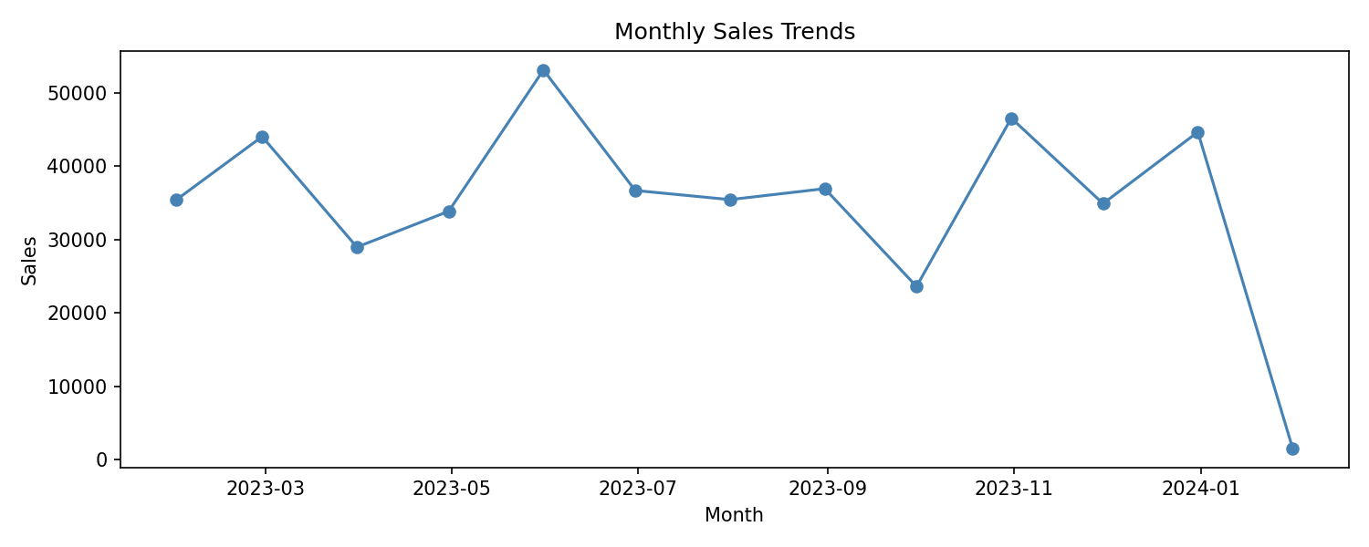
The line chart shows the evolution of total sales month by month, highlighting peaks and troughs across the year.
Figure 2 — Monthly Sales (Bar Chart):
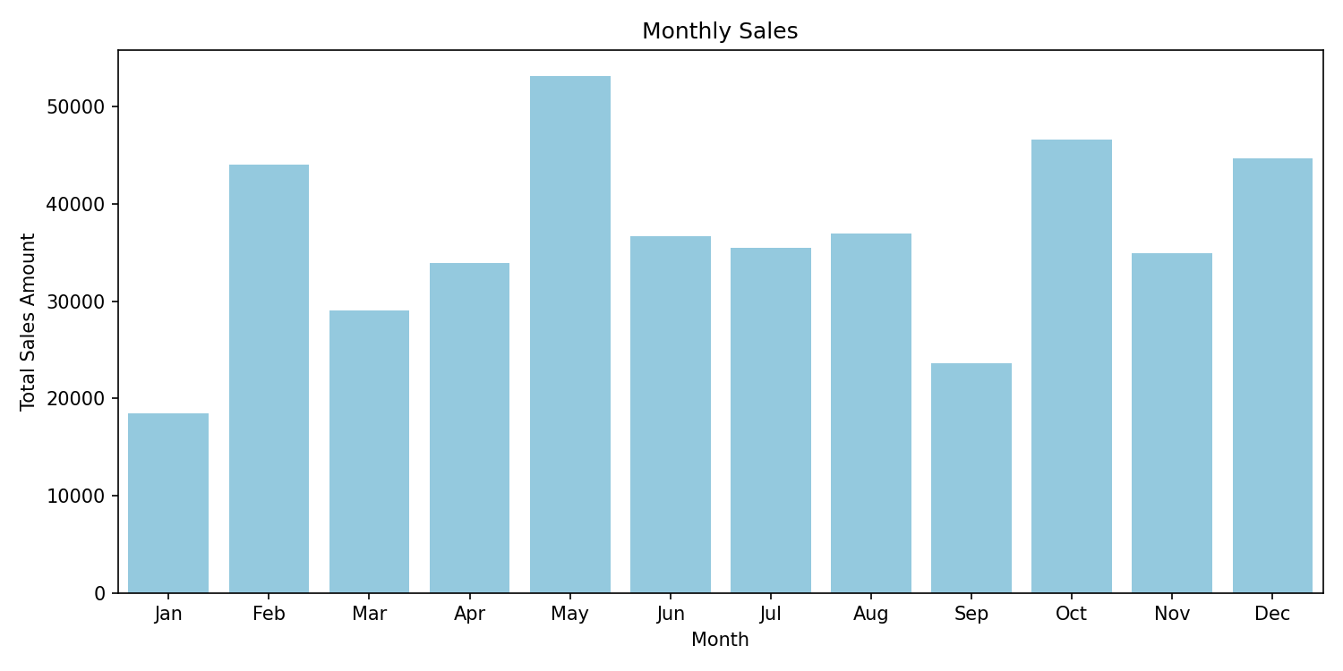
The bar chart provides an at-a-glance comparison of total sales per month, making it easy to identify the strongest and weakest performing periods.

6. Act
Recommendations based on the analysis:
1. Capitalize on peak month (May 2023): increase inventory and staffing ahead of the high-demand period.
2. Address low-sales period (January 2024): run targeted promotions or loyalty campaigns to stimulate demand.
3. Category focus: prioritize high-margin items from (Beauty, Clothing, Electronics) during peak periods.
4. Automate reporting: schedule this analysis monthly to continuously monitor trends.

Appendix — Python Code (main.py)
The following Python script was used to perform the data processing and generate the visualizations:
import pandas as pd
import matplotlib.pyplot as plt
import seaborn as sns
df = pd.read_csv('input/sales.csv')
df.head()
df.info()
df.describe()
df['Date'] = pd.to_datetime(df['Date'])
monthly_sales = df.resample('M', on='Date').sum()
sales_mean = df['Total Amount'].mean()
print(f"Avg Sales by month: {sales_mean:.2f}")
plt.plot(monthly_sales.index, monthly_sales['Total Amount'])
plt.title('Monthly Sales Trends')
plt.xlabel('Month')
plt.ylabel('Sales')
plt.show()
# 2️⃣ Create a "Month" column for the X axis
monthly_sales_reset = monthly_sales.reset_index()
monthly_sales_reset['Month'] = monthly_sales_reset['Date'].dt.strftime('%b')
# 3️⃣ Plot the barplot
plt.figure(figsize=(10,5))
sns.barplot(x='Month', y='Total Amount', data=monthly_sales_reset, color='skyblue', errorbar=None)
plt.title("Monthly Sales")
plt.xlabel("Month")
plt.ylabel("Total Sales Amount")
plt.show()

