Lab Report

# Title: Jump Instructions, For Loop, While Loop, Do While Loop With 8086 Microprocessor

# 1. Write an assembly program that will take two numbers as input and check if the given two numbers are equal or not using JNE.

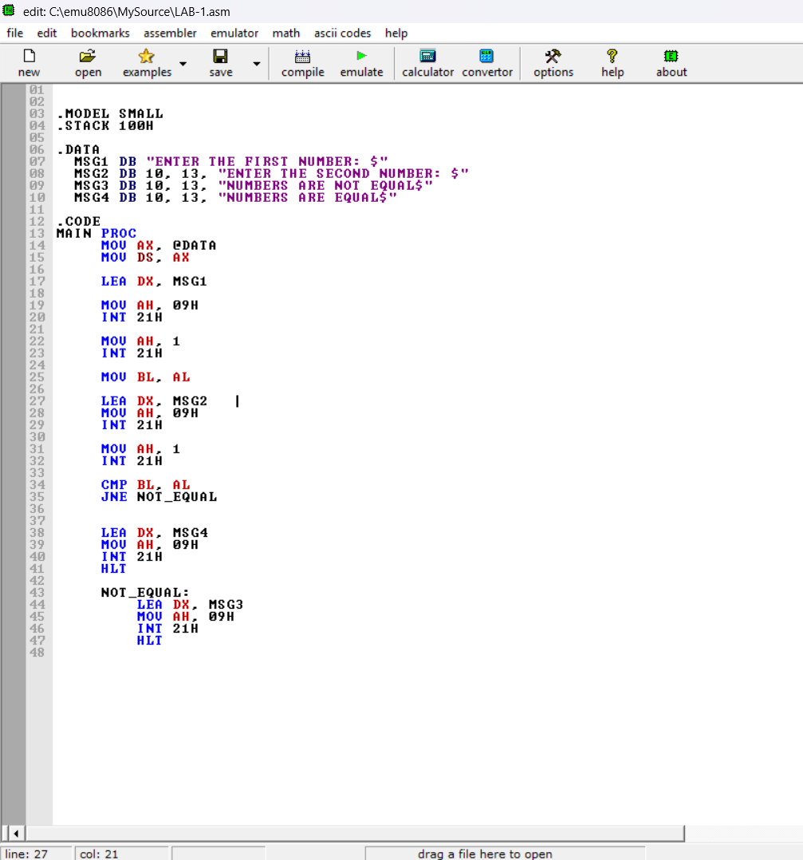

# Output:

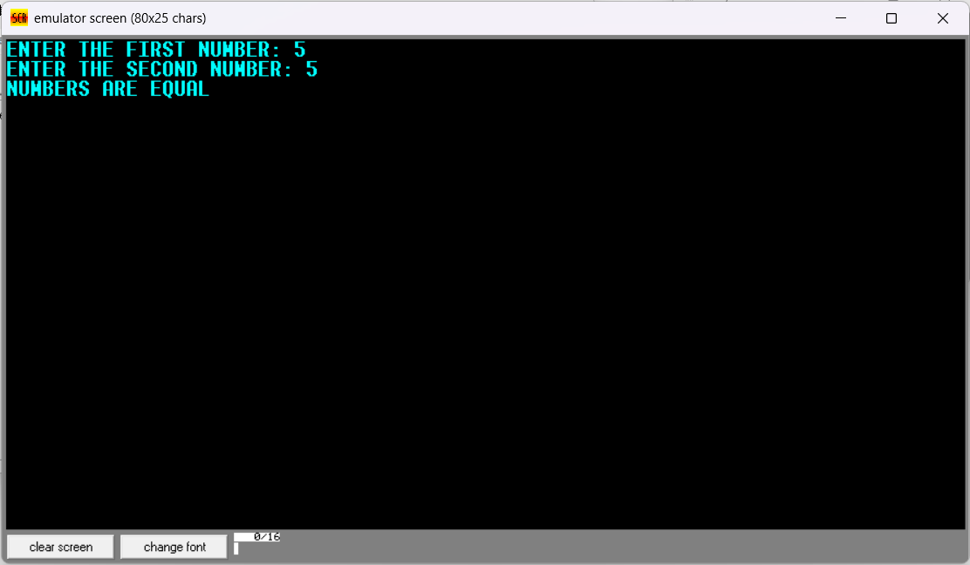

# 2. Write an assembly program that will take two number as input and check if the first number is greater or the second number using JG.

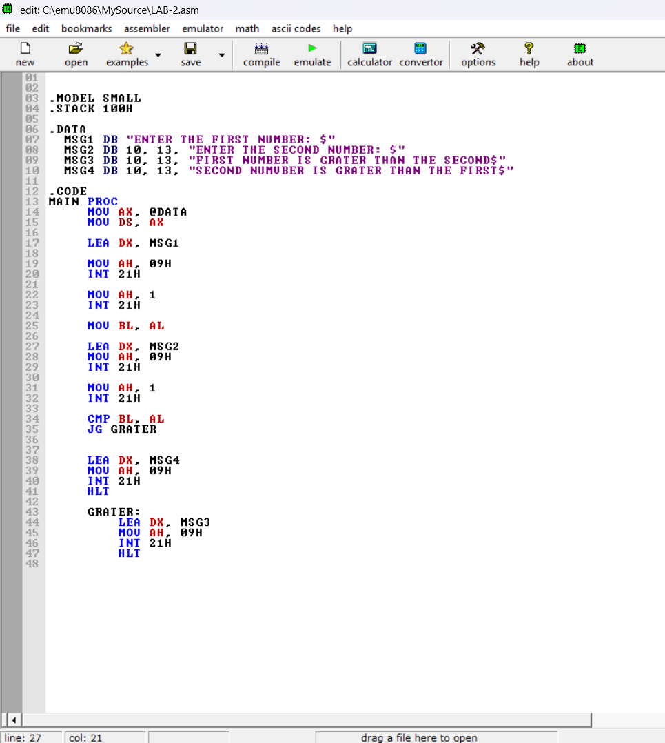

# Output

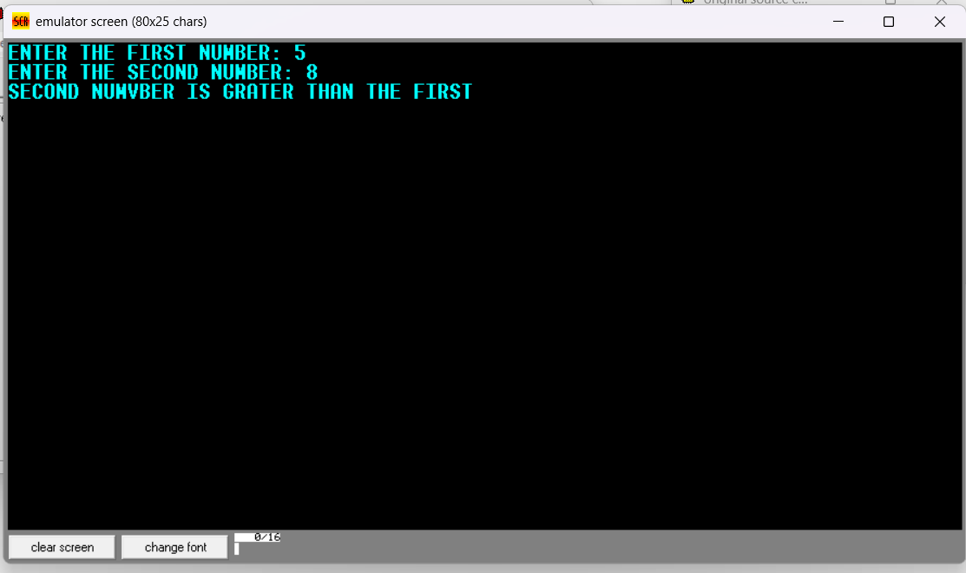

## 3. Write an assembly program that will take three numbers as input and tell which one is largest using JLE.

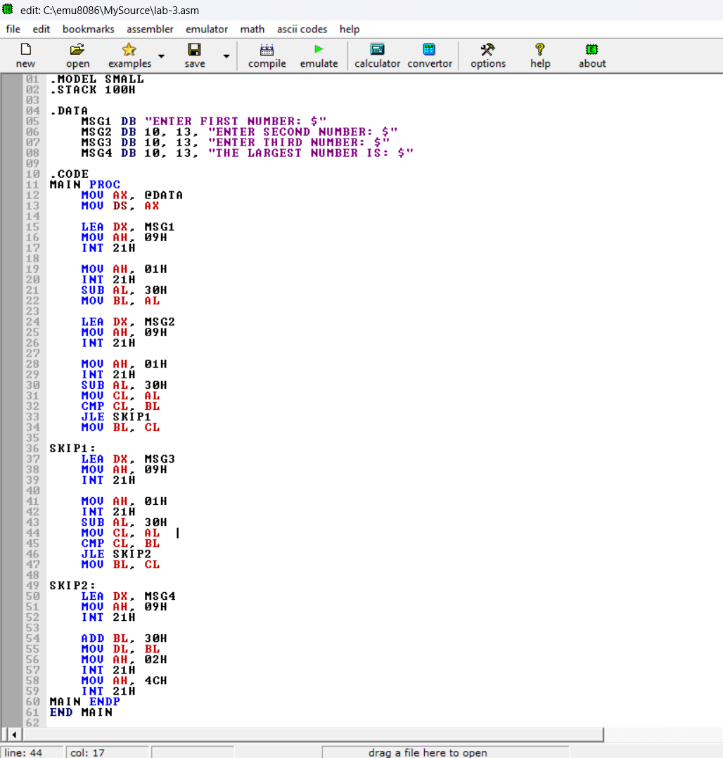

## Output

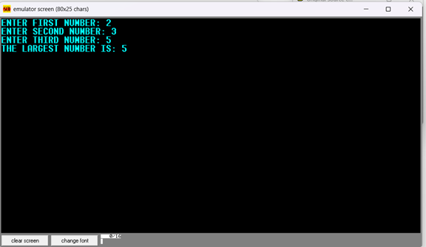

# 4. Write an assembly program that will take a number as input and print “HELLO WORLD” that number of times using for loop.

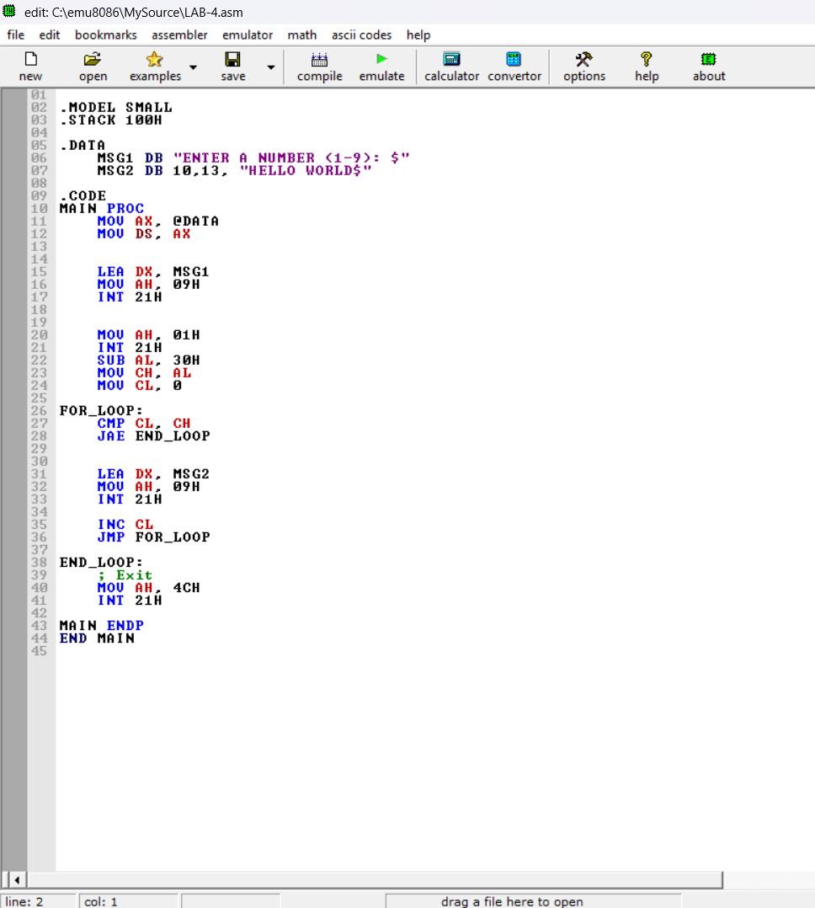

# Output

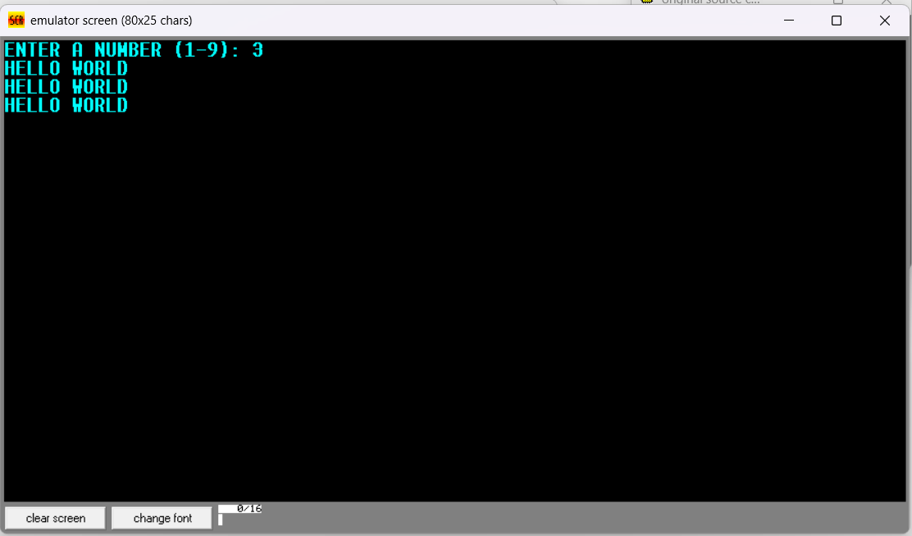

# 5. Write an assembly program that will take a number as input and print 1 to n in reverse order using while loop.

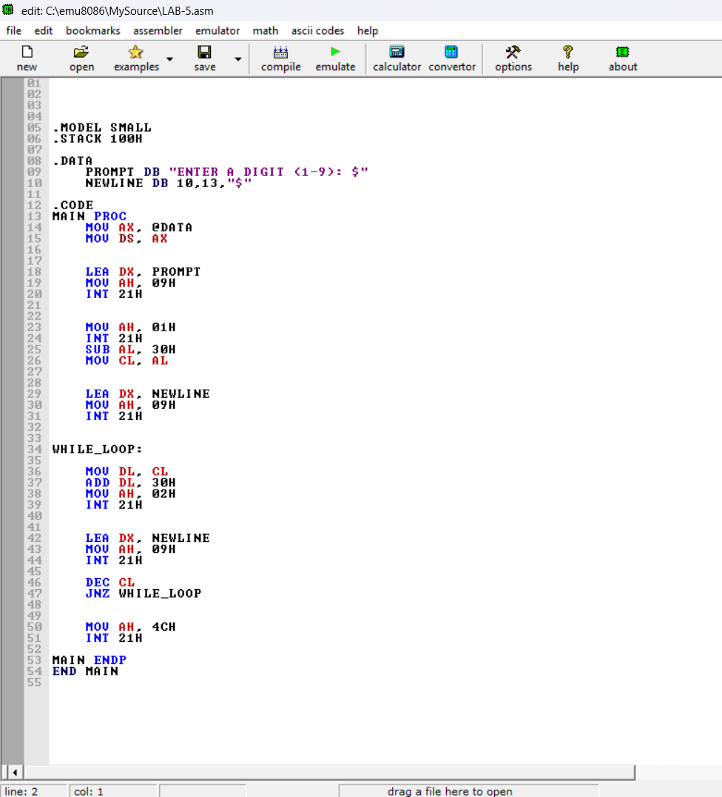

# Output

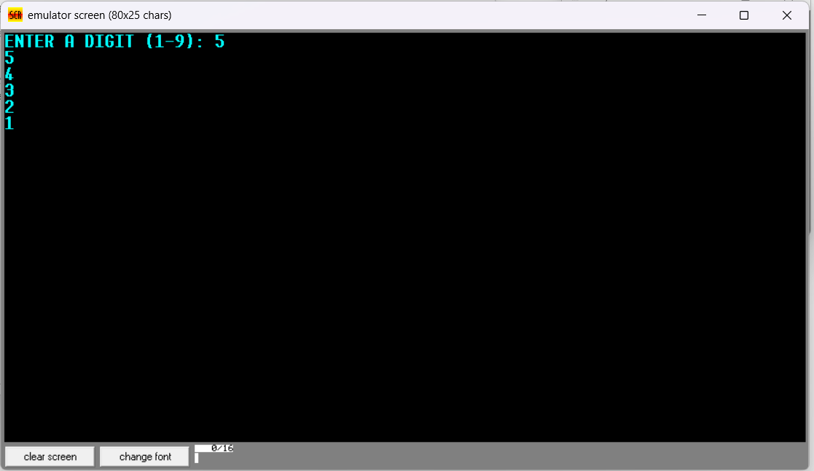

# 6. Write an assembly program that will take a number as input and print a message to mom, at least one time using do while loop.

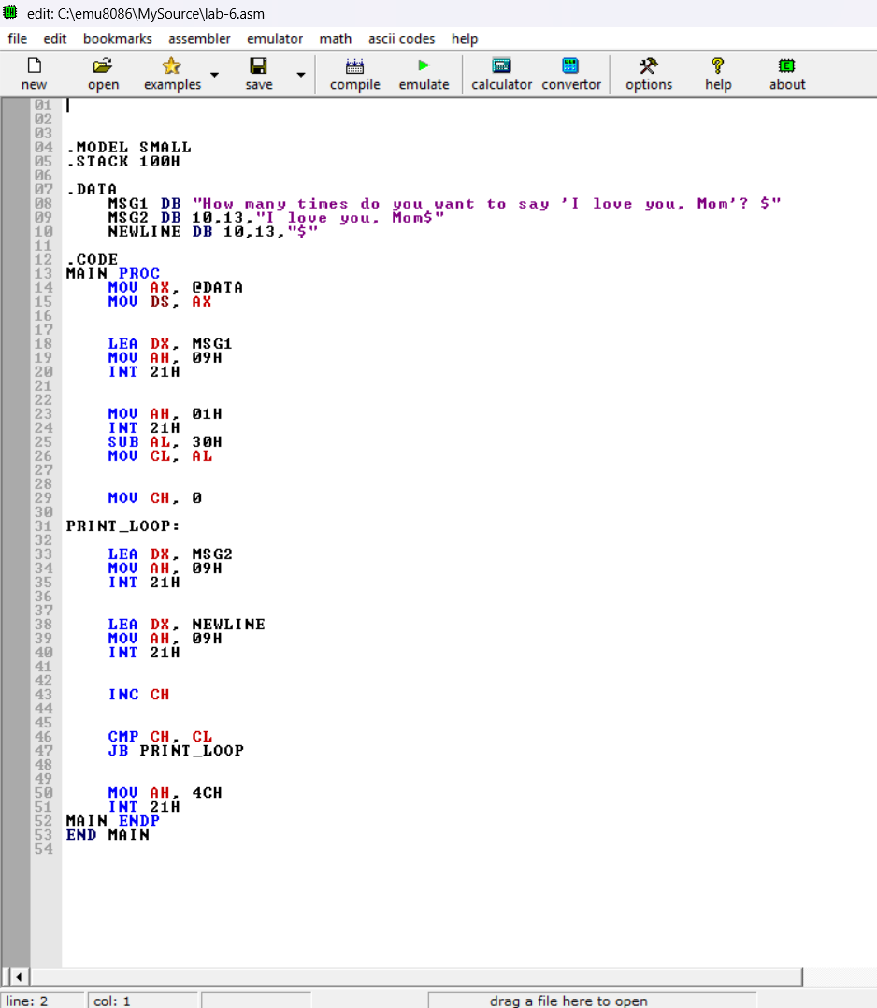

# Output

