Metagenomes

Running Bifrost in /usr/bin/time. Output goes to bifrout_out_mg, stderr goes to run_bifrost_mg_output.txt

Design

Tools

- BufBOSS (build/add/delete)
- DynBoss (build/add/delete)
- Bifrost (build/add)
- FDBG (build/add/delete)
- FDBG-Recsplit (build/add/delete)

Dataset

- N E.coli genomes. N = 12 for testing the setup. I have N = 3682 total. To test scaling, do N = 12 * 2^i for I = 0,1,2,3,4.
- If there is time, do the same with read sets.
- Build an index out of N/2 genomes. Add N/4, delete N/4.

Genomes are at: ~/code/bufboss_experiments/data/coli3682

Generating the sets for N = 12 (6 build, 3 add, 3 delete) (THESE ARE IN data/init.sh):

niklas@phoenix:~/code/bufboss_experiments/data$ ls $PWD/coli3682/*.fna | shuf | head -n 12 > coli12.txt
niklas@phoenix:~/code/bufboss_experiments/data$ head -n 6 coli12.txt > coli12_build.txt
niklas@phoenix:~/code/bufboss_experiments/data$ head -n $(expr 6 + 3) coli12.txt | tail -n 3 > coli12_add.txt
niklas@phoenix:~/code/bufboss_experiments/data$ head -n $(expr 6 + 3 + 3) coli12.txt | tail -n 3 > coli12_del.txt

Generating the sets for N = 3682 (1842 build, 920 add, 920 delete) (maybe too big to use but anyway) (THESE ARE IN data/init.sh):

niklas@phoenix:~/code/bufboss_experiments/data$ ls $PWD/coli3682/*.fna | shuf | head -n 3682 > coli3682.txt
niklas@phoenix:~/code/bufboss_experiments/data$ head -n 1842 coli3682.txt > coli3682_build.txt
niklas@phoenix:~/code/bufboss_experiments/data$ head -n $(expr 1842 + 920) coli3682.txt | tail -n 920 > coli3682_add.txt
niklas@phoenix:~/code/bufboss_experiments/data$ head -n $(expr 1842 + 920 + 920) coli3682.txt | tail -n 920 > coli3682_del.txt

Generate setup the experiment (generate input files from construction, add, del and query).

niklas@phoenix:~/code/bufboss_experiments$ python3 setup.py

Metrics

- Build time/memory/disk
- Add time/memory/disk
- Delete time/memory/disk
- Query time/memory. For bufboss also do a plot of buffer size vs query time.

Build/add/del experiment
- First build, then del, then add (this is the best for bufboss because with combined add/delete the dummies are handled nicely. For bufboss report both separate del/add and combined)

Todos

Query experiment
Dataset is the final index from the build/add/del experiment
Set up the experiment like this:
- Existing sequence: query_kmers.fna (random k-mer subset from build+add-del) and query_nonkmers.fna (random k-mers (not in index with very high prob)).
– How to sample the random k-mers? Query from bufboss and write to disk. Needs a separate main program. → done
- Non-existing sequence: query_reads.fna (real e.coli reads) and query_nonreads.fna (random reads (not in the index with very high prob)).
Supported query types:
- BiFrost: read each read, returns one bit, whether a given fraction of k-mers are found. Rolling implemented
– For existing k-mers and reads, set the fraction to all. This way it needs to search all.
– For non-kmers and non-reads, set the thereshold to 1 / (length – k + 1). This way it has to search all.
- FDBG: query is: check buffer, check hash. Hash can be rolled. Looks like rolling is not implemented
- BufBOSS: can do individual k-mers and can roll k-mers. Query time also a function of buffer size. How to get different buffer sizes? Write a separate main-program that runs the queries at given increments of buffer fraction → done. Rolling is implemented.
- DynBOSS: can do individual k-mers and can roll k-mers. Rolling not implemented

Todos
- Measure just query time, not index loading. Need to add timing code to the tools 2h to do? Print a line to stdout/stderr and parse from plot script.
– Bifrost CHECK
– FDBG
– BufBOSS CHECK
– DynBOSS

Bahar seems to measure addition time, not query time in Bifrost. Hmm??? The code she was using didn’t have the queries implemented yet in the main function…. No, there it looks like she is doing the queries and measuring with usr/bin/time

home="/s/apu/a/homes/baharpan"
bifrost="$home/bifrost/bin/Bifrost"
Input="/s/nut/a/data/Bahar/dynBoss/e.coli"
Tocheck="/s/nut/a/data/Bahar/dynBoss/salmonella/to_add/10-11.fasta"
k=31
num=(20K_e 200K_e 2M_e 14M_e 28M_e 20K 200K 2M 11M 55M 150M 600M)
for n in "${num[@]}"
do
#cmd="$bifrost build -t 1 -k $k -i -d -o ${f%.*}.bfrst -s $file"
cmd="$bifrost query -t 1 -e 1 -g $n-refbased.bfrst.gfa -q $Tocheck -o presence_queries"
echo $cmd
/usr/bin/time -v $cmd

Running BufBOSS
(Todo: bufboss logs some stuff without using the callback)
(Todo: construction with KMC count. Make a version that takes a KMC database as input. Give those k-mers as a k-mer stream to my builder. Change my k-mer sorter to the EM sorter of Themisto.).
(Todo: don’t replace non-ACGT with dollar but rather don’t include those k-mers at all. If built from KMC, it works like this already.)
(Todo: add/del from KMC database. This could be slower because we can’t roll the k-mer, but could be faster because we add/del each k-mer only once)
(Todo: don’t need to search reverse complement if index has them)
Run commands at niklas@phoenix:~/code/bufboss_experiments. The k of bufboss is the nodemer k.

BufBOSS construction of build.fna from KMC gives:

0.0010 Thu Jan 28 09:56:34 2021 Building from KMC database
12.5870 Thu Jan 28 09:56:47 2021 Build BOSS (k = 30) with 25413901 nodes and 25651872 edges
12.6050 Thu Jan 28 09:56:47 2021 Number of dummy nodes: 39382
12.6050 Thu Jan 28 09:56:47 2021 Number of k-mer nodes: 25374519

While building with my own hashing gives:

17.5560 Thu Jan 28 10:55:18 2021 25678898 unique 31-mers hashed
17.5560 Thu Jan 28 10:55:18 2021 30866 total non-AGCT characters replaced with random nucleotides
30.0680 Thu Jan 28 10:55:31 2021 Build BOSS (k = 30) with 25480969 nodes and 25719130 edges
30.0870 Thu Jan 28 10:55:31 2021 Number of dummy nodes: 38580
30.0870 Thu Jan 28 10:55:31 2021 Number of k-mer nodes: 25442389
30.0870 Thu Jan 28 10:55:31 2021 Writing BOSS to temp
33.3710 Thu Jan 28 10:55:34 2021 Done

Number of k-mer nodes does not match. Maybe it’s because KMC supposedly ignores non-ACGT characters

Let’s try 0.fna. Now it matches:

niklas@phoenix:~/code/bufboss_experiments$ ./bufboss/bin/bufboss_build -k 30 -o temp -a temp/0.fna --revcomp
0.0010 Thu Jan 28 10:57:09 2021 1 input files.
0.0010 Thu Jan 28 10:57:09 2021 Hashing 31-mers
0.0010 Thu Jan 28 10:57:09 2021 Processing file temp/0.fna
3.5430 Thu Jan 28 10:57:13 2021 9108538 unique 31-mers hashed
3.5430 Thu Jan 28 10:57:13 2021 0 total non-AGCT characters replaced with random nucleotides
7.6700 Thu Jan 28 10:57:17 2021 Build BOSS (k = 30) with 9107011 nodes and 9108598 edges
7.6700 Thu Jan 28 10:57:17 2021 Number of dummy nodes: 59
7.6700 Thu Jan 28 10:57:17 2021 Number of k-mer nodes: 9106952
7.6700 Thu Jan 28 10:57:17 2021 Writing BOSS to temp
8.6280 Thu Jan 28 10:57:18 2021 Done
niklas@phoenix:~/code/bufboss_experiments$ ./bufboss/KMC/bin/kmc -k31 -m1 -ci1 -cs1 -fm temp/0.fna temp/kmc_db temp
******
Stage 1: 100%
Stage 2: 100%
1st stage: 0.191904s
2nd stage: 0.095348s
Total : 0.287252s
Tmp size : 4MB

Stats:
No. of k-mers below min. threshold : 0
No. of k-mers above max. threshold : 0
No. of unique k-mers : 4554269
No. of unique counted k-mers : 4554269
Total no. of k-mers : 4641622
Total no. of sequences : 1
Total no. of super-k-mers : 355872
niklas@phoenix:~/code/bufboss_experiments$ ./bufboss/bin/bufboss_build -o temp --KMC temp/kmc_db
0.0010 Thu Jan 28 10:58:34 2021 Building from KMC database
4.5700 Thu Jan 28 10:58:39 2021 Build BOSS (k = 30) with 9107011 nodes and 9108598 edges
4.5700 Thu Jan 28 10:58:39 2021 Number of dummy nodes: 59
4.5700 Thu Jan 28 10:58:39 2021 Number of k-mer nodes: 9106952
4.5700 Thu Jan 28 10:58:39 2021 Writing BOSS to temp
4.5810 Thu Jan 28 10:58:39 2021 Done

Preparation
mkdir bufboss_out
mkdir bufboss_out/build
mkdir bufboss_out/add
mkdir bufboss_out/del
mkdir bufboss_out/adddel

Construction
Set buffer fraction to 1e9 to avoid flushing the buffer before end. Todo: build from KMC k-mers. Todo: avoid first flush
./bufboss/bin/bufboss_update -k 30 -r -b 1000000000 -o bufboss_out/build --add-files data/coli12_build.txt
0.0020 Mon Jan 25 19:47:25 2021 6 input files for addition.
0.0020 Mon Jan 25 19:47:25 2021 0 input files for deletion.
0.0060 Mon Jan 25 19:47:25 2021 Initialized empty BOSS with k = 30
0.0060 Mon Jan 25 19:47:25 2021 Loading deletions
0.0060 Mon Jan 25 19:47:25 2021 Loading additions
0.0060 Mon Jan 25 19:47:25 2021 Adding k-mers of file /home/niklas/code/bufboss_experiments/data/coli3682/GCA_000250155.2_ASM25015v2.fna
0.0350 Mon Jan 25 19:47:25 2021 Flushing the buffer
0.0350 Mon Jan 25 19:47:25 2021 Flushing 0 deletions and 23086 additions
0.0360 Mon Jan 25 19:47:25 2021 Adding dummies
0.0360 Mon Jan 25 19:47:25 2021 BOSS edgemers: 0
0.0360 Mon Jan 25 19:47:25 2021 BUF+ edgemers: 23082
0.0360 Mon Jan 25 19:47:25 2021 BUF- edgemers: 0
0.0400 Mon Jan 25 19:47:25 2021 118 dummy edgemers added
14.8000 Mon Jan 25 19:47:40 2021 Adding k-mers of file /home/niklas/code/bufboss_experiments/data/coli3682/GCA_000700505.1_ASM70050v1.fna
28.3300 Mon Jan 25 19:47:54 2021 Adding k-mers of file /home/niklas/code/bufboss_experiments/data/coli3682/GCA_000503615.1_Ecoli87A.fna
40.9250 Mon Jan 25 19:48:06 2021 Adding k-mers of file /home/niklas/code/bufboss_experiments/data/coli3682/GCA_000351805.1_Esch_coli_KTE86_V1.fna
53.4410 Mon Jan 25 19:48:19 2021 Adding k-mers of file /home/niklas/code/bufboss_experiments/data/coli3682/GCA_000703525.1_ASM70352v1.fna
68.3450 Mon Jan 25 19:48:34 2021 Adding k-mers of file /home/niklas/code/bufboss_experiments/data/coli3682/GCA_000779005.1_ASM77900v1.fna
79.7030 Mon Jan 25 19:48:45 2021 Flushing the buffer
79.7030 Mon Jan 25 19:48:45 2021 Flushing 0 deletions and 25420197 additions
81.4920 Mon Jan 25 19:48:47 2021 Adding dummies
81.4920 Mon Jan 25 19:48:47 2021 BOSS edgemers: 23200
81.5350 Mon Jan 25 19:48:47 2021 BUF+ edgemers: 25655816
81.5350 Mon Jan 25 19:48:47 2021 BUF- edgemers: 0
104.4630 Mon Jan 25 19:49:10 2021 40188 dummy edgemers added
117.8950 Mon Jan 25 19:49:23 2021 30866 total non-AGCT characters replaced with random nucleotides
117.8950 Mon Jan 25 19:49:23 2021 Merged BOSS (k = 30) has 25481040 nodes and 25719204 edges
117.9140 Mon Jan 25 19:49:23 2021 Number of dummy nodes: 38651
117.9140 Mon Jan 25 19:49:23 2021 Writing merged BOSS to bufboss_out/build
117.9440 Mon Jan 25 19:49:23 2021 Done

Add
./bufboss/bin/bufboss_update -k 30 -r -b 0.05 -i bufboss_out/build/ --add-files data/coli12_add.txt -o bufboss_out/add/
0.0010 Mon Jan 25 19:49:23 2021 3 input files for addition.
0.0010 Mon Jan 25 19:49:23 2021 0 input files for deletion.
0.0280 Mon Jan 25 19:49:23 2021 Loaded BOSS (k = 30) with 25481040 nodes and 25719204 edges
0.0280 Mon Jan 25 19:49:23 2021 Loading deletions
0.0280 Mon Jan 25 19:49:23 2021 Loading additions
0.0280 Mon Jan 25 19:49:23 2021 Adding k-mers of file /home/niklas/code/bufboss_experiments/data/coli3682/GCA_000987555.1_ASM98755v1.fna
12.4180 Mon Jan 25 19:49:36 2021 Adding k-mers of file /home/niklas/code/bufboss_experiments/data/coli3682/GCA_000703725.1_ASM70372v1.fna
13.5900 Mon Jan 25 19:49:37 2021 Flushing the buffer
13.6120 Mon Jan 25 19:49:37 2021 Flushing 0 deletions and 1425544 additions
13.6870 Mon Jan 25 19:49:37 2021 Adding dummies
13.6870 Mon Jan 25 19:49:37 2021 BOSS edgemers: 25719204
13.6890 Mon Jan 25 19:49:37 2021 BUF+ edgemers: 1400684
13.7160 Mon Jan 25 19:49:37 2021 BUF- edgemers: 0
22.3130 Mon Jan 25 19:49:46 2021 5470 dummy edgemers added
56.1440 Mon Jan 25 19:50:19 2021 Flushing the buffer
56.1670 Mon Jan 25 19:50:19 2021 Flushing 0 deletions and 1372022 additions
56.2350 Mon Jan 25 19:50:20 2021 Adding dummies
56.2350 Mon Jan 25 19:50:20 2021 BOSS edgemers: 27125358
56.2380 Mon Jan 25 19:50:20 2021 BUF+ edgemers: 1350632
56.2670 Mon Jan 25 19:50:20 2021 BUF- edgemers: 0
64.7020 Mon Jan 25 19:50:28 2021 73 dummy edgemers added
100.9600 Mon Jan 25 19:51:04 2021 Flushing the buffer
100.9840 Mon Jan 25 19:51:04 2021 Flushing 0 deletions and 1548710 additions
101.0700 Mon Jan 25 19:51:04 2021 Adding dummies
101.0700 Mon Jan 25 19:51:04 2021 BOSS edgemers: 28476063
101.0720 Mon Jan 25 19:51:04 2021 BUF+ edgemers: 1521878
101.1030 Mon Jan 25 19:51:04 2021 BUF- edgemers: 0
111.2330 Mon Jan 25 19:51:15 2021 25 dummy edgemers added
148.3590 Mon Jan 25 19:51:52 2021 Adding k-mers of file /home/niklas/code/bufboss_experiments/data/coli3682/GCA_000460995.1_Esch_coli_UMEA_3233-1_V1.fna
152.8510 Mon Jan 25 19:51:56 2021 Flushing the buffer
152.8770 Mon Jan 25 19:51:56 2021 Flushing 0 deletions and 1794844 additions
152.9750 Mon Jan 25 19:51:56 2021 Adding dummies
152.9750 Mon Jan 25 19:51:56 2021 BOSS edgemers: 29997966
152.9780 Mon Jan 25 19:51:56 2021 BUF+ edgemers: 1760030
153.0100 Mon Jan 25 19:51:56 2021 BUF- edgemers: 0
165.0330 Mon Jan 25 19:52:08 2021 48 dummy edgemers added
207.0490 Mon Jan 25 19:52:50 2021 Flushing the buffer
207.0760 Mon Jan 25 19:52:50 2021 Flushing 0 deletions and 1113168 additions
207.1300 Mon Jan 25 19:52:50 2021 Adding dummies
207.1300 Mon Jan 25 19:52:50 2021 BOSS edgemers: 31758044
207.1320 Mon Jan 25 19:52:50 2021 BUF+ edgemers: 1089550
207.1660 Mon Jan 25 19:52:50 2021 BUF- edgemers: 0
214.9550 Mon Jan 25 19:52:58 2021 0 dummy edgemers added
247.1190 Mon Jan 25 19:53:30 2021 24036 total non-AGCT characters replaced with random nucleotides
247.1190 Mon Jan 25 19:53:30 2021 Merged BOSS (k = 30) has 32475454 nodes and 32847594 edges
247.1420 Mon Jan 25 19:53:30 2021 Number of dummy nodes: 44037
247.1420 Mon Jan 25 19:53:30 2021 Writing merged BOSS to bufboss_out/add/
247.1790 Mon Jan 25 19:53:30 2021 Done

Delete
./bufboss/bin/bufboss_update -k 30 -r -b 0.05 -i bufboss_out/build/ --del-files data/coli12_del.txt -o bufboss_out/del/
0.0000 Mon Jan 25 19:53:30 2021 0 input files for addition.
0.0000 Mon Jan 25 19:53:30 2021 3 input files for deletion.
0.0290 Mon Jan 25 19:53:31 2021 Loaded BOSS (k = 30) with 25481040 nodes and 25719204 edges
0.0290 Mon Jan 25 19:53:31 2021 Loading deletions
0.0290 Mon Jan 25 19:53:31 2021 Deleting k-mers of file /home/niklas/code/bufboss_experiments/data/coli3682/GCA_000798595.1_Escherichia_coli_CVM_N33601PS_v._1.0.fna
55.3820 Mon Jan 25 19:54:26 2021 Deleting k-mers of file /home/niklas/code/bufboss_experiments/data/coli3682/GCA_000692755.1_Esch_coli_MGH_57_V1.fna
112.8270 Mon Jan 25 19:55:23 2021 Deleting k-mers of file /home/niklas/code/bufboss_experiments/data/coli3682/GCA_000776675.1_ASM77667v1.fna
166.0710 Mon Jan 25 19:56:17 2021 Loading additions
166.0710 Mon Jan 25 19:56:17 2021 Flushing the buffer
166.0950 Mon Jan 25 19:56:17 2021 Flushing 13676812 deletions and 0 additions
166.0950 Mon Jan 25 19:56:17 2021 Adding dummies
166.0950 Mon Jan 25 19:56:17 2021 BOSS edgemers: 25719204
166.0950 Mon Jan 25 19:56:17 2021 BUF+ edgemers: 0
166.1240 Mon Jan 25 19:56:17 2021 BUF- edgemers: 13676812
394.7070 Mon Jan 25 20:00:05 2021 3522769 dummy edgemers added
425.2470 Mon Jan 25 20:00:36 2021 67540 total non-AGCT characters replaced with random nucleotides
425.2470 Mon Jan 25 20:00:36 2021 Merged BOSS (k = 30) has 15537302 nodes and 15565161 edges
426.2830 Mon Jan 25 20:00:37 2021 Number of dummy nodes: 3398835
426.2830 Mon Jan 25 20:00:37 2021 Writing merged BOSS to bufboss_out/del/
426.3010 Mon Jan 25 20:00:37 2021 Done

Combined Add and Delete
./bufboss/bin/bufboss_update -k 30 -r -b 0.05 -i bufboss_out/build/ --add-files data/coli12_add.txt --del-files data/coli12_del.txt -o bufboss_out/adddel/
0.0000 Mon Jan 25 20:00:37 2021 3 input files for addition.
0.0000 Mon Jan 25 20:00:37 2021 3 input files for deletion.
0.0280 Mon Jan 25 20:00:37 2021 Loaded BOSS (k = 30) with 25481040 nodes and 25719204 edges
0.0280 Mon Jan 25 20:00:37 2021 Loading deletions
0.0280 Mon Jan 25 20:00:37 2021 Deleting k-mers of file /home/niklas/code/bufboss_experiments/data/coli3682/GCA_000798595.1_Escherichia_coli_CVM_N33601PS_v._1.0.fna
53.2820 Mon Jan 25 20:01:30 2021 Deleting k-mers of file /home/niklas/code/bufboss_experiments/data/coli3682/GCA_000692755.1_Esch_coli_MGH_57_V1.fna
109.7050 Mon Jan 25 20:02:27 2021 Deleting k-mers of file /home/niklas/code/bufboss_experiments/data/coli3682/GCA_000776675.1_ASM77667v1.fna
159.7420 Mon Jan 25 20:03:17 2021 Loading additions
159.7420 Mon Jan 25 20:03:17 2021 Adding k-mers of file /home/niklas/code/bufboss_experiments/data/coli3682/GCA_000987555.1_ASM98755v1.fna
171.9620 Mon Jan 25 20:03:29 2021 Adding k-mers of file /home/niklas/code/bufboss_experiments/data/coli3682/GCA_000703725.1_ASM70372v1.fna
173.1040 Mon Jan 25 20:03:30 2021 Flushing the buffer
173.1260 Mon Jan 25 20:03:30 2021 Flushing 5802030 deletions and 1425544 additions
173.2000 Mon Jan 25 20:03:30 2021 Adding dummies
173.2000 Mon Jan 25 20:03:30 2021 BOSS edgemers: 25719204
173.2020 Mon Jan 25 20:03:30 2021 BUF+ edgemers: 1400684
173.2300 Mon Jan 25 20:03:30 2021 BUF- edgemers: 5802030
277.5900 Mon Jan 25 20:05:14 2021 1353610 dummy edgemers added
313.0200 Mon Jan 25 20:05:50 2021 Flushing the buffer
313.0390 Mon Jan 25 20:05:50 2021 Flushing 0 deletions and 1272450 additions
313.1030 Mon Jan 25 20:05:50 2021 Adding dummies
313.1030 Mon Jan 25 20:05:50 2021 BOSS edgemers: 22671468
313.1050 Mon Jan 25 20:05:50 2021 BUF+ edgemers: 1252868
313.1290 Mon Jan 25 20:05:50 2021 BUF- edgemers: 0
321.4430 Mon Jan 25 20:05:58 2021 66 dummy edgemers added
353.6350 Mon Jan 25 20:06:30 2021 Flushing the buffer
353.6560 Mon Jan 25 20:06:30 2021 Flushing 0 deletions and 1601686 additions
353.7530 Mon Jan 25 20:06:31 2021 Adding dummies
353.7530 Mon Jan 25 20:06:31 2021 BOSS edgemers: 23924402
353.7550 Mon Jan 25 20:06:31 2021 BUF+ edgemers: 1577846
353.7810 Mon Jan 25 20:06:31 2021 BUF- edgemers: 0
364.0530 Mon Jan 25 20:06:41 2021 0 dummy edgemers added
396.7610 Mon Jan 25 20:07:14 2021 Flushing the buffer
396.7840 Mon Jan 25 20:07:14 2021 Flushing 0 deletions and 1296534 additions
396.8500 Mon Jan 25 20:07:14 2021 Adding dummies
396.8500 Mon Jan 25 20:07:14 2021 BOSS edgemers: 25502248
396.8520 Mon Jan 25 20:07:14 2021 BUF+ edgemers: 1275022
396.8800 Mon Jan 25 20:07:14 2021 BUF- edgemers: 0
405.9570 Mon Jan 25 20:07:23 2021 0 dummy edgemers added
438.0270 Mon Jan 25 20:07:55 2021 Adding k-mers of file /home/niklas/code/bufboss_experiments/data/coli3682/GCA_000460995.1_Esch_coli_UMEA_3233-1_V1.fna
439.4930 Mon Jan 25 20:07:56 2021 Flushing the buffer
439.5160 Mon Jan 25 20:07:56 2021 Flushing 0 deletions and 1389550 additions
439.5840 Mon Jan 25 20:07:56 2021 Adding dummies
439.5840 Mon Jan 25 20:07:56 2021 BOSS edgemers: 26777270
439.5860 Mon Jan 25 20:07:56 2021 BUF+ edgemers: 1366930
439.6150 Mon Jan 25 20:07:56 2021 BUF- edgemers: 0
448.2890 Mon Jan 25 20:08:05 2021 88 dummy edgemers added
485.7940 Mon Jan 25 20:08:43 2021 Flushing the buffer
485.8180 Mon Jan 25 20:08:43 2021 Flushing 0 deletions and 1504936 additions
485.9080 Mon Jan 25 20:08:43 2021 Adding dummies
485.9080 Mon Jan 25 20:08:43 2021 BOSS edgemers: 28144288
485.9100 Mon Jan 25 20:08:43 2021 BUF+ edgemers: 1473666
485.9410 Mon Jan 25 20:08:43 2021 BUF- edgemers: 0
496.7390 Mon Jan 25 20:08:54 2021 0 dummy edgemers added
536.2820 Mon Jan 25 20:09:33 2021 Flushing the buffer
536.3080 Mon Jan 25 20:09:33 2021 Flushing 0 deletions and 1695986 additions
536.4070 Mon Jan 25 20:09:33 2021 Adding dummies
536.4070 Mon Jan 25 20:09:33 2021 BOSS edgemers: 29617954
536.4090 Mon Jan 25 20:09:33 2021 BUF+ edgemers: 1662164
536.4420 Mon Jan 25 20:09:33 2021 BUF- edgemers: 0
549.3650 Mon Jan 25 20:09:46 2021 0 dummy edgemers added
584.0920 Mon Jan 25 20:10:21 2021 Flushing the buffer
584.1180 Mon Jan 25 20:10:21 2021 Flushing 0 deletions and 640924 additions
584.1450 Mon Jan 25 20:10:21 2021 Adding dummies
584.1450 Mon Jan 25 20:10:21 2021 BOSS edgemers: 31280118
584.1460 Mon Jan 25 20:10:21 2021 BUF+ edgemers: 629552
584.1800 Mon Jan 25 20:10:21 2021 BUF- edgemers: 0
588.8940 Mon Jan 25 20:10:26 2021 21 dummy edgemers added
619.5210 Mon Jan 25 20:10:56 2021 91576 total non-AGCT characters replaced with random nucleotides
619.5210 Mon Jan 25 20:10:56 2021 Merged BOSS (k = 30) has 31564736 nodes and 31909691 edges
620.1500 Mon Jan 25 20:10:57 2021 Number of dummy nodes: 1332048
620.1500 Mon Jan 25 20:10:57 2021 Writing merged BOSS to bufboss_out/adddel/
620.1870 Mon Jan 25 20:10:57 2021 Done

Query

bufboss/bin/bufboss_query -i bufboss_out/deleted -o bufboss_out/queries.txt -q data/reads/coli_reads_half1.fasta
0.0010 Tue Feb 2 14:58:59 2021 Index directory: bufboss_out/deleted
0.0010 Tue Feb 2 14:58:59 2021 Query file: data/reads/coli_reads_half1.fasta
0.0010 Tue Feb 2 14:58:59 2021 Output file: bufboss_out/queries.txt
0.0690 Tue Feb 2 14:58:59 2021 Loaded BufBOSS (k = 30) with 23761487 nodes and 23823548 edges
0.0690 Tue Feb 2 14:58:59 2021 Addition buffer has 0 nodemers
224.0750 Tue Feb 2 15:02:43 2021 8103707/75049520 edgemers found (10.7978%)
224.0750 Tue Feb 2 15:02:43 2021 Done
Command being timed: "bufboss/bin/bufboss_query -i bufboss_out/deleted -o bufboss_out/queries.txt -q data/reads/coli_reads_half1.fasta"
User time (seconds): 220.26
System time (seconds): 1.00
Percent of CPU this job got: 98%
Elapsed (wall clock) time (h:mm:ss or m:ss): 3:44.07
Maximum resident set size (kbytes): 36624

Only 10% of edgemers were found! Speed was:

>>> 224/75049520
2.9846959714066125e-06 seconds per edgemer

DynBOSS paper:
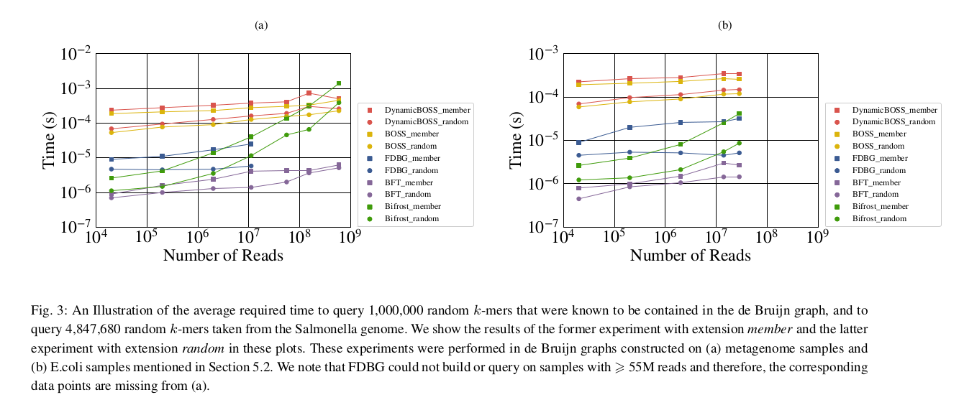

Let’s try the edgemers in the add-set from the added-index.

bufboss/bin/bufboss_query -i bufboss_out/added -o bufboss_out/queries.txt -q temp/add.fasta
0.0010 Tue Feb 2 15:08:27 2021 Index directory: bufboss_out/added
0.0010 Tue Feb 2 15:08:27 2021 Query file: temp/add.fasta
0.0010 Tue Feb 2 15:08:27 2021 Output file: bufboss_out/queries.txt
0.0970 Tue Feb 2 15:08:27 2021 Loaded BufBOSS (k = 30) with 32453734 nodes and 32825592 edges
0.0970 Tue Feb 2 15:08:27 2021 Addition buffer has 0 nodemers
11.2970 Tue Feb 2 15:08:38 2021 15117634/15142210 edgemers found (99.8377%) (why not 100%? Because of non-acgt?)
11.2970 Tue Feb 2 15:08:38 2021 Done
Command being timed: "bufboss/bin/bufboss_query -i bufboss_out/added -o bufboss_out/queries.txt -q temp/add.fasta"
User time (seconds): 11.02
System time (seconds): 0.07
Percent of CPU this job got: 98%
Elapsed (wall clock) time (h:mm:ss or m:ss): 0:11.30
Average shared text size (kbytes): 0
Average unshared data size (kbytes): 0
Average stack size (kbytes): 0
Average total size (kbytes): 0
Maximum resident set size (kbytes): 52256
Average resident set size (kbytes): 0
Major (requiring I/O) page faults: 0
Minor (reclaiming a frame) page faults: 13458
Voluntary context switches: 89
Involuntary context switches: 2244
Swaps: 0
File system inputs: 79368
File system outputs: 29576
Socket messages sent: 0
Socket messages received: 0
Signals delivered: 0
Page size (bytes): 4096
Exit status: 0

Speed is

>>> 11.2970 / 15142210
7.46060185402263e-07 seconds per edgemer

Query performance as a function of buffer fraction
As soon as there is something in the buffer, seems to be about constant:
./bufboss/bin/query_performance_experiment -i bufboss_out/built --add-files data/coli12_add.txt --buf-fraction-increment 0.01 --max-buf-fraction 1.0 -q data/existing/sequence.fna --tempdir temp --experiment-out buf-frac-query-existing-seq.txt
niklas@phoenix:~/code/bufboss_experiments$ tail -f buf-frac-query-existing-seq.txt
0 0.70267
0.0100657 0.888835
0.0200206 0.89298
0.0303807 0.858017
0.0404527 0.8928
0.054839 0.943801
0.0734636 0.886852
0.073505 0.90974
0.085145 0.927221
0.0904484 0.918571
0.100434 0.932087
0.11146 0.952812
0.121065 0.877481
0.130141 0.89316
0.143642 0.896224

Next experiment: add all in addlist to buffer. Don’t flush. Then query:

- All sequences in addlist
- All k-mers in addlist
- All sequences in buildlist
- All k-mers in buildlist

This will reveal how much benefit there is if we find the k-mer in the hash-table.

Experiment running but the the take-away seems to be that the buffer adds about 10% to the query time. It could be better if we checked the buffer before
updating the node on the BOSS. But maybe not worth the effort because the buffer is supposed to be small and k-mers are supposed to be found on it only rarely.
Results are in now (below). First column is buffer fraction and second column is microseconds per edgmer.

==> buf-frac-query-existing-added-edgemers.txt <==
0 11.7872
0.0100657 12.0784
0.0200206 12.0824
0.0303807 12.1074
0.0404527 12.1554
0.054839 12.2535
0.0734636 12.1784
0.073505 12.4076
0.085145 12.3946
0.0904484 12.3035
0.100434 13.19
0.11146 12.7478
0.121065 13.6073
0.130141 13.5473
0.143642 14.0386

==> buf-frac-query-existing-added-seq.txt <==
0 1.14613
0.0100657 1.26383
0.0200206 1.27049
0.0303807 1.24667
0.0404527 1.28059
0.054839 1.32723
0.0734636 1.27029
0.073505 1.31269
0.085145 1.30381
0.0904484 1.30562
0.100434 1.30946
0.11146 1.31511
0.121065 1.23355
0.130141 1.23375
0.143642 1.29472

==> buf-frac-query-existing-build-edgemers.txt <==
0 14.0796
0.0100657 14.4001
0.0200206 14.2208
0.0303807 14.2879
0.0404527 14.4902
0.054839 14.7897
0.0734636 14.5954
0.073505 14.5353
0.085145 14.5383
0.0904484 14.5423
0.100434 14.7156
0.11146 15.7202
0.121065 15.8464
0.130141 14.5123
0.143642 14.5333

==> buf-frac-query-existing-build-seq.txt <==
0 0.674736
0.0100657 0.877841
0.0200206 0.878202
0.0303807 0.854774
0.0404527 0.888114
0.054839 0.935151
0.0734636 0.88451
0.073505 0.884149
0.085145 0.90181
0.0904484 0.910641
0.100434 0.927401
0.11146 0.964346
0.121065 0.872255
0.130141 0.932087
0.143642 0.952091

==> buf-frac-query-random-edgemers.txt <==
0 5.209
0.0100657 5.456
0.0200206 5.473
0.0303807 5.456
0.0404527 5.444
0.054839 5.466
0.0734636 5.479
0.073505 5.593
0.085145 5.707
0.0904484 5.608
0.100434 5.549
0.11146 5.519
0.121065 5.547
0.130141 5.607
0.143642 5.556

==> buf-frac-query-random-seq.txt <==
0 2.93065
0.0100657 3.14607
0.0200206 3.30213
0.0303807 3.13936
0.0404527 3.39894
0.054839 3.38871
0.0734636 3.31133
0.073505 3.32907
0.085145 3.28516
0.0904484 3.30468
0.100434 3.302
0.11146 3.32604
0.121065 3.26136
0.130141 3.13187
0.143642 3.11697

Running DynamicBOSS
Script at run.py. Results:
Part, time (s), mem (bytes)
dsk 34.4 1642631168
pack 3.33 259985408
build 8.57 26488832
add 6675.0 1568292864
del 9046.0 1440923648

Running BiFrost
Playing around
+ /usr/bin/time -v ./build/src/Bifrost build -r ../data/coli12_build.txt -k 31 -y -o coli12
Command being timed: "./build/src/Bifrost build -r ../data/coli12_build.txt -k 31 -y -o coli12"
User time (seconds): 52.28
System time (seconds): 0.05
Percent of CPU this job got: 99%
Elapsed (wall clock) time (h:mm:ss or m:ss): 0:52.33
Maximum resident set size (kbytes): 138360 (138MB)
+ /usr/bin/time -v ./build/src/Bifrost update -g coli12.gfa -r ../data/coli12_add.txt -k 31 -o coli12_added
Command being timed: "./build/src/Bifrost update -g coli12.gfa -r ../data/coli12_add.txt -k 31 -o coli12_added"
User time (seconds): 48.13
System time (seconds): 0.18
Percent of CPU this job got: 99%
Elapsed (wall clock) time (h:mm:ss or m:ss): 0:48.34
Maximum resident set size (kbytes): 359076 (359MB)

Build and add

Running the whole coli-12 set (other programs running at the same time):

Part, time (s), mem (bytes)
bifrost-build 51.72 150736896 (150M)
bifrost-update 43.0 36936908 (40M)

Query
bifrost/build/src/Bifrost query -g bifrost_out/added.dbg.gfa -q data/coli12_add.txt -o bifrost_out/queries.txt
Command being timed: "bifrost/build/src/Bifrost query -g bifrost_out/added.dbg.gfa -q data/coli12_add.txt -o bifrost_out/queries.txt"
User time (seconds): 3.31
System time (seconds): 0.17
Percent of CPU this job got: 98%
Elapsed (wall clock) time (h:mm:ss or m:ss): 0:03.53
Maximum resident set size (kbytes): 373172

>>> 3.53 / 15142210
2.3312317026378578e-07 seconds per k-mer.

Running FDBG
The FDBG code does not have a tool to add or delete k-mers from the index with a fasta-file. But Bahar seems to have implemented this. Downloading Bahar’s stuff from nut. It is at:
/s/apu/a/homes/baharpan/fdbg
She has made some changes to the code and has created test.cpp which does additions and deletions. In fact there are two test.cpp: one at the root and one at cpp-src/test.cpp. The difference seems to be that one uses std::set and one std:.vector. Running… 3.7 times “impossible” in stderr.

What does it do?
- Reads k-mers into vector<string> kmer_2
- Reads FDBG graph
- For all k-mers in kmer_2, take prefix u and suffix v, pack each uint64_t, add pair (u,v) to vector<pair<uint64_t,> uint64_t> > nodes. (Why is it called nodes and not edges?)
- For each pair (u,v) in nodes, check if the edge is in the graph. If no, add the edge to set<pair<uint64_t, uint64_t> > added_deleted_edges.
- For each edge (u,v) in added_deleted_edges, if u is in graph, add it to added_deleted_nodes (std::set<uint64_t>).
- Start the clock
- Add all nodes in added_deleted_nodes to the graph
- Add all edges in added_deleted_edges to the graph
- Stop the clock, print elapsed time
- Verifies that all added nodes and edges are found in the graph
- Start the clock
- Delete all edges in added_deleted_edges from the graph
- Delete all nodes in added_deleted_nodes from the graph
- Stop the clock, print elapsed time
- Verifies that all deleted nodes and edges are found in the graph

What prints “impossible”?
bool newDynamicAddEdge( const kmer_t& u, const kmer_t& v ) {
if (!this->detect_membership(u)) cerr<<"No u"<<endl; ← not printed
if (!this->detect_membership(v)) cerr<<"No v"<<endl; ← not printed
assert(this->detect_membership(u));
assert(this->detect_membership(v));
assert(this->edgePossible(u,v));
if (!this->edgePossible(u, v)) {
cerr << "impossible" << endl; return false;
}
...
Asserts are disabled because I compile with -DNDEBUG. What does edgePossible do?
bool edgePossible(const kmer_t& u, const kmer_t& v) {
unsigned ui, vi;
for (unsigned i = 0; i < (this->k - 1); ++i) {
ui = access_kmer( u, this->k, i + 1 );
vi = access_kmer( v, this->k, i );
if (ui != vi) {
return false;
}
}
return true;
}

It checks that the suffix of u is equal to the prefix of v. This should never fail in our case. Made it print u and v as 29-mers (edgemers are 30-mers) in the case it prints impossible:

CAGCCAATAAAACATTTACATTATGAATA
AGCCAATAAAACATTTACATTATGAATAA
impossible
CAGCCAATAAATAGTCGGCAGGTAGATTT
AGCCAATAAATAGTCGGCAGGTAGATTTT
impossible
CAGCCAATAAATATTCGCTGGCACGTTCA
AGCCAATAAATATTCGCTGGCACGTTCAC
impossible
CAGCCAATAACACCGAGTTTGAACCGGAA
AGCCAATAACACCGAGTTTGAACCGGAAC
impossible

It does look correct! What is this this→k? 30. So the k in the dfbg filename is the nodemer k but the test program takes the edgemer k. Rerunning.

niklas@phoenix:~/code/bufboss_experiments/bahar-fdbg/cpp-src$ ./test-jarno $(head -n 1 ../../data/coli12_add.txt) 31 200Kfdbg30.bin

Now it is playing nice.

Setting FBDG up for experiments
Nodes are k-mers, edges are (k+1)-mers. The input k of the programs is the nodemer k.
todo: stream k-mers
I need three programs: fdbg-build and fdbg-add and fdbg-delete.
- The build program is like the main program of fdbg but with edge addition and removal verification tests removed. Done: fdbg-build-jarno.cpp.
- The add program is the addition part of Bahar’s code, but with streaming k-mers instead of std::vectoring everything. Done: fdbg-add-jarno.cpp.
- The delete program is the deletion part of Bahar’s code, but with streaming k-mers instead of std::vectoring everything. Done: fdbg-del-jarno.cpp.
FDBG can not really add edges if one endpoint does not exist in the graph. It uses a dynamic buffer kind of like buffboss. But there is no efficient merge: everything needs to be rebuilt from scratch. The working memory will blow up. We could rebuild from scratch at that point but maybe we can just say that rebuilding is not implemented and we don’t have to implement it because it’s not our tool.
Results of run_fdbg.py:
TBA. Report RSS/time and index sizes

Dynamicboss

dsk-1.6906/dsk data/one_31mer.fasta 31
bin/cosmo-pack one_31mer.solid_kmers_binary
bin/dynamicBOSS build -p one_31mer.solid_kmers_binary.packed
/usr/bin/time -v bin/dynamicBOSS add -g one_31mer.solid_kmers_binary.packed.dbg -s ../data/reads/coli_reads_half1.fasta

Note that in this run the program was probably compiled no to do reverse complements.

====================================================================
OPENING KMER FILE
Reading FASTA file ../data/reads/coli_reads_half1.fasta
8388682 distinct kmers were counted
====================================================================
PROCESS STARTS
99.9919% of kmers were processeddd
100% of kmers were processed
1 (1.19208e-05%) of the kmers were already in the graph
8388681 kmers added to the graph in 7025.41 (s)
Time per operaition: 0.000837486 (s)
====================================================================
PROCESS FINISHED
Updated graph:
k : 31
num_nodes() : 8850022
num_edges() : 8941272
Total size : 8.58064 MB
Bits per edge : 8.05027 Bits
Writing the updated DynamicBOSS in file: one_31mer.solid_kmers_binary.packed.dbg.updated
DONE!
Command being timed: "bin/dynamicBOSS add -g one_31mer.solid_kmers_binary.packed.dbg -s ../data/reads/coli_reads_half1.fasta"
User time (seconds): 8650.53
System time (seconds): 6.96
Percent of CPU this job got: 99%
Elapsed (wall clock) time (h:mm:ss or m:ss): 2:24:19
Average shared text size (kbytes): 0
Average unshared data size (kbytes): 0
Average stack size (kbytes): 0
Average total size (kbytes): 0
Maximum resident set size (kbytes): 1454248 (1.4G! Comes from std::set<std:.string> of k-mers)
Average resident set size (kbytes): 0
Major (requiring I/O) page faults: 0
Minor (reclaiming a frame) page faults: 403747
Voluntary context switches: 1
Involuntary context switches: 44106
Swaps: 0
File system inputs: 0
File system outputs: 11568
Socket messages sent: 0
Socket messages received: 0
Signals delivered: 0
Page size (bytes): 4096
Exit status: 0

Made a new main-function file dynamicBOSS-jarno.cpp that takes as a parameter the path of the output file rather than appending a suffix to the input file. Wrote run_dynboss.py to the project root.

Bufboss peak space optimization

BufBoss (old CLI)

./bin/merge -k 30 -o out1 -d data/coli_reads_half1.fna -r

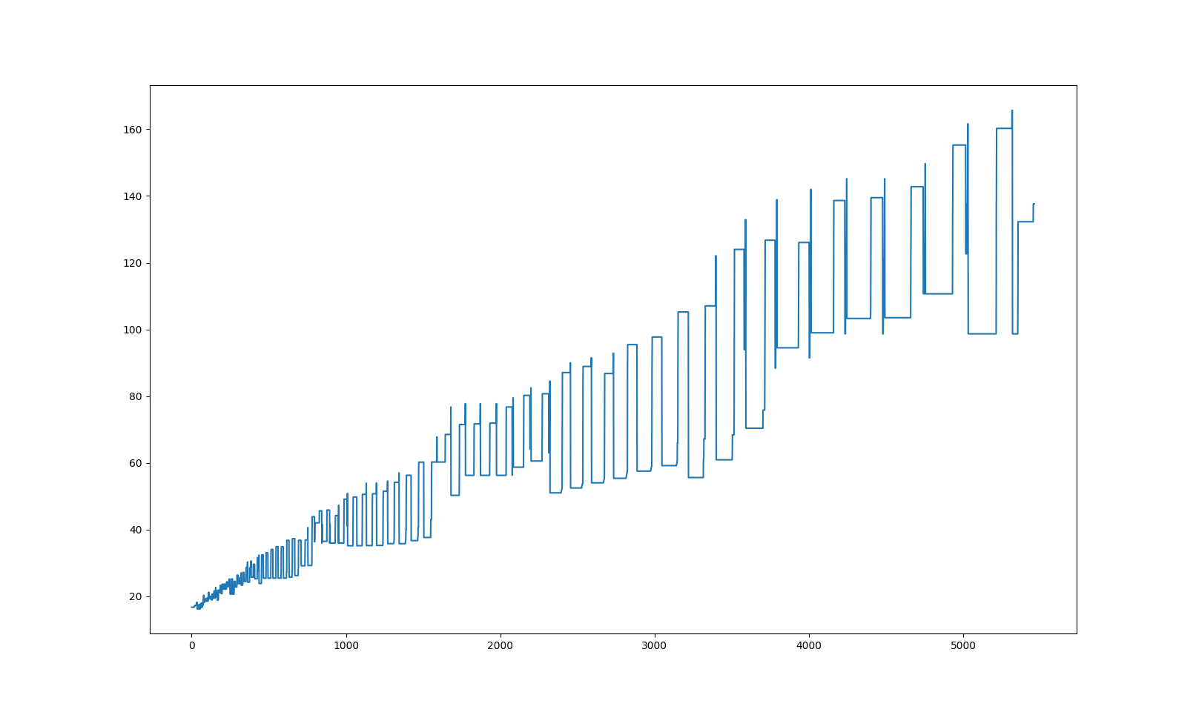

^ y-axis is kilobytes, x axis is samples ^

579.7040 Sat Jan 23 18:06:42 2021 Merged BOSS (k = 30) has 11749132 nodes and 11865952 edges
580.0810 Sat Jan 23 18:06:42 2021 Number of dummy nodes: 1376699
580.0810 Sat Jan 23 18:06:42 2021 Writing merged BOSS to out1
580.0920 Sat Jan 23 18:06:42 2021 Done

niklas@phoenix:~/code/bufboss_experiments/bufboss$ la -la out1
total 12984
drwxr-xr-x 2 niklas niklas 4096 tammi 23 18:06 .
drwxr-xr-x 11 niklas niklas 4096 tammi 23 17:56 ..
-rw-r--r-- 1 niklas niklas 4 tammi 23 18:06 alphabet
-rw-r--r-- 1 niklas niklas 3 tammi 23 18:06 boss_k
-rw-r--r-- 1 niklas niklas 1824 tammi 23 18:06 C
-rw-r--r-- 1 niklas niklas 9 tammi 23 18:06 constants
-rw-r--r-- 1 niklas niklas 2951896 tammi 23 18:06 indegs
-rw-r--r-- 1 niklas niklas 737992 tammi 23 18:06 indegs_rs
-rw-r--r-- 1 niklas niklas 349506 tammi 23 18:06 indegs_ss0
-rw-r--r-- 1 niklas niklas 369190 tammi 23 18:06 indegs_ss1
-rw-r--r-- 1 niklas niklas 2951896 tammi 23 18:06 outdegs
-rw-r--r-- 1 niklas niklas 737992 tammi 23 18:06 outdegs_rs
-rw-r--r-- 1 niklas niklas 349546 tammi 23 18:06 outdegs_ss0
-rw-r--r-- 1 niklas niklas 369174 tammi 23 18:06 outdegs_ss1
-rw-r--r-- 1 niklas niklas 4429767 tammi 23 18:06 outlabels

>>> 4429767 + 369174 + 349546 + 737992 + 2951896 + 369190 + 349506 + 737992 + 2951896 + 9 + 1824 + 3 + 4
13248799 bytes total for BOSS

>>> 13248799 * 8 / 11865952
8.932312552755986 bits per edge for BOSS

Peak buffering memory looks like about 160MB.
>>> 160 * 2**20 * 8 / 11865952
113.11163908298298 bits per edge peak buffering memory

580 seconds buffering time.

Divided flush threshold by 5

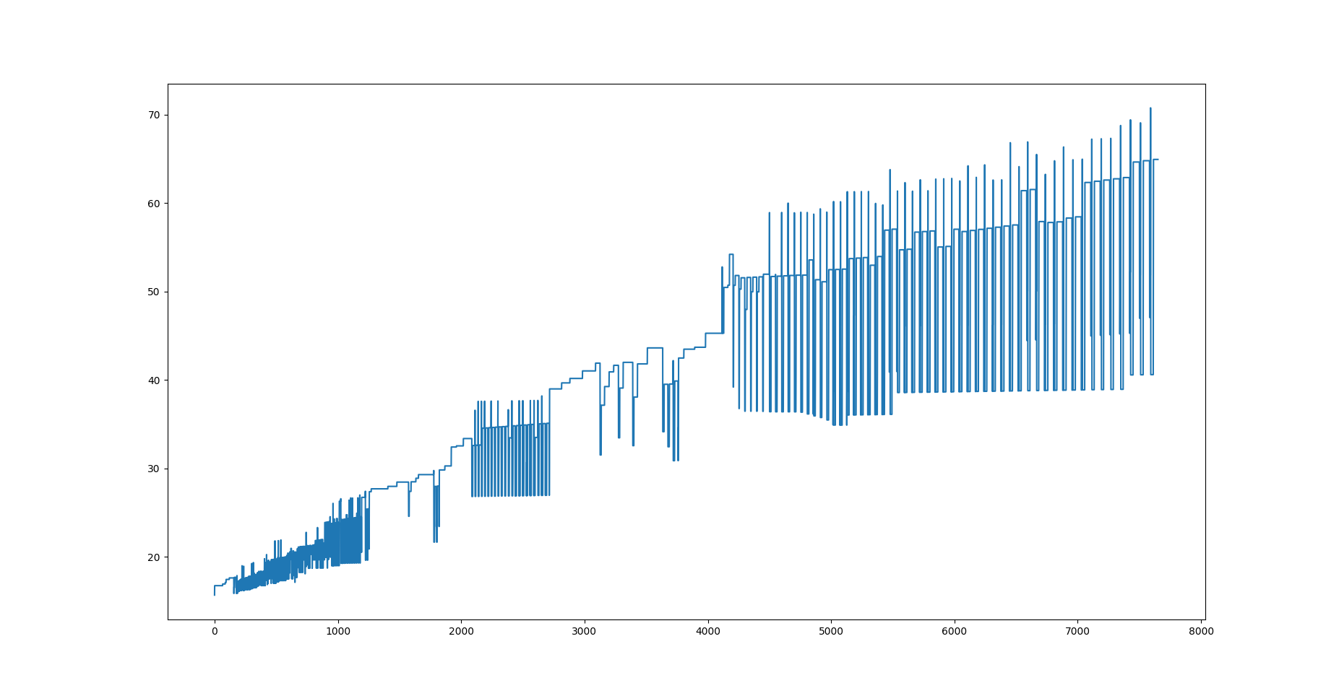

1468.9490 Sat Jan 23 20:01:32 2021 Merged BOSS (k = 30) has 11759944 nodes and 11877283 edges
1469.4680 Sat Jan 23 20:01:32 2021 Number of dummy nodes: 1387511
1469.4680 Sat Jan 23 20:01:32 2021 Writing merged BOSS to out1
1469.4820 Sat Jan 23 20:01:32 2021 Done

niklas@phoenix:~/code/bufboss_experiments/bufboss$ la -la out1
total 12996
drwxr-xr-x 2 niklas niklas 4096 tammi 23 18:06 .
drwxr-xr-x 11 niklas niklas 4096 tammi 23 17:56 ..
-rw-r--r-- 1 niklas niklas 4 tammi 23 20:01 alphabet
-rw-r--r-- 1 niklas niklas 3 tammi 23 20:01 boss_k
-rw-r--r-- 1 niklas niklas 1824 tammi 23 20:01 C
-rw-r--r-- 1 niklas niklas 9 tammi 23 20:01 constants
-rw-r--r-- 1 niklas niklas 2954664 tammi 23 20:01 indegs
-rw-r--r-- 1 niklas niklas 738680 tammi 23 20:01 indegs_rs
-rw-r--r-- 1 niklas niklas 349853 tammi 23 20:01 indegs_ss0
-rw-r--r-- 1 niklas niklas 369561 tammi 23 20:01 indegs_ss1
-rw-r--r-- 1 niklas niklas 2954664 tammi 23 20:01 outdegs
-rw-r--r-- 1 niklas niklas 738680 tammi 23 20:01 outdegs_rs
-rw-r--r-- 1 niklas niklas 349885 tammi 23 20:01 outdegs_ss0
-rw-r--r-- 1 niklas niklas 369513 tammi 23 20:01 outdegs_ss1
-rw-r--r-- 1 niklas niklas 4434053 tammi 23 20:01 outlabels

>>> 12996 * 2**10 * 8 / 11877283
8.963601524018582 bits per edge in BOSS

>>> 70 * 2**20 * 8 / 11865952
49.48634209880505 bits per edge peak memory

Where is the peak coming from? BOSS takes 13MB at the end. We have about 70MB space peak. That is a 57MB overhead which is about

>>> 57 * 2**20 * 8 / 11877283
40.36 bits per edge overhead
In column permutation we keep two columns as char vectors, and we also take the outlabels out of the wavelet tree into a std::string
→ 24 bits per edge of working space. Could be 6 bits per edge. Could improve overhead by 18 bits, which is almost 50% of the overhead, and 36% of total space. Worth it?
I suppose the rest of the overhead is in the colex-sorted k-mer buffer. Each record is 8 bytes in the k-mer and 2 bytes in the edge information → 80 bits per buffer k-mer. It could be streamed from disk. But then we take a hit in time.

Optimized peak space some
Running… it actually made it worse!? Maybe it just exposed a peak that was lost in sampling before?
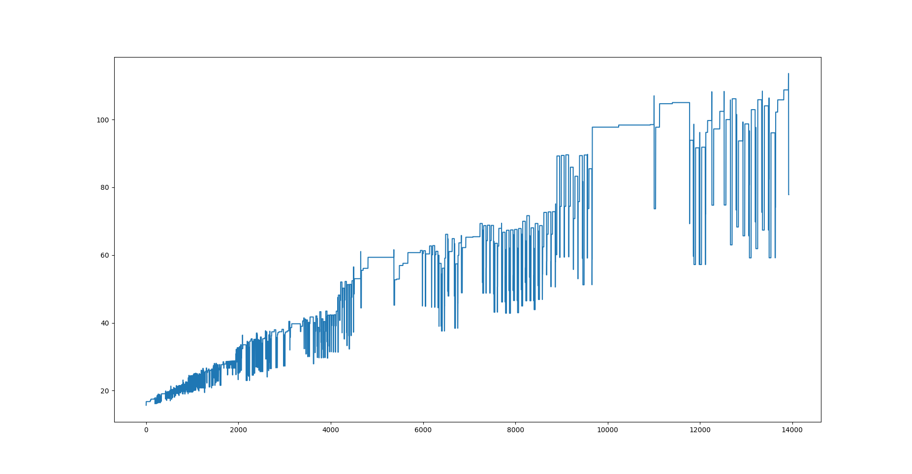

1480.7630 Sat Jan 23 21:03:42 2021 Merged BOSS (k = 30) has 11759944 nodes and 11877283 edges
1481.1320 Sat Jan 23 21:03:42 2021 Number of dummy nodes: 1387511
1481.1320 Sat Jan 23 21:03:42 2021 Writing merged BOSS to out1
1481.1450 Sat Jan 23 21:03:42 2021 Done

Try constant 0.01 buffer fraction. Also running with /usr/bin/time -v to check peak RSS
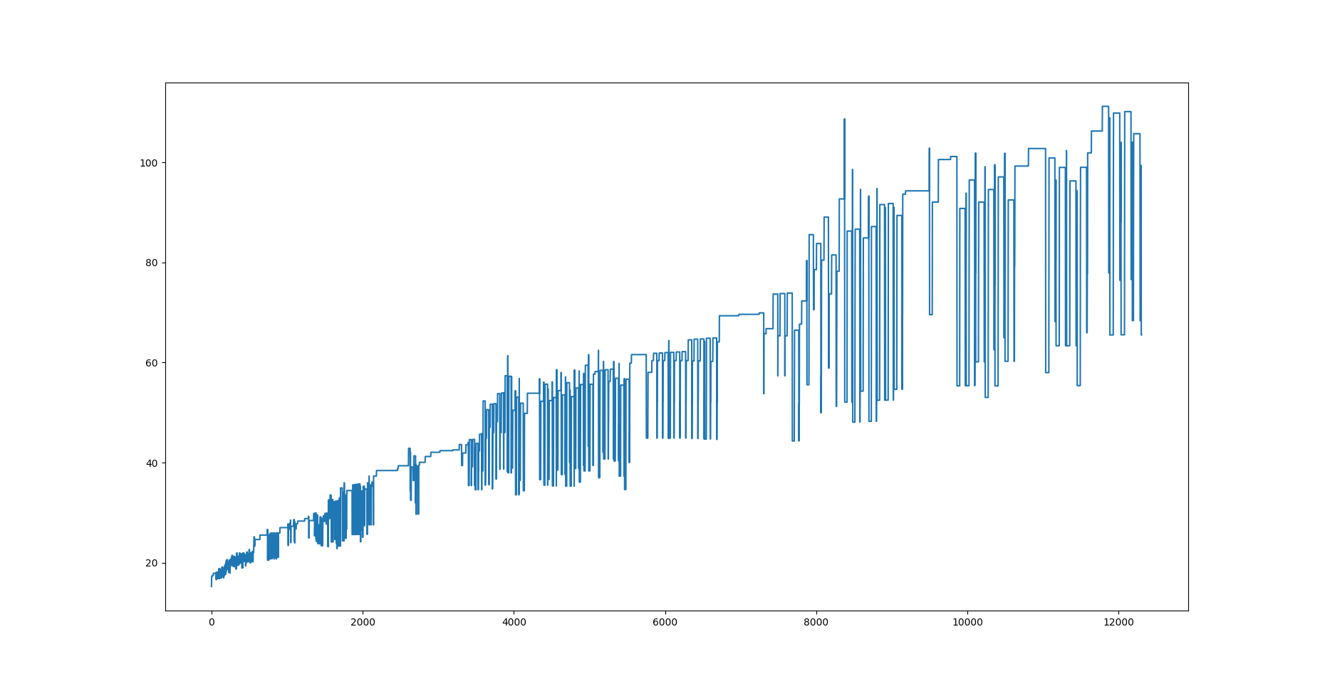

1308.1120 Sat Jan 23 22:01:22 2021 Merged BOSS (k = 30) has 11752895 nodes and 11869895 edges
1308.5540 Sat Jan 23 22:01:22 2021 Number of dummy nodes: 1380462
1308.5540 Sat Jan 23 22:01:22 2021 Writing merged BOSS to out1
1308.5670 Sat Jan 23 22:01:22 2021 Done

Command being timed: "./bin/merge -k 30 -o out1 -d data/coli_reads_half1.fna -r --buffer-fraction 0.01"
User time (seconds): 1307.69
System time (seconds): 0.81
Percent of CPU this job got: 99%
Elapsed (wall clock) time (h:mm:ss or m:ss): 21:48.57
Average shared text size (kbytes): 0
Average unshared data size (kbytes): 0
Average stack size (kbytes): 0
Average total size (kbytes): 0
Maximum resident set size (kbytes): 97976 (97 MB. Less than the plot. Huh? Ohhh, it’s virtual memory in the script! Fixed now)
Average resident set size (kbytes): 0
Major (requiring I/O) page faults: 0
Minor (reclaiming a frame) page faults: 786730
Voluntary context switches: 1
Involuntary context switches: 1568
Swaps: 0
File system inputs: 0
File system outputs: 25952
Socket messages sent: 0
Socket messages received: 0
Signals delivered: 0
Page size (bytes): 4096
Exit status: 0

Try constant 0.01 buffer fraction, fixed VSZ → RSS

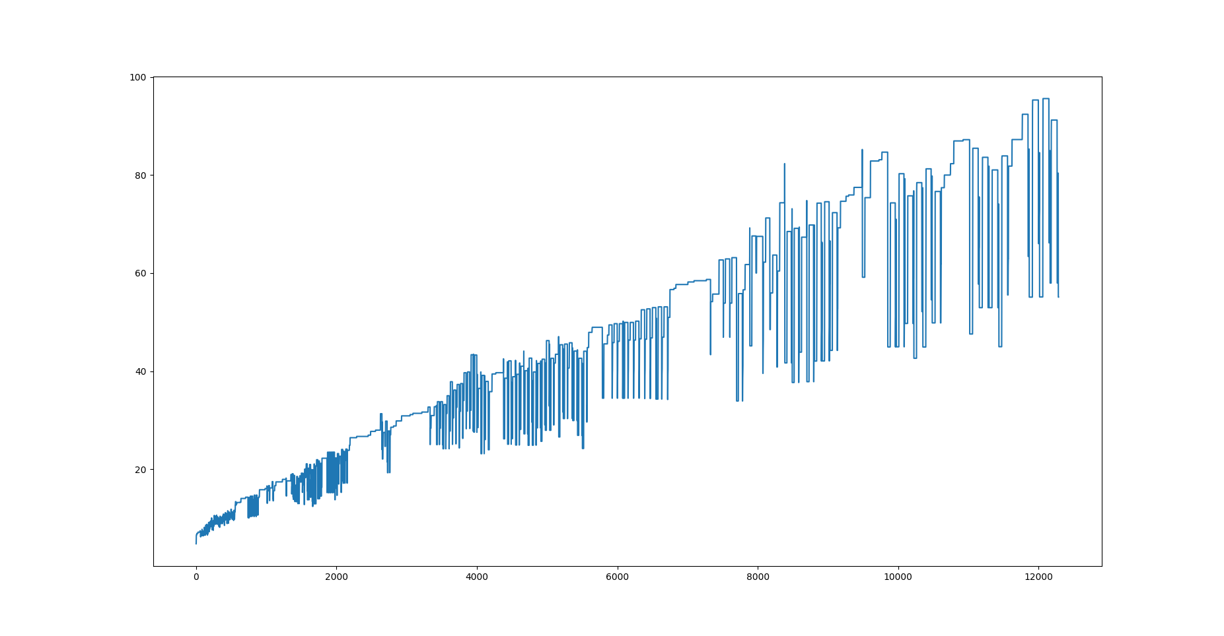

1306.0720 Sat Jan 23 22:26:13 2021 Merged BOSS (k = 30) has 11752895 nodes and 11869895 edges
1306.4220 Sat Jan 23 22:26:13 2021 Number of dummy nodes: 1380462
1306.4220 Sat Jan 23 22:26:13 2021 Writing merged BOSS to out1
1306.4360 Sat Jan 23 22:26:13 2021 Done
Command being timed: "./bin/merge -k 30 -o out1 -d data/coli_reads_half1.fna -r --buffer-fraction 0.01"
User time (seconds): 1305.46
System time (seconds): 0.92
Percent of CPU this job got: 99%
Elapsed (wall clock) time (h:mm:ss or m:ss): 21:46.43
Average shared text size (kbytes): 0
Average unshared data size (kbytes): 0
Average stack size (kbytes): 0
Average total size (kbytes): 0
Maximum resident set size (kbytes): 97900
Average resident set size (kbytes): 0
Major (requiring I/O) page faults: 0
Minor (reclaiming a frame) page faults: 786729
Voluntary context switches: 1
Involuntary context switches: 1857
Swaps: 0
File system inputs: 0
File system outputs: 25952
Socket messages sent: 0
Socket messages received: 0
Signals delivered: 0
Page size (bytes): 4096
Exit status: 0
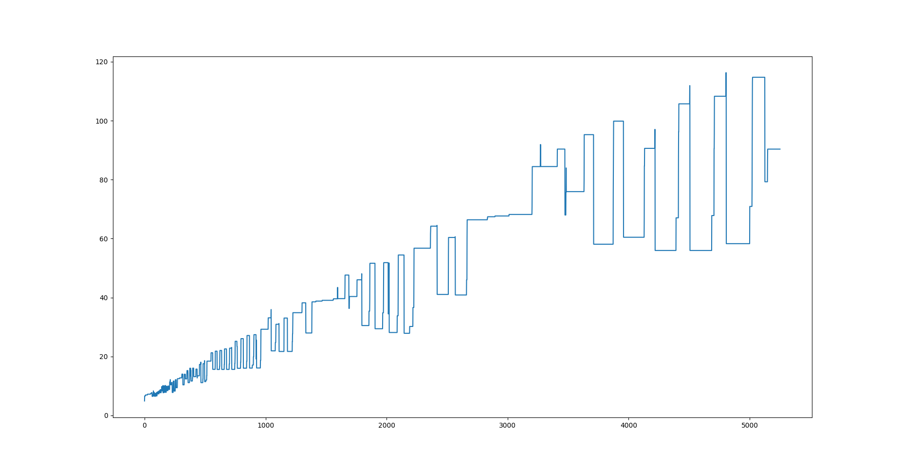

Same as above but with 0.05 buffer fraction
558.0720 Sat Jan 23 22:39:33 2021 Merged BOSS (k = 30) has 11748016 nodes and 11864781 edges
558.4280 Sat Jan 23 22:39:34 2021 Number of dummy nodes: 1375583
558.4280 Sat Jan 23 22:39:34 2021 Writing merged BOSS to out1
558.4410 Sat Jan 23 22:39:34 2021 Done
Command being timed: "./bin/merge -k 30 -o out1 -d data/coli_reads_half1.fna -r --buffer-fraction 0.05"
User time (seconds): 558.19
System time (seconds): 0.23
Percent of CPU this job got: 99%
Elapsed (wall clock) time (h:mm:ss or m:ss): 9:18.44
Average shared text size (kbytes): 0
Average unshared data size (kbytes): 0
Average stack size (kbytes): 0
Average total size (kbytes): 0
Maximum resident set size (kbytes): 119088
Average resident set size (kbytes): 0
Major (requiring I/O) page faults: 0
Minor (reclaiming a frame) page faults: 204679
Voluntary context switches: 1
Involuntary context switches: 457
Swaps: 0
File system inputs: 0
File system outputs: 25952
Socket messages sent: 0
Socket messages received: 0
Signals delivered: 0
Page size (bytes): 4096
Exit status: 0

