# Around the world content

## Home page

### Information

Around the world is a basic darts game that people mainly play when practicing or are beginning to play darts and want to learn the scoring positions on the board. It is also known as ‘Round the Board’, ‘Round the Clock’ and ‘Once Round the Island’.

The object of the game is to hit every number on the board in order finishing with the bullseye. It is a very easy game to play but is good practice as it uses the whole board. It is also a fast moving game.

### Equipment

To set up;

* Tape measure
* Wall (that is ok if a dart hits it)
* Marker for the ground

To play;

* Dart Board
* 2 sets of darts (3 per set)
* 2 players

### Tutorials

The tutorials on this website will teach you

* how to set up a dart board correctly
* good aiming practices
* how to play around the world

click start to see what tutorials are available

## Tutorials page

### Tutorial 1

In this tutorial you will learn how to set up a dart board. This includes the correct measurements for where the dart board gets positioned and the distance at which you throw your darts.

### Tutorial 2

In this tutorial you will learn the basics of how to hold darts and some throwing techniques. This will include how to hold a dart and the stance to stand in when you throw it.

### Tutorial 3

In this tutorial you will be introduced to around the world. This will include instructions and tips on how to play.

### Tutorial 4

This tutorial is for more advanced players. It will give you options for harder gameplay of around the world.

## Tutorial 1

### Step One - Dartboard Height

Grab a tape measure and measure the height. Position the dartboard at the right height. The dartboard height is measured from the centre of the dartboard to the ground. That is from the centre of the bulls-eye to the ground. The height is 5 feet 8 inches, 68 inches, 1.73 metres or 173 centimetres.

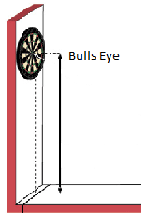

### Step Two – Standing Position

Grab a tape measure and measure the distance. The distance is measured from the front of the dartboard to the throwing line. The distance is 93.25 inches, 2.37 metres or 237 centimetres. Mark a line on the floor. (can be a simple line or a raised bar) This is the point that you stand at and must not cross.

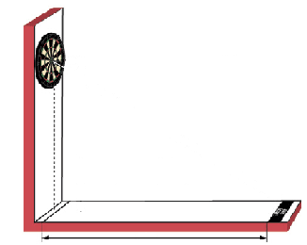

### Step Three – Diagonal Positioning

After the dartboard has been set up it is a good idea to measure the distance diagonally. Grab a tape measure and measure from the centre of the bull diagonally down to your throwing line. The distance should be 9 feet 6 inches, 115.35 inches, 2.93 meters or 293 centimetres. If that is correct your dart board is set up.

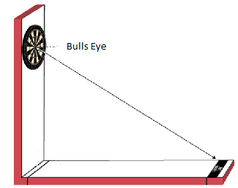

## Tutorial 2

### Step One – Grip

Put the dart in your open palm. Balance it and find the center of gravity. Now with your thumb roll the dart to your finger tips. Place your thumb a bit behind the center of gravity, hold it with as much fingers as you like, then move your arm to aiming position. Try to point your dart up slightly. Have a firm grip but don’t strain your finger muscles. It is advised to hold a dart with at least three fingers.

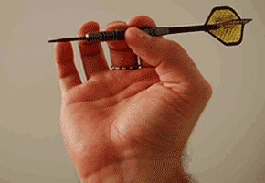

### Step Two – Throw

Aiming

Put your eyes, the dart and the target you want to hit in one line. Focus the target, not the dart. Use aiming points on the target if you like, or aim in a different way.

Backward Move

Make sure to do this slowly. Move back a little bit so that you don’t bang your face.

Acceleration

Try to do this naturally. Don’t move too fast and too rough. Do it smoothly in one move and follow through.

Release

Try to do this naturally. Try not to raise your elbow.

Follow-through

After releasing the dart try to keep your hand aiming at the target. Keep your arm in the straight and slight upward position.

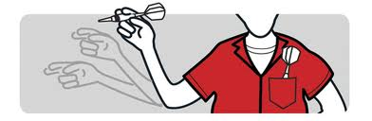

### Step Three - Stance

There is only one proper stance that meets the requirements for throwing: The right foot (left foot for left handers) forward stance.

Shoulder angle

It defines the stance. You should try to get close to the perfect 90 degrees, but not making throwing uncomfortable. Proper angles start from approx. 50 to 80 degrees. The exact value here is your personal preference.

Feet angle

The feet angle simply follows the shoulder angle, otherwise you will fall on the floor.

Balance

Try to stay perfectly balanced. Try not to lean forward too much

Weight Distribution

Rest most of your weight on your forward foot. Balance yourself with your behind foot.

Leaning Forward

Lean forward. Not too much that you feel unbalanced.

Torso

Don’t arch your back. Keep your spine straight. Keep your body strained but arm relaxed.

### Stance

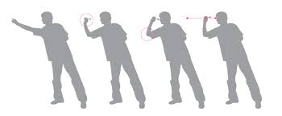

## Tutorial 3

### Step One – Aim of the game

The aim of the game is to hit every number on the board in order. If you are playing against someone else another aim is to finish before that player.

### Step Two – Scoring of the game

The only scoring needed is a record of the numbers that the players are up to.

### Step Three – Rules of the game

Any part of a numbers triangle on the board counts as a hit for that number.

The first player tries to hit 1 first. They keep aiming for 1 until it is hit. When 1 is hit the player can aim for 2 and so on until all three darts have been thrown.

The second player then does the same thing.

Once a player hits 20 they can aim for the bullseye.

## Tutorial 4

### Step One – Aim of the game

This version of around the world if for more advanced players. The aim of the game is to hit every number on the board in order. If you are playing against someone else another aim is to finish before that player.

### Step Two – Scoring of the game

The only scoring needed is a record of the numbers that the players are up to.

### Step Three – Rules of the game

Only the double section of a numbers triangle on the board counts as a hit for that number.

The first player tries to hit 1 first. They keep aiming for 1 until it is hit. When 1 is hit the player can aim for 2 and so on until all three darts have been thrown.

The second player then does the same thing.

Once a player hits 20 they can aim for the centre of the bullseye.

### Extra

For even harder gameplay.

Only the triple section of a numbers triangle on the board counts as a hit for that number.