ATW – Around The World

Information Architecture Analysis Document

WEB601

Rebekah Rossiter

Contents

Goals 2

User Experience 2

Scenarios 2

Intermediate aged children 2

Parents 2

Teachers 3

Darts Players 3

Content and Functions 3

Appendix A – Competitive Analysis 6

Site 1 6

Site 2 7

Site 3 8

Site 4 9

Site 5 10

Appendix B – Content Inventory 11

# Goals

The goals of the ATW website are;

* Teach around the world
* Visitors learn how to play around the world
* Offer a scoreboard
* Visitors use the scoreboard

# User Experience

The users are expected to be;

* Intermediate aged children
* Parents
* Teachers
* Darts Players

## Scenarios

### Intermediate aged children

Tim is an 11 year old boy who goes to Nelson Intermediate. He wants to learn how to play around the world but has no knowledge of the subject.

Tim loads the website. He reads the introduction then examines the equipment list to make sure that he has the required equipment. He then goes to the tutorials page. From the Tim clicks on the link for the first tutorial. Tim decides that he wants to record some notes for himself. He goes to the top of the screen and click register. From there he is prompted for his details. Once he is registered, he goes back to tutorial 1 and adds some notes at the bottom of the page. Tim then continues through the rest of the tutorials. Once Tim is finished he decides that he wants to use the scoreboard, so he navigates to that page and starts to play.

### Parents

Susan is a 35 year old mum who lives in Timaru. She wants to see how her daughter is progressing through the tutorials. She also wants to make sure that the website is suitable for her daughter to be using. Her daughter’s name is Kate.

Kate directs her mum to ATW website and logs in. Susan takes over but gets Kate to sit next to her so that she can explain some things to her. They go through all of the pages and look at the notes that Kate has written. Susan then goes to the scoreboard to see how interactive it is. Susan then logs out and says to Kate that she is happy for her to continue using the website.

### Teachers

Grant is a 30 year old teacher. He teaches at in intermediate in Nelson called Broadgreen Intermediate. He has heard from an old school mate that there is this website that has popped up for learning how to play around the world. He is told that it is for intermediate aged children, has tutorials and an interactive bit as well. This piques his interest, so he decides to have a look for himself.

Grant loads the webpage and decides to create an account. After creating an account he reads the introduction and the equipment list that are on the home page. He then reads the small blurb about the tutorials and after being satisfied with these he click start. He is taken to a page that has several links to tutorials with a brief explanation of what each one entails. He decides to start from the beginning. He clicks start and is taken to the first tutorial which has pictures and easy to understand instructions. After this he breezes through the others but still checking the language that is used. On the last tutorial there is a button that takes him to the interactive scoreboard. He is pleasantly surprised that it is interactive and very easy to use. After flicking through the site again he logs out.

Grant then decides that he wishes to use this site with his class. So then he takes the link to his boss to discuss the suitability and is told that he will know the decision the following week. The following week Grant is called into his boss’s office for a meeting where he is given the thumbs up for using the website.

### Darts Players

June is a 45 year old professional darts player who lives in Wellington. She is already registered to the ATW website as she regularly uses the scoreboard when practicing for competitions. Today that is what she is going to do again.

June logs into the ATW website and heads straight to the scoreboard. She decides that she is going to play herself and grans two sets of darts so that she doesn’t confuse herself. She starts playing and marks off the numbers as she hits them. Once she has finished she decides to play a few more rounds before logging out

For the competitive analysis please refer to Appendix A.

# Content and Functions

The content inventory is all of the ‘stuff’ that is going to be on the website. This includes all web pages and what is going to be on them.

The content has been named and grouped as follows:

* Pages
  + Main Page
  + Tutorial Page
  + Tutorials
  + Scoreboard Page
  + Contact Page
* Information
  + Instructions
  + Equipment List
  + Headings
  + Images
* Interaction
  + Scoreboard
  + Buttons
  + Notes text boxes

For content inventory please refer to Appendix B.

# Site Structure

“Life’s journey is a bicycle ride down the hill” The structure of the site is based on going through the tutorials so this metaphor seems to make sense.

The site structure listing is as follows:

|  |  |  |  |
| --- | --- | --- | --- |
| Section 1 | Welcome |  |  |
| Section 2 | Tutorials |  |  |
|  |  | Section 2.1 | Tutorial 1 |
|  |  | Section 2.2 | Tutorial 2 |
|  |  | Section 2.3 | Tutorial 3 |
|  |  | Section 2.4 | Tutorial 4 |
| Section 3 | Scoreboard |  |  |
| Section 4 | Contact |  |  |
| Section 5 | Register |  |  |
| Section 6 | Login |  |  |

The navigation will be a menu at the top of the page with a possible list underneath tutorial.

# Visual Design

The layout sketches (wireframe layouts) are as follows:

Welcome (Home Page)

Tutorial Intro

Page Heading

Navigation Bar

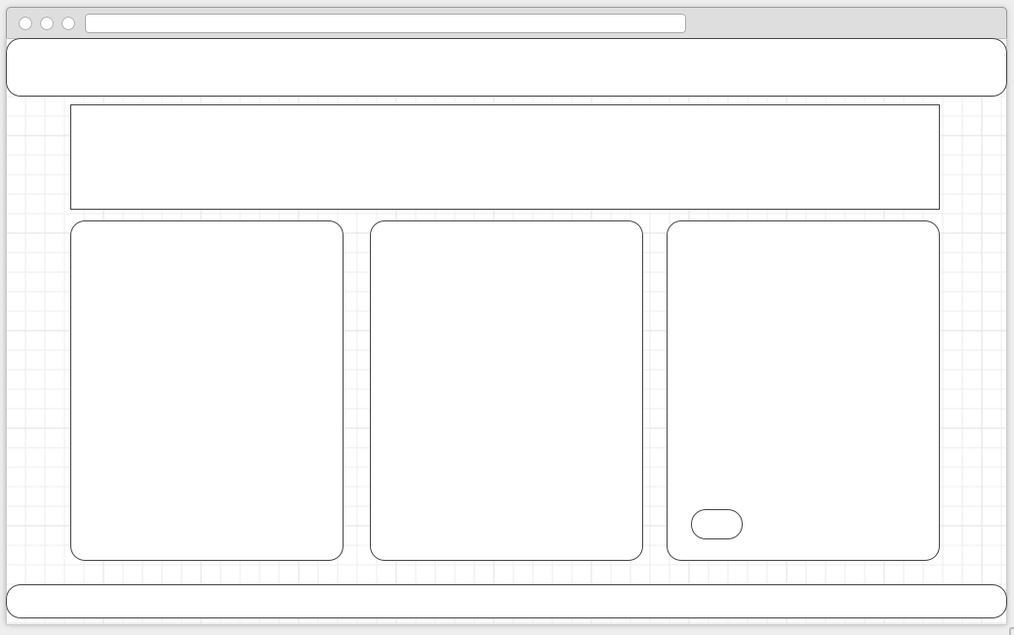

Introduction

Equipment List

Start button for tutorials

Footer

Tutorials

Footer

Tutorial Description

Tutorial Number

Navigation Bar

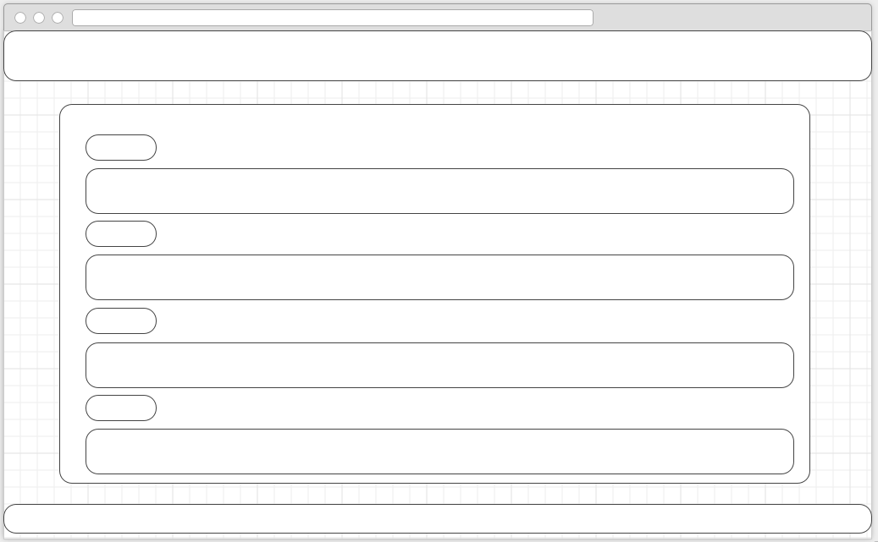

Tutorial page (eg tutorial 1)

Footer

Image

Heading

Info

Step

Navigation Bar

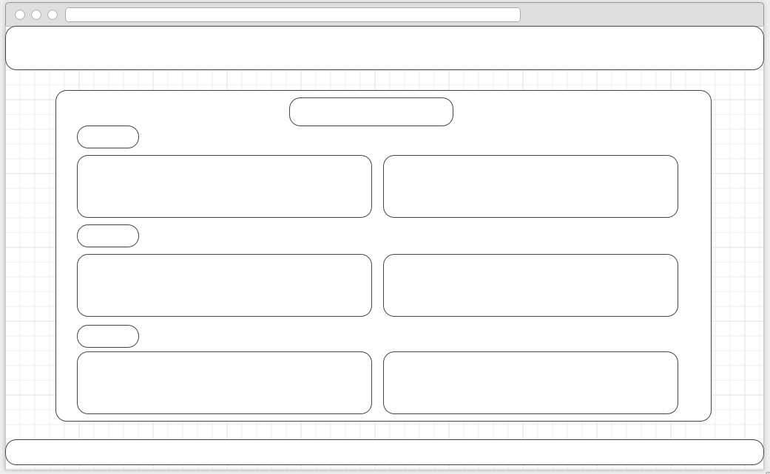

Scoreboard

Heading

Footer

Scoreboard

Navigation Bar

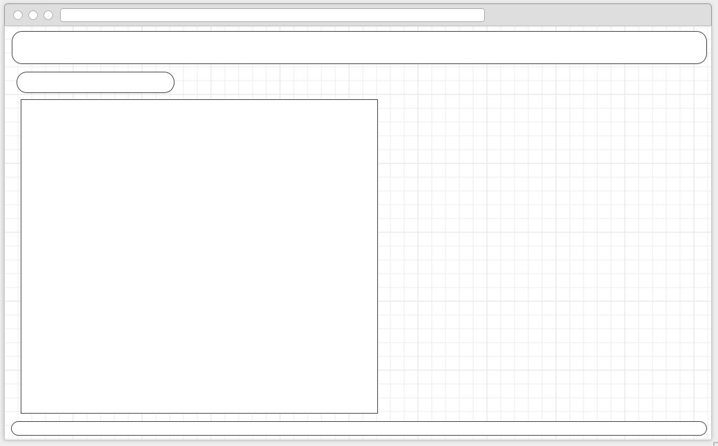

The mock-ups are as follows:

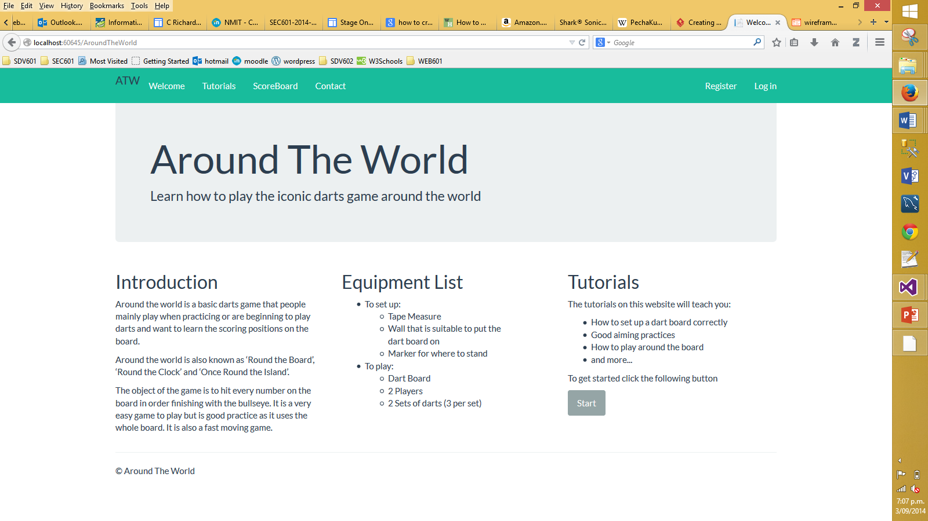

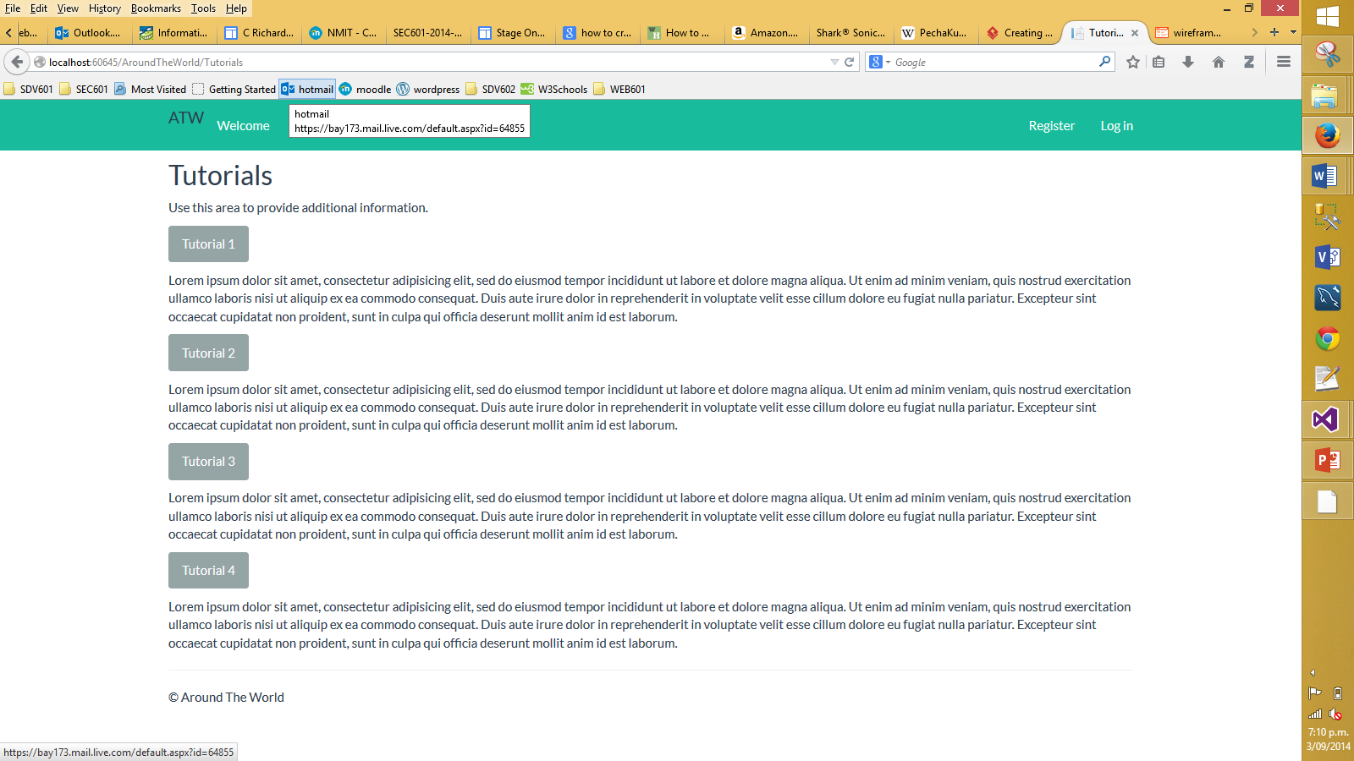

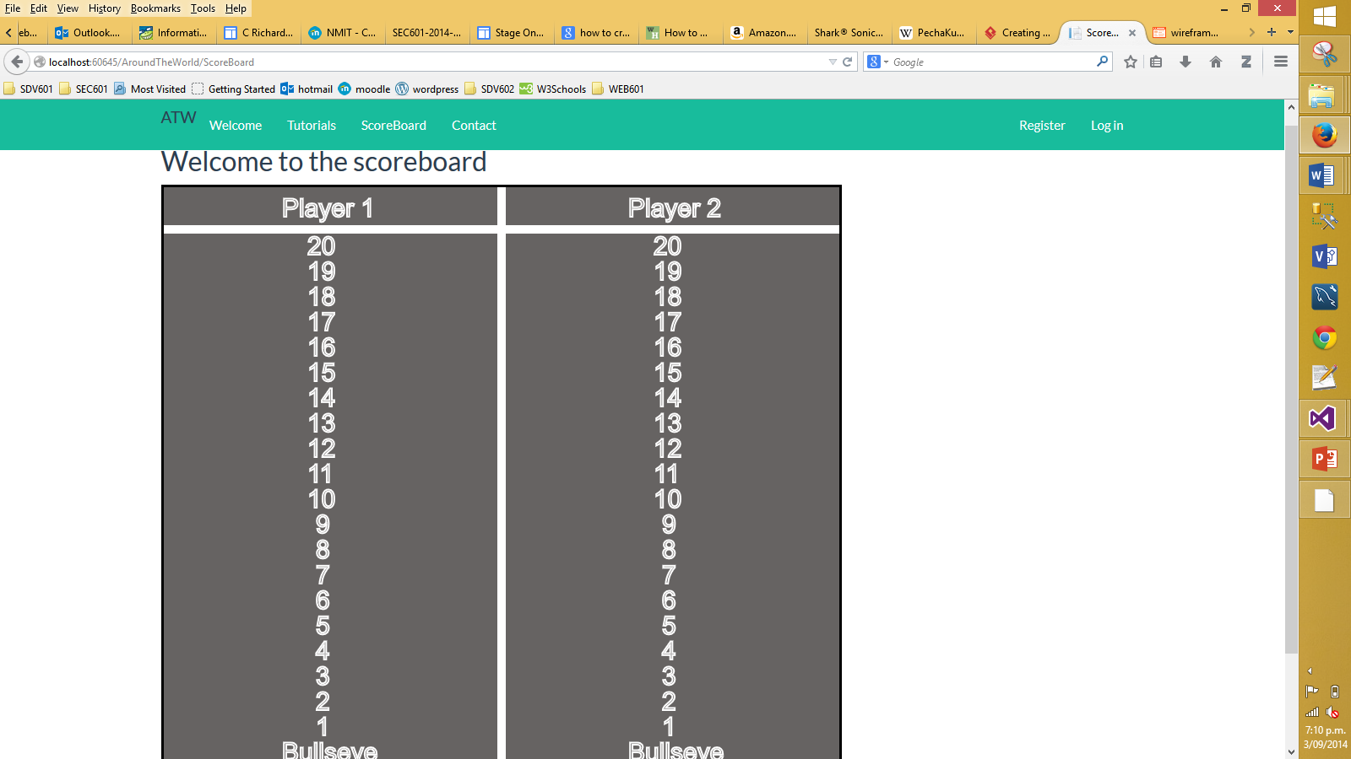

# Appendix A – Competitive Analysis

Site 1 = <http://www.mostdartgames.com/clock.html>

Site 2 = <http://www.ehow.com/how_4525054_play-around-clock-dart-game.html>

Site 3 = <http://www.chinadart.com/darts_playing_rules_round_the_world.htm>

Site 4 = <http://www.monkeysee.com/play/10143-practice-dart-games-counting-and-around-the-world>

Site 5 = <http://www.darting.com/Darts-Rules/Round-the-World/>

|  |  |  |  |  |  |  |
| --- | --- | --- | --- | --- | --- | --- |
|  | | Site 1 | Site 2 | Site 3 | Site 4 | Site 5 |
| General Site Features | |  |  |  |  |  |
|  | Site design (1-10) | 2 | 3 | 5 | 4 | 5 |
|  | Easy navigation (1-10) | 10 | 10 | 10 | 10 | 10 |
|  | No of pages | 1 | 1 | 1 | 1 | 2 |
|  | Suitable layout (1-10) | 1 | 1 | 5 | 4 | 5 |
|  | Look and feel (1-10) | 1 | 1 | 4 | 4 | 5 |
| Personalization | |  |  |  |  |  |
|  | Personal start page |  |  |  |  |  |
|  | Images |  | **X** |  |  |  |
|  | Easy to understand language |  |  |  |  | **X** |
|  | Equipment List |  |  |  |  | **X** |
|  | Suitable for children |  |  |  |  |  |

## Site 1

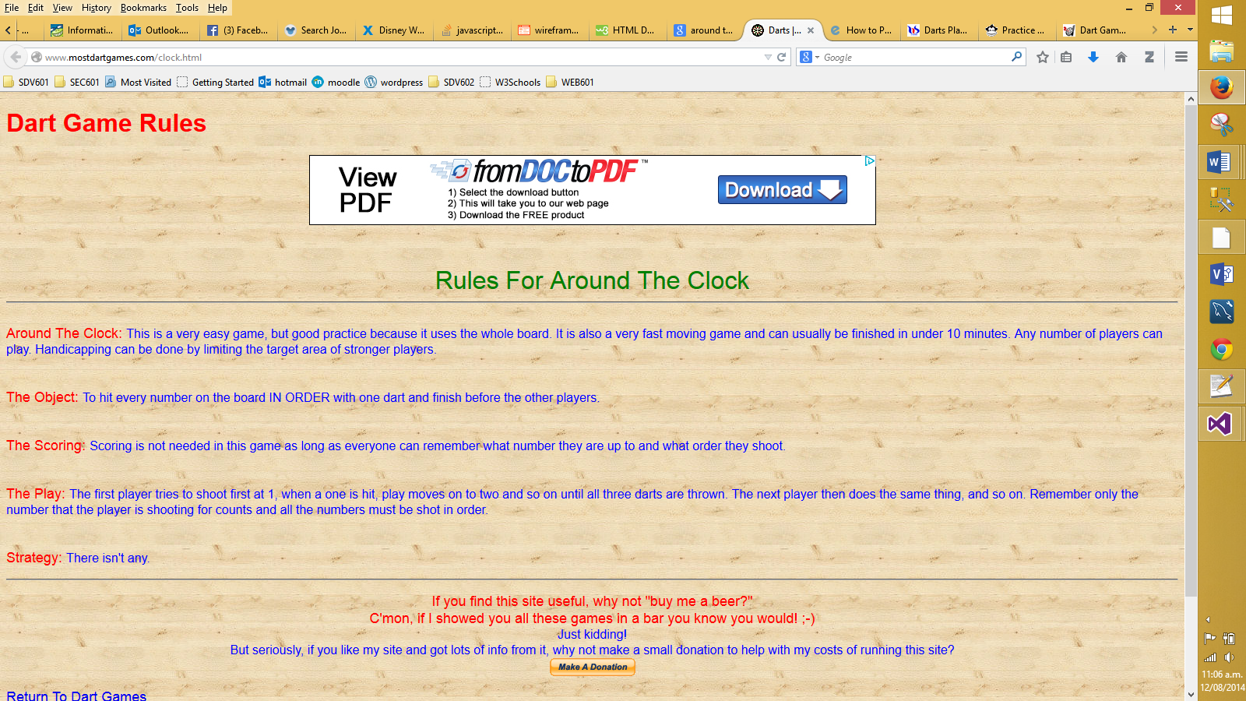

|  |  |
| --- | --- |
| **Pros** | **Cons** |
| * Won’t get lost (1 page) * Has headings * Good main heading * Simple-ish URl to remember | * Not very informative * Confusing use of colour |

## Site 2

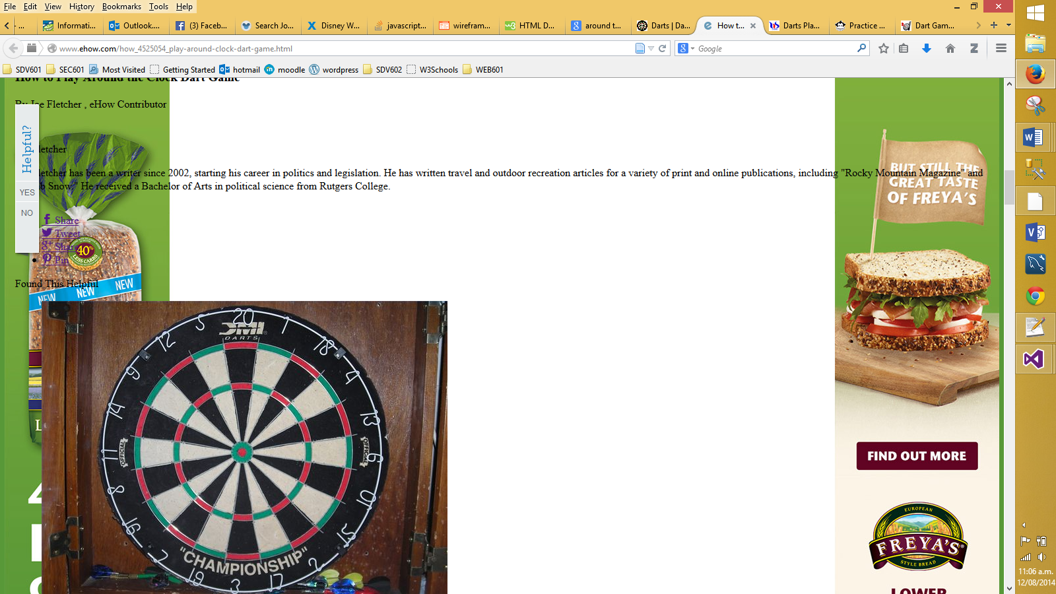

|  |  |
| --- | --- |
| **Pros** | **Cons** |
| * Won’t get lost (1 page) | * Too much advertising * Hard to read due to overlapping ads * No explanation * You don’t realise where the instructions are * Very confusing * Hard URl to remember |

## Site 3

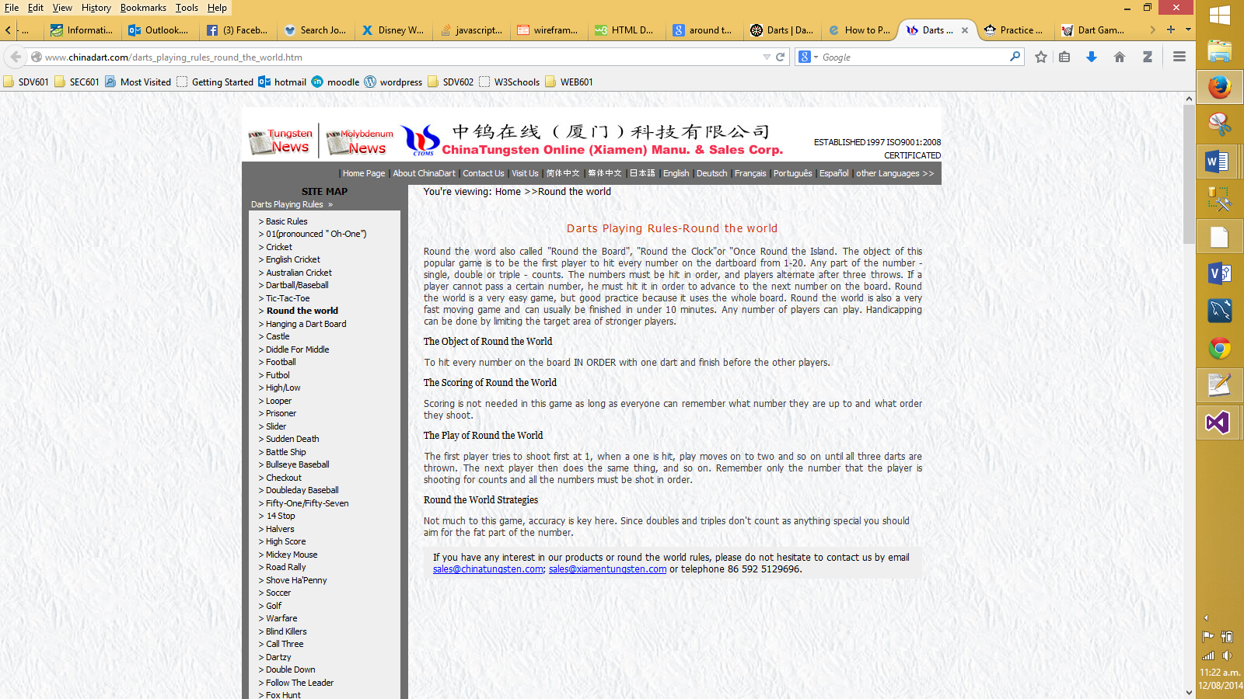

|  |  |
| --- | --- |
| **Pros** | **Cons** |
| * Won’t get lost (1 page) * Basic layout * Good headings * Has links to other games * Multiple language choices | * Background makes the text a little hard to read * Not in a language suitable for children to understand * Hard URL to remember |

## Site 4

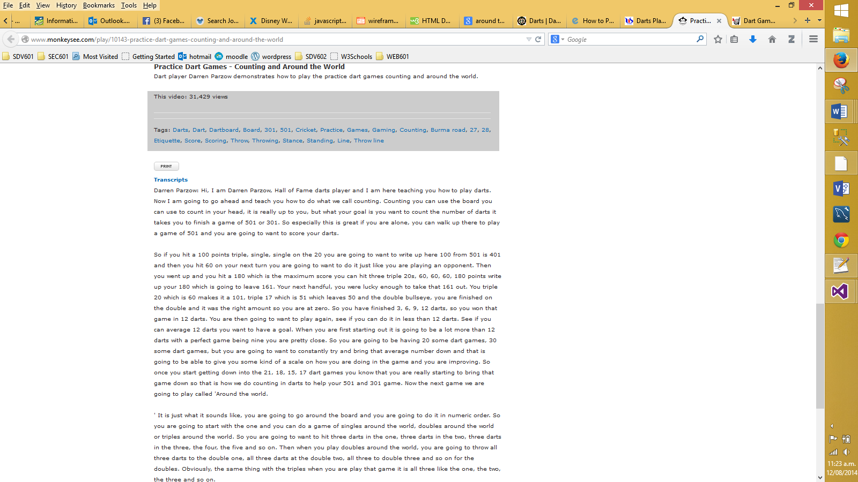

|  |  |
| --- | --- |
| **Pros** | **Cons** |
| * Won’t get lost (1 page) * Basic layout * Has links to other how to’s | * Have to scroll down before you find any information * Text is small and hard to read * No obvious headings * No obvious structure in text |

## Site 5

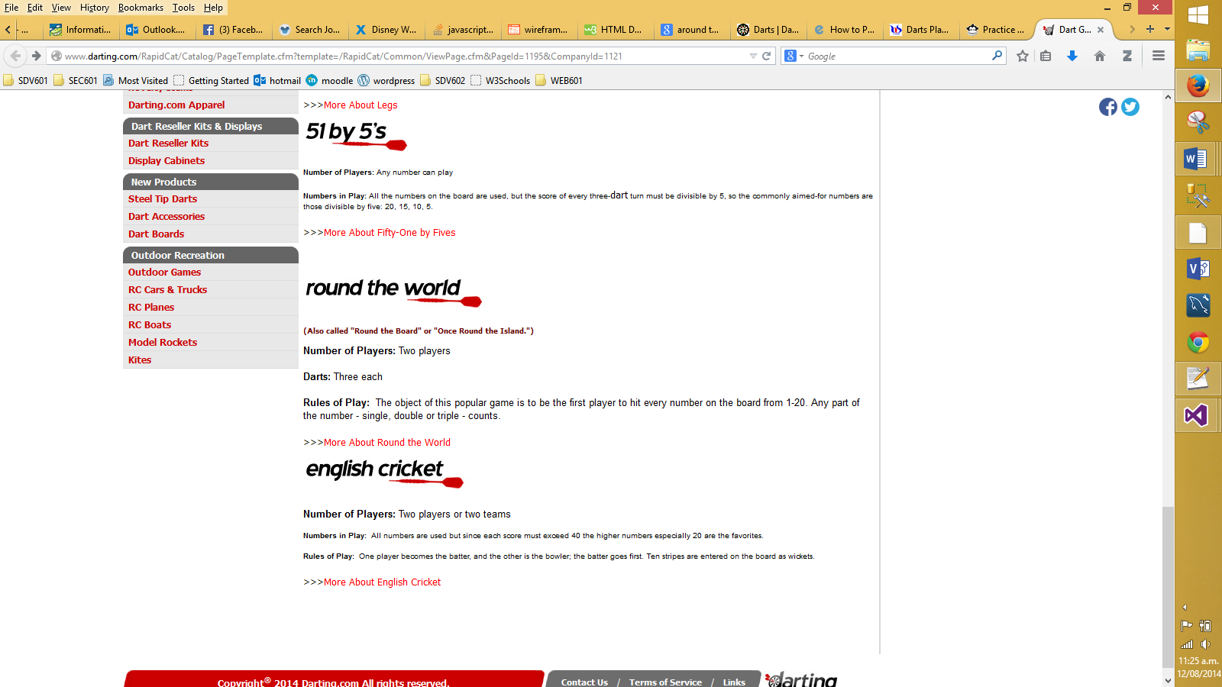

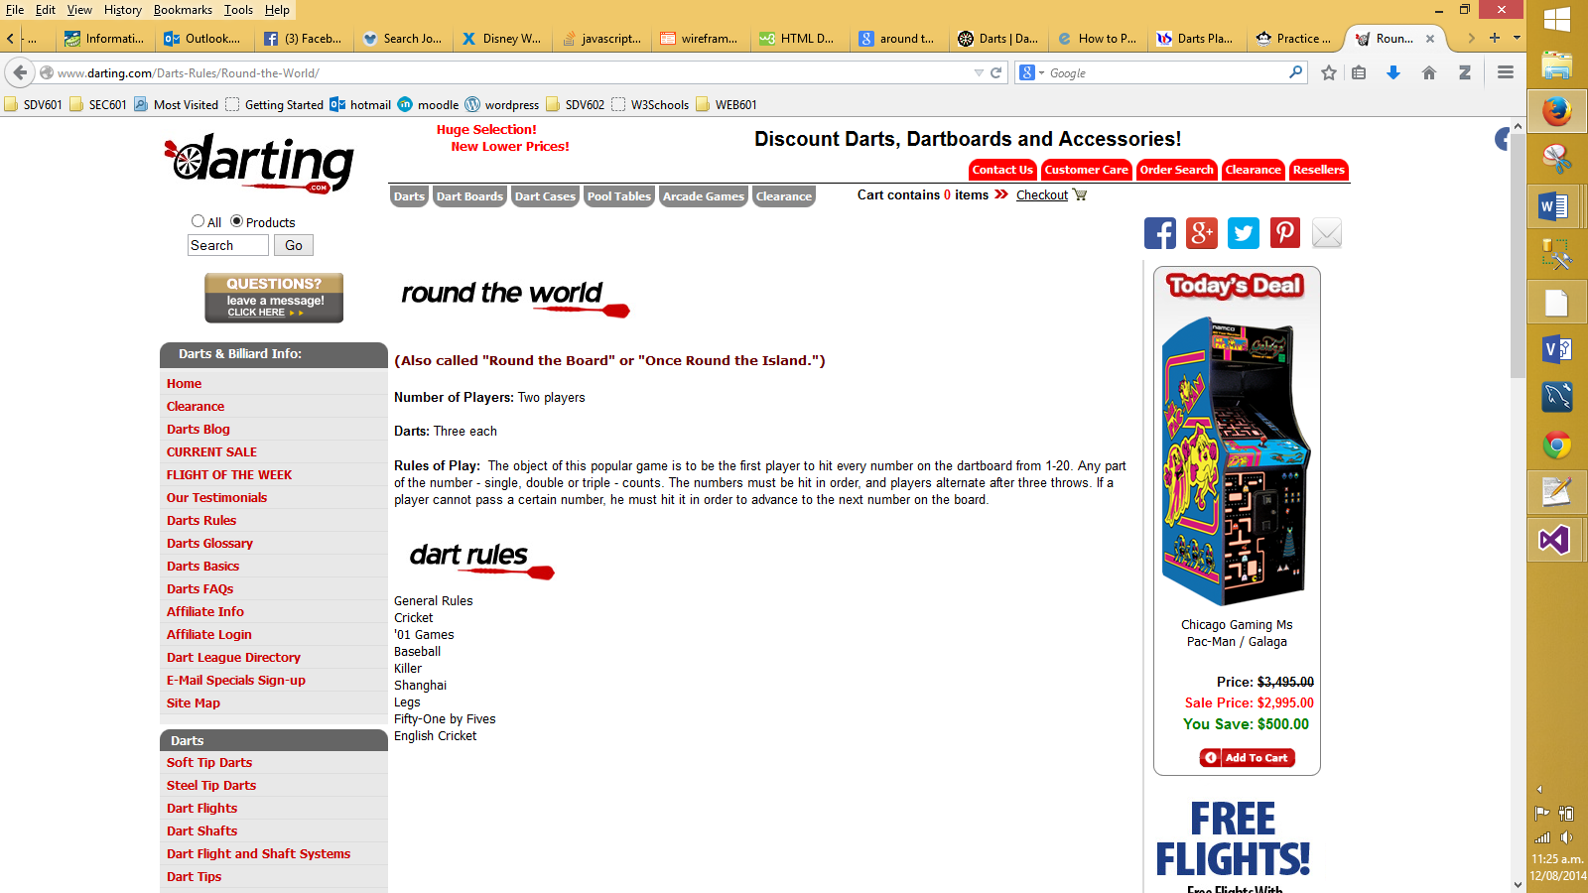

|  |  |
| --- | --- |
| **Pros** | **Cons** |
| * Basic layout * Good use of white space * Has an equipment list * Easy to understand * Obvious headings * Includes rules for other games | * Not much information * No images to aide user |

# Appendix B – Content Inventory

|  |  |  |
| --- | --- | --- |
| **Content Elements** | **Functional Requirements** |  |
| Main page | Register | 4 |
| Tutorial Page | Log in | 5 |
| Tutorials *(maybe 5 – unsure at the moment)* | Interactive scoreboard | 2 |
| Scoreboard Page | Navigation | 1 |
| Contact Page | Form for contact page | 7 |
| Notes on each page | Log out | 6 |
| Equipment List | Save notes | 3 |
| Instructions |  |  |
| Headings |  |  |
| Buttons |  |  |
| Images |  |  |
| scoreboard |  |  |