[Date]

Rebekah Rossiter

Milestone One

WEB601

Contents

Introduction 2

Findings 2

Project Brief 2

Information Architecture 3

Goals 3

User Experience 3

Content and Functions 4

Site Structure 5

Visual Design 6

Appendix A – Competitive Analysis 10

Appendix B – Content Inventory 14

Coding 15

Around the world controller 15

Welcome View 16

Tutorials View 17

Scoreboard View 18

Stakeholders Feedback 20

Conclusion 20

# Introduction

Around the world is a darts game that is mainly used for practice and aiming purposes, but can be a fun game if played with another person. This is what my website is about. The purpose of this report is to show my understanding of the processes that I have undertaken in creating this website. As the project is indicative this is the first step of my work. This has been requested by Todd Cochrane and is due on Friday 5th September at 9am.

# Findings

## Project Brief

This website will contain instructions on how to play around the world using a dart board. It is based for intermediate aged children.

The site will start with a welcome page that will have an introduction as well as an equipment list. There will be a log in and register section so that progress through the tutorials can be tracked and score boards can be saved. There will then be a link to an introduction tutorial on setting up and getting prepared e.g. where to stand, how to aim for the board etc..

After that there will be instructions on how to play around the world. This will include pictures showing examples.

At the end there will be a scoreboard that has two columns – one for each player – their name should go at the top. Under that there will be the numbers 1 – 20 listed down both columns. This should be interactive so that the children can mark off numbers once they have achieved them. There will be an option to continue the previous game or start a new one. There will be a save button so that the game can be continued at a later stage.

At the bottom of each page there will be a notes box for anything that the child wants to keep a note of.

There will be a navigation bar that can take children to stages during the tutorials or the scoreboard in case they want to have another look at a certain part of it or have finished the tutorial previously. There will also be a marker pointing to a stage of a tutorial if a child is part way through in case they want to continue from that point.

The colour themes will be based on the colours of a dart board. These are black, yellow, green and red.

The aim of the game is to be the first one to hit every single number on the board as well as the bulls-eye. You go for the numbers numerically for example you start on 1 and then go to 2 up to 20. You cannot continue onto another number until you have hit the number you are aiming for. Once you have hit 20 you try for the bulls-eye. The winner is the first person to hit all the numbers and the bulls-eye.

## Information Architecture

### Goals

The goals of the ATW website are;

* Teach around the world
* Visitors learn how to play around the world
* Offer a scoreboard
* Visitors use the scoreboard

### User Experience

The users are expected to be;

* Intermediate aged children
* Parents
* Teachers
* Darts Players

#### Scenarios

##### Intermediate aged children

Tim is an 11 year old boy who goes to Nelson Intermediate. He wants to learn how to play around the world but has no knowledge of the subject.

Tim loads the website. He reads the introduction then examines the equipment list to make sure that he has the required equipment. He then goes to the tutorials page. From the Tim clicks on the link for the first tutorial. Tim decides that he wants to record some notes for himself. He goes to the top of the screen and click register. From there he is prompted for his details. Once he is registered, he goes back to tutorial 1 and adds some notes at the bottom of the page. Tim then continues through the rest of the tutorials. Once Tim is finished he decides that he wants to use the scoreboard, so he navigates to that page and starts to play.

##### Parents

Susan is a 35 year old mum who lives in Timaru. She wants to see how her daughter is progressing through the tutorials. She also wants to make sure that the website is suitable for her daughter to be using. Her daughter’s name is Kate.

Kate directs her mum to ATW website and logs in. Susan takes over but gets Kate to sit next to her so that she can explain some things to her. They go through all of the pages and look at the notes that Kate has written. Susan then goes to the scoreboard to see how interactive it is. Susan then logs out and says to Kate that she is happy for her to continue using the website.

##### Teachers

Grant is a 30 year old teacher. He teaches at in intermediate in Nelson called Broadgreen Intermediate. He has heard from an old school mate that there is this website that has popped up for learning how to play around the world. He is told that it is for intermediate aged children, has tutorials and an interactive bit as well. This piques his interest, so he decides to have a look for himself.

Grant loads the webpage and decides to create an account. After creating an account he reads the introduction and the equipment list that are on the home page. He then reads the small blurb about the tutorials and after being satisfied with these he click start. He is taken to a page that has several links to tutorials with a brief explanation of what each one entails. He decides to start from the beginning. He clicks start and is taken to the first tutorial which has pictures and easy to understand instructions. After this he breezes through the others but still checking the language that is used. On the last tutorial there is a button that takes him to the interactive scoreboard. He is pleasantly surprised that it is interactive and very easy to use. After flicking through the site again he logs out.

Grant then decides that he wishes to use this site with his class. So then he takes the link to his boss to discuss the suitability and is told that he will know the decision the following week. The following week Grant is called into his boss’s office for a meeting where he is given the thumbs up for using the website.

##### Darts Players

June is a 45 year old professional darts player who lives in Wellington. She is already registered to the ATW website as she regularly uses the scoreboard when practicing for competitions. Today that is what she is going to do again.

June logs into the ATW website and heads straight to the scoreboard. She decides that she is going to play herself and grans two sets of darts so that she doesn’t confuse herself. She starts playing and marks off the numbers as she hits them. Once she has finished she decides to play a few more rounds before logging out

For the competitive analysis please refer to Appendix A.

### Content and Functions

The content inventory is all of the ‘stuff’ that is going to be on the website. This includes all web pages and what is going to be on them.

The content has been named and grouped as follows:

* Pages
  + Main Page
  + Tutorial Page
  + Tutorials
  + Scoreboard Page
  + Contact Page
* Information
  + Instructions
  + Equipment List
  + Headings
  + Images
* Interaction
  + Scoreboard
  + Buttons
  + Notes text boxes

For content inventory please refer to Appendix B.

### Site Structure

“Life’s journey is a bicycle ride down the hill” The structure of the site is based on going through the tutorials so this metaphor seems to make sense.

The site structure listing is as follows:

|  |  |  |  |
| --- | --- | --- | --- |
| Section 1 | Welcome |  |  |
| Section 2 | Tutorials |  |  |
|  |  | Section 2.1 | Tutorial 1 |
|  |  | Section 2.2 | Tutorial 2 |
|  |  | Section 2.3 | Tutorial 3 |
|  |  | Section 2.4 | Tutorial 4 |
| Section 3 | Scoreboard |  |  |
| Section 4 | Contact |  |  |
| Section 5 | Register |  |  |
| Section 6 | Login |  |  |

The navigation will be a menu at the top of the page with a possible list underneath tutorial.

### Visual Design

The layout sketches (wireframe layouts) are as follows:

Welcome (Home Page)

Tutorial Intro

Page Heading

Navigation Bar

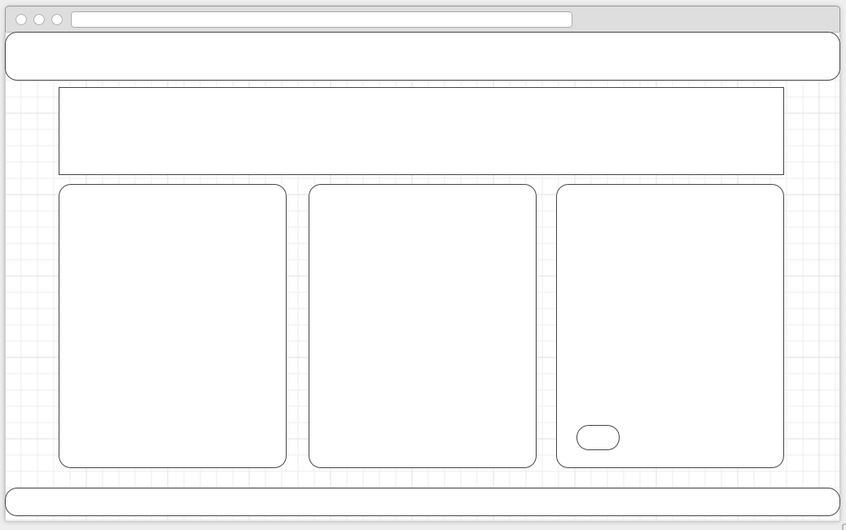

Introduction

Equipment List

Start button for tutorials

Footer

Tutorials

Footer

Tutorial Description

Tutorial Number

Navigation Bar

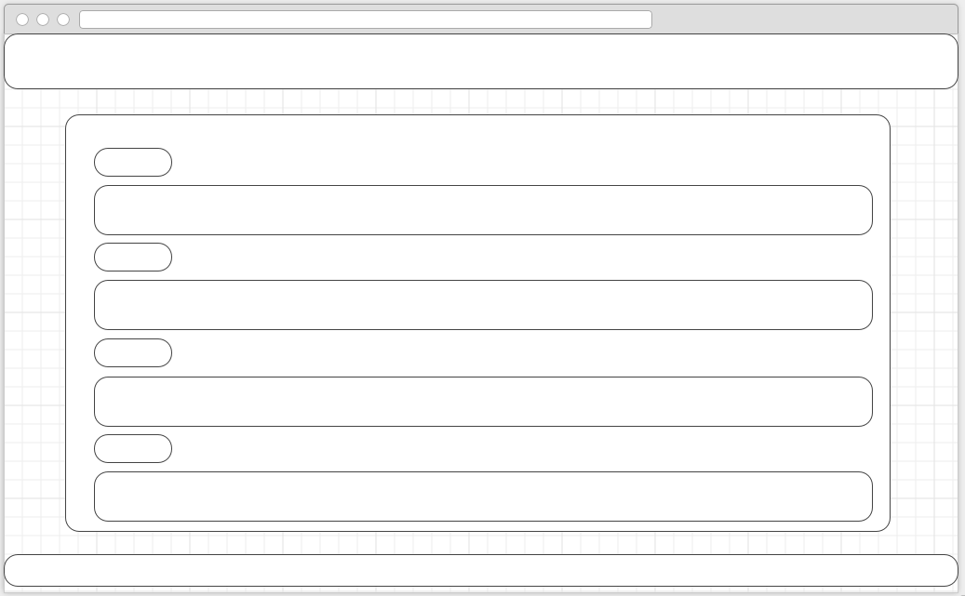

Tutorial page (eg tutorial 1)

Footer

Image

Heading

Info

Step

Navigation Bar

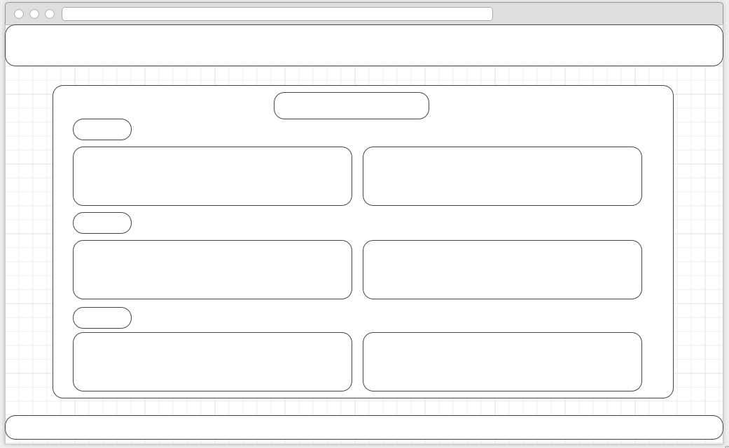

Scoreboard

Heading

Footer

Scoreboard

Navigation Bar

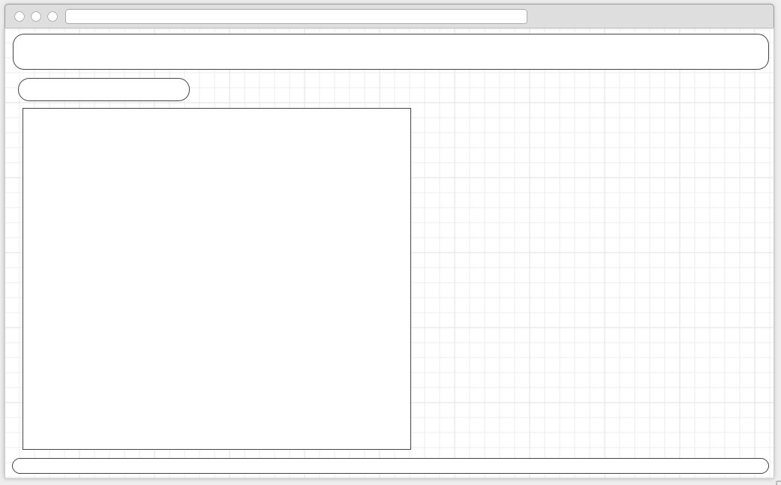

The mock-ups are as follows:

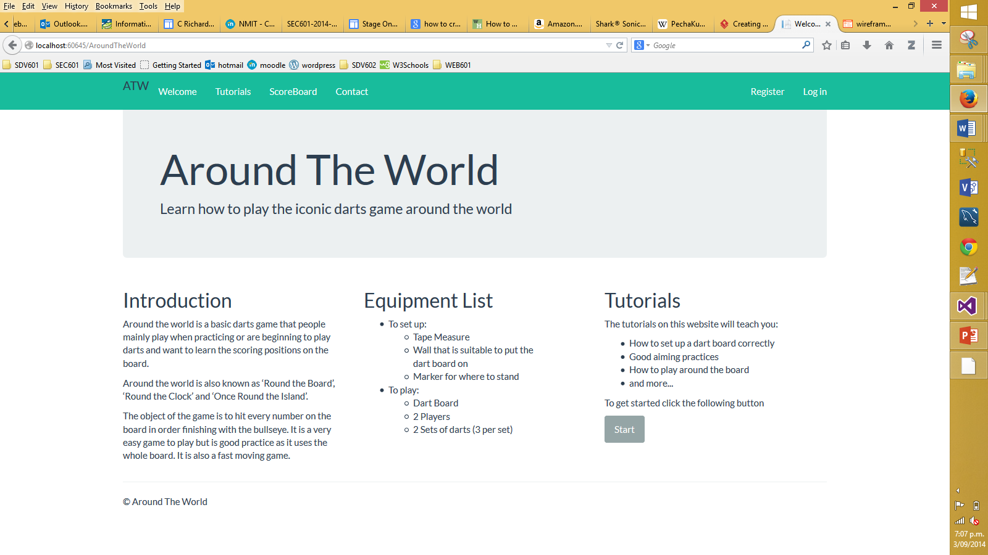

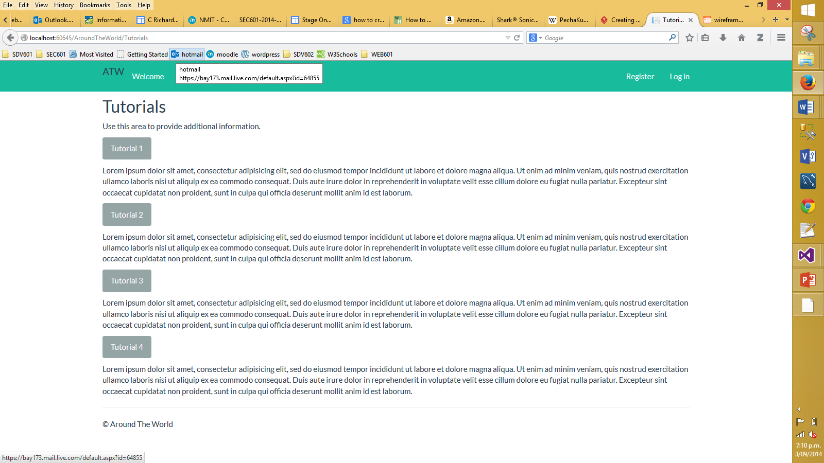

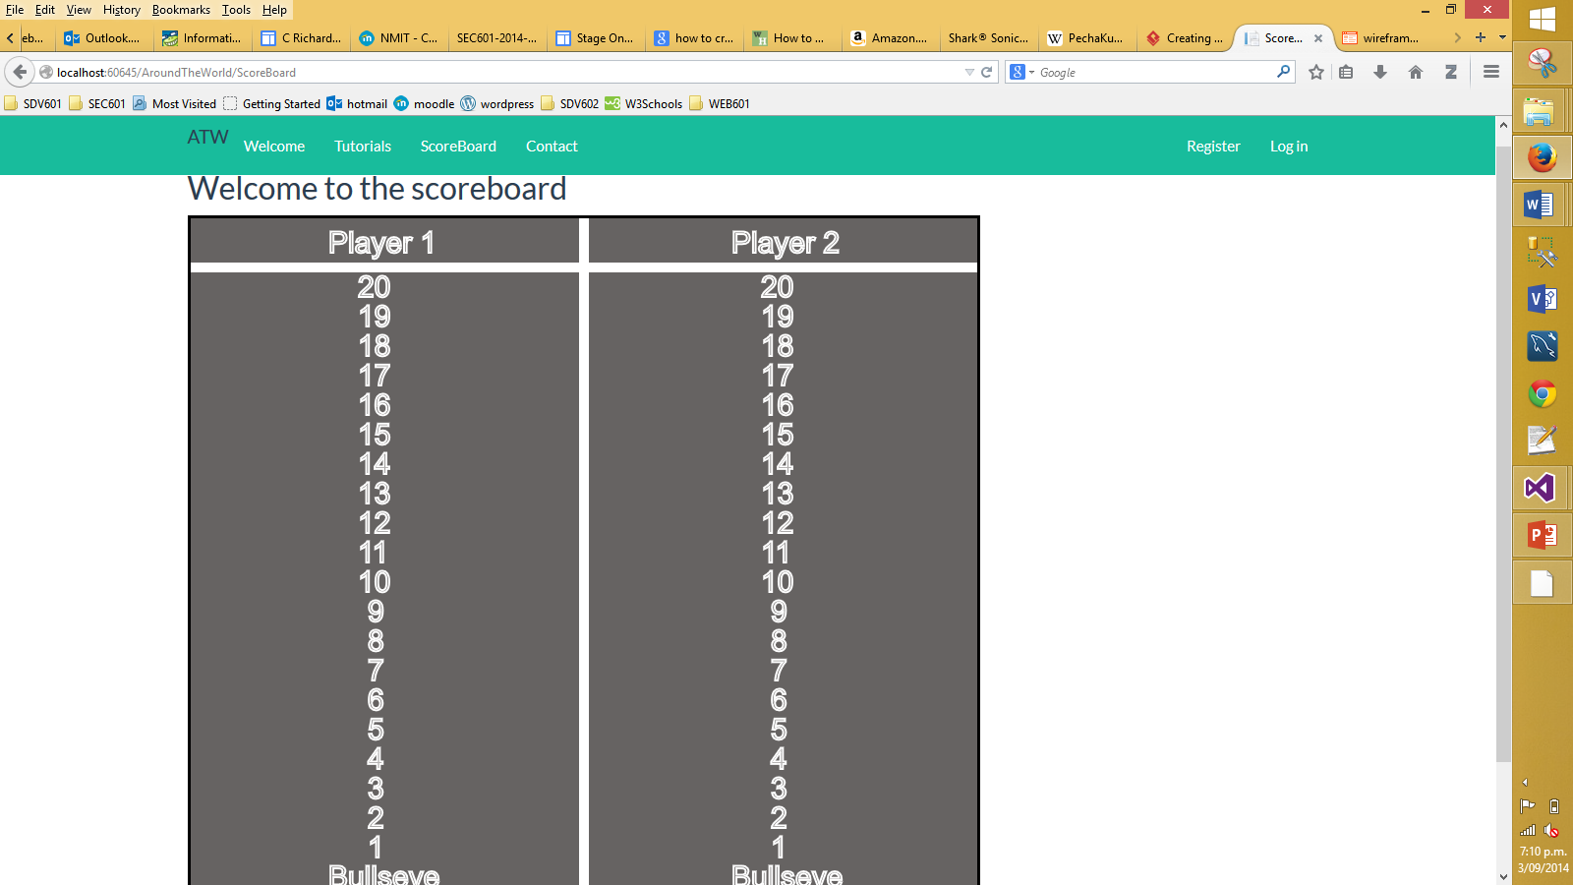

### Appendix A – Competitive Analysis

Site 1 = <http://www.mostdartgames.com/clock.html>

Site 2 = <http://www.ehow.com/how_4525054_play-around-clock-dart-game.html>

Site 3 = <http://www.chinadart.com/darts_playing_rules_round_the_world.htm>

Site 4 = <http://www.monkeysee.com/play/10143-practice-dart-games-counting-and-around-the-world>

Site 5 = <http://www.darting.com/Darts-Rules/Round-the-World/>

|  |  |  |  |  |  |  |
| --- | --- | --- | --- | --- | --- | --- |
|  | | Site 1 | Site 2 | Site 3 | Site 4 | Site 5 |
| General Site Features | |  |  |  |  |  |
|  | Site design (1-10) | 2 | 3 | 5 | 4 | 5 |
|  | Easy navigation (1-10) | 10 | 10 | 10 | 10 | 10 |
|  | No of pages | 1 | 1 | 1 | 1 | 2 |
|  | Suitable layout (1-10) | 1 | 1 | 5 | 4 | 5 |
|  | Look and feel (1-10) | 1 | 1 | 4 | 4 | 5 |
| Personalization | |  |  |  |  |  |
|  | Personal start page |  |  |  |  |  |
|  | Images |  | **X** |  |  |  |
|  | Easy to understand language |  |  |  |  | **X** |
|  | Equipment List |  |  |  |  | **X** |
|  | Suitable for children |  |  |  |  |  |

#### Site 1

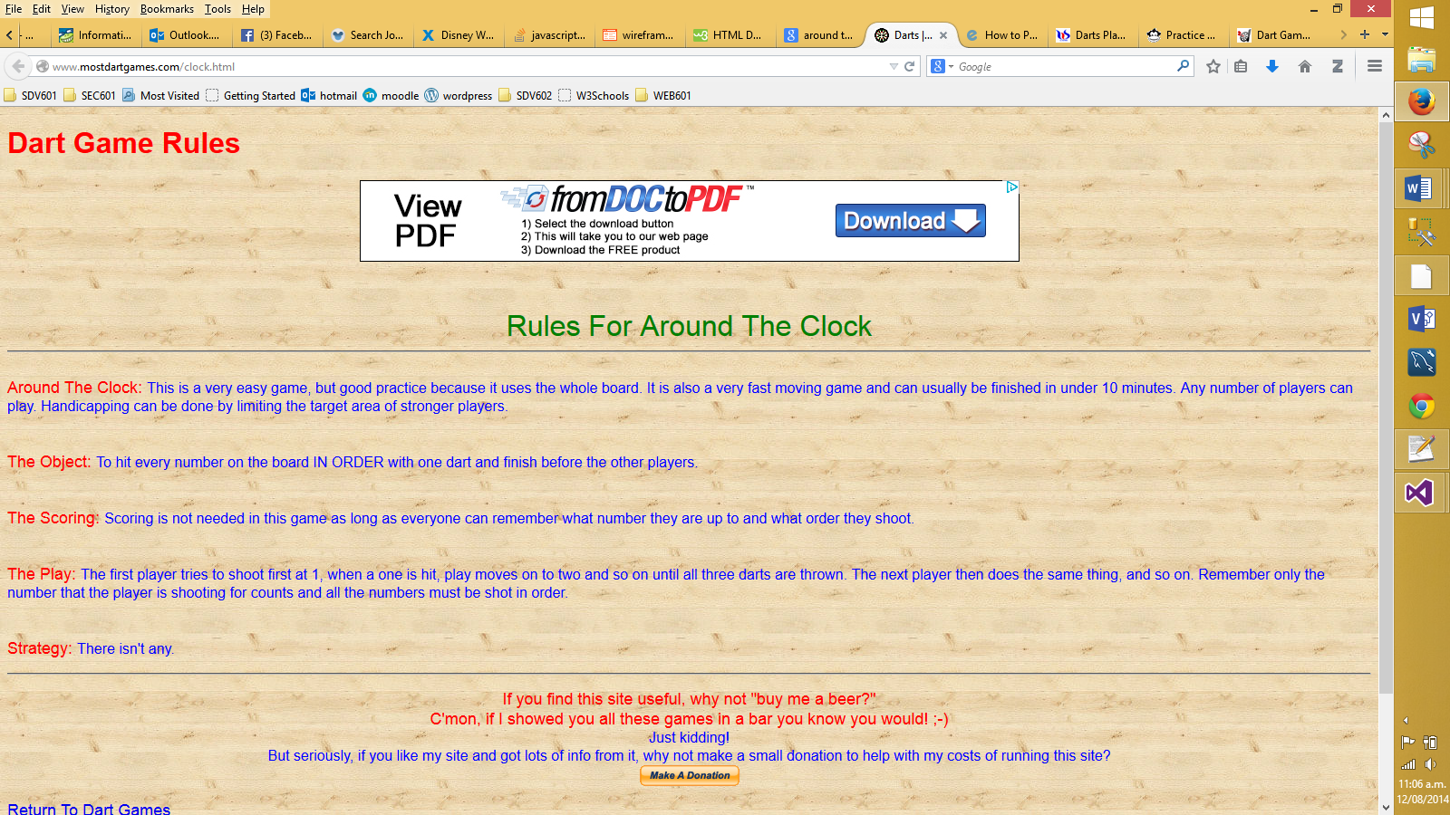

|  |  |
| --- | --- |
| **Pros** | **Cons** |
| * Won’t get lost (1 page) * Has headings * Good main heading * Simple-ish URl to remember | * Not very informative * Confusing use of colour |

#### Site 2

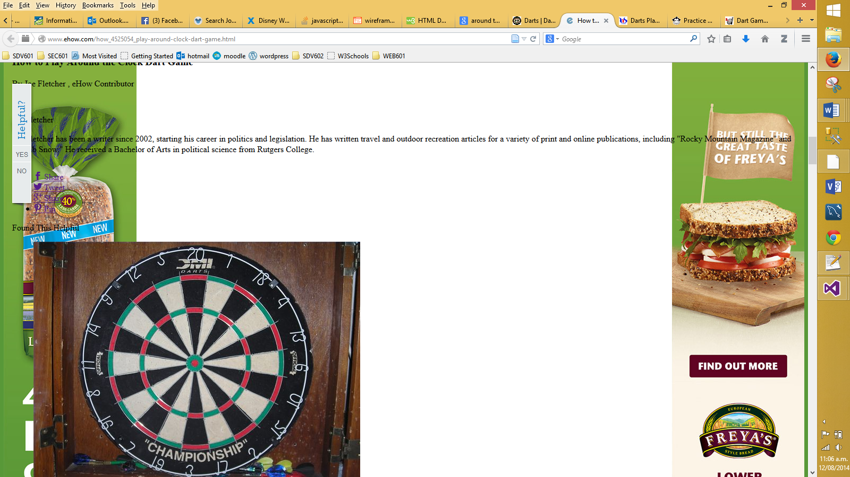

|  |  |
| --- | --- |
| **Pros** | **Cons** |
| * Won’t get lost (1 page) | * Too much advertising * Hard to read due to overlapping ads * No explanation * You don’t realise where the instructions are * Very confusing * Hard URl to remember |

#### Site 3

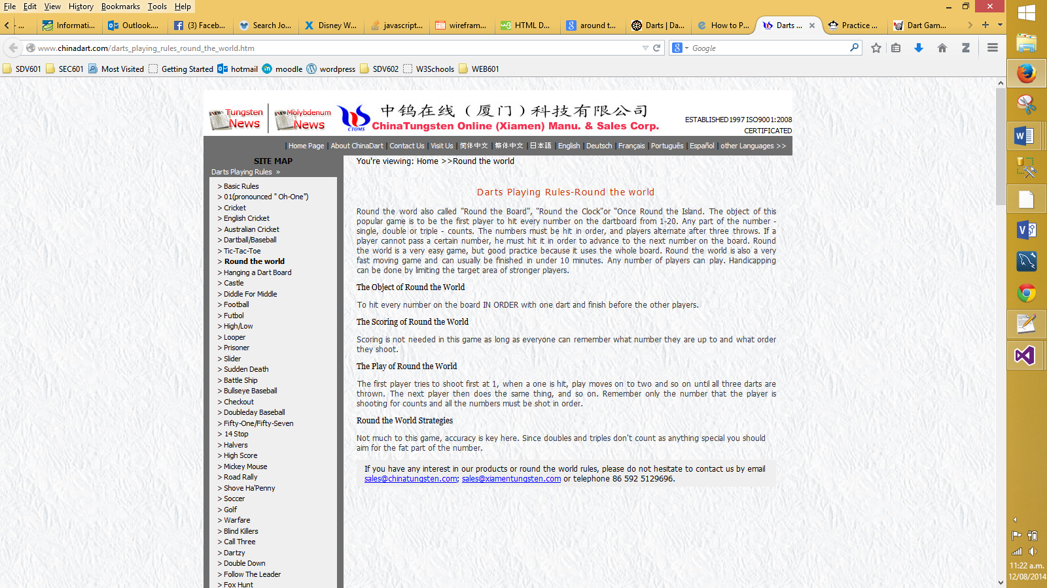

|  |  |
| --- | --- |
| **Pros** | **Cons** |
| * Won’t get lost (1 page) * Basic layout * Good headings * Has links to other games * Multiple language choices | * Background makes the text a little hard to read * Not in a language suitable for children to understand * Hard URL to remember |

#### Site 4

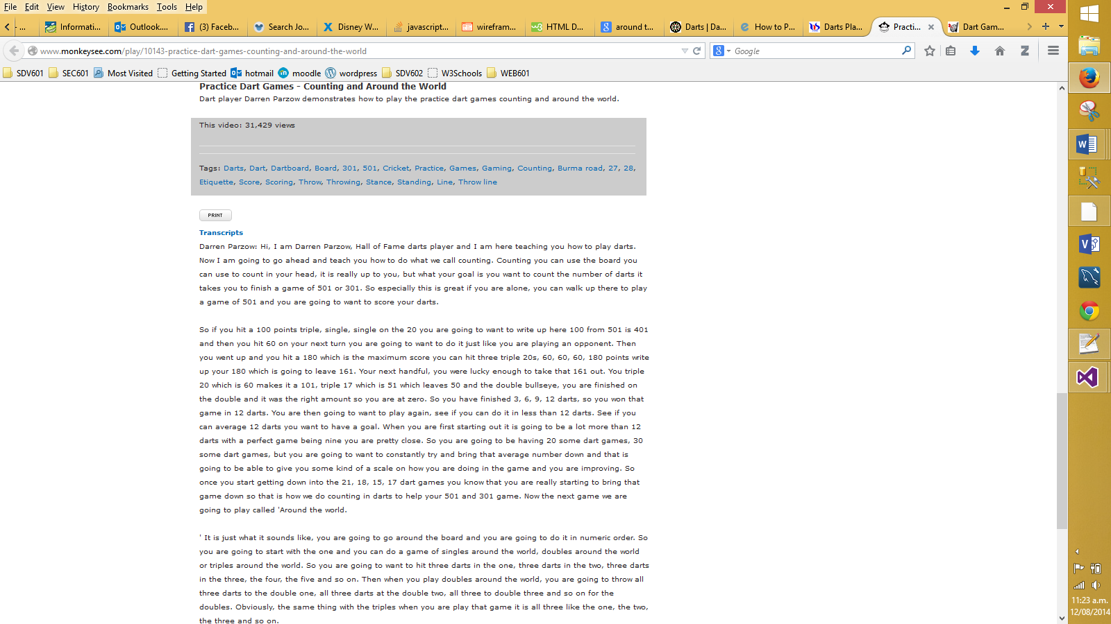

|  |  |
| --- | --- |
| **Pros** | **Cons** |
| * Won’t get lost (1 page) * Basic layout * Has links to other how to’s | * Have to scroll down before you find any information * Text is small and hard to read * No obvious headings * No obvious structure in text |

#### Site 5

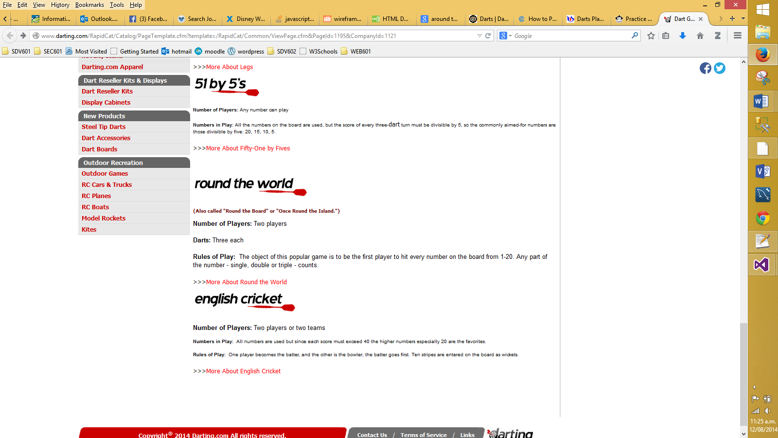

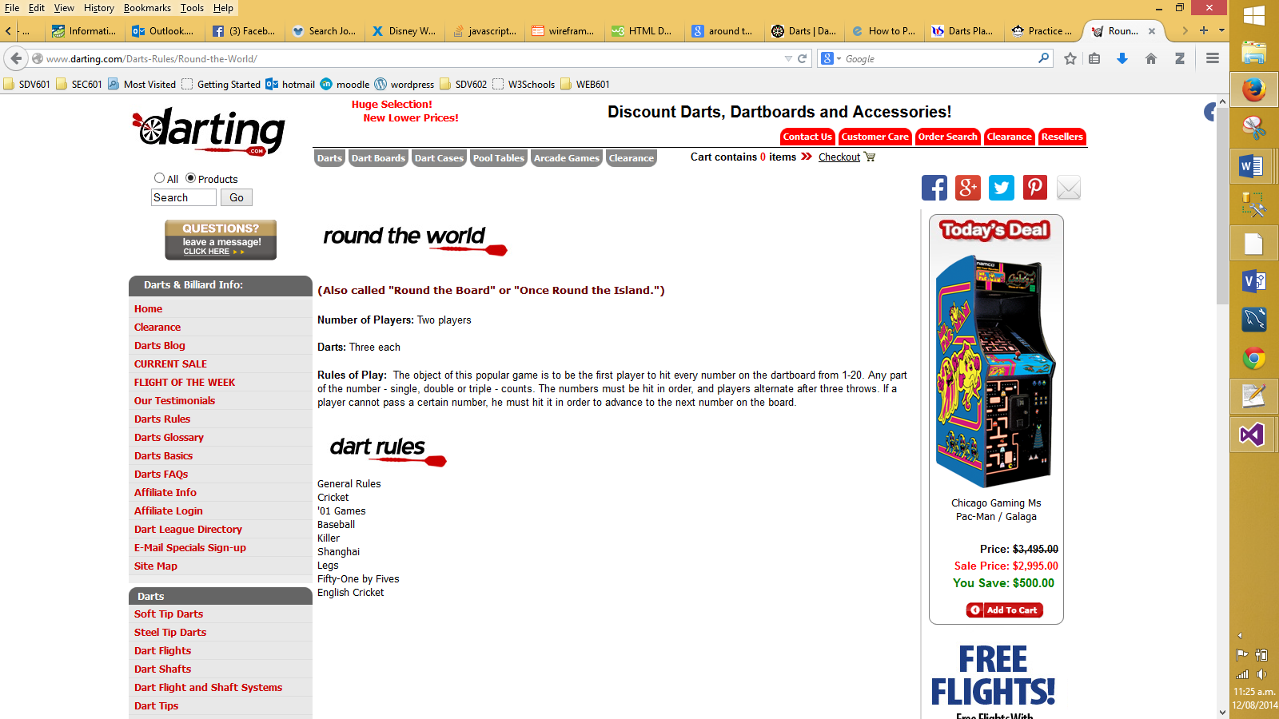

|  |  |
| --- | --- |
| **Pros** | **Cons** |
| * Basic layout * Good use of white space * Has an equipment list * Easy to understand * Obvious headings * Includes rules for other games | * Not much information * No images to aide user |

### Appendix B – Content Inventory

|  |  |  |
| --- | --- | --- |
| **Content Elements** | **Functional Requirements** |  |
| Main page | Register | 4 |
| Tutorial Page | Log in | 5 |
| Tutorials *(maybe 5 – unsure at the moment)* | Interactive scoreboard | 2 |
| Scoreboard Page | Navigation | 1 |
| Contact Page | Form for contact page | 7 |
| Notes on each page | Log out | 6 |
| Equipment List | Save notes | 3 |
| Instructions |  |  |
| Headings |  |  |
| Buttons |  |  |
| Images |  |  |
| scoreboard |  |  |

## Coding

### Around the world controller

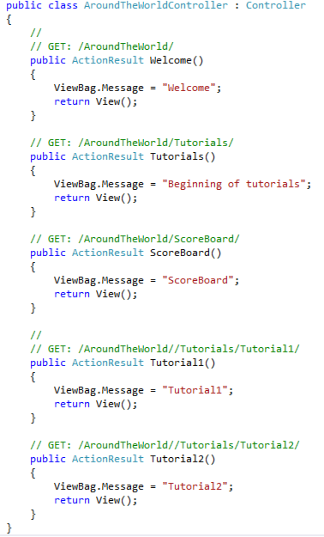

There are five methods that display a title and return a view

### Welcome View

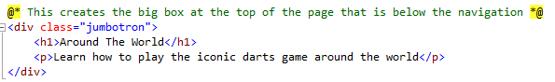

As stated in the comment the code creates the box at the top of the page. There is a heading and a paragraph.

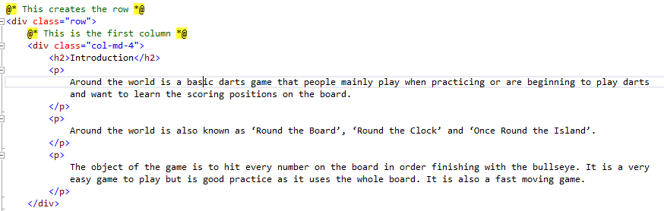

As stated in the comment the code creates a row on the page. Inside that row is the first column on the page. There is a heading and three paragraphs.

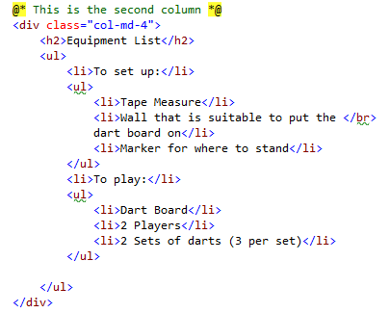

Also inside that row is the second column on the page. There is a heading and two unordered lists.

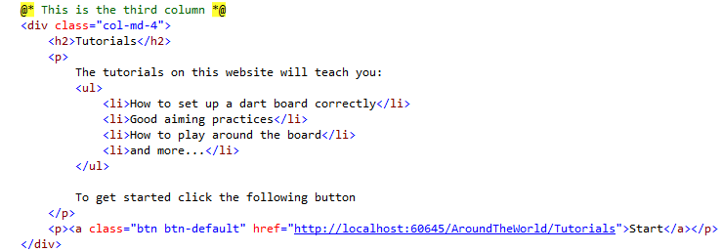

Also inside that row is the third column on the page. There is a heading and two paragraphs. Inside the first paragraph is an unordered list. Inside the second paragraph is a button.

### Tutorials View

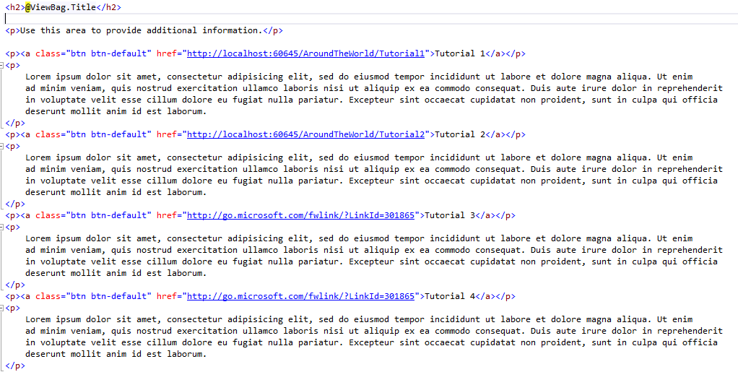

There are nine paragraphs. Inside four of them are buttons.

### Scoreboard View

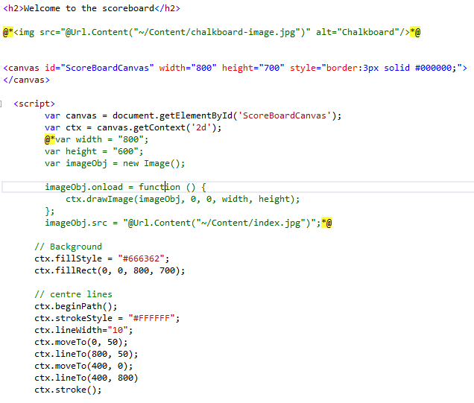

There is a heading and a canvas. There was an image but it would not let me draw lines on top of it so as you can see I created a background. Then there is the code for the centre lines.

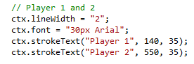

This code writes the words player 1 and player 2

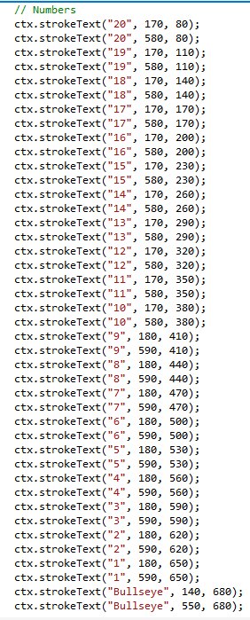

This code write all of the numbers in both columns.

# Stakeholders Feedback

This is the feedback that I received from potential stakeholders on the views that I had created.

1. Stakeholder A
   * Looks good
   * Navigation is easy to use
   * Scoreboard is a great idea
2. Stakeholder B
   * Looks good
   * Would be happy for my child to use it
   * Functionality of scoreboard sounds good
   * If I can use it, an intermediate-aged child can
3. Stakeholder C
   * Looks alright
   * Good navigation
   * Looks simple and easy to use
   * Looks like content will be alright

# Conclusion

I have started learning how to code using the MVC structure. It is a very different approach but after doing a little bit of coding I have discovered that it isn’t too bad. With the information architecture I have found the metaphor exploration the hardest part. In my coding there are a few ‘things’ that have ‘DISABLED’ next to them as they will be implemented at a later stage.