5/29/2014

Rebekah Rossiter

SDV601

Assignment 2

Stage 1

# **Screenshots**

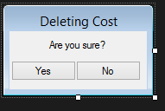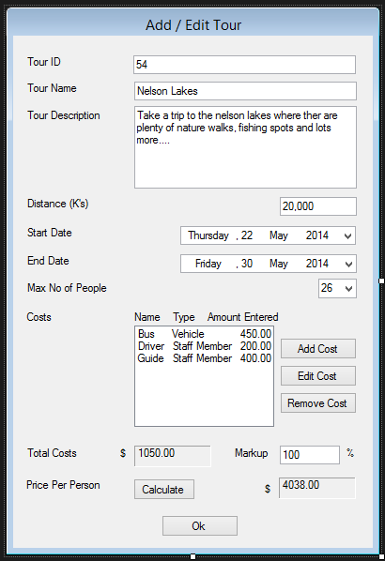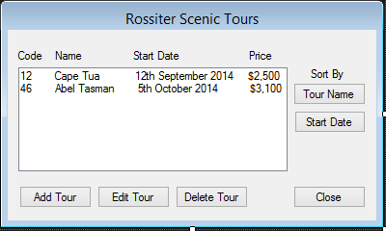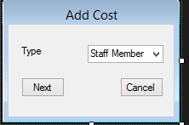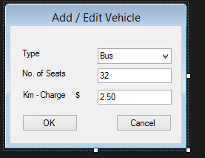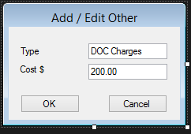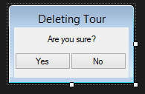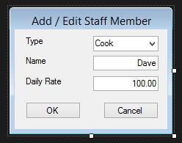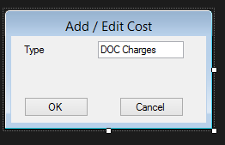

# **Errors**

|  |  |  |
| --- | --- | --- |
| **Message Text** | **Cause** | **From Form** |
| “You need to create a tour before you can use the sort feature” | Clicking on ‘Tour Name’ or ‘Start Date’ sort buttons while the tour list is empty | FrmMain |
| “You need to create a tour before you can edit a tour” | Clicking on ‘Edit Tour’ button while the tour list is empty | FrmMain |
| “You have no tours to delete” | Clicking on the ‘Delete Tour’ button while the tour list is empty | FrmMain |
| “Tour must have an ID” | ‘Tour ID’ textbox being empty when ‘OK’ button is clicked | FrmTour |
| “Tour ID must be unique” | ‘Tour ID’ textbox containing an ID already in use when ‘OK’ button is clicked | FrmTour |
| “Tour must have a name” | ‘Tour Name’ textbox being empty when ’OK’ button is clicked | FrmTour |
| “Distance must be a positive number” | ‘Distance’ textbox containing a negative number when ‘OK’ button is clicked | FrmTour |
| “You need to create a cost before you can edit a cost” | Clicking on ‘Edit Cost’ button while the cost list is empty | FrmTour |
| “There must be at least one cost before price per person can be calculated” | Clicking on ‘Calculate’ button while cost list is empty | FrmTour |
| “Are you sure you wish to cancel?” | Clicking on ‘Cancel’ button | FrmTour |
| “There must be a type” | ‘Type’ textbox being empty when ‘OK’ button is clicked | FrmOtherCost |
| “The cost must be a positive number” | ‘Cost’ textbox containing a negative number when ‘OK’ button is clicked | FrmOtherCost |
| “Are you sure you wish to cancel adding this cost?” | Clicking on ‘Cancel’ button |  |
| “There must be a type” | ‘Type’ textbox being empty when ‘OK’ button is clicked | FrmStaffMemberCost |
| “The Daily Rate must be a positive number” | ‘Daily Rate’ textbox containing a negative number when ‘OK’ button is clicked | FrmStaffMemberCost |
| “Are you sure you wish to cancel adding this cost?” | Clicking on ‘Cancel’ button |  |
| “There must be a type” | ‘Type’ textbox being empty when ‘OK’ button is clicked | FrmVehicleCost |
| “No. of Seats must be a positive number” | ‘No. of Seats’ textbox containing a negative number when ‘OK’ button is clicked | FrmVehicleCost |
| “Km - Charge must be a positive number” | ‘Km - Charge’ textbox containing a negative number when ‘OK’ button is clicked | FrmVehicleCost |
| “Are you sure you wish to cancel adding this cost?” | Clicking on ‘Cancel’ button |  |
| “The start date must be after today’s date” | ‘Start Date’ combobox containing a date that is before the current date when the ‘OK’ button is clicked |  |
| “The end date must be after the start date” | ‘End Date’ combobox containing a date that is before the ‘Start Date’ combobox when the ‘OK’ button is clicked |  |

# **Use-Case Priority Order**

|  |  |  |
| --- | --- | --- |
| **Priority** | **Use-Case** | **Reason** |
| 1 | Edit Tour | This use-case is included in Add Tour and is used often |
| 2 | Add Tour | This use-case uses Edit Tour and is one of the main activities in the program |
| 3 | Save | This use-case is reasonably important for saving progress |
| 4 | Retrieve | This use-case is reasonably important for retrieving data at last save point |
| 5 | Edit Cost | This use-case is included in New Cost and is used often but not too important as it is extended from Edit Tour |
| 6 | New Cost | This use-case uses Edit Cost and isn’t high in priority due to being extended from Edit Tour |
| 7 | Delete Tour | This use-case isn’t a high priority as it is not essential for other use-cases |
| 8 | Delete Cost | This use-case isn’t a high priority as it is not essential for other use-cases |
| 9 | Re-sort Tours | This is the least important use-case due to it not being an essential part of the program |

# **Edit Tour**

|  |  |  |
| --- | --- | --- |
| **Use-Case** | | Edit Tour |
| **Version / Date** | | 1 18/05/2014 |
| **Author** | | Rebekah Rossiter |
| **Summary** | | User edits a tour on the system |
| **Priority** | | 1 |
| **Dependencies** | **Uses** | N/A |
| **Used By** | Add Tour |
| **Actors** | | User |
| **Trigger** | | Selecting action (Form, button) |
| **Pre-Conditions** | | At least one tour must exist |
| **Description** | | 1 The system brings up FrmTour  2 The system displays selected tour details  3 User edits data  4 Ok is clicked  5 The system resaves the tour |
| **Extensions / Exceptions** | | 1a There was no selection, the system pops up a message saying “You need to create a tour before you can edit a tour”  4a Mandatory textboxes are empty, the system pops up a message for example “Tour must have an ID”  4b Invalid input, the system pops up a message for example “The cost must be a positive number”  4c There are no costs in the list to edit, the system pops up a message saying “You need to create a cost before you can edit a cost”  4e Price per person cannot be calculated due to no costs in the cost list, the system pops up a message saying “There must be at least one cost before price per person can be calculated”  4f The user selects cancel, the system pops up a message for confirmation then closes form |
| **Illustrations** | | Screenshots on page |
| **Post-Conditions** | | The selected tours details are updated in FrmMains list |

# **Delete Tour**



|  |  |  |
| --- | --- | --- |
| **Use-Case** | | Delete Tour |
| **Version / Date** | | 1 19/05/2014 |
| **Author** | | Rebekah Rossiter |
| **Summary** | | User deletes a tour on the system |
| **Priority** | | 7 |
| **Dependencies** | **Uses** | N/A |
| **Used By** | N/A |
| **Actors** | | User |
| **Trigger** | | Selecting action (Form, button) |
| **Pre-Conditions** | | At least one tour must exist |
| **Description** | | 1 System throws confirmation message “Are you sure you wish to delete this tour?”  2 Yes is selected and system deletes tour from list |
| **Extensions / Exceptions** | | 1a There was no selection or the list is empty, the system pops up a message saying “You have no tours to delete”  2b No is selected and deletion is cancelled |
| **Illustrations** | | Screenshots on page |
| **Post-Conditions** | | The selected tour is deleted from the system |

# **New Cost**



|  |  |  |
| --- | --- | --- |
| **Use-Case** | | New Cost |
| **Version / Date** | | 1 19/05/2014 |
| **Author** | | Rebekah Rossiter |
| **Summary** | | User adds a new cost to a tour |
| **Priority** | | 6 |
| **Dependencies** | **Uses** | Edit Cost |
| **Used By** | N/A |
| **Actors** | | User |
| **Trigger** | | Selecting action (Form, button) |
| **Pre-Conditions** | | FrmTour must be open |
| **Description** | | 1 The system opens FrmAddCost  2 Type of cost is selected and system opens cost form relevant to combo box selection  3 Go to use case Edit Cost  4 The system saves the cost and closes the form |
| **Extensions / Exceptions** | | 3a User cancelled in FrmAddCost, do nothing  4a Use case Edit Cost was unsuccessful, do nothing  4b The user selects cancel, the system pops up a message for confirmation then closes form |
| **Illustrations** | | Screenshots on page |
| **Post-Conditions** | | The selected cost is added to the selected tour |





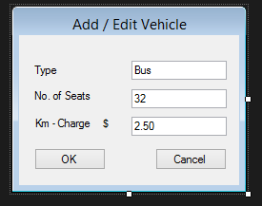

# **Class Diagram**

