8/29/2014

Rebekah Rossiter

Milestone One

SDV602

Contents

Introduction 2

Findings 2

Project Brief 2

Storyboards 2

Class Diagram 6

Model 6

Controllers 6

Views 6

Views 7

Suspect List 7

Weapon List 8

Location List 9

Button Display 10

Player View (map) 11

Conclusion 11

# Introduction

Who Killed Mr Sims is a text based game that is based on a solving a murder case. The purpose of this report is to show my understanding of the processes that I have undertaken in creating this game. As the project is indicative this is the first step of my work. This has been requested by Todd Cochrane and is due on Friday 29th August at 5 pm.

# Findings

## Project Brief

My game is called Who Killed Mr Sims. It is going to be a text based interactive game. The aim is to work out who killed the victim, where the victim was killed and what weapon was used. The victim’s name is Walter Sims. There are 5 suspects that are: his wife, his mistress, the cleaner, the gardener and his neighbour. There are 5 locations that are: the bedroom, bathroom, lounge, kitchen and patio. There are 5 weapons which are: a knife, gun, scarf, cleaver and poison.

The main screen will show the map with a little list of suspects, weapons and locations. As the player goes through the game he/she can go into those lists and remove items off of those lists. When the player thinks that they have the answer they can solve it to see if they were right. There will be a section at the bottom of the page that allows the player to type and see what they have previously typed. That is also where any information from the game will be displayed.

When a player types roll and presses enter they will get a random number of spaces to move and options of what direction that they can go in.

## Storyboards

**Screenshot 1**

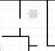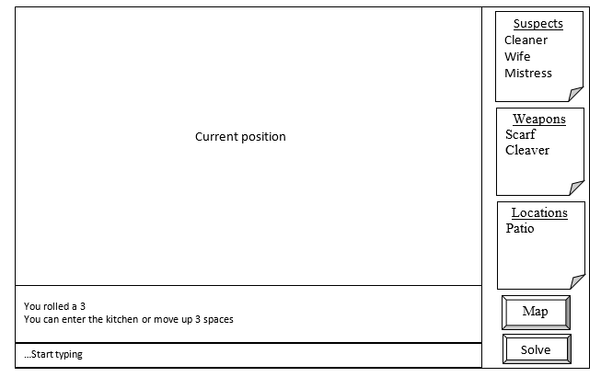

|  |
| --- |
| This is the main screen with example data There are; > 3 lists of evidence *Screenshot 1* > two “buttons” indicating a map and solve > a textbox *Screenshot 3* > a box for the “conversation” *Screenshot 4* > players current position on map *Screenshot 11* |

**Screenshot 2**

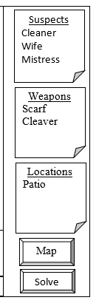

|  |
| --- |
| This contains a list of current suspects. You can open it to view the suspects that you have ruled out. *See screenshot 5 for expansion of list.* |
| This contains a list of current weapons. You can open it to view the weapons that you have ruled out. *See screenshot 6 for expansion of list.* |
| This contains a list of current locations. You can open it to view the locations that you have ruled out. *See screenshot 7 for expansion of list.* |
| This takes you to a bigger view of the map. *Screenshot 10* |
| This ends the game and shows whether you solved the case or not. *Screenshots 8 & 9* |

**Screenshot 3**

…Start typing

|  |
| --- |
| This is where the user types text. After typing the user must press enter. |

**Screenshot 4**

You rolled a 3

You can enter the kitchen or move up 3 spaces

|  |
| --- |
| This is where the text that the user entered shows up and what the games reply is. |

**Screenshot 5**

|  |
| --- |
| This will open on top of the map. It is an example of the complete suspect list. It has two suspects with a line through their names as they have been eliminated as suspects. There are three options that are eliminate, add and close. Eliminate puts a line through a name, Add removes the line from a name and Close closes the view. |

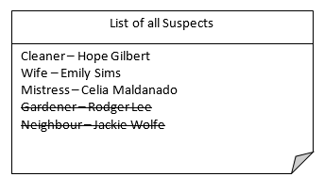

Eliminate

Add

Close

**Screenshot 6**

|  |
| --- |
| This will open on top of the map. It is an example of the complete weapon list. It has three weapons with a line through their names as they have been eliminated as the murder weapon. There are three options that are eliminate, add and close. Eliminate puts a line through a name, Add removes the line from a name and Close closes the view. |

Eliminate

Add

Close

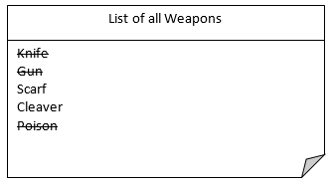

**Screenshot 7**

|  |
| --- |
| This will open on top of the map. It is an example of the complete location list. It has four locations with a line through their names as they have been eliminated as the murder location. There are three options that are eliminate, add and close. Eliminate puts a line through a name, Add removes the line from a name and Close closes the view. |

Eliminate

Add

Close

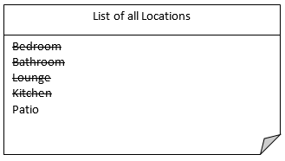

**Screenshot 8**

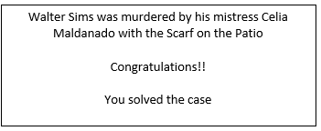

|  |
| --- |
| This is the message that will pop up if the player had the correct suspect, weapon and location |

**Screenshot 9**

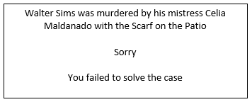

|  |
| --- |
| This is the message that will pop up if the player had the incorrect suspect, weapon and location |

**Screenshot 10**

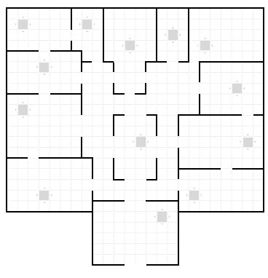

|  |
| --- |
| This is the complete map. The star is a pointer showing the players position on the map. *This is just an example.* |

**Screenshot 11**



|  |
| --- |
| This is the segment of the map that the player is currently on. It is displayed on the main screen. The star is a pointer showing the players position on the map. *This is just an example.* |

## Class Diagram

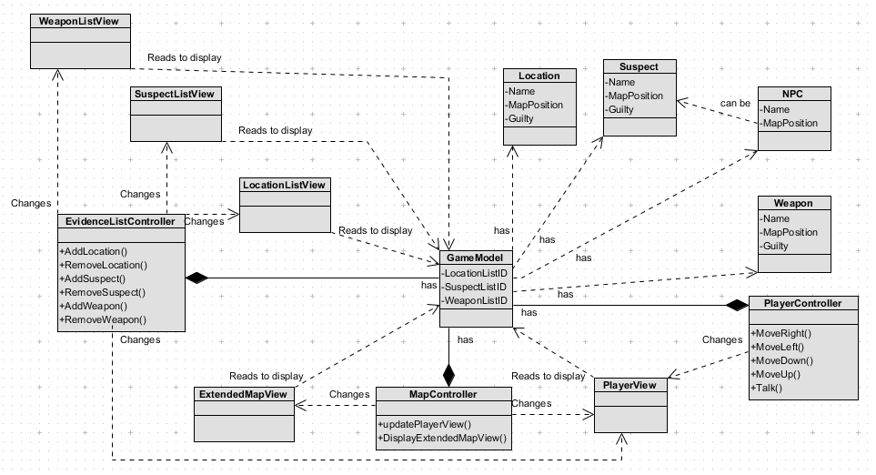

### Model

In my class diagram there is one model called Game Model. It contains all of the data for the game including the evidence lists. It also has locations, weapons, suspects and NPC’s.

### Controllers

There are three controllers. They are named; Player Controller, Map Controller and Evidence List Controller. Player Controller contains the methods; Move Right, Move Left, Move Down, Move Up and Talk which are all self-explanatory. Map Controller contains the methods Update Player View and Display Extended Map View which are also self-explanatory. Evidence List Controller contains the methods Add Location, Remove Location, Add Suspect, Remove Suspect, Add Weapon and Remove weapon which are also self-explanatory.

### Views

There are five views. They are named; Player View, Extended Map View, Location List View, Suspect List View and Weapon List View. They all read the Game Model to display. Location List View, Suspect List View and Weapon List View are all changed by the Evidence List Controller. Extended Map View is changed by the Map Controller. Player view is changed by all three controllers.

## Views

### Suspect List

#### HTML



I have put this canvas into a div element so that I could have more than one canvas on the page with the positioning that I choose.

#### JS

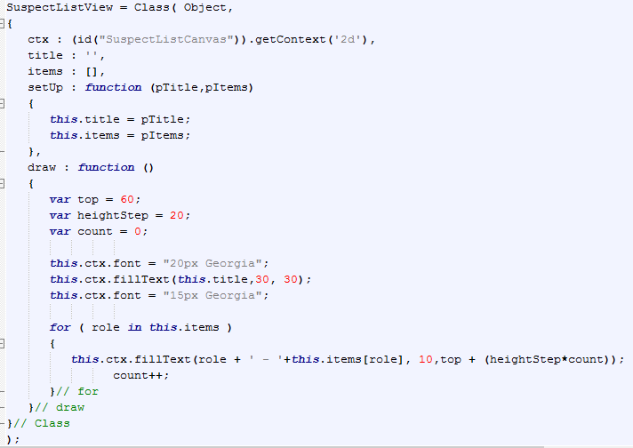

This is the code that Todd reworked for me so that it was in a class. This is defining it

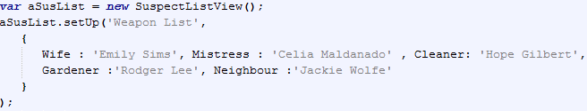

This is an instance of the class



This instantiates the class

### Weapon List

#### HTML

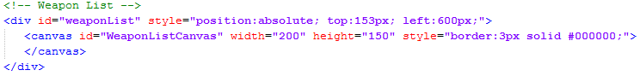

I have put this canvas into a div element so that I could have more than one canvas on the page with the positioning that I choose.

#### JS

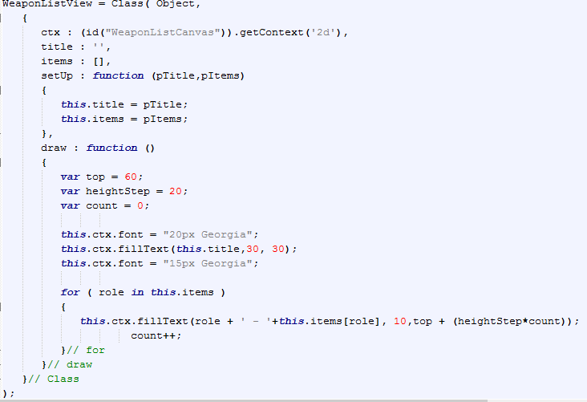

I reused the code from the suspect list view and made changes to suit the weapon list view

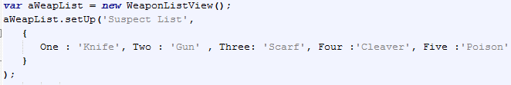

This is an instance of the class



This instantiates the class

### Location List

#### HTML

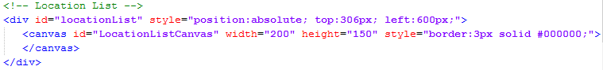

I have put this canvas into a div element so that I could have more than one canvas on the page with the positioning that I choose.

#### JS

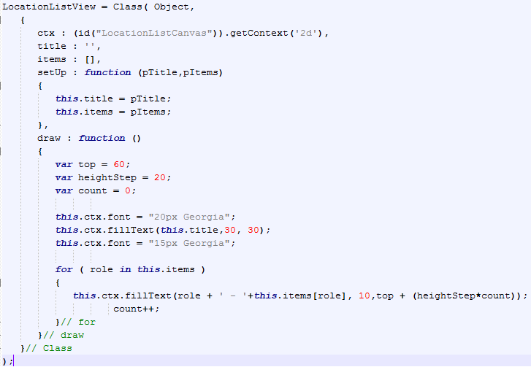

I reused the code from the suspect list view and made changes to suit the location list view

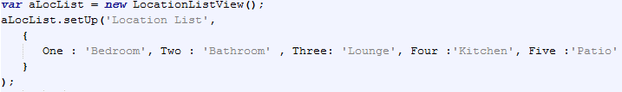

This is an instance of the class



This instantiates the class

### Button Display

#### HTML

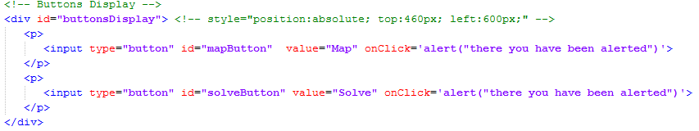

Here I have not used a canvas due to having two buttons. I have put them both into paragraph tags inside a div element for positioning purposes

#### CSS

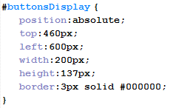

This is for the display of the buttons

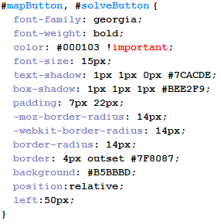

This sets the styling properties to both of the buttons

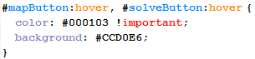

This is the code for the hover effect of the buttons

### Player View (map)

#### HTML

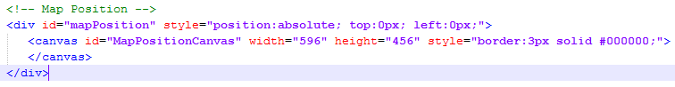

I have put this canvas into a div element so that I could have more than one canvas on the page with the positioning that I choose

#### JS

My code didn’t want to work so for now I have done this;

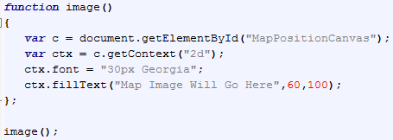

I have put writing onto the canvas stating that an image will go here

# Conclusion

I have started learning to code in JavaScript and have reused some of my knowledge of HTML and CSS in this stage of the project. I have found the MVC architecture a little confusing using notepad ++. I understand functions but making classes had me a little confused. With my research and Todd’s help I have managed to get to the point that I am currently at.