‘Who Killed Mr Sims’ Storyboards

**Screenshot 1**

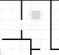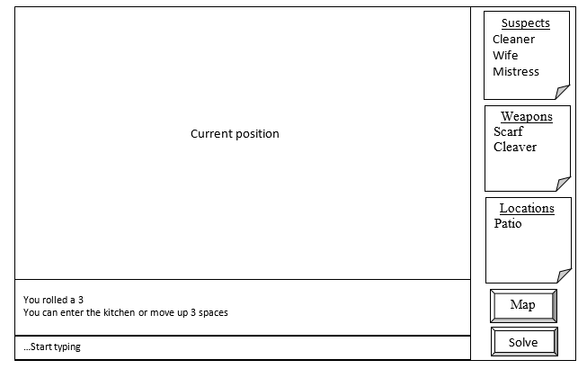

|  |
| --- |
| This is the main screen with example data There are; > 3 lists of evidence *Screenshot 1* > two “buttons” indicating a map and solve > a textbox *Screenshot 3* > a box for the “conversation” *Screenshot 4* > players current position on map *Screenshot 11* |

**Screenshot 2**

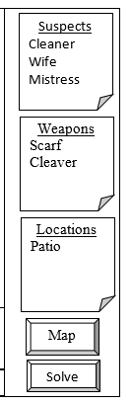

|  |
| --- |
| This contains a list of current suspects. You can open it to view the suspects that you have ruled out. *See screenshot 5 for expansion of list.* |
| This contains a list of current weapons. You can open it to view the weapons that you have ruled out. *See screenshot 6 for expansion of list.* |
| This contains a list of current locations. You can open it to view the locations that you have ruled out. *See screenshot 7 for expansion of list.* |
| This takes you to a bigger view of the map. *Screenshot 10* |
| This ends the game and shows whether you solved the case or not. *Screenshots 8 & 9* |

**Screenshot 3**

…Start typing

|  |
| --- |
| This is where the user types text. After typing the user must press enter. |

**Screenshot 4**

You rolled a 3

You can enter the kitchen or move up 3 spaces

|  |
| --- |
| This is where the text that the user entered shows up and what the games reply is. |

**Screenshot 5**

|  |
| --- |
| This will open on top of the map. It is an example of the complete suspect list. It has two suspects with a line through their names as they have been eliminated as suspects. There are three options that are eliminate, add and close. Eliminate puts a line through a name, Add removes the line from a name and Close closes the view. |

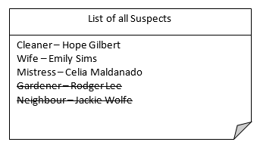

Eliminate

Add

Close

**Screenshot 6**

|  |
| --- |
| This will open on top of the map. It is an example of the complete weapon list. It has three weapons with a line through their names as they have been eliminated as the murder weapon. There are three options that are eliminate, add and close. Eliminate puts a line through a name, Add removes the line from a name and Close closes the view. |

Eliminate

Add

Close

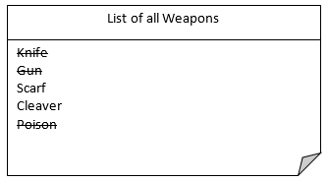

**Screenshot 7**

|  |
| --- |
| This will open on top of the map. It is an example of the complete location list. It has four locations with a line through their names as they have been eliminated as the murder location. There are three options that are eliminate, add and close. Eliminate puts a line through a name, Add removes the line from a name and Close closes the view. |

Eliminate

Add

Close

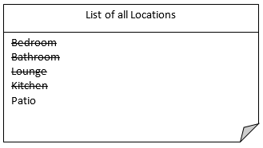

**Screenshot 8**

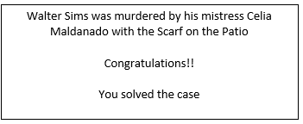

|  |
| --- |
| This is the message that will pop up if the player had the correct suspect, weapon and location |

**Screenshot 9**

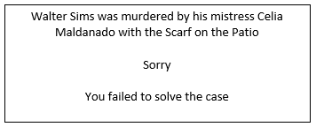

|  |
| --- |
| This is the message that will pop up if the player had the incorrect suspect, weapon and location |

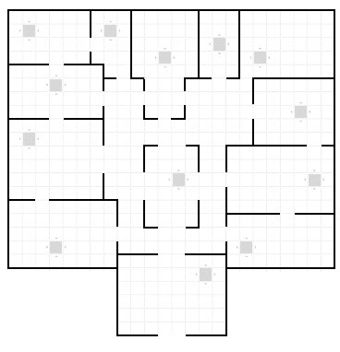

**Screenshot 10**

|  |
| --- |
| This is the complete map. The star is a pointer showing the players position on the map. *This is just an example.* |

**Screenshot 11**



|  |
| --- |
| This is the segment of the map that the player is currently on. It is displayed on the main screen. The star is a pointer showing the players position on the map. *This is just an example.* |