Start of Storyboards

**Screenshot 1**

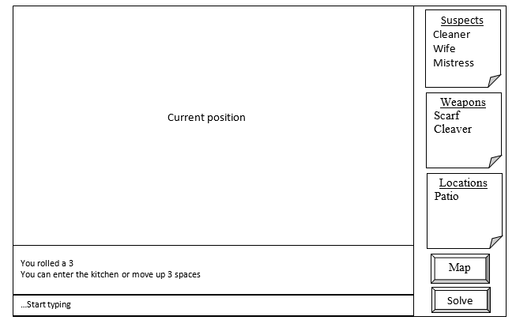

|  |
| --- |
| This is the main screen with example data There are; > 3 lists of evidence > two “buttons” indicating a map and solve > a textbox > a box for the “conversation” > players current position on map |

**Screenshot 2**

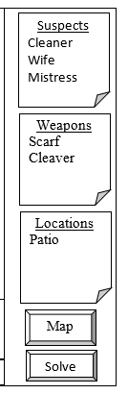

|  |
| --- |
| This contains a list of current suspects. You can open it to view the suspects that you have ruled out. See screenshot 5 for expansion of list. |
| This contains a list of current weapons. You can open it to view the weapons that you have ruled out. |
| This contains a list of current locations. You can open it to view the locations that you have ruled out. |
| This takes you to a bigger view of the map. |
| This ends the game and shows whether you solved the case or not. |

**Screenshot 3**

…Start typing

|  |
| --- |
| This is where the user types text. After typing the user must press enter. |

**Screenshot 4**

You rolled a 3

You can enter the kitchen or move up 3 spaces

|  |
| --- |
| This is where the text that the user entered shows up and what the games reply is. |

**Screenshot 5**

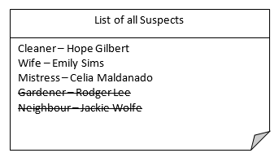

|  |
| --- |
| This is an example of the complete suspect list. It has two suspects with a line through their names as they have been eliminated as suspects. |

**Screenshot 6**

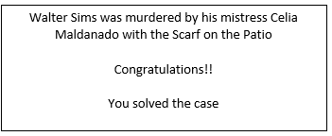

|  |
| --- |
| This is the message that will pop up if the player had the correct suspect, weapon and location |

**Screenshot 7**

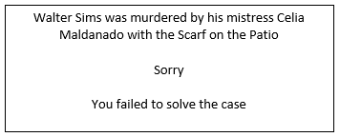

|  |
| --- |
| This is the message that will pop up if the player had the incorrect suspect, weapon and location |

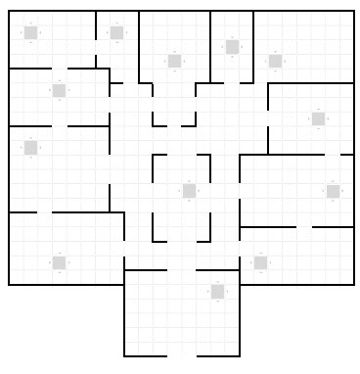

**Screenshot 8**

|  |
| --- |
| This is the complete map. The star is a pointer showing the players position on the map. *This is just an example.* |

**Screenshot 9**

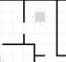

|  |
| --- |
| This is the segment of the map that the player is currently on. It is displayed on the main screen. The star is a pointer showing the players position on the map. *This is just an example.* |