2014

Rebekah Rossiter

Milestone Two

SDV602

Contents

Introduction 2

Findings 2

WampServer 2

WhoKilledMrSims – MySQL Database 2

Suspect Table 2

NPC Table 3

Location Table 4

Weapon Table 4

MapPosition Table 5

Player Table 6

Game Table 6

Linking to my Database 7

Displaying data 8

Conclusion 9

# Introduction

Who Killed Mr Sims is a text based game that is based on a solving a murder case. The purpose of this report is to show my understanding of the processes that I have undertaken in creating this game. As the project is indicative this is the second step of my work. This has been requested by Todd Cochrane and is due on Friday 17th October at 9 am. In the middle of the first half of the semester I came down with a really bad case of the flu. Because of this I had to take three weeks off where I was basically bed-ridden and couldn’t study at all. This has affected my learning of the ‘stuff’ required for this milestone.

# Findings

## WampServer

For this milestone we had to download WampServer. We then had to do our assignment work on this server. When I save a file I save it in the www folder that is located in the wamp folder in my C drive. So now instead of clicking run in Notepad ++ I open a browser and type *localhost/* followed by the file name and extension that I want to open. To enable WampServer I had to go into my local services and disable MySQL as WampServer has its own MySQL incorporated into it. If I didn’t do this WampServer wouldn’t work.

## WhoKilledMrSims – MySQL Database

In this stage of the project I was set the task of creating a database for my game. As my heading states the name of my database is WhokilledMrSims. WhoKilledMrSims contains seven tables; Suspect, NPC, Location, Weapon, MapPosition, Player and Game.

### Suspect Table

This is what my Suspect table looks like in WampServers MySQL console;

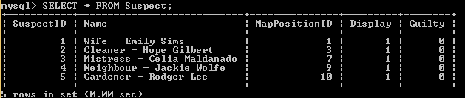

There are five suspects. They have a SuspectID, Name, MapPositionID, Display and Guilty. Display is for whether the suspect gets displayed on the screen. Guilty is for whether the suspect is the suspect of the game.

This is the create table statement;

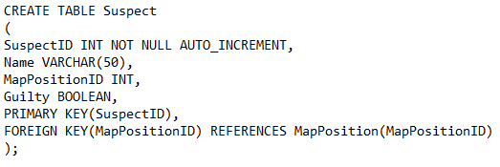

As you can see it looks different from the actual table. I added a column called Display. It is a Boolean with a default of 1 which means true. I also added a default to guilty of 0 which means false. SuspectID is the primary key. MapPositionID is a foreign key that links to the MapPosition table.

### NPC Table

This is what my NPC table looks like in WampServers MySQL console;

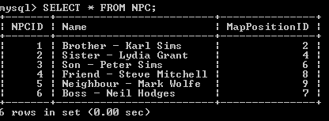

NPCs are non-playing characters or in the case of this game non-suspects. There are six NPCs.

This is the create table statement;

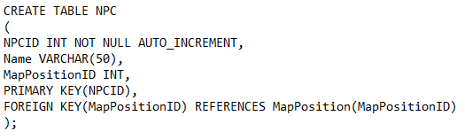

NPCID is the primary key. MapPositionID id a foreign key that links to the MapPosition table.

### Location Table

This is what my Location table looks like in WampServers MySQL console;

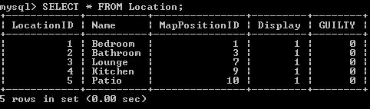

Locations are the possible spots of the murder. There are five locations. They have a LocationID, Name, MapPositionID, Display and Guilty. Display is for whether the suspect gets displayed on the screen. Guilty is for whether the suspect is the suspect of the game.

This is the create table statement;

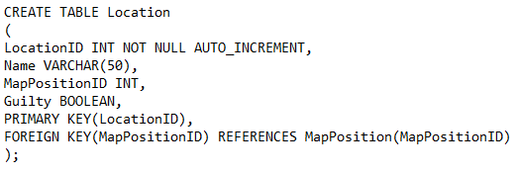

As you can see it looks different from the actual table. I added a column called Display. It is a Boolean with a default of 1 which means true. I also added a default to guilty of 0 which means false. LocationID is the primary key. MapPositionID is a foreign key that links to the MapPosition table.

### Weapon Table

This is what my Weapon table looks like in WampServers MySQL console;

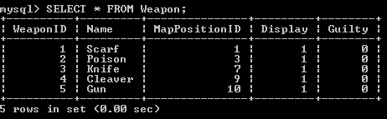

There are five weapons. They have a WeaponID, Name, MapPositionID, Display and Guilty. Display is for whether the suspect gets displayed on the screen. Guilty is for whether the suspect is the suspect of the game.

This is the create table statement;

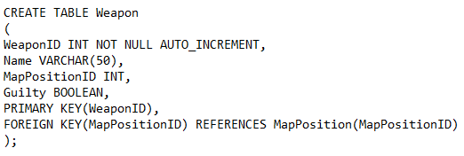

As you can see it looks different from the actual table. I added a column called Display. It is a Boolean with a default of 1 which means true. I also added a default to guilty of 0 which means false. WeaponID is the primary key. MapPositionID is a foreign key that links to the MapPosition table.

### MapPosition Table

This is what my MapPosition table looks like in WampServers MySQL console;

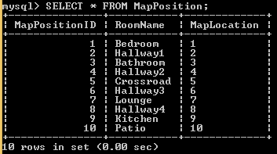

There are 10 MapPositions that correspond to the map of the game.

This is the create table statement;

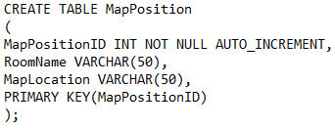

MapPositionID is the primary key.

### Player Table

This is what my Player table looks like in WampServers MySQL console;



This table is empty as no players have played a game yet.

This is the create table statement;

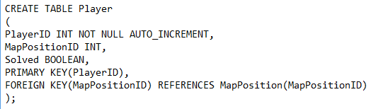

There are three columns. A player will have a PlayerID, MapPositionID and Solved. Solved is whether their guess was correct or not. PlayerID is the primary key. MapPositionID is a foreign key linking to the MapPosition table. This points to where the player is currently positioned.

### Game Table

This is what my Player table looks like in WampServers MySQL console;

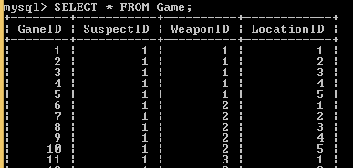

I have only included a snapshot of part of the table as there are 125 games. Each game has a suspect, weapon and location. These are the correct answers for the particular game.

This is the create table statement;

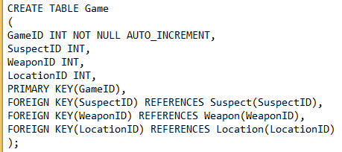

GameID is the primary key. There are three foreign keys that link to their respective tables. They are: SuspectID, WeaponID and LocationID.

## Linking to my Database

To link my database to my game I am supposed to use PHP. I have the code that Todd provided the class. It is in a file called databaseJSON.php.

First you have to call the PHP file in JavaScript.

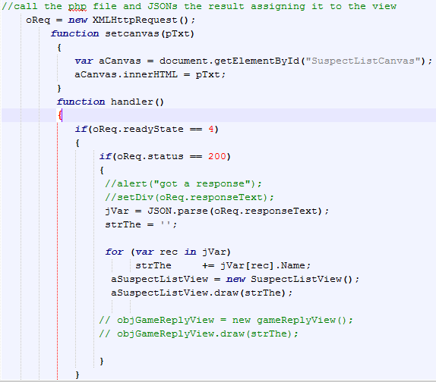

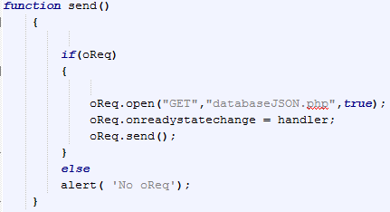

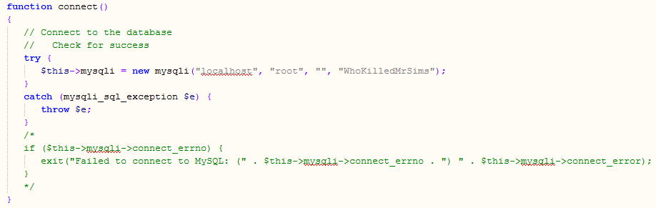Then the PHP file connects to the database.

(this code is inside a PHP file)

## Displaying data

To display data you must first have a query. The following code will run a query using a variable as a placeholder.

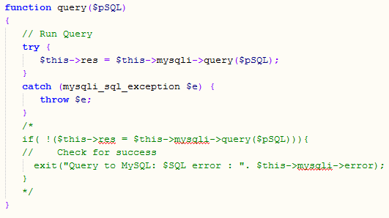

This code will display the results of the query.

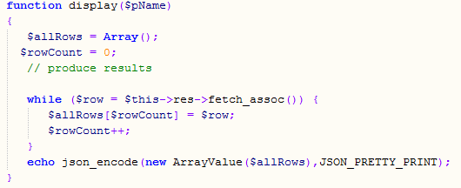

This code is the creation of the actual query, running of the query and displaying it.

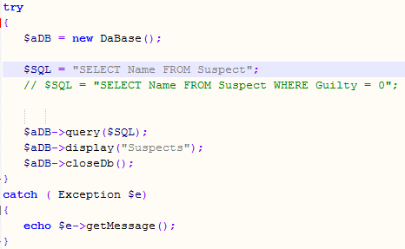

My code from databaseJSON.php was given to me from a classmate that I changed to suit my needs. However it does not seem to work for me.

## Class Diagram

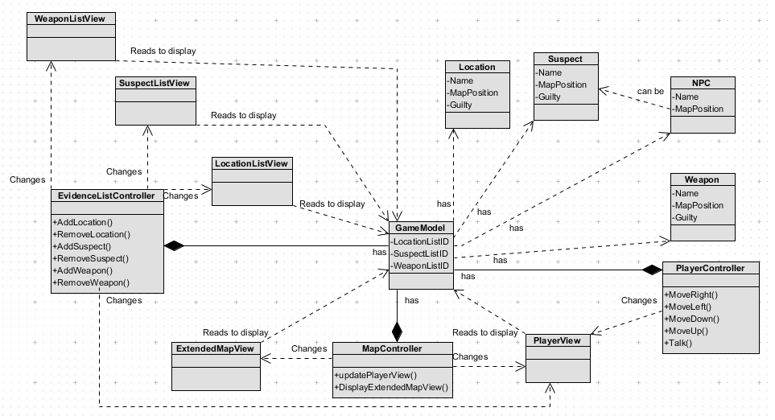

### Model

In my class diagram there is one model called Game Model. It contains all of the data for the game including the evidence lists. It also has locations, weapons, suspects and NPC’s.

### Controllers

There are three controllers. They are named; Player Controller, Map Controller and Evidence List Controller. Player Controller contains the methods; Move Right, Move Left, Move Down, Move Up and Talk which are all self-explanatory. Map Controller contains the methods Update Player View and Display Extended Map View which are also self-explanatory. Evidence List Controller contains the methods Add Location, Remove Location, Add Suspect, Remove Suspect, Add Weapon and Remove weapon which are also self-explanatory.

### Views

There are five views. They are named; Player View, Extended Map View, Location List View, Suspect List View and Weapon List View. They all read the Game Model to display. Location List View, Suspect List View and Weapon List View are all changed by the Evidence List Controller. Extended Map View is changed by the Map Controller. Player view is changed by all three controllers.

# Conclusion

I was really stoked with my marks for the first milestone due to not being sure about it. I have had a bit of struggle with this milestone due to being sick.